A Case Study of Software Development Life Cycle Efficiency

Richard Kapalko
CSU Global University
MIS5581: Capstone – Business Intelligence and Data Analytics
Dr. Lisa Bryan
October 10, 2021

Abstract
A Software Development Life Cycle may be analyzed with Lean Manufacturing principles with Key Performance Indicators of lead-time and activity-ratio. An Application Lifecycle Management repository change history log provides a time-stamped sequence of software component state changes at an established U.S. organization. The project objective is to find the influencers of and inefficiencies within the development life cycle through study of the given transaction log. An interactive visualization provides ad-hoc exploratory analysis of sequence wait time, a correlation test finds a surprising relationship between team maturity and activity-ratio, and a regression analysis supports the elusiveness of lead-time. The case-study demonstrates to the organization how tools pgAdmin, Tableau, SAS, R, and GitHub can be used to analyze the dataset.
Keywords: SDLC, Lead Time, Activity Ratio, Tableau, R, SAS, PostgreSQL, GitHub.

Contents
Project Context 5
Organization Overview 5
Software Development Life Cycle 6
Application of Lean Manufacturing Principles 7
Key Performance Indicators 7
Research Questions 8
Research Dataset 8
Data Acquisition 9
Dimensional Model 10
Dataset Specifics 11
Dataset Potential 12
Research Hypotheses 13
Research Design 13
Methodology 14
Tools 14
Techniques 15
Project Management 15
Accompanying Presentation 16
Research Limitations 16
Literature Review 17
Security, Ethical, and Privacy Considerations 18
GitHub Repository 18
Research Analysis Results 18
RQ₁: Identifying Areas of Waste 18
RQ₂: Comparing Team Efficiency 19
RQ₃: Predicting Lead-Time 19
Research Conclusions 20
Business Insights 20
Recommendations 20
References 21
Appendix A (Project Screenshots) 26
GitHub and Git - Project Assets Management 26
Jira and JQL – Data Acquisition 27
Excel - Exploratory Analysis 28
pgAdmin and PostgreSQL - Dimensional Modeling 29
Tableau Public – Interactive Visualization for RQ₁ 30
SAS Studio and SQL – Correlation Analysis for RQ₂ 31
R Studio and R – Linear Regression for RQ₃ 33

A Case Study of Software Development Life Cycle Efficiency
An organization in the United States, an accompanying dataset, and a selection of tools were chosen for analytics research. The project purpose was to show the organization how the tools could be used to analyze the data. After an orientation to the project context and dataset, hypotheses and research design is presented followed by project management concerns and results. Screenshots of the work is given in Appendix A.

Project Context
This project is a case study and will follow a typical management plan. The scope is to address the research questions with respective hypotheses to uncover business insights hidden within the given transactional log dataset. Results are expected to create immediate benefit to company process improvement decisioning and enable the possibility of reporting and visualization automation.

Organization Overview
For over twenty years and based in Fort Collins, Colorado, established company AFH has provided IT support services for the development, modernization, and maintenance of software solutions for a U.S. government agency with the goal of providing scientific-based support for land conservation initiatives. AFH manages software applications that ultimately enable farmers and ranchers simplified access to government technical and financial assistance for their conservation practices. This is a multimillion-dollar annual operation that lives under the umbrella of U.S. regulatory and contract compliance guardrails including quality control and process innovation expectations.
AFH develops web-based software components. With approximately 250 full-time employees, there is a topology of twenty software development teams that are collectively managed with a common Application Lifecycle management (ALM) tool. The AFH mission is to efficiently move thousands of software components, “Stories,” through their Software Development Life Cycle (SDLC).
The company was chosen for a data analytics project for several reasons. As demonstrated by a substantial and consistent annual increase of conservation agriculture practice worldwide (Kassam et al., 2018), the conservation mission is easy to understand and support. Existing relationships were leveraged because AFH operates locally, therefore the project has access to Subject Matter Experts (SMEs) who are essential to the elicitation, elaboration, and accommodation of unique business rules (Ploder & Kohlegger, 2018). Finally, the relative size of the operation is proportionate to meaningful research and potential benefits while remaining within the project schedule and budget constraints.

Software Development Life Cycle
The study of transactional data can provide insight into SDLC process optimization (Mahmood & Beg, 2012). The data is comprised of the activity state changes captured by the ALM as each Story moving through the SDLC from ideation to completion has a sequence of value-added activities. These transactional facts are the most basic view of AFH’s business operations (Kimball & Ross, 2002).
Figure 1
The SDLC has multiple states that are like a manufacturing timeline.
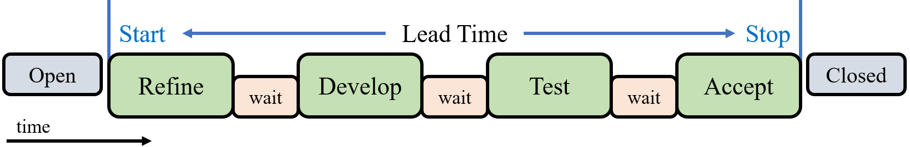
Note. Screenshot snip of R. Kapalko PowerPoint on August 19, 2021.
As shown in the previous figure, the local SDLC consists of refine, develop, test, and accept states. Although not always the case these states are meant to be executed sequentially for each Story. The twenty AFH teams shepherd thousands of Stories through this pipeline per calendar quarter.

Application of Lean Manufacturing Principles
The SDLC resembles a manufacturing pipeline and Lean Manufacturing (LM) principles may be applied to the process (Yadav et al., 2018). For example, Value Stream Mapping (VSM) is a LM technique used to differentiate waste from value-added activities (Sweeney, 2017). Therefore, VSM and other LM principles may be applied to the analysis of SDLC efficiency with respect to value-added activities separated by time waiting for the next activity.
As Stories move through the SDLC, the ALM transactional log is maintained in a way that captures the state of each Story. This log, as viewed through the lens of LM, is the source of inspiration for analytics research to identify the inefficiencies within and the influencers of the given SDLC. This view enables the use of widely accepted Key Performance Indicators (KPIs).

Key Performance Indicators
The primary KPIs for SDLC productivity are Lead-Time and Activity-Ratio (Yadav et al., 2018). Lead-Time is the length of time between Story start and Story stop as recorded in the transactional log. Activity-Ratio is a measure of efficiency, calculated as value-added time divided by Lead-Time, and typically presented as a percentage. Both KPIs are measured per Story and average Lead-Time and average Activity-Ratio apply to the responsible teams. Some teams have more experience than others as measured by the number of Stories finished. Each Story has several initial characteristics that may be contributing factors to Lead-Time.
The project objective is to identify the influencers of and the inefficiencies within the given SDLC. The project results may benefit the management of the AFH high-variance SDLC processes because machine learning and process mining can generate Lead-Times (Welsing et al., 2020). The business intelligence achieved through the analysis of these KPIs is expected to increase SDLC decisioning efficacy. AFH would like to shorten Lead-Time which allows for timelier feedback from end users and familiarity with the Activity-Ratio can help guide process improvement initiatives.

Research Questions
Project success begins with and pivots on actionable research questions (O’Leary, 2004). Some AFH personnel were assigned as SMEs for the project for requirements elicitation, analysis, and specification and remained engaged to define the SDLC states, confirmation of LM approach, and KPIs. The following research questions (RQ) are aligned with business goals:
RQ₁: Where is the largest portion of wait time?
RQ₂: Do longer running teams have better efficiency?
RQ₃: Does initial Story characteristics explain SDLC efficiency?
The project will follow a typical management plan. The scope is to address the research questions with respective hypotheses. Research results are expected to create immediate benefit to AFH decisioning and enable the possibility of permanent automation of KPI reporting and visualization.

Research Dataset
The development team members continuously update the state of their respective Stories by using a common Atlassian Jira repository as the ALM tool. Jira is purpose built to plan, track, and release software with a hierarchical data organization and an accompanying change history log (Atlassian, 2021). Through training, practice, and longevity, the AFH teams and team members are versed at consistent usage of Jira.

Data Acquisition
The original dataset was acquired on August 17, 2021. The in-house Jira transactional log is reasonably accurate and consistent, therefore, there is a strong readiness-level as defined by Sharda, Delen, and Turban (2017). The data was Extracted, Transformed, and Loaded (ETL) from the access-controlled repository into a PostgreSQL database as shown in the next figure.
Figure 2
The project ETL process.
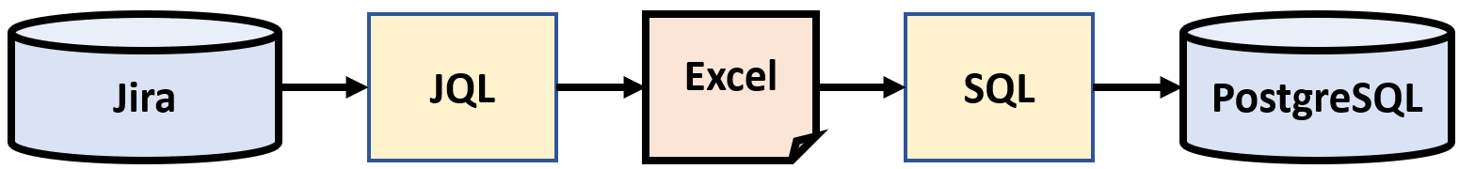
Note. Screenshot snip of R. Kapalko PowerPoint on September 3, 2021.
Jira Query Language (JQL) returns all collateral attached to a Story and over 1,000 associated fields, therefore, Jira User Interface (UI) was used to display and extract eight potentially useful fields. Jira Export to Excel function was used to create several Microsoft Excel files which were then ingested by SQL into the pgAdmin PostgreSQL database and dimensional model. To address the privacy, security, and ethics challenges, the project team first came to understand the complete ETL pipeline (Lazell-Fairman, 2019) including data acquisition, manipulation, and final presentation (Chalcraft, 2018). This mindset includes isolating the project ETL library dependencies from the normal production systems (Li, 2015).
Excel was used for minor data transformation. For example, all records were artificially given a unique index number for data traceability through the ETL steps and due to a nuance of Jira Export, completely null records were removed. Further, the whole SDLC process, team topology, and staffing are considered ABCB proprietary. Therefore, the dataset usernames are considered Personally Identifiable Information (PII) and under the guidance of SMEs were removed along with eleven special Stories used solely for training purposes.

Dimensional Model
Nineteen teams finished 2,037 Stories totaling 12,618 state transitions. Along with calculated fields Lead-Time and Activity-Ratio, this data was organized in a PostgreSQL database. The WorkItems dimension table is a static look-up with four Story characteristics. The Transactions fact table houses SDLC state changes with FromState, ToState, and DateTime. This two table datamart schema was a vital component to allow for future scalability across the business with big data in a distributed environment (Patel, 2019). The project used structured data only because security is more difficult with unstructured data (Islam & Islam, 2014). A portion of these two tables is shown in the following figure.
Figure 3
Two dimensional model tables with 2,037 work items and 12,618 transactions.
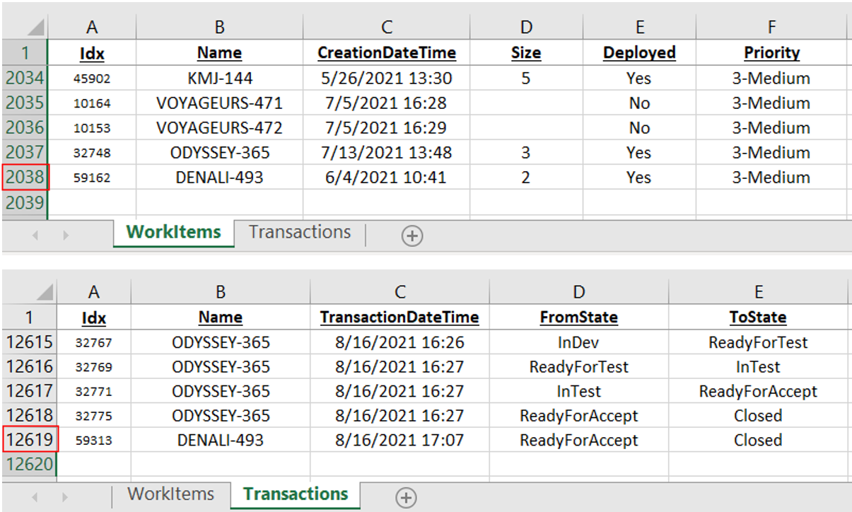
Note. Screenshot snip of R. Kapalko Excel on August 20, 2021.

Dataset Specifics
For the analysis, the project sampled a subset of the data model into two Excel tables. The first table is a simple paired list of Count of Stories and Activity-Ratio for each of the 19 teams. Count is an integer and Activity-Ratio is a percentage. The second table is 1,525 quadruples of StoryPts (size), Priority, Deployed, and Lead-Time per Story. Lead-Time is a calculated field that was previously generated in the PostgreSQL database via SME business rules. These two structured lists are shown in the following figure.
Figure 4
Portions of the two tables extracted from the project data model.
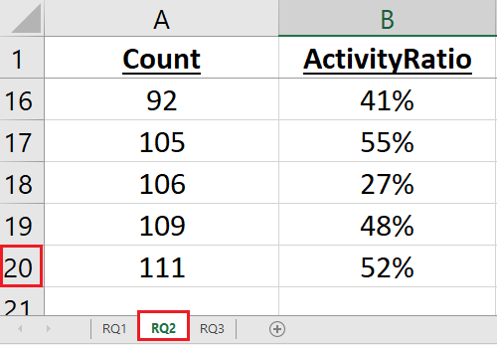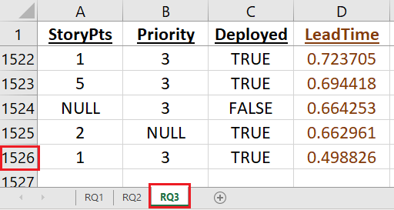
Note. Screenshot snip of R. Kapalko Excel on August 30, 2021.
StoryPts and Priority are numeric but considered categorical for the analysis because, for example, StoryPts = 4 does not imply twice as much work as a StoryPts = 2. Priority is given as 1, 2, 3, or 4 which are equivalent to critical, high, medium, and low respectively. Deployed is a binary. All three of StoryPts, Deployed, and Priority may be null, so some data wrangling is expected. The fourth field is Lead-Time in days, maintained as double precision for minutes and seconds, and ranges from 0.0 to 133.8. SMEs advised that a Lead-Time of less than eight hours shall not be considered, therefore these records were removed leaving 1,526 Stories for the analysis.

Dataset Potential
The dataset had strong potential. The research team had credentialed access to the repository, which was relatively accurate, consistent, clean, and granular because the AFH teams are adept at using Jira for their SDLC processes. Meaningful business questions were studied regarding the efficiency of the SDLC. Specifically, the change history log contains transactional facts, and the hierarchical structure of the data allowed for a significant range of business inquiry.
Although designed to provide current state, as configured by AFH the capability to credibly study the change history log within the Jira ALM was unavailable. The Activity-Ratio and Lead-Time KPIs could not previously be calculated. Therefore, AFH can benefit because the transactional data was an otherwise unleveraged asset, and the study of these quality-related costs can provide insight toward SDLC process optimization (Mahmood & Beg, 2012).
Among other benefits, the Jira repository has options for integration. For example, automated ETL capability may facilitate future deployment of an analytics solution. The project is expected to be the prototype for real-time (R/T) integration of dashboards and visualization. This solution may augment the existing KPI capture system with R/T data feeds and early consideration of these deployment hurdles can remove obstacles in realizing these benefits (Abbott, 2014).

Research Hypotheses
The SMEs have determined that the first research question was answered with a Tableau interactive visualization and therefore does not have specific hypotheses. The second research question posits that the teams with a longer history would have a higher Activity-Ratio. Knowing this could help AFH manage staffing mix and team cross-training decisions. The hypotheses pair is:
H₂0: There is no positive correlation between teams’ Count and Activity-Ratio.
H₂A: There is a statistical significance in this positive correlation.
The third research question posits that initial characteristics of a Story could predict the eventual Lead-Time of the Story. Given estimated Story size and assigned priority, then the Lead-Time may be a foregone conclusion. Knowing this could be used to improve SDLC processes and dictate process improvement. The hypotheses pair is:
H₃0: Initial Story characteristics do not contribute to associated Lead-Time.
H₃A: Some portion of Lead-Time is explained by initial Story characteristics.

Research Design
The project leveraged a deductive approach to avoid risk of data destruction and honor a short project timeline. The project deduced hypothesis from current SDLC understanding and LM principles, formulated operational hypotheses that proposed variable relationships, executed tests, and translated conclusions into actionable insights. The project did not alter the raw data and all the phenomena are described numerically. Therefore, the project case-study followed a quantitative method using exploration, hypothesis, correlation, and regression qualitative methods.

Methodology
The project loosely followed the sample, explore, modify, model, and assess steps of SEMMA as defined by the SAS software company (Bruce et al., 2018). The dataset is a sample taken from a Jira repository. The sample was loaded into pgAdmin PostgreSQL for the techniques of normalization and dimensional data modeling. The project used SAS Studio to explore the dataset statistically. Exploration techniques included summary statistics, correlation, and outlier analysis. Exploring the dataset graphically was accomplished in part with SAS Studio and with the Tableau Public Edition platform. The project then modified the dataset in pgAdmin with data wrangling and calculated field techniques. To model and assess, the project used R Studio as an integrated suite of statistical, graphic, and computing capabilities. The techniques involved included hypothesis analysis, statistical inference, and multiple linear regression.

Tools
The project used an AFH provided PC outfitted with standard VPN, virus and malware protection, and backups. Jira and pgAdmin repositories have active-access control so only credentialed users could access, alter, or delete project data. All the project work resided in a single folder so the data dissemination will be limited to the final PowerPoint presentation and associated Zoom session recording.
Research Question 1 was answered by SMEs interacting with a Tableau visualization. The visualization was designed to use filters that allow ad-hoc exploration of different combinations of teams and activity states. This method enabled identification of significant areas of inactivity in the SDLC. Research Question 2 was answered by reviewing the association between the two variables Story count and average Activity-Ratio per team. SAS was used to perform relevant summary statistics, identification of outliers, and a Pearson Correlation test. This method enables quantification of the strength of relationship. Research Question 3 was answered by modeling the dataset’s three independent variables against the dependent variable Lead-Time with a multiple logistic regression per Story. R was used to show that the assumptions were met, develop a regression model, and analyze the strength of results.

Techniques
Question 1 about significant waste activity was satisfied by graphical exploration in Tableau Public with SAS used for summary statistics. Hypothesis pair 2 addressed the correlation, a measure of linear relationship, between Story Count and Activity-Ratio. Correlation is defined as the statistical association between two variables. The technique of analysis was a simple Pearson Correlation test, with 5% confidence, on the related pairs. The Count variable was considered as continuous, outliers were removed, and the assumption of linearity was reviewed.
Hypothesis pair 3 addressed the functional relationship between independent variables StoryPts, Deployed, and Priority and dependent variable Lead-Time. The method used was multiple logistic regression. During the analysis, the assumptions of logistic regression were reviewed including linear relationship between dependent and independent variables, normally distributed residuals, and no indication of multicollinearity.

Project Management
The project was executed over eight weeks in 2021 with a single analyst and a focus group of SMEs. Project success was the identified influencers of and the inefficiencies within the given SDLC. The business intelligence achieved through analysis of Lead-Time and Activity-Ratio has raised AFH decisioning efficacy. AFH would like to shorten Lead-Time which allows for timelier feedback and familiarity of Activity-Ratio can help process improvement initiatives.
The project followed expert suggestion to be more explicit and controlling than the given AFH policy environment (Davis, 2012) and incorporated privacy and security by design (Haber & Tamò-Larrieux, 2020). To this end, as early as possible in the ETL process, the project scrubbed usernames, company logos, and hyperlinks. The raw data was never included in printed collateral, emails, flash drives, or social media. For decision traceability, each data record included an index to the raw data and the project retained backups of each data transformation step.

Accompanying Presentation
The project included a defined approach to reduce privacy, security, and ethical concerns when presenting visual data analytics to the diverse audience of AFH. The project team and SMEs will review the results, model assessment, and final analysis for bias and possible misinterpretation before articulating the goals of the presentation. The presentation does not include raw data, identifiers, nor links and will not be bought or sold which removes inherent responsibility issues (Davis, 2012). The presentation and recording were controlled by company policy to avoid the unintended privacy and security consequence of algorithmic evaluation (Cardon et al., 2021).

Research Limitations
The project is limited to the efficacy of the sampled raw data. The results are beholden to this data and the business interpretation given by the SMEs. For example, the study analyzes Stories, not “Features” which are groups of related Stories. Therefore, the results do not address the situation where one team’s Story has a dependency on another team’s Story and Stories are considered independent phenomena. The project followed a strict timeline and concluded within eight weeks with one part-time analyst. The project was limited to the chosen pgAdmin, SAS, Tableau, and R analytics tools and the AFH provided equipment. Finally, results from Null Hypothesis Significance Testing (NHST) can be dubious and hard to replicate (Szucs & Ioannidis, 2017).

Literature Review
This project exists within the greater realm of analytical research and communication. For example, benefits are achieved by reliance on local SMEs (Ploder & Kohlegger, 2018) and visualizations create clearer research direction with improved communication (Yalcin et al., 2018). Efficacy of results is improved with clear processes (Stahl, 2018) and decision traceability (Jackson, 2018). Second, there is precedent to parallel areas of knowledge. For example, the study of a SDLC may leverage the greater knowledgebase of Supply Chain Management (SCM) and Lean Manufacturing (LM) (Yadav et al., 2018) for SDLC optimization (Mahmood & Beg, 2012). Further, machine learning and process mining can help generate Lead-Times in high-variance processes (Welsing et al., 2020) as exists herein.
This project is significant because it demonstrates the potential for Atlassian Jira fields, especially the Change History log, to be used for Lead-Time and Activity-Ratio quantification in an Agile SDLC setting. Business insights for AFH are immediate. This research fills a knowledge gap by providing a case-study that exemplifies the efficiency of an industry typical SDLC implementation.

Security, Ethical, and Privacy Considerations
Data ethics challenges included analytical bias, interpretation accuracy, and data mishandling (Scione, 2017). Unintended bias of the project analyst and SMEs, that are embedded in the context, were managed by transparency and peer review of final presentation. These discussions prior to and during project execution created clear direction, control scope creep, provided a basis for monitoring, and are essential to success (Houston, 2020). Early in the data pipeline, the dataset was scrubbed of PII following AFH policies, all project data, tools, and results remained on provided equipment. SMEs were given ethical oversight needed to ensure proper balance of potential misuse and analytical benefits (Hand, 2018).

GitHub Repository
The project assets were managed in a GitHub repository. GitHub is growing in popularity in computer science (Glassey, 2019) and GitHub forums are an effective mechanism to address user requests, error reporting, and to overcome maintenance challenges (Raza et al., 2013). The static image of the repository is presented in Appendix A.

Research Analysis Results
The investment for analyzing the dataset provided immediate business insights towards identified questions but also helps to drive the future for the SDLC monitor and control practice at AFH. The following three research questions have been addressed. Accompanying pictorial review of code and results can be found in Appendix A.

RQ₁: Identifying Areas of Waste
Pie charts should only be used for relative compositions of a specific measure (Delen et al., 2017) which was the question here. Individual and group exploratory analysis using the project created interactive visualization (Kapalko, 2021) determined that delay waste obviously centers around waiting for development activity. The research question is answered. The SMEs gained immediate and actionable insight and therefore required no further analysis.

RQ₂: Comparing Team Efficiency
The expectation was that teams with longer track record would have a higher average Activity-Ratio. The data had an approximately normal distribution, are continuous, and one outlier was removed leaving 18 related pairs that meet the assumptions of the Pearson Correlation method. The correlation coefficient of -0.43 indicated that an average strength of relationship exists with 7.5% confidence, but the relationship is opposite the stakeholders’ expectation and therefore extremely insightful. The null hypothesis is not rejected that there is no positive correlation between teams’ Count and Activity-Ratio. With this surprising analytical result, the more Stories a team completes does not statistically lend to higher Activity-Ratio.

RQ₃: Predicting Lead-Time
The Story records have several initial characteristics including estimated size, given priority, team assignment, and whether the Story was eventually deployed. The project made reasonable assumptions that the relationships are linear, the variance of residuals are the same, observations are independent, and the respective data was normally distributed. The generated linear model had the characteristics of extremely small p-value and R-squared of 2% which indicated that nearly none of Lead-Time is explained by initial characteristics of a Story.
The analysis was extended by including team name with the result of 14% R-squared, but that was still much less than what was considered valuable in this context. The null hypothesis is not rejected with no further review of the model or its variations. This result importantly confirms that Lead-Time is not a forgone conclusion and should be managed independently of initial Story characteristics.

Research Conclusions
The project is a success because some important influencers of and the inefficiencies within the given SDLC have been identified. The business intelligence achieved through analysis of Lead-Time and Activity-Ratio is expected to immediately increase AFH decisioning efficacy. Forthcoming AFH initiatives are more likely to positively shorten Lead-Time which allows for timelier feedback and a new familiarity of Activity-Ratio can generally support process improvement.

Business Insights
With 920,000 unfilled IT positions, 63% of executives reporting that developers are an area of concern (Pham, 2021) and a growing need for more sophistication in SDLC automation (Singaraju, 2019), there is a great need industry wide for SDLC efficiency. Business insights have been attained by analyzing the AFH software development lifecycle. This case study determined that the significant delay in Story Lead-Time occurs between Story refinement and development states. This result is team agnostic. The created interactive visualization deliverable is a permanent asset to the organization. Importantly, teams that stay together longer do not have an improved average Activity-Ratio and as expected, Lead-Time cannot be predetermined by initial Story characteristics. Collectively, AFH decision-makers are expected to immediately benefit from deeper understanding of the influencers of and the inefficiencies within their SDLC.

Recommendations
The benefit of the one-time Tableau visualization can be extended to a real-time (R/T) dashboard through automated ETL connectivity with Atlassian Jira (“REST APIs,”, 2021). Further research should be conducted as to the reasons for the abnormal time between refine and development states. Company SMEs would like to know more about long-lived teams not producing better Activity-Ratios which is generally considered essential for productivity (“Agile Teams,” 2020). Without consideration of initial Story characteristics, effects of Lead-Time and Activity-Ratio should generally be further studied. Finally, the project team remains mindful that state changes can move backwards in the SDLC, and these are potentially interesting events for further review.

References
Abbott, D. (2014). Applied Predictive Analytics: Principles and Techniques for the Professional Data Analyst. John Wiley and Sons, Inc.
Agile teams. (2020, July 26). Scaled Agile Framework. https://www.scaledagileframework.com/agile-teams/
Atlassian. (2021). Jira | Issue & project tracking software | Atlassian. https://www.atlassian.com/software/jira
Bruce, P.C., Lichtendahl, K.C., Patel, N.R., Shmueli, G., and Yahav, I. (2018). Data mining for business analytics. John Wiley and Sons, Inc.
Cardon, P. W., Ma, H., & Fleischmann, C. (2021). Recorded business meetings and AI algorithmic tools: Negotiating privacy concerns, psychological safety, and control. International Journal of Business Communication, 232948842110370. https://doi.org/10.1177/23294884211037009
Chalcraft, J. (2018, January). Drawing ethical boundaries for data analytics. https://imm.arma.org/publication/?i=467917&article_id=2981892&view=articleBrowser&ver=html5
Davis, K. (2012). Ethics of big data: Balancing risk and innovation. O'Reilly Media.
Glassey, R. (2019). Adopting git/Github within teaching. Proceedings of the ACM Conference on Global Computing Education. https://doi.org/10.1145/3300115.3309518
Haber, E., & Tamò-Larrieux, A. (2020). Privacy and security by design: Comparing the EU and Israeli approaches to embedding privacy and security. Computer Law & Security Review, 37, 105409. https://doi.org/10.1016/j.clsr.2020.105409
Hand, D. J. (2018). Aspects of data ethics in a changing world: Where are we now? Big Data, 6(3), 176-190. https://doi.org/10.1089/big.2018.0083
Houston, M. (2020, November 12). Forbes. https://www.forbes.com/sites/melissahouston/2020/11/12/the-top-5-advantages-of-planning-ahead-in-your-business/?sh=5d1d094a6ce5
Islam, R., & Islam, E. (2014). An approach to provide security to unstructured big data. The 8th International Conference on Software, Knowledge, Information Management and Applications (SKIMA 2014). https://doi.org/10.1109/skima.2014.7083392
Jackson, B. (2018). The changing research data landscape and the experiences of ethics review board chairs: Implications for library practice and partnerships. The Journal of Academic Librarianship, 44(5), 603-612. https://doi.org/10.1016/j.acalib.2018.07.001
Kapalko, R. (2021, August 27). Total Days in each SDLC State. Free Data Visualization Software | Tableau Public. https://public.tableau.com/app/profile/richard.kapalko8595/viz/rKapalko_MIS581_a/MIS581a
Kapalko, R. (2021, September). Kapalkor/MIS581. GitHub. https://github.com/kapalkor/MIS581
Kassam, A., Friedrich, T., & Derpsch, R. (2018). Global spread of conservation agriculture. International Journal of Environmental Studies, 76(1), 29-51. https://doi.org/10.1080/00207233.2018.1494927
Kimball, R., & Ross, M. (2002). The data warehouse toolkit: The complete guide to dimensional modeling. John Wiley & Sons.
Lazell-Fairman, K. (2020, February 16). Learning from machines: The data supply chain. Medium. https://towardsdatascience.com/learning-from-machines-the-data-supply-chain-4380f420bb2c
Li, M. (2015, September 15). Three best practices for building successful data pipelines. O’Reilly Media. https://www.oreilly.com/ideas/three-best-practices-for-building-successful-data-pipelines
Moktadir, M. A., Ali, S. M., Paul, S. K., & Shukla, N. (2019). Barriers to big data analytics in manufacturing supply chains: A case study from Bangladesh. Computers & Industrial Engineering, 128, 1063-1075. https://doi.org/10.1016/j.cie.2018.04.013
Mahmood, P., & Beg, M. (2012). Measuring cost of quality(coq)- on SDLC projects is indispensible for effective software quality assurance. International Journal of Soft Computing and Software Engineering, 2(9), 1-15. https://doi.org/10.7321/jscse.v2.n9.1
O'Leary, Z. (2004). Business Intelligence, analytics, and data science. SAGE.
Patel, J. (2019). An effective and scalable data modeling for enterprise big data platform. 2019 IEEE International Conference on Big Data (Big Data). https://doi.org/10.1109/bigdata47090.2019.9005614
Pham, T. (2021, April 13). Forbes. https://www.forbes.com/sites/forbestechcouncil/2021/04/13/analyzing-the-software-engineer-shortage/?sh=53533ed321c6
Ploder, C., & Kohlegger, M. (2018). A model for data analysis in SMEs based on process importance. Communications in Computer and Information Science, 26-35. https://doi.org/10.1007/978-3-319-95204-8_3
Raza, A., Capretz, L. F., & Ahmed, F. (2013). Maintenance support in open source software projects. Eighth International Conference on Digital Information Management (ICDIM 2013). https://doi.org/10.1109/icdim.2013.6694005
REST APIs. (2021). Atlassian Developer. https://developer.atlassian.com/server/jira/platform/rest-apis/
Scione, L. (2017, May 22). 5 ways to use predictive analytics in an ethical Manner - Page 2 of 2 - eCampus news. eCampus News. https://www.ecampusnews.com/2017/05/31/predictive-analytics-ethical/2/
Sharda, R., Delen, D., & Turban, E. (2017). Business intelligence: A managerial perspective on analytics. Pearson.
Singaraju, P. (2019, June 22). Forbes. https://www.forbes.com/sites/forbestechcouncil/2019/07/22/how-is-ai-influencing-the-overall-software-development-life-cycle/?sh=14d9ea7a3cee
Stahl, B. C., & Wright, D. (2018). Ethics and privacy in AI and big data: Implementing responsible research and innovation. IEEE Security & Privacy, 16(3), 26-33. https://doi.org/10.1109/msp.2018.2701164
Szucs, D., & Ioannidis, J. P. (2017). When null hypothesis significance testing is unsuitable for research: A reassessment. Frontiers in Human Neuroscience, 11. https://doi.org/10.3389/fnhum.2017.00390
Sweeney, B. (2017). Lean QuickStart guide: The simplified beginner's guide to lean. ClydeBank Media LLC.
Welsing, M., Maetschke, J., Thomas, K., Gützlaff, A., Schuh, G., & Meusert, S. (2020). Combining process mining and machine learning for lead time prediction in high variance processes. Lecture Notes in Production Engineering, 528-537. https://doi.org/10.1007/978-3-662-62138-7_53
Yadav, R., Mittal, M., & Jain, R. (2018). Adoption of lean principles in software development projects. International Journal of Lean Six Sigma, 11(2), 285-308. https://doi.org/10.1108/ijlss-03-2018-0031
Yalcin, M. A., Elmqvist, N., & Bederson, B. B. (2018). Keshif: Rapid and expressive tabular data exploration for novices. IEEE Transactions on Visualization and Computer Graphics, 24(8), 2339-2352. https://doi.org/10.1109/tvcg.2017.2723393

Appendix A

Project Screenshots
The project was constrained by a selection of tools. Tools used include GitHub, Jira, Excel, pgAdmin, Tableau. SAS, and R. PowerPoint and Zoom were used for the project presentation. The following sections provide reference screen shots that support the use of these tools for the case-study.

GitHub and Git - Project Assets Management
The project used GitHub and Git commands to manage the project assets. Company SMEs have access to this repository as a starting place to continued research. The following figure depicts this repository.
Figure A1
The project GitHub Repository.
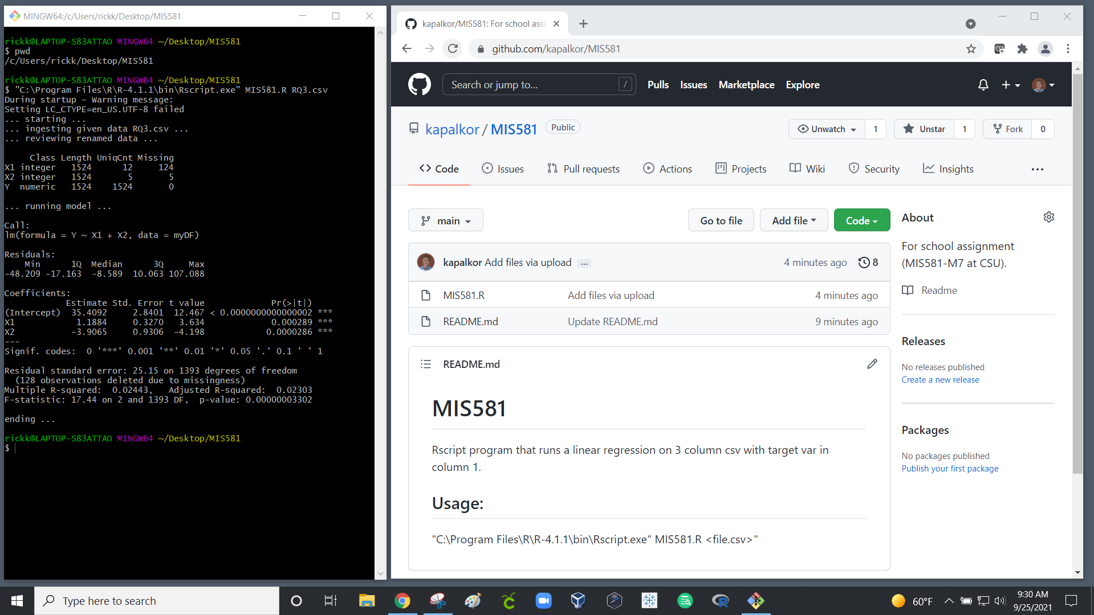
Note. Screenshot snip of R. Kapalko GitHub repository on October 23, 2021.

Jira and JQL – Data Acquisition
The project leveraged Atlassian Jira and JQL for data acquisition. Jira has its own Jira Query Language (JQL) that allows users to search and display subsets of the work item repository (Atlassian, 2021). With consultation of local SMEs, JQL was used to extract Stories of all twenty teams that are in a finished state (“Done” or “Closed”). This data became the raw data source for the ETL pipeline and project analysis. The following JQL was executed on April 18, 2021.
Figure A2
The JQL and display choices that instigated the dataset records.
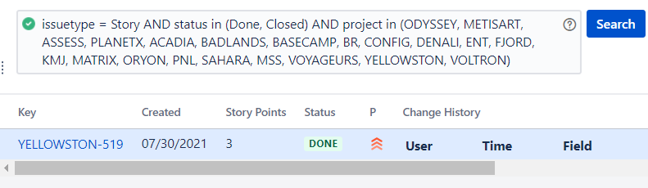
Note. Screenshot snip of R. Kapalko JQL on August 20, 2021.

Excel - Exploratory Analysis
Microsoft Excel was used for portions of the ETL pipeline and again for initial data exploration. During elaboration of research questions, SMEs spent time reviewing various combinations of average Lead-Time compared and average Activity-Ratio per team. The following two figures depict these machinations.
Figure A3
The Excel initial exploratory work.
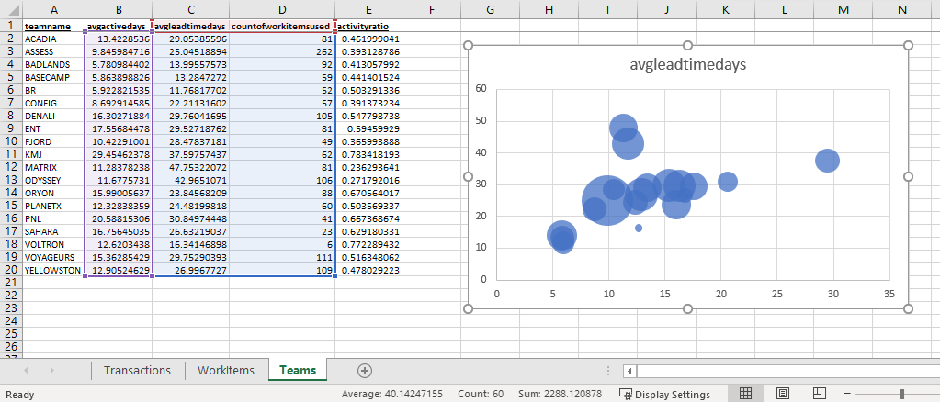
Note. Screenshot snip of R. Kapalko Excel on August 30, 2021.
Figure A4
Relationship of Story Count and Activity-Ratio for the 19 teams.
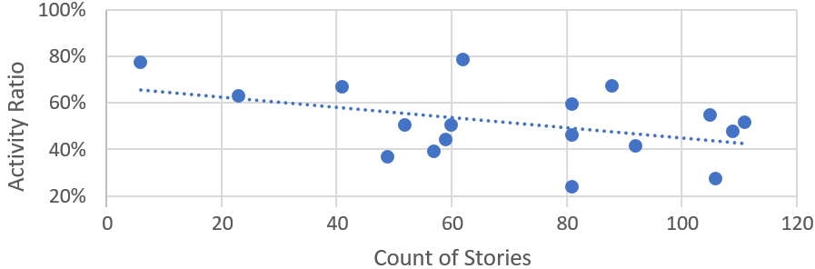
Note. Screenshot snip of R. Kapalko Excel on September 12, 2021.

pgAdmin and PostgreSQL - Dimensional Modeling
The project leveraged pgAdmin and PostgreSQL for dimensional modeling and generation of calculated fields. The following two figures present the data dictionary generated by SQL code and ERD generated by DbVisualizer tool. The project expanded the dataset with the creation of calculated fields for length of time in each state as well Lead-Time and Activity-Ratio per Story.
Figure A5
The dataset data dictionary.
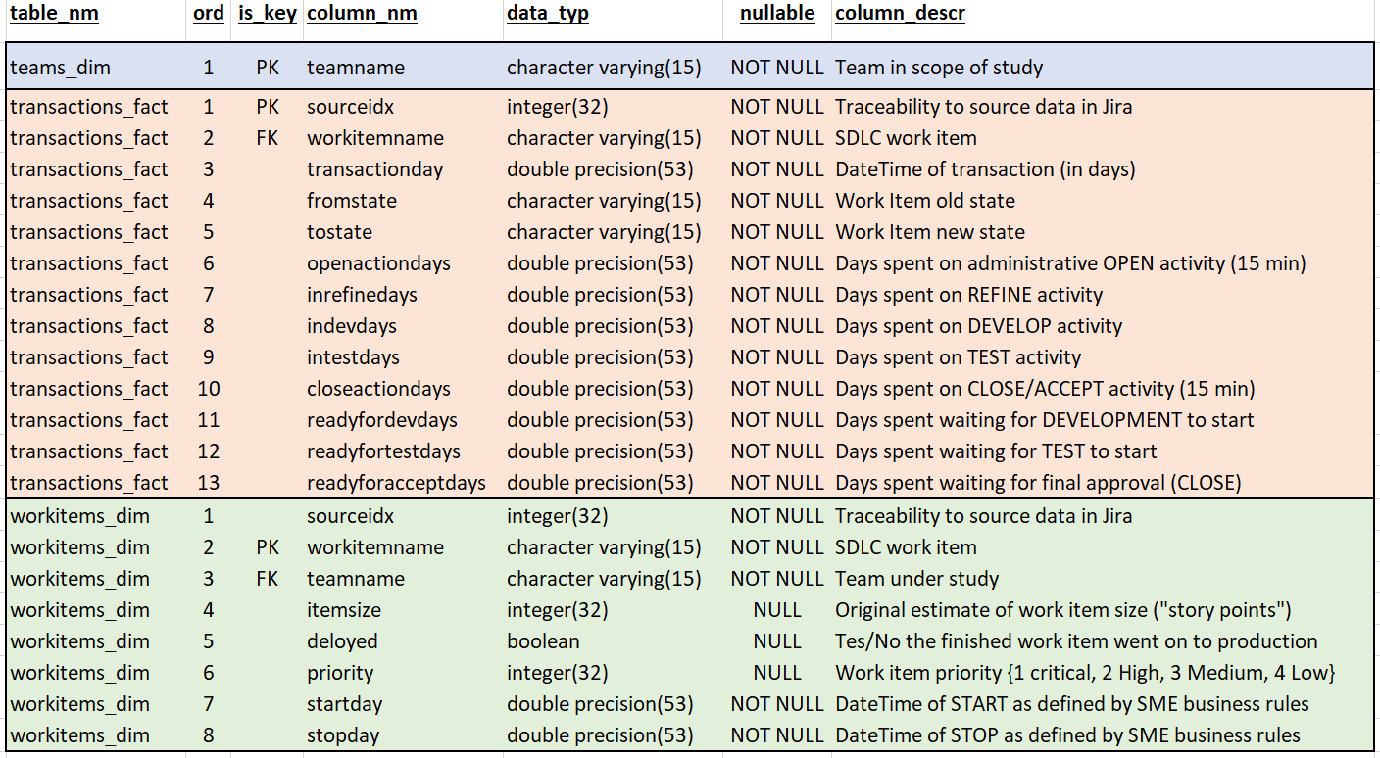
Note. Screenshot snip of R. Kapalko Excel on August 25, 2021.
Figure A6
The dataset Entity Relationship Diagram (ERD).
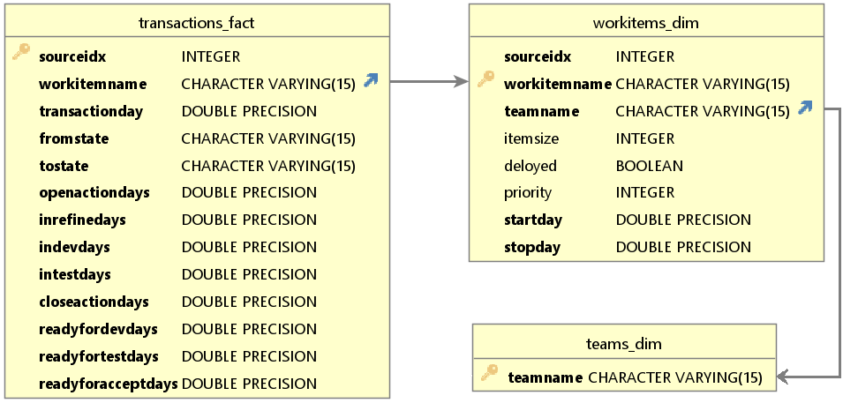
Note. Screenshot snip of R. Kapalko DbVisualizer on August 25, 2021.

Tableau Public – Interactive Visualization for RQ₁
The project leveraged Tableau Public to create interactive visualization. This live visualization may be found at the Tableau Public website (Kapalko, 2021). The company SMEs are pleased with this permanent deliverable of the project. The following is a static screenshot of the Tableau site.
Figure A7
The interactive visualization for areas of value-added activity and waste.
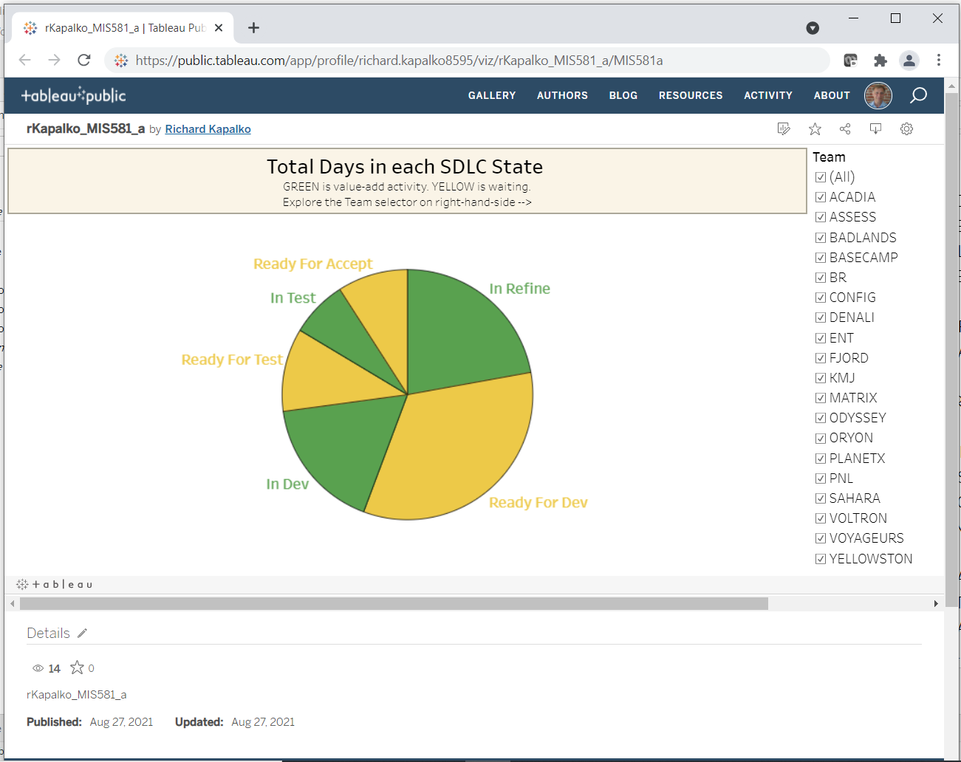
Note. Screenshot snip of R. Kapalko Tableau on September 10, 2021.

SAS Studio and SQL – Correlation Analysis for RQ₂
SAS Studio and SQL was used to plot a relationship and perform correlation analysis. The two variables in question were Story Count and Activity-Ratio for each team. The following three figures depict the SAS code and results.
Figure A8
SAS code used to answer RQ₂.
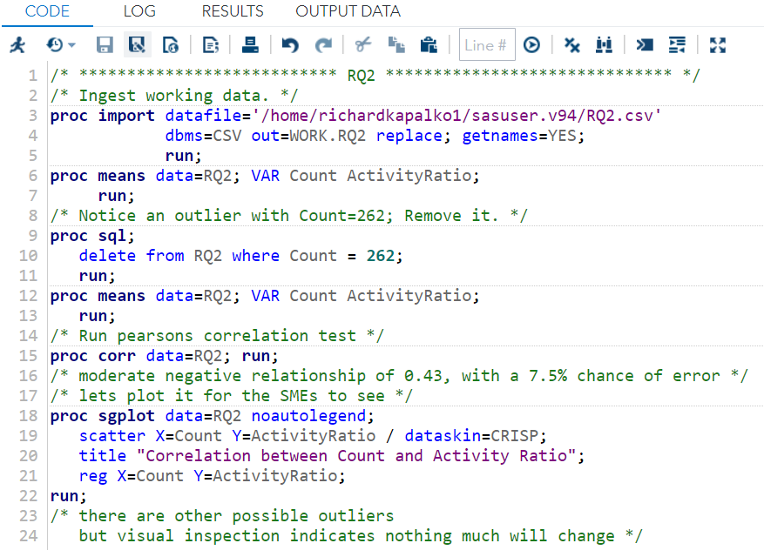
Note. Screenshot snip of R. Kapalko SAS Studio on September 12, 2021

Figure A9
The association of Story count and Activity-Ratio per team.
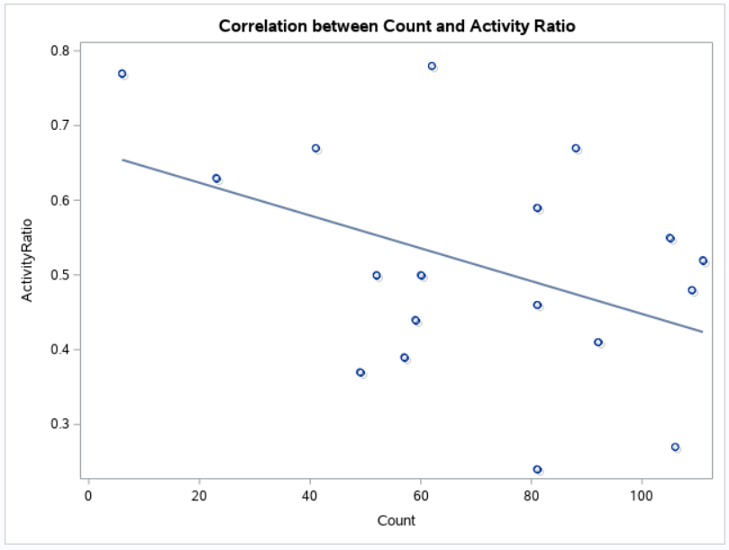
Note. Screenshot snip of R. Kapalko SAS Studio on September 12, 2021.
Figure A10
SAS Results of the Pearson Correlation test.
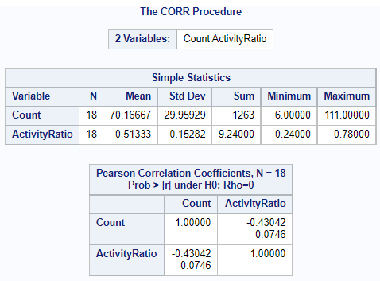
Note. Screenshot snip of R. Kapalko SAS Studio on September 12, 2021.

R Studio and R – Linear Regression for RQ₃
The project used R Studio to create R code for the linear regression. Multiple model runs were made on the dataset. The following figures show the code, data review, and model results.
Figure A11
R code used to answer RQ₃.
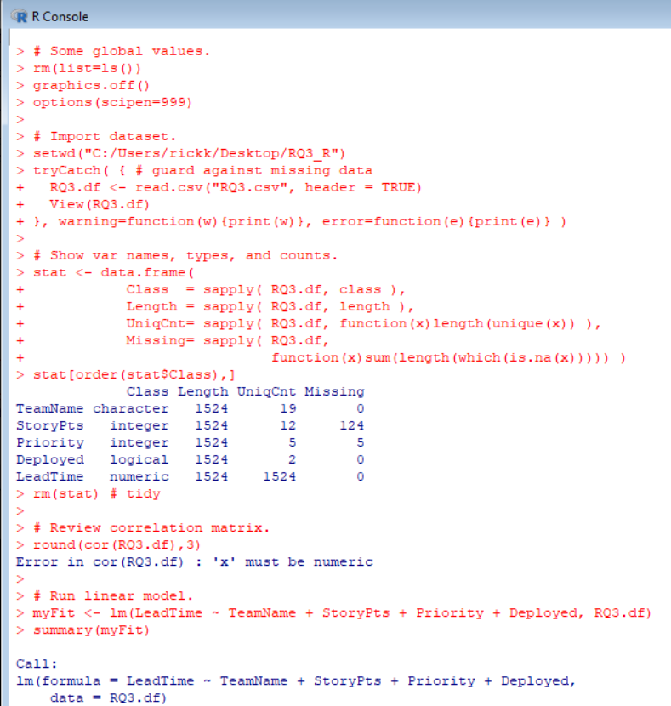
Note. Screenshot snip of R. Kapalko R Studio on September 12, 2021.
Figure A12
The R code generated data frame review.
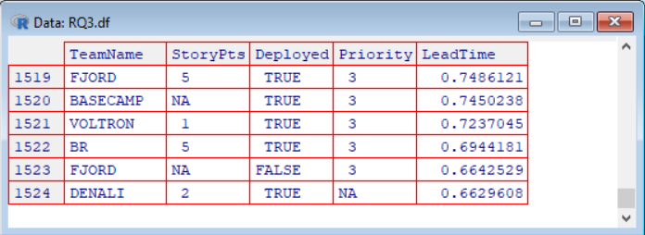
Note. Screenshot snip of R. Kapalko R Studio on September 12, 2021.
Figure A13
The results of linear regression in R.
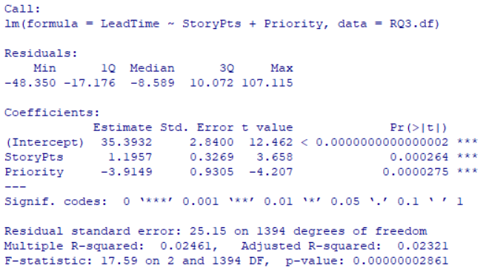
Note. Screenshot snip of R. Kapalko R Studio on September 14, 2021.

