Morby Ver1.0 — Pitch Brief
From a customer question to a disbursed loan — one automated, compliant flow
Morby Ver1.0 · the Bank Mortgage Buddy · Live POC on Cloudflare · Internal

The one-liner
Morby turns a WhatsApp-style chat into a scored, routed, SLA-tracked mortgage lead — and lets customers self-serve answers, simulations, and application status — while keeping sensitive eKTP data minimised and auditable.
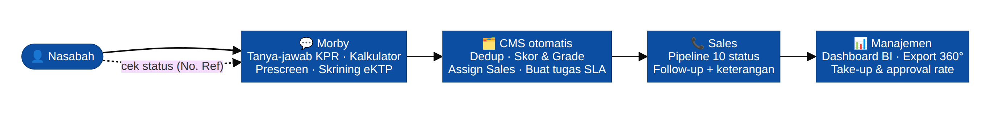
The Morby funnel: chat → screening → CMS → sales pipeline → management BI

The problem
- KPR sales teams drown in repetitive questions and manual, error-prone lead intake.
- Leads go cold: no SLA, no single pipeline, no real-time visibility for management, no status for the customer.
- eKTP/NIK handled by email/manual copies is a UU PDP / OJK exposure.

The solution
- A 24/7 AI assistant that answers (grounded on the Bank's own product facts — never invented numbers), simulates installments/cashback (with a downloadable non-binding PDF), and runs a guided prescreen + eKTP screening.
- An automatic CMS that deduplicates, scores (A+–D), routes to the right salesperson by region, and starts SLA timers — no human data entry.
- Role-based portals: management sees a live BI dashboard and Customer-360 exports; each salesperson gets their own scoped pipeline with follow-up notes.
- Customer self-service: a reference number lets applicants track status in chat.

Why it's different
 | Typical chatbot | Morby
Numbers | May hallucinate rates/fees | Deterministic — every figure from one knowledge base
Identity (eKTP) | Stores the whole scan | Stores extracted text + pas foto only (PDP data-minimisation)
After the chat | A transcript to read | A scored, routed lead with SLA timers, in a CMS
Governance | Ad-hoc | Role-scoped access + full audit log from day one
Deployment | Cloud lock-in | Clear on-prem path with self-hosted AI (data sovereignty)

Proof it works (live POC)
- Full funnel deployed on Cloudflare (Workers + R2 + D1 + Gemini + Resend + Cron) — chat, calculator, prescreen, eKTP OCR, CMS Phases 1–8, Sales portal, and customer status check are all live.
- Deterministic engine verified: scoring (Surabaya/3M/60jt → A/A/A, owner HB), rate table, NIK validator, Customer-360 XLSX, BI numbers all match the data.
- Privacy-by-design already in place: un-ticked recorded consent, masked NIK in DB, no full eKTP scan stored, tamper-logged audit trail.

The numbers we move
- Take-up rate (disbursed / leads) and approval rate — shown live on the BI dashboard.
- Response speed — SLA call within 30 minutes, enforced by cron reminders.
- RM time saved — repetitive Q&A and manual identity/prescreen entry are automated.

Compliance & production path
- Engineered against UU PDP 27/2022 and OJK/BI expectations; the audit's one critical item (cross-border AI + data localization) is resolved by the planned on-premise deployment with self-hosted models (Sahabat-AI/SEA-LION/Qwen2.5 for chat, Qwen2.5-VL for eKTP OCR, BGE-M3 for RAG).
- Investment options costed (cloud vs on-prem TCO) in the final audit; on-prem is the compliance-driven choice for sovereignty.

Roadmap after the POC
Phase | Focus
Now (POC) | Full funnel live on Cloudflare; deterministic core + CMS + Sales portal + status check
Hardening | MFA + stronger password hashing, global rate limiting, retention/erasure automation, official consent PDF
On-prem | Self-hosted AI + MinIO/PostgreSQL/vLLM/SMTP; onshore data; OJK/PDP sign-off
Integrate | Core-banking / credit-engine hooks; per-sales email routing; analytics deepening

The ask
- Green-light a pilot with real (consented) applicants on the hardened build, and approve the on-premise deployment for data sovereignty.
- Assign a DPO/Compliance reviewer and confirm onshore-placement scope for eKTP/NIK.
Internal document. Compliance conclusions require sign-off by the Bank's DPO, Legal, and Compliance. Live POC: https://ef6af686-sakhapr.hendrik-panthron.workers.dev

