How Morby Ver1.0 Works
the Bank Mortgage Buddy — Business/Workflow & System/Architecture (high-level + detailed)
Morby (the Bank Mortgage Buddy) is a browser-based GenAI KPR (mortgage) assistant with eKTP/NIK screening and a built-in lead CMS. This document summarizes how it works from two angles — Business/Workflow and System/Architecture — each in a high-level and a detailed version.

1. Business / Workflow

1A. High-level
The whole funnel — from a customer question to a disbursed loan — runs in one flow, mostly automated.
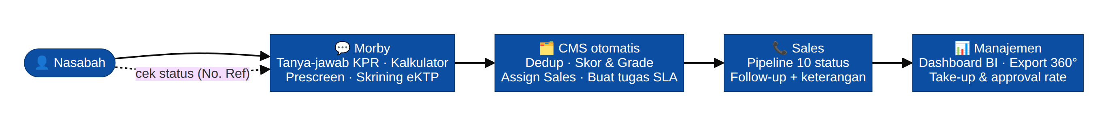
Business — high-level funnel
In one line: a customer chats → gets answers, a simulation, and completes a prescreen + eKTP → the system automatically scores and routes the lead to the right salesperson with SLA timers → sales work the pipeline → management sees everything live. The customer can check their own status anytime with a reference number.

1B. Detailed
Five actors, end to end. Everything a customer touches is on one chat screen; the back office is the CMS and role-based portals.
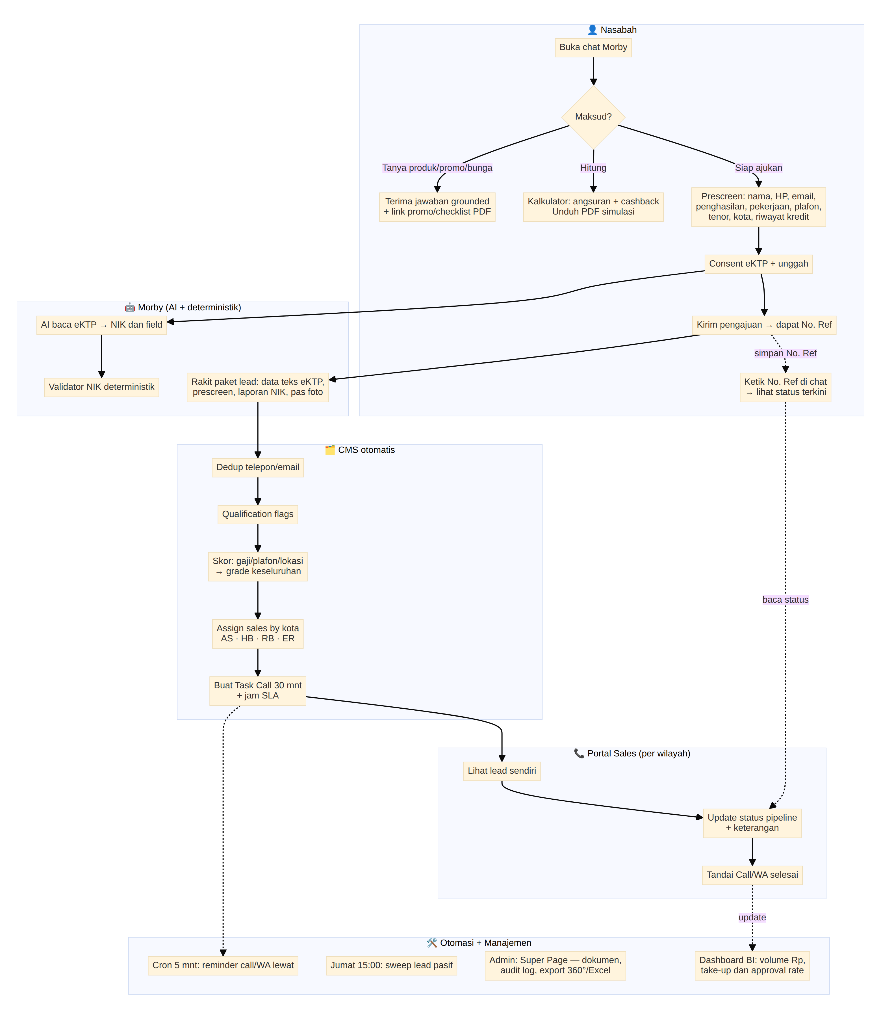
Business — detailed swimlane (Nasabah · Morby · CMS · Sales · Otomasi/Manajemen)
Key business rules (exact, from the brief):
- Scoring = 40% income grade + 40% plafon grade + 20% location grade → overall A+…D.
- Sales routing by city: AS (Jabodetabek/Medan/Batam), HB (Surabaya/Gresik/Sidoarjo/Makassar/Bali), RB (Bandung/Yogya/Semarang), ER (others = escalation).
- SLA: Task Call due 30 min after a lead arrives; Task WA due 1 h after the call is done; overdue → email reminder; Friday 15:00 WIB weekly sweep.
- Pipeline: 10 statuses (uncontacted → slow_response → collect_data → submitted → approved → approved_not_disbursed → disbursed; plus drop_process / rejected / deal_other_bank).
- Customer self-service: a reference number returns first name + current status only (no other PII).

2. System / Architecture

2A. High-level
A single lightweight stack: a static browser app talking to one Cloudflare Worker that fronts storage, AI, and email.
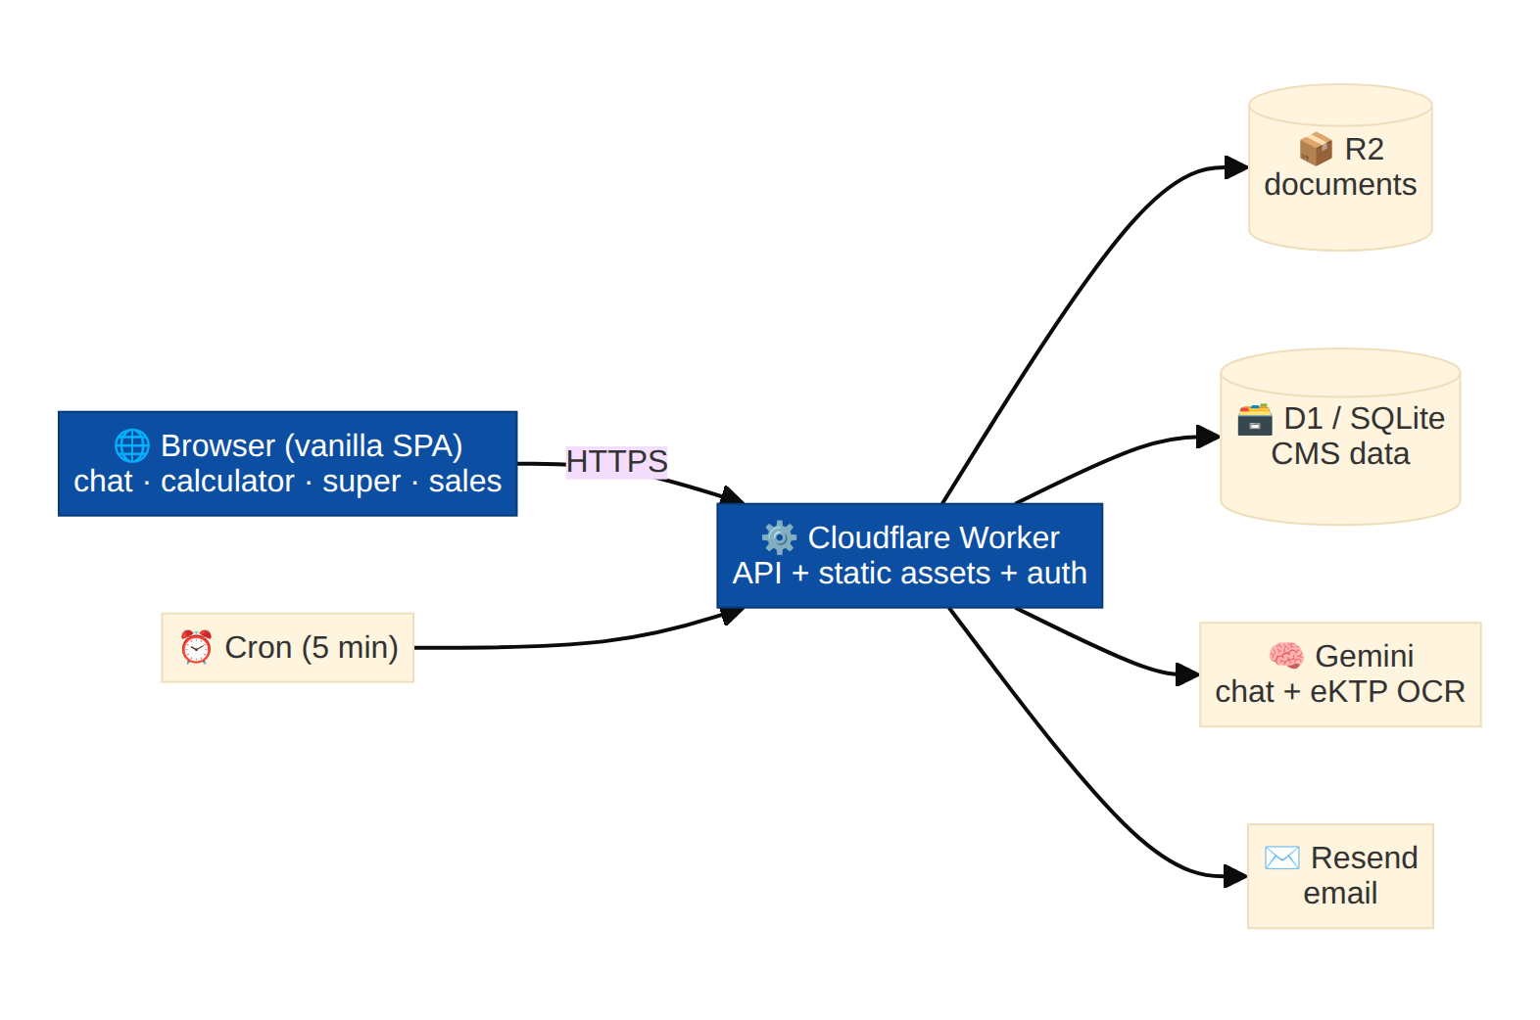
Architecture — high-level stack
In one line: everything runs on Cloudflare — one Worker serves the pages and the API, stores files in R2 and structured data in D1, calls Gemini for AI and Resend for email, and a Cron trigger drives the SLA reminders. Production target is the same design on-premise with self-hosted AI.

2B. Detailed
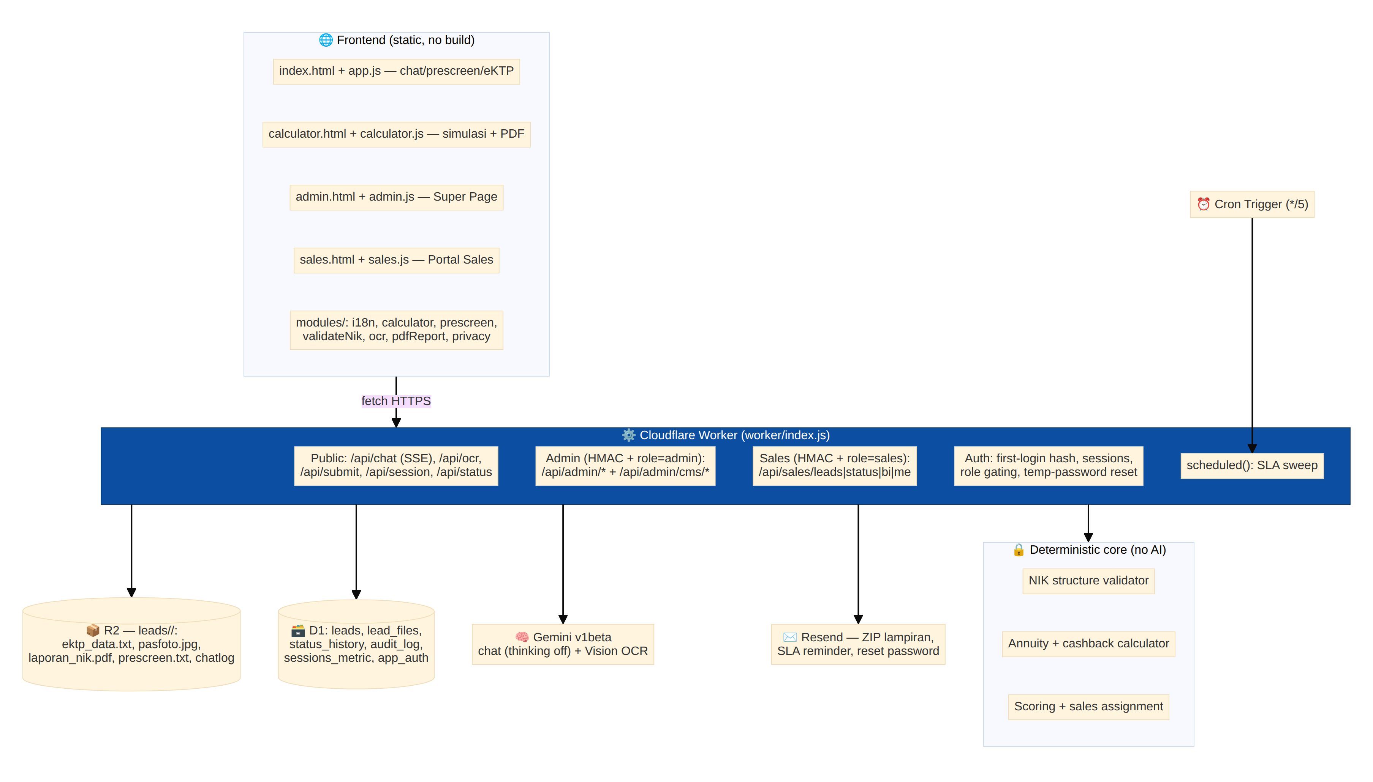
Architecture — detailed components
Component notes:
- Frontend: plain HTML/CSS/ES modules, no build step, strict CSP, self-hosted fonts; four pages share styles.css and modules/.
- Worker: one file routes public/admin/sales APIs and serves static assets; streams chat via SSE; runs the Cron scheduled() sweep.
- Data: R2 holds per-lead documents (eKTP stored as text only + cropped pas foto — the full card scan is never stored); D1 holds the queryable CMS (only a masked NIK). Schema self-heals missing columns.
- AI: Gemini for chat (grounded on the knowledge base, thinking disabled for fast first token) and eKTP Vision OCR (JSON fields) — always checked by the deterministic NIK validator.
- Auth/roles: first-login password hashed in D1 (nothing in the repo); HMAC HttpOnly sessions carry role (admin/sales) and sales owner; every sensitive action is written to audit_log.
- Deterministic core: all money and identity logic (installments, cashback, NIK validity, scoring, routing) is code + the knowledge base — AI never invents numbers.
- Production path: the same architecture on-prem — MinIO (R2), PostgreSQL (D1), vLLM self-hosted models (Gemini), internal SMTP (Resend) — see ON_PREM_ARCHITECTURE.md.

Summary
View | High-level | Detailed
Business | Nasabah → Morby → CMS auto (skor/assign) → Sales pipeline → Manajemen BI; self-service status by ref | 5 actors, exact scoring/routing/SLA/pipeline rules + customer status loop
Architecture | Browser SPA → 1 Cloudflare Worker → R2 + D1 + Gemini + Resend + Cron | Frontend pages/modules, public/admin/sales routes, D1 tables + R2 layout, AI + deterministic core, auth/roles, on-prem path
Internal summary for Morby Ver1.0 (POC). Compliance conclusions require DPO/Legal sign-off.

