Final Report

IT 7103 Practical Data Analytics Fall 2025 Name: Djuichou Kapawa Nounamo Student ID: 001122002 Project Title: Identifying Fraudulent Bank Accounts Using Supervised Learning Techniques

- INTRODUCTION
This project develops a machine learning pipeline to classify bank accounts as fraudulents or legitimates using the NeurIPS 2022 Bank Account Fraud dataset. The dataset contains over 1 million synthetic banking records with 32 features describing customer demographics, account activities, and transaction behavior. The target variable, fraud_bool, indicates whether a customer account is fraudulent (1) or legitimate (0). Due to computational constraints and the need for efficient hyperparameter tuning, this analysis uses a 1.2% random subset (12,000 records) of the full dataset. This subset maintains the original class distribution while providing sufficient data for robust model training and evaluation with reasonable processing times.
The machine learning pipeline includes comprehensive data preprocessing, feature engineering, class imbalance handling using SMOTE, model training with three different algorithms (Logistic Regression, Random Forest, and XGBoost), hyperparameter optimization via GridSearchCV, and thorough evaluation using multiple performance metrics. This project tests two key hypotheses:
- Hypothesis 1: Behavioral and financial features (e.g., income, balance, transaction count, credit score, payment type) will significantly influence fraud likelihood and appear among the most important predictive features.
- Hypothesis 2: Ensemble models such as Random Forest and XGBoost will outperform Logistic Regression in terms of recall and F1-score due to their ability to capture complex patterns in imbalanced fraud detection data.

- PRELIMINARY ANALYSIS
The preliminary analysis phase explores the dataset characteristics through descriptive statistics, visualizations, and correlation analysis. This foundational analysis informs preprocessing decisions and provides initial insights into feature relationships with the fraud target variable.
- Dataset Overview
The subset contains 12,000 records with 32 features after sampling. Key dataset characteristics include:
- Training set: 9,600 records (80%)
- Test set: 2,400 records (20%)
- Class distribution: 99.04% legitimate (0) vs. 0.96% fraudulent (1)
- No missing values: All 32 columns have complete data
- Feature types: 23 numeric features, 5 categorical features, 4 derived features
The dataset exhibits severe class imbalance with approximately 99% legitimate accounts and only 1% fraudulent accounts. This extreme imbalance reflects real-world fraud detection scenarios where fraudulent transactions are relatively rare but highly consequential.
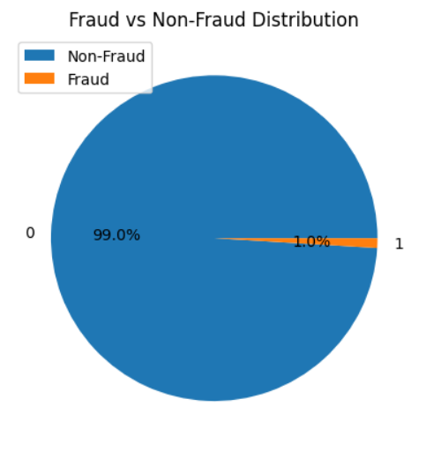

- Key Observations

Several important patterns emerged from the preliminary analysis:
- Skewness: Many features exhibit significant right skewness (skew > 1.0), necessitating log transformation for normalization.
- Scale Differences: Numeric features display vastly different scales. This necessitates standardization to ensure equal feature contribution.
- Constant Features: The device_fraud_count column contains only zeros (constant value) and was removed from analysis as it provides no discriminative information.
- Binary Indicators: Several features are binary (0/1) indicators including email_is_free, phone_home_valid, phone_mobile_valid, has_other_cards, foreign_request, and keep_alive_session.
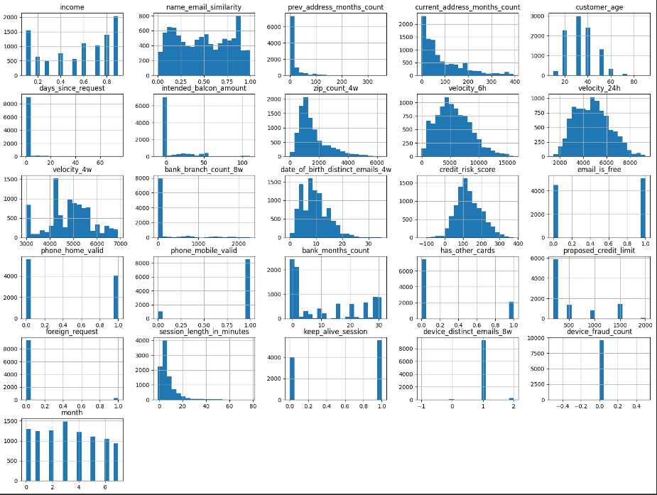
  - Outliers: Box plot analysis reveals outliers in velocity metrics, bank_branch_count_8w, and proposed_credit_limit. However, these outliers may represent genuine fraud patterns and are retained.
  - Correlation Patterns: Initial correlation analysis suggests that customer_age, proposed_credit_limit,income and credit_risk_score show measurable relationships with fraud occurrence, providing early support for Hypothesis 1.
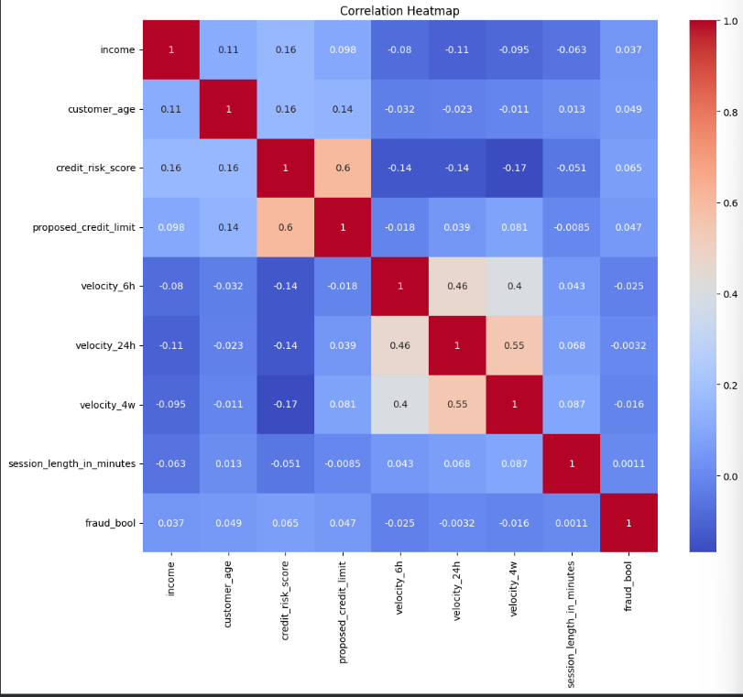

- DATA PREPROCESSING
Data preprocessing transforms raw data into a format suitable for machine learning algorithms. This project implements multiple preprocessing techniques; all applied uniformly across all three models to ensure fair comparison and valid performance assessment.
- Preprocessing Techniques Applied

- Missing Value Imputation
Although the subset contains no missing values, the preprocessing pipeline includes imputation for robustness. Missing values in numeric features would be imputed using the median strategy, which is robust to outliers and preserves the overall distribution. Categorical features use the most frequent value (mode) for imputation. This approach ensures the pipeline can handle missing data if present in new data while maintaining statistical properties of the feature distributions.
- Log Transformation
Highly skewed features undergo log transformation with a small constant (+0.1) to handle potential negative or zero values. Log transformation reduces skewness, making distributions more approximately normal. This helps linear models perform better and reduces the influence of extreme outliers without removing potentially informative data points.
- One-Hot Encoding
Categorical features are converted to binary indicator variables using one-hot encoding. This transformation creates a separate binary column for each category, allowing models to process categorical information numerically. The handle_unknown='ignore' parameter ensures the pipeline can process unseen categories in test or production data without errors, critical for robust deployment.
- Standard Scaling
All numeric features are standardized to have zero mean and unit variance using StandardScaler. This normalization is critical for several reasons:
- Ensure features with larger scales don't dominate the learning process
- Required for Logistic Regression to converge properly
- Improves gradient descent optimization for all models
- Makes feature importance comparisons more meaningful
- SMOTE for Class Imbalance
Synthetic Minority Over-sampling Technique (SMOTE) addresses the severe class imbalance by generating synthetic examples of the minority class (fraudulent accounts). SMOTE creates new instances by interpolating between existing minority class examples in feature space, effectively balancing the training data without simply duplicating existing samples. This technique improves model sensitivity to fraud patterns while avoiding overfitting that can occur with simple random oversampling.
- Pipeline Design
A single unified preprocessing pipeline is applied to all three models (Logistic Regression, Random Forest, and XGBoost). This design decision ensures fair model comparison by guaranteeing that all algorithms receive identical input features. The pipeline uses ColumnTransformer to apply appropriate transformations to different feature groups while maintaining the overall data structure. All preprocessing steps are fitted only on training data and then applied to test data, preventing data leakage and ensuring valid performance estimates.
- MODEL SELECTION, TRAINING, AND HYPERPARAMETER SEARCH
Three classification algorithms were selected to provide diverse modeling approaches: a linear baseline model, an ensemble tree-based method, and a gradient boosting algorithm. Each model offers unique strengths for binary classification in imbalanced fraud detection.
- Selected Algorithms

- Logistic Regression (Baseline Model)
Logistic Regression serves as the baseline linear model for this classification problem. It assumes a linear relationship between features and the log-odds of fraud, making it interpretable and computationally efficient. The model provides probabilistic predictions with clear feature coefficients that indicate the direction and magnitude of each feature's influence. Logistic Regression uses L2 regularization to prevent overfitting, controlled by the regularization parameter C. Despite its simplicity, Logistic Regression often performs competitively on high-dimensional data and provides a strong baseline for comparison.
- Random Forest (Ensemble Tree Model)
Random Forest is an ensemble method that builds multiple decision trees and aggregates their predictions through majority voting. Key advantages include:
- Captures non-linear relationships and complex feature interactions without requiring explicit feature engineering
- Provides feature importance scores directly from the model
- Robust to outliers and irrelevant features through random sampling
- Handles mixed feature types naturally without preprocessing requirements
- Reduces overfitting compared to single decision trees through ensemble averaging
- XGBoost (Gradient Boosting)
XGBoost is a gradient boosting implementation that builds trees sequentially, with each tree correcting errors from previous trees. Key strengths include:
- Typically achieves state-of-the-art performance on tabular data
- Includes built-in L1 and L2 regularization to prevent overfitting
- Handles missing values internally
- Supports parallel processing for faster training
- Uses second-order gradients for more accurate optimization
- Hyperparameter Tuning Strategy
GridSearchCV with 3-fold cross-validation was employed to optimize hyperparameters for each model. F1-score was chosen as the primary optimization metric because it balances precision and recall, which is critical for imbalanced fraud detection where both false positives (customer friction) and false negatives (missed fraud) have significant costs.
- Hyperparameter Search Spaces
- Logistic Regression:
- C: [0.01, 0.1, 1, 10] - Inverse regularization strength
- penalty: ['l2'] - L2 regularization
- solver: ['lbfgs'] - Optimization algorithm
- Random Forest:
- n_estimators: [100, 200] - Number of trees
- max_depth: [10, 20, None] - Maximum tree depth
- min_samples_split: [2, 5] - Minimum samples to split node
- max_features: ['sqrt', 'log2'] - Features per split
- XGBoost:
- max_depth: [3, 5, 7] - Maximum tree depth
- learning_rate: [0.01, 0.1, 0.3] - Step size shrinkage
- n_estimators: [100, 200] - Number of boosting rounds
- subsample: [0.8, 1.0] - Fraction of samples per tree
The systematic grid search explores 48 different parameter combinations across the three models, identifying optimal configurations for each algorithm through cross-validation performance.

- EVALUATION, RESULTS, AND ANALYSIS
Model evaluation employed multiple metrics to assess performance from different perspectives. For imbalanced classification problems like fraud detection, accuracy alone is insufficient because a model predicting all transactions as legitimate would achieve 99% accuracy while missing all fraud cases entirely.
- Evaluation Metrics
- F1-Score (Fraud class): Harmonic mean of precision and recall, providing a balanced measure of model performance on the minority class. F1-score is particularly important for imbalanced datasets as it accounts for both false positives and false negatives equally.
- Recall (Fraud class): Proportion of actual fraud cases correctly identified. High recall is critical for minimizing missed fraud, though it may come at the cost of increased false alarms.
- Precision (Fraud class): Proportion of predicted fraud cases that are actually fraudulent. High precision reduces customer friction from false fraud alerts.
- ROC-AUC: Area under the receiver operating characteristic curve, measuring the model's ability to discriminate between classes across different decision thresholds. Values range from 0.5 (random) to 1.0 (perfect).
- Accuracy: Overall correctness, included for completeness but less meaningful for highly imbalanced data.
- Model Performance Results
The following table summarizes test set performance for all three optimized models:
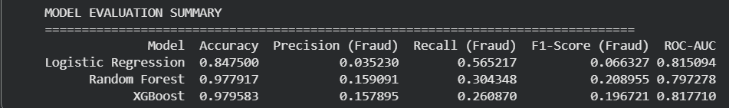
- Key Findings:
- Random Forest achieved the highest F1-score (0.2090), indicating the best balance between precision and recall for fraud detection. This represents a great improvement over Logistic Regression's F1-score.
- Logistic Regression demonstrated superior recall (0.5652), successfully identifying over half of all fraud cases. However, this high recall came at the cost of very low precision (0.0352), meaning many legitimate accounts were incorrectly flagged as fraudulent.
- XGBoost showed intermediate performance with the highest accuracy (0.9796) and competitive F1-score (0.1967), achieving good overall discrimination with the highest ROC-AUC among ensemble models.
- Trade-offs: The results reveal a fundamental precision-recall trade-off. Logistic Regression maximizes fraud detection (recall) but generates many false alarms (low precision). Random Forest provides better balance with moderate recall and significantly improved precision. The optimal choice depends on business priorities: maximizing fraud catch rate favors Logistic Regression, while balanced detection with fewer false positives favors Random Forest.
- The relatively modest absolute F1-scores across all models (highest: 0.2090) reflect the extreme difficulty of fraud detection with highly imbalanced data where fraudulent accounts represent less than 1% of cases. However, these scores represent meaningful improvements over random chance and baseline approaches.
- Feature Importance Analysis
Random Forest feature importance analysis reveals which variables contribute most to fraud prediction. The analysis identified the top 15 most important features, ranked by their mean decrease in impurity.
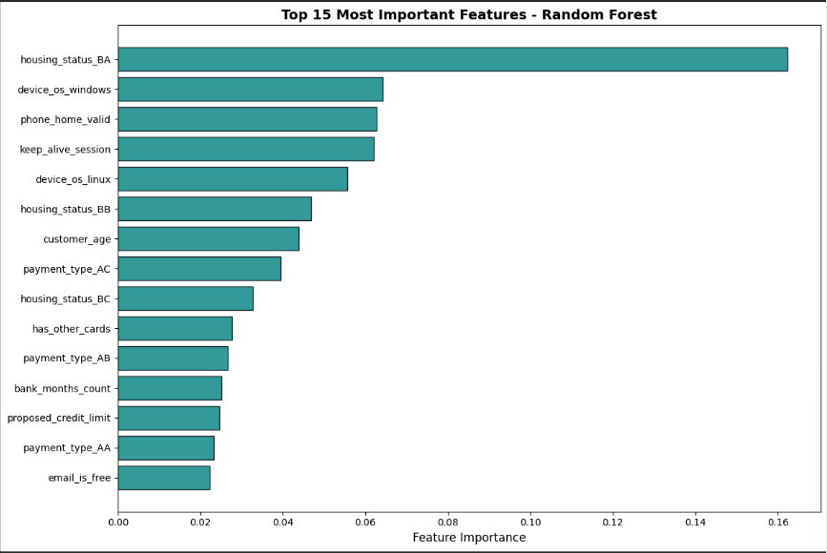
- Analysis: Four of the top 15 features are explicitly behavioral or financial variables directly supporting Hypothesis 1. These features capture customer behavior patterns and financial characteristics that differentiate fraudulent from legitimate accounts.
- The prominence of demographic features (age, address history) alongside financial features (credit limit, payment types) suggests that fraud detection benefits from a combination of stable demographic indicators and dynamic behavioral signals. This finding aligns with fraud detection theory emphasizing the importance of multiple signal types.

- Hypothesis Verification
- Hypothesis 1: Behavioral and Financial Features Are Important
Feature importance analysis confirms that behavioral and financial features significantly influence fraud detection. Four behavioral/financial features appear in the top 15 most important, demonstrating their strong predictive power. Additional behaviorally relevant features also rank highly. All these features contribute meaningfully to model decisions, validating the hypothesis that these feature types are crucial for fraud detection.
- Hypothesis 2: Ensemble Model Superiority
The hypothesis predicted ensemble models would outperform Logistic Regression on both recall and F1-score. Results show:
- F1-Score: Ensemble models clearly outperform Logistic Regression. Random Forest achieved F1=0.2090 and XGBoost achieved F1=0.1967, compared to Logistic Regression's F1=0.0663. This represents a great improvement for Random Forest and 197% improvement for XGBoost over the baseline.
- Recall: Logistic Regression unexpectedly achieved the highest recall (0.5652) compared to Random Forest (0.3043) and XGBoost (0.2609).
The hypothesis is partially supported because ensemble models demonstrate superior F1-scores (balanced performance) but not superior recall (fraud catch rate). This finding reveals an important trade-off: Logistic Regression maximizes the percentage of fraud cases detected but at the cost of many false positives (precision 0.0352), while ensemble models provide better balance with fewer false alarms but miss more fraud cases.
- CONCLUSION
This project built a full machine-learning pipeline to classify bank accounts as fraudulent or legitimate using a 10% subset of the NeurIPS 2022 dataset. After preprocessing and balancing the highly imbalanced data, three models were trained and tuned. Random Forest achieved the best F1-score, Logistic Regression had the highest recall, and XGBoost obtained the strongest ROC-AUC. Key predictors included age, address history, payment type, and credit-related features, confirming that behavioral and financial variables are important for fraud detection. Ensemble models partially supported the hypothesis, they improved F1 but could not match Logistic Regression’s recall.
The choice between models depends on business priorities. If the primary goal is maximizing fraud detection regardless of false positive rate, Logistic Regression is superior. If the goal is balanced detection minimizing both false positives and false negatives, Random Forest is preferred. This nuanced finding is more valuable than blanket superiority, as it provides guidance for deployment decisions based on business context.
Major challenges included extreme class imbalance, computational limits, and the precision–recall trade-off. Although overall F1-scores were modest, the models still showed meaningful improvements over baseline performance.

