# Spring Data Rest

## Insert Record

1. Entity class

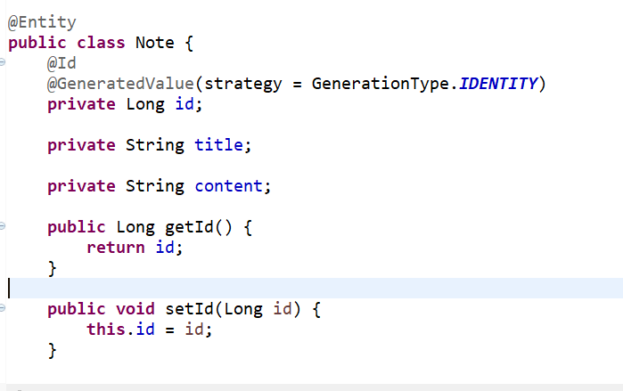

1. CRUDRepository Mapping (Default Methods):
   1. GET -> Maps to findById
   2. POST -> Maps to save
   3. PUT -> Maps to save/update
   4. DELEET -> To delete record
2. Open Postman
3. Enter url with POST request

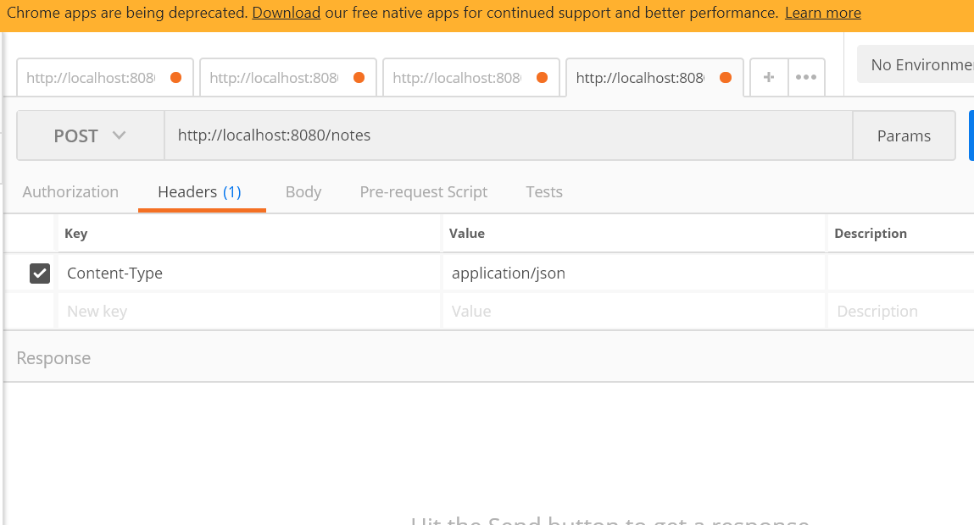

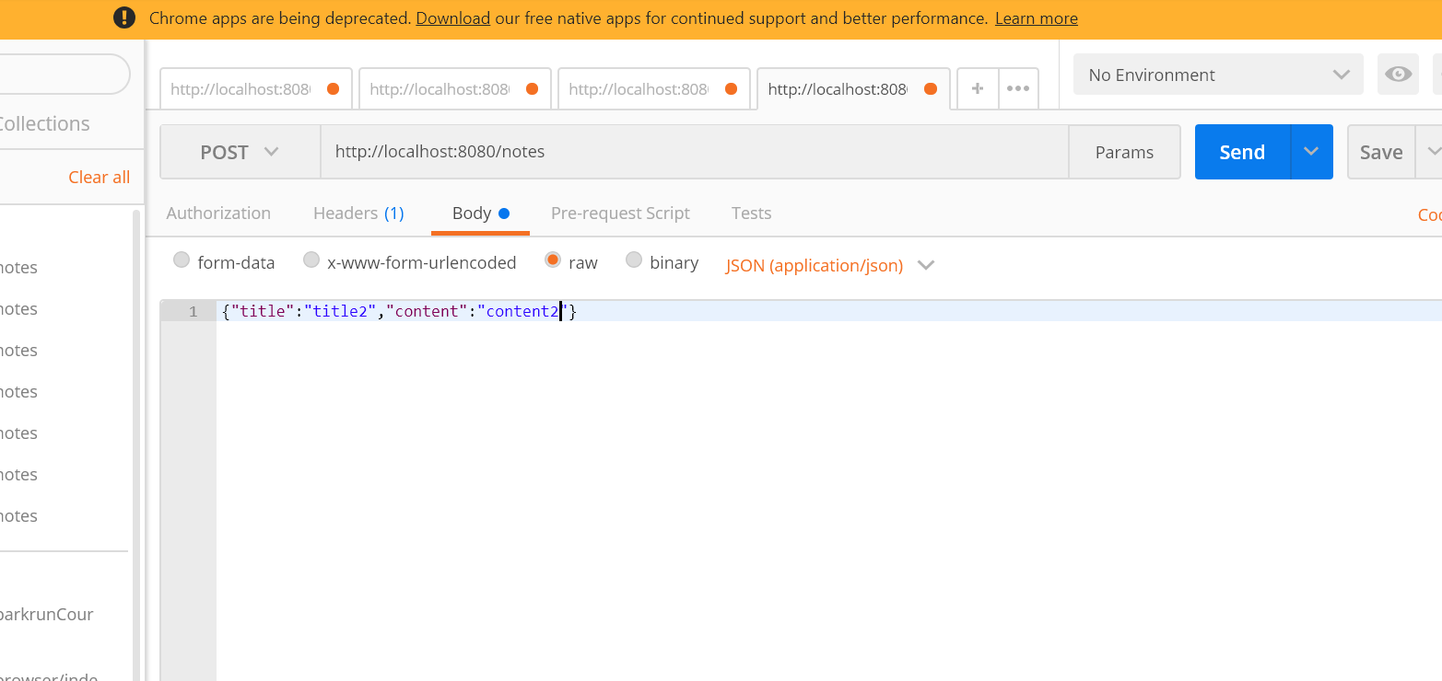

1. Now content is inserted after clicking send button
2. You can view now by hitting url in browser

<http://localhost:8080/notes/2> (here ‘notes’ is the repository name & 2 is the id name)

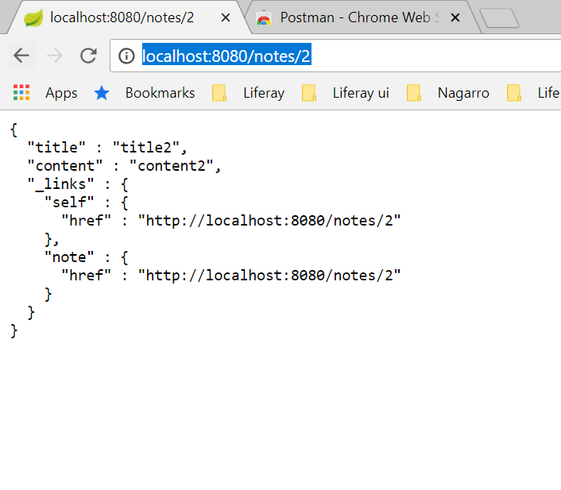

## Search Record

1. Class

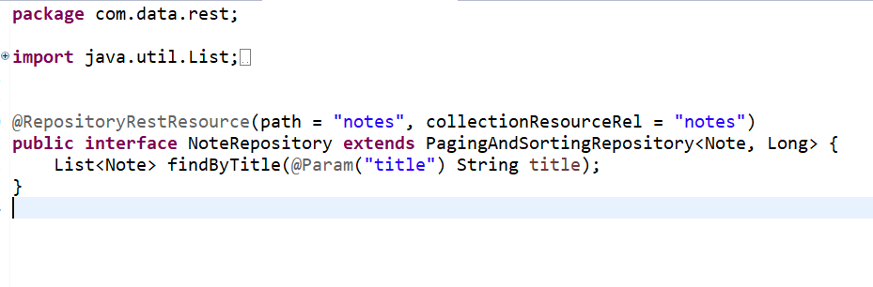

1. Hit URL <http://localhost:8080/notes/search/findByTitle?title=title1>

