Assignment 5 JavaScript Basics
ORBIT After Hours Observatory
Student: Alikhan Shikhiyev
University: Astana IT University
Group: IT-2510
Date: 26 October 2026
GitHub repository URL:
https://github.com/kapchaman/WEB_Frontend_Assignment5
ORBIT is a standalone page with three JavaScript activities: a turn-based space battle, an Astro Club task board and a crew character creator. The theme connects astronomy with a student evening in Astana, including guitar and dombra tasks. The project runs by opening index.html and does not need a build step or external libraries.
Task | Chosen option | Source file
1 | B Turn based battle | js/task1-battle.js
2 | A Kanban board | js/task2-board.js
3 | B Character creator | js/task3-crew.js

Visual direction
Dark instrument panels, mint and violet accents, orbital artwork and personal Astro Club content give the three tasks a consistent identity. All artwork and styling are local CSS and SVG.

Figure 1. The ORBIT opening screen and personal observatory theme.

Task 1 Turn based battle
The player controls Steppe Voyager against Silent Echo. Both start at 100 HP. Attack deals 8 to 15 damage, the enemy responds for 5 to 14, and each side has a 10% critical-hit chance. Defend halves the next incoming hit, rounded up. Repair restores up to 20 HP and can be used three times.
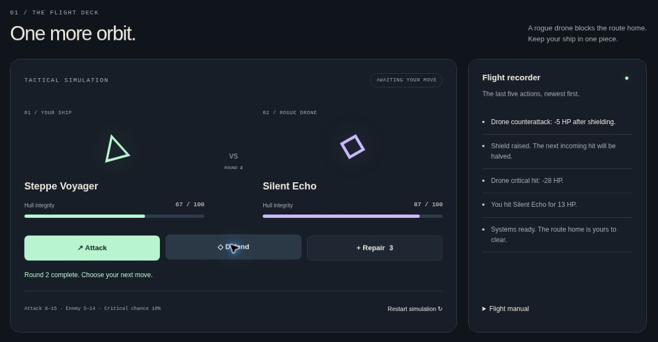
Figure 2. A running battle with HP bars, remaining repair kits and the latest five actions.

How the state changes
GAME stores the numeric configuration at the top of the script. battleState stores HP, kits, the round, the phase and the log. playTurn checks whether the move is allowed, updates this object and calls renderBattle. The renderer updates text, progress elements, disabled buttons and result classes.
randomInteger uses Math.floor(Math.random() * (max - min + 1)) + min. Both boundaries are included. Math.max prevents negative HP, and Math.min limits repairs. The conditions use &&, || and === for invalid moves, ongoing play, victory and defeat.

Invalid moves and end states
Repair at full HP or with no kits is rejected before the state changes. If the enemy reaches zero HP, the function returns before a counterattack. On defeat or victory the controls stop accepting moves. Restart replaces the state object and redraws the game without reloading the page.
Checks included full-HP repair, exhausted kits, one-turn shielding, critical hits on both sides, victory, defeat, repeated restarts and changed game constants. The log retains the five newest actions.

Task 2 Data driven Kanban board
The night board is generated from 12 objects. Each has a unique id, title, description, tag, priority, duration, outdoor flag and status. These include string, number and boolean values. No task cards or columns are hard-coded in the HTML.
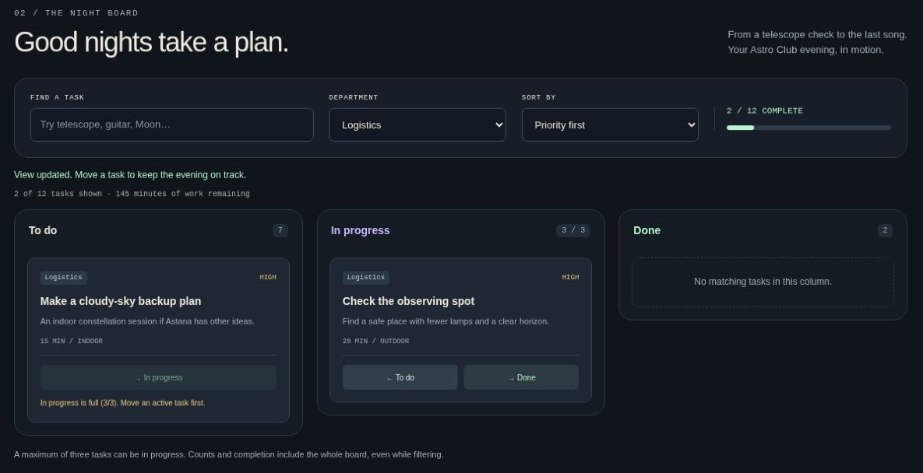
Figure 3. The Logistics filter, a blocked move and the global three-task limit.

Rendering and calculations
renderBoard is the main rendering function. It derives the filter options from the array, filters by department and search text, sorts by priority or title, removes old nodes and creates the current columns and cards with createElement, textContent, classList and dataset. It is called after each move or filter change.
getBoardStats uses a for...of loop to count completed and active tasks and sum the minutes of unfinished work. Initially, 2 of 12 tasks are complete and 145 minutes remain. The progress bar uses done / total * 100. These totals include all tasks even when the view is filtered.

Delegation and the blocked action
One click listener is attached to task-board. The click bubbles from a card button; closest identifies that button, dataset identifies the task and destination, and find retrieves the object. The handler checks the limit before changing status, then rerenders the board.
In progress holds at most three tasks. A blocked button has aria-disabled and a visible reason, but remains focusable so the user can request an explanation. Moving an active task out frees a slot. Empty filters show a message. Keyboard focus is restored to the moved card after the DOM is rebuilt.

Task 3 Live form validation
The character creator has seven fields: callsign, role, color and four numeric skills. The preview changes on every input. A character needs exactly 20 points, each skill must be an integer from 1 to 10, and the selected role requires a primary skill of at least 7.
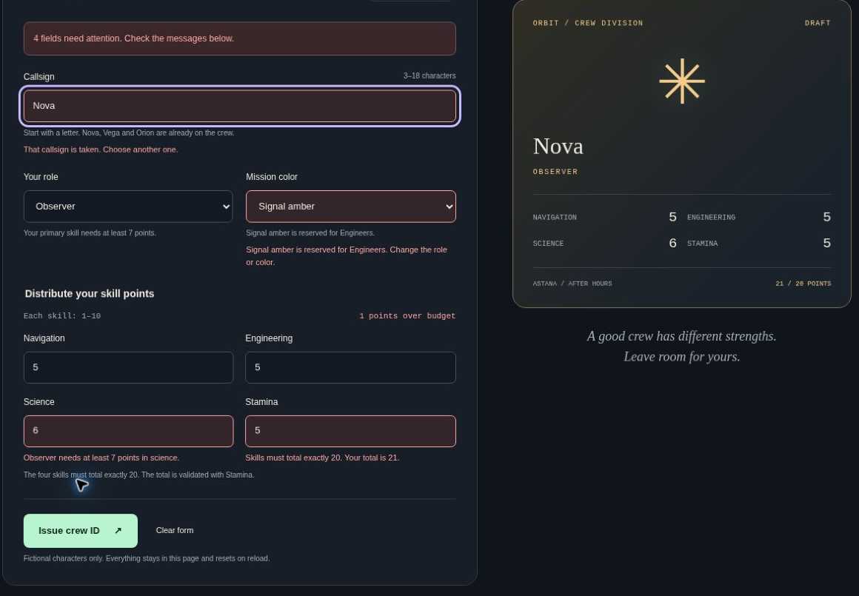
Figure 4. Four invalid fields, a clear summary, focus on the callsign and a live draft preview.

Validation timing and accessibility
The untouched form starts without errors. blur adds a field to touchedFields; later input and change events revalidate touched fields. Rechecking all touched fields keeps messages accurate when the role, color or skill total changes. Each checked field receives aria-invalid and a message below it, connected with aria-describedby.
form.noValidate disables browser popups while retaining HTML constraints. getCrewError first clears old custom validity, checks native validity, then applies the four custom rules. submit uses preventDefault, checks every field and focuses the first error. The summary counts invalid fields, not individual broken rules.

Task 3 Validation rules
The examples below assume the initial name list and otherwise valid inputs. Skill vectors are written as Navigation / Engineering / Science / Stamina. Rules marked Custom depend on other fields or runtime data and cannot be expressed by normal single-field HTML attributes.
Field | Rule | Valid example | Invalid example
Callsign | HTML: required; 3-18 characters; starts with a letter; letters, digits, spaces, _ and - only. | Xialik | 2star; A; <script>
Callsign | Custom 1: must not be in takenNames, ignoring case; the trimmed name is checked. | Xialik before its first successful issue | Nova; nOvA; Xialik after its ID has been issued
Role and color | HTML required plus membership in the configured role and color lists. | Observer and Aurora mint | No role or no color selected
Each skill | HTML: required integer from 1 to 10, using min, max and step. | 1; 5; 10 | 0; 11; 1.5; empty
Four skills | Custom 2: sum must equal 20. The total error is shown under Stamina. | 4 / 4 / 8 / 4 | 5 / 5 / 6 / 5 (21 points)
Primary skill | Custom 3: the chosen role needs at least 7 in its primary skill. | Observer: science 8; Engineer: engineering 7; Pilot: navigation 7 | Observer: science 6; Engineer: engineering 6; Pilot: navigation 6
Color and role | Custom 4: Signal amber is reserved for Engineers. | Engineer + amber; any role + mint or violet | Observer + amber; Pilot + amber

Examples for the demonstration
Invalid submission: Nova, Observer, Signal amber, skills 5 / 5 / 6 / 5. Four fields are invalid: callsign, color, Science and Stamina. The summary says 4 fields need attention and focuses the callsign.
Valid submission: Xialik, Observer, Aurora mint, skills 4 / 4 / 8 / 4. The total is 20, Science meets the minimum and the color is allowed. After success, xIaLiK is rejected as a duplicate during the same page session.

Successful result and verification
A successful submission builds a final card through DOM methods, reserves the callsign in takenNames and resets the form. The issued card stays visible. The next preview uses the default values, and errors are cleared. All state is local to the page and resets on reload.
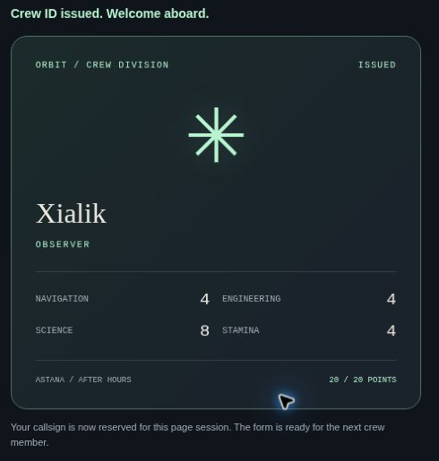
Figure 5. The issued Xialik card with the valid 4 / 4 / 8 / 4 distribution.

Verification
All three scripts passed syntax checks. Nineteen deterministic logic checks passed, covering inclusive random endpoints, invalid moves, game endings, modified constants, array calculations and the custom form rules. Browser checks also covered blocked moves, filtering, error focus, duplicate names, decimal and out-of-range skills, empty required fields and successful reset.
The page was checked in 1280-pixel and 375-pixel frames. Document width equalled scroll width in both, so there was no horizontal overflow. The layout changes from multiple columns to a single column on small screens. No application JavaScript errors were observed in Chromium; unrelated browser-extension messages were excluded.

Conclusion
The main lesson from this project is to keep data separate from its display. A move changes the game state or task array first, and rendering then shows that state. Validation has the same separation: the preview can show unfinished input, but the final result is created only when every rule passes. Event delegation, guard clauses and clear feedback make repeated interactions predictable.

