Assignment 6
  - jQuery Selectors Effects and Animations
Alikhan Shikhiyev
Group IT-2510
Astana IT University

Project overview
This project reconstructs the birthday party from the assignment picture and solves all 20 detective cases using jQuery searches of the DOM. The original party contains 21 guests in four rooms on two floors. The final case identifies Zarina as the guest who matches every clue about the missing cake.
Task 1 builds the scene from an array, highlights matches, animates one jump and displays the result. Task 2 is a separate copy with spotlight effects, animated guest details, movement between rooms and reversible sorting by arrival time.

Source code repository
GitHub repository URL: https://github.com/kapchaman/WEB_Frontend_Assignment6

Running the project
Extract the complete project folder and open dist/index.html. Choose Task 1 or Task 2. The full jQuery 3.7.1 build and all avatar files are stored locally, so the project can run without a server or internet connection.

Implementation files
File | Responsibility
data.js | Room and guest data in picture order
cases.js | Twenty jQuery case chains that search DOM cards
app.js | Rendering, case events, results, highlighting and Clear
motion.js | Task 2 details, movement and animated sorting
styles.css | Static layout and styling without CSS animations
assets | Local jQuery and free avatar images

All interaction handlers use jQuery .on(). Effects use jQuery .animate(), .fadeIn(), .fadeOut() and .fadeTo(). No additional JavaScript library or inline onclick handler is used.

Task 1 party data
Rows follow the picture from left to right within each room. Floor 2 is upstairs; floor 1 is downstairs. AITU is stored as a Boolean and things as an array of item names.
Room | Floor | Guest | Color | Arrival | AITU | Things
Balcony | 2 | Aigerim | green | 20:45 | Yes | cup, crumbs
Balcony | 2 | Aliya | black | 21:15 | No | phone, cup
Balcony | 2 | Madina | green | 22:10 | No | phone, bag, crumbs
Balcony | 2 | Ivan | black | 20:10 | Yes | cup
Hall | 2 | Arman | yellow | 20:35 | No | bag, glasses
Hall | 2 | Sophia | purple | 21:20 | Yes | phone
Hall | 2 | Dias | green | 19:45 | Yes | None
Hall | 2 | Bekzat | purple | 20:55 | No | bag, cup, crumbs
Hall | 2 | Aruzhan | blue | 21:50 | Yes | phone
Hall | 2 | Saule | green | 21:25 | No | glasses
Kitchen | 1 | Nurlan | red | 19:40 | Yes | phone, cup
Kitchen | 1 | Emma | black | 20:15 | No | bag
Kitchen | 1 | Timur | green | 21:05 | Yes | phone, bag, crumbs
Kitchen | 1 | Sergey | yellow | 20:50 | No | None
Kitchen | 1 | Yerlan | red | 21:40 | Yes | glasses, phone
Kitchen | 1 | Kamila | green | 20:05 | No | cup
Living room | 1 | Daniel | blue | 19:55 | Yes | glasses
Living room | 1 | Zarina | green | 21:10 | No | bag, phone, crumbs
Living room | 1 | Natasha | yellow | 20:30 | Yes | None
Living room | 1 | Askar | black | 21:00 | Yes | phone
Living room | 1 | Inkar | purple | 20:20 | No | bag

From data to the page
The renderer creates floor sections, room sections and guest buttons with jQuery. Every card shows a local avatar, a ring in the clothing color, name, arrival time, item symbols and an AITU or guest badge. The legend explains the symbols.
Classes such as aitu, color-green and has-phone support selectors. Attributes store the guest name, arrival time, item count and minutes after midnight. A case always starts with render(), which reconstructs the scene before its DOM query runs.
Room cases count rooms and highlight their borders. In Task 2, every guest inside a matched room stays bright. The following pages show the exact chain and observed result for each case, starting from the original party.

Case 1 Who is in the hall
Result: 6 guests — Arman, Sophia, Dias, Bekzat, Aruzhan, Saule.
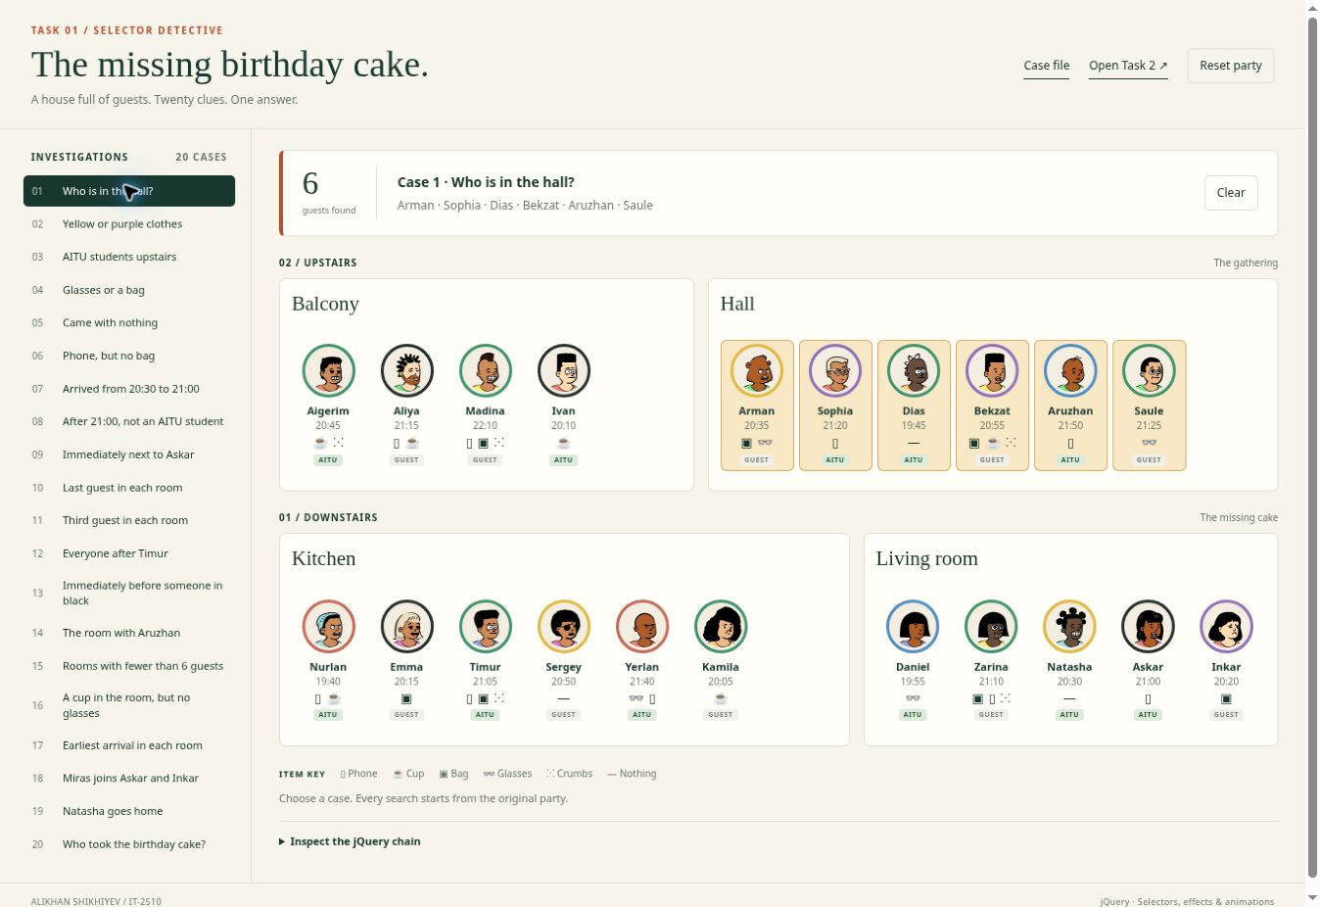
Figure 1. Case 1 after the search and effects have finished.

jQuery chain
$('#hall .guest');
The room ID limits the search to descendants of the hall. The result contains all six guests in their picture order.

Case 2 Yellow or purple clothes
Result: 6 guests — Arman, Sophia, Bekzat, Sergey, Natasha, Inkar.
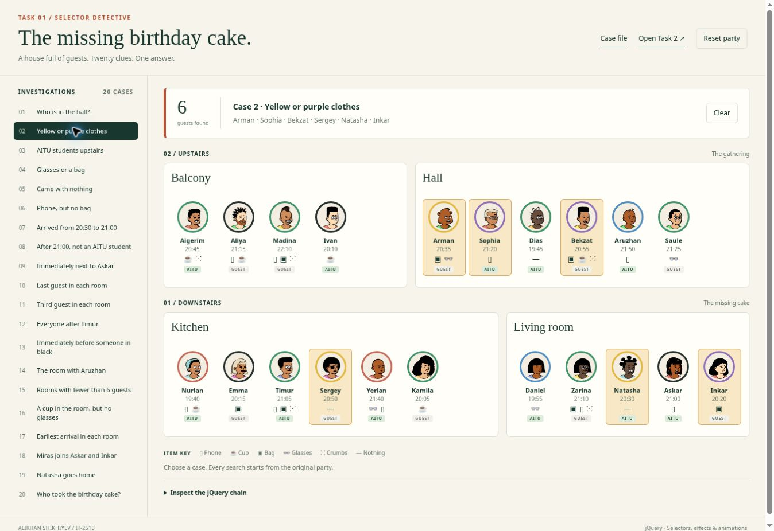
Figure 2. Case 2 after the search and effects have finished.

jQuery chain
$('.guest.color-yellow, .guest.color-purple');
The comma joins two selector alternatives. A guest can match yellow or purple; jQuery returns a unique combined set.

Case 3 AITU students upstairs
Result: 5 guests — Aigerim, Ivan, Sophia, Dias, Aruzhan.
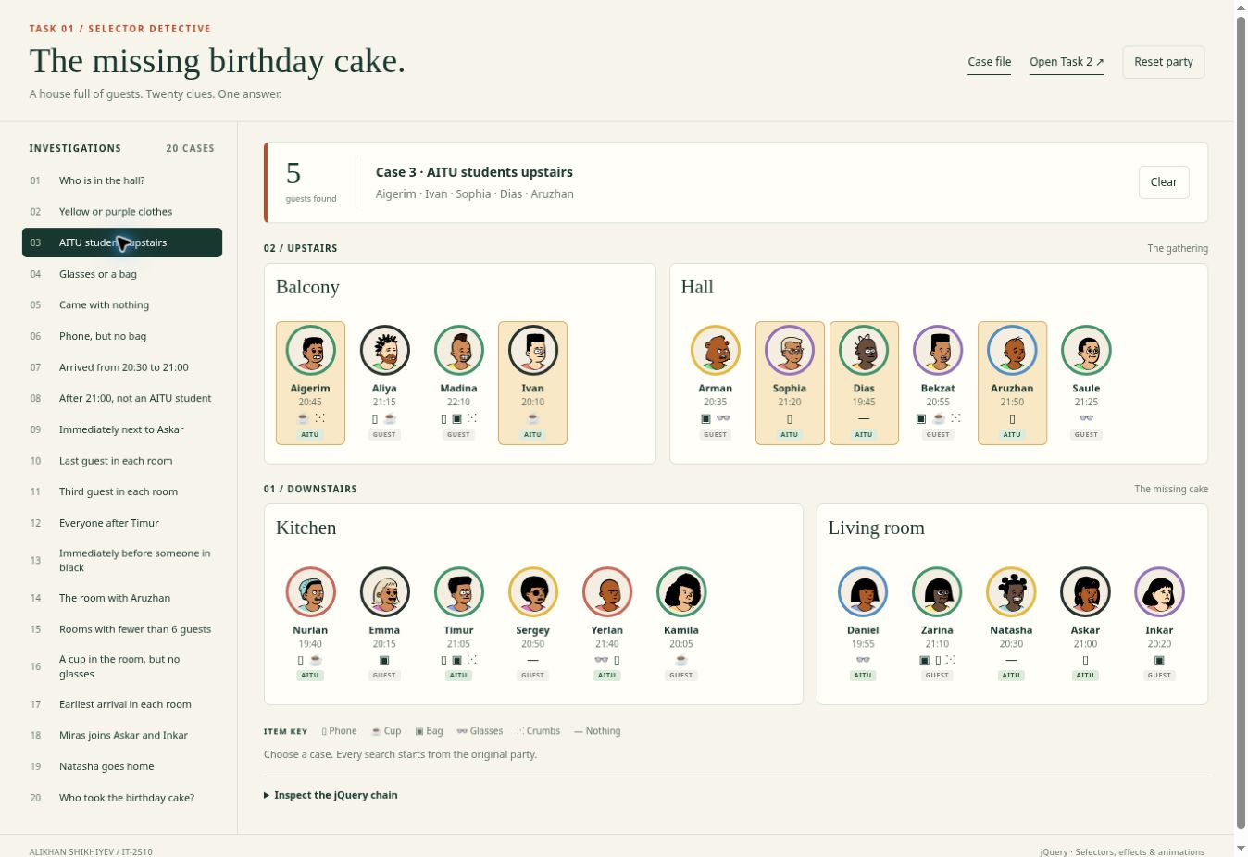
Figure 3. Case 3 after the search and effects have finished.

jQuery chain
$('.floor[data-floor="2"] .guest.aitu');
The floor attribute selects upstairs. The aitu class restricts the result to students on that floor.

Case 4 Glasses or a bag
Result: 10 guests — Madina, Arman, Bekzat, Saule, Emma, Timur, Yerlan, Daniel, Zarina, Inkar.
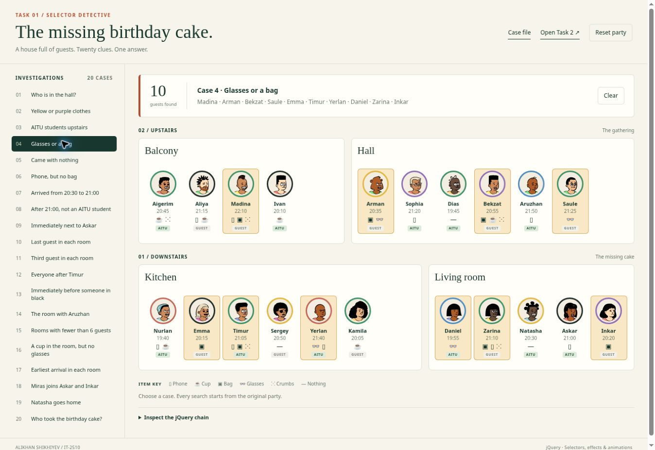
Figure 4. Case 4 after the search and effects have finished.

jQuery chain
$('.guest.has-glasses, .guest.has-bag');
Two item classes are combined with a comma. A guest with both a bag and glasses is counted only once.

Case 5 Came with nothing
Result: 3 guests — Dias, Sergey, Natasha.
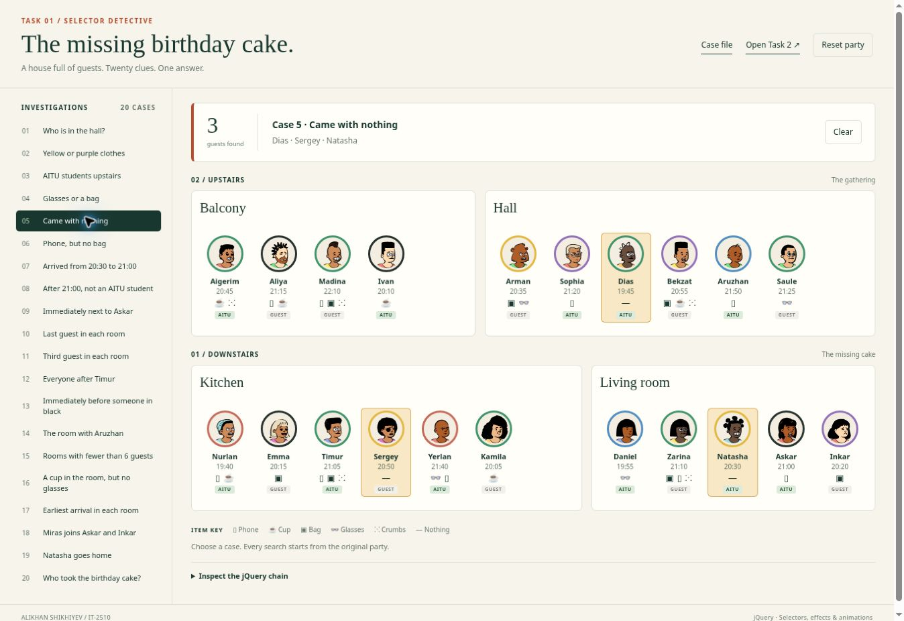
Figure 5. Case 5 after the search and effects have finished.

jQuery chain
$('.guest[data-things="0"]');
The data-things attribute stores the number of items. A value of zero identifies guests who came with nothing.

Case 6 Phone but no bag
Result: 6 guests — Aliya, Sophia, Aruzhan, Nurlan, Yerlan, Askar.
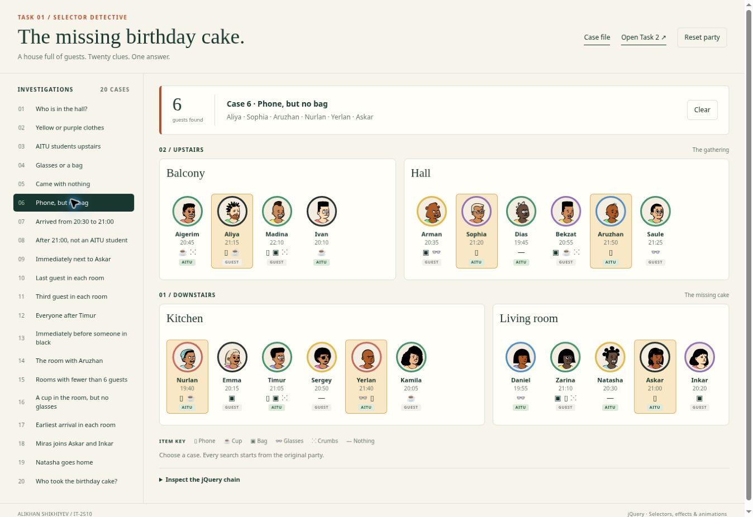
Figure 6. Case 6 after the search and effects have finished.

jQuery chain
$('.guest.has-phone').not('.has-bag');
The first selector finds phones. The not method removes every guest who also has a bag.

Case 7 Arrived from 20:30 to 21:00
Result: 6 guests — Aigerim, Arman, Bekzat, Sergey, Natasha, Askar.
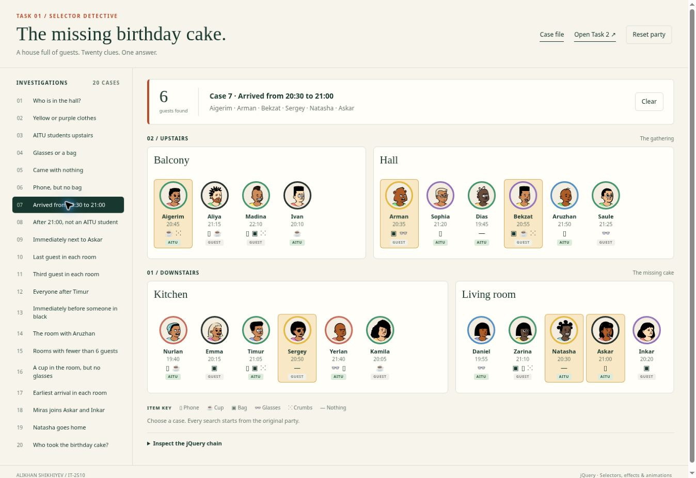
Figure 7. Case 7 after the search and effects have finished.

jQuery chain
$('.guest').filter(function () {
return +$(this).attr('data-minutes') >= 1230 && +$(this).attr('data-minutes') <= 1260;
});
Arrival times are stored as minutes after midnight. The comparisons include both 20:30 (1230) and 21:00 (1260).

Case 8 After 21:00 not an AITU student
Result: 4 guests — Aliya, Madina, Saule, Zarina.
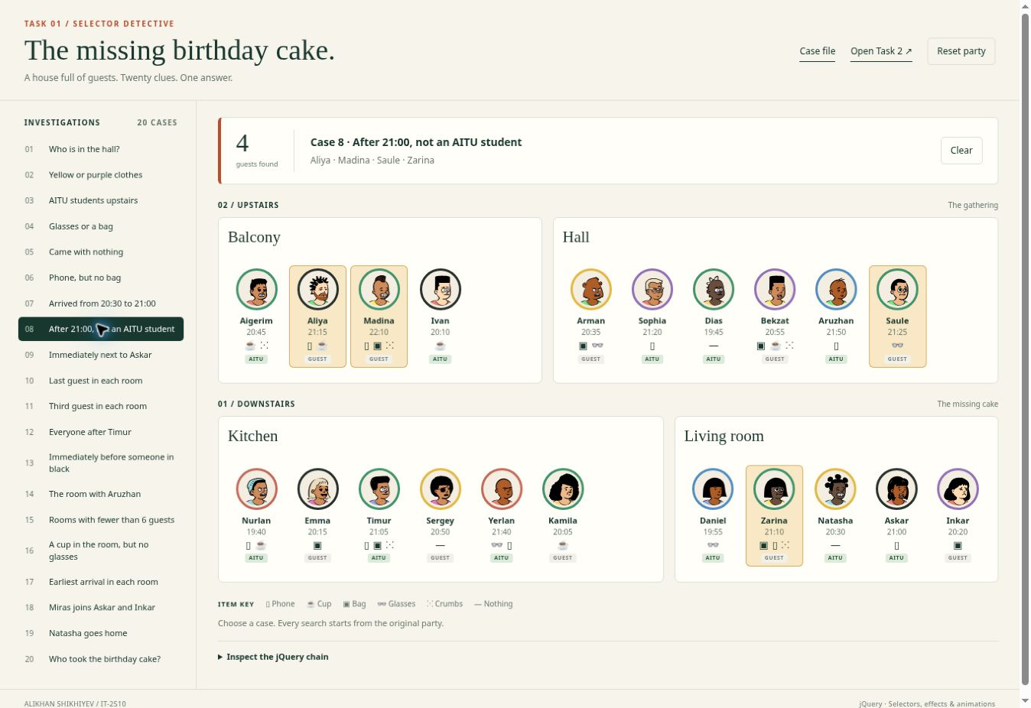
Figure 8. Case 8 after the search and effects have finished.

jQuery chain
$('.guest').not('.aitu').filter(function () {
return +$(this).attr('data-minutes') > 1260;
});
The not method excludes AITU students. The time comparison is strict, so an arrival at exactly 21:00 is excluded.

Case 9 Immediately next to Askar
Result: 2 guests — Natasha, Inkar.
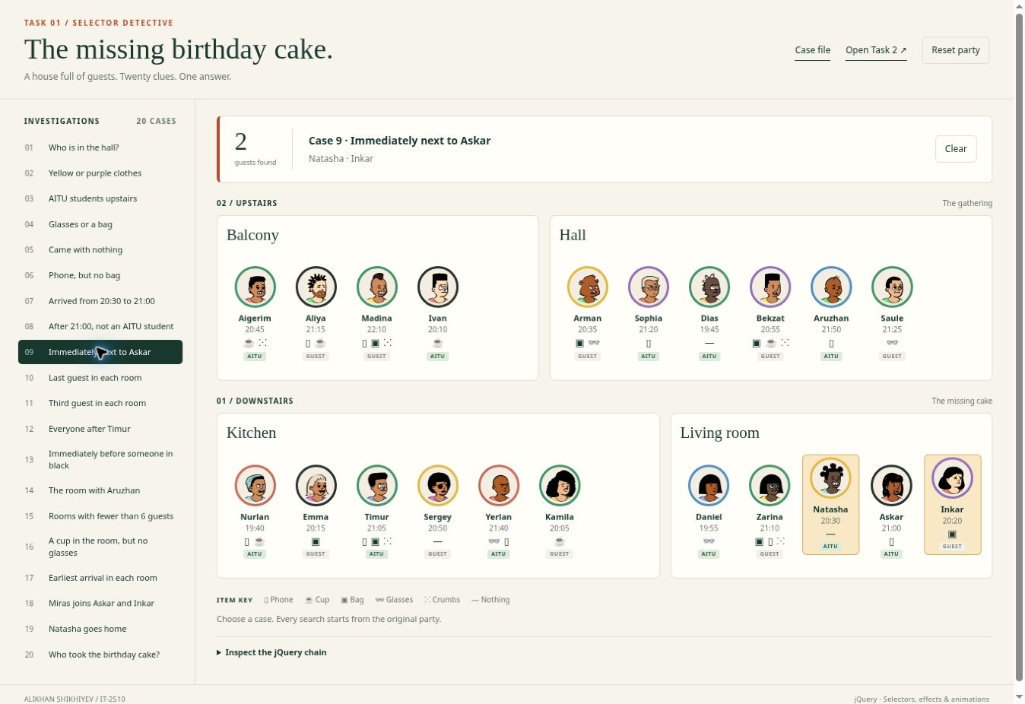
Figure 9. Case 9 after the search and effects have finished.

jQuery chain
$('.guest[data-name="Askar"]').prev('.guest').add($('.guest[data-name="Askar"]').next('.guest'));
prev and next find the two immediate siblings of Askar. add combines them without selecting everyone else in the room.

Case 10 Last guest in each room
Result: 4 guests — Ivan, Saule, Kamila, Inkar.
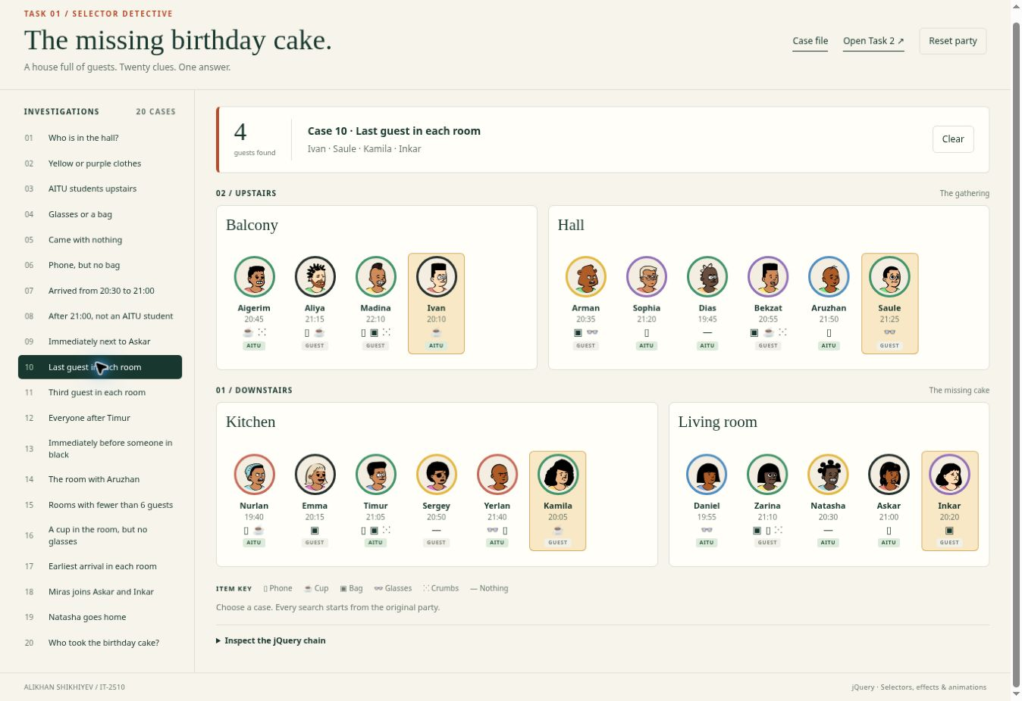
Figure 10. Case 10 after the search and effects have finished.

jQuery chain
$('.guest-list > .guest:last-child');
Each guest list contains only guest cards. last-child therefore selects exactly the last card in each room.

Case 11 Third guest in each room
Result: 4 guests — Madina, Dias, Timur, Natasha.
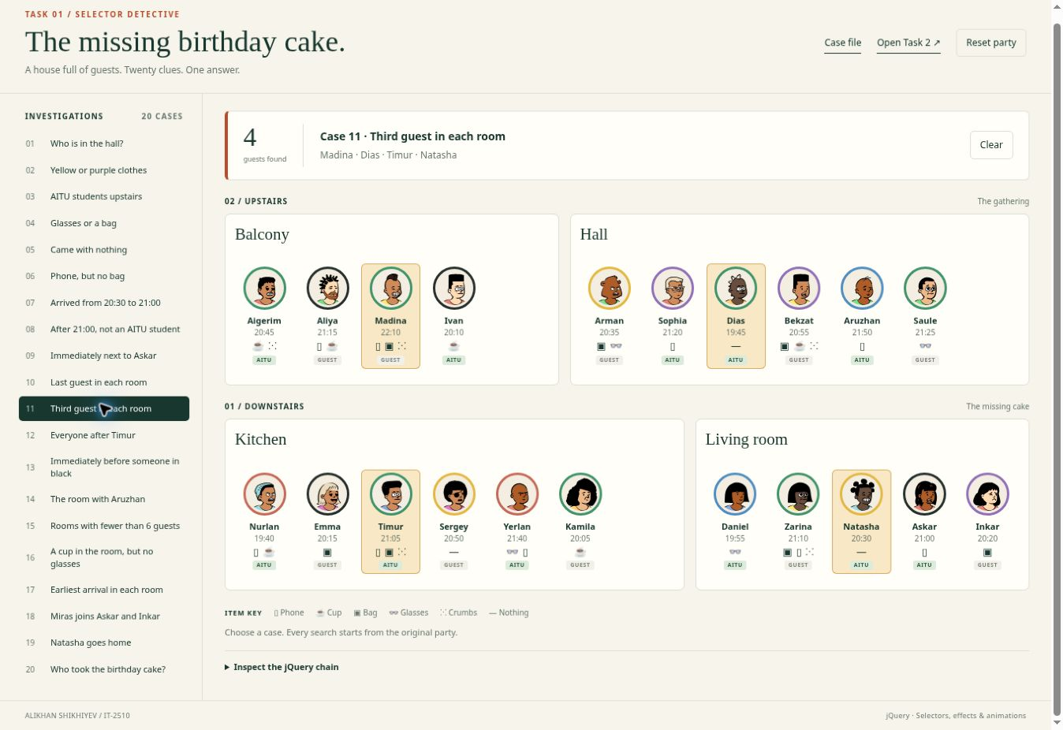
Figure 11. Case 11 after the search and effects have finished.

jQuery chain
$('.guest-list > .guest:nth-child(3)');
nth-child uses a one-based index. The selector finds the third card separately in each guest list.

Case 12 Everyone after Timur
Result: 3 guests — Sergey, Yerlan, Kamila.
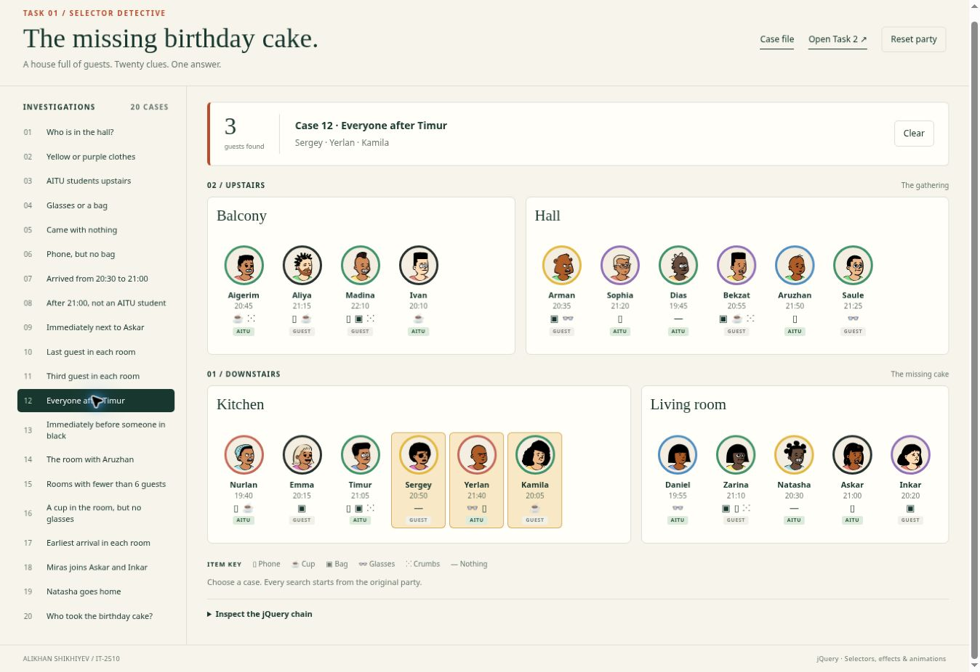
Figure 12. Case 12 after the search and effects have finished.

jQuery chain
$('.guest[data-name="Timur"]').nextAll('.guest');
nextAll searches later siblings in the same list. It cannot continue into a different room.

Case 13 Immediately before someone in black
Result: 4 guests — Aigerim, Madina, Nurlan, Natasha.
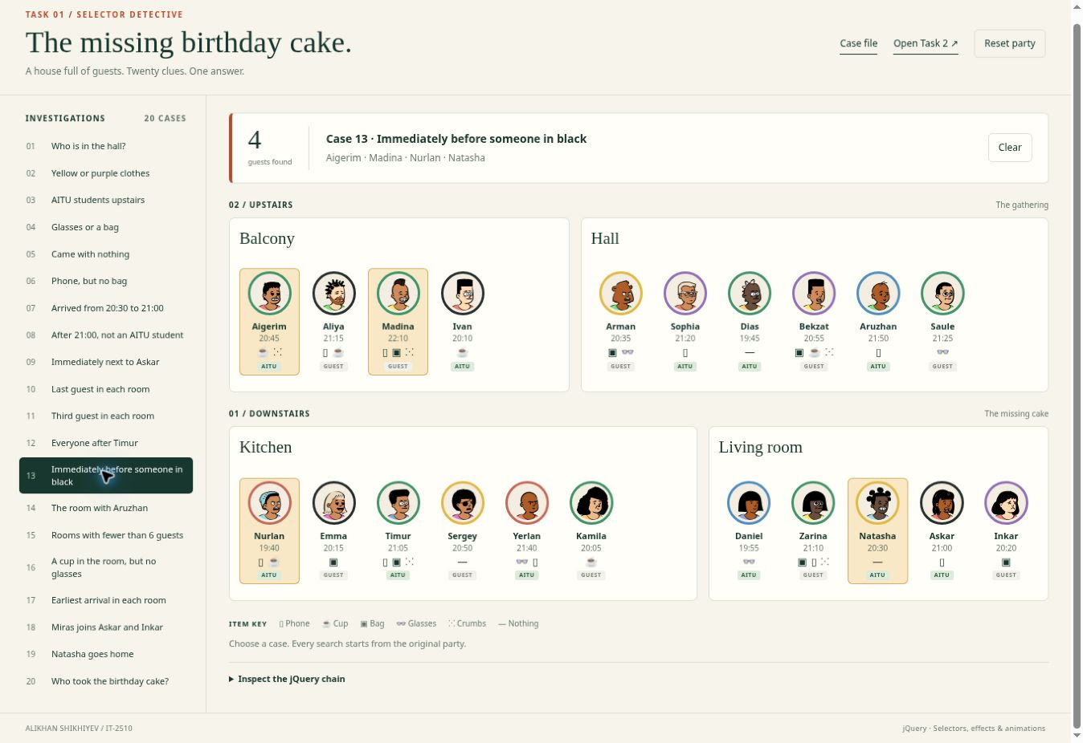
Figure 13. Case 13 after the search and effects have finished.

jQuery chain
$('.guest.color-black').prev('.guest');
The search starts with black clothing, then prev returns the guest immediately before each match. A black-clothed first guest would contribute no predecessor.

Case 14 The room with Aruzhan
Result: 1 room — Hall.
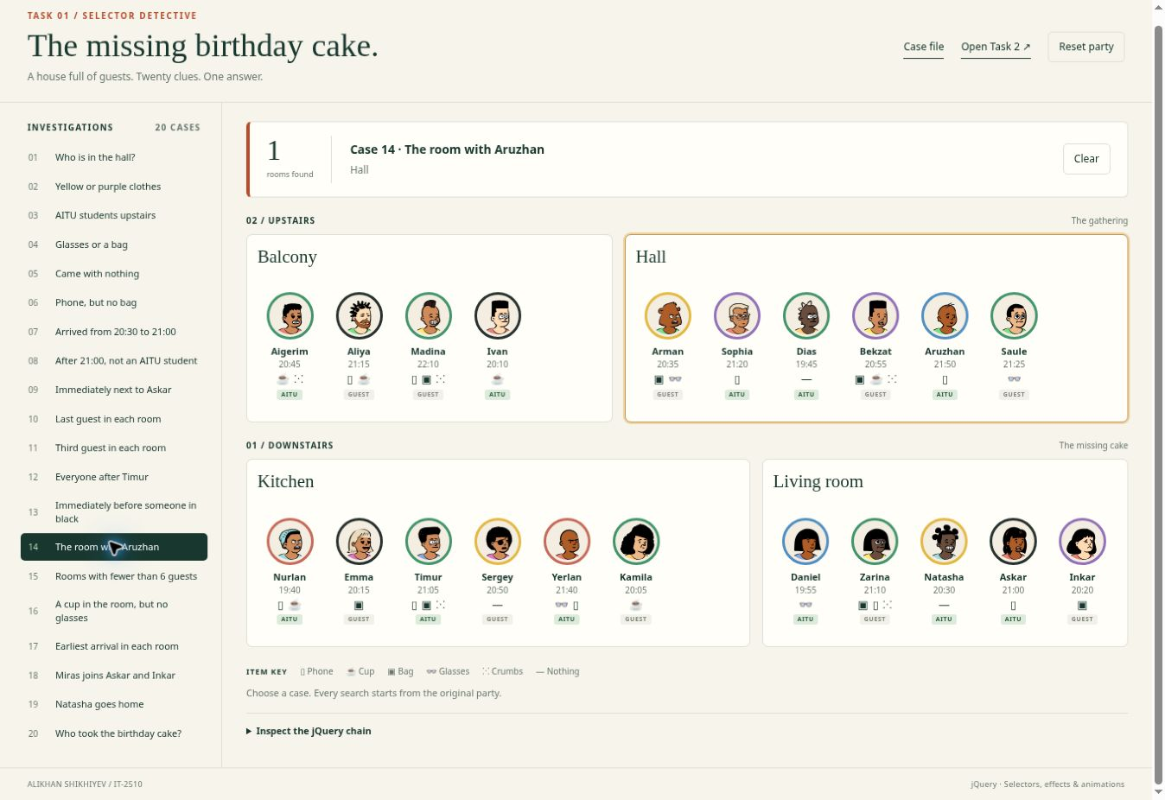
Figure 14. Case 14 after the search and effects have finished.

jQuery chain
$('.guest[data-name="Aruzhan"]').closest('.room');
closest walks upward from Aruzhan until it reaches a room. This is a room result, so the displayed count is a number of rooms.

Case 15 Rooms with fewer than 6 guests
Result: 2 rooms — Balcony, Living room.
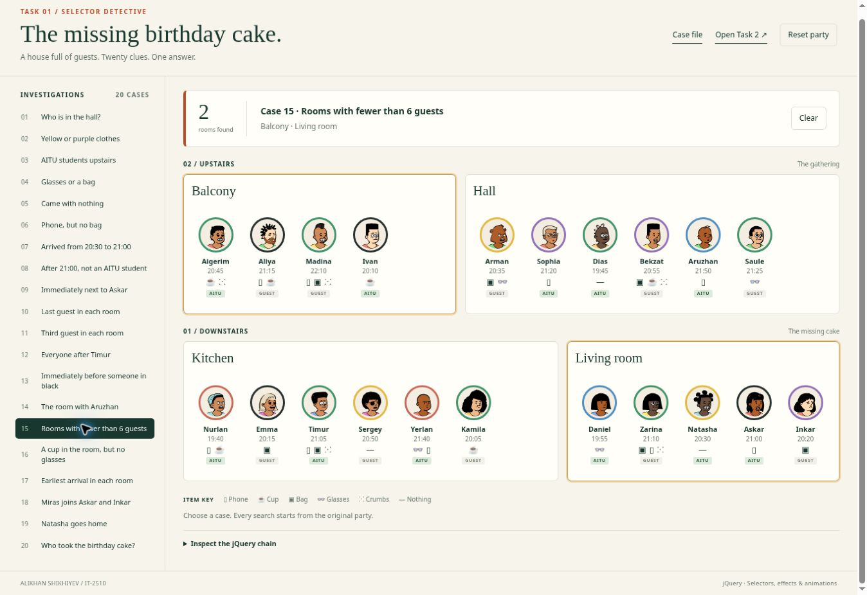
Figure 15. Case 15 after the search and effects have finished.

jQuery chain
$('.room').filter(function () {
return $(this).find('.guest').length < 6;
});
filter checks the number of DOM guest cards in each room. The threshold is strictly fewer than six.

Case 16 A cup in the room but no glasses
Result: 1 room — Balcony.
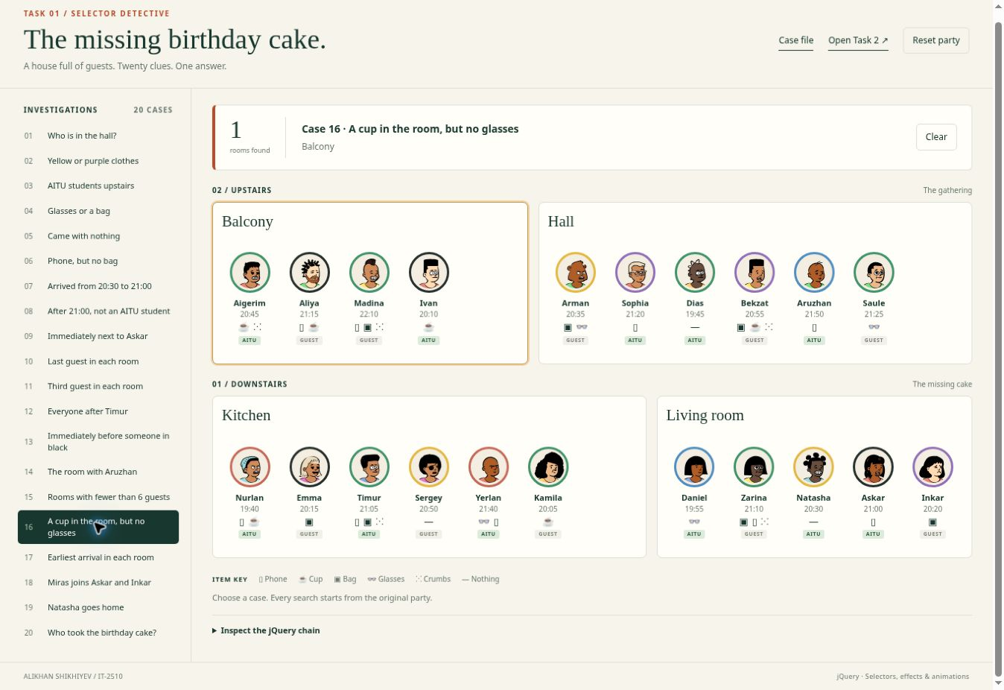
Figure 16. Case 16 after the search and effects have finished.

jQuery chain
$('.room').has('.guest.has-cup').not(':has(.guest.has-glasses)');
has requires at least one cup. not with has excludes any room containing glasses, even when the glasses belong to a different guest.

Case 17 Earliest arrival in each room
Result: 4 guests — Ivan, Dias, Nurlan, Daniel.
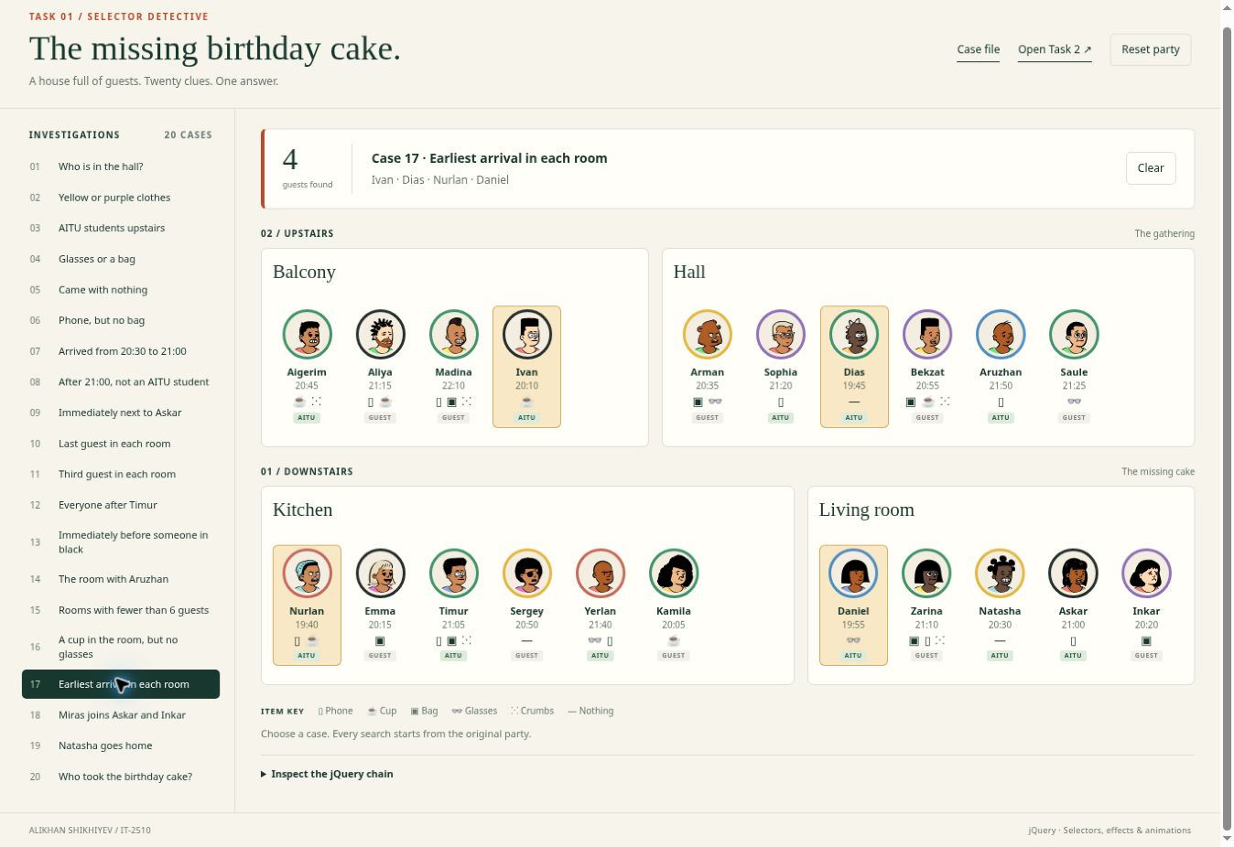
Figure 17. Case 17 after the search and effects have finished.

jQuery chain
$('.guest').filter(function () {
const minutes = +$(this).attr('data-minutes');
return $(this).siblings('.guest').filter(function () {
return +$(this).attr('data-minutes') < minutes;
}).length === 0;
});
For each guest, the predicate checks whether any sibling arrived earlier. A guest is retained only if no earlier sibling exists. Equal earliest times would all be retained.

Case 18 Miras joins Askar and Inkar
Result: 1 guest — Miras.
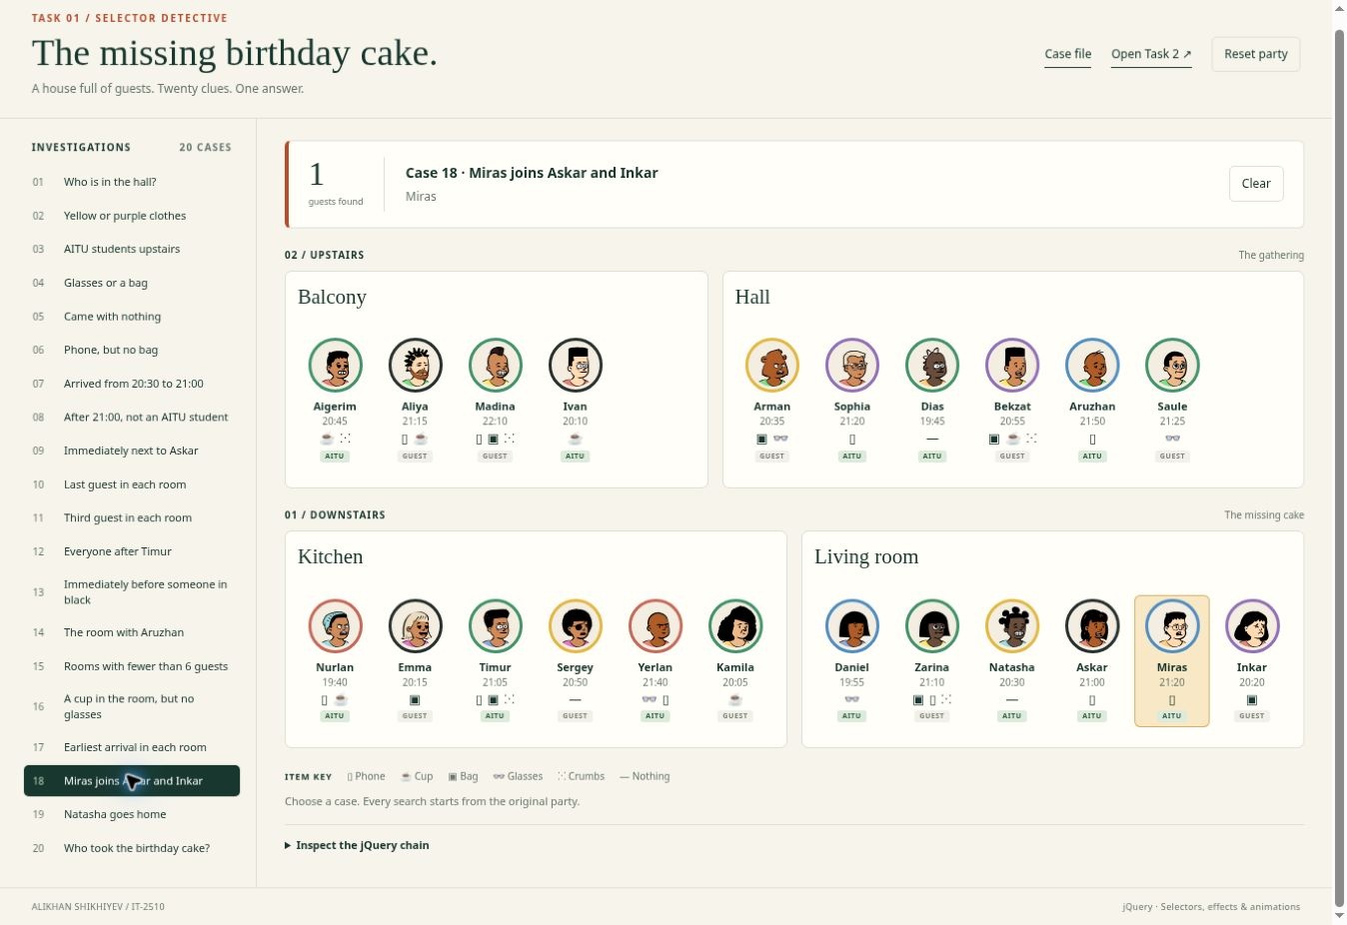
Figure 18. Case 18 after the search and effects have finished.

jQuery chain
Party.getOrMakeGuest({ name: 'Miras', color: 'blue', arrival: '21:20', aitu: true, things: ['phone'] })
.hide().insertAfter('.guest[data-name="Askar"]').fadeIn(350);
getOrMakeGuest searches the DOM for Miras first and creates his card only if needed. The chain inserts this one card after Askar and fades it in. In the original party, he stands before Inkar. Repeating the case after moving him cannot create a duplicate.

Case 19 Natasha goes home
Result: 1 guest — Natasha.
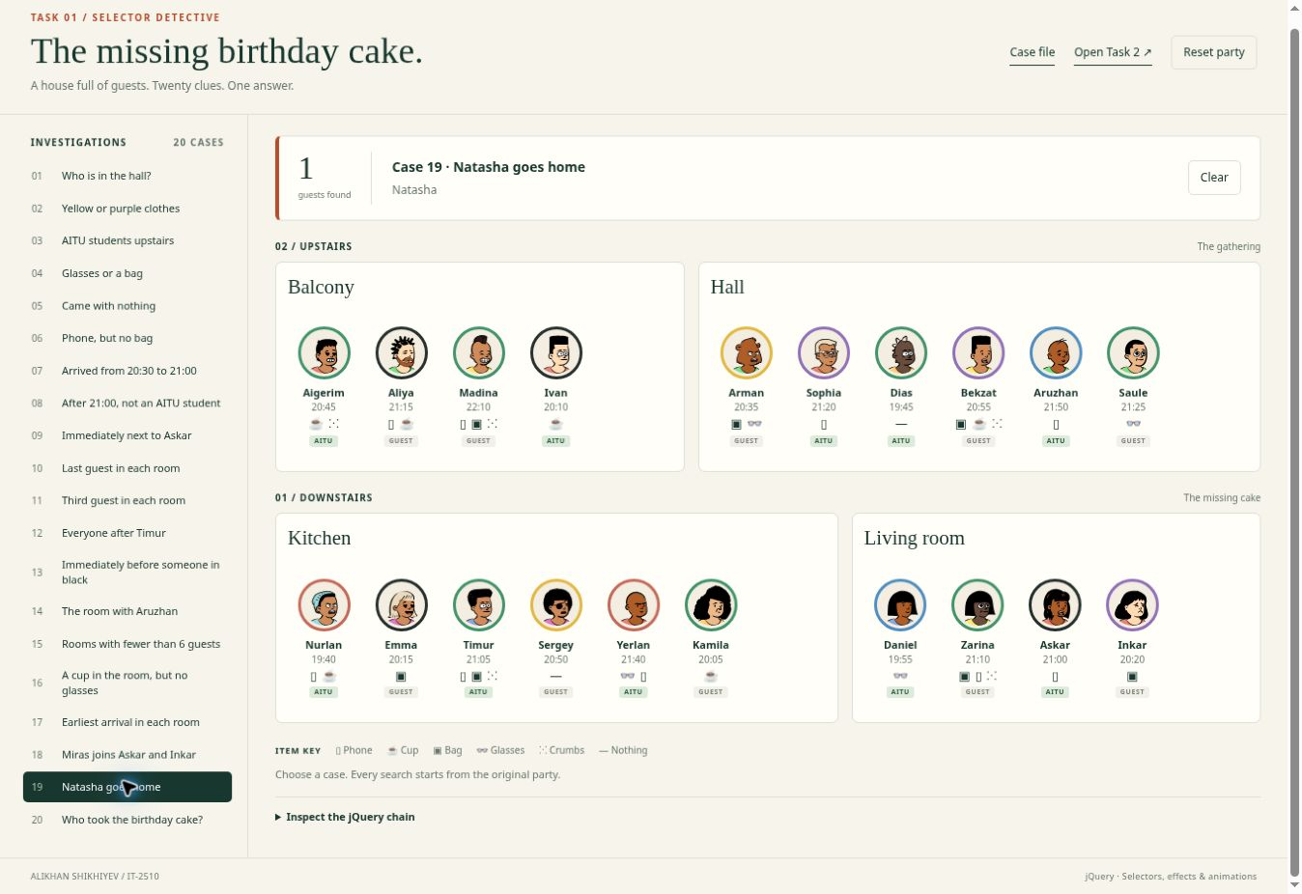
Figure 19. Case 19 after the search and effects have finished.

jQuery chain
$('.guest[data-name="Natasha"]').animate({ top: -10 }, 140).animate({ top: 0 }, 160).fadeOut(350, function () {
$(this).remove();
$('#house').attr('aria-busy', 'false');
});
Natasha jumps once, fades out, and is removed in the completion callback. The result identifies the one affected guest; the party now contains 20 cards. The callback also clears the accessibility busy state.

Case 20 Who took the birthday cake
Result: 1 guest — Zarina.
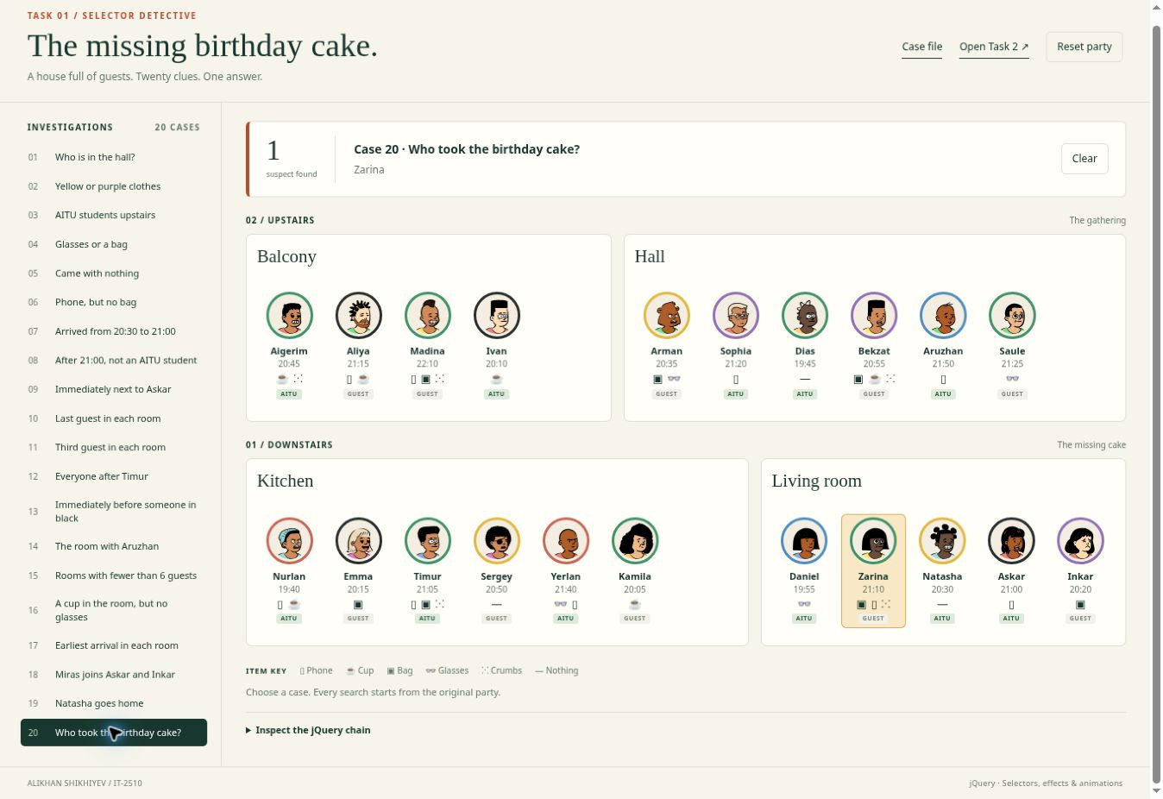
Figure 20. Case 20 after the search and effects have finished.

jQuery chain
$('.floor[data-floor="1"] .guest.has-crumbs').not('.has-cup').filter(function () {
const minutes = +$(this).attr('data-minutes');
return minutes > 1260 && minutes < 1290 &&
($(this).prev('.guest').is('.aitu') || $(this).next('.guest').is('.aitu'));
});
Zarina is downstairs, arrived at 21:10, has crumbs and no cup, and stands next to AITU students Daniel and Natasha. Timur has the right time and items, but neither immediate neighbor is an AITU student.

Task 2 spotlight
After a case, all guests outside the result fade to opacity 0.2 over 300 ms. Matches keep full opacity. For a room result, the code first collects the guest cards inside the matched rooms. Clear stops old effects and restores every visible card to opacity 1.
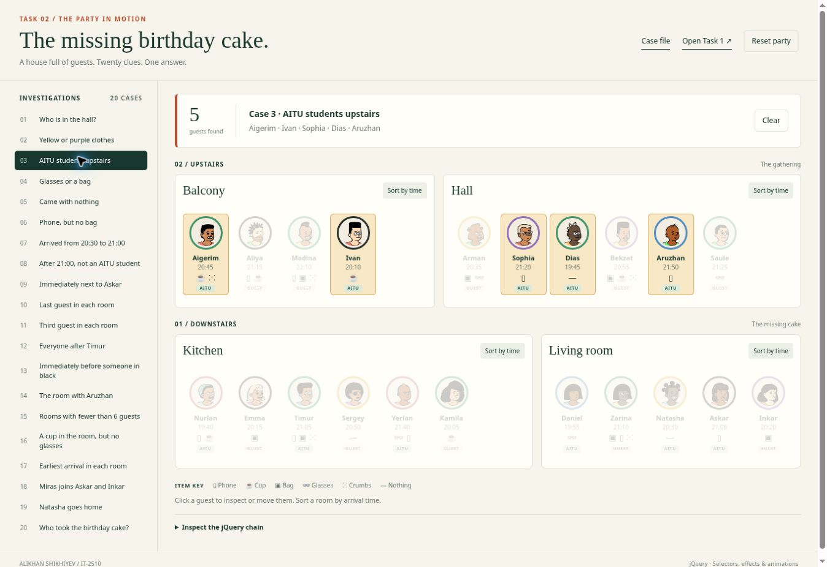
Figure 21. Case 3 keeps the five upstairs AITU students bright.

Animation excerpt
$('.guest').not($connected).stop(true, false).fadeTo(300, 0.2);
// Clear
Party.finishCase();
$('#house .guest').fadeTo(300, 1);

Task 2 guest details
A guest click starts the detail panel at the avatar’s position and size. jQuery animates it to its full dimensions in the center of the viewport. Esc, the close button or an outside click shrinks the panel back to the avatar. A new guest request closes the current panel before opening the latest requested guest.
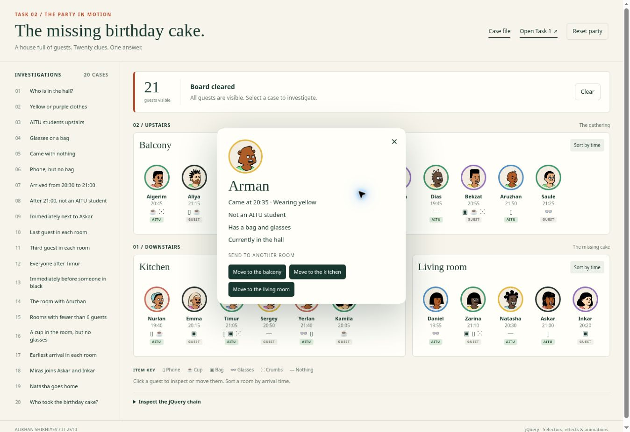
Figure 22. Arman’s card describes his time, clothing, student status and items.

Animation excerpt
$panel.stop(true, false).animate({
left: ($(window).width() - width) / 2,
top: Math.max(14, ($(window).height() - height) / 2),
width: width, height: height
}, 260);

Task 2 moving guests
A move immediately updates both room arrays. A clone flies from the old coordinates to the destination, while two temporary slots close the old gap and open the new gap. Completion replaces the destination slot with the real card and removes the clone. If another action interrupts the move, finishMove settles that move exactly once.
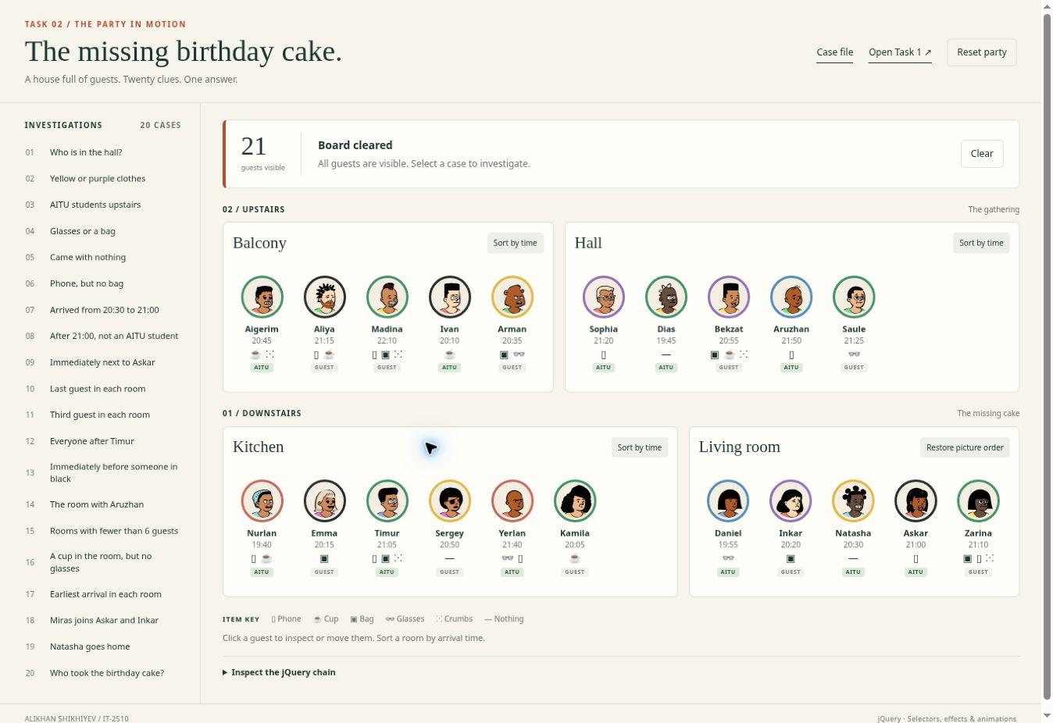
Figure 23. Arman is at the end of the balcony and no longer in the hall.

Animation excerpt
$oldSlot.animate({ width: 0 }, 500);
$newSlot.animate({ width: width }, 500);
$flight.animate({
left: end.left - $(window).scrollLeft(),
top: end.top - $(window).scrollTop()
}, 500, finishMove);
After moving Arman, case 1 returned Sophia, Dias, Bekzat, Aruzhan and Saule. This confirms that rebuilding the DOM preserved his new room.

Task 2 sorting and fast clicks
The sort button toggles between ascending arrival time and the baseline room order. The code records current card positions, changes DOM order, offsets each card back to its old visual position, and animates the offsets to zero. A new click stops the old motion and starts from the current positions. Every click toggles the logical state, so five rapid clicks from the original order end in the sorted order.
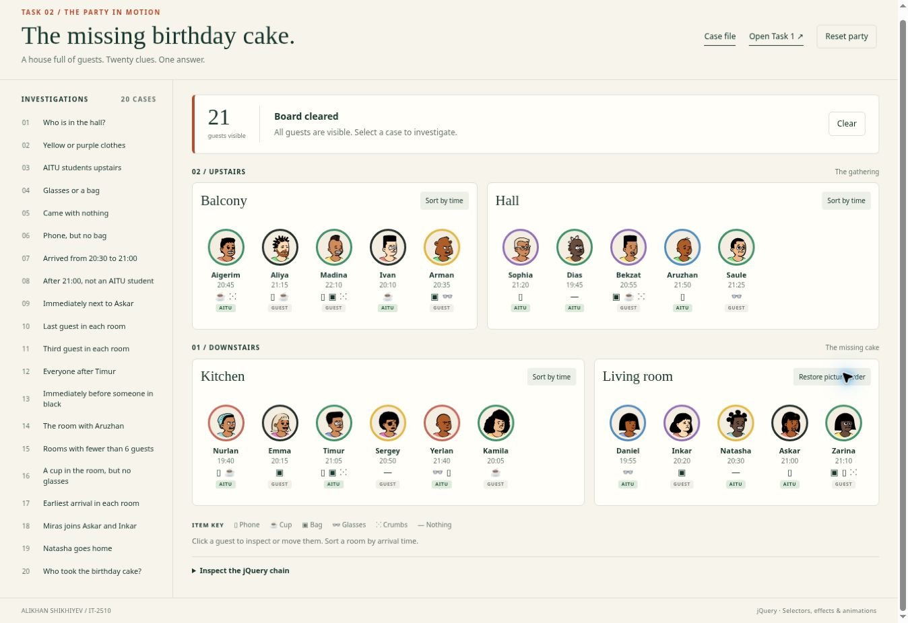
Figure 24. The living room is sorted by arrival time.

Animation excerpt
$(this).css({
left: before.left - after.left,
top: before.top - after.top
}).animate({ left: 0, top: 0 }, { duration: 450, queue: 'layout' })
.dequeue('layout');
The sorted living room times are 19:55, 20:20, 20:30, 21:00 and 21:10. The next click restores Daniel, Zarina, Natasha, Askar and Inkar. Moved guests are appended to the updated baseline order of their destination.

Verification and conclusion
The screenshots and table record the original Chrome checks against the assignment picture. The revised code also has repeatable DOM regression checks at dist/tests/index.html, including rapid removal, Clear, sorting and movement. DOM checks do not verify the visual flight path.
Check | Observed result | Status
All 20 cases | All displayed counts and names match the original party. | Pass
Case 3 and Clear | Five upstairs AITU students remain bright; Clear restores opacity 1. | Pass
Guest and Esc | One detail card opens; Esc removes it after the closing effect. | Pass
Switch guest and outside click | The latest requested guest is shown in one panel; clicking outside closes it. | Pass
Move Arman to balcony | Arman is appended to the balcony; a later case 1 excludes him. | Pass
Sort living room twice | Times become 19:55, 20:20, 20:30, 21:00, 21:10; the next click restores picture order. | Pass
Five rapid sort clicks | The room ends in ascending arrival order. | Pass
Natasha removal in Task 2 | Natasha is removed and the remaining 20 guests have opacity 0.2. | Pass

State and animation decisions
Each case rebuilds from the current room array. Moves persist between cases within the page session. Cases 18 and 19 are temporary scenario changes; the next case resets them from that array. Sorting preserves the array so it can restore baseline order. Reset party reloads the original data.
finishCase uses .finish() to complete the entire case queue, including Natasha’s removal callback, before Clear, sort or move. Sorting uses a separate layout queue so retargeting a slide cannot cancel removal or spotlight effects. A version counter rejects stale callbacks; the detail panel keeps only the latest request. A moved Miras is removed from every room array before being stored once in his destination.

Conclusion
The main takeaway is that selectors describe sets of elements, while traversal describes relationships between them. State must be updated alongside visible movement or the next render will undo it. Animation callbacks and queue control are needed to make repeated clicks produce a predictable final state. The detective cases connect these ideas: the final DOM query identifies Zarina by combining location, time, items and immediate neighbors.

References and asset credits
Assignment 6 jQuery Selectors Effects Animations, supplied assignment brief.
jQuery API: https://api.jquery.com/animate/ and https://api.jquery.com/stop/
jQuery effects and traversal: https://api.jquery.com/category/effects/ and https://api.jquery.com/category/traversing/
Open Peeps by Pablo Stanley, CC0: https://www.dicebear.com/styles/open-peeps/

