Git / Github setup for MATH 343

You are assumed to be taking or have taken 342W in which case you (1) have git installed (2) have a github account (3) generated SSH keys and uploaded the public key to your github account settings (4) have a repository for 342W. You will have little to do here but clone the 343 class materials and create your own 343 repository.

You can close the 343 repository by logging into github, then visiting <https://github.com/kapelner/QC_MATH_343_Spring_2024>. When there, click the green code button and choose “SSH” then use the copy button on the right:

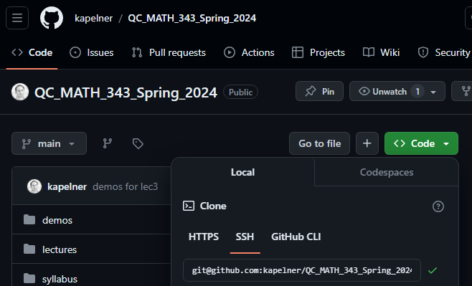

Now go to your terminal which is in the folder of your class materials and run

git clone [paste]

where if pastes successfully should yield the following command

git@github.com:kapelner/QC_MATH_343_Spring_2024.git

Press enter to run. If it complains “are you sure…” just type “yes”.

Now we can create your own class repository. Go to github.com and click the green new button:

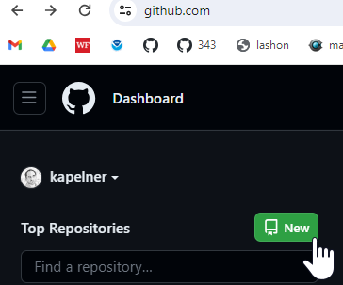

Under “repository name” type “QC_MATH_343”. Then click the “private” button (we will do this for now to prevent cheating). Then check the box “Add a README”. That checkbox is required as otherwise you won’t be able to clone. Your screen should look like:

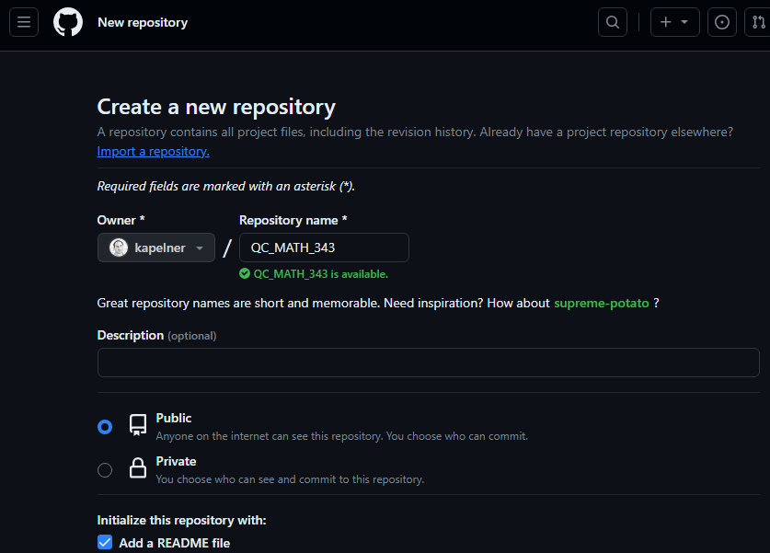

On the bottom, click the green “Create Repository” button. You should now be taken to the repository homepage. As before, we want to clone it. So click the green “Code” button and then the SSH option and click the copy button until you see the green check mark:

Now let’s clone it. Go back to your main directory where you want to store your files for me that’s done by typing the following in the terminal:

cd ~/workspace

Now we clone, type the following

git clone [paste]

For [paste] you’ll press ctrl + v to paste your ssh link that you just copied from your repo page. My link is “git@github.com:kapelner/QC_MATH_343.git” but yours will be different as your username will replace my username, “Kapelner”.

Now you will have that folder on your computer. Verify it with file explorer. Now we navigate into the folder

cd QC_MATH_343

You can now create directories for your assignments:

mkdir homeworks

mkdir labs

Now we’ll copy the lab assignment from my class repository into your repository

cp ../QC_MATH_343_Spring_2024/labs/lab01.Rmd labs/

We will now add this file to your repository by running

git add .

You can make sure lab01.Rmd is added by running

git status

You should see it listed in green. The “status” commands tells you if anything has changed.

Now we will commit this file. Always write comments that make sense.

git commit -am “added lab01 assignment”

For some reason the quotes don’t copy well from Microsoft Word. Another thing Microsoft gets wrong. So type the command yourself manually if it didn’t work.

Now we’re ready to push these commits to github via

git push

Now if you refresh your github page you’ll see the new directory:

In the future, you’ll repeat this git add, git commit, git push sequence for each new assignment. For the theory homeworks, you’ll add the PDF of your scanned homework to the homeworks directory and name it “hw0x.pdf”. Follow instructions so we can grade your homeworks and labs without searching for them!

The last step is to add me as a collaborator on your private repo. This allows us to access your files and grade your assignments. If you don’t do this, you will obviously not get credit for any of your homeworks. On the QC_MATH_343 repository page, click “Settings” and then on the left menu, click “Collaborators”

Now it will ask for your password again. Then click the green “Add People” button. You’ll type in “kapelner” for me and click my account when it comes up. Then click “Add kapelner to this repository”.

You should see kapelner as “pending Invite”.

Congrats you’re now al set up!