Git / Github setup for MATH 343

You are assumed to be taking or have taken 342W in which case you (1) have git installed (2) have a github account (3) generated SSH keys and uploaded the public key to your github account settings (4) have a repository for 342W. If you haven’t done this yet, please visit the MATH 342 homepage and follow the directions there.

You will have little to do here but clone the 343 class materials and create your own 343 repository. Go to github.com, login to your account and then click the green new button:

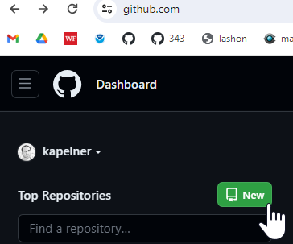

Under “repository name” type “QC_MATH_343”. Then click the “private” button (we will do this for now to prevent cheating). Then check the box “Add a README”. That checkbox is required as otherwise you won’t be able to clone. Your screen should look like:

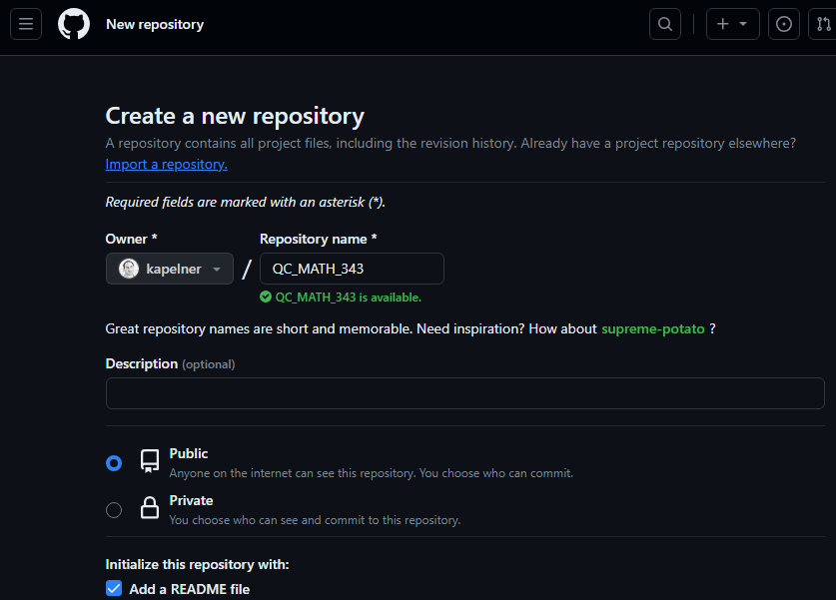

On the bottom, click the green “Create Repository” button. You should now be taken to the repository homepage. As before, we want to clone it. So click the green “Code” button and then the SSH option and click the copy button until you see the green check mark:

Now let’s clone it. Go back to your main directory where you want to store your files. Now we clone, type the following

git clone [paste]

For [paste] you’ll press ctrl + v (or cmd + v or shift + ins) to paste your ssh link that you just copied from your repo page. My link is “git@github.com:kapelner/QC_MATH_343.git” but yours will be different as your username will replace my username, “kapelner”.

Now you will have that folder on your computer. Verify it with file explorer. Now we navigate into the folder

cd QC_MATH_343

You can now create directories for your assignments:

mkdir homeworks

mkdir labs

Now you can download the lab assignment from the course homepage and move it into QC_MATH_343/labs and then you can git add ., git commit and git push. For homeworks, add to the homeworks subdirectory and do the same.

The last step is to add me as a collaborator on your private repo. This allows us to access your files and grade your assignments. If you don’t do this, you will obviously not get credit for any of your homeworks. On the QC_MATH_343 repository page, click “Settings” and then on the left menu, click “Collaborators”

Now it will ask for your password again. Then click the green “Add People” button. You’ll type in “kapelner” for me and click my account when it comes up. Then click “Add kapelner to this repository”.

You should see kapelner as “pending Invite”.

Congrats you’re now all set up!