Standard Deck of Cards - 52 Cards (no Jokers)

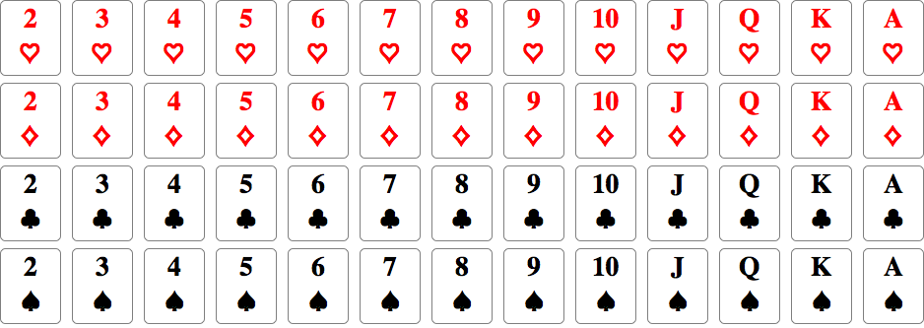

Top two rows (hearts and diamonds) are colored red.

Bottom two rows (clubs and spades) are colored black.