STEP-BY-STEP SOLUTION

Task 1— Create the Project Structure

Goal
Create separate directories for Terraform and Ansible, matching the assignment's intended structure, adapted for AWS instead of Azure.

Steps
- Create the mini-finance project directory with terraform/ and ansible/ subfolders.
- Copy your existing, simpler AWS EC2 Terraform file(s) into terraform/.
- Create the Ansible files (inventory.ini, site.yml).
- Create README.md and .gitignore.
- Verify the structure.

Commands
Step 1: Create the mini-finance project directory with terraform/ and ansible/ subfolders.
cd ~
mkdir -p mini-finance/terraform mini-finance/ansible
cd mini-finance
touch ansible/inventory.ini ansible/site.yml
Screenshot shows files structure created
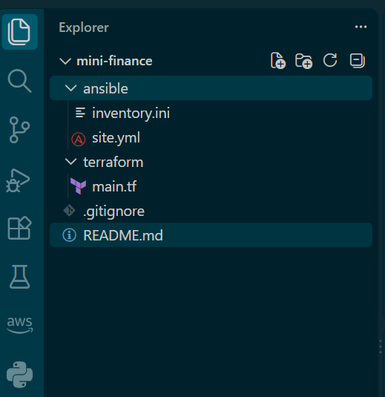
Step 2: Create README.md and .gitignore.
touch README.md .gitignore

Step 3: files to .gitignore. (Paste on your terminal)
cat > .gitignore << 'EOF'
.terraform/
*.tfstate
*.tfstate.*
*.tfplan
crash.log
crash.*.log
*.pem
*.key
EOF
Screenshot shows .gitignore created
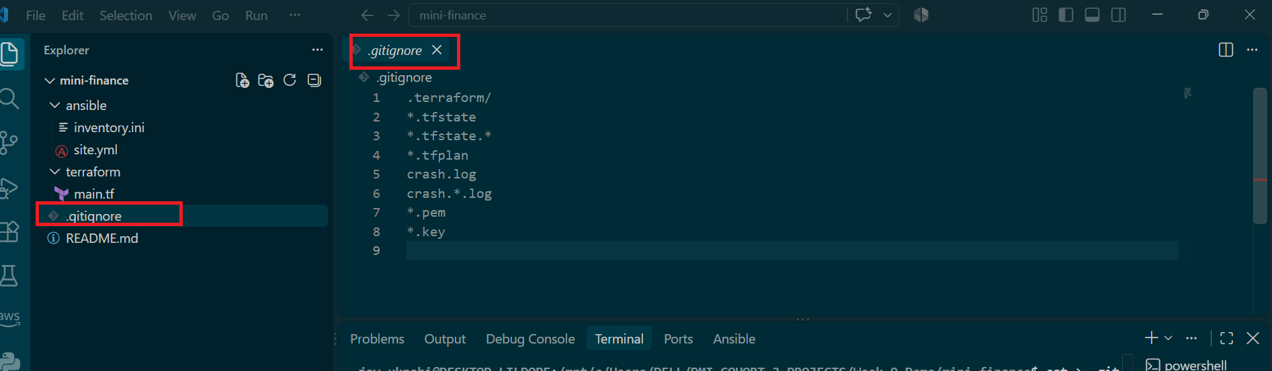

Screenshot shows main.tf created
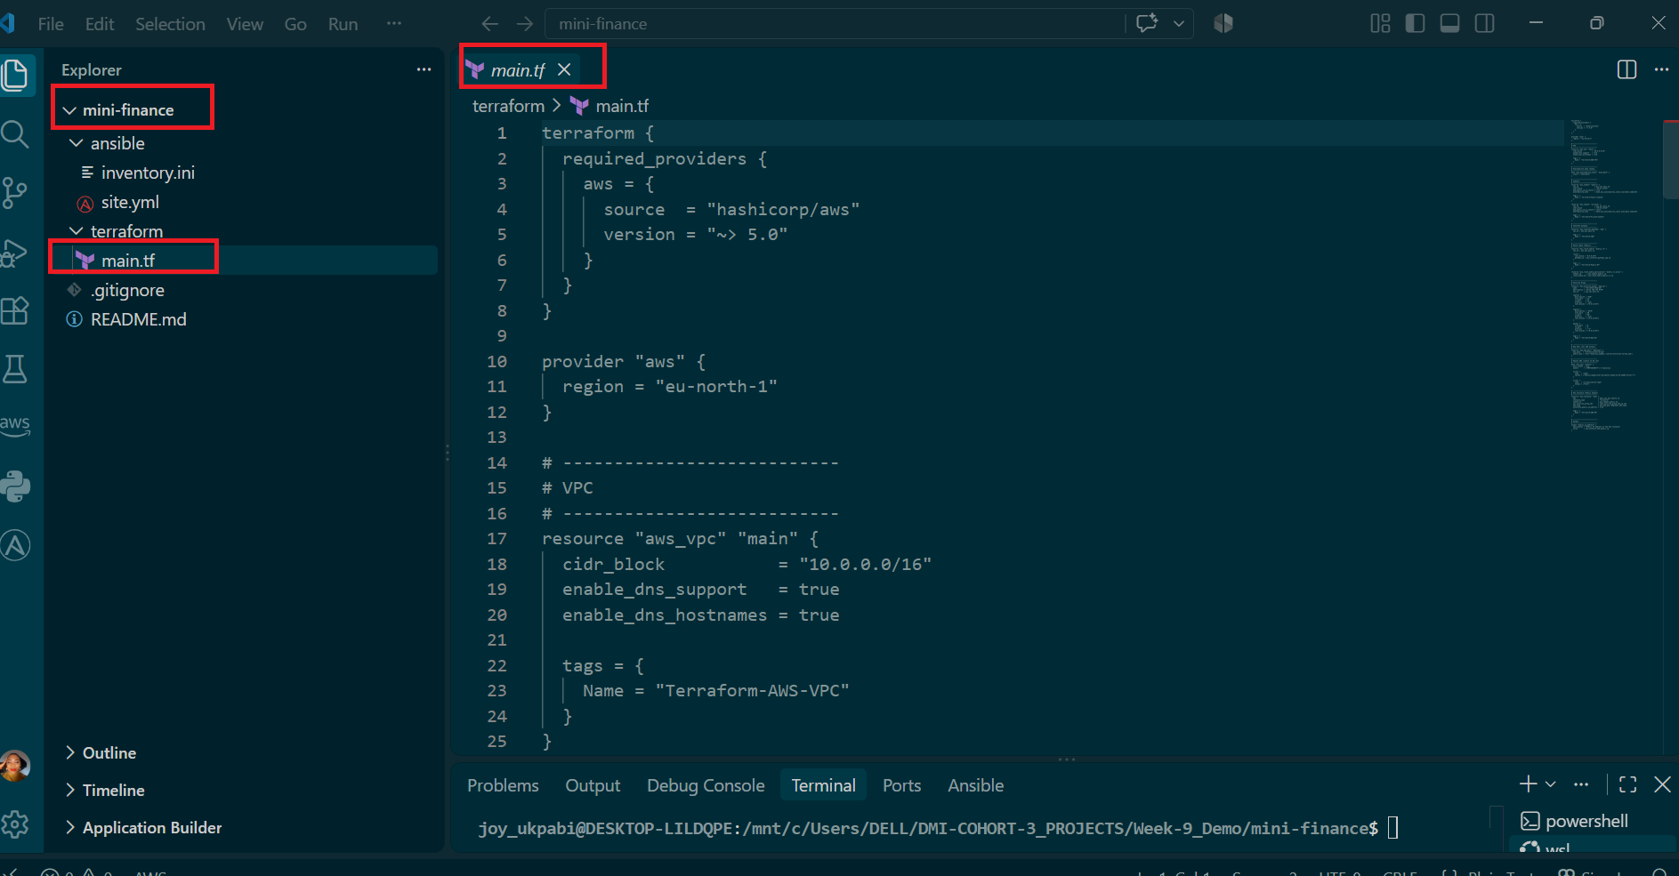
Now let's bring in your existing EC2 Terraform file. Where is it currently located? Paste back either:
- The full path to the existing .tf file(s), so we can cp/rsync them in, or
- Just paste the file content directly here, and I'll help you place it correctly in terraform/
Once that's in, we'll verify the structure with:
find . -maxdepth 2 -type f | sort
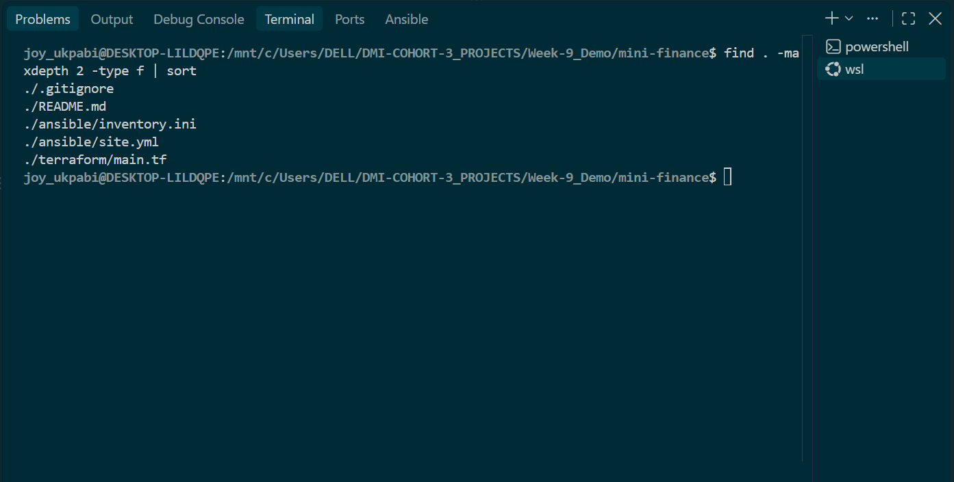

Task 2 — Create the AWS Infrastructure Using Terraform

Goal
Use Terraform to provision an Ubuntu EC2 instance with the required AWS networking and security resources — a VPC, public and private subnets, an Internet Gateway, a route table, a security group, and SSH key authentication — reusing a previously tested Terraform configuration rather than writing it from scratch.

Steps
- Navigate to the terraform directory inside the new project.
- Create new terraform configuration files or Bring in your existing, tested EC2 Terraform configuration (main.tf), excluding any prior state files so this project starts as a genuinely new deployment.
- Add an outputs.tf file exposing the values later tasks depend on, most importantly a public_ip output.
- Add a variables.tf file for reusable input values, and wire main.tf to reference those variables rather than hardcoding values directly.
- Confirm the SSH key referenced by the configuration actually exists on the controller.
- Save all Terraform files.
Important Note
If you already have a tested EC2 Terraform configuration, copy it into this project's /terraform folder rather than writing a new one.
Step 1: Set your paths:
OLD=/mnt/c/Users/<YourWindowsUsername>/<YourEC2ProjectFolder>
NEW=/mnt/c/Users/<YourWindowsUsername>/<YourProjectsFolder>/<WeekFolder>/mini-finance/terraform

IMPORTANT NOTE: Replace <YourWindowsUsername>, <YourEC2ProjectFolder>, <YourProjectsFolder>, and the week folder name with your own actual values. If your project structure doesn't use week folders at all, simply drop that part of the path and adjust accordingly.
If you're unsure of your own exact path, run pwd from inside your existing EC2 Terraform folder — it prints the full current path, which you can copy directly as OLD.
Step 2: Copy the code (excludes state files, so this becomes a fresh, independent deployment):
rsync -av \
--exclude 'terraform.tfstate' \
--exclude 'terraform.tfstate.backup' \
--exclude '.terraform/' \
"$OLD"/ "$NEW"/

Example (mine):
OLD=/mnt/c/Users/DELL/terraform-aws-vm
NEW=/mnt/c/Users/DELL/DMI-COHORT-3_PROJECTS/Week-9_Demo/mini-finance/terraform

rsync -av \
--exclude 'terraform.tfstate' \
--exclude 'terraform.tfstate.backup' \
--exclude '.terraform/' \
"$OLD"/ "$NEW"/

If you don't have existing code to reuse, write your Terraform configuration files (main.tf, variables.tf, outputs.tf) directly in /terraform instead.
Screenshot shows main.tf files added
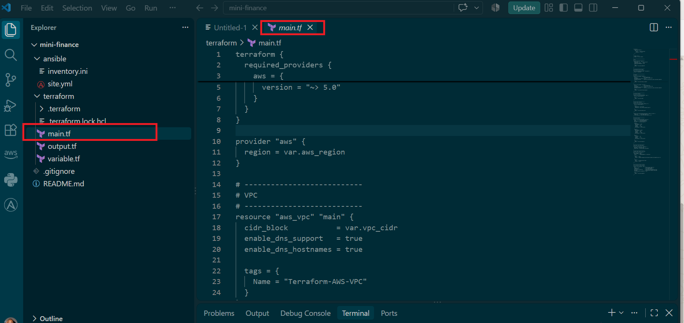

Screenshot shows output.tf files added
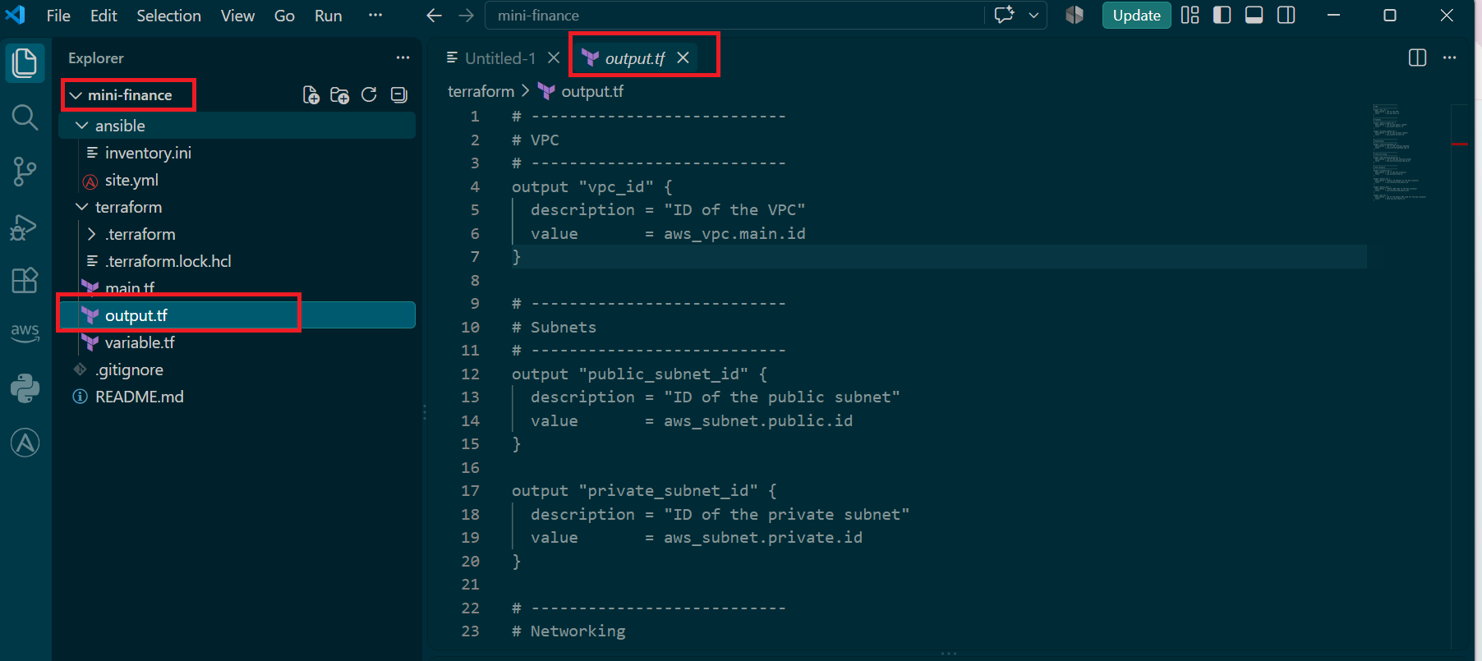

Screenshot shows variable.tf files added
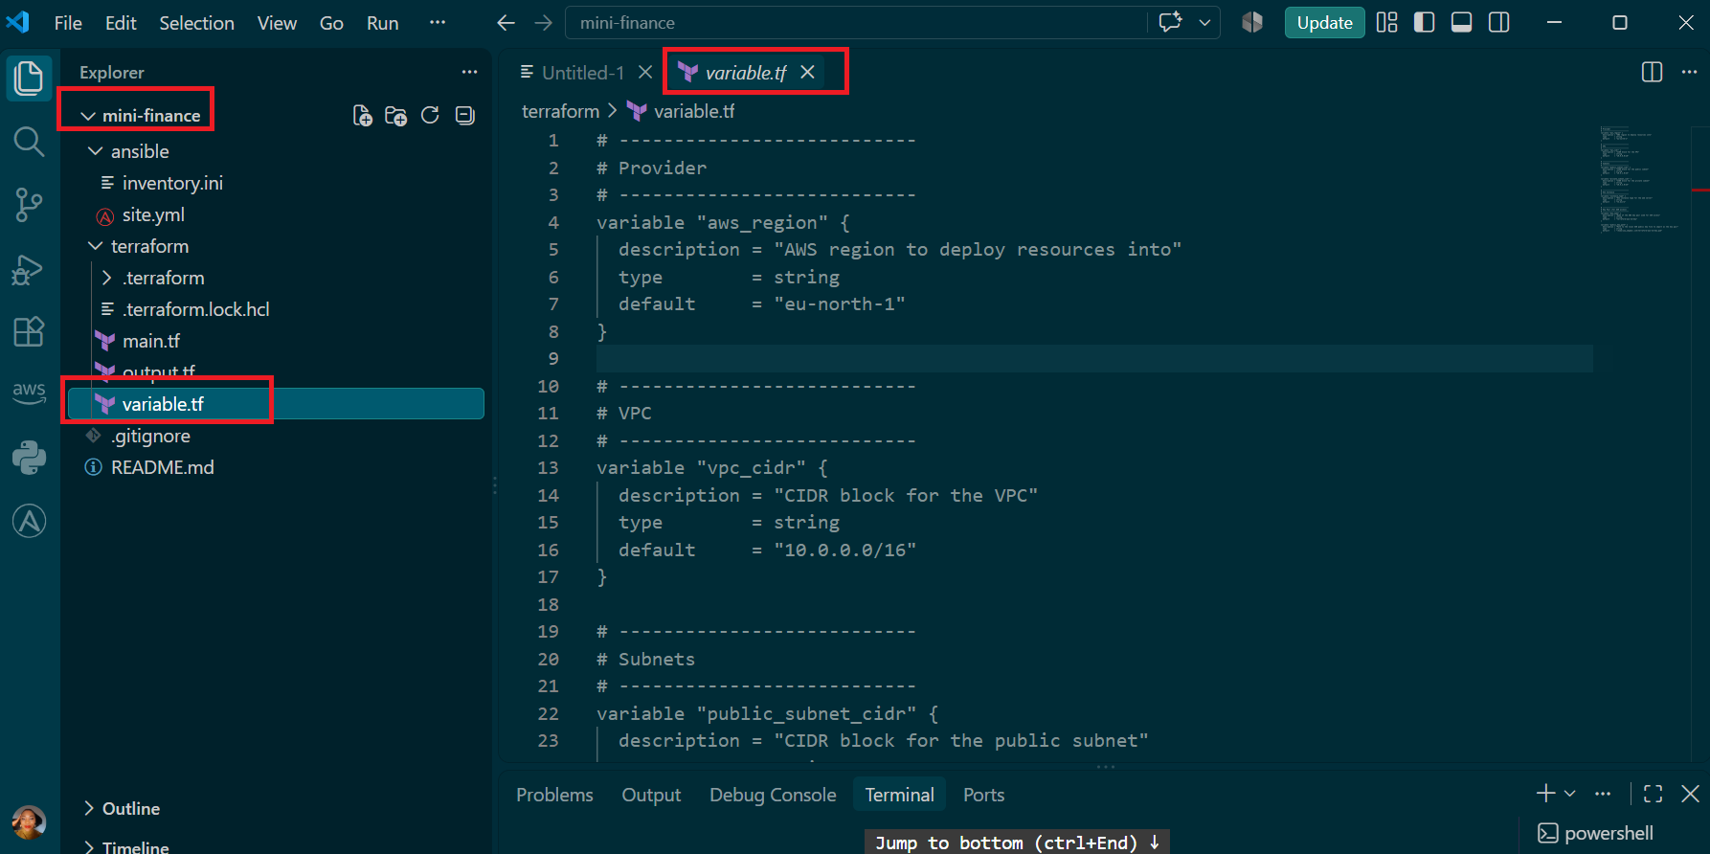

Task 3 — Initialize and Apply the Terraform Configuration

Goal
Format and validate the Terraform configuration, review the execution plan, and provision the Azure infrastructure.

Steps
- Navigate to the terraform directory.
- Format the Terraform configuration.
- Initialize the Terraform working directory.
- Validate the configuration.
- Review the Terraform execution plan.
- Apply the configuration.
- Display the VM’s public IP address.

Commands
Navigate to the Terraform directory:
cd ~/ansible-onboarding/mini-finance/terraform
Format the Terraform files:
terraform fmt
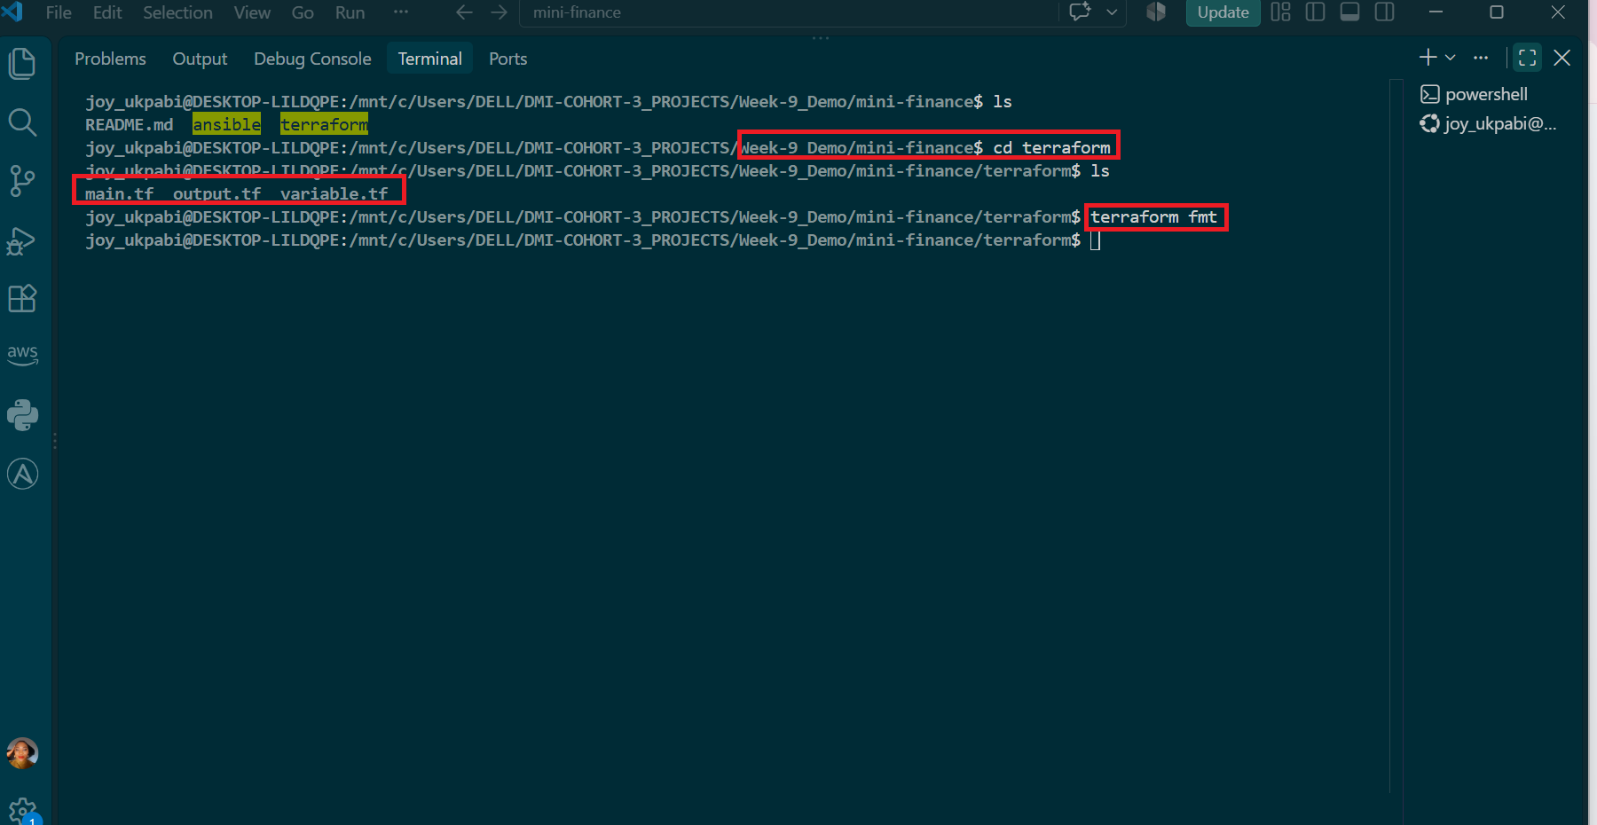
Initialize the Terraform working directory:
terraform init
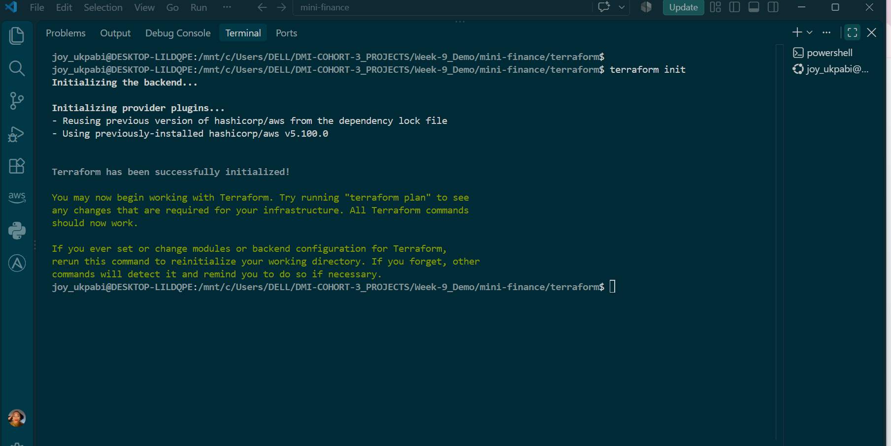
Validate the Terraform configuration:
terraform validate
Review the execution plan:
terraform plan

Carefully review the plan and confirm that Terraform will create only the resources required for this assignment.

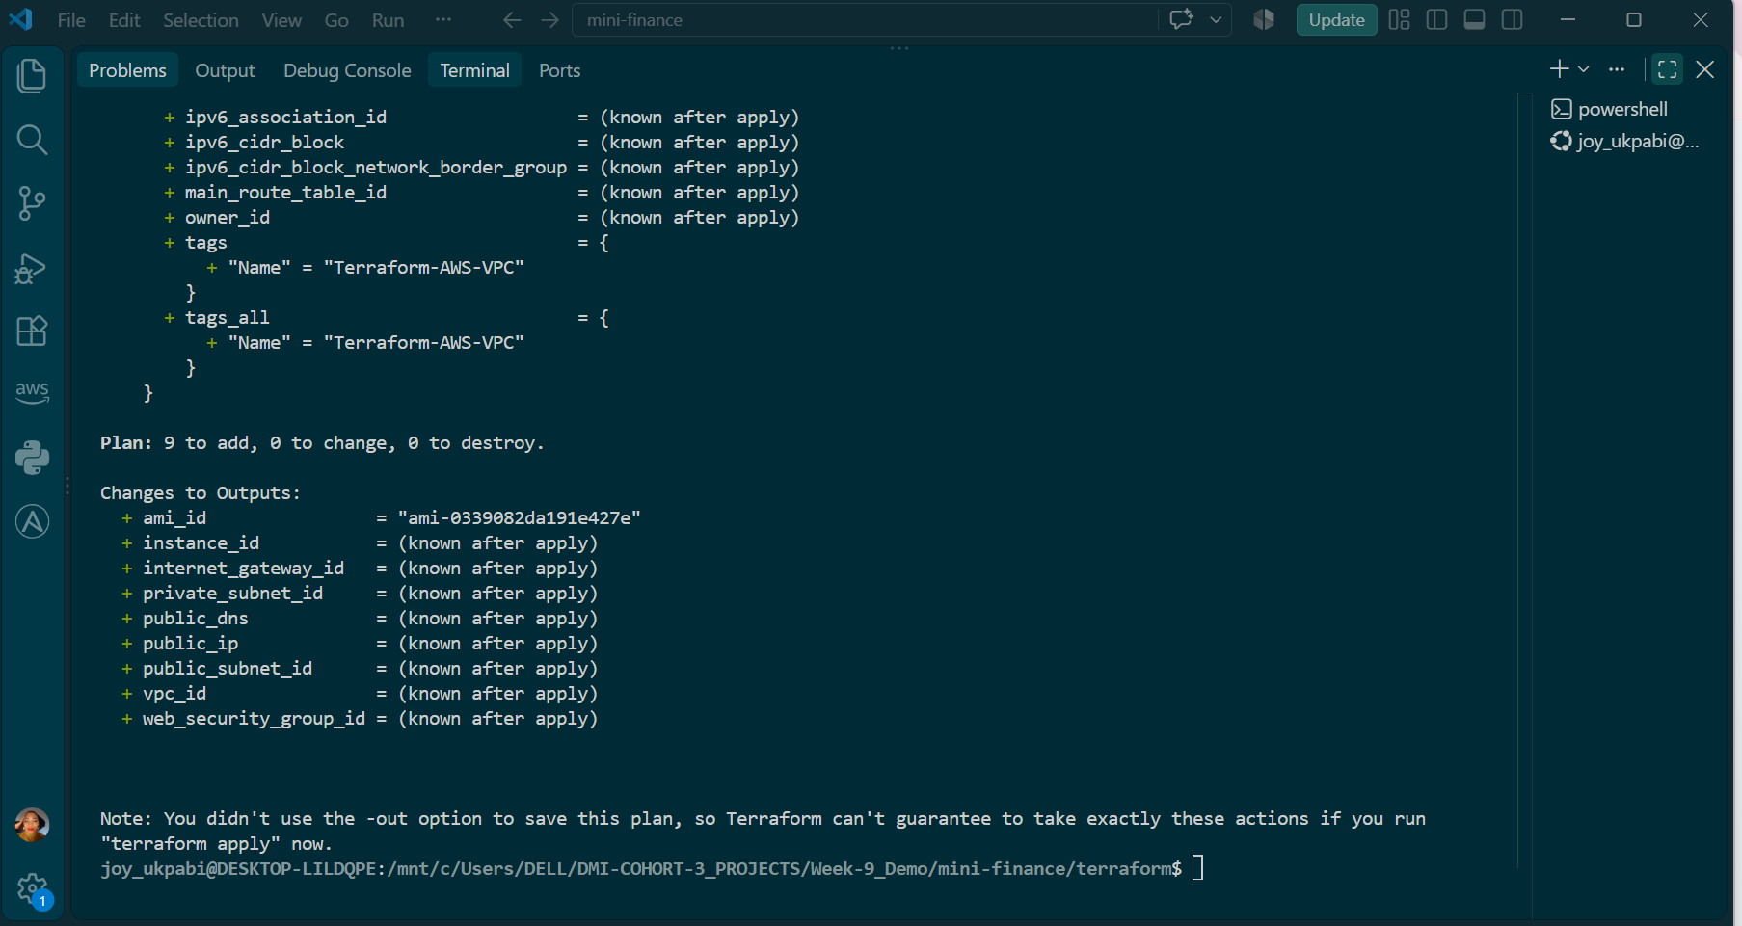

Apply the Terraform configuration:
terraform apply

When Terraform asks for confirmation, enter:
yes
Wait until the deployment is complete.

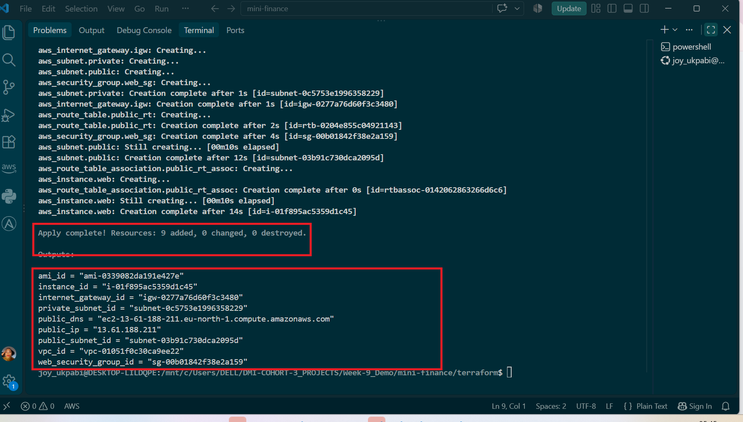
Display the public IP address:
terraform output public_ip
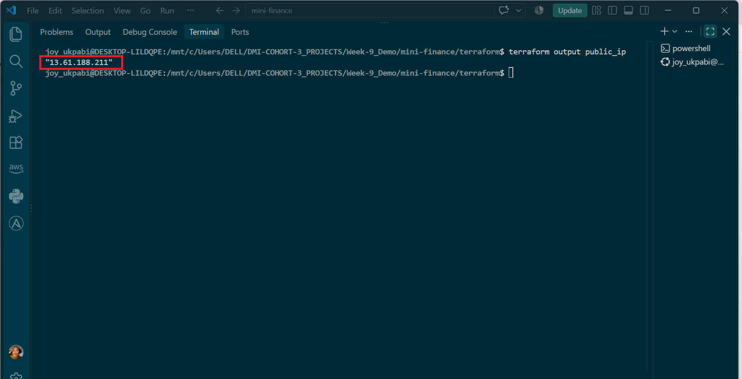

Expected Output
terraform init should complete successfully:
Terraform has been successfully initialized!
terraform validate should confirm that the configuration is valid:
Success! The configuration is valid.
terraform plan should show that Terraform will create the required Azure resources without unexpected deletions or replacements.
terraform apply should finish with an output similar to:
Apply complete! Resources: <number> added, 0 changed, 0 destroyed.
The exact number of resources may vary depending on how you organized the Terraform configuration.
terraform output public_ip should display the public IP address assigned to vm-mini-finance:
- "<PUBLIC_IP_ADDRESS>"
Save this public IP address. You will use it in the SSH, Ansible inventory, and
browser verification tasks.

Task 4 — Verify Passwordless SSH Access

Goal
Confirm that the Ansible controller can connect to the Terraform-provisioned VM using SSH key authentication.

Steps
- Retrieve the VM's public IP from the Terraform output
- Connect to the instance using the matching SSH private key.
- Confirm the VM returns its hostname.
- Confirm no password is requested.

Commands
Step 1: Display the VM’s public IP address if required:
cd ~/ansible-onboarding/mini-finance/terraform
terraform output public_ip

Step 2 : Test passwordless SSH access:
ssh -i ~/.ssh/id_ed25519 azureuser@<PUBLIC_IP> "hostname"
Replace <PUBLIC_IP> with the public IP address displayed by Terraform.

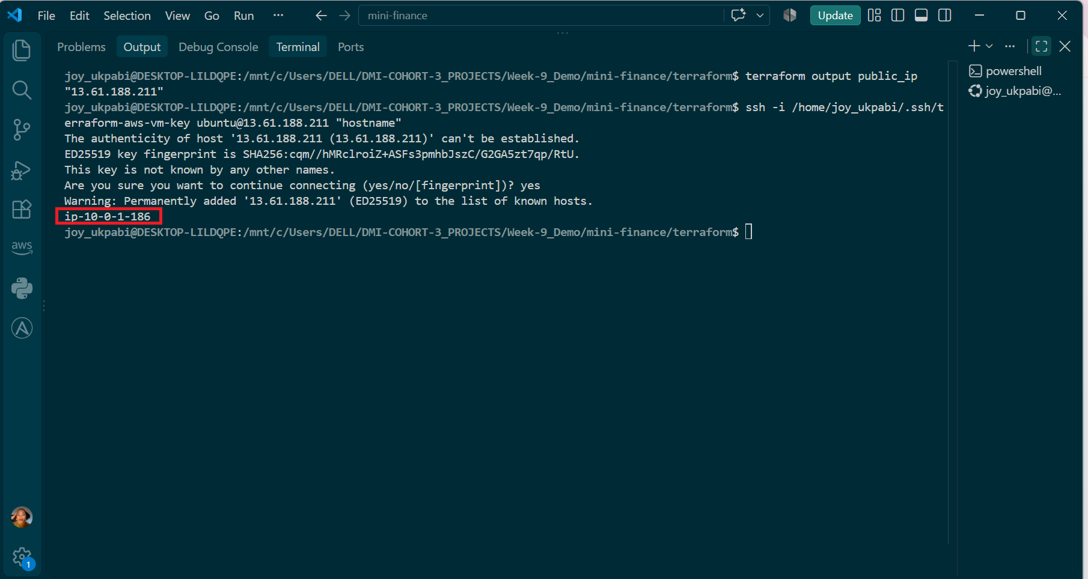
Explanation
The -i flag explicitly points SSH at the private key matching the public key Terraform registered via aws_key_pair.deployer — this key pair is named terraform-aws-vm-key, distinct from both the EpicBook project's key and SSH's default id_ed25519 name, so it must be specified explicitly rather than relying on SSH's automatic key discovery.
A successful connection here — the VM returning its actual hostname with no password requested — confirms the full chain Terraform set up is working correctly: the public key registered with AWS matches the private key on the controller, the security group's SSH rule (currently open to 0.0.0.0/0, per the earlier documented decision) allows the connection, and the instance itself booted correctly with SSH running

Task 5 — Create the Ansible Inventory and Verify Connectivity

Goal
Add the Terraform-provisioned Azure VM to the Ansible inventory and confirm that Ansible can connect to it.

Steps
- Navigate to the ansible directory.
- Open inventory.ini.
- Add the VM’s public IP address under the [web] group.
- Configure the SSH username and private key path.
- Save the inventory.
- Test Ansible connectivity to the VM.

Commands
Step 1: Navigate to the Ansible directory
cd ~/ansible-onboarding/mini-finance/ansible
Step 2: Open the inventory file:
nano inventory.ini
Step 3: Add the following configuration:
- [web]
- <PUBLIC_IP>

- [web:vars]
- ansible_user=azureuser
- ansible_ssh_private_key_file=~/.ssh/id_ed25519
Replace <PUBLIC_IP> with the public IP address displayed by:
Save and exit Nano:
- Press CTRL + O
- Press Enter
- Press CTRL + X
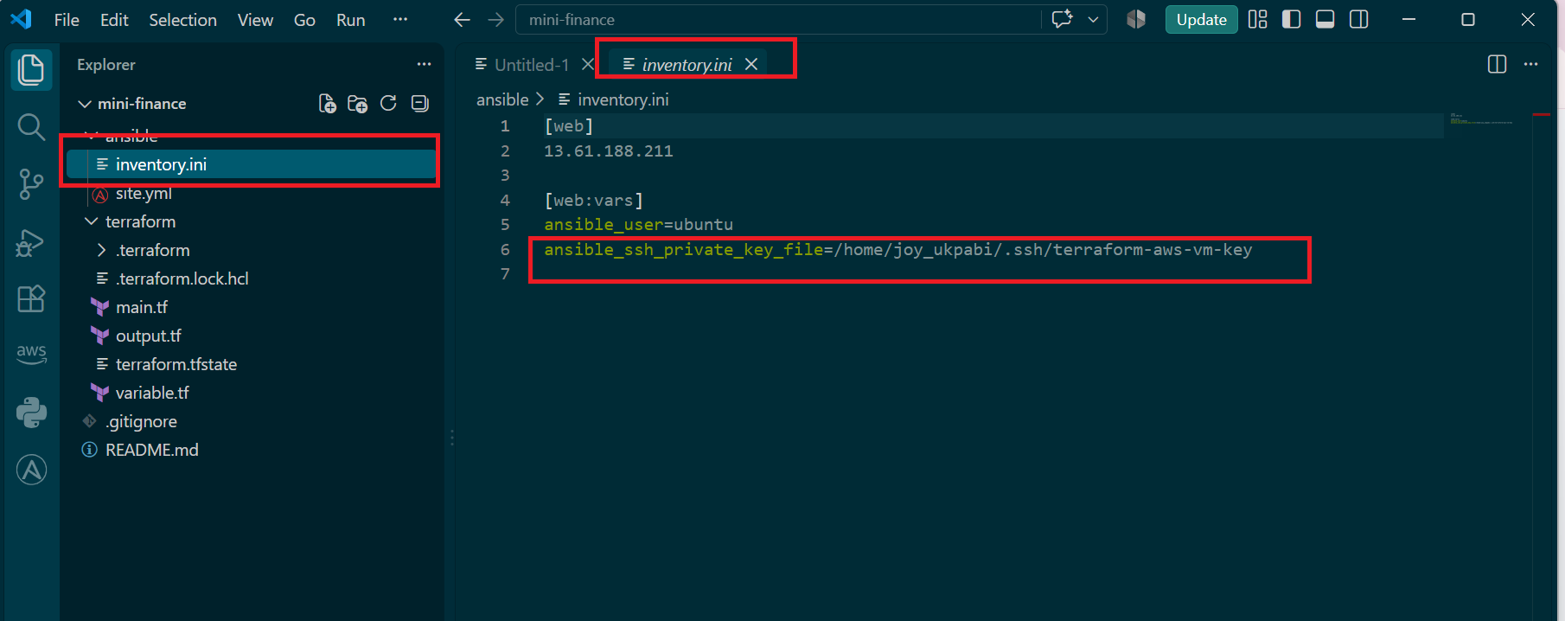
Step 4: Test Ansible connectivity:
ansible web -i inventory.ini -m ping

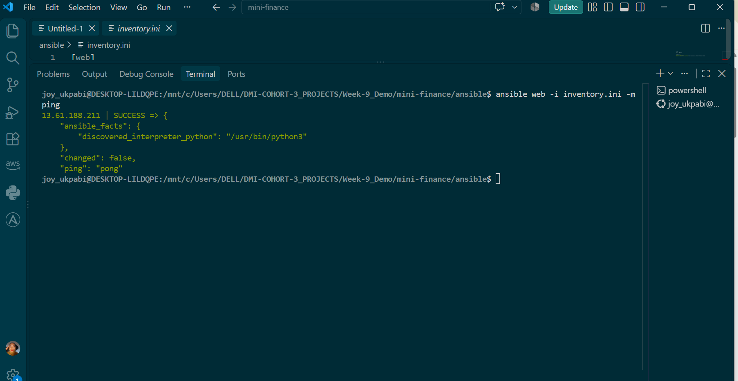

Expected Output
The Azure VM should return SUCCESS and pong:
- <PUBLIC_IP> | SUCCESS => {
- "changed": false,
- "ping": "pong"
- }

Task 6 — Create the Multi-Play Ansible Playbook

Goal
Create one Ansible playbook containing separate plays to install Nginx, deploy the Mini Finance website, and verify the deployment.

Steps
- Navigate to the ansible directory.
- Open site.yml.
- Create the three plays described below.
- Maintain correct YAML indentation.
- Save the file.

Commands
cd ~/ansible-onboarding/mini-finance/ansible
nano site.yml
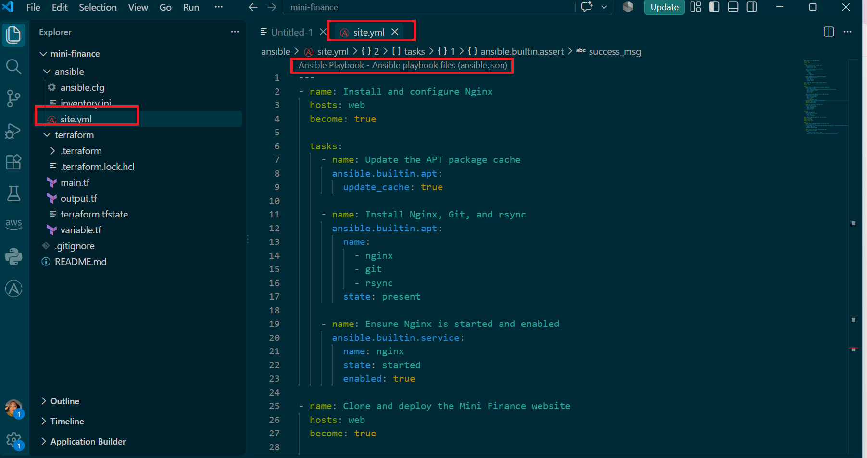

Explanation

Before writing the playbook itself, it helps to understand exactly what each piece is doing and why it's called what it's called.
What is a playbook?
An Ansible playbook is a YAML file that describes a series of automated actions to perform on one or more managed servers. Instead of manually typing commands into each server one at a time, you write down what should happen, and Ansible carries it out for you, consistently, every time. site.yml is simply the name given to this project's playbook — "site" is just a common naming convention (not a required keyword), often used for the main, top-level playbook that sets up an entire server or application.
What is a play?
A single playbook file can contain multiple plays. A play is one self-contained block that says: "On these specific hosts, using these specific settings, run these specific tasks." Each play can target different hosts and behave completely differently from the plays around it. This project's site.yml contains three plays — one targeting the web server to install Nginx, a second (also targeting the web server) to deploy the website, and a third targeting the controller itself (localhost) to verify everything worked. Ansible always runs plays strictly in the order they appear in the file, finishing one completely before starting the next.
What is a task?
Inside each play, a task is one specific action — install a package, start a service, copy a file, send an HTTP request. Each task calls a module (see below) to actually do the work.
What is a module?
A module is a small, purpose-built program that Ansible ships with, each designed to manage one specific kind of thing. Rather than writing raw shell commands yourself, you tell a module what state you want things to end up in, and the module figures out how to get there — including checking whether that state already exists, so it doesn't repeat work unnecessarily. This is why Ansible modules are generally preferred over raw shell commands: they're idempotent by design (safe to run repeatedly) and give clear, structured feedback (ok, changed, failed) about what actually happened.
ansible.builtin.apt — the module that manages packages on Debian/Ubuntu systems (the same family apt install belongs to on the command line). Instead of running apt-get install nginx as a raw shell command, this module checks whether nginx is already installed at the requested state first, and only takes action if it isn't — meaning re-running this task a second time correctly reports ok (no change) rather than blindly reinstalling.
ansible.builtin.service — the module that manages background services (the same job systemctl start/systemctl enable does manually). It can ensure a service is currently running (state: started) and separately ensure it will automatically start again after a server reboot (enabled: true) — two distinct states handled in one task.
ansible.builtin.git — the module that clones or updates a Git repository, equivalent to running git clone or git pull by hand, but done idempotently: if the repository already exists at the destination, it updates it rather than failing or re-cloning from scratch.
ansible.posix.synchronize — a module that wraps the real rsync command-line tool, used for efficiently copying files and directories, especially useful here because it can copy an entire folder structure in one task rather than needing a task per file.
ansible.builtin.file — a general-purpose module for managing file and directory properties: creating them, setting permissions, or (as used here) changing ownership.
ansible.builtin.uri — a module that sends real HTTP requests (GET, POST, etc.) and captures the response, used here purely to check that a web page returns successfully.
ansible.builtin.assert — a module that checks whether a given condition is true, and explicitly fails the playbook with a clear message if it isn't. This is how a playbook can prove something worked, rather than just assuming success because no error was raised elsewhere.
Handlers — a special kind of task that only runs when explicitly triggered (notify) by another task that reports a real change. This is used here so Nginx only reloads its configuration when the website's files were actually updated, not on every single playbook run.
become: true — tells Ansible to run a play's tasks with elevated (root) privileges, necessary here because installing software and writing to /var/www/html/ requires administrator access on the VM.

Task 7 — Validate and Run the Ansible Playbook

Goal
Validate the syntax of the multi-play Ansible playbook and run it to install Nginx, deploy the Mini Finance website, and verify the deployment

Steps
- Navigate to the ansible directory and confirm both inventory.ini and site.yml are present.
- Run the syntax check.
- Run the playbook for real.
- Confirm the final play recap shows failed=0 and unreachable=0.
Command

Step 1 — Navigate to the Ansible Directory
cd ~/ansible-onboarding/mini-finance/ansible
Confirm that the inventory and playbook files are available:
ls -l
The following files should be visible:
inventory.ini
site.yml
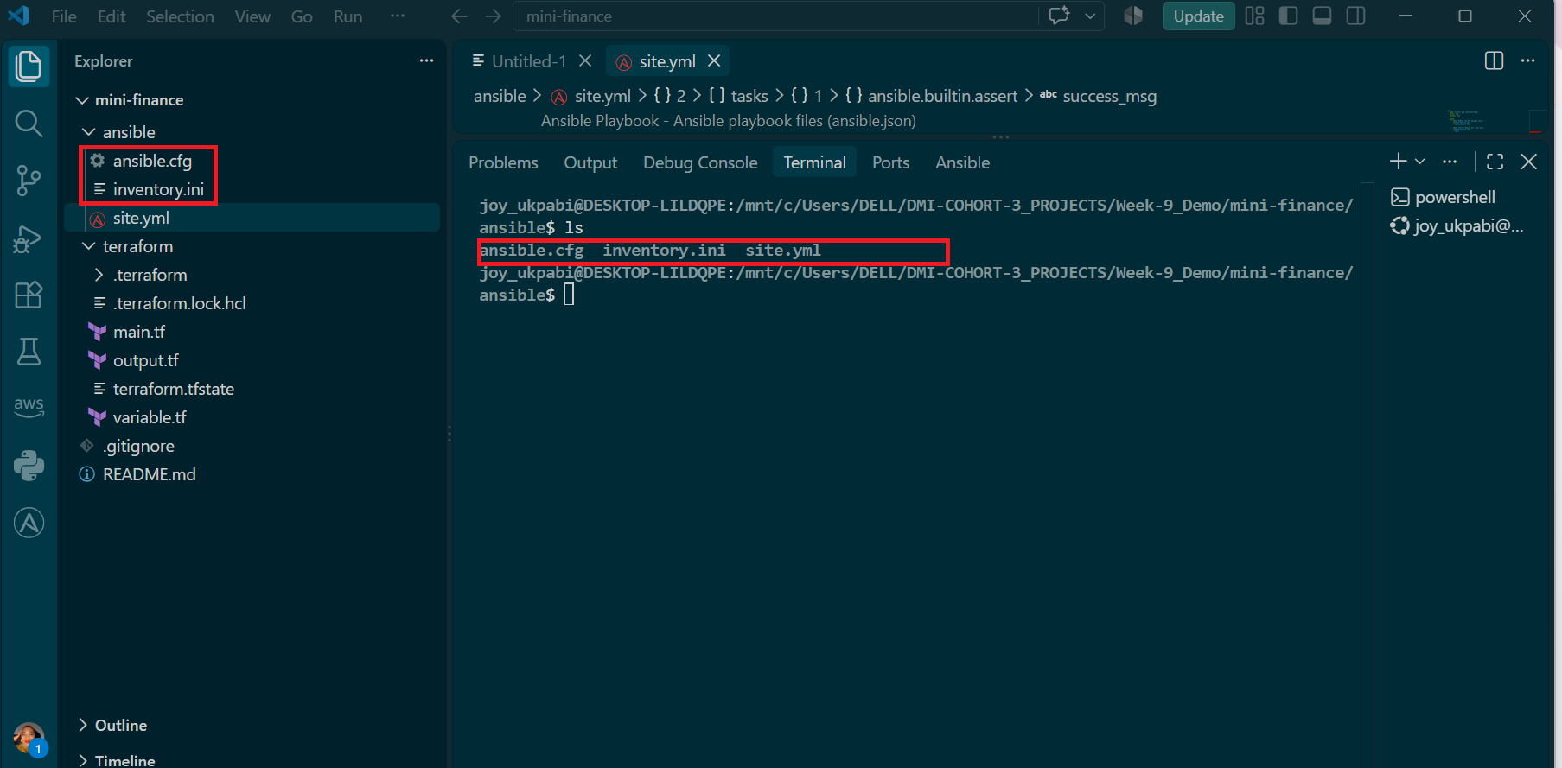

Step 2 — Check the Playbook Syntax
Run:
ansible-playbook -i inventory.ini site.yml --syntax-check

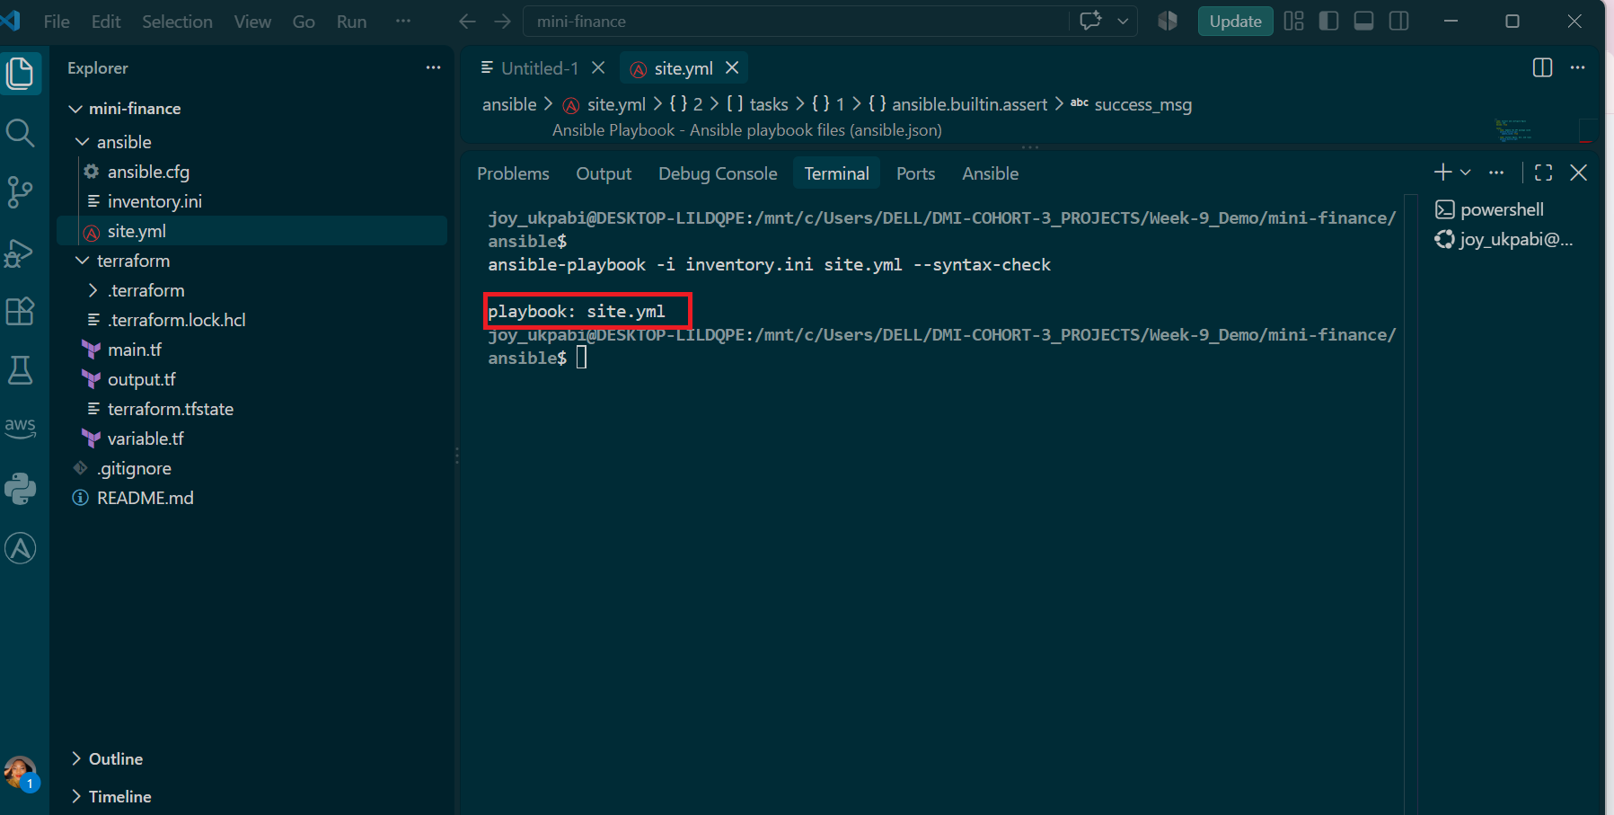

Step 3 — Run the Playbook
Run:
ansible-playbook -i inventory.ini site.yml
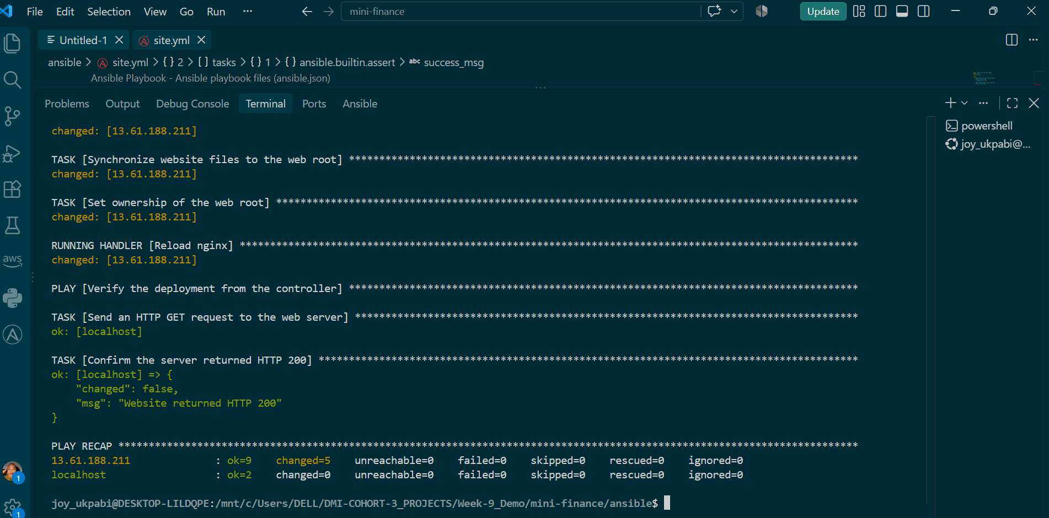

Expected Output
The playbook output should show:
- Play 1 completed successfully.
- Nginx, Git, and rsync installed.
- Nginx started and enabled.
- Play 2 completed successfully.
- Mini Finance repository cloned or updated.
- Website files synchronized to /var/www/html/.
- Nginx reload handler executed when deployment content changed.
- Play 3 completed successfully.
- The HTTP request returned status code 200.
- The assertion completed successfully.
- The final play recap shows:
- failed=0
- unreachable=0
The number of ok and changed tasks may vary depending on whether the playbook has been run previously.

Important Notes
- Run the commands from the ansible directory.
- Ensure the Azure VM is running before executing the playbook.
- Do not continue if the syntax check reports an error.
- If a task fails, read the error message, correct the relevant configuration, and run the playbook again.

Explanation
--syntax-check parses the entire playbook — all three plays, every task, and the handler — confirming the YAML structure and module usage are valid before anything runs for real, without connecting to any server or making changes.
Running the playbook for real executes all three plays in sequence. Play 1 installed and configured Nginx, reporting changed on tasks running for the first time. Play 2 cloned the Mini Finance repository, synchronized its files into /var/www/html/ using ansible.posix.synchronize, and set the correct ownership (www-data:www-data) so Nginx can actually serve the deployed files. Because the synchronize task reported a real content change, the Reload nginx handler correctly fired afterward — this is the notify/handler pattern working exactly as intended: Nginx only reloads when there's genuinely new content to serve, not on every run.
Play 3 is the definitive proof point: it runs entirely from the controller's own perspective (connection: local, targeting localhost), sending a real HTTP request to the deployed site's public IP and explicitly asserting the response is 200 OK. A passing assertion here confirms — independently of the deployment tasks themselves — that the website is genuinely live and reachable, not just that Ansible reported success internally.
The final PLAY RECAP is the definitive summary: failed=0 and unreachable=0 across both the web server and the controller confirms every task in every play completed successfully, with no host ever becoming unreachable during the run — exactly the outcome this task is meant to demonstrate.

Task 8 — Test the Mini Finance Website in a Browser

Goal
Confirm that the Mini Finance website is publicly accessible through the EC2 instance's public IP address, rendering correctly in a real browser.

Steps
- Retrieve the instance's public IP from Terraform's output.
- Open the IP address in a web browser.
- Confirm the website loads with correct content and styling, and that the public IP is visible in the address bar.
