SECTION 1: STEP-BY-STEP SOLUTION

Task 0 — Verify Prerequisites and Environment Setup

Goal
Confirm the Ansible controller (your workstation) has all required tools installed, the AWS CLI is authenticated, an SSH key pair exists for VM access, and the controller's public IP is known — all before provisioning any infrastructure.

Steps
- Activate the existing Python virtual environment used for Ansible.
- Verify Terraform, Ansible, SSH client, and Git are installed.
- Verify AWS CLI is installed and authenticated to the correct account.
- Verify an SSH key pair exists (create one if missing).
- Get the controller's public IP address, which will later be used to restrict SSH access in the security group.

Commands

Step 1 — Activate virtual environment
bash
source ~/ansible-onboarding/.venv/bin/activate

Step 2 — Verify core tools
bash
terraform version
ansible --version
ssh -V
git --version

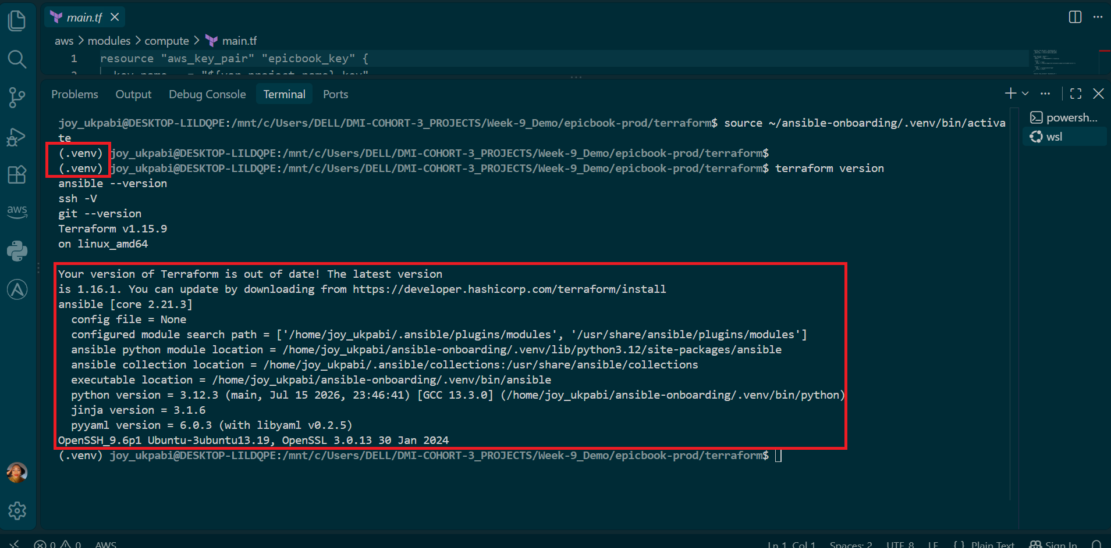

Step 3 — Verify AWS CLI and authentication
bash
aws --version
aws sts get-caller-identity

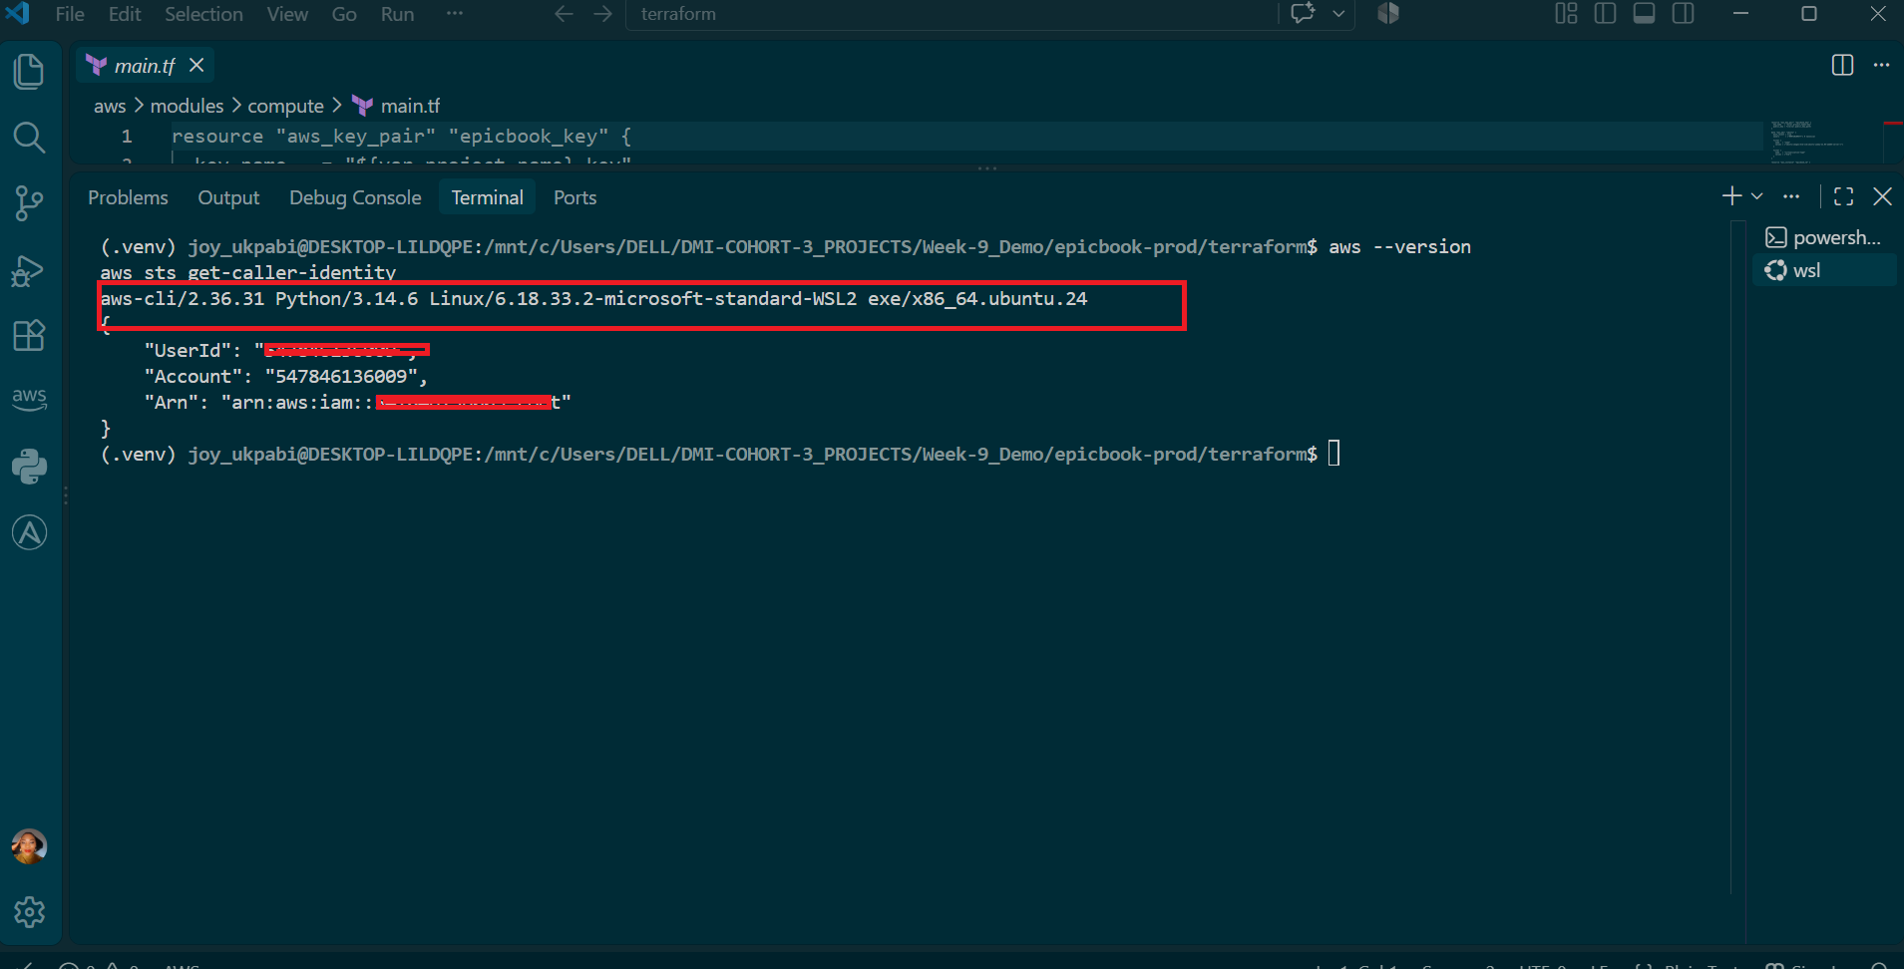

Step 4 — Verify SSH key pair
bash
ls -l ~/.ssh/id_ed25519 ~/.ssh/id_ed25519.pub

If missing, create one:
bash
ssh-keygen -t ed25519 -C "epicbook-capstone"
Step 5 — Get controller public IP
bash
curl -4 ifconfig.me

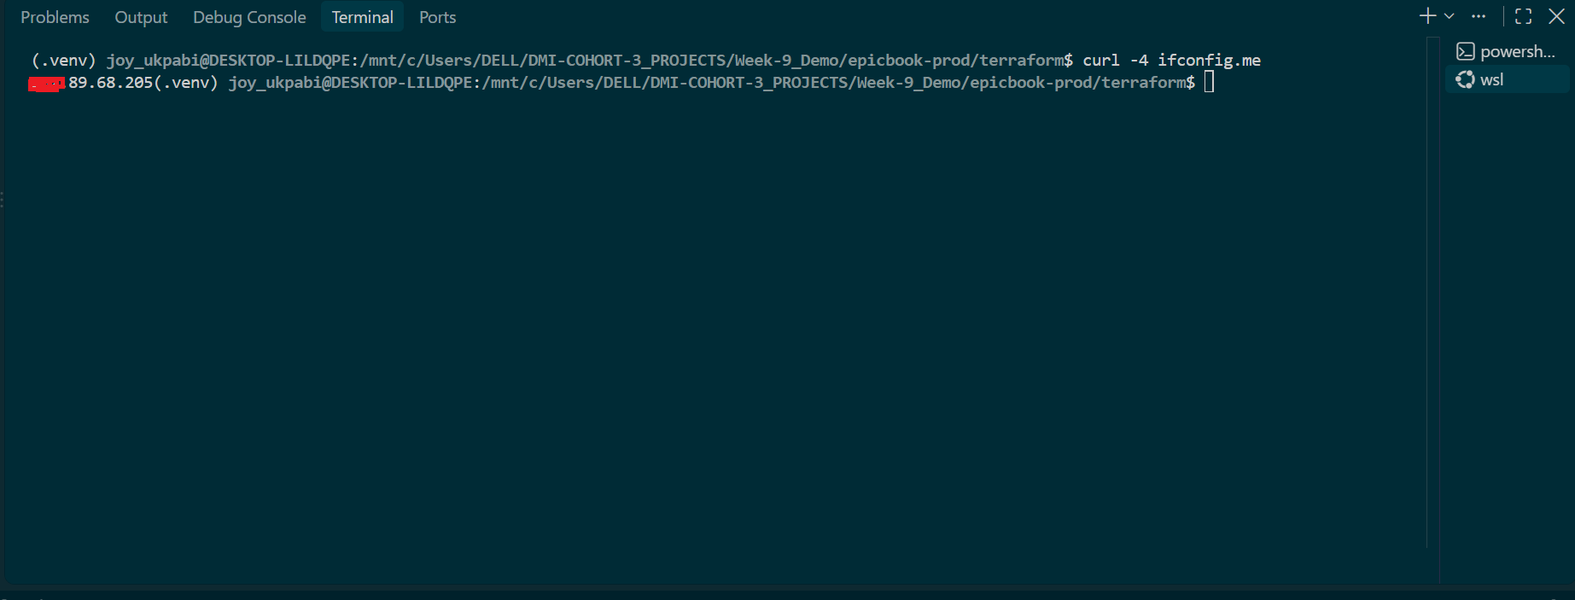

Explanation
Before provisioning any real cloud infrastructure, it's important to confirm the controller itself is correctly set up — otherwise, failures later (during terraform apply or an Ansible playbook run) could be caused by a missing tool or misconfigured credential rather than an actual mistake in the project code, making them much harder to debug.
Verifying Terraform, Ansible, SSH, and Git confirms the core tooling this entire capstone depends on is present and functioning, since every later task calls one of these directly.
Verifying AWS CLI authentication (aws sts get-caller-identity) confirms the controller can actually talk to AWS with valid, active credentials before running terraform apply — catching an expired or missing credential here is a quick fix, whereas discovering it mid-apply can leave partially created resources behind.
Rather than assuming the SSH key path from the assignment's example (~/.ssh/id_ed25519), the actual path was found by searching the Terraform code directly (grep -rn "key" ...). This matters because this project reuses a previously tested Terraform configuration, and that configuration was written to expect a specific key name (epicbook-aws-key) at a specific path, set via the public_key_path variable in terraform.tfvars. Terraform's aws_key_pair resource reads this public key file and registers it with AWS, so if the file doesn't exist at that exact path, terraform apply would fail immediately when trying to create the key pair. Confirming the file exists before running Terraform avoids that failure.
Finally, curl -4 ifconfig.me retrieves the controller's public IP address as seen from the internet. This is required because the assignment mandates that SSH (port 22) on the VM's security group be restricted to only this controller's IP (using a /32 CIDR), rather than left open to the world. This is a real security requirement, not just a formality: leaving port 22 open to 0.0.0.0/0 would expose the VM to SSH brute-force attempts from anywhere on the internet. The -4 flag ensures an IPv4 address is returned, matching the IPv4 CIDR format the security group rule expects.

Task 1 — Set Up the Project Folder Layout

Goal
Create the project folder structure for Terraform and Ansible roles, separating infrastructure provisioning code from configuration management code, and reuse the already-tested Terraform code instead of rewriting it from scratch.

Steps
- Go to your Ansible onboarding workspace.
- Create the epicbook-prod project directory with a terraform/aws subfolder and the Ansible subfolders, including the three role folders (common, nginx, epicbook).
- Copy your previously tested Terraform code used for Epicbook terraform assignment (root files + all four modules) into the new epicbook-prod/terraform/aws folder, excluding state files and provider caches so the new folder starts clean.
- Verify the folder structure and copied files.

Commands

Step 1: Create the Project Folder Structure (Run at once)

cd ~/ansible-onboarding # or your equivalent workspace path

mkdir -p epicbook-prod/terraform/aws
mkdir -p epicbook-prod/ansible/group_vars
mkdir -p epicbook-prod/ansible/roles/common/tasks
mkdir -p epicbook-prod/ansible/roles/nginx/tasks
mkdir -p epicbook-prod/ansible/roles/nginx/templates
mkdir -p epicbook-prod/ansible/roles/epicbook/tasks

Step 2: Copy Your EpicBook Terraform Code (or Write New Configuration Files)
If you already have tested Terraform code from a previous assignment (epicbook deployment) , copy it into this project's /terraform folder rather than rewriting it.

Step 1 Setting Your Own Paths (Set the OLD and NEW variables)
IMPORTANT NOTE: Replace <YourWindowsUsername>, <YourProjectsFolder>, and the week folder names with your own actual values. If your project structure doesn't use week folders at all, simply drop that part of the path and adjust accordingly.
If you're unsure of your own exact path, run pwd from inside your old project folder — it prints the full current path, which you can copy directly as OLD.

Command
OLD=/mnt/c/Users/<YourWindowsUsername>/<YourProjectsFolder>/<OldWeekFolder>/terraform-aws-epicbook
NEW=/mnt/c/Users/<YourWindowsUsername>/<YourProjectsFolder>/<NewWeekFolder>/epicbook-prod/terraform/aws

Example (This is my own):
OLD=/mnt/c/Users/DELL/DMI-COHORT-3_PROJECTS/Week-8_Demo/terraform-aws-epicbook
NEW=/mnt/c/Users/DELL/DMI-COHORT-3_PROJECTS/Week-9_Demo/epicbook-prod/terraform/aws

If you're unsure of your own exact path, run this from inside your old epic book project folder for terraform week assignment, it prints the full current path, copy the path directly as OLD:
pwd

Step 2 — Navigate into your new project's terraform folder
Use your own real path here (not a variable):
cd /mnt/c/Users/DELL/DMI-COHORT-3_PROJECTS/Week-9_Demo/epicbook-prod/terraform/aws

Step 3 — Run the copy ( The command below)
This reuses the $OLD and $NEW variables you already set in Step 1 — no further replacing needed here:
Command
rsync -av \
--exclude 'terraform.tfstate' \
--exclude 'terraform.tfstate.backup' \
--exclude '.terraform/' \
--exclude 'main.tf.old-flat-backup' \
"$OLD"/ "$NEW"/

Note: $OLD and $NEW only exist for the current terminal session. If you close the terminal or open a new one, you'll need to re-run Step 1 before running the copy command again.

Confirm all was created and all files copied in VS code

find "$NEW" -maxdepth 4 -type f | sort

Screenshot shows the old terraform files to be copied
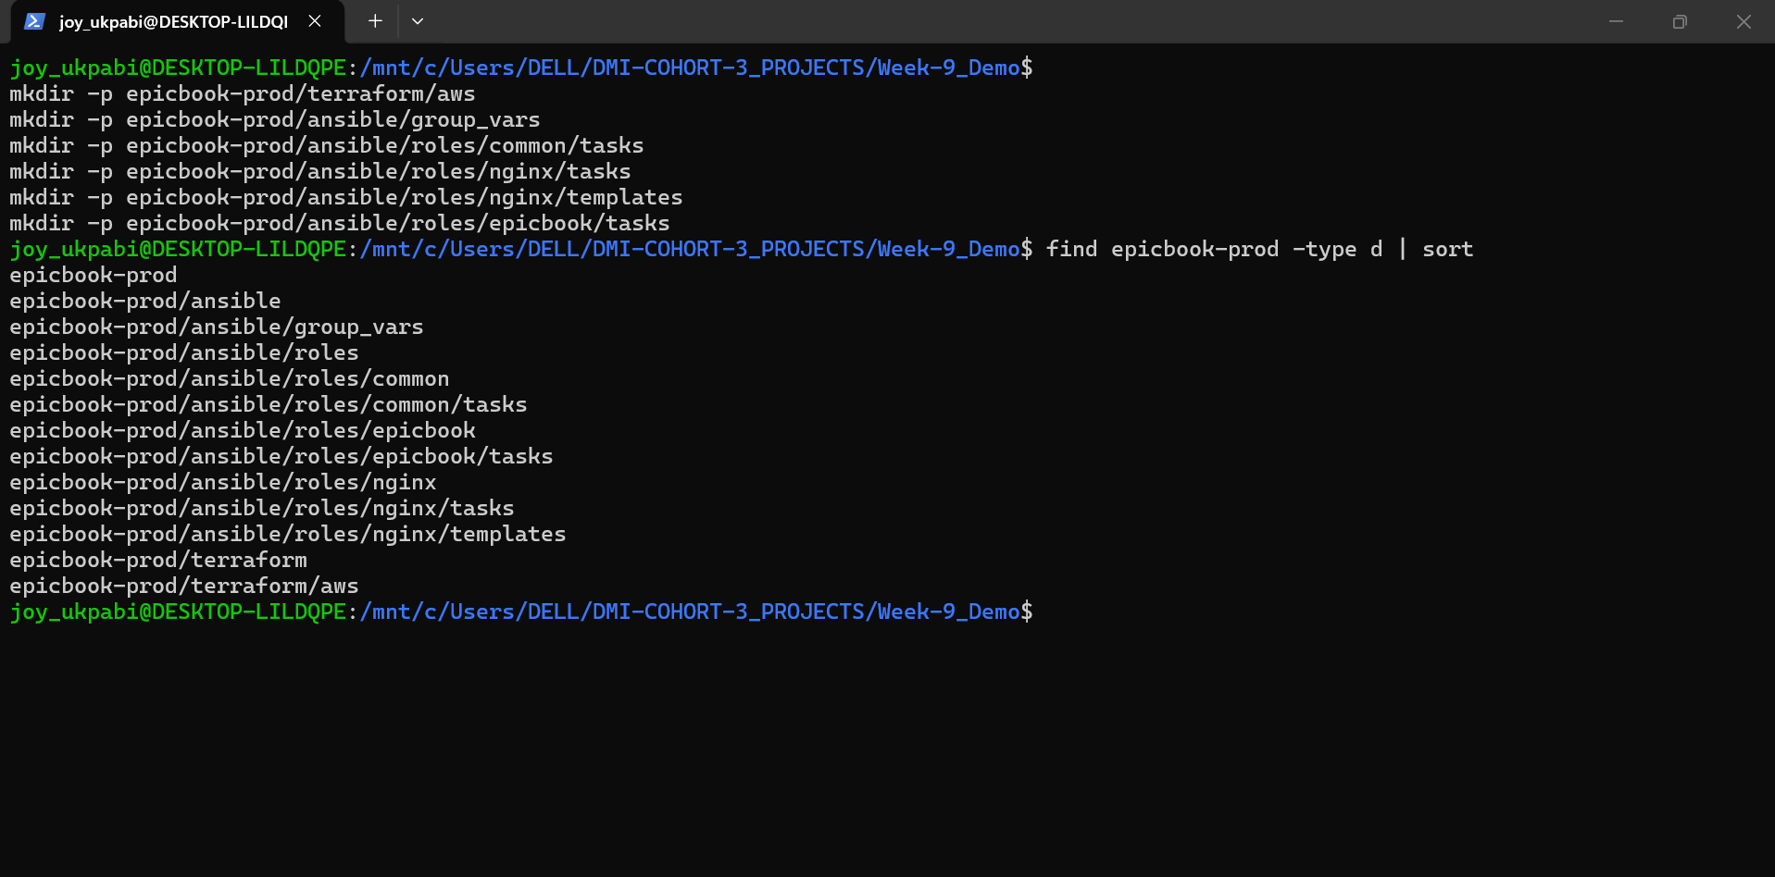

Screenshot shows the terraform files structure created and ready to copy files into it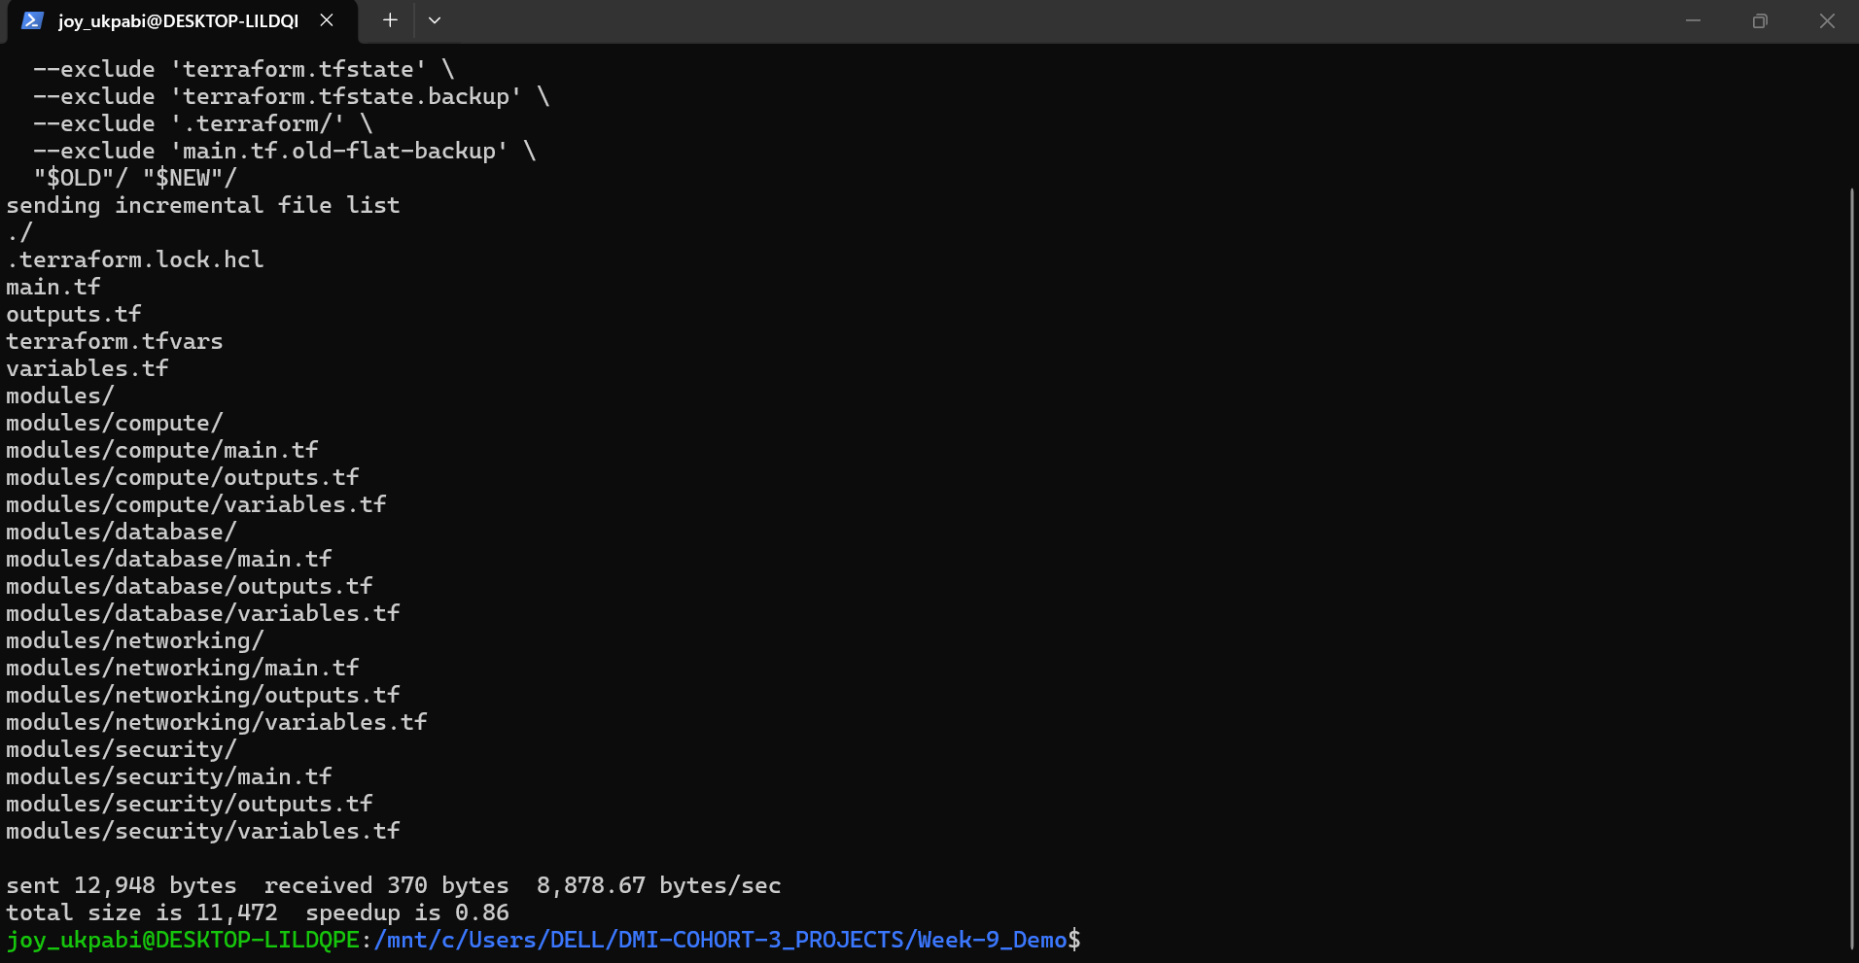

Screenshot shows the files structure created with terraform files copied into it
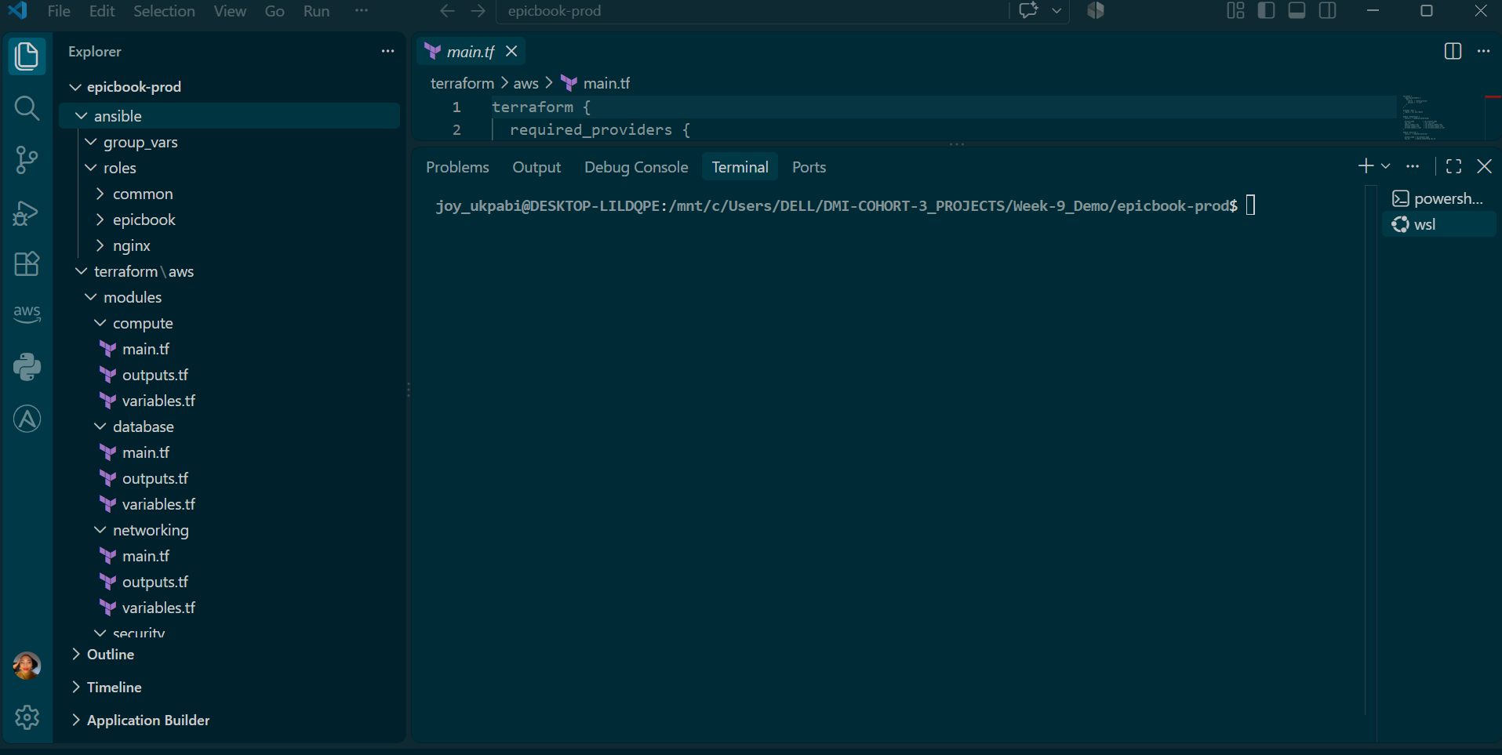

Explanation
This folder structure follows a common real-world DevOps convention: infrastructure code (Terraform) and configuration/deployment code (Ansible) live in separate folders within the same project, even though they work together to deliver one outcome. Terraform is responsible for creating the things — the VM, the database, the network — while Ansible is responsible for configuring those things once they exist. Keeping them physically separate makes each easier to read, test, and reuse independently.
If you already have working, tested Terraform code from an earlier project, there's no need to rewrite it. Terraform code is meant to be reusable — that's part of its design. Copying it into a new project folder and re-running terraform init there proves this: terraform init re-downloads the provider plugins fresh, and because no terraform.tfstate file is carried over, Terraform has no memory of any previous deployment. It will treat the copied code as a brand-new configuration and, on apply, create an entirely new, independent set of cloud resources.
This is why terraform.tfstate and the .terraform/ provider cache are deliberately excluded when copying. The state file is what ties Terraform's code to one specific, already-existing set of real cloud resources — if you copied it along with the code, Terraform would think the new project "owns" the old resources, which is not what you want. Leaving it behind, along with the local sensitive parts of the old project (untouched, in its original folder), ensures the two deployments stay completely separate, while still letting you skip the time-consuming and error-prone work of writing Terraform HCL from scratch again.

Task 2 — Provision the Infrastructure with Terraform

Goal
Run Terraform to provision the cloud infrastructure for the EpicBook deployment — one Ubuntu VM, one managed MySQL database, required networking, and required security rules — and confirm that every value the rest of the project depends on (VM IP, database host, database name, database username) is actually available through terraform output. .

Steps
- Go to your Terraform folder for the selected cloud provider.
- Initialize Terraform so it downloads the provider plugins into this project folder.
- Review the execution plan before making any changes.
- Apply the configuration to create the resources.
- Check which values the module outputs currently expose, and which ones are missing.
- Wire up any missing outputs (db_name, db_username) so they're available at the root level, alongside the existing ec2_public_ip and rds_endpoint.
- Re-apply — this only updates outputs, not infrastructure — and confirm all four values are now visible.
- Locate where the database credentials actually come from in the code, and confirm the password is never committed to version control.

Check what outputs already exist
bash
cat modules/database/outputs.tf
cat outputs.tf

Add the missing outputs

A Terraform module only exposes values that are explicitly declared in its own outputs.tf — even if the underlying resource has that attribute internally. And the root project only sees a module's outputs if the root outputs.tf explicitly pulls them up. This project's database module already exposed db_name, but not db_username, and the root outputs.tf hadn't pulled db_name up yet either. Both were added:

In modules/database/outputs.tf: ADD

output "db_username" {

value = aws_db_instance.epicbook_db.username

}

In the root outputs.tf:

output "db_name" {
description = "EpicBook database name"
value = module.database.db_name
}

output "db_username" {
description = "EpicBook database admin username"
value = module.database.db_username
}

Trace where the database credentials actually come from
bash
cat modules/database/main.tf
grep -n "default" variables.tf modules/database/variables.tf
grep -n "db_username\|db_password\|db_name" terraform.tfvars

Commands
cd <your-new-project-path>/epicbook-prod/terraform/aws

terraform init

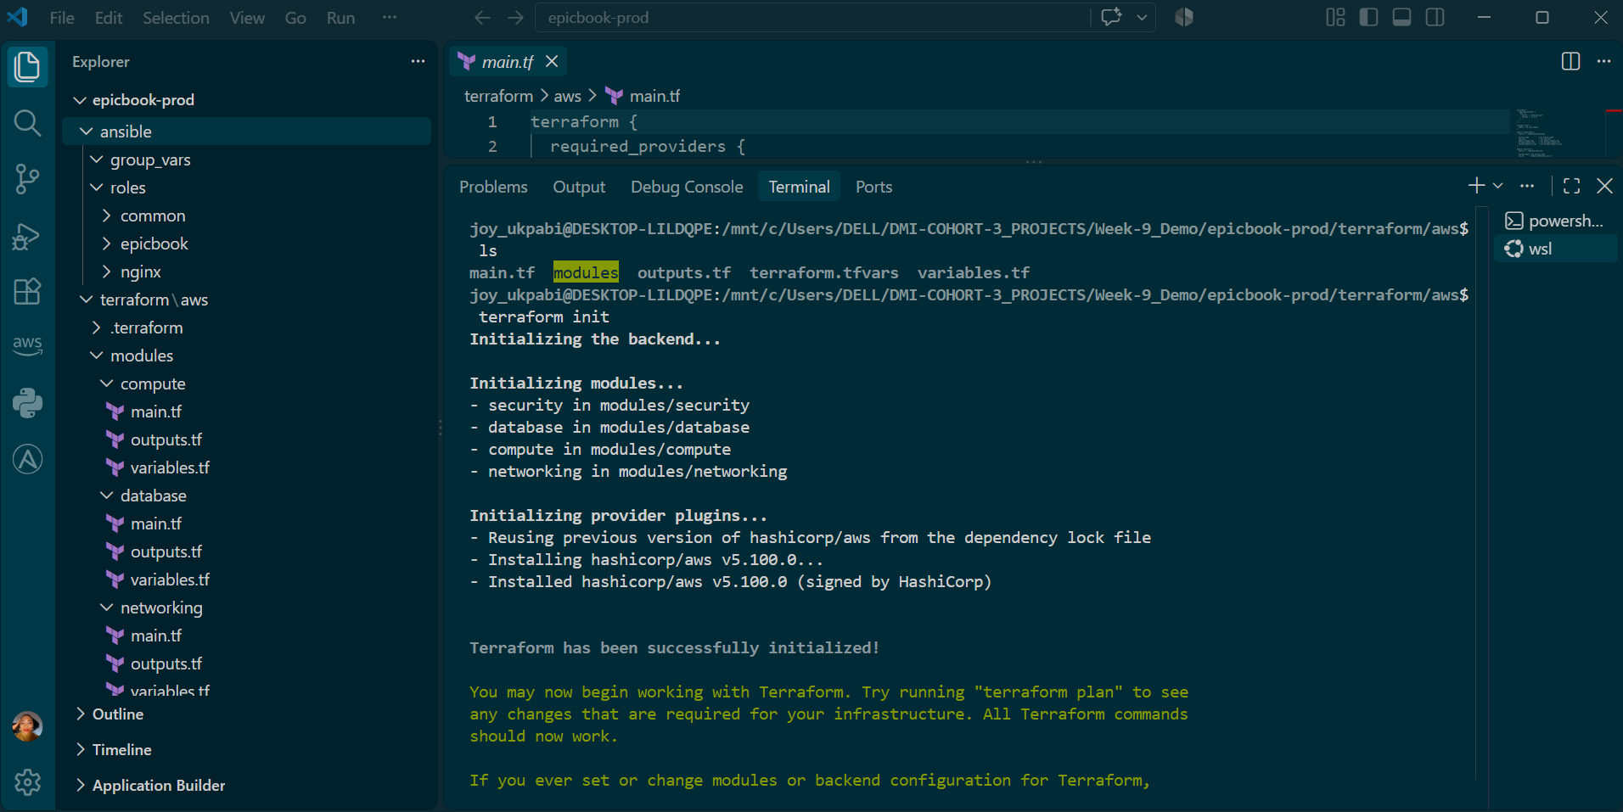

terraform plan

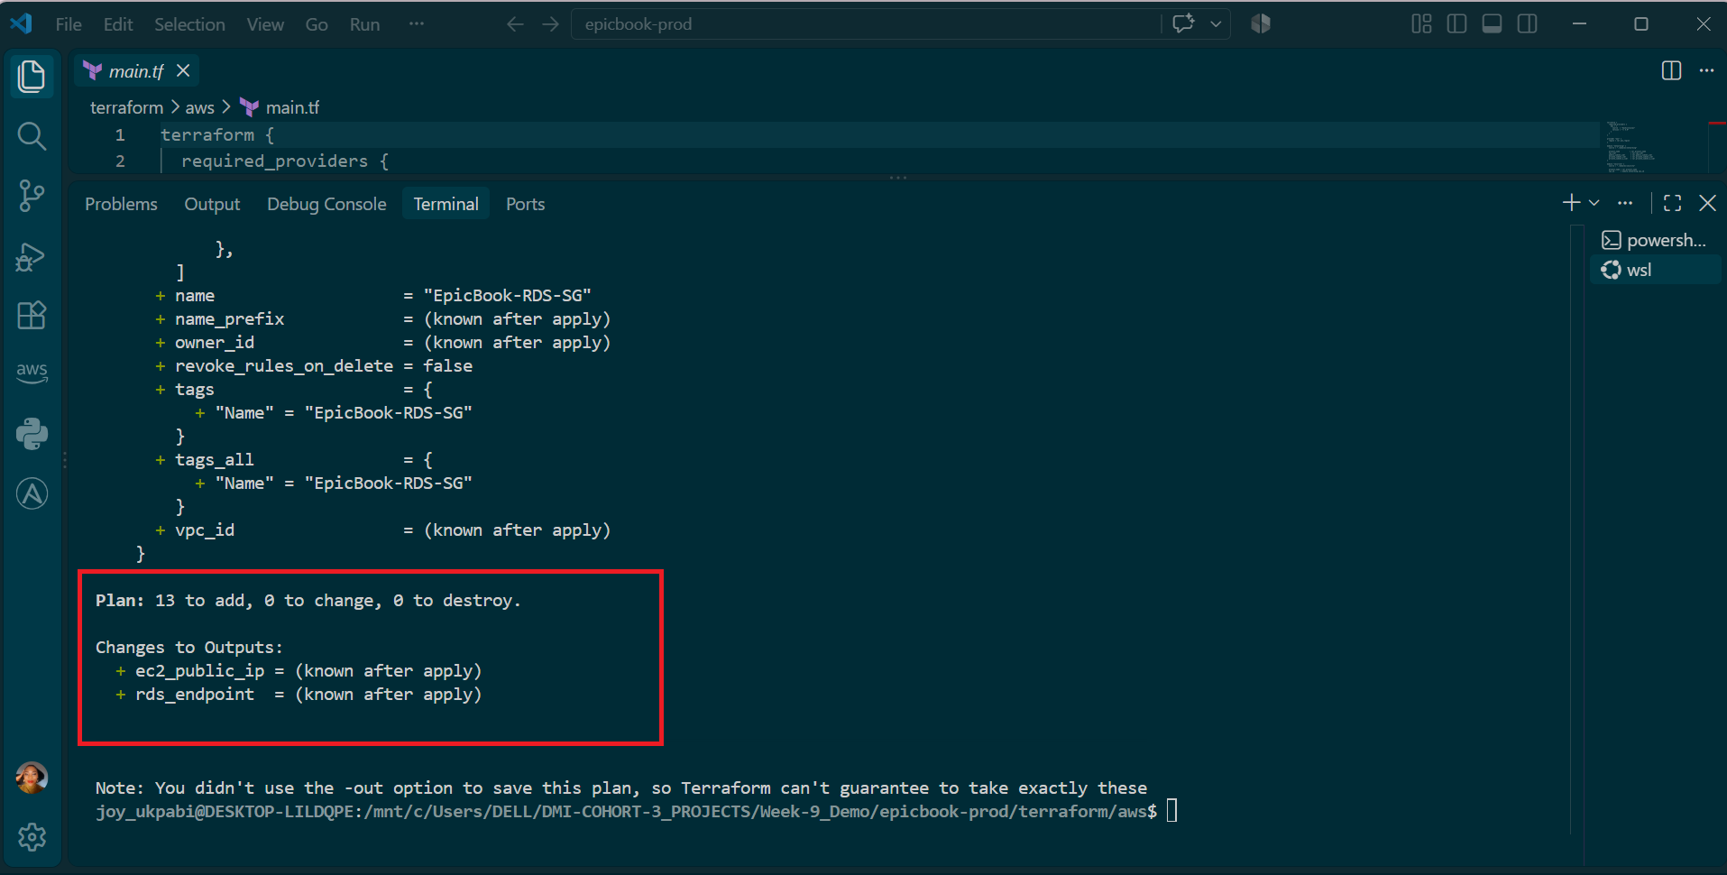

terraform apply

When prompted, type yes to confirm.
terraform output
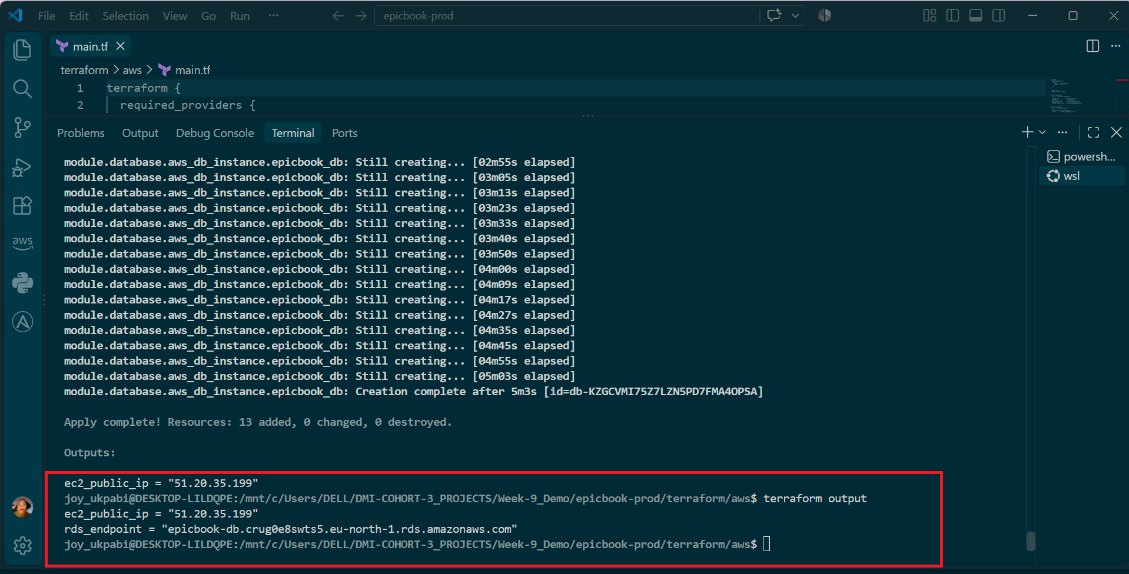
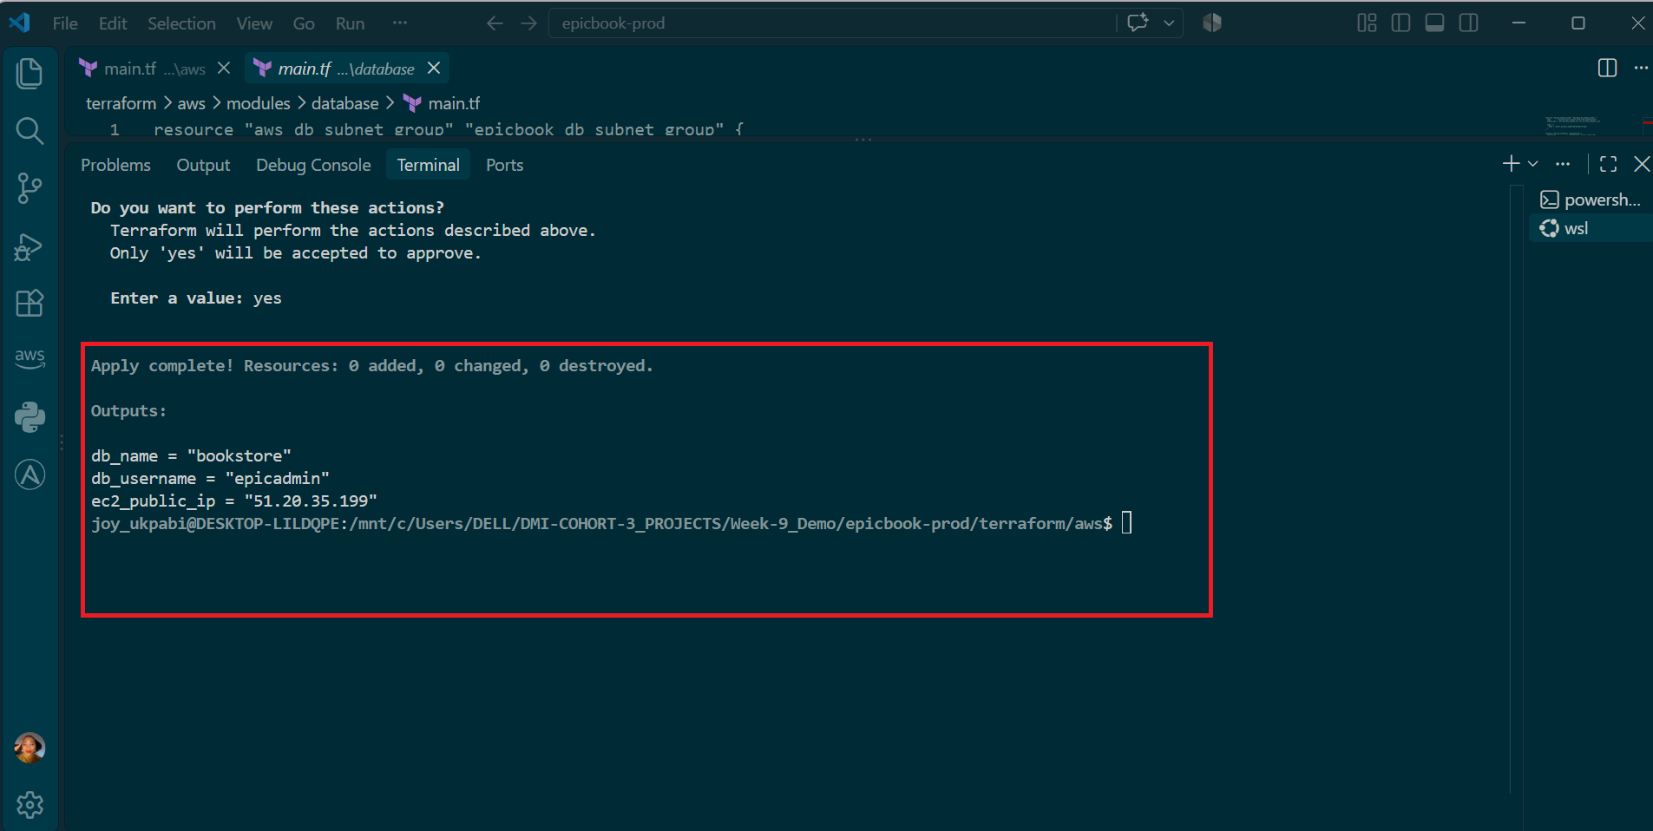

Explanation
terraform init prepares a folder to be used with Terraform. It reads the provider block in your code (in this case, the AWS provider) and downloads the matching plugin — the piece of software Terraform actually uses to talk to AWS's API. This has to be run once per project folder, which is why it's needed again here even though the code itself was already tested elsewhere: a fresh folder has no providers downloaded yet.
terraform plan is a dry run. It compares what your code says should exist against what Terraform currently knows about (from its state file, which in this case is empty since this is a new project) and prints out exactly what it intends to create, change, or destroy — without actually doing any of it. Reading the plan before applying is a core Terraform habit: it's your last chance to catch a mistake, like a wrong region or an unexpectedly large resource, before it becomes a real, billable cloud resource.
terraform apply executes the plan for real. Since this project's state starts empty, the plan will show everything being created from scratch — the VM, the managed MySQL database, the VPC/networking, and the security groups — even though this exact code already exists as running infrastructure elsewhere. That's expected and correct: Terraform state is scoped per-project-folder, not per-code, so a copy of the code in a new folder with no state is treated as an entirely new deployment.
terraform output prints the values your code has explicitly declared as outputs — typically things other tools or humans need after provisioning, like the VM's public IP address, the database hostname, or an admin username. These outputs matter a lot for the rest of this assignment: Ansible's inventory file will need the VM's public IP, and the application's database configuration will need the managed database's hostname. A well-written Terraform project deliberately avoids putting secrets like database passwords in plain output — if a password does appear in terraform output, that's a sign the outputs need to be reviewed before moving on.

Confirm secrets are excluded from version control or add them
bash
cd <your-project-path>/epicbook-prod
cat .gitignore 2>/dev/null

cat > .gitignore << 'EOF'
# Terraform
*.tfvars
*.tfstate
*.tfstate.backup
.terraform/

# SSH keys
*.pem
id_ed25519*
epicbook-aws-key*

# Ansible
*.retry
EOF

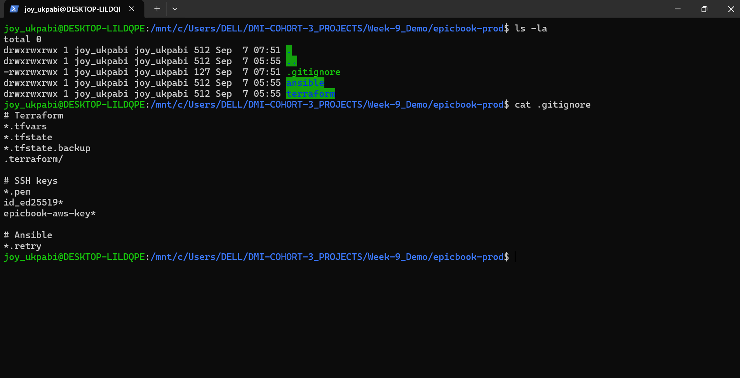

Explanation — Why .gitignore Lives at the Project Root
The .gitignore file should be created at epicbook-prod/.gitignore — the top level of the whole project — rather than inside terraform/aws/ alone. This placement matters because a .gitignore file protects everything underneath the folder it sits in, once the project is tracked by Git. Since epicbook-prod/ contains both the terraform/ and ansible/ folders, a single root-level .gitignore covers sensitive files from either side of the project, rather than needing two separate ones that could easily drift out of sync or be forgotten in one folder.
This matters concretely for two different kinds of secrets that will exist in this project by the end:
- On the Terraform side, terraform.tfvars holds the real database password in plain text, and .terraform/ and terraform.tfstate can also contain sensitive values (state files sometimes store resource attributes, including credentials, depending on the resource type).
- On the Ansible side, later tasks (like Task 9 — Group Variables) will store database connection details in group_vars/web.yml, and depending on how credentials are handled there, that file could also end up holding a real secret.
A single .gitignore at the root, listing patterns like *.tfvars, *.tfstate, .terraform/, and any SSH key file patterns, means Git will refuse to track any file matching those patterns anywhere in the project — whether it's sitting in terraform/aws/ or ansible/group_vars/ — without needing a duplicate .gitignore in every subfolder.
It's also worth understanding what .gitignore actually does and doesn't do: it only prevents Git from tracking a file going forward. If a file was already committed before being added to .gitignore, it stays in Git's history regardless — the ignore rule only stops new commits from including it. Since this project hasn't run git init yet, creating .gitignore now, before any commit happens, is the correct order of operations: it means terraform.tfvars and the SSH keys will never enter Git history at all, rather than needing to be scrubbed out later.

Task 3 — Verify SSH Key-Based Access

Goal
Confirm that the newly created VM can be reached from the Ansible controller using SSH key-based authentication, before any Ansible work begins — since Ansible itself connects to managed hosts over SSH, this step proves the foundation Ansible will rely on actually works.

Steps
- Get the VM's public IP address from Terraform output.
- Determine the correct SSH admin username for the VM.
- Connect to the VM from the Ansible controller using the SSH key referenced in terraform.tfvars.
- Confirm the VM responds with its hostname, with no password prompt.

Commands
Get the public IP (already available)
Commands
cd <your-project-path>/epicbook-prod/terraform/aws

# Get the public IP
terraform output ec2_public_ip

# Determine the AMI, which determines the login username
grep -n "ami\|user" modules/compute/main.tf modules/compute/variables.tf terraform.tfvars

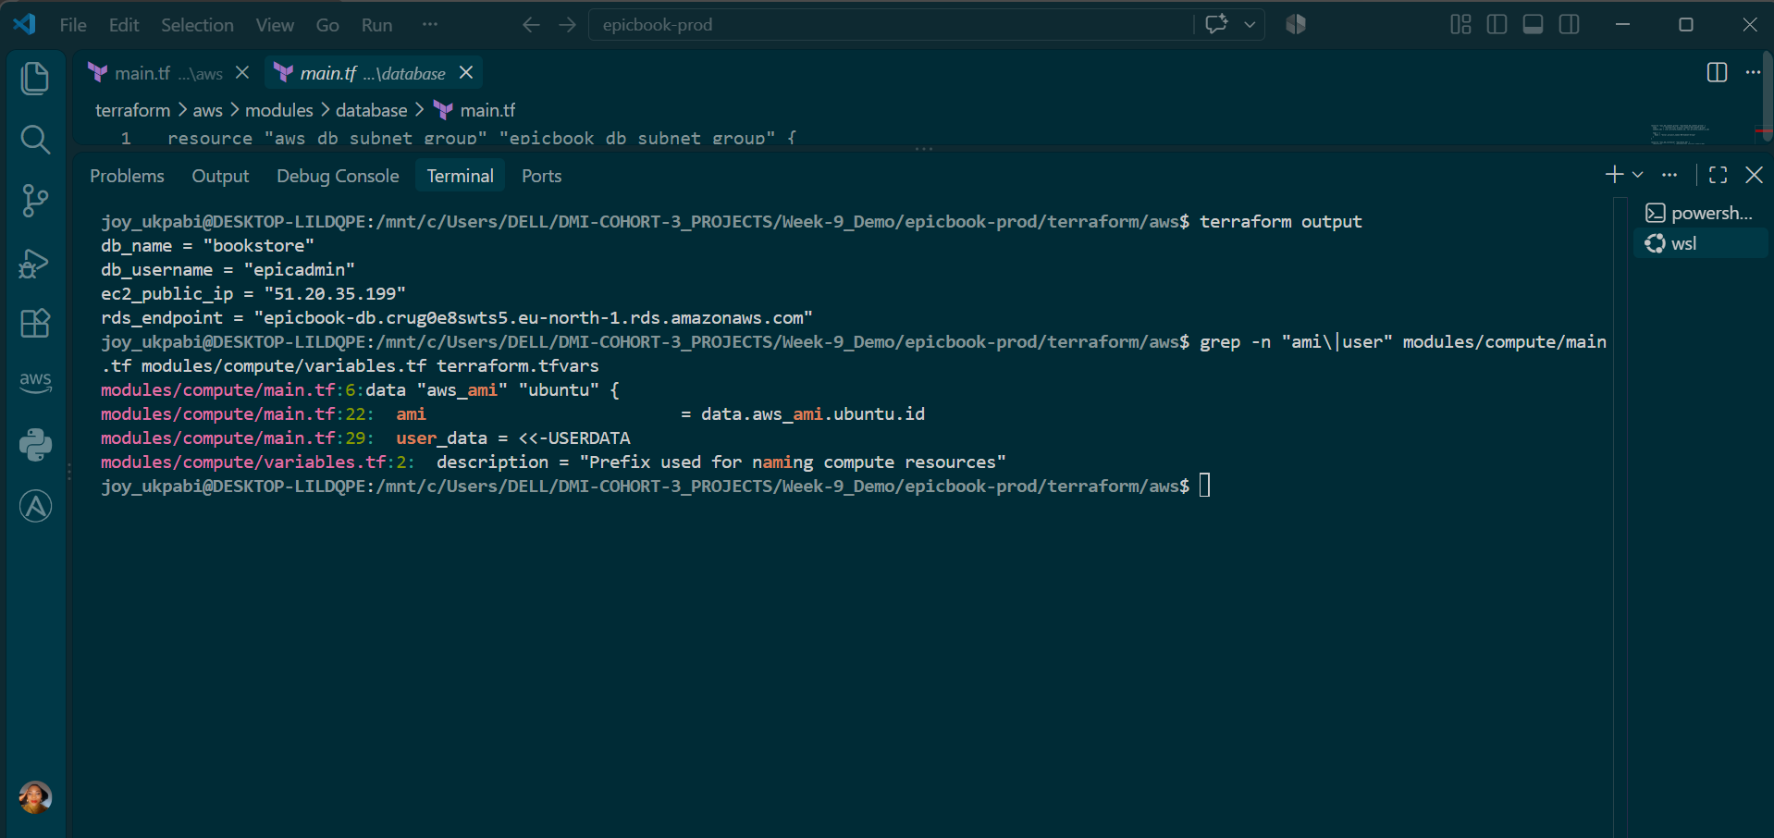

Test SSH access
ssh -i /home/joy_ukpabi/.ssh/epicbook-aws-key <admin_user>@<ec2_public_ip> "hostname"

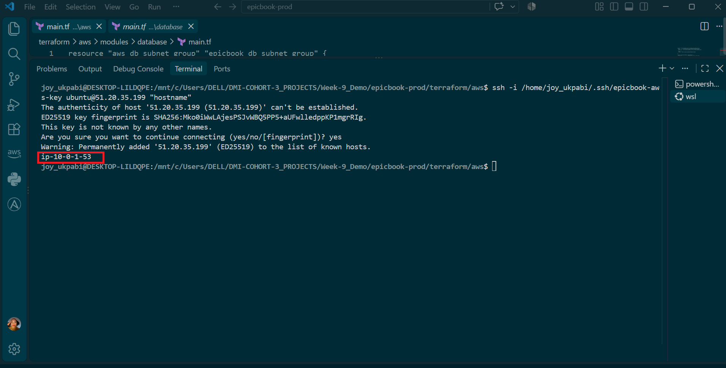

Explanation
The VM's public IP is already available from Terraform's output (ec2_public_ip), but the admin username isn't currently exposed as an output — it depends on which Ubuntu AMI the compute module used, since AWS's official Ubuntu AMIs default to the login user ubuntu (this differs by distribution — Amazon Linux uses ec2-user, for example). Rather than guessing, checking the compute module directly confirms which AMI was selected and whether a username was explicitly set anywhere in the code.
The -i flag on ssh tells it exactly which private key to use for authentication, rather than relying on SSH's default key discovery — this matters because the key pair used here (epicbook-aws-key) isn't the default id_ed25519 name, so SSH won't find it automatically without being told where to look.
A successful connection here proves the full chain set up by Terraform actually works end-to-end: the public key registered with AWS (aws_key_pair.epicbook_key, built from the same public_key_path) matches the private key sitting locally on the controller, the VM's security group allows inbound SSH from this machine, and the VM itself booted correctly and is running its SSH daemon. If this fails, the cause is almost always one of those three things — wrong key, security group not allowing the connection, or using the wrong username for the AMI.
No password should ever be requested. If one is, or if the connection is refused with Permission denied (publickey), it signals a mismatch somewhere in that chain — most commonly the wrong username for the AMI, or a security group rule that hasn't been opened correctly.

Task 4 — Create the Ansible Inventory and Configuration

Goal
Create the Ansible inventory file and a local ansible.cfg, so Ansible knows which VM to manage, which SSH user and key to use to connect, and can successfully ping the host before any real configuration work begins.

Steps
- Go to the ansible directory inside the project.
- Create or open inventory.ini.
- Add the VM's public IP address under the web group, along with the SSH username and private key path.
- Create a local ansible.cfg for this project.
- Validate the inventory structure.
- Test Ansible connectivity to the VM.
- If a "world writable directory" warning appears and ansible.cfg is being ignored, explicitly point Ansible at the config file instead of relying on auto-discovery.

Commands
bash
cd <your-project-path>/epicbook-prod/ansible
nano inventory.ini ( Add this in the inventory.ini)
- <public_ip> with the VM public IP address from Terraform output
- <admin_user> with the admin username from Terraform output

[web]
epicbook ansible_host=51.20.35.199

[web:vars]
ansible_user=ubuntu
ansible_ssh_private_key_file=/home/joy_ukpabi/.ssh/epicbook-aws-key

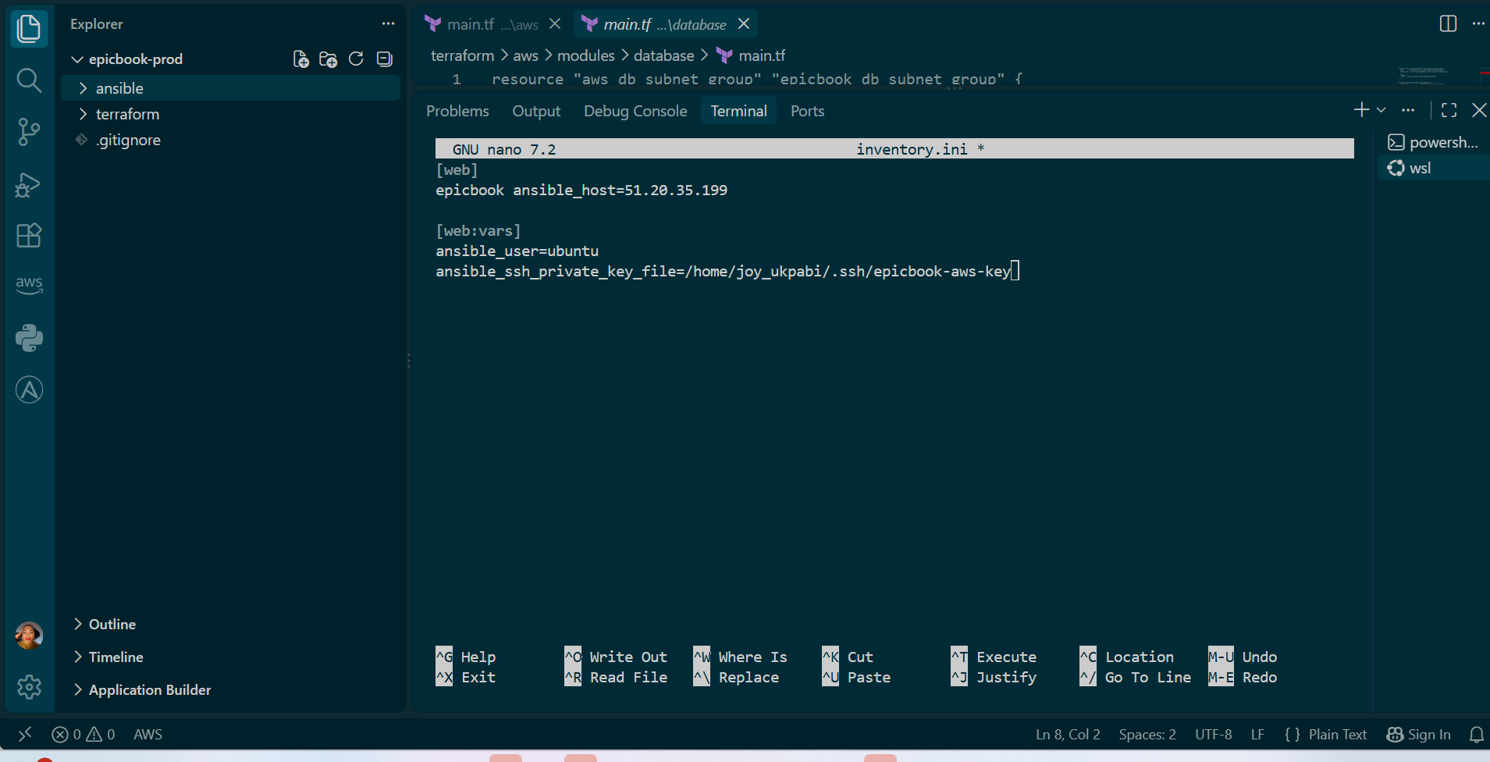

nano ansible.cfg (Add this )

[defaults]
host_key_checking = False

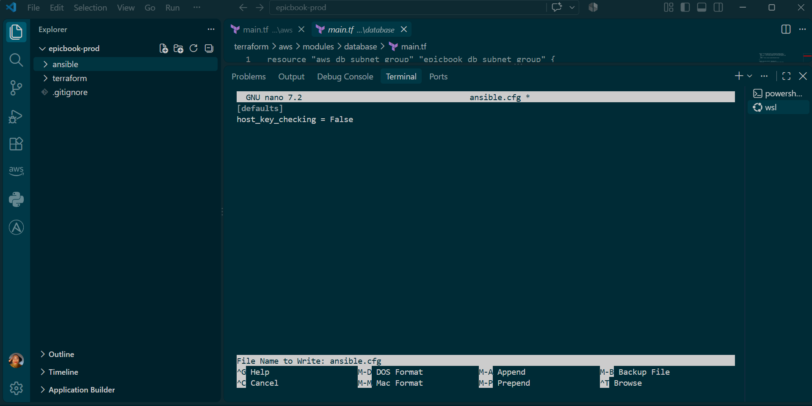

Validate and test:
bash
ansible-inventory -i inventory.ini --graph
ansible web -i inventory.ini -m ping

If a warning appears saying Ansible is ignoring ansible.cfg because the directory is "world writable," point Ansible at the config explicitly as in the screenshot below:

Command

export ANSIBLE_CONFIG=<your-project-path>/epicbook-prod/ansible/ansible.cfg

ansible web -i inventory.ini -m ping

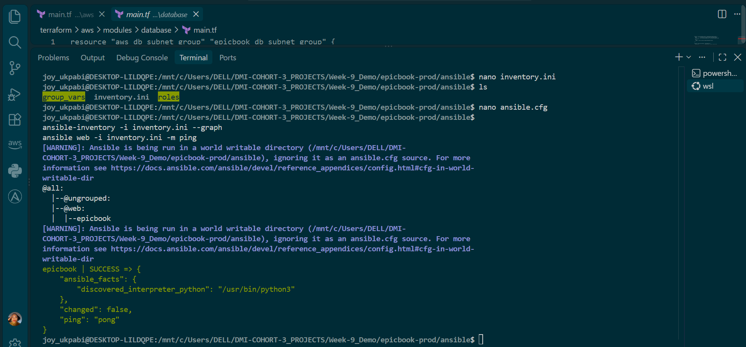

Example (mine):
export ANSIBLE_CONFIG=/mnt/c/Users/DELL/DMI-COHORT-3_PROJECTS/Week-9_Demo/epicbook-prod/ansible/ansible.cfg

ansible web -i inventory.ini -m ping

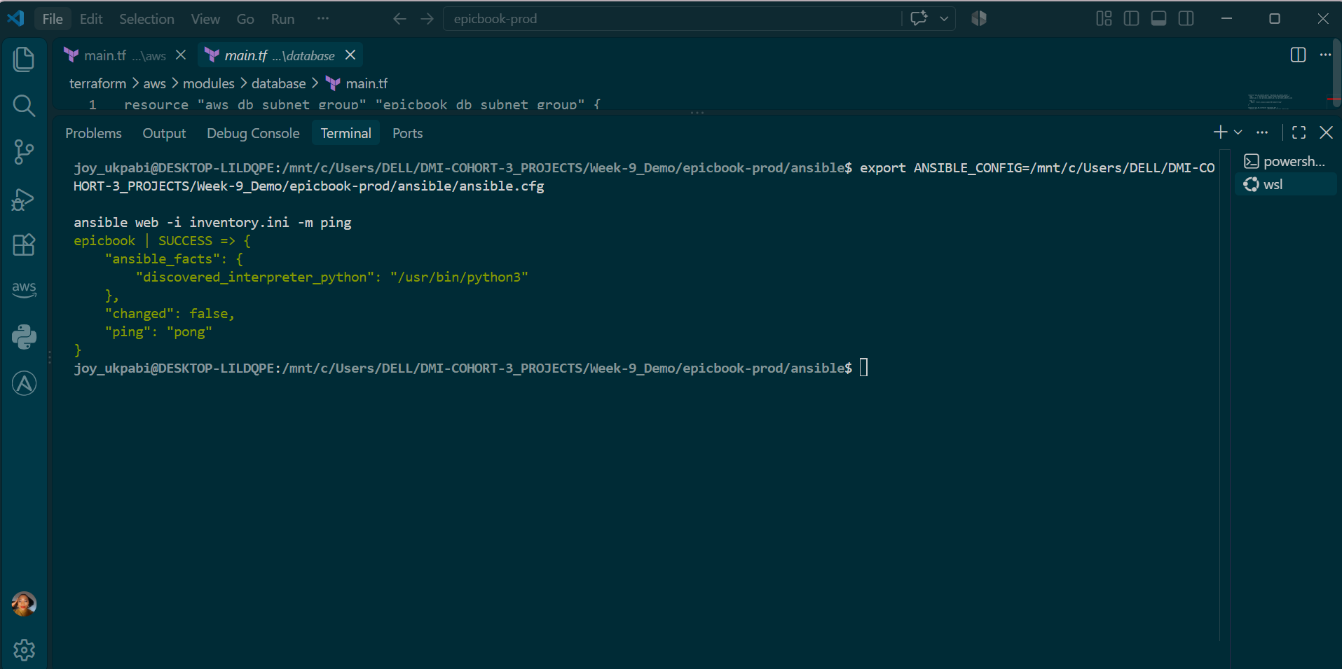

If you're unsure of your own exact path, run this from inside the ansible folder first:
bash
pwd

That prints your full current path — append /ansible.cfg to it and use that as the value for ANSIBLE_CONFIG.

Explanation
The inventory file is how Ansible knows which machines exist and how to reach them — without it, Ansible has nothing to act on. The host is named epicbook here (an arbitrary label Ansible uses internally to refer to this machine), while ansible_host supplies the actual IP address to connect to. Separating the label from the address matters because later tasks and templates can refer to the host by its friendly name, even if the underlying IP ever changes.
The [web:vars] section applies shared connection settings to every host in the web group at once, rather than repeating them per host — useful here with only one host, but this is exactly the pattern that scales cleanly if a second web server were added later. ansible_user=ubuntu and ansible_ssh_private_key_file=... mirror precisely what was already proven to work manually in Task 3's raw ssh command — Ansible is just automating that same connection, not doing anything fundamentally different.
ansible.cfg's host_key_checking = False disables the same fingerprint-confirmation prompt seen in Task 3. That prompt is fine for one manual SSH connection, but it would interrupt Ansible mid-run since Ansible can't answer an interactive yes/no prompt on its own — the playbook would simply hang or fail on first connection. Disabling it is acceptable for a temporary lab environment like this one; in a production setting, host key checking should stay enabled, and fingerprints should be pre-approved through a properly managed known_hosts file instead of turned off entirely — this is a lab convenience, not a practice to bring into real deployments.
ansible-inventory -i inventory.ini --graph is a read-only sanity check — it just prints Ansible's interpretation of the inventory file's structure, confirming the web group exists and contains the expected host, without connecting to anything yet.
ansible web -i inventory.ini -m ping is the real connectivity test. Despite the name, this isn't a network-layer ICMP ping — it's Ansible's own ping module, which connects over SSH exactly like a real task would, and confirms Ansible can authenticate and successfully execute a module on the remote host. A pong response with SUCCESS means Ansible is fully ready to run real configuration tasks against this VM.

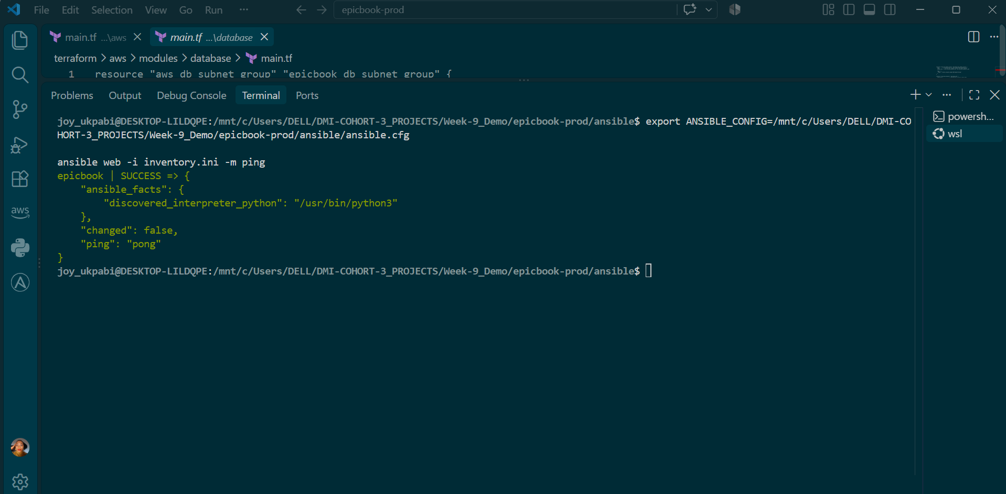

Task 5 — Create the Main Ansible Playbook

Goal
Create site.yml, the main Ansible playbook that calls the common, nginx, and epicbook roles in the correct order, so the actual configuration logic can live cleanly inside each role rather than being written directly into the main playbook.

Steps
- Go to the ansible directory.
- Open site.yml.
- Add the playbook content, referencing the three roles in the order they must run.
- Save the file.
- Verify the YAML and Ansible syntax is valid before ever running it for real.

Commands
cd <your-project-path>/epicbook-prod/ansible

nano site.yml

Add the following content:
---
- name: Deploy EpicBook application
hosts: web
become: true

roles:
- common
- nginx
- epicbook

Save and exit (Ctrl+O, Enter, Ctrl+X).
Check the syntax before running it for real:

ansible-playbook -i inventory.ini site.yml --syntax-check

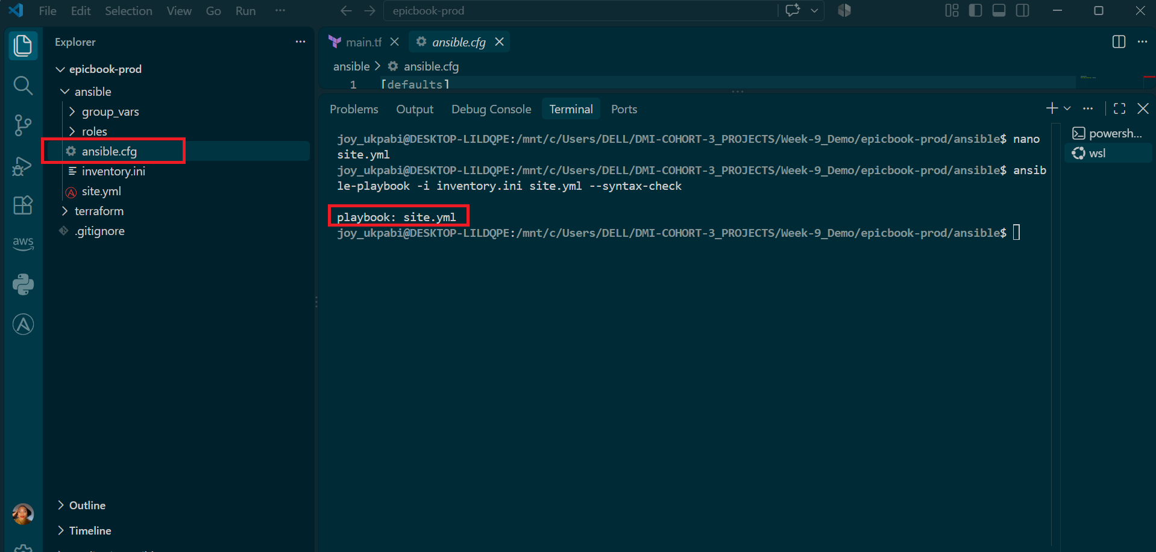

Explanation
site.yml is intentionally thin — it doesn't contain any actual configuration tasks itself. Instead, it declares which hosts this playbook targets (hosts: web, matching the group defined in inventory.ini), that tasks should run with elevated privileges (become: true, since installing packages and editing system files requires root), and then simply lists the roles to run, in order.
This separation matters for a reason beyond tidiness: it mirrors how the underlying infrastructure is actually built up in layers. The common role has to run first because it prepares the VM with baseline tools (git, curl, mysql-client, etc.) that later roles may depend on. nginx runs second because it needs to be installed and configured as a reverse proxy before the application is expected to be reachable through it. epicbook runs last because deploying and starting the actual application only makes sense once the server is prepared and the reverse proxy is ready to receive traffic for it. Ansible runs roles strictly in the order they're listed under roles:, so this ordering in the code is not cosmetic — it directly determines the order operations happen on the VM.
Keeping role-specific logic out of site.yml and inside each role's own tasks/main.yml is what makes roles genuinely reusable — the nginx role, for instance, could be dropped into an entirely different project and reused as-is, precisely because it doesn't know or care about anything specific to site.yml beyond the variables it's given.
--syntax-check parses the entire playbook — reading through site.yml and, since it references roles, checking that Ansible can locate and parse those role directories too — without connecting to any real server or making any changes. This is a completely safe, local check. Catching a YAML indentation mistake or a typo in a role name here costs nothing; catching the same mistake midway through a real playbook run against a live VM is a much more annoying way to find out.

Task 6 — Create the common Role

Goal
Create the common role's task file so it prepares the Ubuntu VM with the baseline packages every later role depends on — updating the package cache and installing tools like git, curl, unzip, software-properties-common, and mysql-client — before Nginx or the application are ever touched.

Steps
- Go to the common role's tasks directory.
- Open main.yml.
- Add a task to update the apt package cache.
- Add a task to install the required baseline packages.
- Save the file.
- Validate the syntax against the full playbook.

Commands
cd <your-project-path>/epicbook-prod/ansible/roles/common/tasks
nano main.yml

Add the following content:
----
- name: Install Nginx
ansible.builtin.apt:
name: nginx
state: present

- name: Deploy EpicBook Nginx site configuration
ansible.builtin.template:
src: epicbook.conf.j2
dest: /etc/nginx/sites-available/epicbook
owner: root
group: root
mode: "0644"
notify: Reload nginx

- name: Enable the EpicBook site
ansible.builtin.file:
src: /etc/nginx/sites-available/epicbook
dest: /etc/nginx/sites-enabled/epicbook
state: link
notify: Reload nginx

- name: Disable the default Nginx site
ansible.builtin.file:
path: /etc/nginx/sites-enabled/default
state: absent
notify: Reload nginx

- name: Validate Nginx configuration
ansible.builtin.command: nginx -t
changed_when: false

- name: Ensure Nginx is started and enabled
ansible.builtin.service:
name: nginx
state: started
enabled: true

Save and exit (Ctrl+O, Enter, Ctrl+X).

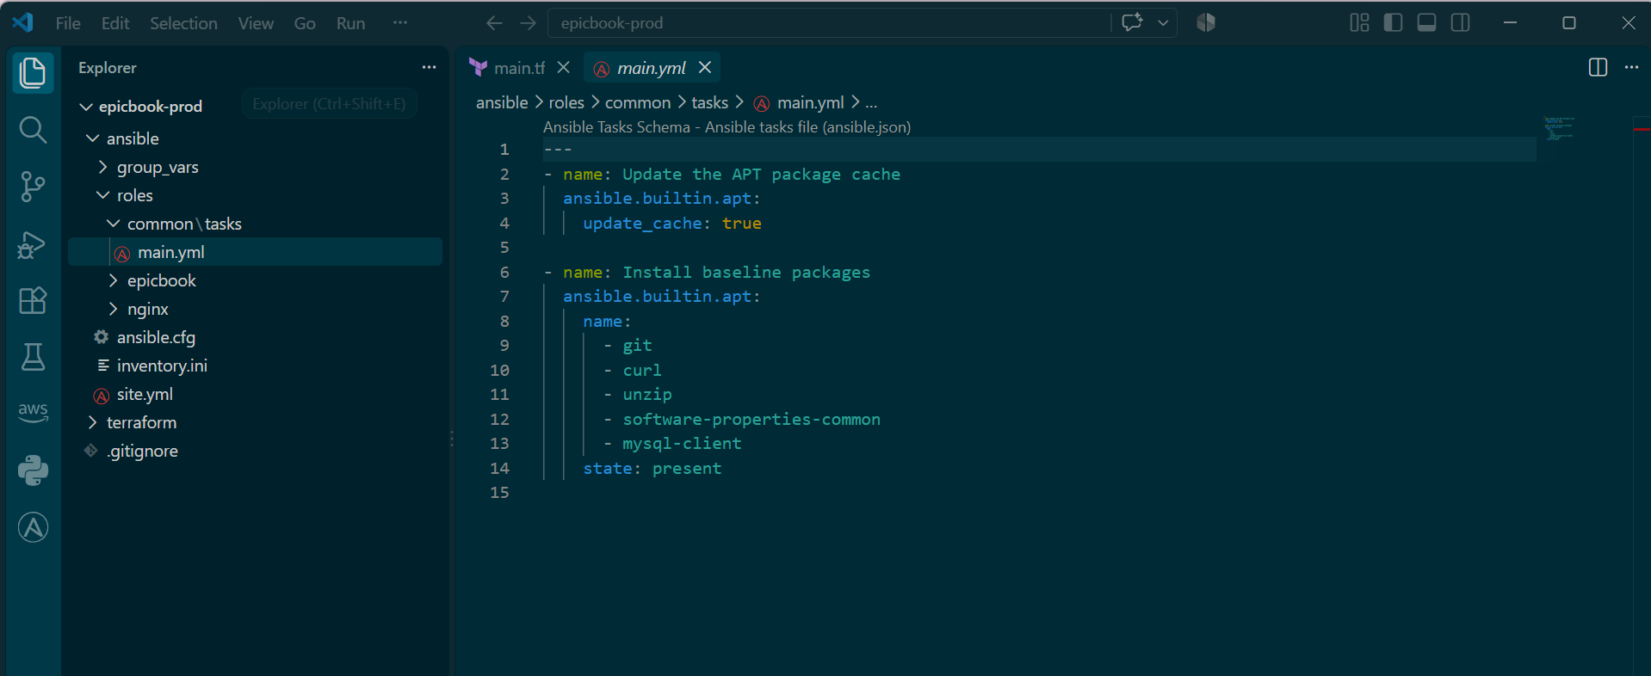

Now create the separate handlers file:
bash
mkdir -p handlers

cat > handlers/main.yml << 'EOF'
---
- name: Reload nginx
ansible.builtin.service:
name: nginx
state: reloaded
EOF

cat handlers/main.yml
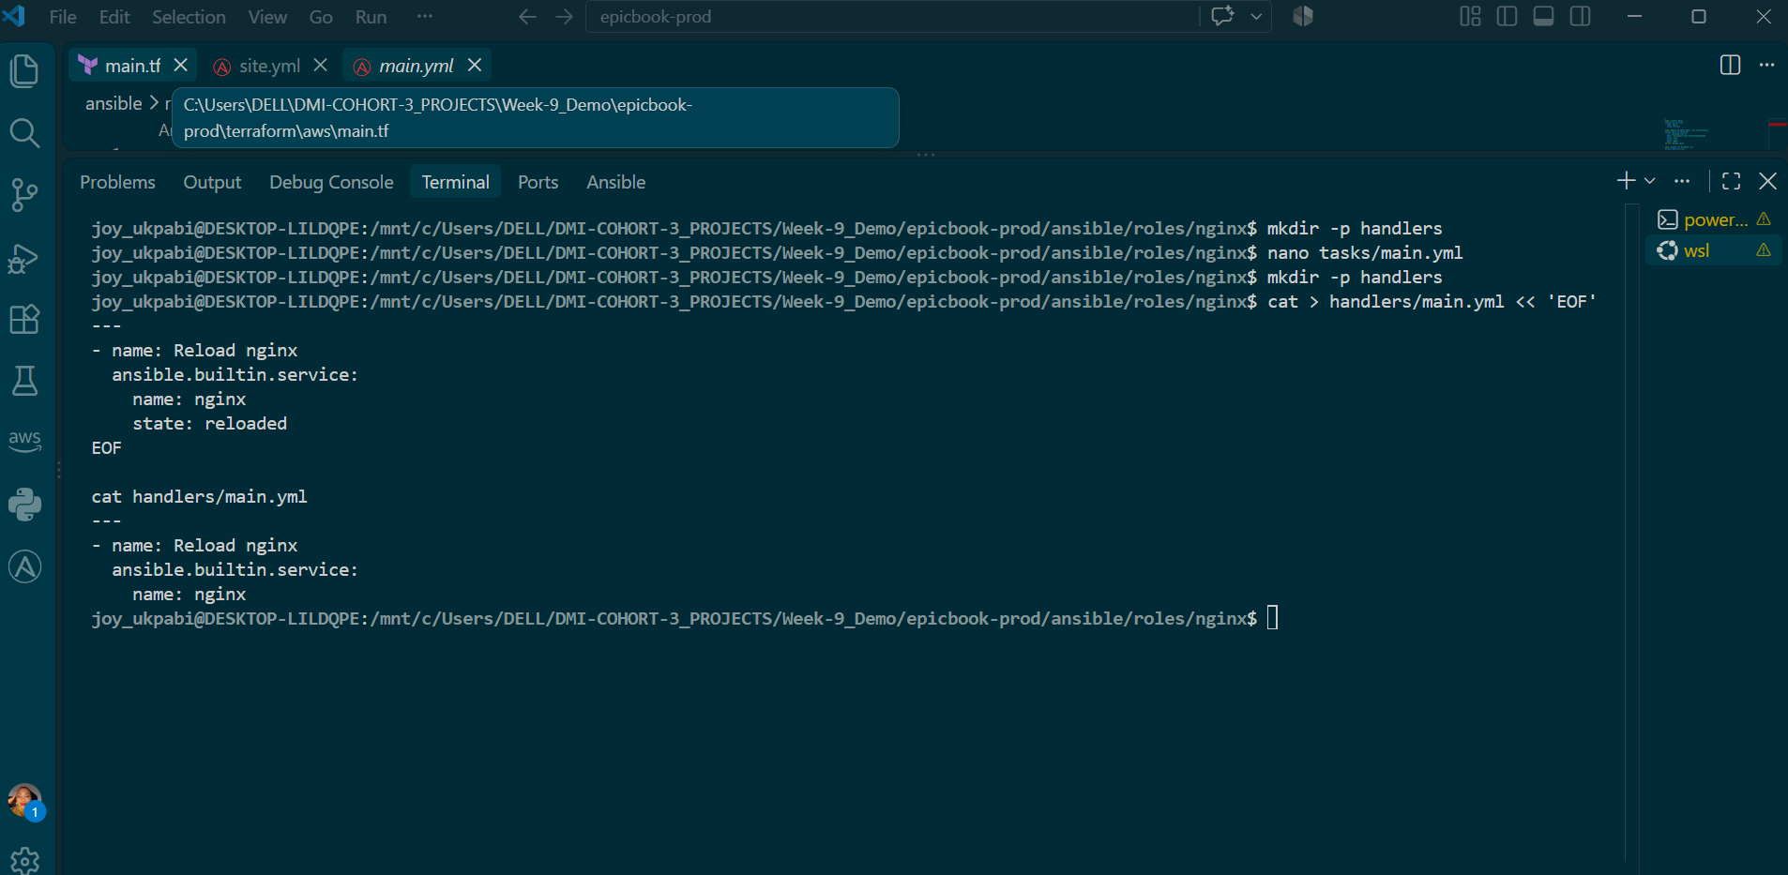

Validate from the ansible directory:
bash
cd <your-project-path>/epicbook-prod/ansible
ansible-playbook -i inventory.ini site.yml --syntax-check

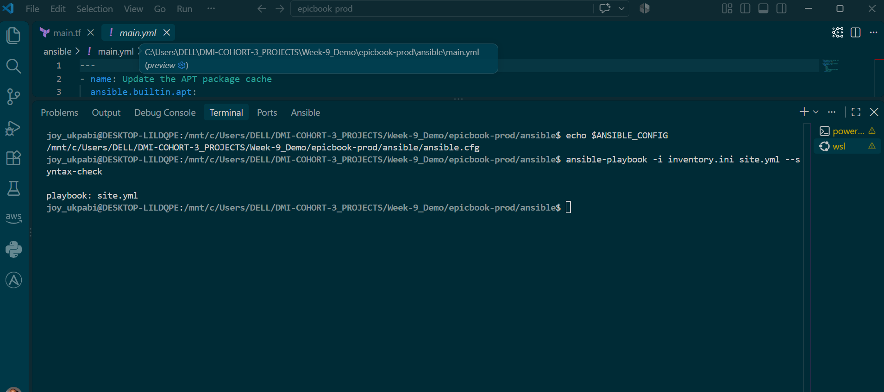

Explanation
The Nginx role has one main responsibility:
Install Nginx and configure it to send web requests to the EpicBook application.
The EpicBook role is responsible for running the application itself. Keeping these responsibilities separate makes each role easier to understand, test, and reuse.
- Install Nginx — uses ansible.builtin.apt to install Nginx. Ansible checks whether Nginx is already installed before making a change, so it does not reinstall it unnecessarily.
- Deploy EpicBook Nginx site configuration — uses the template module because the configuration contains variables such as {{ server_name }} and {{ app_port }}. Ansible replaces these variables with the actual values from group_vars/web.yml. If the configuration has not changed, Ansible does not copy it again or reload Nginx.
- Enable the EpicBook site — creates a symbolic link from sites-available to sites-enabled. Nginx only uses configurations that are enabled this way.
- Disable the default Nginx site — removes Ubuntu's default Nginx configuration so that Nginx serves the EpicBook application instead of the default welcome page.
- Validate Nginx configuration — runs:
nginx -t
This checks that the Nginx configuration is valid before Nginx is restarted. changed_when: false tells Ansible that this is only a check and does not change anything.
- Ensure Nginx is started and enabled — makes sure Nginx is running now and will automatically start again after a server reboot.

Why are handlers in a separate file?
A role's tasks/main.yml should contain a list of tasks.
Handlers are different. They are actions that only run when a task notifies them.
For example:
notify: Reload nginx
The handler belongs in:
roles/nginx/handlers/main.yml
Ansible automatically finds this file when the role is used.
The flow is:
Task changes Nginx configuration
↓
notify: Reload nginx
↓
Handler is triggered
↓
Nginx reloads
This is also why the earlier handlers: block caused YAML errors when it was placed directly inside tasks/main.yml: a tasks file expects a list of task items, while handlers: is a separate YAML structure.

What does the Nginx template do?
The template creates a reverse proxy.
The basic flow is:
Browser
↓
Nginx :80
↓
127.0.0.1:{{ app_port }}
↓
EpicBook Node.js application
listen 80 means Nginx accepts HTTP requests on port 80.
proxy_pass http://127.0.0.1:{{ app_port }};
means Nginx forwards those requests to the Node.js application running locally on the same server.
The Node.js application therefore does not need to be exposed directly to the internet.
The proxy_set_header lines pass important information to the application, such as:
- the original client IP
- the original protocol
- the original hostname
Finally, using:
{{ app_port }}
instead of hardcoding a port such as 8080 makes the configuration reusable. The port is controlled from group_vars/web.yml, so changing the port does not require changing the Nginx template.

Task 7 — Create the nginx Role

Goal
Create the nginx role so Nginx is installed and configured as a reverse proxy, forwarding browser traffic on port 80 to the EpicBook Node.js application running locally on port 8080.

Steps
- Go to the nginx role directory.
- Add tasks to install Nginx, deploy the site configuration from a template, enable the site, disable the default site, validate the config, and reload/restart Nginx when it changes.
- Create the templates/epicbook.conf.j2 reverse proxy configuration, using variables for the server name and application port rather than hardcoding them.
- Confirm both files actually exist and hold the expected content — a syntax check alone won't catch a template file that was never saved.
- Create a separate handlers/main.yml for the Nginx reload handler, since handlers must live in their own file, not inside tasks/main.yml.
- Validate the syntax against the full playbook.

Commands
cd <your-project-path>/epicbook-prod/ansible/roles/nginx

Bash this configuration on your terminal

cat > tasks/main.yml << 'EOF'
---
- name: Install Nginx
ansible.builtin.apt:
name: nginx
state: present

- name: Deploy EpicBook Nginx site configuration
ansible.builtin.template:
src: epicbook.conf.j2
dest: /etc/nginx/sites-available/epicbook
owner: root
group: root
mode: "0644"
notify: Reload nginx

- name: Enable the EpicBook site
ansible.builtin.file:
src: /etc/nginx/sites-available/epicbook
dest: /etc/nginx/sites-enabled/epicbook
state: link
notify: Reload nginx

- name: Disable the default Nginx site
ansible.builtin.file:
path: /etc/nginx/sites-enabled/default
state: absent
notify: Reload nginx

- name: Validate Nginx configuration
ansible.builtin.command: nginx -t
changed_when: false

- name: Ensure Nginx is started and enabled
ansible.builtin.service:
name: nginx
state: started
enabled: true
EOF

Create the reverse proxy template, working directly inside the templates/ folder to avoid saving it in the wrong location:
Command
cd templates

cat > epicbook.conf.j2 << 'EOF'
server {
listen 80;
server_name {{ server_name }};

location / {
proxy_pass http://127.0.0.1:{{ app_port }};
proxy_http_version 1.1;
proxy_set_header Upgrade $http_upgrade;
proxy_set_header Connection 'upgrade';
proxy_set_header Host $host;
proxy_set_header X-Real-IP $remote_addr;
proxy_set_header X-Forwarded-For $proxy_add_x_forwarded_for;
proxy_set_header X-Forwarded-Proto $scheme;
proxy_cache_bypass $http_upgrade;
}
}
EOF

Confirm both files actually exist with real content before moving on — this step matters, since a template referenced by a task but never actually saved to disk won't be caught by a syntax check, only by a real run:
cd ..
ls -la templates/
cat templates/epicbook.conf.j2

Create the separate handlers file:
mkdir -p handlers

cat > handlers/main.yml << 'EOF'
---
- name: Reload nginx
ansible.builtin.service:
name: nginx
state: reloaded
EOF

Validate from the ansible directory:
cd <your-project-path>/epicbook-prod/ansible
ansible-playbook -i inventory.ini site.yml --syntax-check

Explanation
The Nginx role has one clear responsibility: install Nginx and configure it to send requests to the EpicBook application. It does not start or manage the application itself; that responsibility belongs to the epicbook role. Keeping the roles separate makes them easier to understand, test, and reuse.
The Install Nginx task uses ansible.builtin.apt to install Nginx. Ansible checks the current state first, so it does not reinstall Nginx when it is already present. The Deploy EpicBook Nginx site configuration task uses the template module instead of copy because the configuration contains variables such as {{ server_name }} and {{ app_port }}. These values come from group_vars/web/vars.yml and are inserted when Ansible deploys the template. The notify: Reload nginx instruction means Nginx is reloaded only when the configuration actually changes.
The Enable the EpicBook site task creates the symbolic link that activates the configuration. Ubuntu's Nginx setup uses sites-available for available configurations and sites-enabled for configurations that are actually active. The Disable the default Nginx site task removes the default configuration so Nginx serves EpicBook instead of Ubuntu's default page and avoids conflicts between active server blocks listening on port 80.
The Validate Nginx configuration task runs nginx -t to check that the configuration is valid. changed_when: false tells Ansible that this is only a check and does not change the server. Performing this check before restarting Nginx helps prevent an invalid configuration from breaking a working Nginx service. The Ensure Nginx is started and enabled task then makes sure Nginx is running now and will automatically start after a server reboot.
The handler is kept in its own file, roles/nginx/handlers/main.yml, rather than being placed inside tasks/main.yml. A tasks file is expected to contain a list of tasks, while handlers: is a separate YAML structure. Keeping handlers in their dedicated file follows Ansible's role structure and allows Ansible to discover them automatically. The task can then trigger the handler with notify: Reload nginx when the configuration changes.
The template file was also checked directly with cat after it was created. This is important because a syntax check does not prove that the intended configuration is actually present and correct. A file could exist but be empty or contain incorrect content while the surrounding playbook still passes a basic syntax check. Checking the file directly provides an additional verification step before running the deployment.
The Nginx template creates a reverse proxy. Nginx listens for incoming HTTP requests on port 80 and forwards them to the Node.js application running locally on the server:
Browser
↓
Nginx :80
↓
127.0.0.1:{{ app_port }}
↓
Node.js application
The proxy_set_header settings preserve important information such as the client's IP address, the original protocol, and the original hostname when the request is passed from Nginx to the Node.js application. Using {{ app_port }} instead of hardcoding 8080 also keeps the configuration flexible. The actual application port is defined in group_vars/web/vars.yml, so changing the port only requires changing it in one place rather than editing the Nginx template.

Task 8 — Create the epicbook Role

Goal
Create the epicbook role to clone the EpicBook repository onto the VM, install its Node.js dependencies, configure its database connection to the managed MySQL instance, import the required schema/seed SQL, and run the application under PM2 on port 8080 — the last piece needed before the site is actually reachable.

Steps
- Go to the epicbook role directory.
- Open tasks/main.yml.
- Add tasks to clone the repository to the path defined in group_vars/web.yml.
- Add a task to install Node.js dependencies with npm install.
- Add a task to configure the application's database connection using variables (no hardcoded secrets).
- Add a task to import the SQL files from the repository's db/ directory into the managed MySQL database.
- Add tasks to install PM2 and start/restart the EpicBook app under it, ensuring it listens on port 8080.
- Save the file.

Commands
bash
cd <your-project-path>/epicbook-prod/ansible/roles/epicbook

BASH THIS ON THE TERMINAL

---
- name: Ensure application destination directory exists
ansible.builtin.file:
path: "{{ app_dest }}"
state: directory
owner: "{{ app_user }}"
group: "{{ app_user }}"
mode: "0755"

- name: Clone the EpicBook repository
ansible.builtin.git:
repo: "{{ app_repo }}"
dest: "{{ app_dest }}"
version: main
force: true

- name: Install Node.js dependencies
community.general.npm:
path: "{{ app_dest }}"
state: present

- name: Deploy environment configuration for database connection
ansible.builtin.template:
src: .env.j2
dest: "{{ app_dest }}/.env"
owner: "{{ app_user }}"
group: "{{ app_user }}"
mode: "0600"

- name: Check whether the database schema has already been imported
ansible.builtin.command: >
mysql -h {{ db_host }} -u {{ db_user }} -p{{ db_password }} {{ db_name }}
-e "SHOW TABLES;"
register: epicbook_db_tables
changed_when: false
no_log: true

- name: Import EpicBook SQL files into the managed database
ansible.builtin.shell: >
for f in {{ app_dest }}/db/*.sql; do
mysql -h {{ db_host }} -u {{ db_user }} -p{{ db_password }} {{ db_name }} < "$f";
done
when: epicbook_db_tables.stdout == ""
no_log: true

- name: Install PM2 globally
community.general.npm:
name: pm2
global: true
state: present

- name: Check if EpicBook is already running in PM2
ansible.builtin.command: pm2 describe {{ pm2_app_name }}
register: pm2_describe
changed_when: false
failed_when: false

- name: Delete existing PM2 process to apply current environment
ansible.builtin.command: pm2 delete {{ pm2_app_name }}
when: pm2_describe.rc == 0

- name: Start EpicBook with PM2
ansible.builtin.command: pm2 start server.js --name {{ pm2_app_name }}
args:
chdir: "{{ app_dest }}"
environment:
PORT: "{{ app_port }}"
NODE_ENV: production
JAWSDB_URL: "mysql://{{ db_user }}:{{ db_password }}@{{ db_host }}:3306/{{ db_name }}"
no_log: true

- name: Save the PM2 process list so it survives reboot
ansible.builtin.command: pm2 save
changed_when: false

Verify the configuration was correctly created

cat tasks/main.yml

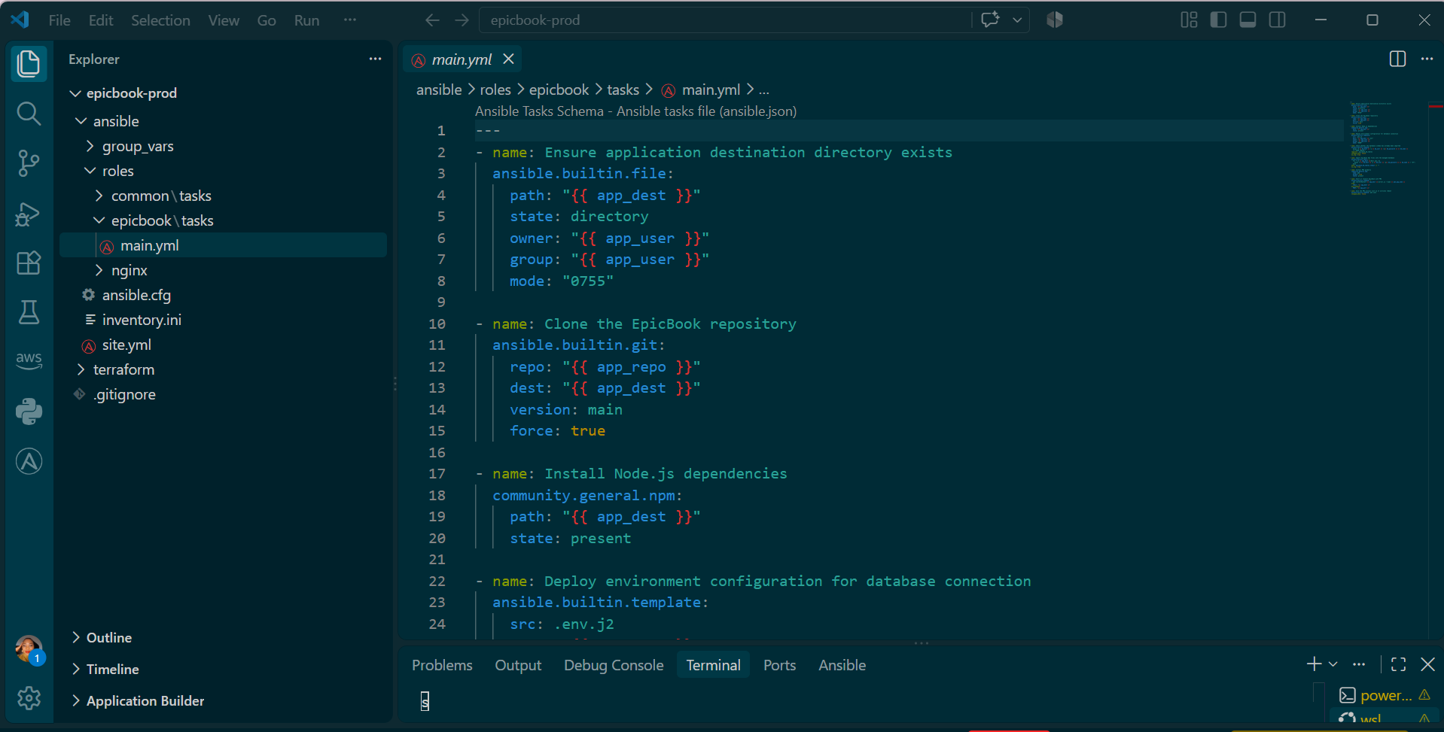
Now create the .env template, which keeps secrets out of the committed template file itself:
bash

cd <your-project-path>/epicbook-prod/ansible/roles/epicbook
mkdir -p templates

BASH ON THE TERMINAL

cat > templates/.env.j2 << 'EOF'
DB_HOST={{ db_host }}
DB_USER={{ db_user }}
DB_PASSWORD={{ db_password }}
DB_NAME={{ db_name }}
PORT={{ app_port }}
EOF

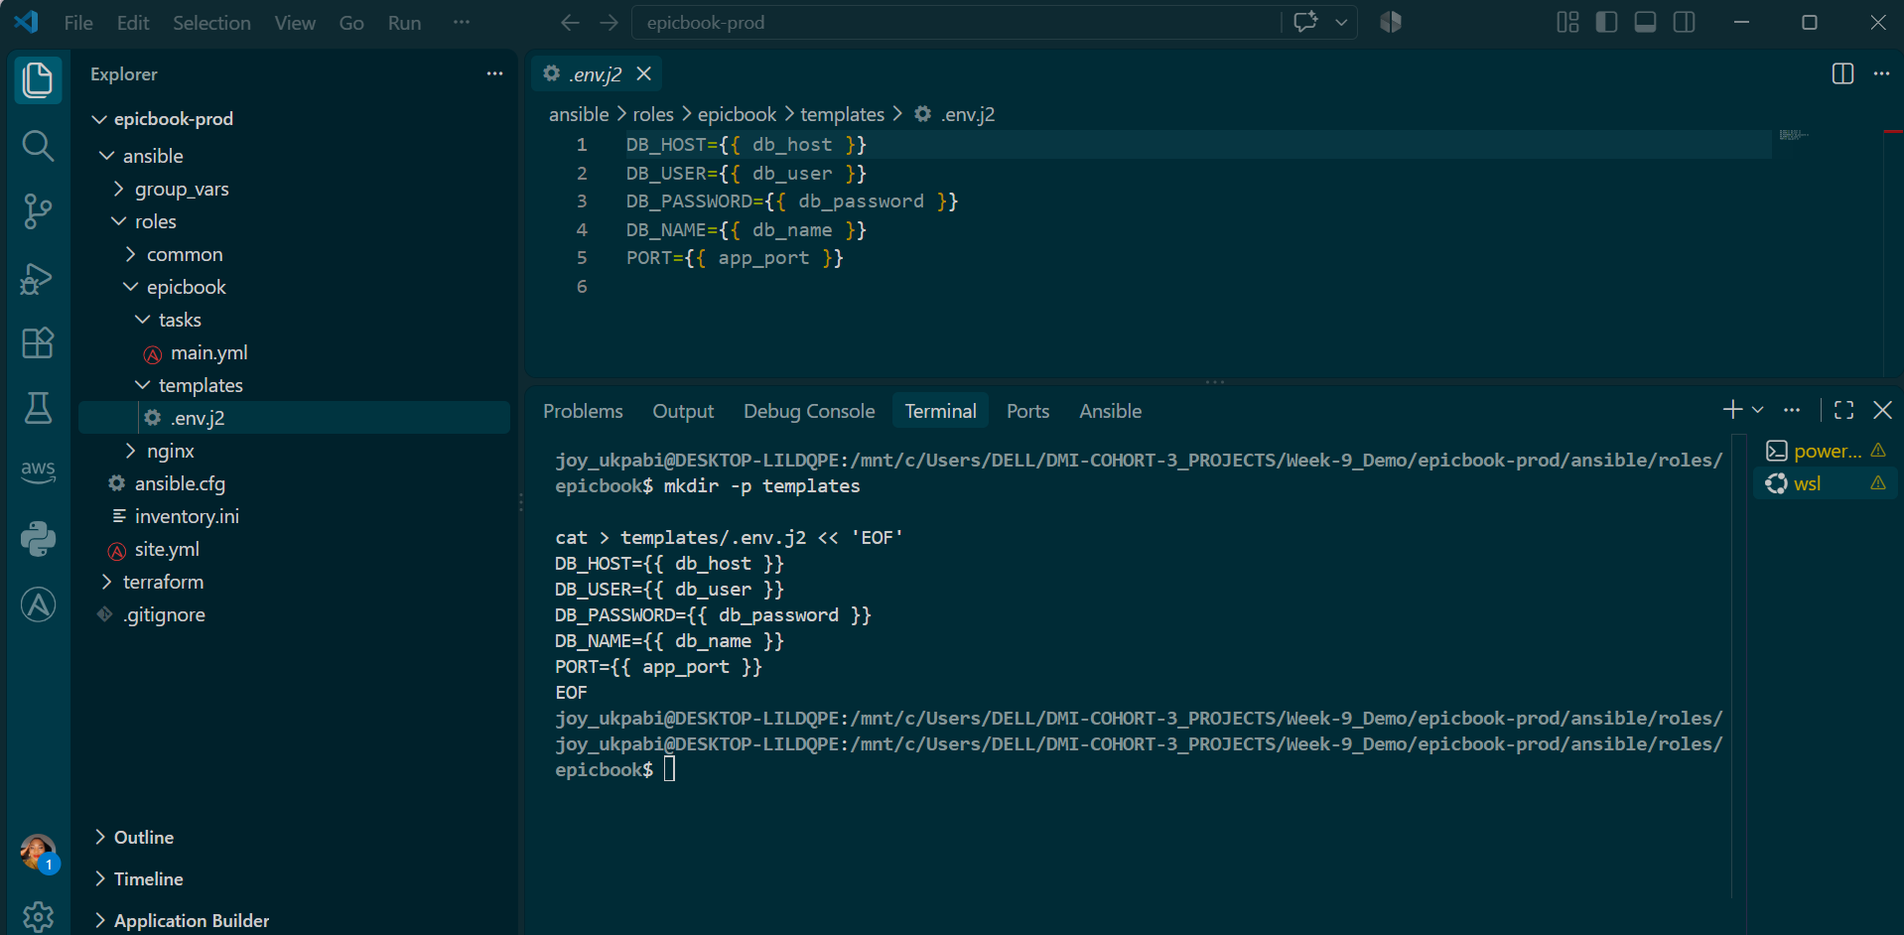
Validate:
bash
cd <your-project-path>/epicbook-prod/ansible
ansible-playbook -i inventory.ini site.yml --syntax-check

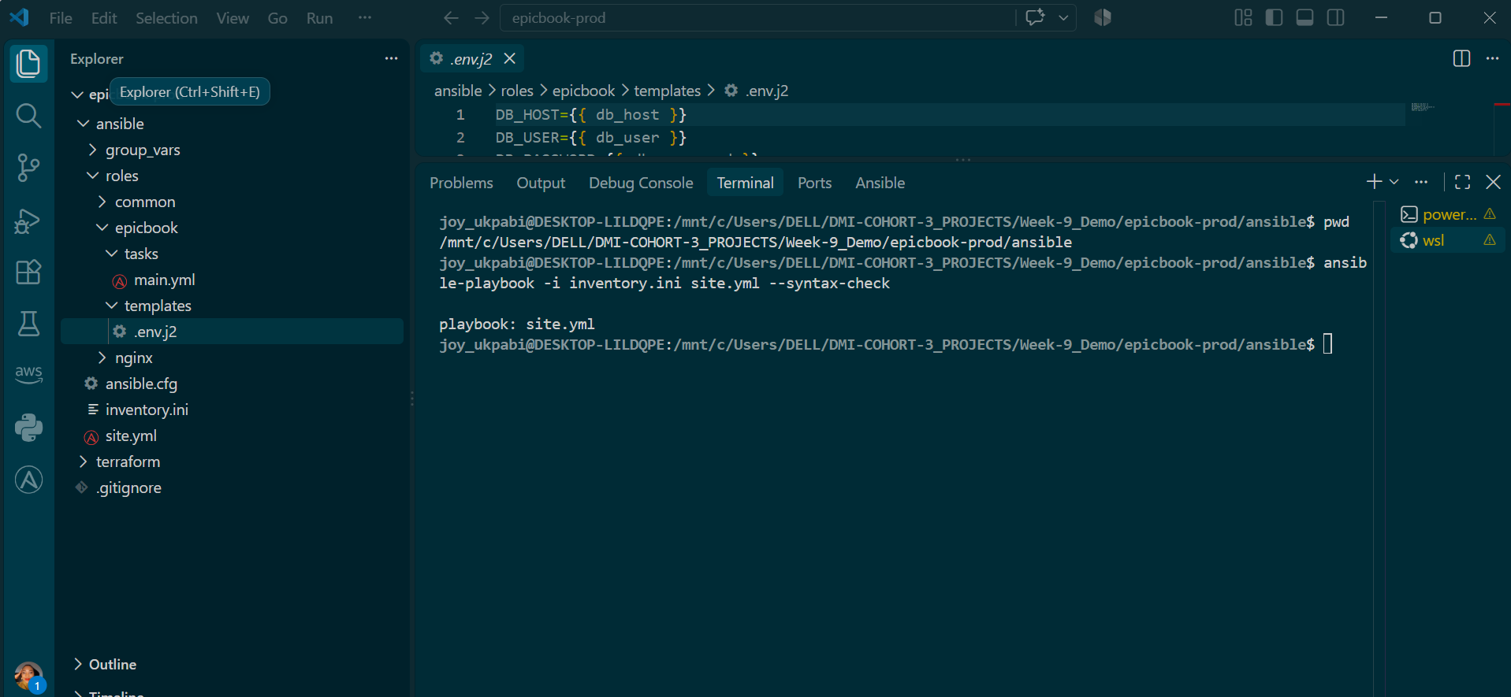

Explanation
The EpicBook role is responsible for getting the application onto the server, connecting it to the database, and starting it.

1. Variables keep the role flexible
Values such as:
app_dest
app_repo
db_host
db_user
db_password
db_name
app_port
pm2_app_name
are variables, not fixed values.
They will be provided through group_vars/web.yml.
This means the role's tasks don't need to change when the environment changes. For example, the database password is not written directly into the task.
Tasks define what to do; variables provide the values to use.

2. Create the application directory and get the code
The role first creates the directory where the application will live.
Then it uses Ansible's git module to download the EpicBook repository.
Using the git module instead of:
git clone ...
makes the task idempotent. If the repository is already there, Ansible doesn't clone it again unnecessarily.

3. Install Node.js dependencies
The role uses:
community.general.npm
to install the application's Node.js dependencies.
This is preferable to simply running:
npm install
through a shell because the Ansible module can check the current state and avoid unnecessary work.
Because npm belongs to the community.general collection, that collection may need to be installed on the Ansible controller:
ansible-galaxy collection install community.general
A syntax check won't detect a missing collection because syntax checking doesn't actually execute the task.

4. Create the .env file
The database information is placed into a .env file using an Ansible template.
For example:
DB_HOST=...
DB_USER=...
DB_PASSWORD=...
DB_NAME=...
The actual values come from the variables.
The password isn't hardcoded into the application code.
The file is also given:
0600
permissions, meaning only the file owner can read or write it.
The basic idea is:
Variables
↓
Ansible template
↓
.env file on server
↓
Node.js application reads environment variables

5. Import the database only when necessary
The database SQL files should not be imported every time Ansible runs.
Otherwise, a second deployment could try to recreate tables that already exist.
Instead, the role first checks:
SHOW TABLES;
If tables already exist:
Database already initialized
↓
Skip SQL import
If no tables exist:
No tables found
↓
Import SQL files
↓
Database initialized
This is an idempotency guard.
In other words:
Only perform the database setup when it hasn't already been done.

6. Why no_log: true?
The database tasks contain sensitive information such as the database password.
no_log: true
prevents Ansible from displaying sensitive task details in the output.
This helps prevent credentials from appearing in terminal output or deployment logs.

Overall flow
Variables
↓
Create application directory
↓
Clone repository
↓
Install Node.js dependencies
↓
Create protected .env file
↓
Check database
↓
Import SQL only if database is empty
↓
Configure/start EpicBook application
The key concept is idempotency: running the role again should bring the server to the required state without unnecessarily repeating or damaging work that has already been completed.

Task 9 — Create Group Variables

Goal
Create group_vars/web.yml to hold every reusable value the common, nginx, and epicbook roles depend on — repository URL, application paths, ports, and database connection details — in one place, using Terraform's outputs where applicable, and without committing the database password in plain text.

Steps
- Go to the ansible directory.
- Create group_vars/web.yml with all non-secret variables, referencing a vault variable for the password rather than a literal value.
- Create group_vars/vault.yml, encrypted via ansible-vault, containing the real database password.
- Discover that Ansible only auto-loads group_vars/ files matching an inventory group name exactly — vault.yml was never being loaded, since no group is named "vault".
- Restructure group_vars/web.yml and group_vars/vault.yml into a group_vars/web/ folder, so both are automatically loaded and merged together for the web group.
- Verify the vault decrypts correctly and the password resolves at runtime.

Commands
First, gather the real values from Terraform's outputs (already available from Task 2):
cd <your-project-path>/epicbook-prod/terraform/aws
terraform output

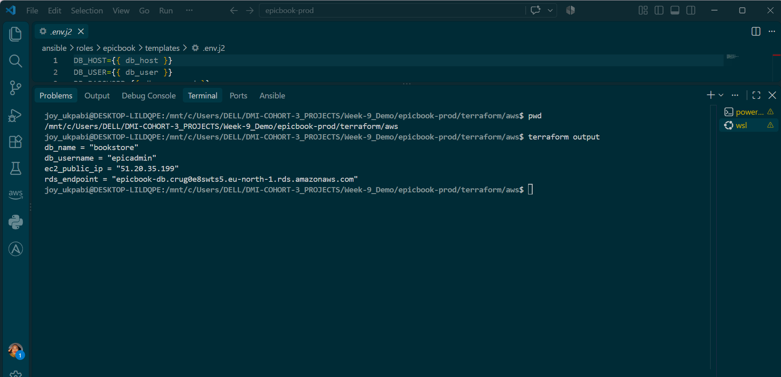

Now build the group vars file:
cd <your-project-path>/epicbook-prod/ansible
nano group_vars/web.yml

Add the following, filling in your own real values from terraform output:
---
# Application
app_repo: https://github.com/pravinmishraaws/theepicbook
app_dest: /home/ubuntu/epicbook
app_user: ubuntu
app_port: 8080
pm2_app_name: epicbook

# Nginx
server_name: 51.20.35.199

# Managed MySQL database (values from terraform output)
db_host: epicbook-db.crug0e8swts5.eu-north-1.rds.amazonaws.com
db_name: bookstore
db_user: epicadmin
db_password: "{{ vault_db_password }}"

Save and exit (Ctrl+O, Enter, Ctrl+X).

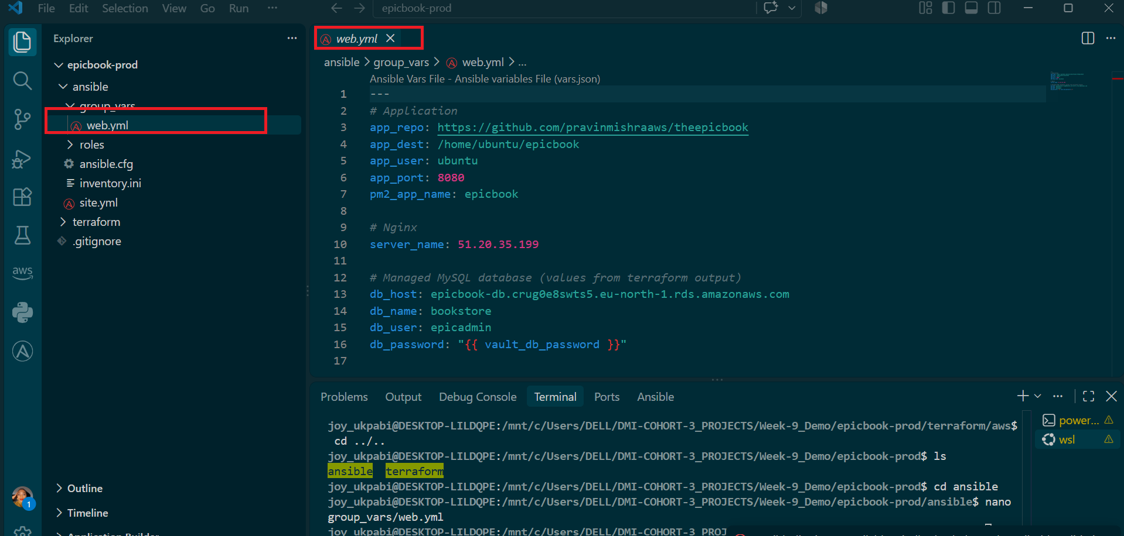
Now create the vaulted file holding the actual password, kept separate from the plain-text file above:
Command
ansible-vault create group_vars/vault.yml

You'll be prompted to set a vault password — remember it, you'll need it every time you run the playbook.

It will prompt:
New Vault password:
Confirm New Vault password:

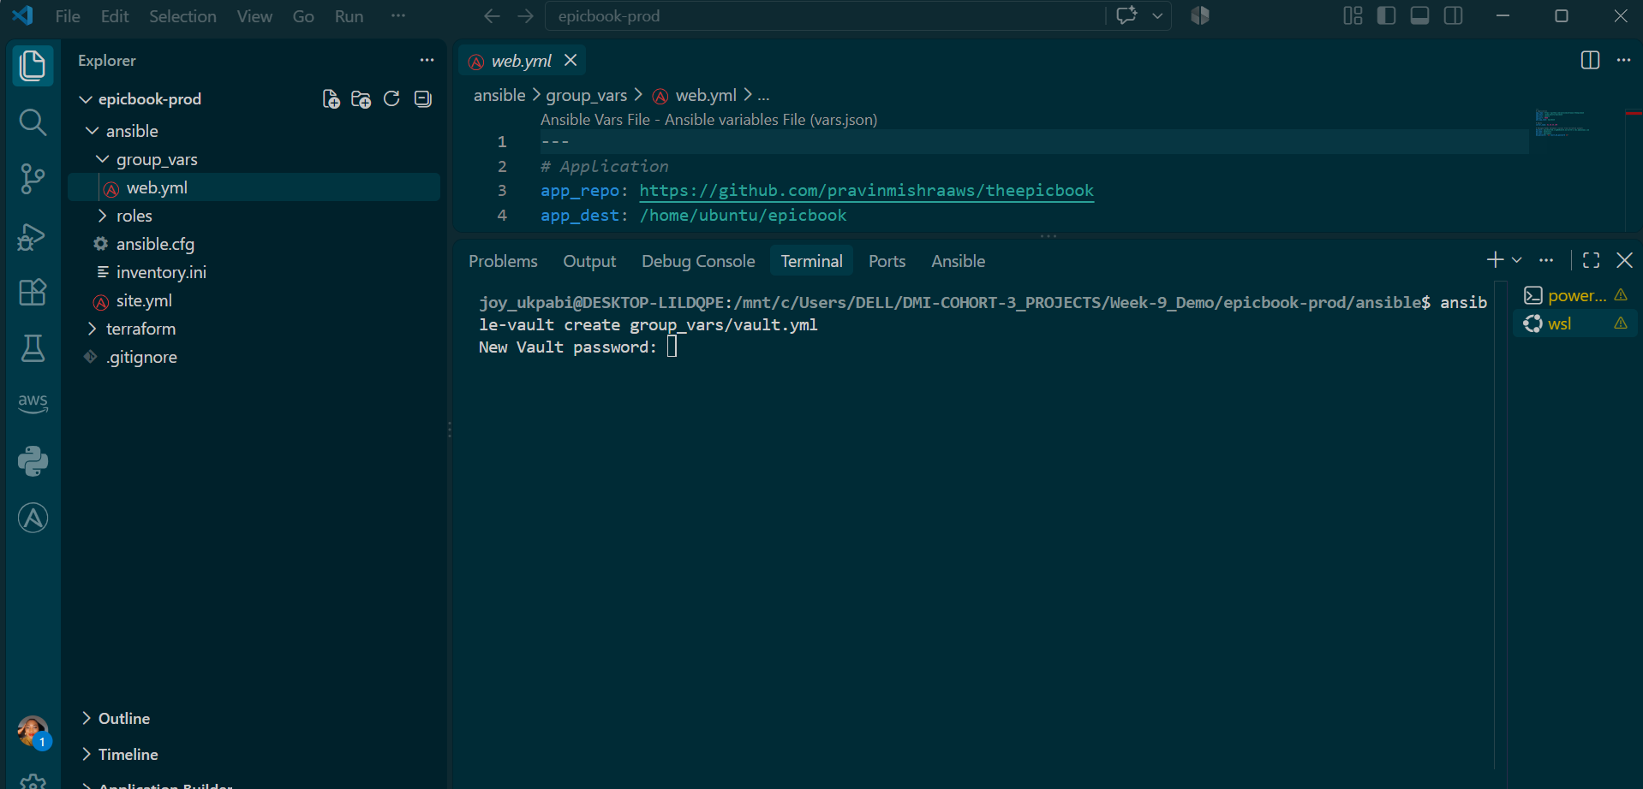
Inside the editor that opens, add:
vault_db_password: <your password>

To save and exit:
- Press Esc (this exits insert/typing mode, if you're in it)
- Type: :wq
- Press Enter

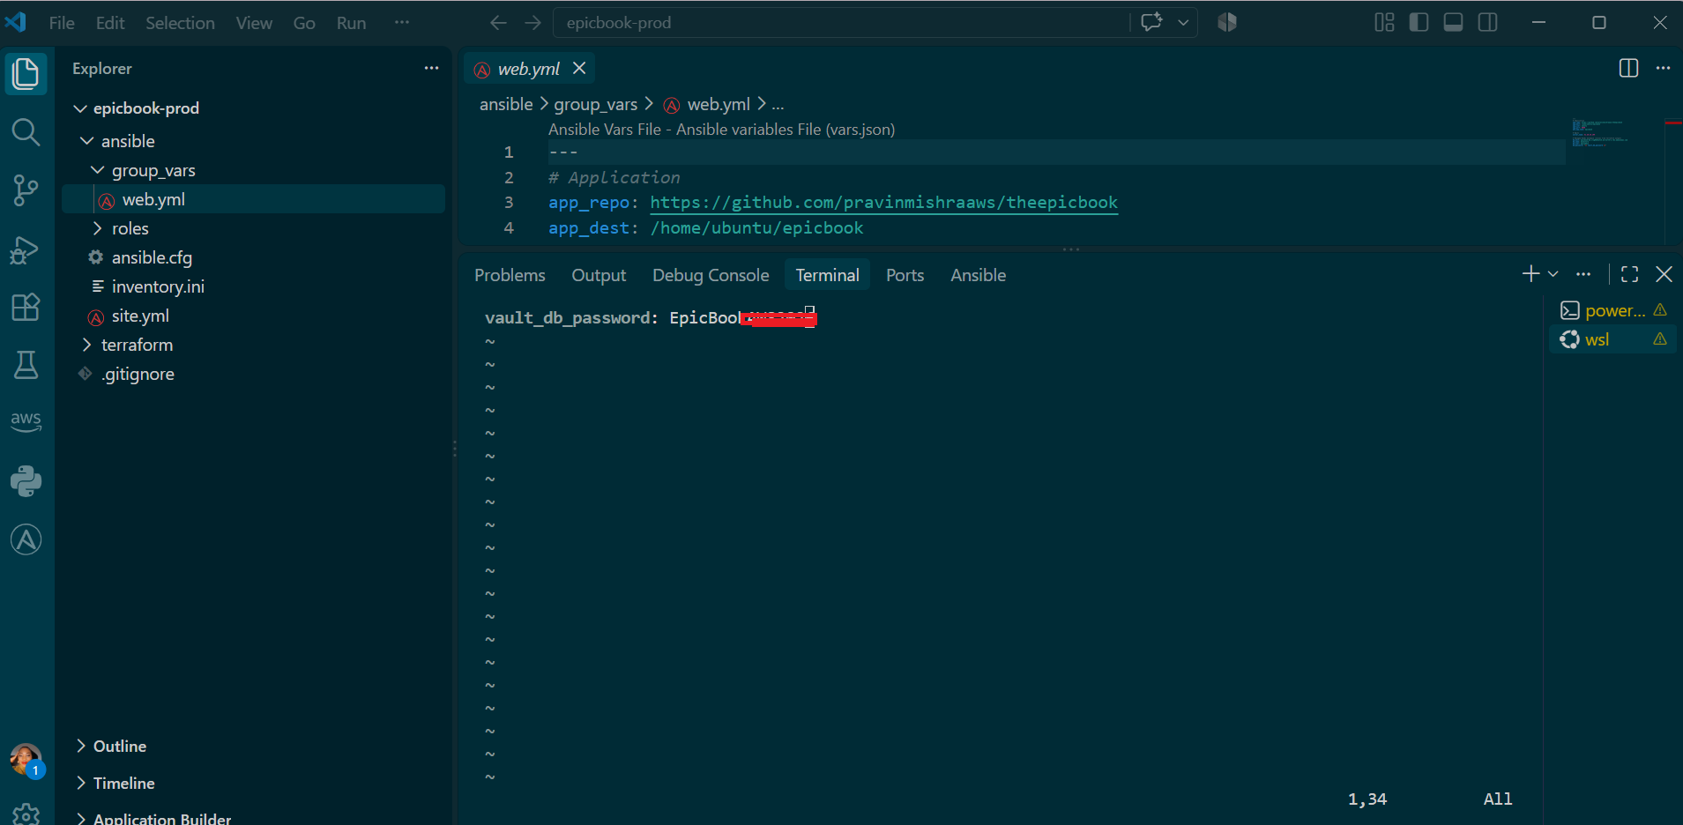

Restructure into a folder so both files are actually loaded:
bash
mkdir group_vars/web
mv group_vars/web.yml group_vars/web/vars.yml
mv group_vars/vault.yml group_vars/web/vault.yml
ls -la group_vars/web/

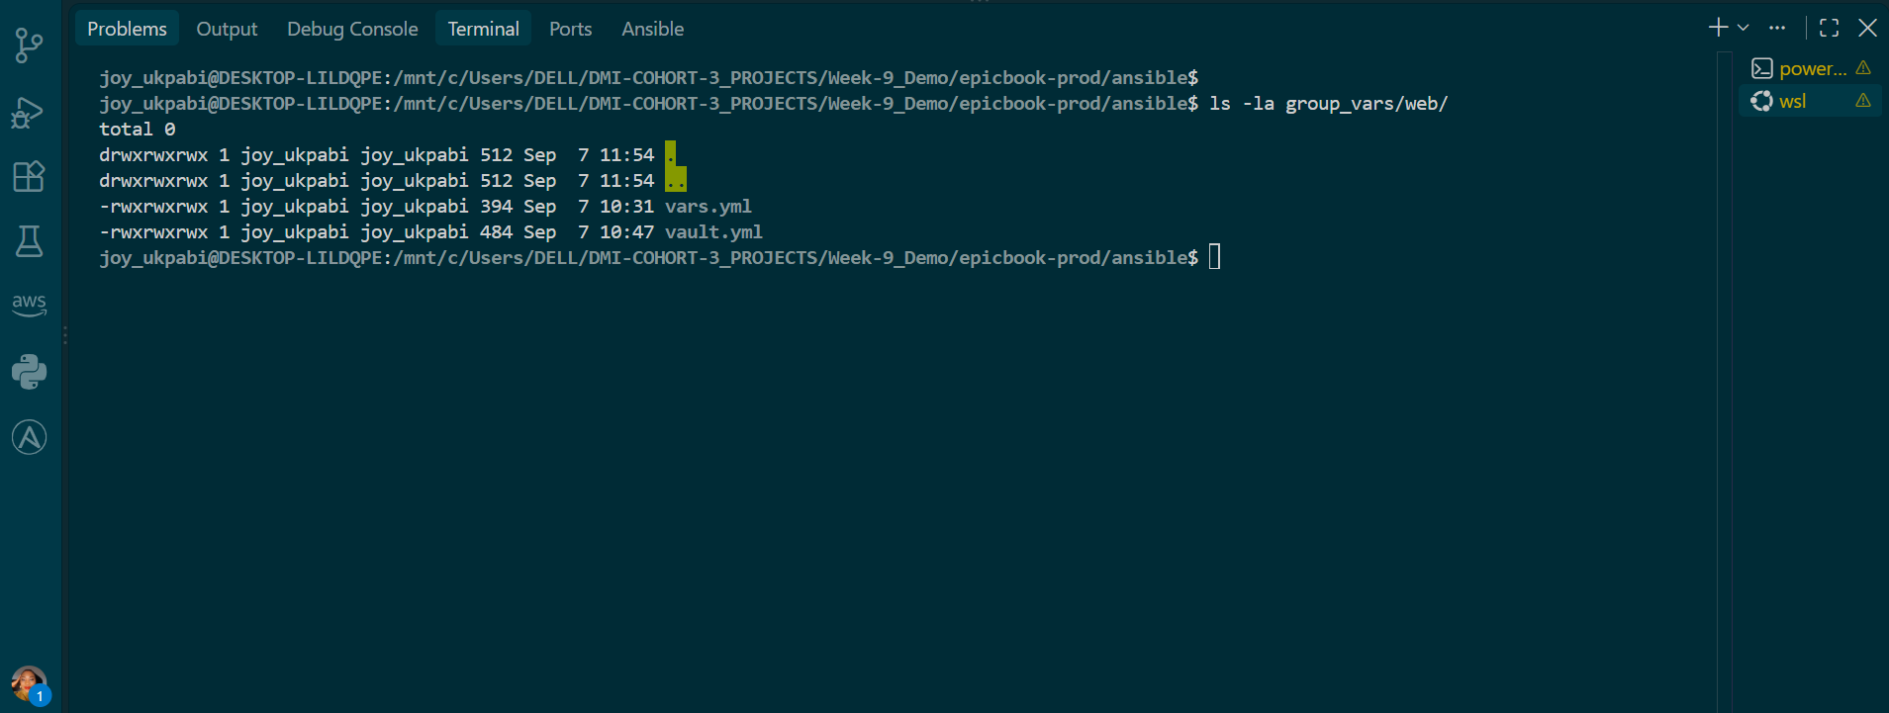

Verify it's encrypted (not readable as plain text):
cat group_vars/vault.yml

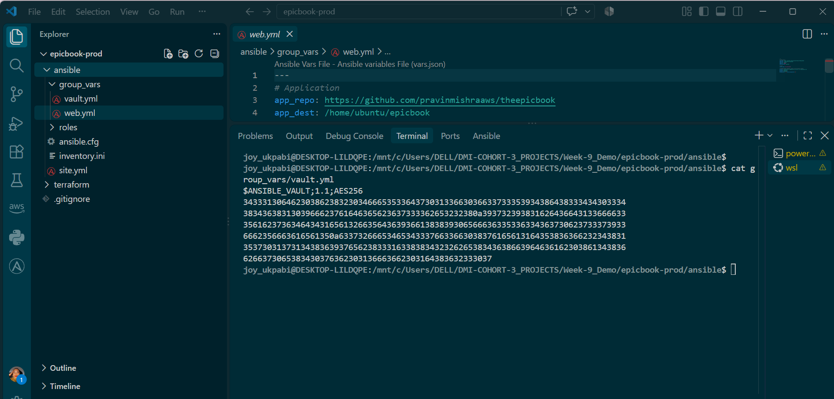

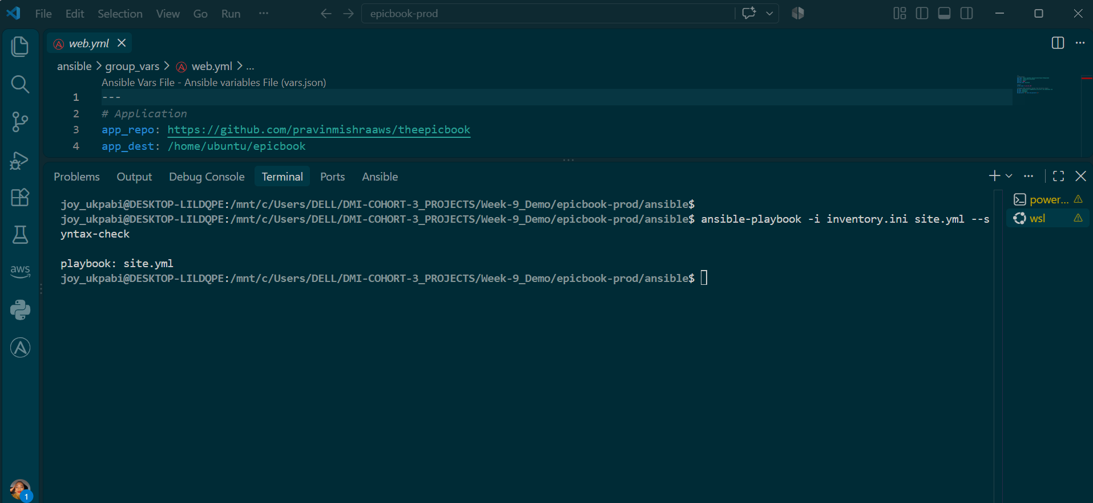

Then, to actually confirm the vault password works and Ansible can decrypt it:
bash
ansible-inventory -i inventory.ini --list --vault-id @prompt

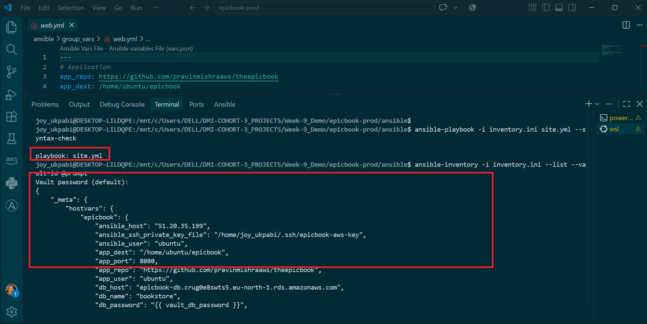

To actually confirm whether the vault decrypted correctly, do a more direct test — use ansible ad-hoc with the debug module, which does fully resolve templates:

ansible web -i inventory.ini -m debug -a "var=db_password" --ask-vault-pass

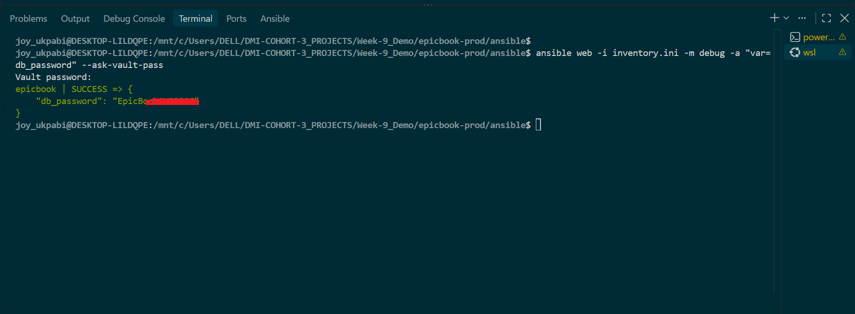

Explanation
The purpose of group_vars is to keep configuration values in one place. Instead of putting values such as the repository URL, application port, or database hostname directly inside the common, nginx, and epicbook roles, the roles use variables. This keeps the roles generic and reusable because their tasks describe what to do, while group_vars provides the values to use.
Some of these values come directly from Terraform's outputs. For example, Terraform creates the database and provides its actual address. Ansible then uses that address when configuring the EpicBook application. This creates a clear handoff between the two tools: Terraform creates the infrastructure, while Ansible configures the servers and connects the application to that infrastructure.
The database password needs different treatment because it should not be stored as plain text in group_vars/web.yml. Instead, Ansible Vault is used to protect it. The normal variables file contains a reference such as db_password: "{{ vault_db_password }}", while the actual password is stored in a separate encrypted Vault file. This keeps the sensitive value protected while still allowing Ansible to use it during deployment.
An important issue was discovered with how Ansible automatically loads group_vars. Ansible associates a group_vars file or directory with an inventory group when their names match. Since the inventory contains a [web] group, group_vars/web.yml was loaded automatically. However, group_vars/vault.yml was not loaded because vault was not an inventory group. The file was encrypted correctly, but Ansible simply did not associate it with the web group.
This caused a particularly important type of configuration problem because it did not necessarily produce an obvious error. When db_password was tested using the Ansible debug module, the reference to vault_db_password remained unresolved instead of returning the actual password. This demonstrates why variable resolution should be deliberately tested rather than assuming that a correctly named file will automatically be loaded.
The solution was to change group_vars from individual files into a directory for the web group. The structure became group_vars/web/vars.yml and group_vars/web/vault.yml. Because both files are now inside the web directory, Ansible knows they belong to the [web] inventory group and automatically loads and combines their variables. The value of db_password in vars.yml can therefore correctly resolve against the encrypted vault_db_password stored in vault.yml.
Running the Ansible command with --ask-vault-pass confirmed that the fix worked. Ansible was able to decrypt the Vault file and resolve db_password to the actual value. The same --ask-vault-pass option will be required when the full playbook is run because the application needs the decrypted database password to create its .env configuration.
The main lesson is that group_vars centralizes configuration, Terraform outputs provide infrastructure information to Ansible, Ansible Vault protects sensitive values, and the group_vars structure must correctly match the inventory groups.

Task 10 — Run the Ansible Playbook
Goal
Run the full site.yml playbook against the VM, executing the common, nginx, and epicbook roles in order, and confirm the entire deployment succeeded — Nginx active, PM2 managing the EpicBook process under the correct production environment, and the application responding on port 8080 with a real connection to the managed MySQL database.

Steps
- Go to the ansible directory.
- Confirm the ANSIBLE_CONFIG environment variable is still set for this session, to avoid Ansible ignoring ansible.cfg due to the "world writable directory" check.
- In the epicbook role, ensure PM2 starts the application with the correct production environment — setting NODE_ENV=production and a JAWSDB_URL connection string — since the application's own Sequelize configuration (config/config.json) expects its database connection this way, rather than as separate DB_HOST/DB_USER variables.
- Run the playbook, supplying the vault password since group_vars/web/vault.yml is encrypted.
- Confirm the final play recap shows failed=0 across all hosts.
- Independently verify Nginx is active.
- Independently verify PM2 shows the EpicBook process running.
- Independently verify the application responds on port 8080 and is actually serving data from the database, not just returning a generic response.

Commands
cd <your-project-path>/epicbook-prod/ansible
echo $ANSIBLE_CONFIG
# If blank, re-export it:
# export ANSIBLE_CONFIG=<your-project-path>/epicbook-prod/ansible/ansible.cfg
The epicbook role's PM2 tasks pass the application's database connection as environment variables directly to the process, matching what the app's own config/config.json expects in production:

Run the playbook:
bash
ansible-playbook -i inventory.ini site.yml --ask-vault-pass

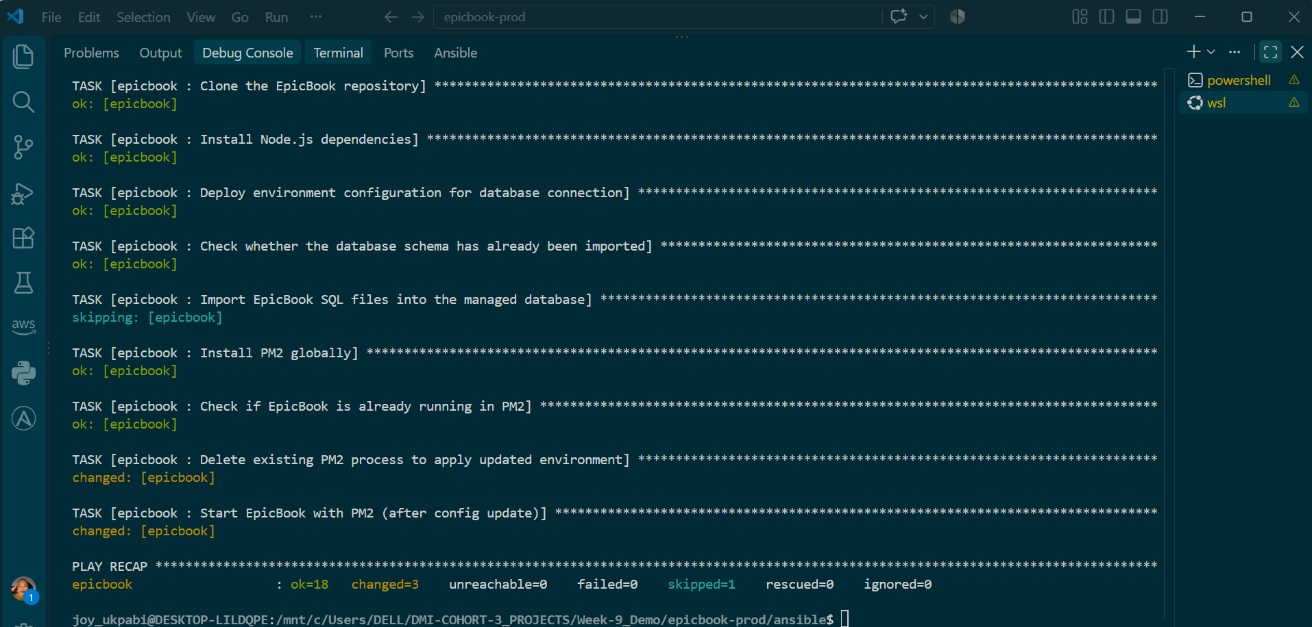

Once complete, run the three independent verification checks — each with --become, since PM2 was run as root during the playbook (via become: true) and maintains a separate process list per user:
ansible web -i inventory.ini -m command -a "systemctl is-active nginx" --become --ask-vault-pass
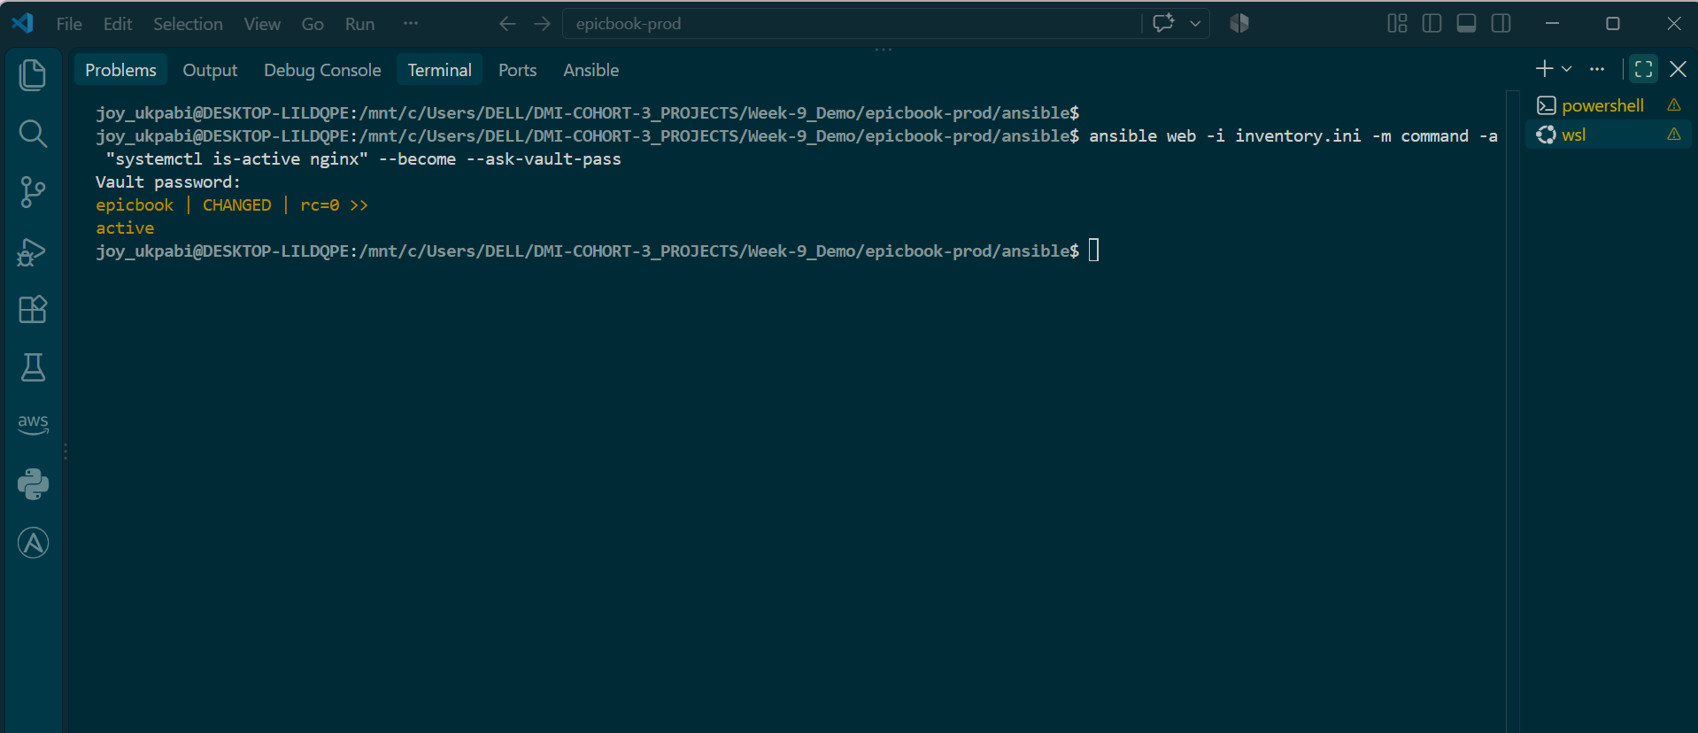
ansible web -i inventory.ini -m command -a "pm2 status" --become --ask-vault-pass
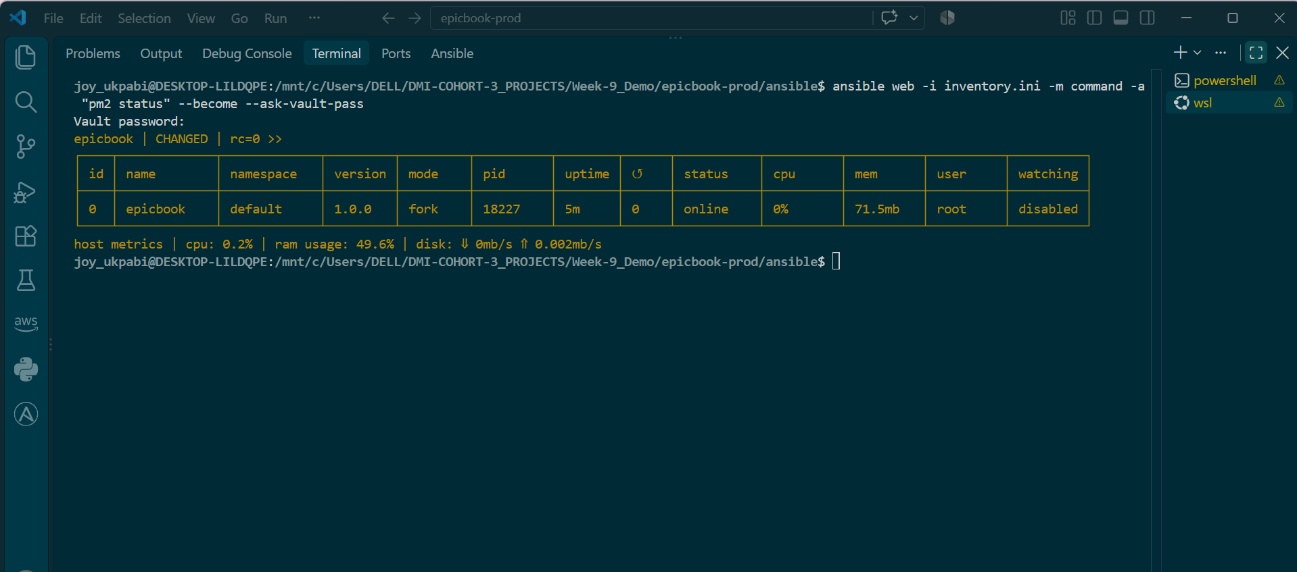

ansible web -i inventory.ini -m command -a "curl -I http://localhost:8080" --become --ask-vault-pass
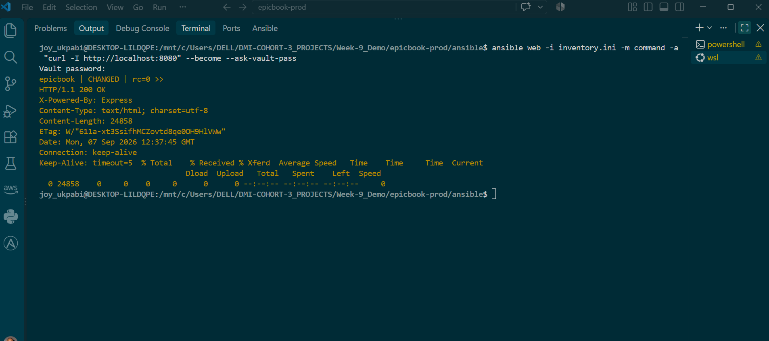
For a deeper look at what the application is actually doing at runtime, its logs confirm real database activity:
ansible web -i inventory.ini -m command -a "pm2 logs epicbook --lines 20 --nostream" --become --ask-vault-pass
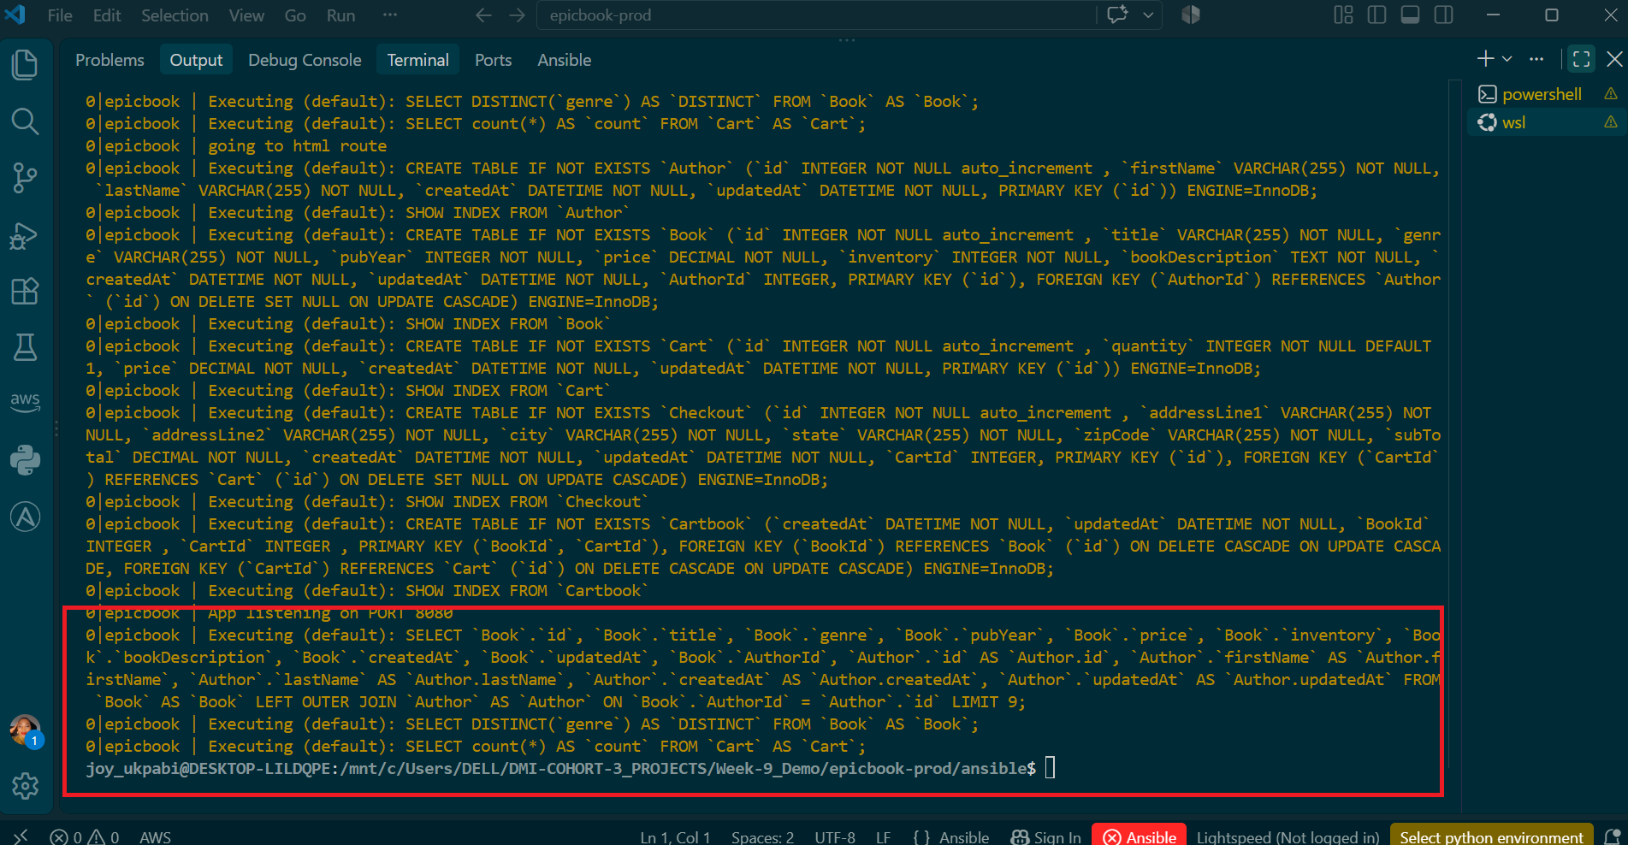

Check application's actual route definitions in it source code
ansible web -i inventory.ini -m command -a "grep -rn \"router.get\|app.get\|router.post\|app.post\" /home/ubuntu/epicbook --include='*.js' --exclude-dir=node_modules" --become --ask-vault-pass

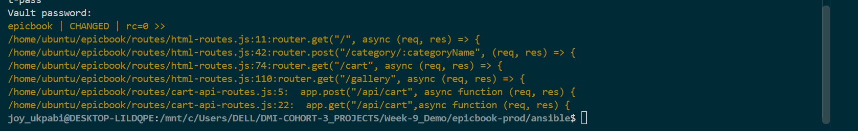

Explanation
Running the full playbook is the point where all the previous work is tested together against a real server. Earlier syntax checks only confirmed that the YAML structure, task files, templates, and role references were valid; they did not prove that the tasks would actually produce a working application. site.yml brings the three roles together in the order established earlier: common prepares the VM with the required baseline tools, nginx installs and configures the reverse proxy, and epicbook deploys and starts the application after the server has been prepared.
The Nginx role remains focused only on the reverse proxy. It installs Nginx, deploys the EpicBook configuration from the template, enables the site, disables the default site, validates the configuration with nginx -t, and ensures the service is running and enabled after reboot. The application itself is handled by the epicbook role. This separation keeps each role responsible for one part of the system and makes troubleshooting easier.
The Nginx template uses variables such as {{ server_name }} and {{ app_port }} rather than hardcoded values. These values come from group_vars/web/vars.yml. Nginx listens on port 80 and forwards requests to the Node.js application on its internal port using proxy_pass. The proxy_set_header directives preserve information such as the original client IP, protocol, and hostname when the request is passed to the application. Because app_port is stored as a variable, changing the application's port does not require editing the Nginx template.
The epicbook role is responsible for getting the application onto the VM and making it ready to run. It creates the application directory, clones the repository using Ansible's git module, installs the Node.js dependencies using community.general.npm, configures the database connection, imports the database schema when necessary, and starts the application with PM2. These tasks also use variables rather than hardcoded values, allowing the same role to be reused with different configuration values.
The database password requires Ansible Vault because it is a sensitive value. The normal variables file contains a reference to vault_db_password, while the actual password is stored in the encrypted Vault file under group_vars/web/. When the full playbook runs, --ask-vault-pass is required so Ansible can decrypt the password and use it when configuring the application. Without the Vault password, Ansible cannot obtain the database credential needed for the application's database connection.
One important issue during this deployment was that the application's database configuration did not work in the way initially expected. Using a .env file with the dotenv package is a common pattern for Node.js applications, but this particular application does not actually load dotenv. Its database configuration is defined in config/config.json and expects the production database connection through a specifically named environment variable containing the full MySQL connection string. This configuration came from the application's original deployment design for a platform-specific MySQL service.
This demonstrates an important deployment principle: the application itself must be inspected before deciding how to configure it. A common pattern cannot automatically be assumed to apply to every application. The correct deployment configuration is determined by how that particular application's source code and configuration files are designed to obtain their database credentials.
The successful Ansible run is confirmed by the play recap, particularly failed=0. This means that all the tasks Ansible was instructed to execute completed without reporting an error. A non-zero changed count is expected during the first deployment because Ansible is installing packages, cloning the repository, creating configuration files, and making other changes that did not previously exist.
However, failed=0 does not prove that the application is healthy. Ansible only knows whether the tasks it executed completed successfully. For example, PM2 can start a Node.js process successfully, but the application could crash a few seconds later because it cannot connect to the database. Ansible would not automatically know about that later failure unless an explicit health check is performed.
This is why the deployment is verified at several different layers. Running systemctl is-active nginx checks the actual Nginx service and confirms that the reverse proxy is running. Running pm2 status checks PM2's process table and confirms that the epicbook process is being managed and is currently online. Running curl -I http://localhost:8080 bypasses Nginx and communicates directly with the Node.js application, confirming that the application is listening and responding on its internal port.
These checks help isolate problems. If the Nginx service check fails, the problem is likely within the Nginx role or its configuration. If PM2 shows the application as stopped or errored, or the direct curl request fails, the problem is likely within the EpicBook deployment or application startup. If the application responds directly but external access still fails, attention can move to the Nginx reverse proxy or the external network path.
The HTTP check itself still does not provide complete proof of application health. A 200 OK response only proves that an HTTP request received a successful response; it does not necessarily prove that the application is correctly communicating with the database or performing its intended functions. For that reason, the application's own runtime logs were examined. Observing the application execute real database queries against the expected tables provides stronger evidence that the application is not merely running but is actually communicating with the database successfully.
The complete deployment can therefore be understood as a chain:
Terraform
↓
Creates infrastructure
↓
Ansible: common
↓
Prepares the VM
↓
Ansible: nginx
↓
Installs reverse proxy
↓
Ansible: epicbook
↓
Deploys and starts application
↓
Nginx → Node.js application
↓
Node.js application → MySQL database
↓
Runtime logs confirm real database activity
The key lesson from Task 10 is that successful automation is not the same as a healthy application. Ansible confirms that its tasks completed, while the follow-up service checks, HTTP test, and application logs confirm that the actual system works across the different layers.

Task 11 — Verify the EpicBook Deployment

Goal
Verify that the EpicBook application is genuinely reachable from outside the VM — not just locally via localhost as tested in Task 10 — confirming it responds correctly over its public IP, that the cart API works end-to-end against the managed database, and that the application renders correctly in a real browser.

Steps
- Test the public HTTP response from the Ansible controller, hitting the VM's public IP directly (through Nginx, not bypassing it as Task 10's localhost checks did).
- Test the cart API by sending a POST request with a real book ID, confirming Nginx correctly proxies API requests through to the application.
- Verify the /cart page returns a successful HTTP status.
- Open the application in a real browser and manually confirm the home page, book browsing, adding to cart, and the cart page all work without visible errors.

Commands
cd <your-project-path>/epicbook-prod/ansible

Test the public HTTP response from the controller

curl -I http://51.20.35.199

http://51.20.35.199


Explanation
This task deliberately re-tests the application from a completely different vantage point than Task 10 did. Every check in Task 10 ran --become directly on the VM against localhost:8080, which proves the application process itself works, but says nothing about whether the public-facing path — internet → security group → Nginx → application — is also correctly configured. Testing against the public IP (51.20.35.199) exercises that entire external path for the first time, going through Nginx's reverse proxy exactly the way a real visitor's browser would, rather than talking to the Node.js process directly.
The cart API test is the most meaningful check in this task, because it exercises the full round trip in one request: the HTTP request has to pass through the security group's open port 80, get correctly proxied by Nginx to the application's internal port 8080 (proving the epicbook.conf.j2 template's proxy_pass configuration is actually correct, not just syntactically valid), be handled by the application's real /api/cart route (confirmed to exist directly from the app's own source code), and finally read and write against the managed RDS database. A successful JSON response here is strong evidence every layer set up across Tasks 2 through 10 is working together correctly, not just individually.
Using bookId: 1 specifically relies on the database actually containing a book with that ID — which traces back to the earlier discovery that this application creates its own schema via Sequelize on first connection, rather than needing the db/*.sql files to be manually imported. Whether seed data (actual book rows, not just table structure) exists depends on how the application seeds itself, which is worth keeping in mind if this specific check returns an empty or error response rather than assuming the whole deployment is broken.
The /cart status check is a simpler, blunter verification — it doesn't inspect content, only confirms the page loads with a 200 rather than a 502 Bad Gateway (which would indicate Nginx can't reach the application) or a 404 (which would indicate a routing problem). This kind of coarse check is useful precisely because it's fast and easy to script repeatedly, complementing the more detailed cart API test rather than replacing it.
Finally, the browser check is the one verification in this entire project that isn't really about infrastructure or automation at all — it's the actual end-user experience the whole deployment exists to produce. Every previous check (curl, pm2 status, database queries in logs) confirms individual technical layers are functioning, but only opening the site in a real browser confirms those layers combine into something a real person could actually use: pages rendering with real styling, book data displaying correctly, the cart interaction actually working when clicked rather than just returning valid JSON to a manually crafted request.

