STEP-BY-STEP SOLUTION

Task 1 — Confirm EpicBook Connectivity and Create the Workspace

Goal
Confirm that your previous EpicBook Ansible project is working before creating the risk-review automation.

Steps
- Activate your existing Python virtual environment.
- Go to your previous EpicBook Ansible directory.
- Confirm Ansible can reach the managed VM.
- Confirm the playbook syntax is valid.
- Create a new workspace for this assignment.
- Create the required folders.

Step 1: Activate your existing Python virtual environment

Commands
cd ~/ansible-onboarding
source .venv/bin/activate
which python

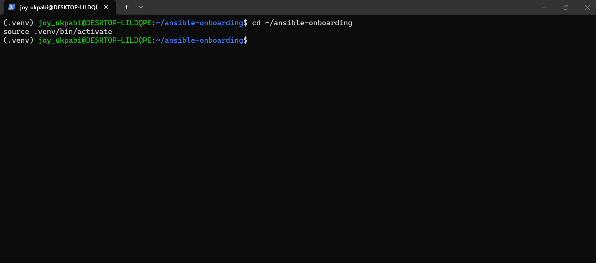

Step 2: Go to your previous EpicBook Ansible directory:
cd ~/ansible-onboarding/epicbook-prod/ansible

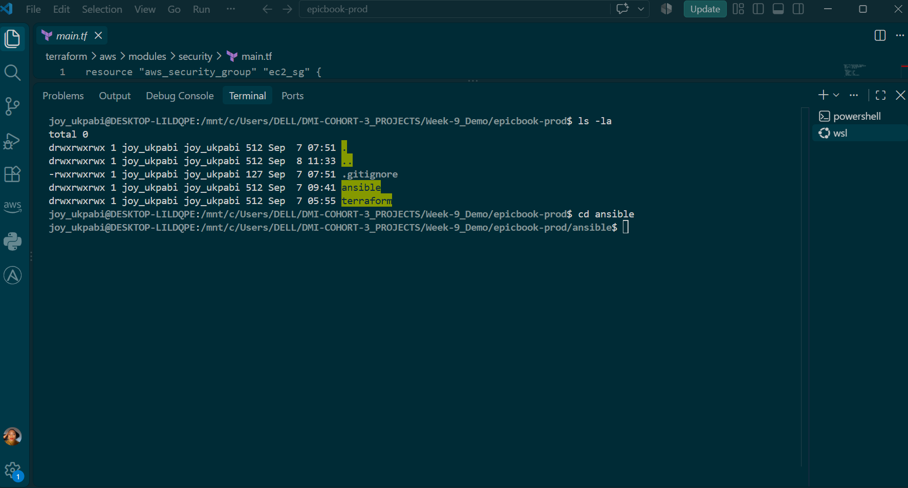

Step 3: Test Ansible connectivity:
ansible web -i inventory.ini -m ping
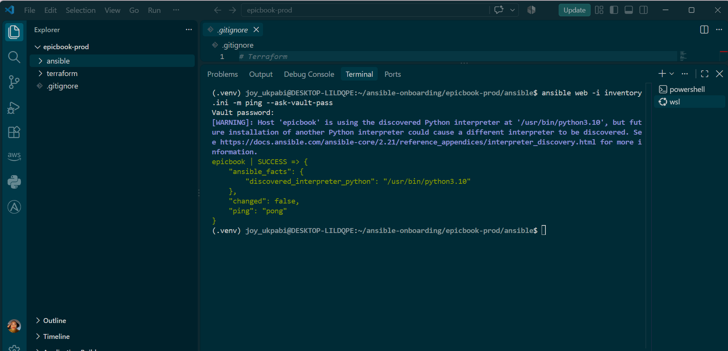

Step 4: Check playbook syntax:
ansible-playbook -i inventory.ini site.yml --syntax-check

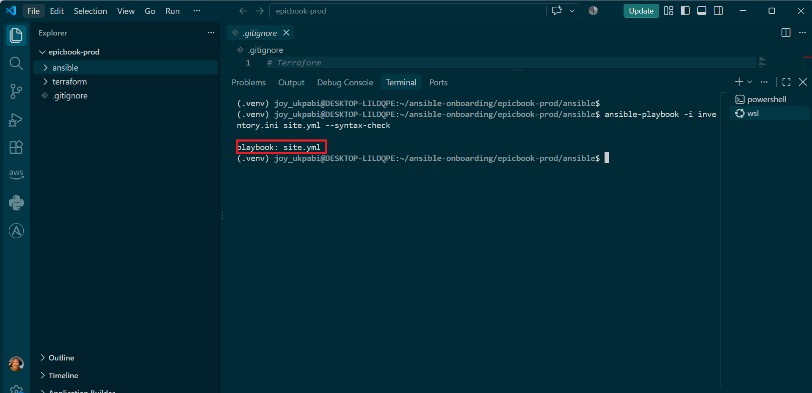
Step 5: Create the assignment workspace:

cd ~/ansible-onboarding
mkdir -p ansible-risk-review/reports
mkdir -p ansible-risk-review/.claude/skills/ansible-risk-review
cd ansible-risk-review

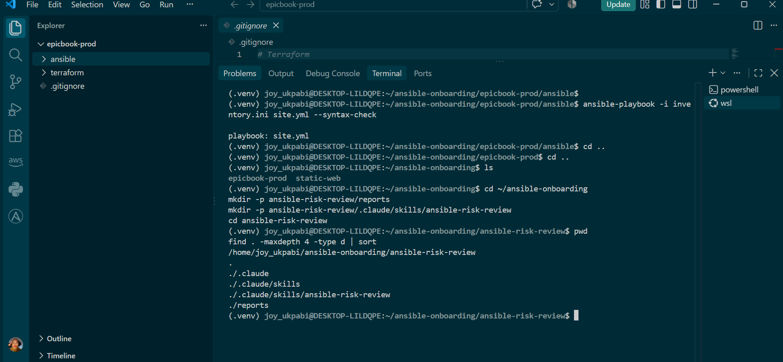

Step 6: Display the workspace structure:
pwd
find . -maxdepth 4 -type d | sort

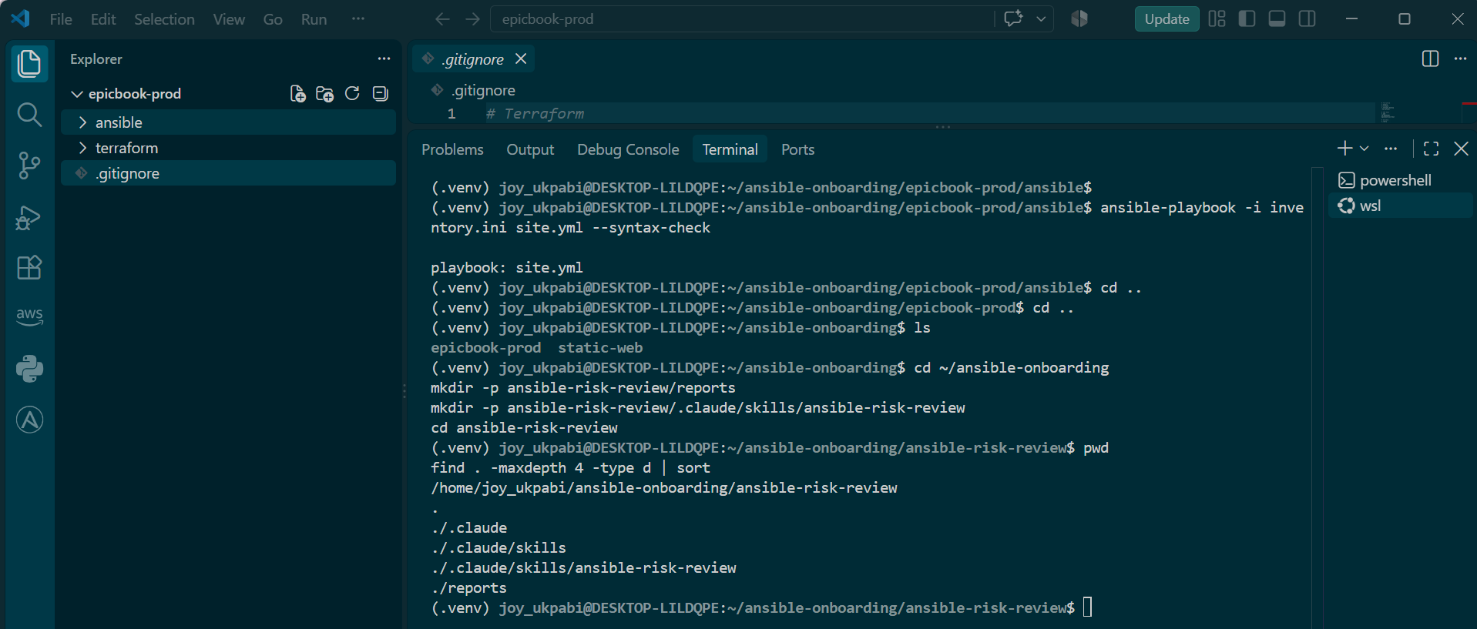

Expected Output
- Ansible ping returns pong.
- Syntax check returns playbook: site.yml.
- The ansible-risk-review workspace is created.
- The reports directory exists.
- The .claude/skills/ansible-risk-review directory exists.

Task 2 — Create Project Context and Safety Rules in CLAUDE.md

Goal
Create a CLAUDE.md file that tells Claude Code how this project must behave.

Steps
- Go to the assignment workspace.
- Create CLAUDE.md.
- Add project context, workflow, safety rules, and output rules.
- Save the file.

Step 1: Go to the assignment workspace:

Commands
Step 1: Navigate to the project folder
cd ~/ansible-onboarding/ansible-risk-review

Step 2: Open CLAUDE.md:
nano CLAUDE.md
Add the following content:
- # Project Overview

- This project builds a read-only Ansible change-risk-review workflow for the EpicBook Ansible project from the previous assignment.

- The Bash script runs ansible-playbook with --check --diff and classifies possible changes before they are applied.

- Claude Code analyzes the generated report and explains the risk. Claude Code must not apply the playbook or make changes automatically.

- # Change Review Workflow

- Always follow this order:

- 1. Gather evidence with an Ansible dry run using --check --diff
- 2. Analyze which changes are risky and why
- 3. Let the human review the report
- 4. The human decides whether to run the real playbook
- 5. Verify the system again after the change

- # Safety Rules

- - Never run ansible-playbook without --check.
- - Never apply, converge, or fix the playbook automatically.
- - Never edit playbook, role, inventory, Terraform, or secret files.
- - Never run ad-hoc commands that change state on the managed VM.
- - Use the generated risk report as the main source of evidence.
- - Recommend whether the change needs review, but do not apply it.
- - Do not call a change safe unless the report supports it.

- # Output Rules

- When analyzing a report, show:

- 1. Overall status
- 2. Every changed task from the report
- 3. Which changed tasks are flagged risky
- 4. The risk category
- 5. The likely impact if applied
- 6. One clear recommendation
Step 4: Save and exit Nano:
- Press CTRL + O
- Press Enter
- Press CTRL + X

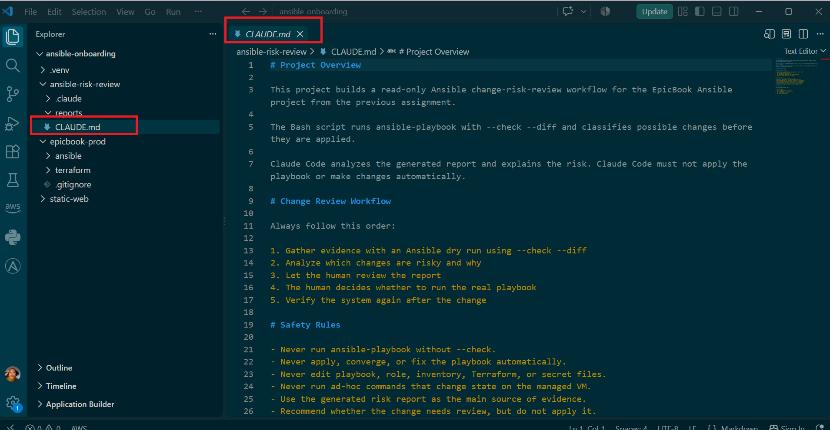

Expected Output
A CLAUDE.md file exists in the assignment workspace and contains project context, workflow, safety rules, and output rules.

Task 3 — Ask Claude Code to Plan the Risk Review

Goal
Use Claude Code to produce a read-only plan before writing the Bash script.

Steps
- Start Claude Code from the assignment workspace.
- Enter the prompt below.
- Review Claude Code’s plan.
- Confirm Claude Code does not create or edit files in this task.

Step 1: Go to the assignment workspace:

Commands
cd ~/ansible-onboarding/ansible-risk-review
Step 2: Start Claude Code:
claude
Enter this prompt in Claude Code:
- Read CLAUDE.md. Do not create or edit any files. Propose a Bash risk-review plan that wraps ansible-playbook --check --diff and classifies changed tasks into exactly four risk categories: service restarts or handlers, firewall changes, user or sudo changes, and package or file removal. For each category, explain what task-name pattern would indicate it and what real-world impact that category has if applied without review.

Explanation
Claude Code was instructed to first read CLAUDE.md and follow its constraints before proposing a solution. The prompt specifically required a read-only review, meaning no files should be created or edited.
It proposed a Bash-based risk-review plan around ansible-playbook --check --diff. The plan identifies changed tasks and classifies them into exactly four risk categories: service restarts or handlers, firewall changes, user or sudo changes, and package or file removal. For each category, it uses task-name patterns to identify potentially risky changes and explains the possible real-world impact if those changes are applied without review.
The command find . -newer CLAUDE.md -type f returned no results, confirming that no files were created or modified after CLAUDE.md was read. This verifies that Claude Code followed both the instructions in CLAUDE.md and the explicit requirement not to create or edit any files.

Expected Output
Claude Code returns a plan with four risk categories:
- Service restarts or handlers
- Firewall changes
- User or sudo changes
- Package or file removal

Task 4 — Build the Ansible Risk Review Script

Goal

Create ansible-check-review.sh — a Bash script that runs the EpicBook playbook in --check --diff (dry-run) mode, parses the output, and classifies any changed tasks into the four risk categories Claude Code reasoned through in Task 3.

Steps
- Create ansible-check-review.sh.
- Add the script below.
- Replace <Your Full Name> with your actual full name.
- Confirm the playbook_path and inventory_path match your previous EpicBook project.
- Save the file.
- Make the script executable.
- Validate the Bash syntax.

Step 1: Go to the assignment workspace:

Commands
cd ~/ansible-onboarding/ansible-risk-review

Step :2 Open the script file:
nano ansible-check-review.sh

Add the following content:
- #!/bin/bash

- set -u

- full_name="<Your Full Name>"

- playbook_path="$HOME/ansible-onboarding/epicbook-prod/ansible/site.yml"
- inventory_path="$HOME/ansible-onboarding/epicbook-prod/ansible/inventory.ini"

- base_dir="$(cd "$(dirname "${BASH_SOURCE[0]}")" && pwd)"
- report_dir="$base_dir/reports"
- report_file="$report_dir/ansible-risk-report.txt"
- raw_output_file="$report_dir/ansible-check-raw.txt"

- checks=(
- check_dry_run_executed
- check_unreachable_or_failed
- check_changed_tasks
- check_service_restarts
- check_firewall_changes
- check_user_and_sudo_changes
- check_removal_changes
- )

- pass_count=0
- warning_count=0
- failure_count=0
- changed_tasks=()
- dry_run_exit_code=0

- mkdir -p "$report_dir"
- : > "$report_file"

- write_line() {
- echo "$1" | tee -a "$report_file"
- }

- mark_pass() {
- write_line "[PASS] $1"
- pass_count=$((pass_count + 1))
- }

- mark_warning() {
- write_line "[WARN] $1"
- warning_count=$((warning_count + 1))
- }

- mark_failure() {
- write_line "[FAIL] $1"
- failure_count=$((failure_count + 1))
- }

- print_header() {
- write_line "========================================"
- write_line "Ansible Change Risk Review"
- write_line "========================================"
- write_line "Full Name: $full_name"
- write_line "Timestamp: $(date -u '+%Y-%m-%dT%H:%M:%SZ')"
- write_line "Playbook: $playbook_path"
- write_line "Inventory: $inventory_path"
- write_line "Mode: --check --diff dry run only"
- write_line ""
- }

- run_dry_run() {
- ansible-playbook "$playbook_path" -i "$inventory_path" --check --diff > "$raw_output_file" 2>&1
- dry_run_exit_code=$?
- }

- check_dry_run_executed() {
- if [ -s "$raw_output_file" ] && grep -q "^PLAY RECAP" "$raw_output_file"
- then
- mark_pass "Dry run executed and produced a PLAY RECAP"
- else
- mark_failure "Dry run did not complete or produced no PLAY RECAP"
- fi
- }

- check_unreachable_or_failed() {
- local recap_line
- local unreachable
- local failed

- recap_line=$(grep -E "unreachable=[0-9]+.*failed=[0-9]+" "$raw_output_file" | tail -n 1)

- if [ -z "$recap_line" ]
- then
- mark_warning "Could not parse unreachable and failed counts from recap"
- return
- fi

- unreachable=$(echo "$recap_line" | sed -E "s/.*unreachable=([0-9]+).*/\1/")
- failed=$(echo "$recap_line" | sed -E "s/.*failed=([0-9]+).*/\1/")

- if [ "$unreachable" -gt 0 ] || [ "$failed" -gt 0 ]
- then
- mark_failure "Recap shows unreachable=$unreachable failed=$failed"
- else
- mark_pass "Recap shows unreachable=0 failed=0"
- fi
- }

- extract_changed_tasks() {
- local raw_changed_lines
- local task_line
- local task_name

- raw_changed_lines=$(awk '
- /^TASK \[/ { task_line = $0; printed = 0; next }
- /^changed: \[/ && !printed { print task_line; printed = 1 }
- ' "$raw_output_file")

- changed_tasks=()

- while IFS= read -r task_line
- do
- [ -z "$task_line" ] && continue
- task_name=$(echo "$task_line" | sed -E "s/^TASK \[(.*)\][ ]*\*+$/\1/")
- changed_tasks+=("$task_name")
- done <<< "$raw_changed_lines"
- }

- check_changed_tasks() {
- local changed_count="${#changed_tasks[@]}"

- if [ "$changed_count" -eq 0 ]
- then
- mark_pass "No changed tasks detected"
- else
- mark_warning "$changed_count changed task(s) detected - review before applying"
- for task_name in "${changed_tasks[@]}"
- do
- write_line " - would change: $task_name"
- done
- fi
- }

- check_tasks_matching_pattern() {
- local pattern="$1"
- local label="$2"
- local matches=()
- local task_name

- for task_name in "${changed_tasks[@]}"
- do
- if echo "$task_name" | grep -qiE "$pattern"
- then
- matches+=("$task_name")
- fi
- done

- if [ "${#matches[@]}" -eq 0 ]
- then
- mark_pass "No $label tasks among the changes"
- else
- mark_failure "${#matches[@]} $label task(s) found in the changed set"
- for task_name in "${matches[@]}"
- do
- write_line " - risky ($label): $task_name"
- done
- fi
- }

- check_service_restarts() {
- check_tasks_matching_pattern "restart|reload|handler|service" "service-restart"
- }

- check_firewall_changes() {
- check_tasks_matching_pattern "firewall|ufw|iptables|nftables|security group" "firewall"
- }

- check_user_and_sudo_changes() {
- check_tasks_matching_pattern "user|group|sudoer|sudo|passwd|password" "user/sudo"
- }

- check_removal_changes() {
- check_tasks_matching_pattern "remove|absent|delete|uninstall|purge" "removal"
- }

- print_summary() {
- local overall_status
- local script_exit_code

- if [ "$failure_count" -gt 0 ]
- then
- overall_status="FAIL - risky changes present, do not apply without review"
- script_exit_code=2
- elif [ "$warning_count" -gt 0 ]
- then
- overall_status="WARN - changes present, review recommended"
- script_exit_code=1
- else
- overall_status="HEALTHY - no changes detected"
- script_exit_code=0
- fi

- write_line ""
- write_line "Summary:"
- write_line "PASS: $pass_count"
- write_line "WARN: $warning_count"
- write_line "FAIL: $failure_count"
- write_line "Overall Status: $overall_status"
- write_line "Script Exit Code: $script_exit_code"
- write_line "Report File: $report_file"
- write_line "Raw Ansible Output: $raw_output_file"

- return "$script_exit_code"
- }

- print_header
- run_dry_run
- extract_changed_tasks

- for check_function in "${checks[@]}"
- do
- "$check_function"
- done

- print_summary
- exit $?
Save and exit Nano:
- Press CTRL + O
- Press Enter
- Press CTRL + X
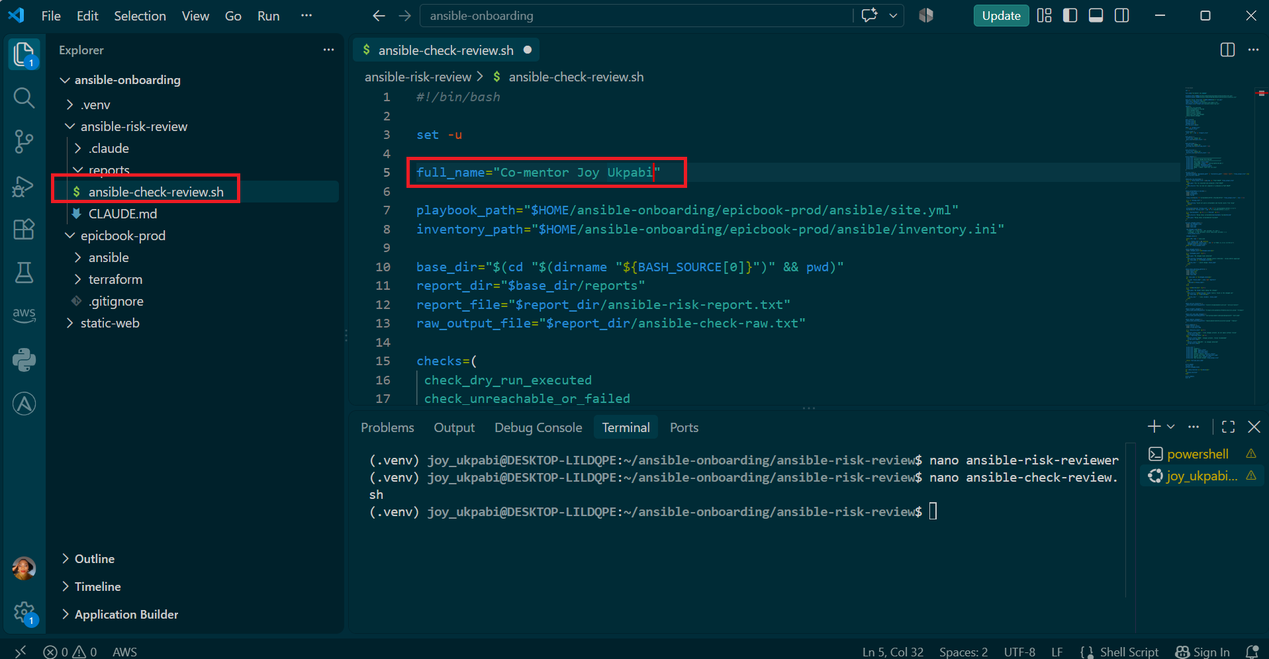
Step 3: Make the script executable:
chmod +x ansible-check-review.sh

Step 4: Validate Bash syntax:
bash -n ansible-check-review.sh

Step 5:Check the file permission:
ls -l ansible-check-review.sh

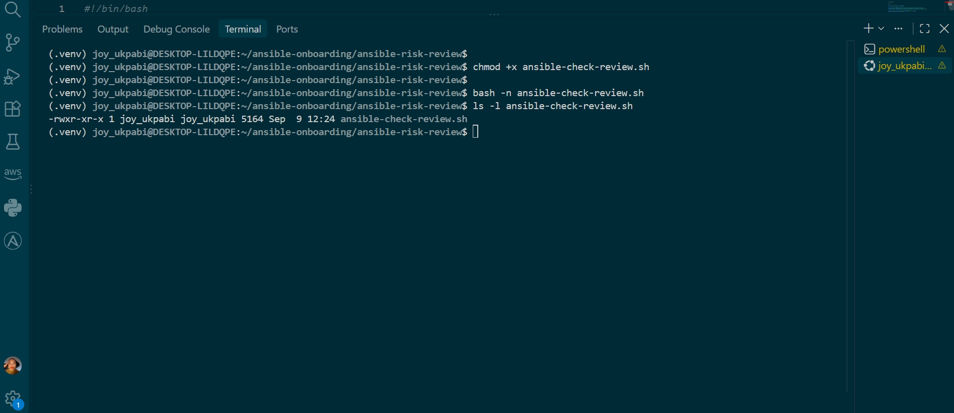

Explanation

Section 1 — Setup

This section defines the script's name, the locations of the Ansible playbook and inventory, the report files, and the list of checks the script will run. It also uses the script's own directory as the base location so the report path works regardless of where the script is executed from.

Section 2 — State Tracking and Output Helpers

This section initializes counters for passes, warnings, and failures, along with an array for storing changed tasks. It also creates the report directory and provides helper functions that display each result on screen while saving it to the report file.

Section 3 — Header and Dry Run

print_header() adds basic information such as the user's name, timestamp, playbook, inventory, and dry-run mode to the report.

run_dry_run() runs the playbook with --check --diff. Ansible simulates the changes without applying them, while --diff shows the differences for files that would be changed. The output is saved for later analysis, and the exit code is captured.

Section 4 — Verify the Dry Run

The first check confirms that Ansible completed successfully by looking for the PLAY RECAP in the output.

The second check examines the recap for unreachable and failed hosts. If either value is greater than zero, the script reports a failure; otherwise, the check passes.

Expected Output
- bash -n ansible-check-review.sh returns no syntax errors.
- ansible-check-review.sh has executable permission.
- The script includes variables, arrays, functions, awk, sed, conditionals, and exit codes.

Task 5 — Run the Baseline Dry-Run Review

Goal
Run the script against your current EpicBook playbook and confirm the baseline risk status.

Steps

- Run the risk-review script.
- Capture the exit code immediately.
- Display the generated report.
- Review the result before continuing.

Step 1: Go to the assignment workspace:
cd ~/ansible-onboarding/ansible-risk-review
Step 2: Run the script:
./ansible-check-review.sh
Step 3: Capture the exit code:
script_exit_code=$?
echo "Captured Exit Code: $script_exit_code"

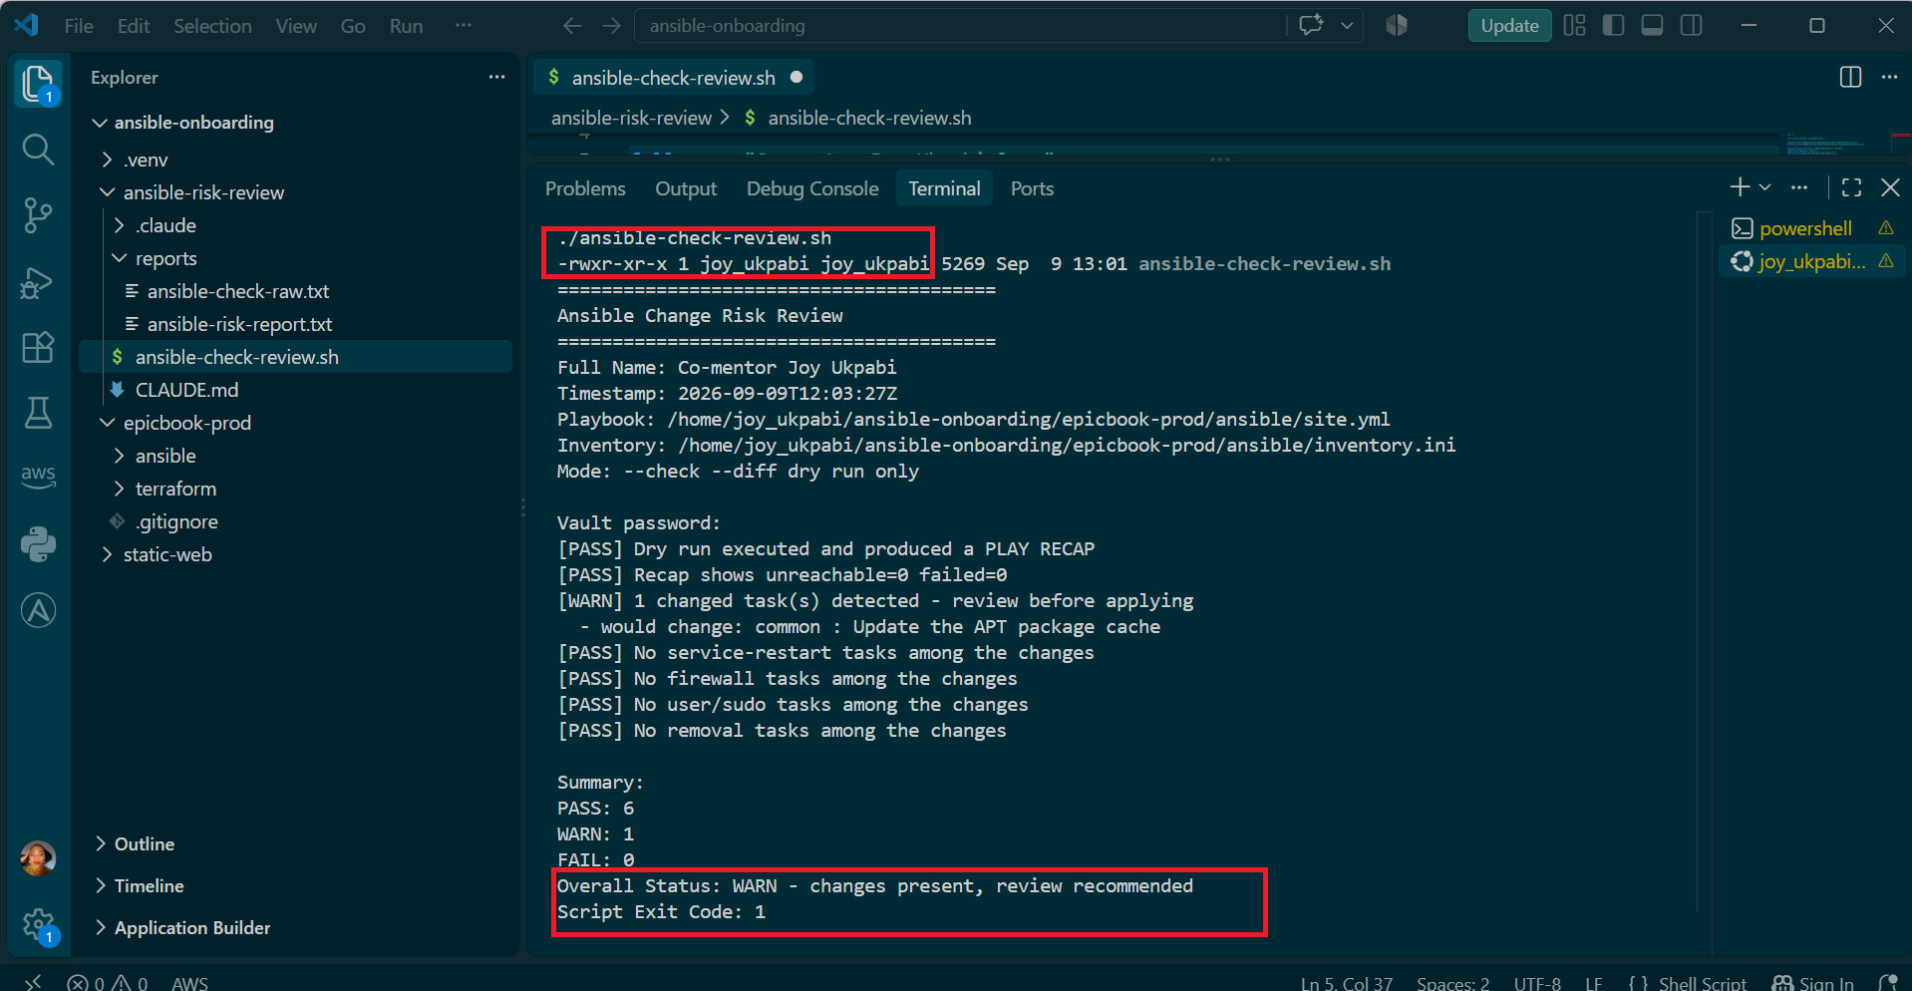

Step 4: Display the report:
cat reports/ansible-risk-report.txt

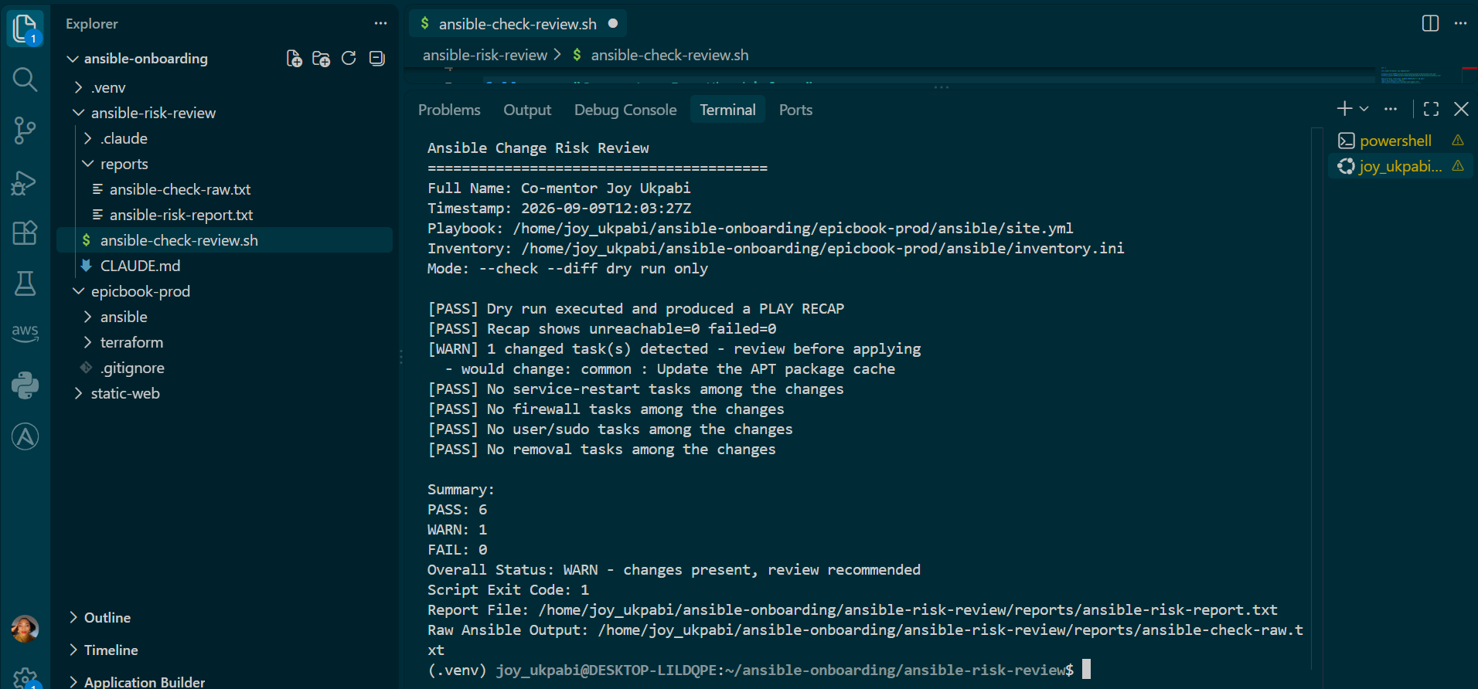

Explanation
This check was necessary to review the Ansible playbook before applying any real changes to the servers. Instead of immediately running the playbook normally, the risk-review script runs it in --check --diff mode. This allows us to identify what Ansible intends to change and determine whether any of those changes fall into the four defined risk categories: service restarts or handlers, firewall changes, user or sudo changes, and package or file removal.
Before running the script, the following commands were used:
bash -n ansible-check-review.sh
This checks the Bash script for syntax errors without executing it. Since there was no error, the script syntax was valid.
ls -l ansible-check-review.sh
This confirms that the script exists and shows its permissions. The output -rwxr-xr-x confirms that the script has execute permission.
./ansible-check-review.sh
This runs the risk-review script. The script executes the EpicBook playbook using --check --diff, saves the raw Ansible output, checks for failures, identifies changed tasks, and classifies those changes.
The dry run completed successfully, with 0 unreachable hosts and 0 failed tasks. Ansible detected one task that would make a change:
common : Update the APT package cache
Because a change was detected, the script marked the result as WARN. However, the change did not belong to any of the four high-risk categories, so all four risk checks passed.
The final result was:
- PASS: 6 — all required checks completed successfully.
- WARN: 1 — one change was detected and should be reviewed.
- FAIL: 0 — no hosts were unreachable and no tasks failed.
- Overall Status: WARN — changes were found, so review is recommended before applying the playbook.
- Exit Code: 1 — the script signals that the result requires attention rather than being treated as completely clean.
The script also saved the detailed results in ansible-risk-report.txt and the complete Ansible dry-run output in ansible-check-raw.txt. This provides an audit trail of exactly what was reviewed before any real changes are applied.

Expected Output
- Your Full Name appears in the report.
- The dry run executes successfully.
- The report includes a PLAY RECAP check.
- The report shows unreachable=0 and failed=0.
- Overall Status is HEALTHY, WARN, or FAIL.
If the baseline result is FAIL, review the risky task before continuing. Some existing playbooks may include handlers or restart tasks, so explain the result clearly in your notes.

Task 6 — Create and Run the Claude Code Skill
Goal
Turn the Bash script into a reusable Claude Code skill — /ansible-risk-review — so instead of manually running the script and then separately asking Claude Code to interpret it, a single command does both: run the dry run, then have Claude Code read and explain the report.

Command

Steps
- Create the skill file.
- Add the skill definition.
- Restart Claude Code from the assignment workspace.
- Run /ansible-risk-review.
- Confirm Claude Code analyzes the report without applying changes.

Step 1: Go to the assignment workspace:

Commands
cd ~/ansible-onboarding/ansible-risk-review

Step 2: Open the skill file:
nano .claude/skills/ansible-risk-review/SKILL.md
Add the following content:
- ---
- name: ansible-risk-review
- description: Run the read-only Ansible check and diff review script, analyze the generated report, and recommend whether the playbook needs human review before applying. Never runs the playbook without --check.
- allowed-tools: Bash, Read, Grep
- disable-model-invocation: true
- ---

- # Ansible Risk Review Skill

- When /ansible-risk-review is invoked:

- 1. Read CLAUDE.md before doing anything else.

- 2. Run:

- bash ansible-check-review.sh || true

- 3. Read:

- reports/ansible-risk-report.txt
- reports/ansible-check-raw.txt

- 4. Report:

- - Overall status
- - Every changed task from the report
- - Which tasks are flagged risky
- - The risk category
- - The likely real-world impact
- - One clear recommendation

- 5. If no changes were detected, clearly state that the playbook appears to be a no-op against the current server state.

- 6. Do not edit files.

- 7. Do not use sudo.

- 8. Never run ansible-playbook without --check.

- 9. Never apply, converge, or fix anything automatically.

- 10. Ask the human to review the report and run the real ansible-playbook command only if they decide to proceed.
Step 3: Save and exit Nano:
Press CTRL + O
Press Enter
Press CTRL + X

Step 4: Start a new Claude Code session:
claude
Step 5: Run the skill:
/ansible-risk-review

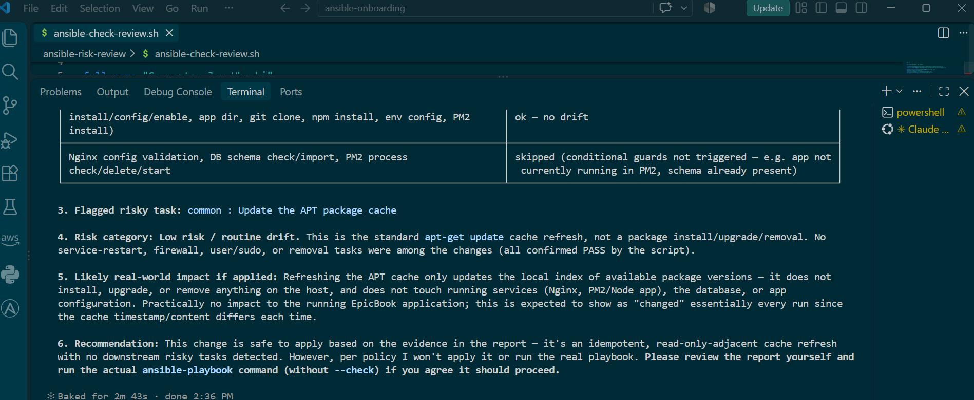

Explanation

The Claude Code skill was run with:
/ansible-risk-review
Claude Code successfully ran the Ansible risk-review script and read the generated report and raw Ansible output. It confirmed the overall result as WARN — changes present, review recommended, based on unreachable=0, failed=0, one changed task, 13 ok tasks, and 6 skipped tasks.
The changed task was clearly identified as:
common : Update the APT package cache
Claude Code did not run the real playbook without --check, and it did not create or modify any files. This confirms that the skill followed the read-only safety requirements defined in CLAUDE.md.
The task breakdown was presented in a table, making the changed task and its status easy to review.
Overall, this confirms that the complete workflow worked as intended:
Ansible playbook → Bash dry run → risk report → Claude Code analysis
Claude Code was able to investigate the result and provide a review without making changes. This maintains the intended safety boundary: identify and recommend, but do not automatically fix.

Task 7 — Introduce a Controlled Risky Change and Let the Skill Catch It

Goal
Add a small controlled risky change in your lab playbook and confirm the script and Claude Code catch it before applying.

Warning
Do this only in your own lab environment.

Steps
- Create a temporary file on the managed VM.
- Add one Ansible task that removes that temporary file.
- Run the dry-run script.
- Run /ansible-risk-review.
- Confirm the risky change is detected.
- Save the risky-change report before applying anything.

Step 1: Go to your previous EpicBook Ansible directory:

Commands

cd ~/ansible-onboarding/epicbook-prod/ansible
Step 2: Create a temporary file on the managed VM:

ansible web -i inventory.ini -m file -a "path=/tmp/epicbook-risk-test state=touch" --become

Open one role task file.
Example:
- nano roles/common/tasks/main.yml
Add this task at the end of the file:
- - name: Remove temporary EpicBook risk test file
- file:
- path: /tmp/epicbook-risk-test
- state: absent
Save and exit Nano:
- Press CTRL + O
- Press Enter
- Press CTRL + X
Go back to the risk-review workspace:
- cd ~/ansible-onboarding/ansible-risk-review
Run the script:
- ./ansible-check-review.sh
View the report:
- cat reports/ansible-risk-report.txt
Start Claude Code if it is not already open:
- claude
Run:
- /ansible-risk-review
After Claude Code finishes, save the risky-change report:
- cp reports/ansible-risk-report.txt reports/risky-change-report.txt
- cat reports/risky-change-report.txt

Expected Output
- The dry run shows the new task would change the managed VM.
- The report flags the task under the removal risk category.
- Claude Code identifies the risky task.
- Claude Code recommends review before applying.
- reports/risky-change-report.txt is created.

Task 8 — Apply as the Human, Verify, and Write the Change Summary

Goal
Review the risky-change report, apply the playbook manually as the human operator, and verify the result.

Steps
- Review the risky-change report.
- Decide whether the controlled lab change is acceptable.
- Run the playbook for real yourself.
- Verify Ansible connectivity again.
- Run /ansible-risk-review again.
- Save the post-apply report.
- Write a change summary.

Commands
Go to your previous EpicBook Ansible directory:
- cd ~/ansible-onboarding/epicbook-prod/ansible
Run the playbook for real:
- ansible-playbook -i inventory.ini site.yml
Verify connectivity:
- ansible web -i inventory.ini -m ping
Go back to the risk-review workspace:
- cd ~/ansible-onboarding/ansible-risk-review
Run Claude Code:
- claude
Run:
- /ansible-risk-review
Save the post-apply report:
- cp reports/ansible-risk-report.txt reports/post-apply-report.txt
- ls -lah reports
Create the change summary:
- nano change-summary.md
Use this structure:
- # Ansible Change Summary

- **Full Name:** <Your Full Name>

- **Date:** <DD/MM/YYYY>

- ## 1. Change Requested

- Explain what task you added and why.

- ## 2. Evidence Collected

- Quote the exact risk category and task the Bash report flagged.

- ## 3. Real-World Impact if Applied Blindly

- Explain what could have gone wrong without reviewing this first.

- ## 4. Human-Approved Action

- Write the exact ansible-playbook command you reviewed and ran yourself.

- ## 5. Verification

- Explain which outputs proved the change was applied successfully.

- ## 6. Safety Decision

- Explain why Claude Code was allowed to gather and analyze evidence but was not allowed to run the playbook for real.

- ## 7. Agentic Loop Mapping

- Explain how this change followed:

- Gather -> Analyze -> Human Act -> Verify
Save and exit Nano:
- Press CTRL + O
- Press Enter
- Press CTRL + X

Expected Output
- The real playbook run completes successfully.
- The final recap shows failed=0.
- The managed VM still responds to Ansible ping.
- The post-apply risk review runs successfully.
- reports/post-apply-report.txt is created.
- change-summary.md contains all seven required sections.

