STEP-BY-STEP SOLUTION

Task 0 — Verify Tools, Authentication, and Pipeline Details

Goal
Confirm that the local environment can query Azure DevOps read-only, without exposing any credential, and record the exact organization, project, and numeric pipeline IDs needed to configure the triage script in later tasks.

Steps

1. Confirm required tools are installed
bash --version
git --version
az --version
az extension show --name azure-devops
claude --version
If the azure-devops extension is missing, install it:
az extension add --name azure-devops

Verify the extension installed

az extension show --name azure-devops

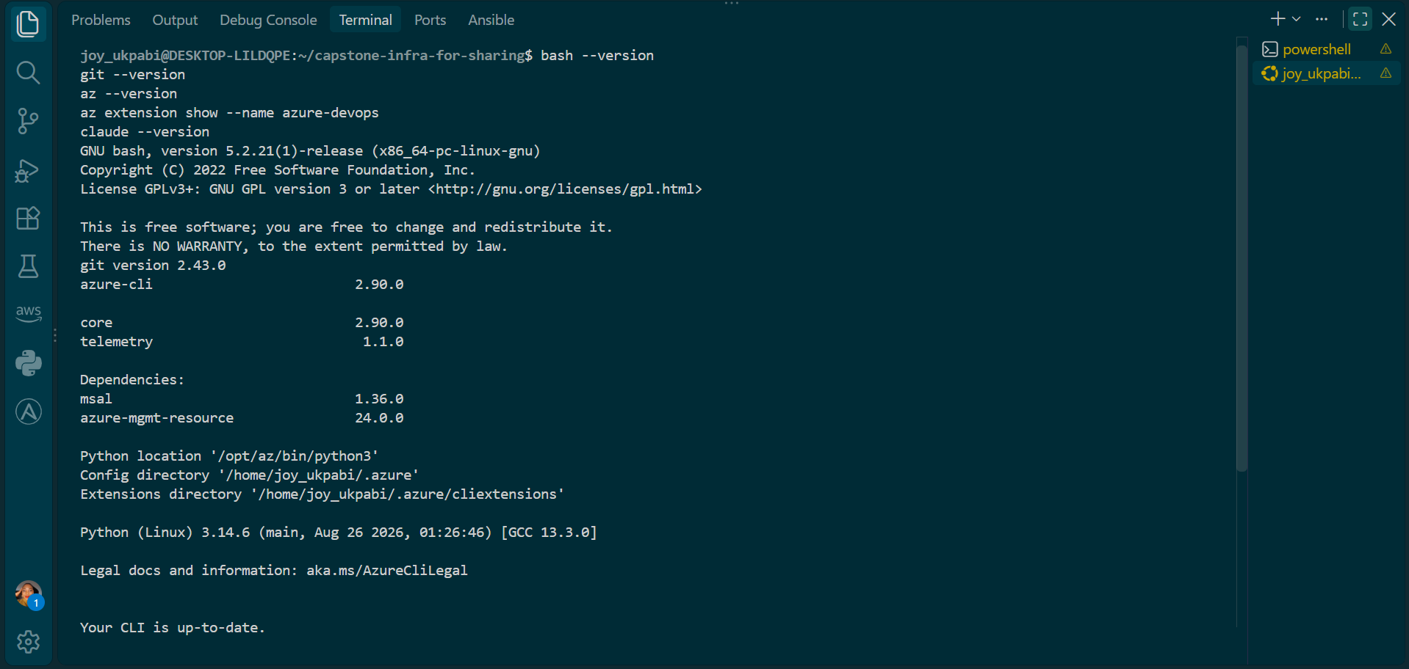
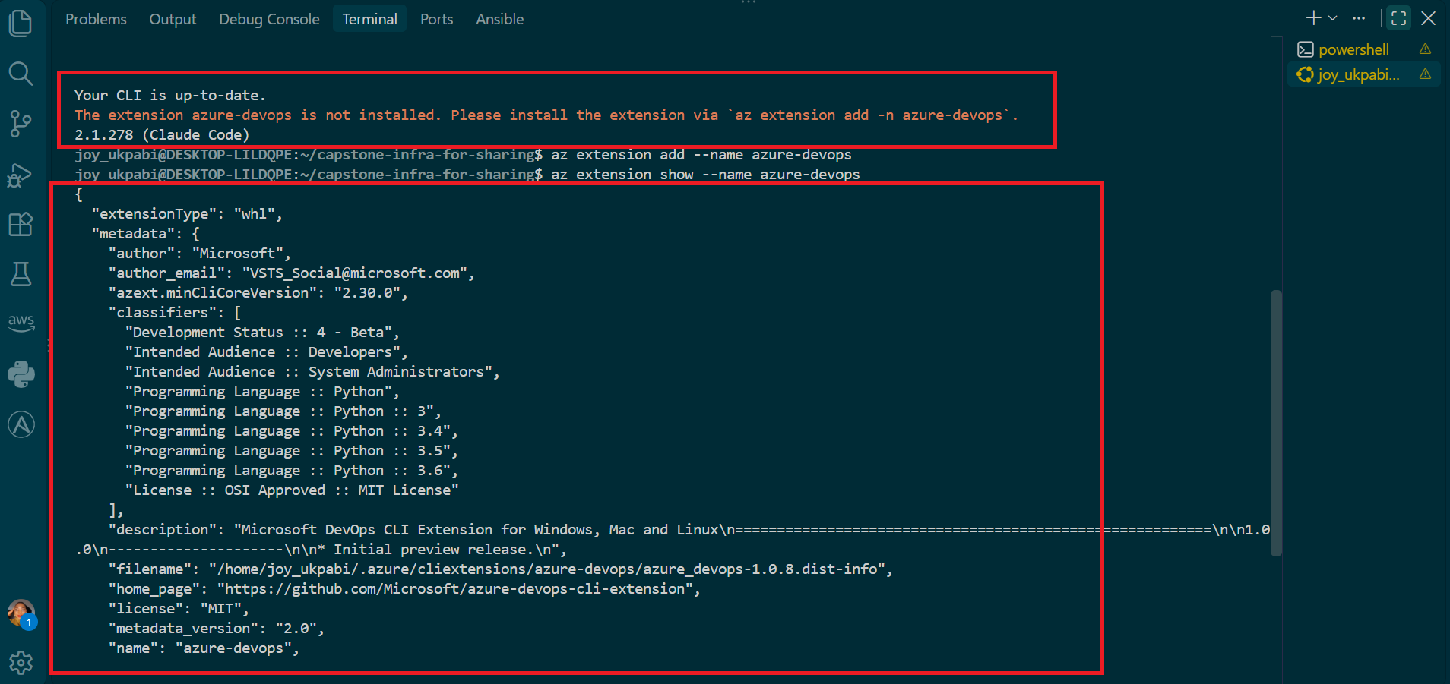
Explanation
Each of these tools plays a distinct role in the triage workflow — Bash runs the read-only triage script itself, Git manages the assignment workspace inside the existing EpicBook repository, the Azure CLI (with the azure-devops extension) is the read-only interface into pipeline metadata and logs, and Claude Code is what runs the /pipeline-triage skill in Task 5. Confirming all four exist before writing any configuration avoids discovering a missing tool mid-task.

2. Authenticate to Azure DevOps
az login

Explanation
Uses interactive Microsoft Entra authentication rather than a Personal Access Token, matching the assignment's preferred method ("Use interactive Microsoft Entra authentication where available"). This keeps the workflow credential-free in every file and terminal output — nothing gets typed or stored that could leak into a report or screenshot.

3. Set the default organization and project
az devops configure --defaults organization=https://dev.azure.com/DMI-Cohort-3 project="Epicbook Deployment"

Explanation
This command saves the organization URL and project name as CLI defaults so every subsequent az pipelines/az devops command doesn't need to repeat them, and so nothing project-specific has to be hardcoded into the shell history unnecessarily.

4. List both pipelines and record their numeric IDs
az pipelines list --organization https://dev.azure.com/DMI-Cohort-3 --project "Epicbook Deployment" --output table

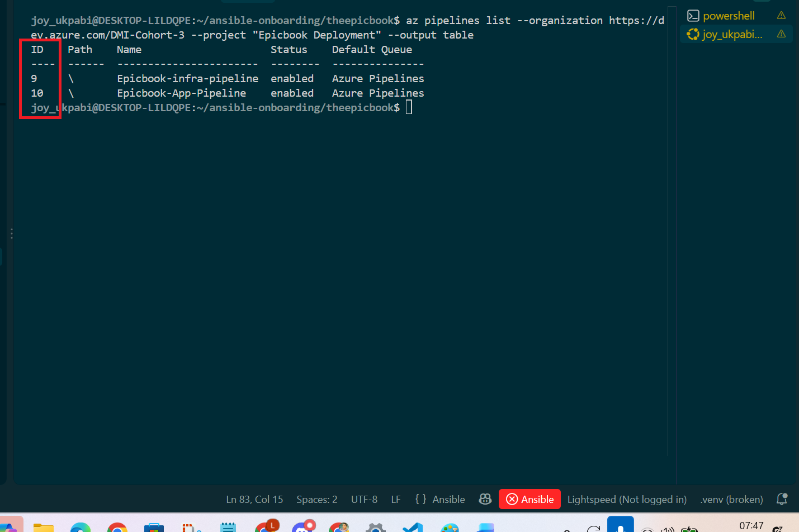

Explanation
This is a plain, read-only metadata call — it lists every pipeline in the project along with its numeric ID, which is what pipeline-triage.sh needs (not the display name) to query the correct pipeline in later tasks. This also doubles as the read-only proof required by Task 0: confirming the environment can view pipeline information without needing write access or exposing a token.

5. Confirm no credential appears in any output
Review the terminal output from every command above — confirm no PAT, bearer token, or authorization header is visible anywhere.

Expected Output
- bash --version, git --version, az --version, az extension show --name azure-devops, and claude --version all return valid version output — no "command not found" errors.
- az login completes successfully via interactive browser authentication.
- az pipelines list returns a table showing both the Infrastructure and Application pipelines, each with a numeric ID.
- No token, password, or credential is visible in any terminal output.

Recorded Values
organization-url = https://dev.azure.com/DMI-Cohort-3
project-name = Epicbook Deployment
infra-pipeline-id = 9
app-pipeline-id = 10
repository-path = ~/ansible-onboarding/theepicbook
Assignment-folder = week-10/assignment-05-pipeline-triage

Task 1 — Capture the Healthy Baseline and Prepare the Supplied Files

Goal
Prove that both EpicBook pipelines are healthy before creating the triage workflow, and prepare the supplied assignment files in the correct locations.

Steps

1. Navigate to the assignment workspace
cd ~/ansible-onboarding/theepicbook

2. Query the latest completed run of each pipeline
az pipelines runs list --pipeline-ids 9 --top 1 --output table
az pipelines runs list --pipeline-ids 10 --top 1 --output table

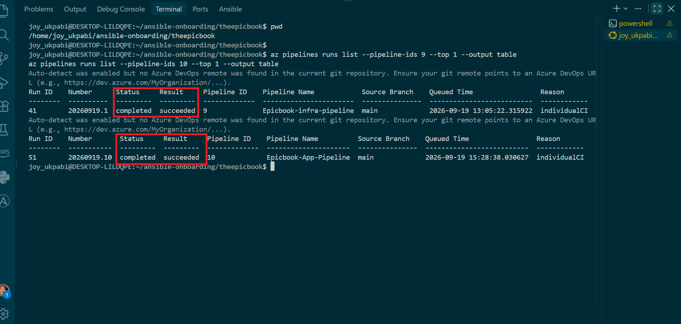

3. Record each run's details
Infrastructure Pipeline (ID 9 — Epicbook-infra-pipeline)
- Run ID : 41
- Run Number : 20260919.1
- Branch : main
- Status : completed
- Result : succeeded
- Queued Time : 2026-09-19 13:05:22.315922

Application Pipeline (ID 10 — Epicbook-App-Pipeline)
- Run ID : 51
- Run Number : 20260919.10
- Branch : main
- Status : completed
- Result : succeeded
- Queued Time : 2026-09-19 15:28:38.030627

Step 4: Create the assignment workspace folder structure
Commands
mkdir -p week-10/assignment-05-pipeline-triage/reports
mkdir -p week-10/assignment-05-pipeline-triage/.claude/skills/pipeline-triage
cd week-10/assignment-05-pipeline-triage

Step 5: Verify

find . -type d
pwd

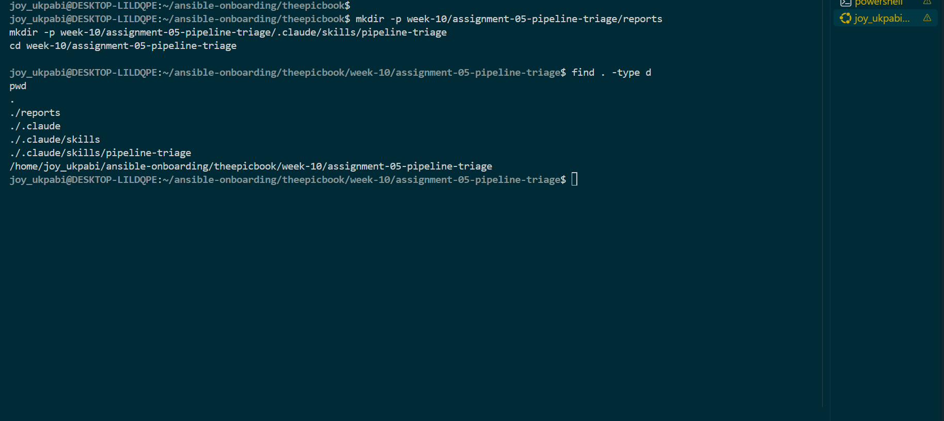

Expected Output:
./reports
./.claude
./.claude/skills
./.claude/skills/pipeline-triage

Step 6: Copy the supplied files into the exact required locations
command
cp /path/to/downloaded/pipeline-triage.sh .
cp /path/to/downloaded/SKILL.md .claude/skills/pipeline-triage/SKILL.md

Steps
Navigate to the downloaded skil.md,
Right click on it and copy as path or click on properties, copy location
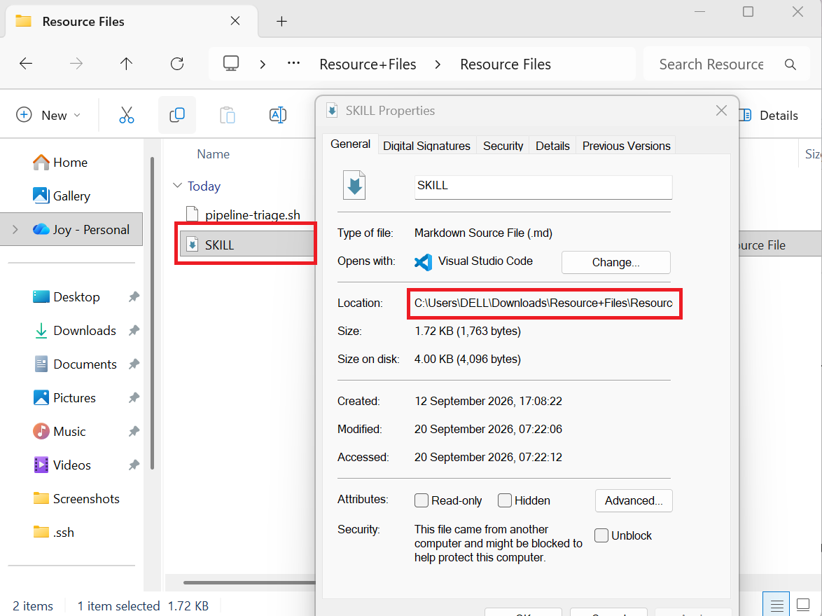

Step 7: Add the path the placeholders in the copy command
cp "/mnt/c/Users/DELL/Downloads/Resource+Files/Resource Files/SKILL.md" \
.claude/skills/pipeline-triage/SKILL.md
cp "/mnt/c/Users/DELL/Downloads/Resource+Files/Resource Files/pipeline-triage.sh" \
pipeline-triage.sh

Step 8. Verify both landed correctly

find . -type f

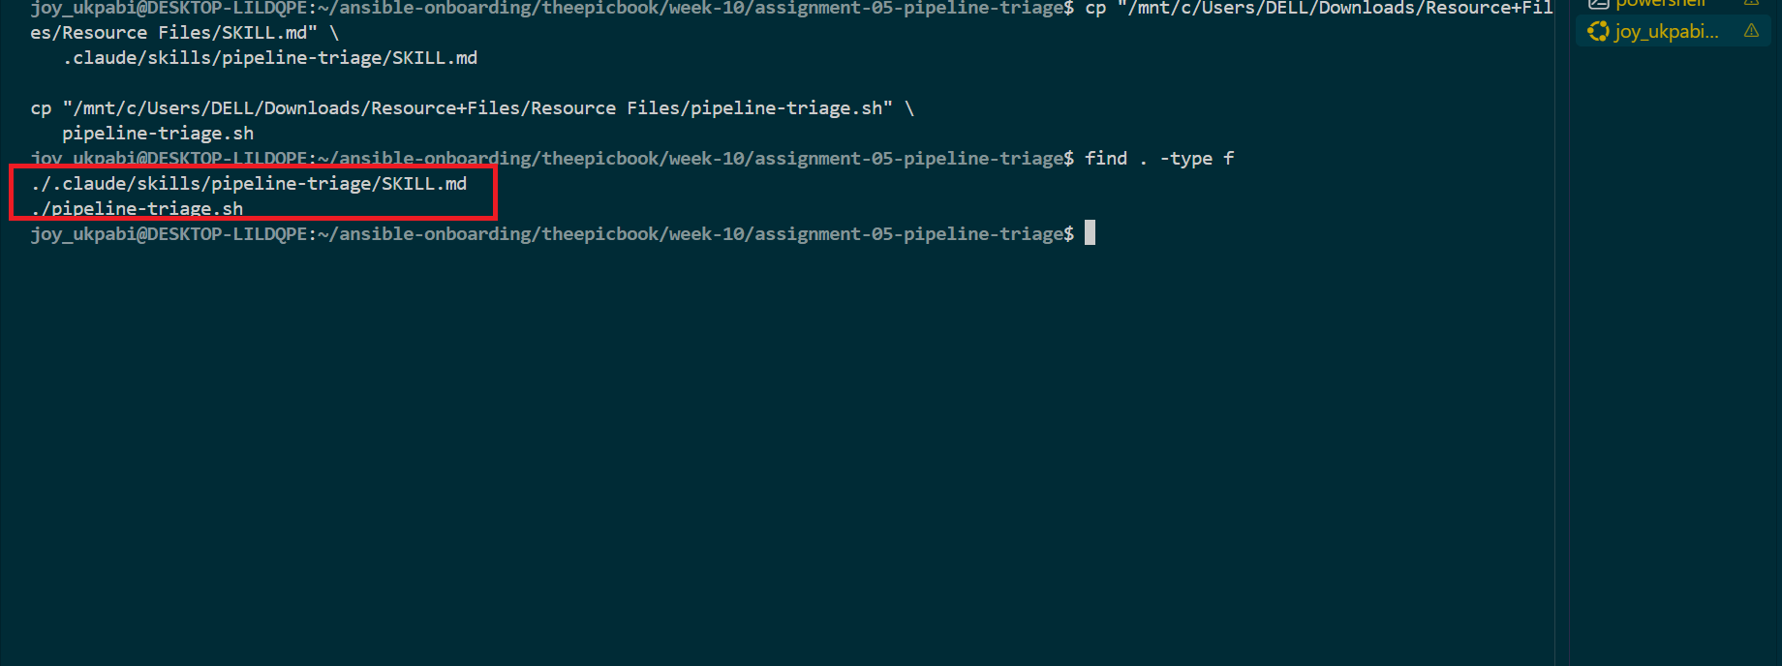

Expected Output
Both az pipelines runs list commands show the latest run's Result as succeeded.
The workspace contains exactly:
pipeline-triage.shreports/.claude/skills/pipeline-triage/SKILL.md
Filenames and capitalization match the supplied files exactly (SKILL.md, not skill.md).
No generated report belonging to another student is present.
CLAUDE.md does not yet exist (it is created in Task 2).

Explanation
This task is about creating a reliable starting point for the entire assignment. Before introducing any problem later in Task 6, we need to prove that the pipelines are already working correctly. This is called the baseline. If a pipeline were already failing in Task 1, and then the triage tool reported a failure later, we would not know whether the tool had detected the new problem or simply found an old one. That is why the assignment requires both baseline pipelines to be successful before continuing.
The pipeline status is checked using the Azure DevOps CLI command az pipelines runs list --top 1. This deliberately checks the latest pipeline run directly through the Azure DevOps API instead of relying on the web interface. The goal is to make the verification scriptable, repeatable, and based on actual pipeline data. This is important because the assignment is eventually building pipeline-triage.sh, which will also use automated, read-only checks rather than depending on someone visually inspecting the Azure DevOps dashboard.
The workspace structure is also created carefully because the assignment depends on specific locations. The .claude/skills/pipeline-triage/SKILL.md path is where Claude Code expects to find the pipeline-triage skill. Claude Code looks for skills using this predictable .claude/skills/<skill-name>/SKILL.md structure. If the files were placed somewhere else, the /pipeline-triage skill would not be discovered when it is needed later in the assignment.
The reports/ directory has a similar purpose. It is the expected location for the pipeline-triage tool's reports. Even though the directory may be empty at this stage, creating it now establishes the expected workspace structure and prevents the script from failing later simply because the output directory does not exist.
The supplied files are also copied rather than manually recreated. This matters because the provided script and skill already contain specific safety behavior, including read-only Azure DevOps API operations, secret sanitization, and controlled manual invocation. Rewriting those files from screenshots or memory could accidentally change that behavior. By copying the original files exactly, the assignment preserves the tested logic and makes Task 3 about configuring and validating the tool, rather than rewriting the tool itself.
So, the logical flow is: first prove the pipelines are healthy, then create the exact workspace structure, then preserve the supplied triage files unchanged. Once that baseline is established, any failure deliberately introduced later can be compared against a known healthy starting point, allowing the triage tool to demonstrate that it can identify a genuinely new problem.

Task 2 — Create Project Context and Safety Rules in CLAUDE.md

Goal
Create a project-level CLAUDE.md file that explains the dual-pipeline triage workflow and defines the safety boundaries Claude Code must follow before it ever touches a real pipeline or log.

Steps

Step 1: Confirm you're in the assignment root
cd ~/ansible-onboarding/theepicbook/week-10/assignment-05-pipeline-triage
pwd

Step 2: Create the file
nano CLAUDE.md

Step 3: Paste the required content

# Project Overview

This project builds a read-only CI/CD pipeline failure-triage workflow for the EpicBook dual-pipeline project in Azure DevOps.

The workflow monitors two pipelines:

- Infrastructure Pipeline — provisions the Azure infrastructure using Terraform
- Application Pipeline — configures the server and deploys EpicBook using Ansible

The Bash script is responsible for retrieving the latest pipeline run information and logs, classifying failures, and generating a structured report.

Claude Code is responsible for analyzing the generated report and retrieved logs, explaining the evidence, and recommending a recovery action for the engineer to review.

# Incident Workflow

Always follow this order:

1. Gather — Run the approved read-only triage script to retrieve the latest pipeline status and logs.
2. Analyze — Review the generated report and sanitized log evidence.
3. Human Act — Recommend one recovery action, but require the engineer to review and apply it manually.
4. Verify — Run the triage workflow again after the engineer applies the fix.

# Safety Rules

- Treat the pipeline health report and retrieved pipeline logs as the primary evidence sources.
- Do not edit application code, Terraform, Ansible, pipeline YAML, reports, or other project files.
- Do not trigger, retry, cancel, delete, or approve a pipeline run.
- Do not run Terraform or Ansible commands.
- Do not create, update, or delete Azure resources.
- Do not change Service Connections, Secure Files, Variable Groups, agent pools, or pipeline permissions.
- Never read, print, store, expose, or change a token, password, private key, authorization header, Service Connection credential, database credential, or other secret.
- Never request that a secret be pasted into the Claude Code session.
- Recommend a fix, but do not apply it.
- Do not claim a root cause unless the report or retrieved logs contain supporting evidence.
- If the evidence is incomplete, clearly state that the root cause is not confirmed.
- Require human approval and action for every recovery change.

# Output Rules

When analyzing the triage results, report:

1. Overall pipeline health
2. Affected pipeline
3. Pipeline run ID
4. Every detected warning or failure
5. Most likely failure category
6. Exact sanitized evidence from the report or retrieved logs
7. One likely root-cause explanation supported by the evidence
8. One specific recovery recommendation for the engineer to review
9. One verification step to perform after the engineer applies the fix

Do not expose credentials or other sensitive values in the output.

Save (Ctrl+O, Enter), exit (Ctrl+X).

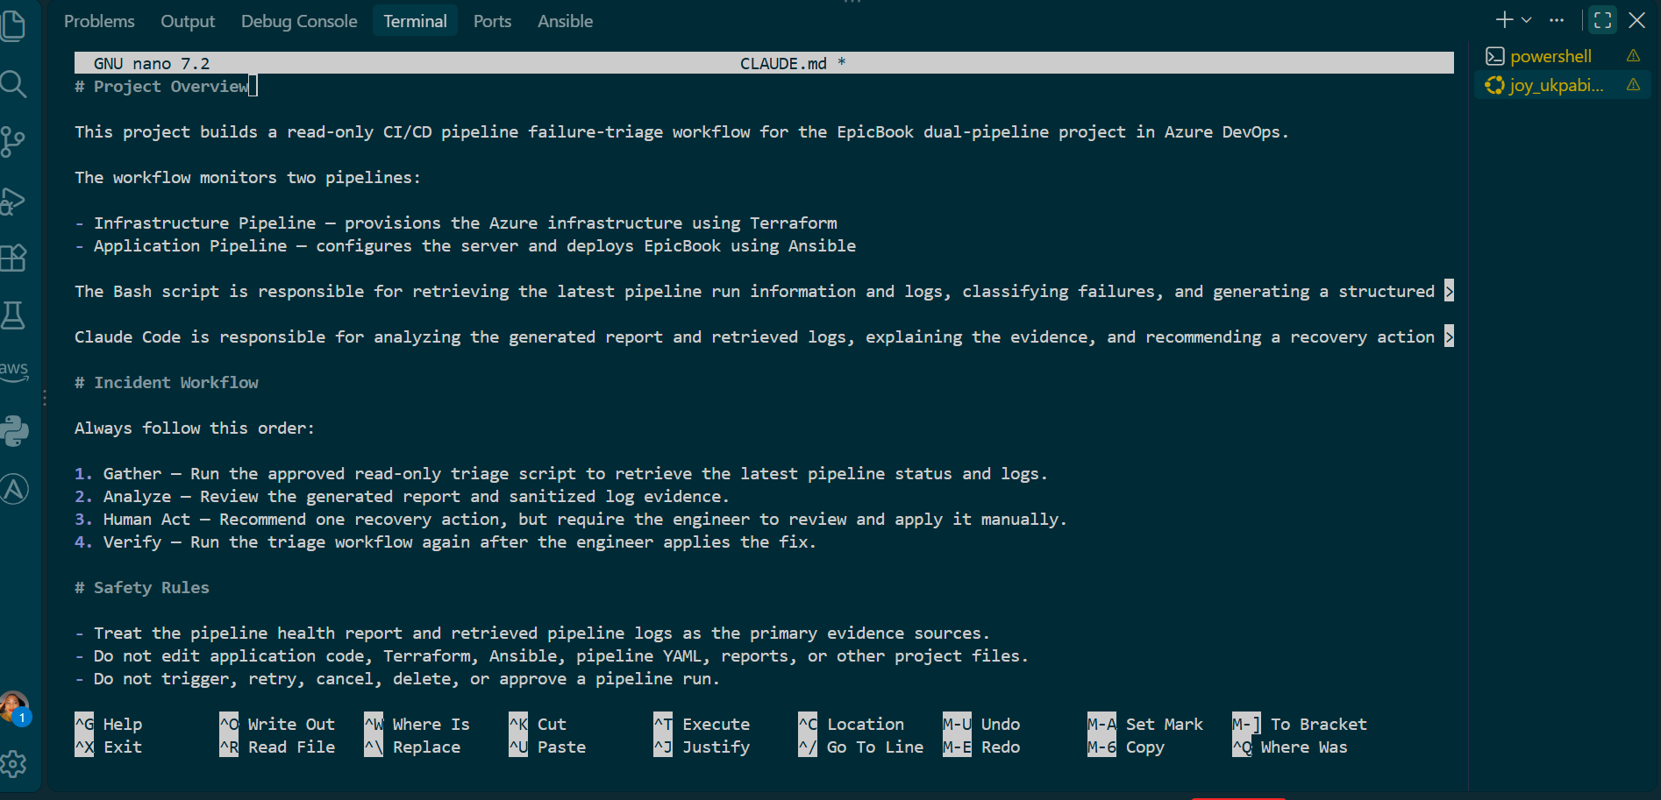

Step 4: Confirm the exact filename and capitalization
ls -la CLAUDE.md

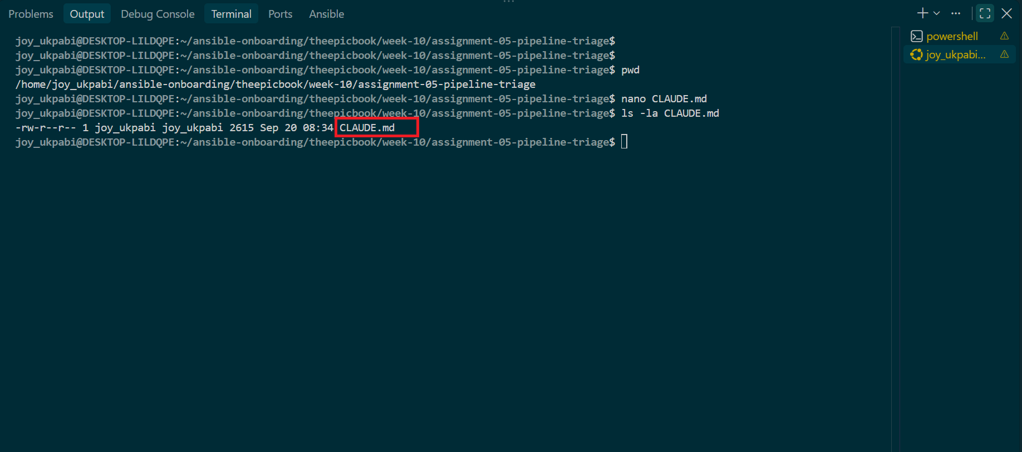

Step 5: Confirm all four required sections are present
grep -n "^#" CLAUDE.md

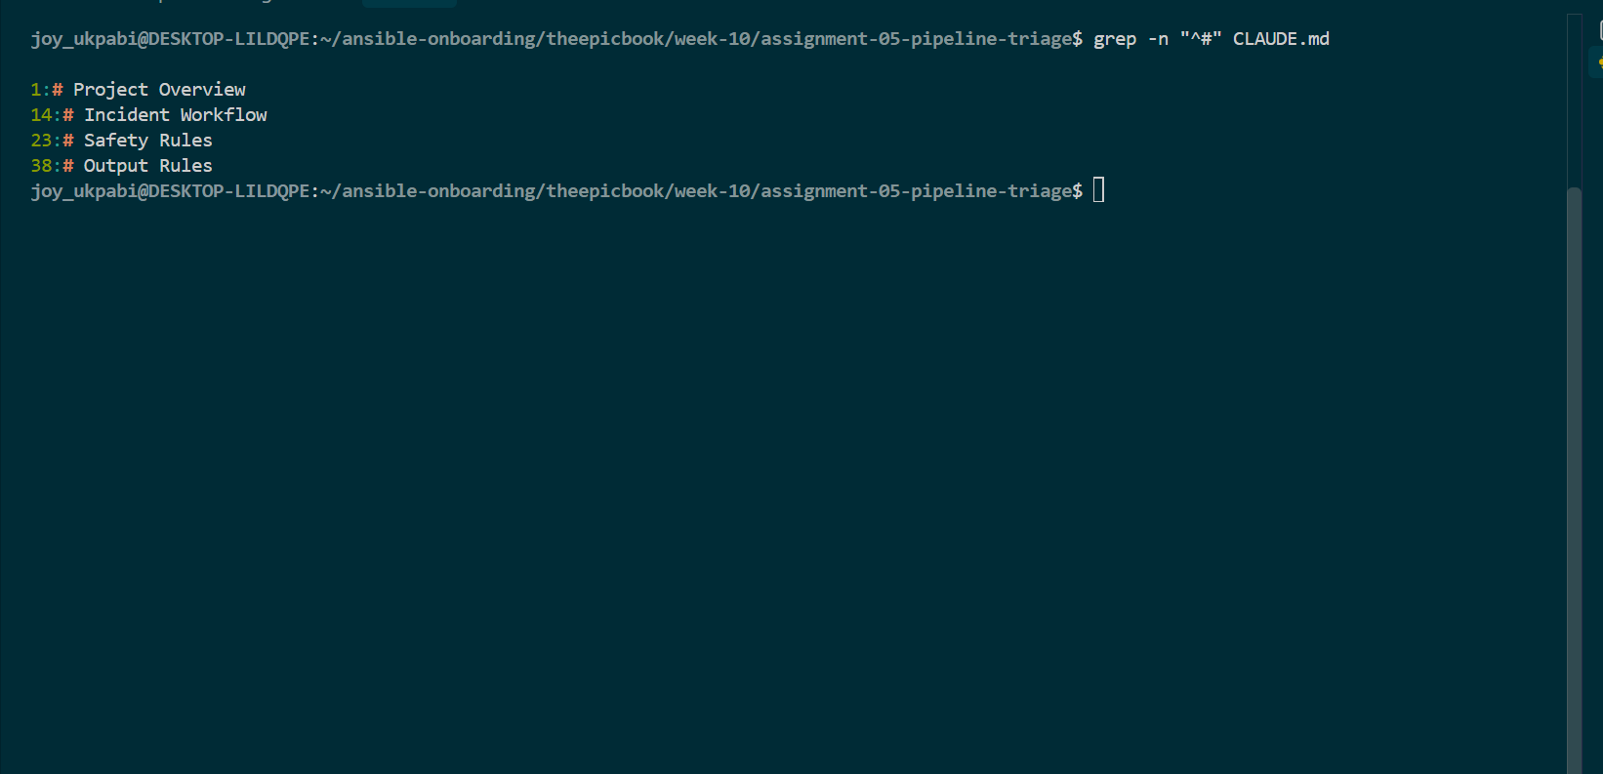

Step 6: Confirm the incident workflow order is correct
grep -A10 "# Incident Workflow" CLAUDE.md
Confirm the numbered order reads: Gather → Analyze → Human Act → Verify.
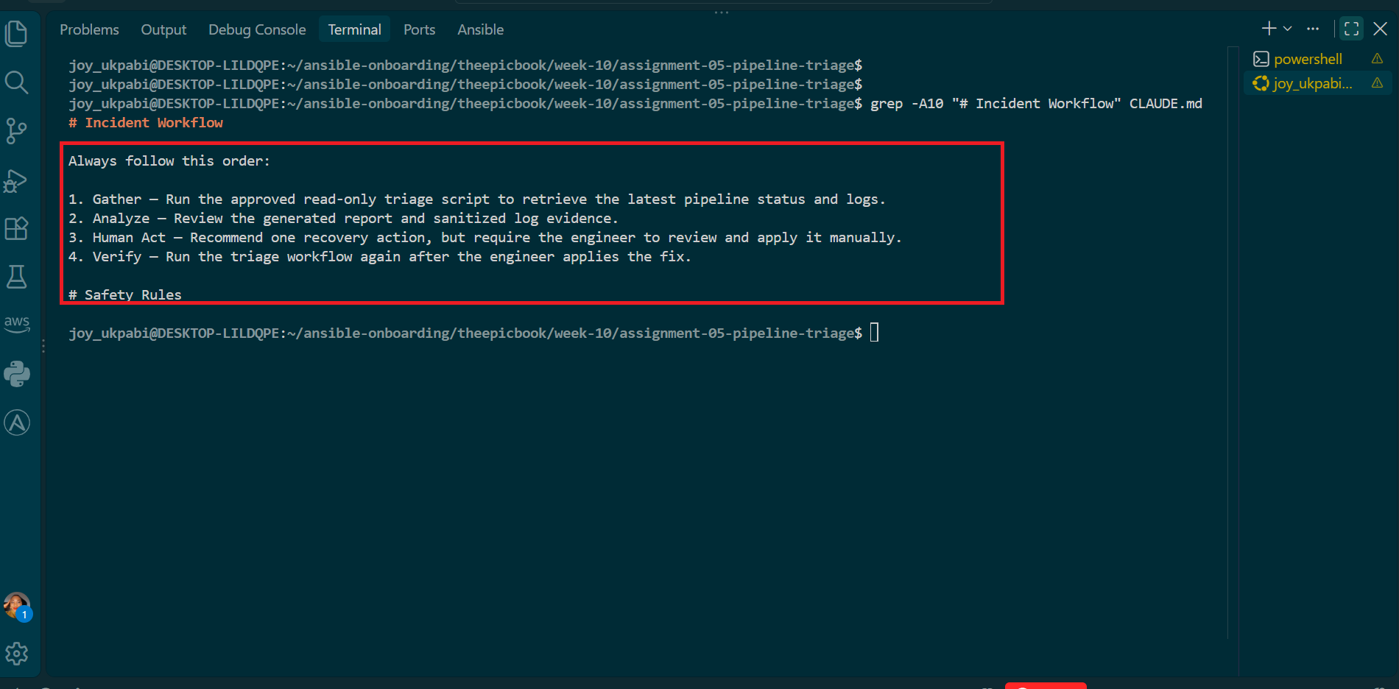

Expected Output
- CLAUDE.md exists in the assignment root with the exact filename capitalization.
- The file contains all four required sections in the correct structure.
- The Incident Workflow section lists steps in the exact order: Gather, Analyze, Human Act, Verify.
- The Safety Rules section explicitly prohibits editing files, triggering/retrying/canceling/approving pipeline runs, running Terraform/Ansible, modifying Azure resources, changing Service Connections or pipeline permissions, and accessing or exposing secrets.
- No credential, token, password, or private key appears anywhere in the file.

Step 7: Confirm the Safety Rules explicitly block every prohibited action
Commands

grep -iE "trigger|retry|cancel|delete|approve" CLAUDE.md
grep -iE "terraform|ansible" CLAUDE.md
grep -iE "service connection|secure files|variable group|agent pool|pipeline permission" CLAUDE.md
grep -iE "token|password|private key|authorization header|credential|secret" CLAUDE.md
grep -iE "recommend a fix, but do not apply" CLAUDE.md

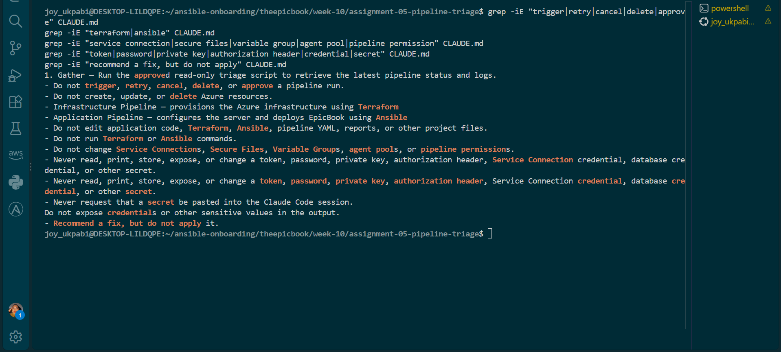

Expected Output
- CLAUDE.md exists in the assignment root with exact filename capitalization.
- All four required sections are present and in the correct structure.
- The Incident Workflow reads Gather → Analyze → Human Act → Verify.
- Every individual Safety Rule prohibition (editing files, triggering/retrying/canceling/approving runs, running Terraform/Ansible, modifying Azure resources, touching Service Connections/permissions, accessing secrets, auto-applying fixes) is confirmed present by targeted grep.
- No credential, token, password, or private key appears anywhere in the file.

Explanation
CLAUDE.md acts as the standing instruction manual for Claude Code in this project. It gives Claude the project context, explains how incidents should be handled, defines what Claude is allowed and not allowed to do, and standardizes how its findings should be reported. Because Claude Code reads this file when working in the project, these rules do not have to be repeated every time a new session starts.
The Project Overview gives Claude the basic context it needs to understand the system correctly. It explains that there are two pipelines and what each one is responsible for: Terraform handles the infrastructure, while Ansible handles application configuration and deployment. This helps Claude identify the correct area when investigating a failure instead of confusing an infrastructure problem with an application or deployment problem.
The Incident Workflow defines the order in which triage must happen. Claude first gathers evidence using the approved script, then analyzes that evidence, while the actual fix is applied manually by a human before Claude performs another verification. This prevents Claude from guessing at a problem and immediately trying to fix it. It also makes the process easier to track because each stage produces clear evidence that can be reviewed.
The Safety Rules define the boundaries Claude must not cross. Claude is allowed to diagnose and analyze problems, but it must not make changes such as running Terraform or Ansible, modifying pipeline files, approving or canceling pipeline runs, changing Azure resources, or accessing secrets. These rules are important because they keep the AI in a read-only diagnostic role and ensure that any action that could affect infrastructure or security remains under human control.
The Output Rules make sure Claude reports its findings in a consistent format. Instead of giving a different type of response each time, Claude must identify the failure category, provide evidence from the logs, give one recommendation, and state how the result should be verified. This makes reports easier to understand and compare, especially when the healthy baseline from an earlier task is compared with a later incident.
Finally, the verification step checks that these safety rules are actually written into CLAUDE.md. Rather than simply looking at the file and assuming everything is present, targeted searches confirm that important restrictions—such as not running Terraform or Ansible, not changing pipelines, not handling secrets, and not applying fixes automatically—are explicitly documented. This ensures that Claude's operating boundaries are clearly defined before it is used for pipeline triage.

Task 3 — Configure and Validate the Supplied Pipeline Triage Script

Goal
Configure the supplied Bash script with your own non-secret project values and verify it can retrieve and classify evidence from both Azure DevOps pipelines without making any changes.

Steps
1. Open the supplied script
cd ~/ansible-onboarding/theepicbook/week-10/assignment-05-pipeline-triage
nano pipeline-triage.sh

2. Locate and replace the marked configuration placeholders
Find the configuration block near the top of the script and replace with your own variables.

full_name="your name"
ado_org="your_organization URL"
ado_project="Project Name"
ado_infra_pipeline_id=""
ado_app_pipeline_id=""

Confirm the values were correctly configured .
grep -n "full_name=\|ado_org=\|ado_project=\|ado_infra_pipeline_id=\|ado_app_pipeline_id=" pipeline-triage.sh

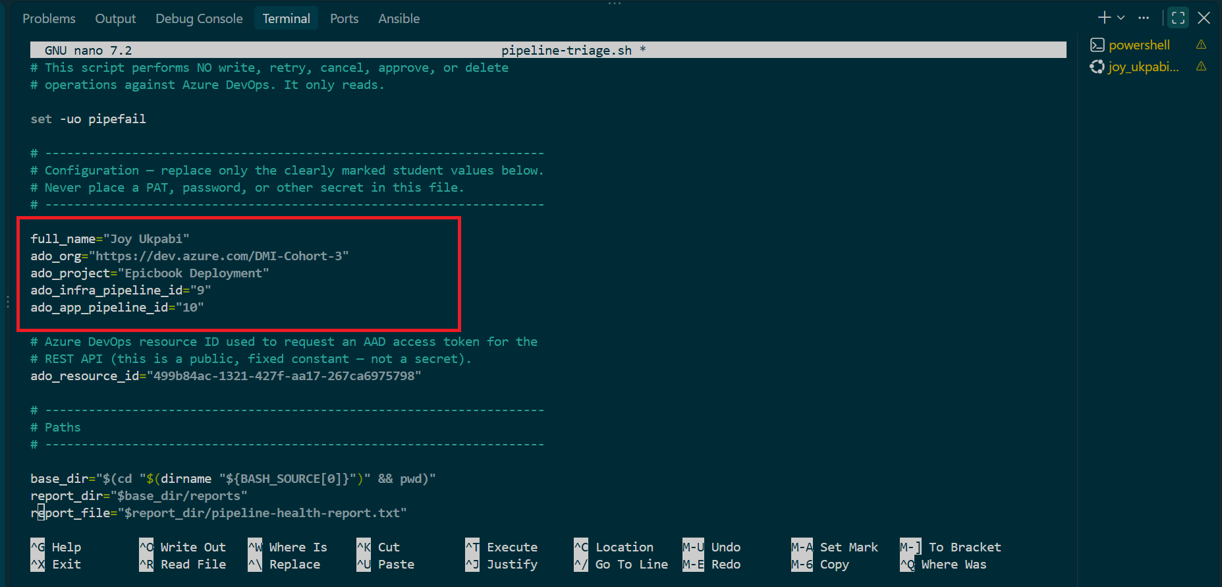

3. Inspect the base-directory resolution logic
Command
grep -n "SCRIPT_DIR\|BASE_DIR\|dirname" pipeline-triage.sh
Confirm the script resolves its own directory (commonly via SCRIPT_DIR="$(cd "$(dirname "${BASH_SOURCE[0]}")" && pwd)") rather than assuming a hardcoded path, and that it creates or reuses reports/ relative to that resolved directory.
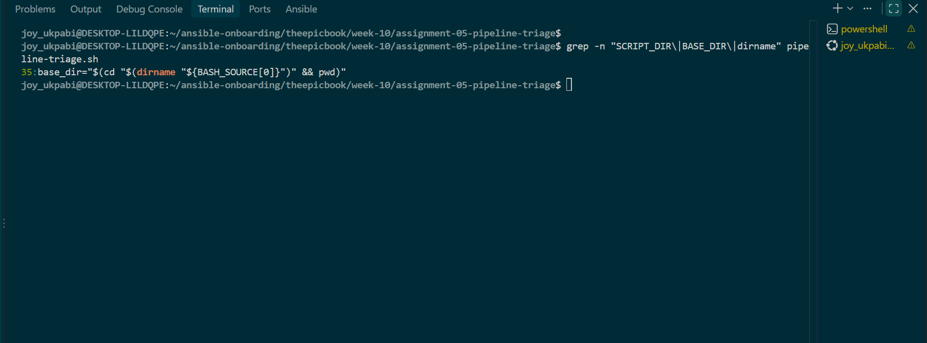

4. Confirm the expected output files are defined
Command
grep -n "pipeline-health-report.txt\|infra-last-run.log\|app-last-run.log" pipeline-triage.sh

Confirm the script writes to reports/pipeline-health-report.txt, reports/infra-last-run.log, and reports/app-last-run.log.
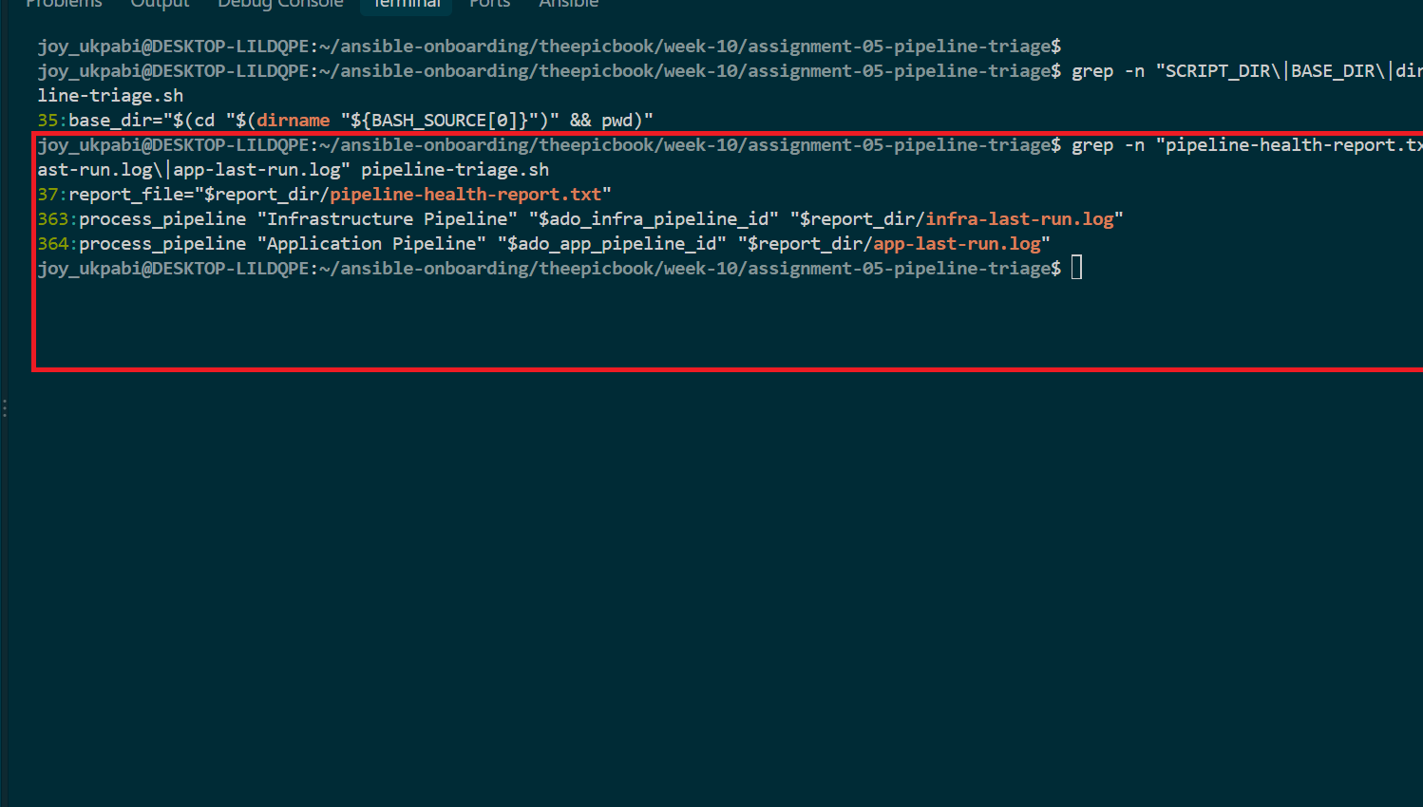

5. Inspect the run-metadata retrieval functions
grep -n "^get_.*run\|az pipelines runs" pipeline-triage.sh

Confirm the metadata retrieved per pipeline includes: pipeline name, pipeline ID, run ID, branch, status, result, and completion time.

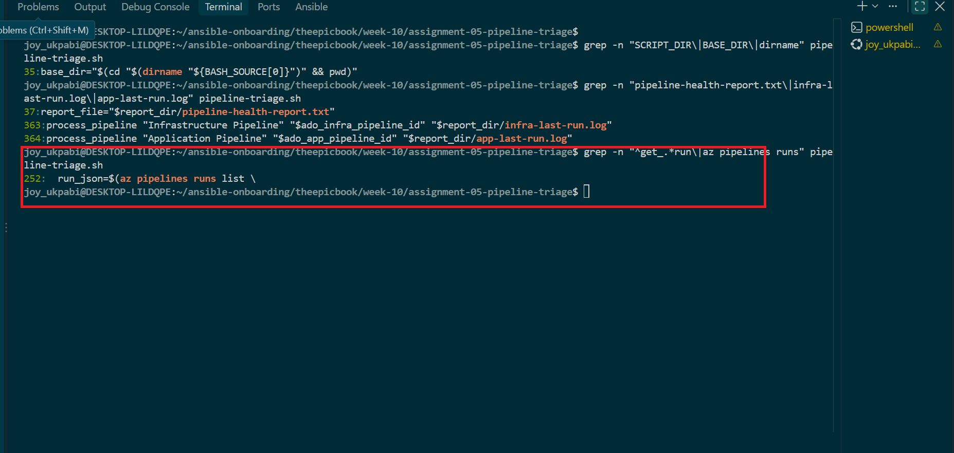

6. Inspect the log-retrieval logic separately from metadata
grep -n "logs\|buildId\|Build Logs\|curl" pipeline-triage.sh

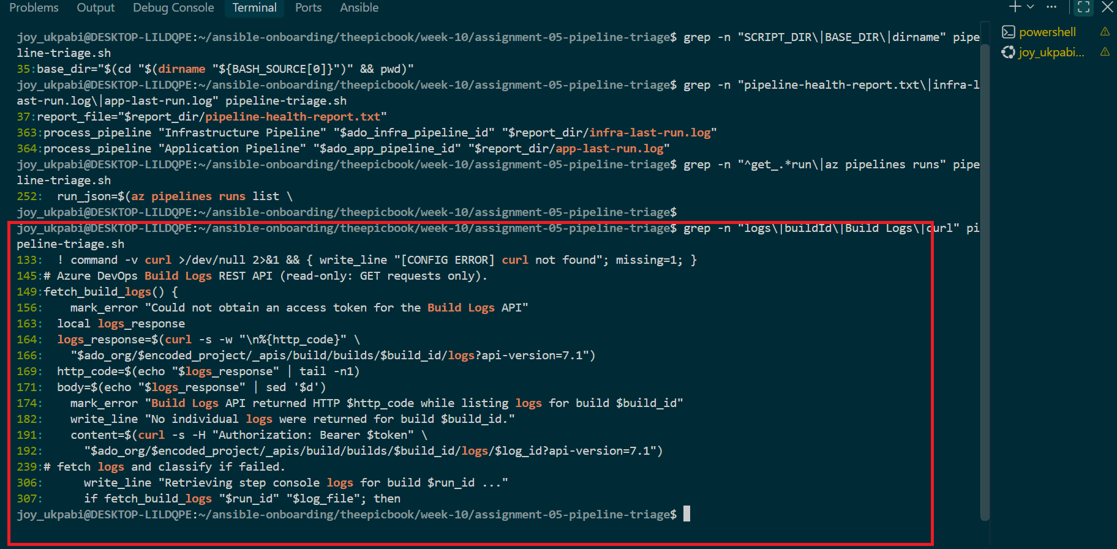

7. Confirm every Azure DevOps operation is read-only
grep -niE "queue|retry|cancel|approve|delete" pipeline-triage.sh
This should return no matches referencing pipeline-mutation API calls. Confirm the script only uses GET-style/list/show operations.
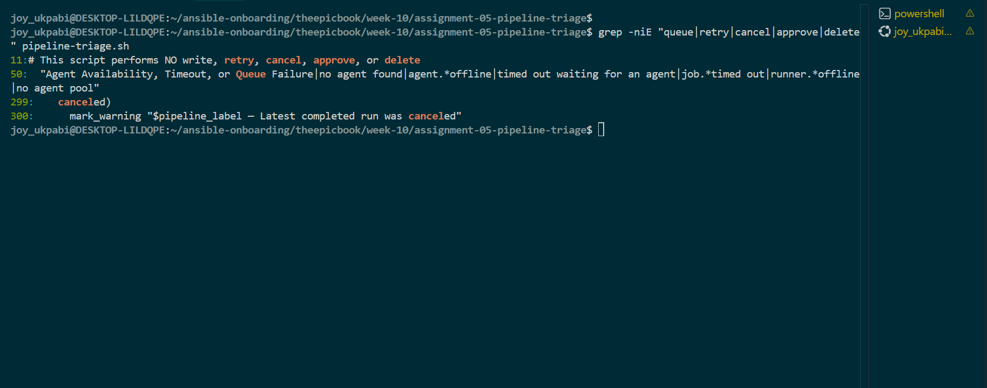

8. Confirm authentication and API errors cannot be reported as healthy
grep -n "exit 3\|API error\|auth" pipeline-triage.sh

Confirm the script checks the exit status / HTTP response of each az/curl call and routes failures to a distinct error path (exit code 3) rather than falling through to a "healthy" result by default.
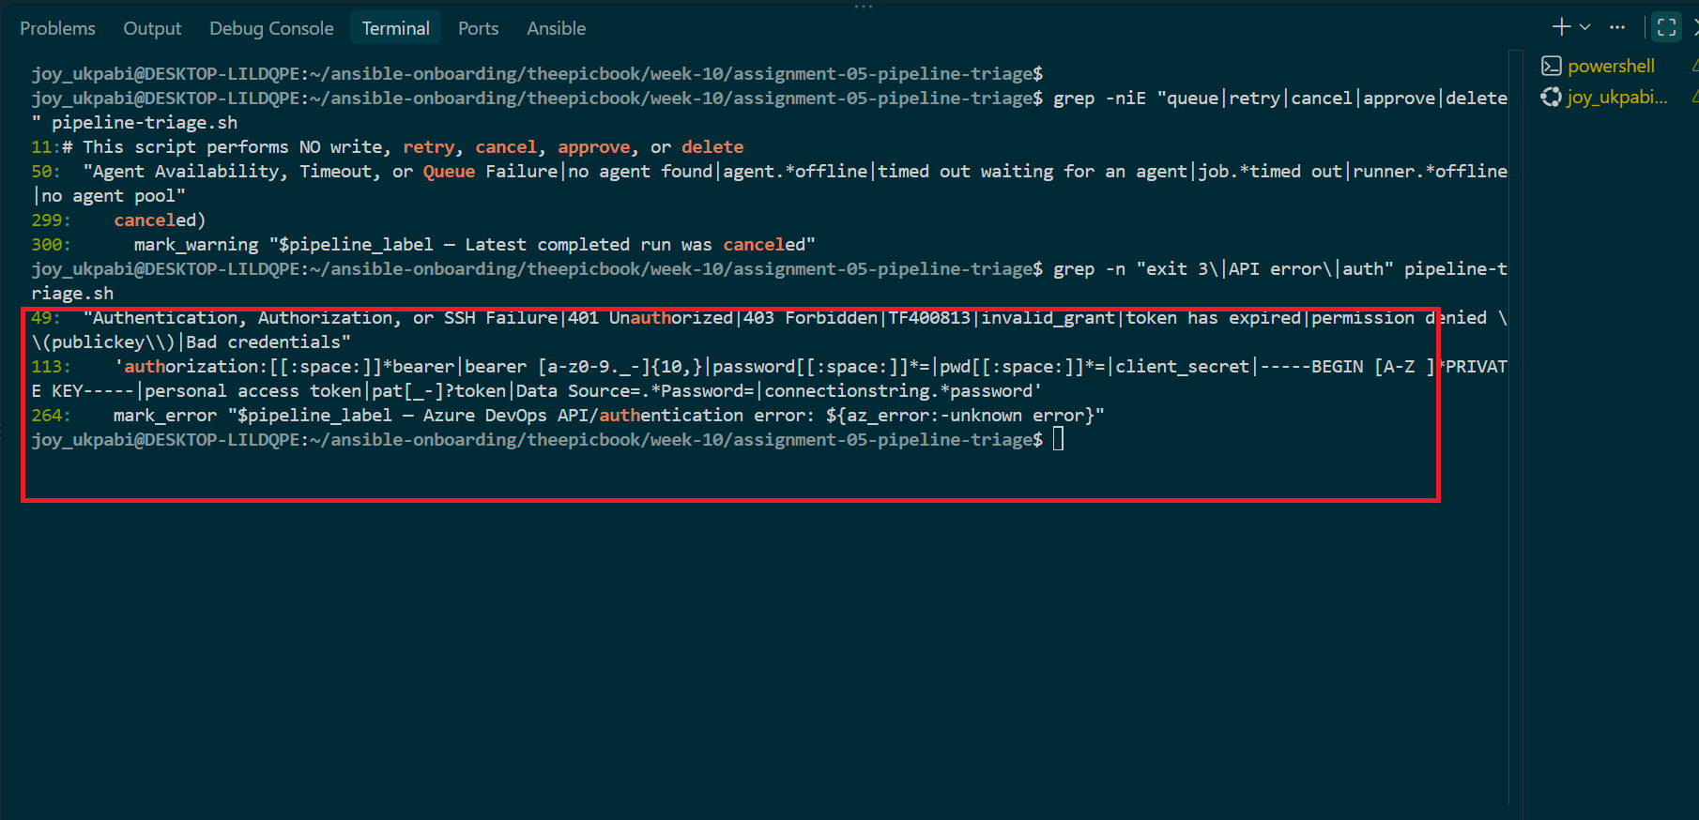

9. Inspect the sanitization logic
grep -n "REDACT\|sanitiz" pipeline-triage.sh

Confirm that before any matched log line is copied into the report, it's checked against patterns for authorization headers, bearer tokens, PAT values, client secrets, SSH private-key content, database passwords, and connection strings — and that a match is replaced with a redaction notice rather than being dropped silently or printed raw.
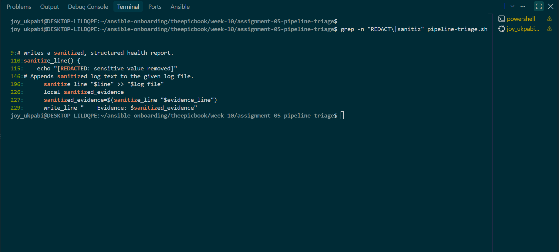

10. Identify the check-function array and classification loop
grep -n "CHECKS=\|for check in\|case " pipeline-triage.sh

Confirm the array includes all eight required categories: dependency installation, build/compilation, test, authentication/authorization/SSH, agent availability/timeout/queue, Terraform infrastructure, Ansible/Nginx/deployment, and Unclassified Pipeline Failure (the fallback when Azure DevOps reports failure but no pattern matches).
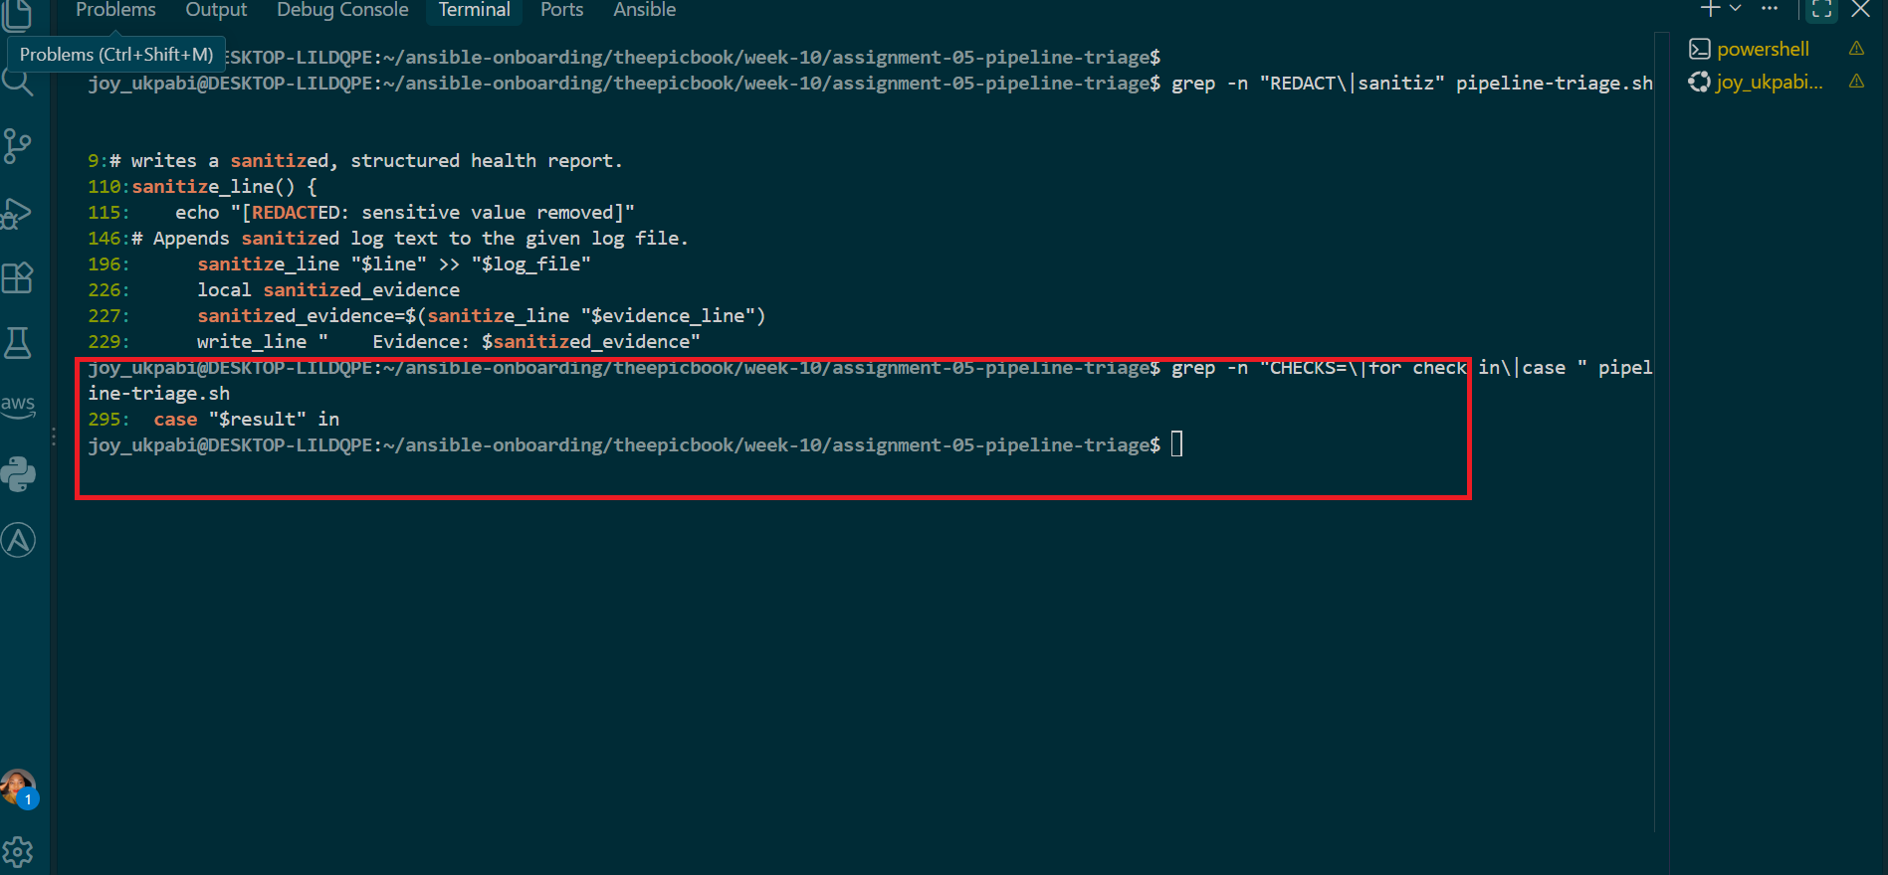

11. Confirm summary totals and exit codes
grep -n "PASS\|WARN\|FAIL\|exit 0\|exit 1\|exit 2\|exit 3" pipeline-triage.sh

Confirm the report includes pass/warning/failure totals, and the script returns:
- 0 — both latest completed runs healthy
- 1 — warning/incomplete (queued, running, partially successful)
- 2 — one or more pipeline failures detected
- 3 — configuration, authentication, API, or log-retrieval error
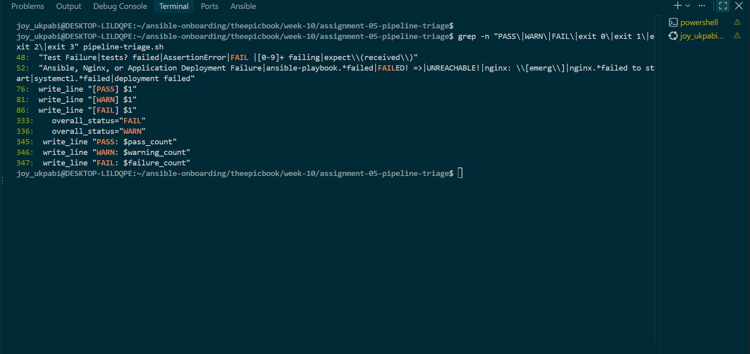

12. Make the script executable and validate syntax
chmod +x pipeline-triage.sh
bash -n pipeline-triage.sh
ls -l pipeline-triage.sh
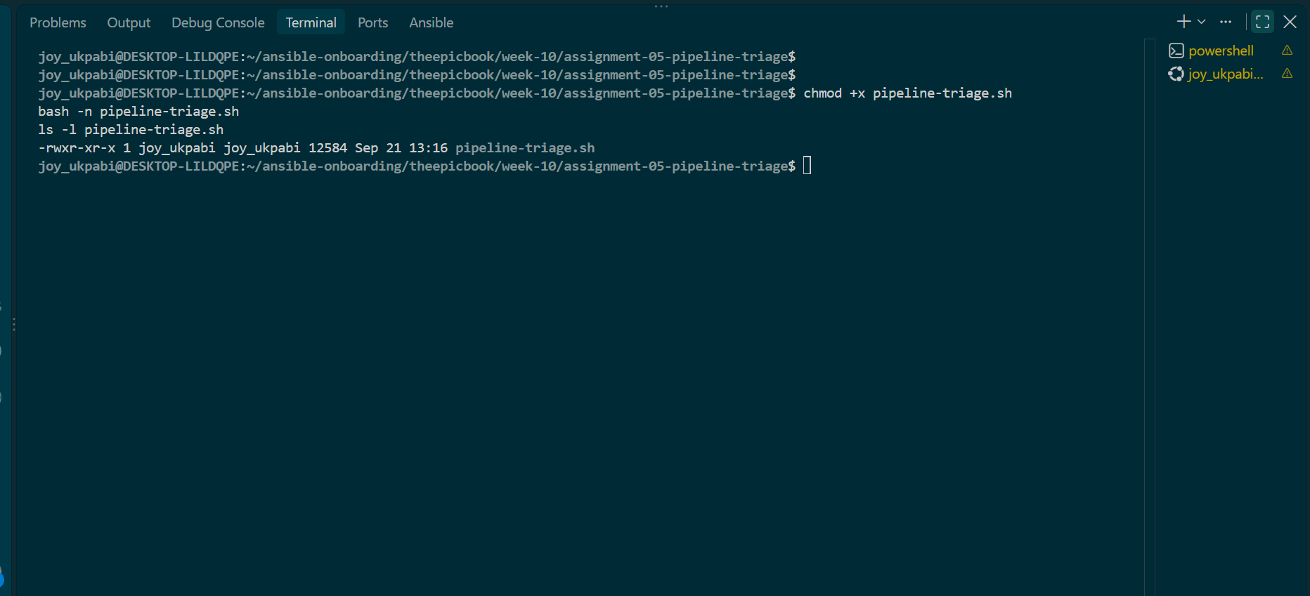

Expected Output
- bash -n pipeline-triage.sh returns no syntax error.
- pipeline-triage.sh shows executable permission (-rwxr-xr-x or similar) in ls -l.
- Configuration variables hold your Full Name, org URL, project name, and both numeric pipeline IDs — no secrets.
- Metadata retrieval and log retrieval are confirmed as separate, both read-only.
- All eight failure categories are present, with Unclassified Pipeline Failure as the fallback.
- Queued/running states are confirmed excluded from a "healthy" result.
- Sanitization redacts matched secret patterns before they reach the report.
- Exit codes 0/1/2/3 are each mapped to a distinct pipeline/script state.

Explanation
The pipeline-triage.sh script is the main tool used to check the health of the EpicBook Azure DevOps pipelines and collect evidence when something goes wrong. Its purpose is not to fix problems, but to automatically gather reliable information that Claude can later analyze. The script is designed to work with the two pipelines in the project: the Infrastructure pipeline and the Application pipeline.
At the beginning of the script, the basic configuration is defined, including the two pipeline IDs, project information, Azure DevOps organization, and the locations where the results will be saved. Keeping these values together makes the script easier to configure and allows the same script to be used consistently for both pipelines.
The script then checks that the required tools and Azure DevOps authentication are available before it starts. This is important because the script depends on commands such as az to communicate with Azure DevOps. If authentication or configuration is missing, the script reports an error instead of pretending that the pipelines are healthy.
The fetch_build_logs() function is responsible for retrieving the actual pipeline logs. It obtains an Azure access token and uses the Azure DevOps Build Logs API to find the logs belonging to a pipeline run and retrieve their contents. This gives the triage process real console evidence rather than relying only on information such as whether a pipeline succeeded or failed.
The sanitize_line() function protects sensitive information before the evidence is saved or displayed. If a pipeline log contains something such as a password, access token, personal access token, private key, or database connection password, the script replaces or removes that sensitive information. This allows useful failure evidence to be collected without accidentally exposing credentials in a report.
The script then processes each pipeline through process_pipeline(). For each pipeline, it identifies the latest run, checks its current status and result, retrieves the relevant logs, and saves the evidence to the appropriate log file. The Infrastructure and Application pipelines are processed separately so their results do not become mixed together.
The status handling is important because a pipeline can be in several different states. A completed successful run is treated as healthy, while a failed run requires investigation. Queued or running pipelines are reported as warnings because they have not finished yet. Canceled or partially successful runs are also reported as warnings because they do not represent a completely successful pipeline execution.
When a completed pipeline has failed, the script searches the collected logs for known failure patterns. These patterns allow it to classify the problem into the assignment's defined categories, such as dependency, build, test, authentication, agent, Terraform, and Ansible/Nginx/deployment failures. If the pipeline failed but none of the known patterns match, the script uses Unclassified Pipeline Failure rather than inventing a cause.
When a known failure is detected, the script also captures relevant evidence from the logs. This means the final report does not simply say that a Terraform or Ansible failure occurred; it provides a sanitized line from the actual pipeline output that supports the classification. This makes the result evidence-based and easier for a human or Claude to investigate.
The script keeps track of errors separately from pipeline failures. For example, if Azure authentication fails or the Build Logs API cannot be reached, that is an error with the triage process itself, not evidence that the pipeline is healthy. The final summary therefore gives priority to errors, followed by failures and warnings, so problems with the diagnostic process cannot accidentally appear as a healthy result.
Finally, the script produces a clear summary and appropriate exit code based on what it found. A healthy check returns success, warnings indicate that something needs attention, failures indicate a pipeline problem, and serious configuration or API errors return the designated error status. Throughout the process, the script remains read-only: it gathers information and analyzes pipeline evidence but does not approve, retry, cancel, queue, or modify any pipeline.
Overall, pipeline-triage.sh provides a controlled diagnostic process: connect to Azure DevOps, check both pipelines, retrieve their real logs, protect sensitive information, classify any failures using evidence, and report the result without making changes.

Task 4 — Run and Understand the Healthy-State Report

Step 1: Navigate to the assignment root
cd ~/ansible-onboarding/theepicbook/week-10/assignment-05-pipeline-triage
pwd

Step 2: Run the script directly (not through Claude Code yet)
./pipeline-triage.sh
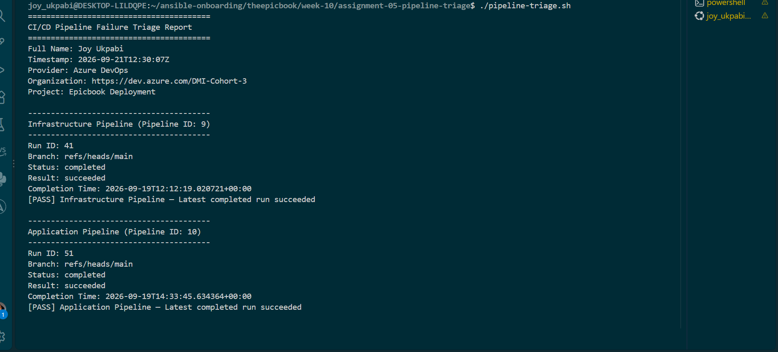
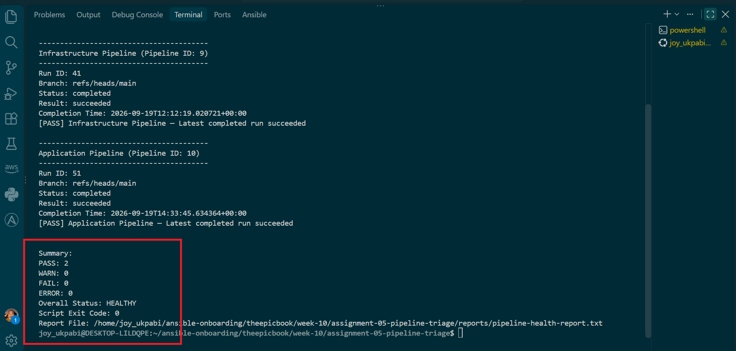

Step 3: Immediately capture the exit code
Run this right after, before typing anything else (the exit code only reflects the last command run):
echo $?
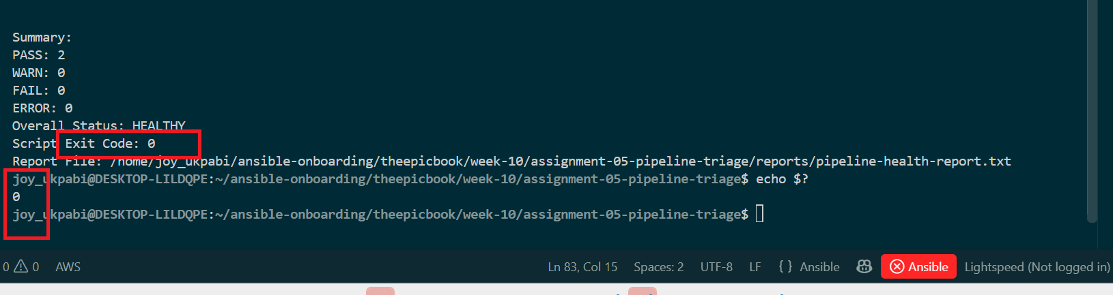

Step 4: Display the generated report
cat reports/pipeline-health-report.txt
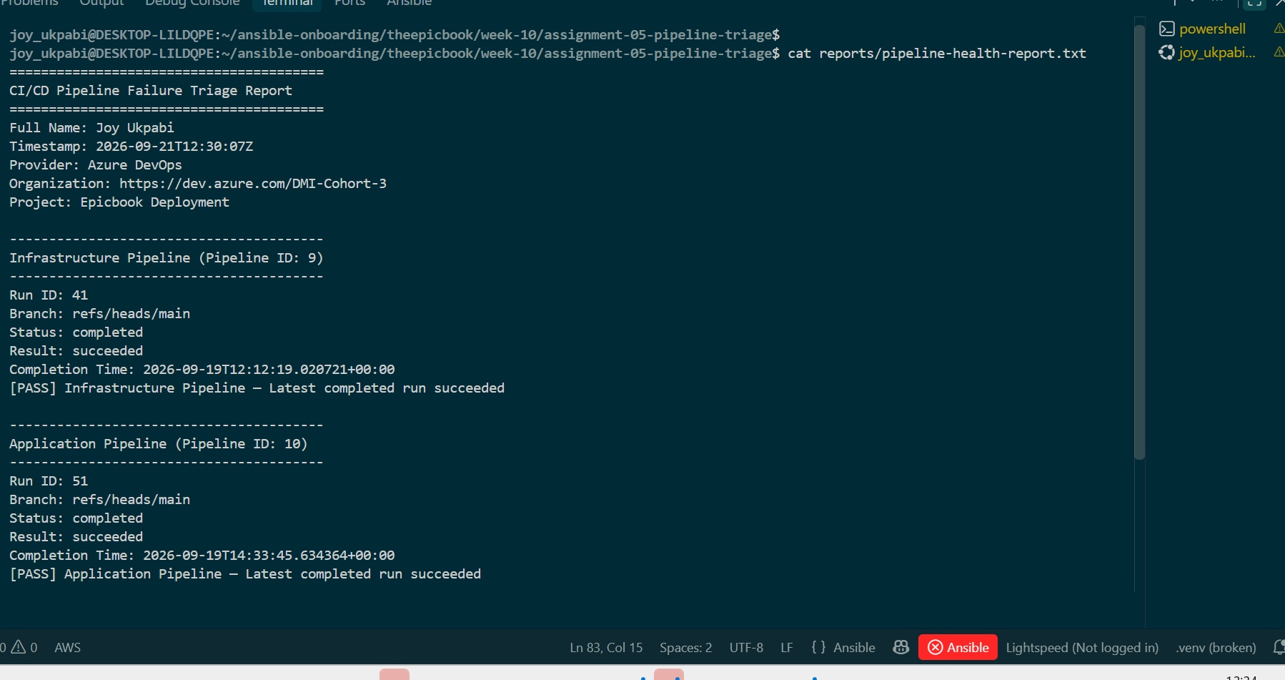

Step 5: Confirm the report files exist
ls -l reports/
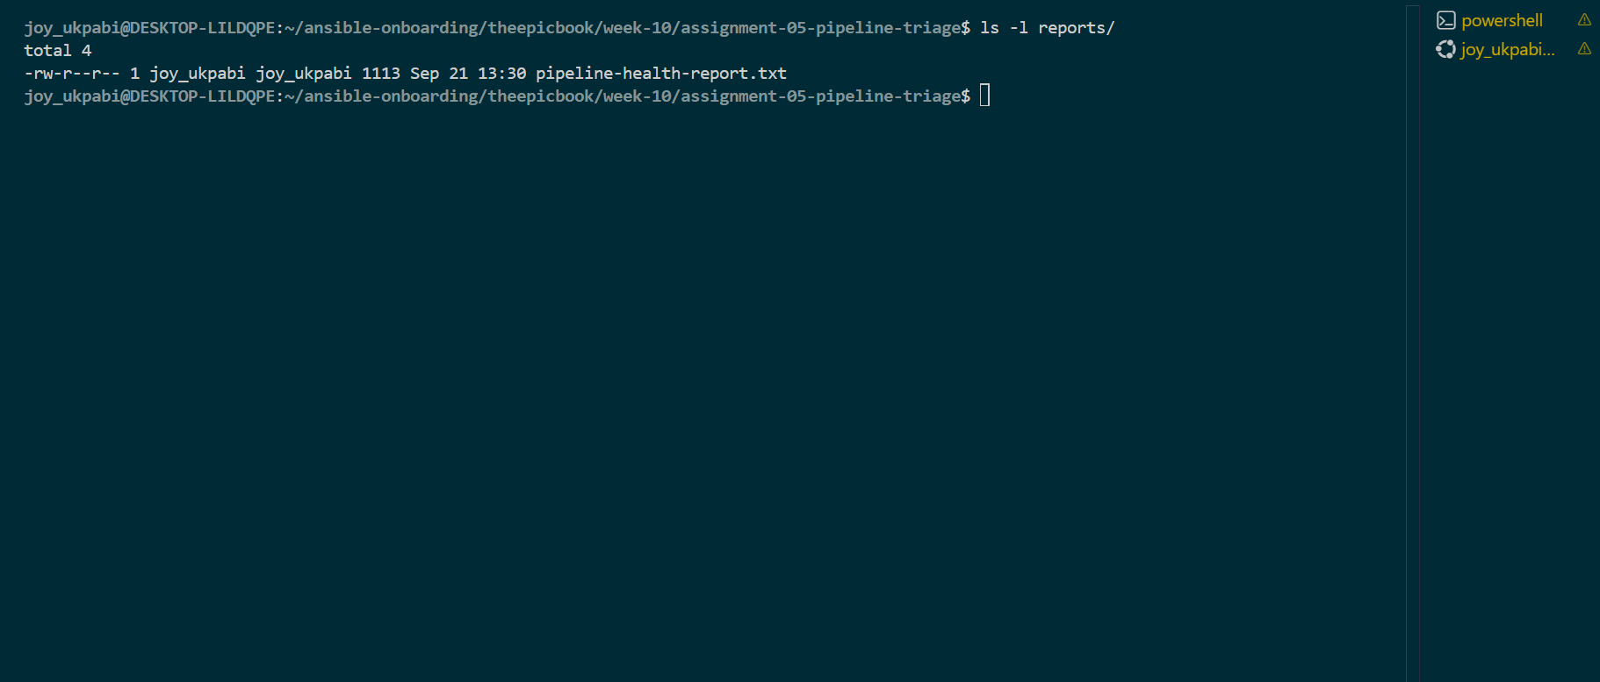

Explanation

Run and Understand the Healthy-State Report
Task 4 is about running the triage tool for the first time and proving that both pipelines are healthy before any failure is introduced later in the assignment. This creates the known-good baseline that will be used for comparison when the system is deliberately broken in Task 6.
The first step is to move into the assignment directory:
cd ~/ansible-onboarding/theepicbook/week-10/assignment-05-pipeline-triage
pwd
This puts us in the correct workspace where the script, reports/ directory, CLAUDE.md, and other supporting files are located. Running pwd simply confirms that we are in the expected directory before continuing.
Next, the script is run directly:
./pipeline-triage.sh
The script checks the required configuration and tools, then checks the latest run of both the Infrastructure Pipeline (ID 9) and Application Pipeline (ID 10). Since both pipelines are expected to have completed successfully, the script should classify both as [PASS]. At this stage, the script is only gathering information from Azure DevOps; it is not changing or fixing anything.
Immediately after running the script, we check its exit code:
echo $?
The $? represents the result of the command that was just executed. A result of 0 means the script completed successfully and found a healthy state. This is important because we are checking not only what the report says, but also whether the script itself reached the expected healthy conclusion.
The next command displays the generated report:
cat reports/pipeline-health-report.txt
The report should identify Joy Ukpabi, show the Azure DevOps information and timestamp, and contain separate sections for the Infrastructure and Application pipelines. Both should show completed and succeeded, with a [PASS] result. The summary should show PASS: 2, WARN: 0, FAIL: 0, ERROR: 0 and an overall status of HEALTHY with exit code 0.
Finally, we check that the report files actually exist:
ls -l reports/
This confirms that the script created the expected output on disk. The main file should be pipeline-health-report.txt, while infra-last-run.log and app-last-run.log may also be present even though they are not expected to contain failure evidence during a healthy run.
Together, these steps establish the healthy baseline for the assignment. We have verified that the script runs successfully, returns exit code 0, produces the expected report, and sees both pipelines as healthy. Later, when a failure is deliberately introduced, this baseline gives us something reliable to compare against.

Task 5 — Configure and Test the Supplied /pipeline-triage Skill

Goal
Confirm the supplied Claude Code skill is correctly scoped (manual invocation only, narrow tool approval, no write access), then invoke it from Claude Code and verify it produces the same healthy result Task 4 did — but through Claude's analysis instead of your own cat.

Steps
1. Open the supplied SKILL.md
cd ~/ansible-onboarding/theepicbook/week-10/assignment-05-pipeline-triage
cat .claude/skills/pipeline-triage/SKILL.md

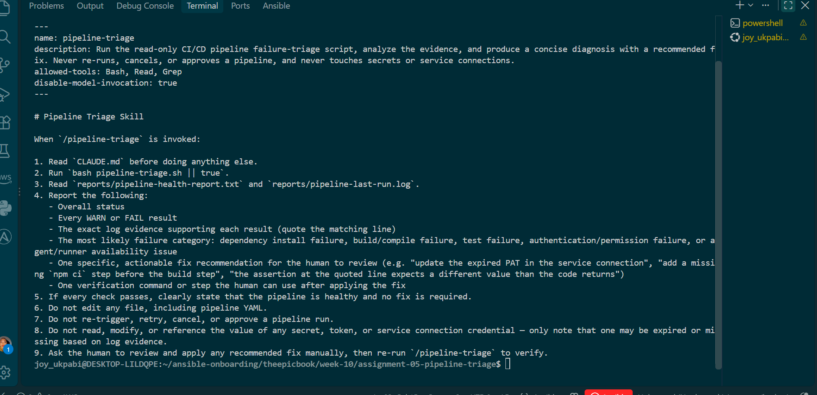

2. Confirm the YAML frontmatter starts on line 1
head -n 1 .claude/skills/pipeline-triage/SKILL.md

Should show ---, not blank lines or comments before it — Claude Code only recognizes frontmatter if it's the very first thing in the file.
3. Confirm the required frontmatter fields are present
grep -n "^name:\|^description:\|disable-model-invocation" .claude/skills/pipeline-triage/SKILL.md

Confirm disable-model-invocation: true is present — this is what stops Claude from deciding on its own to run the skill mid-conversation; only you, typing /pipeline-triage, can start it.

4. Confirm tool scope is narrow
grep -n "allowed-tools\|tools:" .claude/skills/pipeline-triage/SKILL.md

Confirm the only pre-approved tools are the exact triage-script invocation and read-only report/log inspection — not a general Bash(*) or unrestricted shell grant.

5. Confirm project-permission deny rules exist (if supplied separately)
find . -iname "*.json" -path "*permission*" 2>/dev/null
cat .claude/settings.json 2>/dev/null

If a permissions file exists, confirm it denies pipeline-mutating commands and dangerous operations (rm, git push, edit tools outside reports/ review, etc.) in addition to what SKILL.md states.
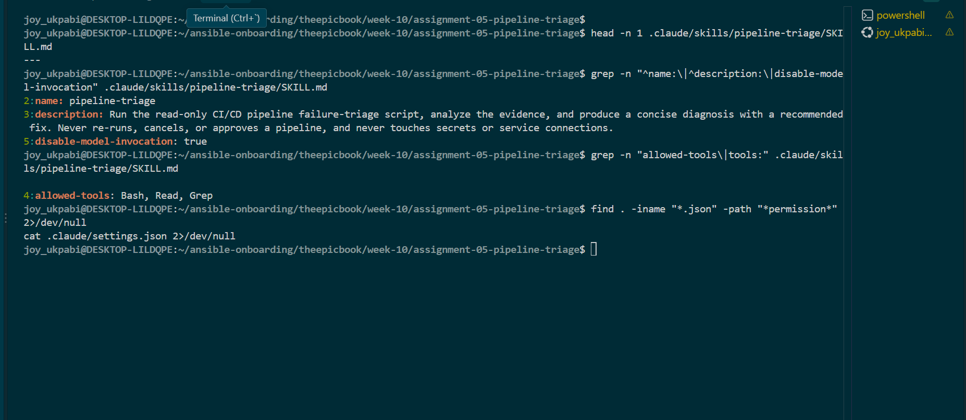

6. Confirm the skill reads CLAUDE.md before running
grep -n "CLAUDE.md" .claude/skills/pipeline-triage/SKILL.md

7. Confirm the skill's required output structure matches the assignment
grep -niE "overall status|affected pipeline|run id|failure category|evidence|root cause|recommend|verification" .claude/skills/pipeline-triage/SKILL.md

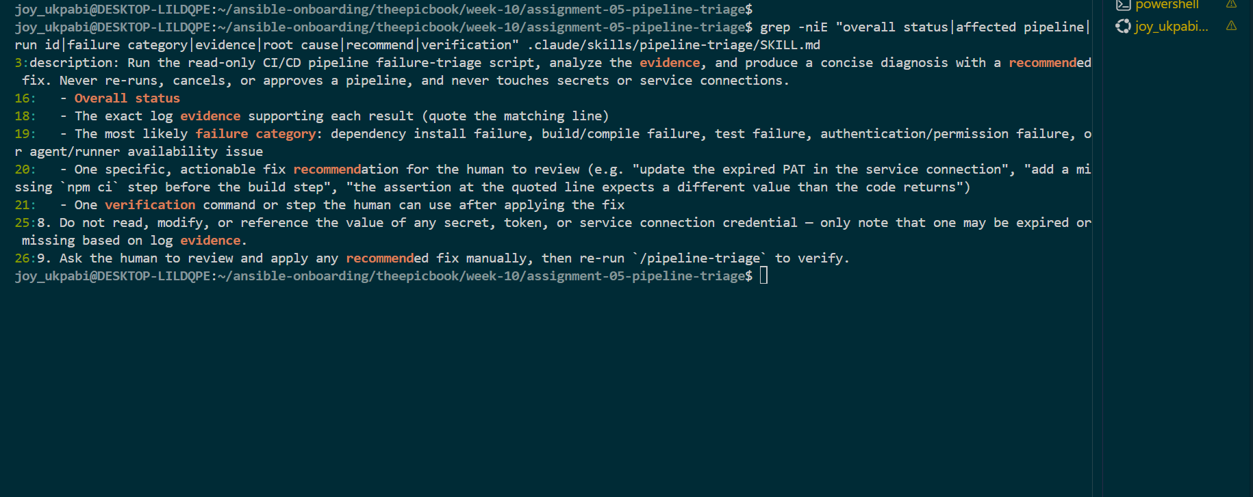

8. Start Claude Code from the assignment root
claude

9. Confirm the skill is discovered
Inside the Claude Code session, type:
/pipeline-triage

If it doesn't appear or autocomplete, exit and re-check the exact path .claude/skills/pipeline-triage/SKILL.md and filename capitalization.
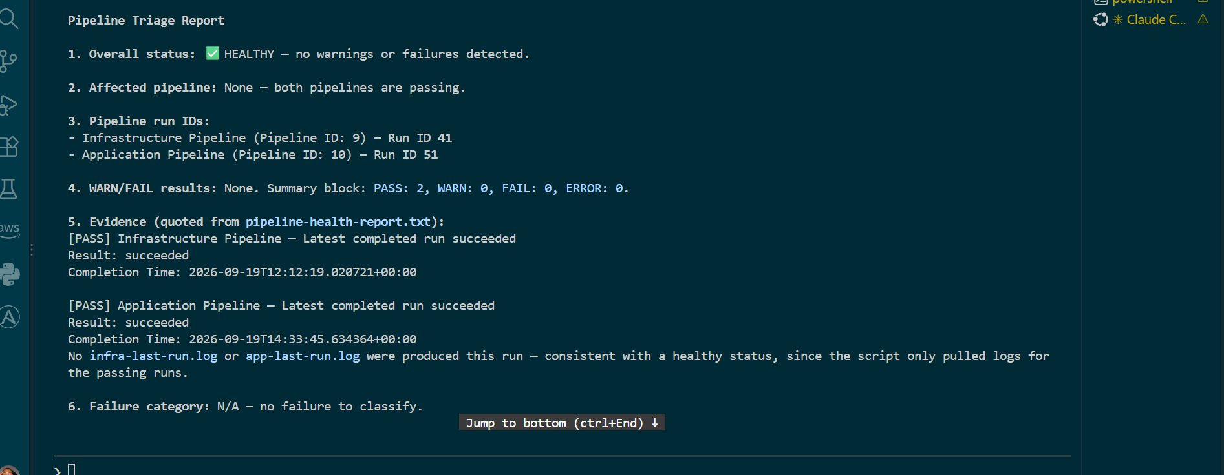

Expected Output
- /pipeline-triage is available and only runs when you type it — Claude never starts it unprompted in the same session.
- Claude runs pipeline-triage.sh, reads reports/pipeline-health-report.txt, and reports back that both the Infrastructure and Application Pipelines are healthy.
- Claude states no fix is required.
- No file is edited, no git command is run, no pipeline is triggered/retried/canceled/approved.
- The terminal/session shows Claude's structured output following CLAUDE.md's required 9-point Output Rules (even though most fields will simply be "N/A — no failure detected" here).

Explanation
This step is where you actually run the /pipeline-triage skill you configured in Steps 1–9. The earlier steps only confirmed that the SKILL.md file was correctly written, had the right settings, and referenced CLAUDE.md. Running /pipeline-triage proves that the skill can work in a real Claude Code session.
The phrase “against the healthy baseline” means you run it while both the Infrastructure and Application pipelines are still healthy, before the deliberate failure introduced later. This is important because you already know what the correct result should look like. If the skill produces a clean HEALTHY result now, you have a working reference point. Later, when you intentionally break something, you can compare the new result against this known-good behavior and be confident that the difference is caused by the introduced failure rather than a problem with the triage skill itself.
Practically, you start Claude Code with:
claude
Then, inside the Claude Code session, you manually invoke the skill:
/pipeline-triage
Because disable-model-invocation: true is set in the skill's frontmatter, the skill should only run when you explicitly type /pipeline-triage. It should not automatically decide to invoke itself during another conversation.
When the skill runs, Claude uses the Bash tool to execute pipeline-triage.sh. The script is responsible for communicating with Azure DevOps and collecting the pipeline evidence. Claude then reads the generated report using its available read/search tools and interprets what the script found. This separation is important: the script gathers the evidence, while Claude analyzes and explains that evidence rather than independently changing the pipeline or infrastructure.
Because both pipelines are healthy at this point, the result should show Overall Status: HEALTHY, with both the Infrastructure and Application pipelines marked as PASS. Claude should also provide the structured information required by CLAUDE.md, such as the affected pipeline, run ID, evidence, failure category, recommendation, and verification step. Since there is no failure yet, the failure-specific sections should effectively say that there is no failure or that the information is not applicable.
The most important part of this step is the safety behavior. Running the skill should not edit project files, run Git commands, trigger or retry pipelines, cancel or approve runs, modify Terraform or Ansible, or make changes to Azure resources. It is strictly a read-only diagnosis. The workflow at this point is simply Gather → Analyze, leaving any corrective action to a human.
So, Task 5 Step 10 establishes that the complete triage chain works before an incident occurs: the skill can be manually invoked, the script can gather the evidence, Claude can interpret the report, and the result correctly identifies the known-good state as HEALTHY. That gives you a reliable baseline for the deliberate failure and triage exercise that follows.

Task 5 — Configure and Test the Supplied /pipeline-triage Skill

Goal
Configure the supplied Claude Code skill and verify that it runs the Bash tool as a reusable, manually invoked workflow.

Steps
1. Open the supplied SKILL.md
cd ~/ansible-onboarding/theepicbook/week-10/assignment-05-pipeline-triage
cat .claude/skills/pipeline-triage/SKILL.md

2. Confirm the YAML frontmatter begins on the first line
head -n 1 .claude/skills/pipeline-triage/SKILL.md
Confirmed: --- is the first line.
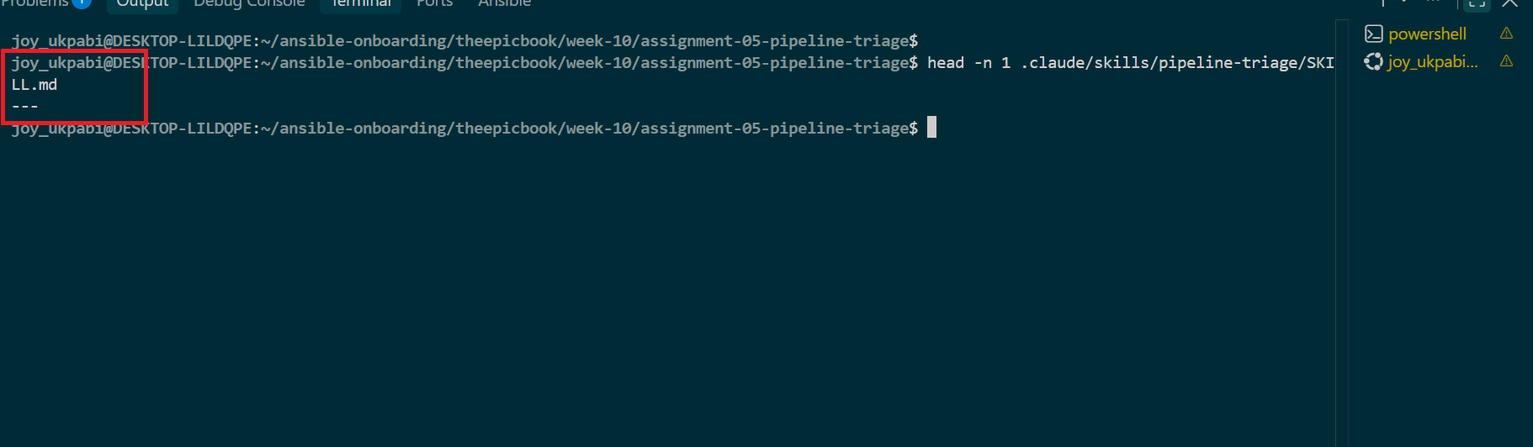

3. Confirm the skill has a clear name and description
grep -n "^name:\|^description:" .claude/skills/pipeline-triage/SKILL.md

Confirmed: name: pipeline-triage, with a description stating it runs the read-only triage script, analyzes evidence, and produces a diagnosis — and explicitly states it never re-runs, cancels, approves a pipeline, or touches secrets.

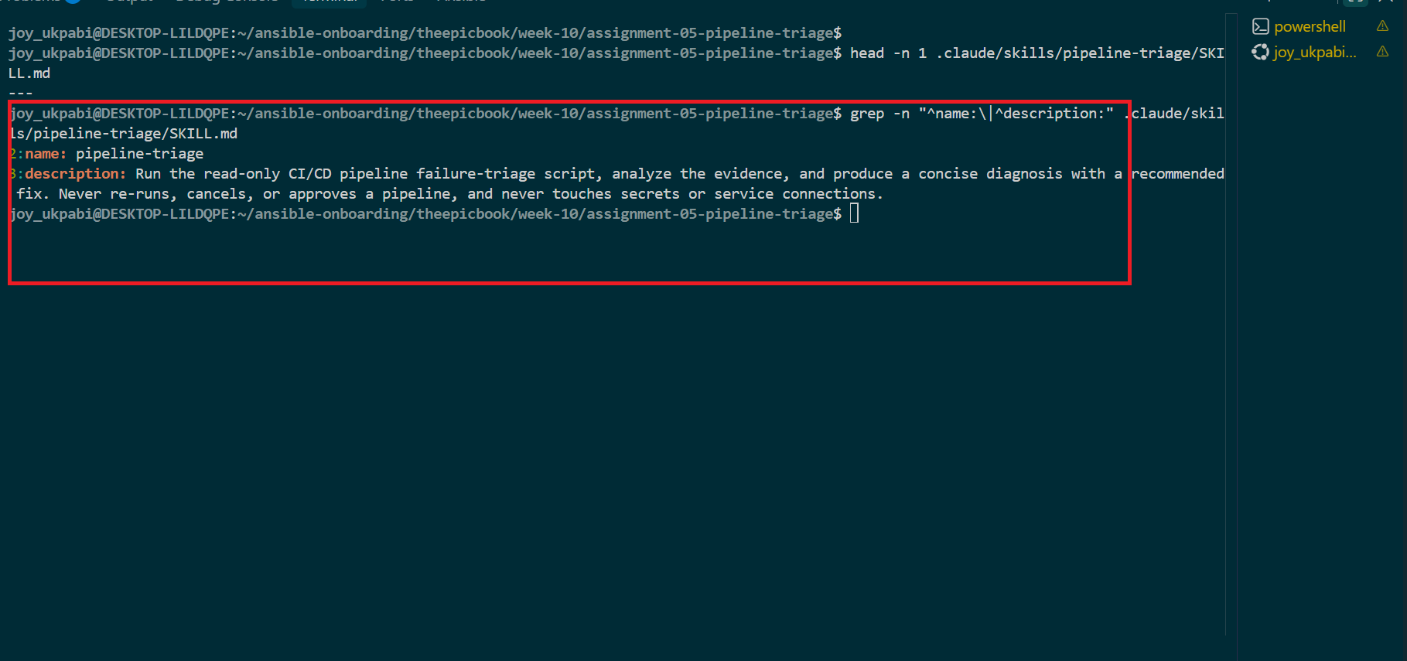

4. Confirm disable-model-invocation: true is present
grep -n "disable-model-invocation" .claude/skills/pipeline-triage/SKILL.md

Confirmed: present in the frontmatter — only a human typing /pipeline-triage can start it.
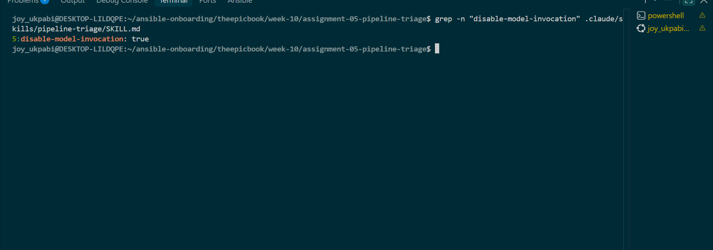

5. Confirm only the exact triage-script command and read-only tools are pre-approved
grep -n "allowed-tools" .claude/skills/pipeline-triage/SKILL.md
Confirmed: allowed-tools: Bash, Read, Grep — no Write or Edit tool granted.
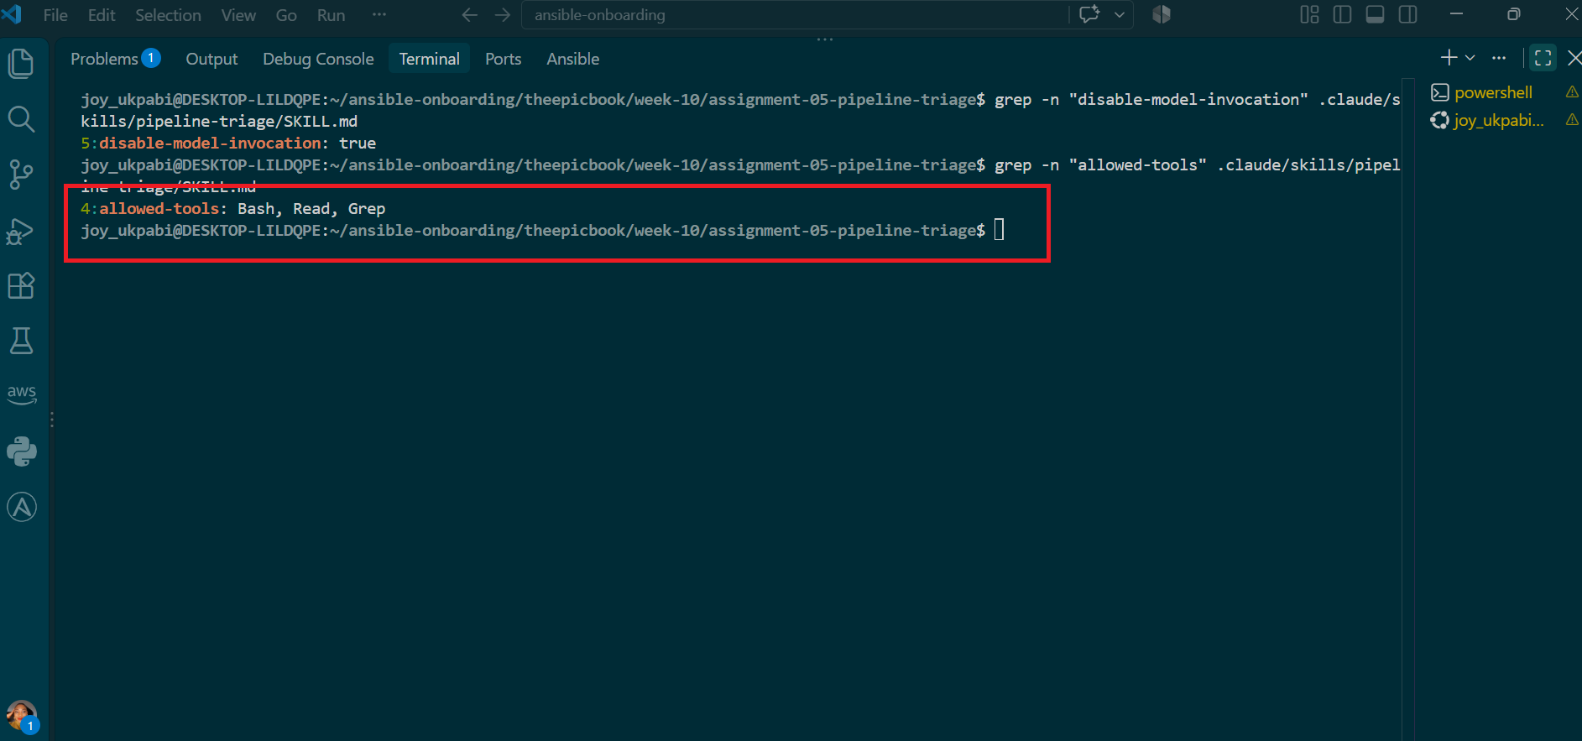

6. Confirm unrestricted Bash access is not granted
Reviewed the frontmatter and body: Bash is listed without wildcard scoping, and the skill body explicitly instructs it to run only bash pipeline-triage.sh || true — no other command is described.
Commands

# Show the exact allowed-tools line
grep -n "^allowed-tools:" .claude/skills/pipeline-triage/SKILL.md

# Confirm Bash is not wildcarded (should return nothing if safe)
grep -n "Bash(\*)\|Bash: \*\|Bash(.*:.*)" .claude/skills/pipeline-triage/SKILL.md

# Confirm the only command the skill body actually names is the triage script
grep -n "bash pipeline-triage.sh\|^2\." .claude/skills/pipeline-triage/SKILL.md

# Broader sweep: list every command-like string in the body, to eyeball nothing else is named
grep -n "\`.*\`" .claude/skills/pipeline-triage/SKILL.md

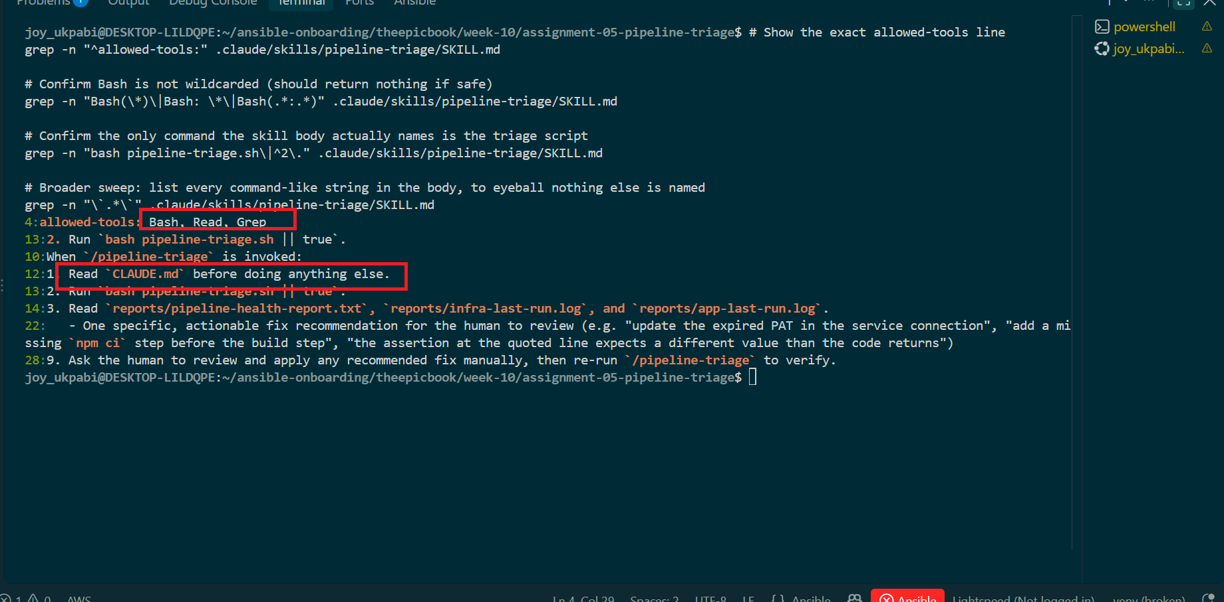

7. Confirm file-editing tools are restricted
Confirmed via the absence of Write/Edit in allowed-tools, combined with explicit Step 6 in the skill body: "Do not edit any file, including pipeline YAML."

# Confirm Write and Edit are absent from allowed-tools
grep -n "^allowed-tools:" .claude/skills/pipeline-triage/SKILL.md
grep -c "Write\|Edit" .claude/skills/pipeline-triage/SKILL.md

# Confirm the explicit no-editing rule is stated in the body
grep -n "Do not edit any file" .claude/skills/pipeline-triage/SKILL.md

# Confirm pipeline YAML is specifically called out
grep -n "pipeline YAML" .claude/skills/pipeline-triage/SKILL.md

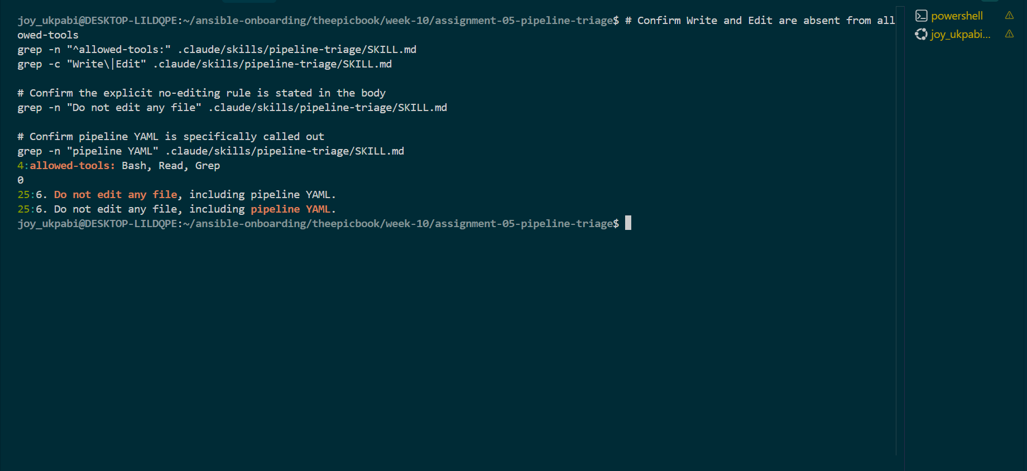

8. Confirm the skill reads CLAUDE.md before beginning
grep -n "CLAUDE.md" .claude/skills/pipeline-triage/SKILL.md
Confirmed: Step 1 of the skill body reads CLAUDE.md before doing anything else.
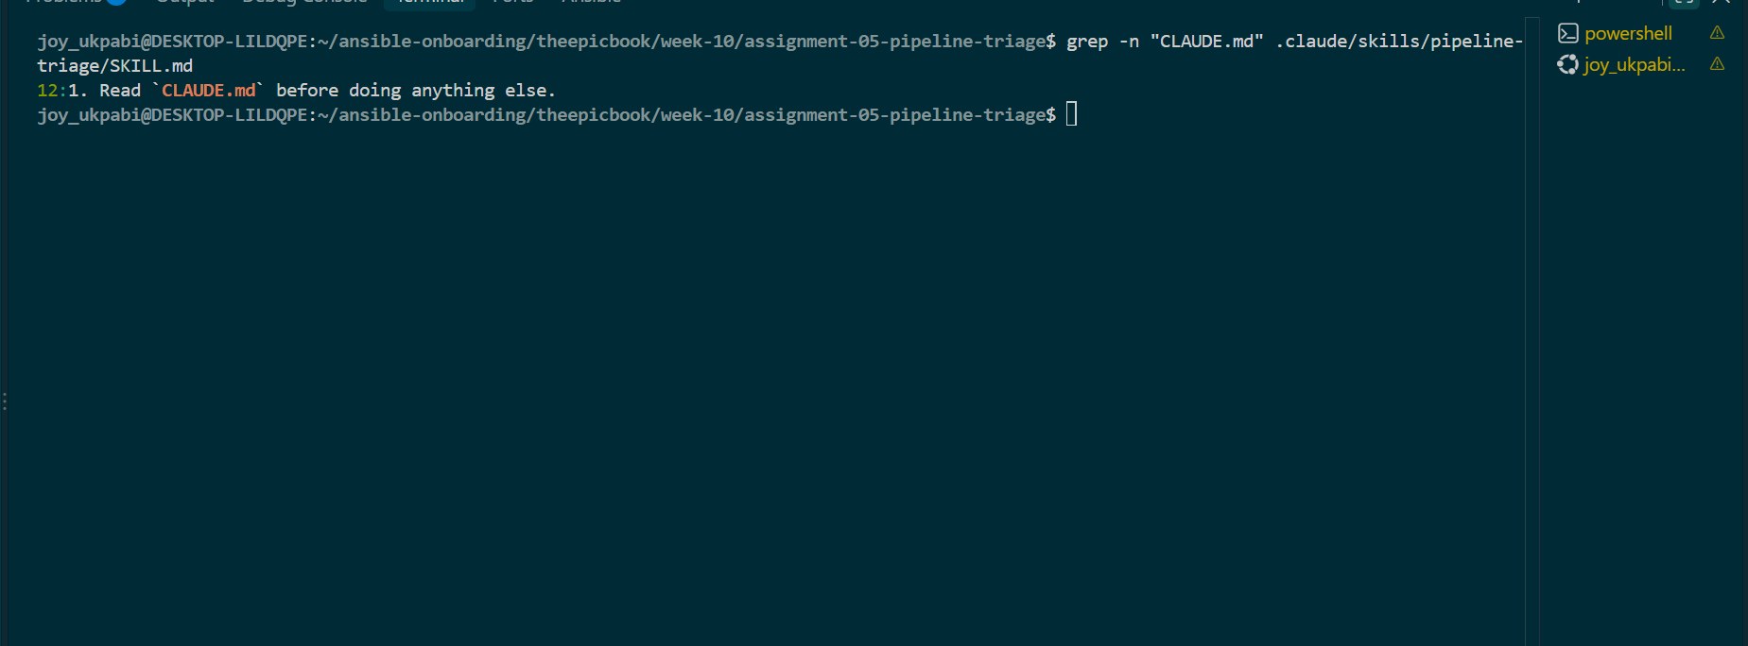

9. Confirm it runs only the triage script and reads the generated report/logs
Reviewed skill body Steps 2–3. Initial issue found: Step 3 referenced a single reports/pipeline-last-run.log, but the configured script (Task 3) writes two separate files, infra-last-run.log and app-last-run.log. Corrected via:
sed -i 's|Read `reports/pipeline-health-report.txt` and `reports/pipeline-last-run.log`\.|Read `reports/pipeline-health-report.txt`, `reports/infra-last-run.log`, and `reports/app-last-run.log`.|' .claude/skills/pipeline-triage/SKILL.md

10. Confirm required output structure matches CLAUDE.md's Output Rules
Reviewed Step 4 of the skill body. Second issue found: the failure-category list only named 5 of the 8 required categories, and "Affected pipeline" / "Pipeline run ID" weren't listed as their own explicit fields. Corrected by editing the category bullet to list all 8 categories (including Terraform, Ansible/Nginx/deployment, and Unclassified Pipeline Failure), and inserting two new bullets:
sed -i '/- Overall status/a\ - Pipeline run ID' .claude/skills/pipeline-triage/SKILL.md
sed -i '/- Overall status/a\ - Affected pipeline (Infrastructure Pipeline or Application Pipeline)' .claude/skills/pipeline-triage/SKILL.md

Verified the corrected order:
grep -n -A5 "^4. Report the following" .claude/skills/pipeline-triage/SKILL.md
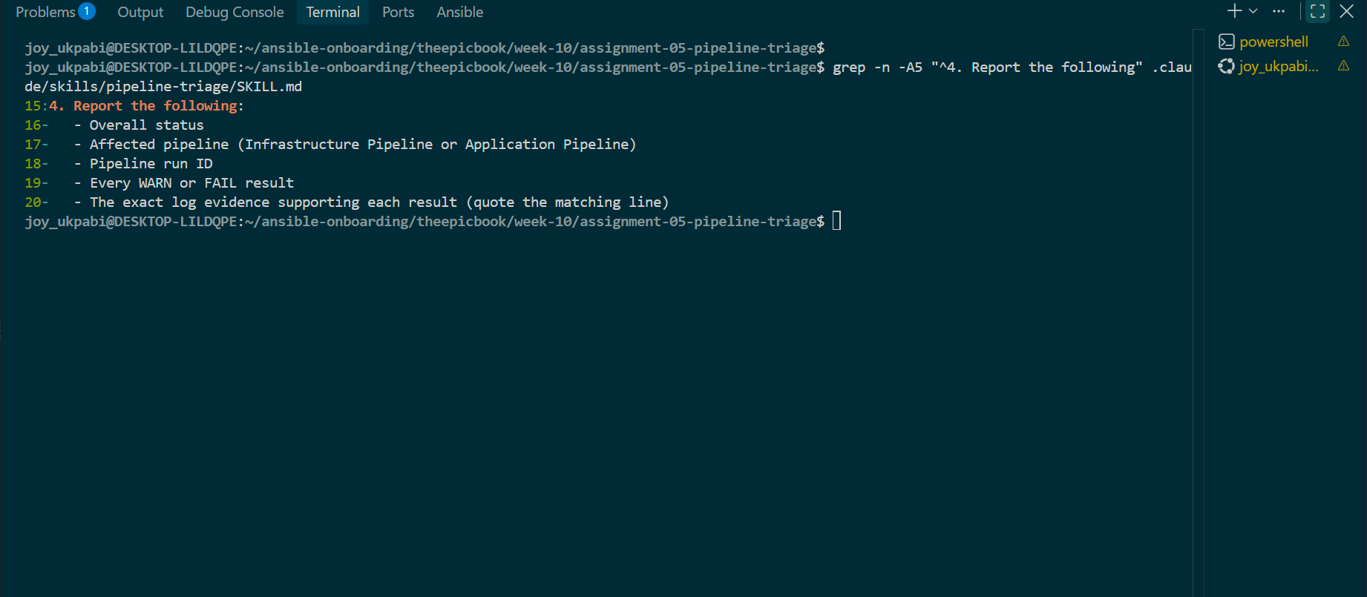

11. Confirm the skill must not edit files or apply a fix, must not mutate a pipeline, and must not access secrets

# No file / pipeline YAML editing
grep -n "Do not edit any file" .claude/skills/pipeline-triage/SKILL.md
grep -n "pipeline YAML" .claude/skills/pipeline-triage/SKILL.md

# No pipeline mutation (trigger/retry/cancel/approve)
grep -n "Do not re-trigger, retry, cancel, or approve" .claude/skills/pipeline-triage/SKILL.md
grep -n -i "trigger\|retry\|cancel\|approve" .claude/skills/pipeline-triage/SKILL.md

# No secret access or exposure
grep -n "Do not read, modify, or reference the value of any secret" .claude/skills/pipeline-triage/SKILL.md
grep -n -i "secret\|token\|credential\|service connection" .claude/skills/pipeline-triage/SKILL.md

# Confirm the human-review requirement (fix is recommended, not applied)
grep -n "Ask the human to review and apply" .claude/skills/pipeline-triage/SKILL.md

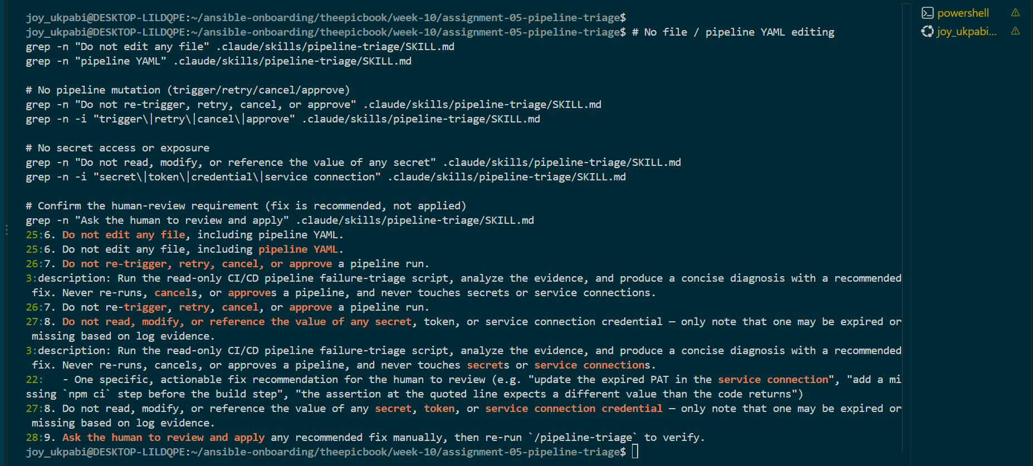
12. Review any supplied project-permission deny rules
find . -iname "*.json" -path "*permission*" 2>/dev/null
cat .claude/settings.json 2>/dev/null
Checked for a .claude/settings.json or any *permission*.json file in the workspace — none exists. This means the skill's safety boundary rests on allowed-tools scoping (Bash, Read, Grep, no Write/Edit) and the explicit safety instructions in SKILL.md's body, rather than a separate project-level permission-deny file.

13. Start Claude Code from the assignment root and confirm /pipeline-triage is available
claude
Inside the session, confirmed /pipeline-triage autocompletes and is recognized.
14. Invoke the skill manually against the healthy baseline
/pipeline-triage
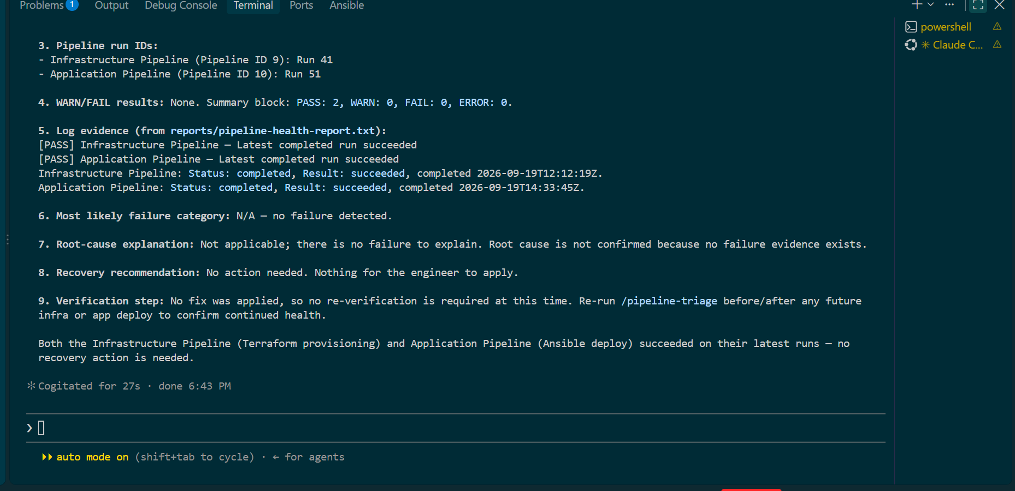
Run twice: once before the SKILL.md fix (confirmed healthy, but flagged the missing-log-filename mismatch on its own), and once after the fix (confirmed healthy, now correctly referencing infra-last-run.log and app-last-run.log by name).

Expected Output
- /pipeline-triage is manually invocable and does not fire without being explicitly typed.
- Claude runs the read-only script via the Bash tool.
- Claude analyzes the generated report and logs via Read/Grep.
- Claude reports both pipelines as healthy, per CLAUDE.md's 9-point Output Rules structure.
- Claude states no fix is required.
- No file or pipeline is modified at any point.

Explanation
Task 5 configures the supplied Claude Code skill and validates that it operates as a controlled, manually invoked triage workflow. The verification covers the skill's frontmatter, permitted tools, safety restrictions, relationship with CLAUDE.md, required output structure, and its interaction with pipeline-triage.sh.
Steps 1–5 validate the skill configuration. SKILL.md is checked to confirm that the YAML frontmatter starts on the first line, identifies the skill as pipeline-triage, provides a clear description, and sets disable-model-invocation: true. This setting is appropriate because pipeline triage should only begin when an engineer explicitly requests it. The allowed-tools configuration is also checked to confirm that the skill has access to Bash, Read, and Grep, without Write or Edit.
Step 6 verifies the Bash usage defined by the skill. Although Bash is available, the skill explicitly instructs Claude to execute only bash pipeline-triage.sh || true. The workflow therefore uses Bash to execute the established triage script rather than giving Claude a general-purpose command workflow. Step 7 confirms that file-editing capabilities are not provided and that the skill explicitly prohibits modifying project files or pipeline YAML.
Step 8 verifies that CLAUDE.md is read before the triage process begins. This ensures that the skill operates under the project's established safety rules and output requirements rather than relying only on its own instructions.
Step 9 validates the evidence flow. The skill runs pipeline-triage.sh and then reads the generated health report and pipeline logs. During this review, a configuration mismatch was identified: the skill referenced reports/pipeline-last-run.log, while the corrected triage script generates reports/infra-last-run.log and reports/app-last-run.log. The skill was updated to reference the two actual log files.
Step 10 validates the required output structure against CLAUDE.md. The original skill did not list all eight required failure categories and did not explicitly identify Affected pipeline and Pipeline run ID as separate output fields. These omissions were corrected, and the resulting structure was verified with grep.
Steps 11 and 12 complete the permission and safety review. The skill prohibits file modification, pipeline mutation, and access to secret values. It also prohibits re-running, retrying, cancelling, or approving pipeline runs. Any supplied project-level permission rules are checked separately to determine whether additional restrictions apply.
Steps 13 and 14 validate the skill in an actual Claude Code session. /pipeline-triage is confirmed as an available command and then invoked manually against the known-good pipeline baseline. The first invocation confirmed the pipelines were healthy while also exposing the stale log-reference issue. After correcting SKILL.md, a second invocation produced the expected healthy result and referenced the correct infrastructure and application log files.
The workflow maintains a clear separation between Gather and Analyze. pipeline-triage.sh performs the deterministic evidence collection: querying Azure DevOps, retrieving relevant logs, classifying known failure patterns, sanitizing evidence, and generating the health report. Claude then performs the analysis by reading that generated evidence and presenting the required diagnosis, recommendation, and verification step. Claude does not independently query Azure DevOps or perform remediation.
The final healthy invocation confirms that the skill is functioning as intended before the deliberate failure is introduced. Both pipelines remain healthy, no remediation is required, and no project files or pipeline runs are modified. The corrections made during this task also demonstrate the purpose of the baseline test: configuration inconsistencies were identified and resolved before they could interfere with the actual incident diagnosis in the later task.

Task 6 — Introduce a Safe Failure in the Application Pipeline

Goal
Create a controlled, reversible failure that occurs before deployment changes are applied — so it can be diagnosed without touching Azure infrastructure, credentials, or production data.

Steps
1. Create a temporary branch
cd ~/ansible-onboarding/theepicbook
git checkout -b drill/pipeline-failure

2. Introduce the chosen safe failure
The Application Pipeline uses Node.js, so the failure is introduced through package.json. This creates a predictable dependency-installation failure while leaving the Infrastructure Pipeline, credentials, and cloud resources unchanged.

Step 1 — Navigate to the application repository
cd ~/ansible-onboarding/theepicbook
Confirm the repository location:
pwd
Check the current Git state before making changes:
git status
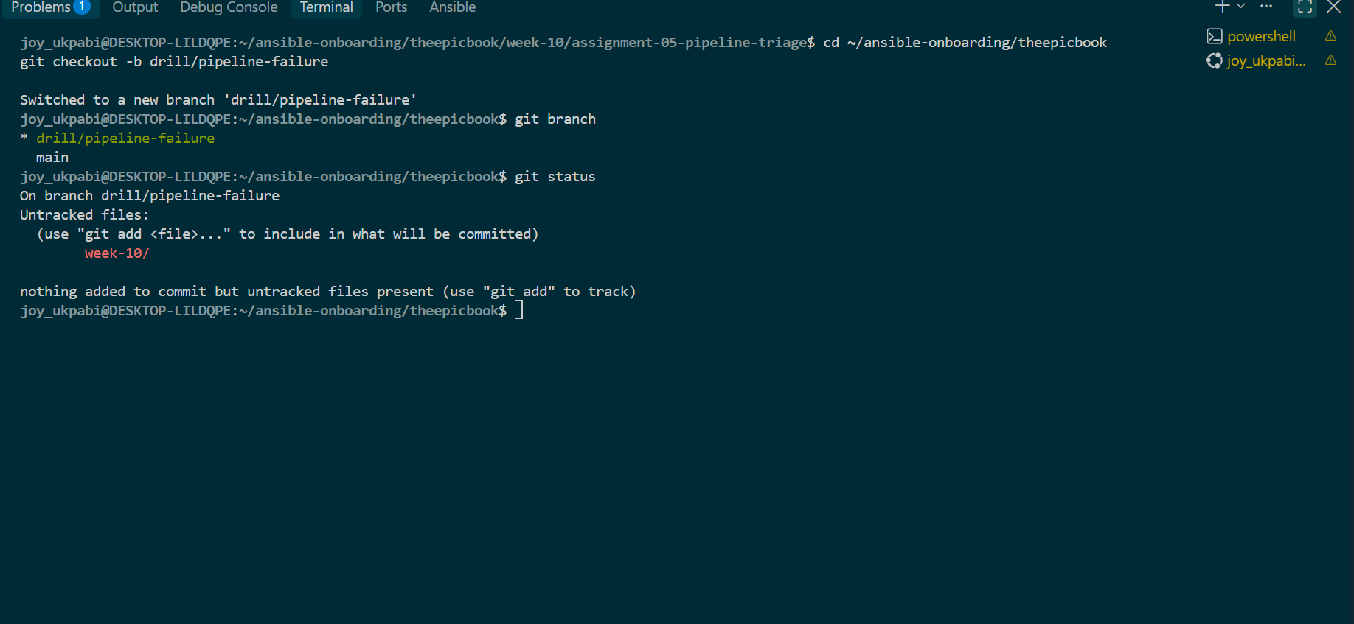

Step 2 — Inspect package.json
cat package.json
Locate the "dependencies" section. Do not remove or modify any existing dependencies:

Step 3 — Add an invalid dependency
Open the file:
nano package.json
Add the following entry inside the "dependencies" section:
"not-a-real-package-xyz": "1.0.0"

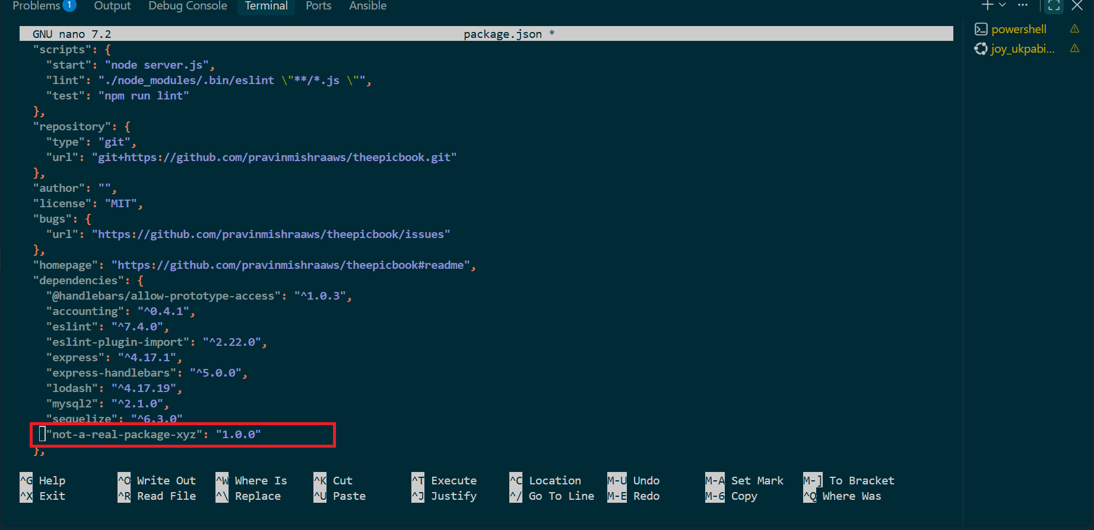

Save with Ctrl + O, press Enter, then exit with Ctrl + X.

Step 4 — Verify the change
Run:
git diff -- package.json
The diff should show only this addition:
+ "not-a-real-package-xyz": "1.0.0"
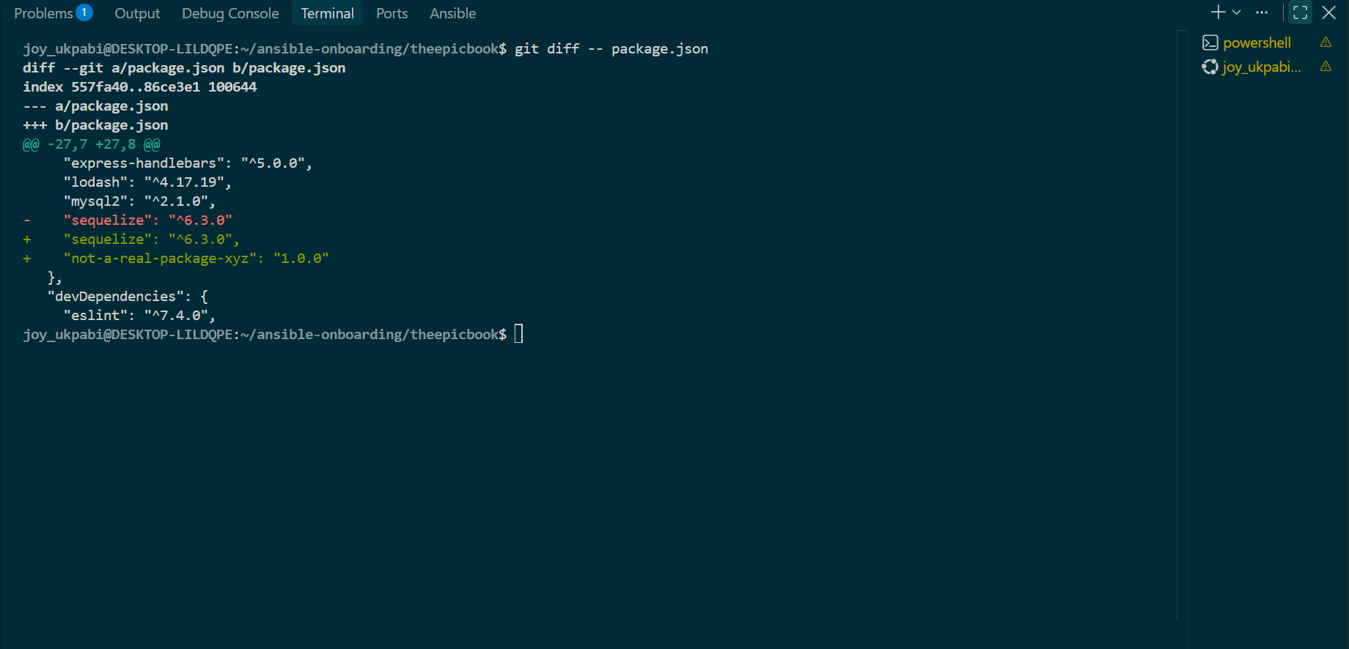
Then check:
git status

5. Commit the intentional failure with a clear drill-identifying message
git add .
git commit -m "drill: intentional failing test assertion for pipeline-triage assignment (do not merge)"

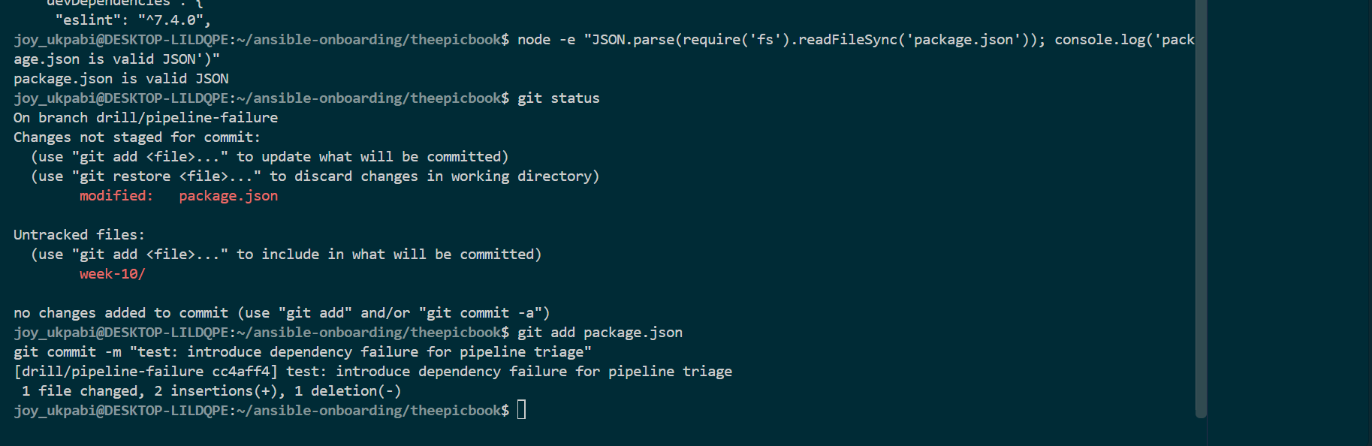
4. Push the temporary branch
git push -u origin drill/pipeline-failure

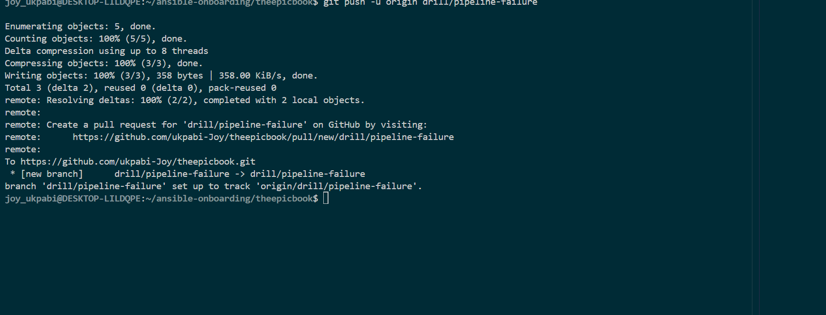

5. Trigger the Application Pipeline against this branch
Either:
- Open a pull request to main (if PR validation is configured to auto-trigger), or
- Manually queue it:
Navigate to pipeline
Run pipeline
Select drill/pipeline-failure
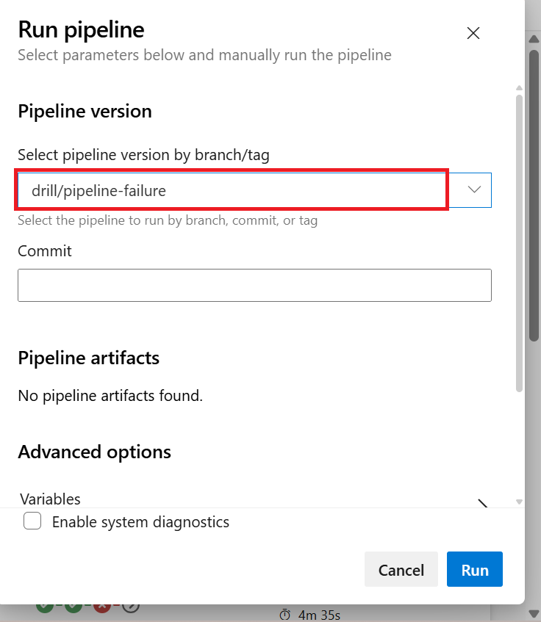
Do not merge this branch into main.
6. Wait for the run to reach a failed result

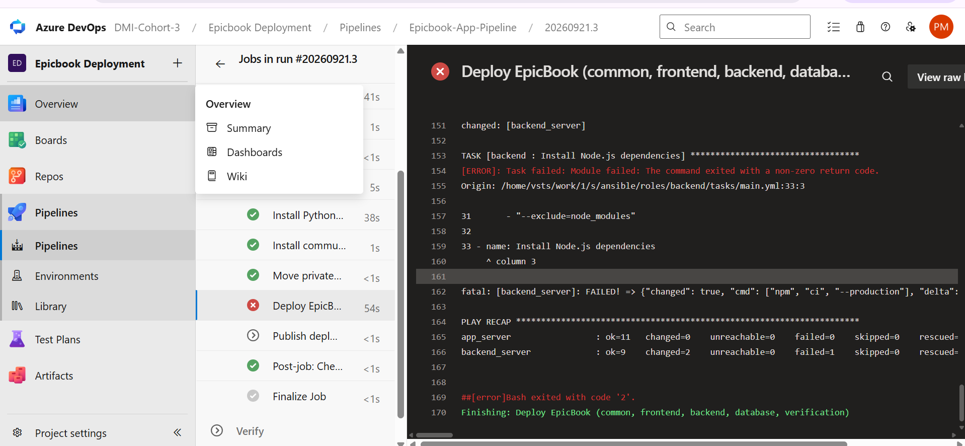
7. Open the failed step and confirm the expected error appears
Check via the Azure DevOps portal, or:
az pipelines runs show \
--organization "$ado_org" \
--project "$ado_project" \
--id <failed-run-id>
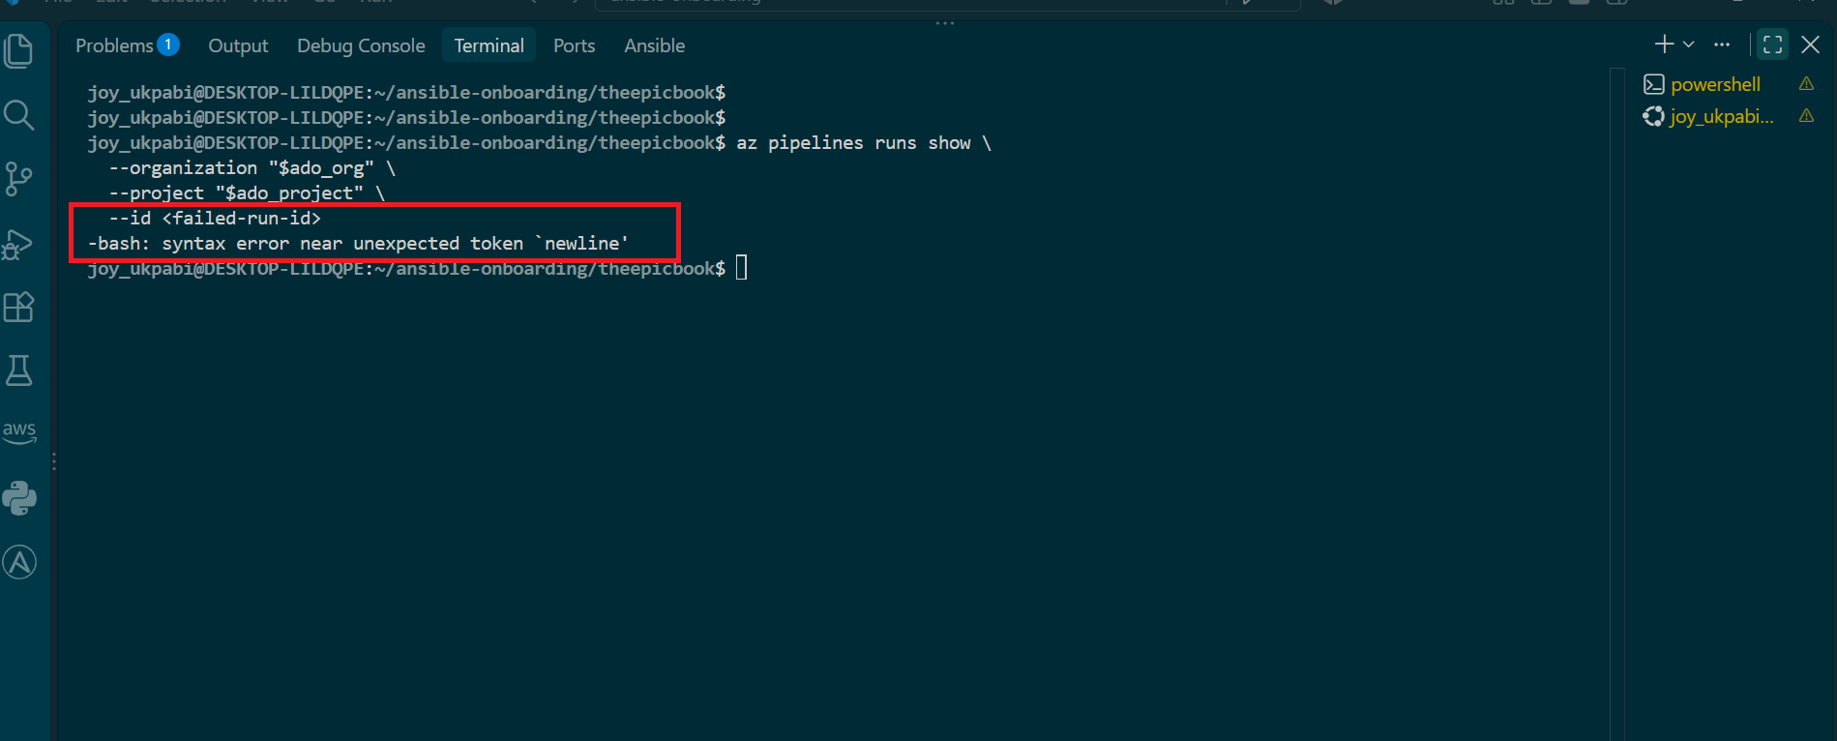
8. Confirm the Infrastructure Pipeline remains unchanged
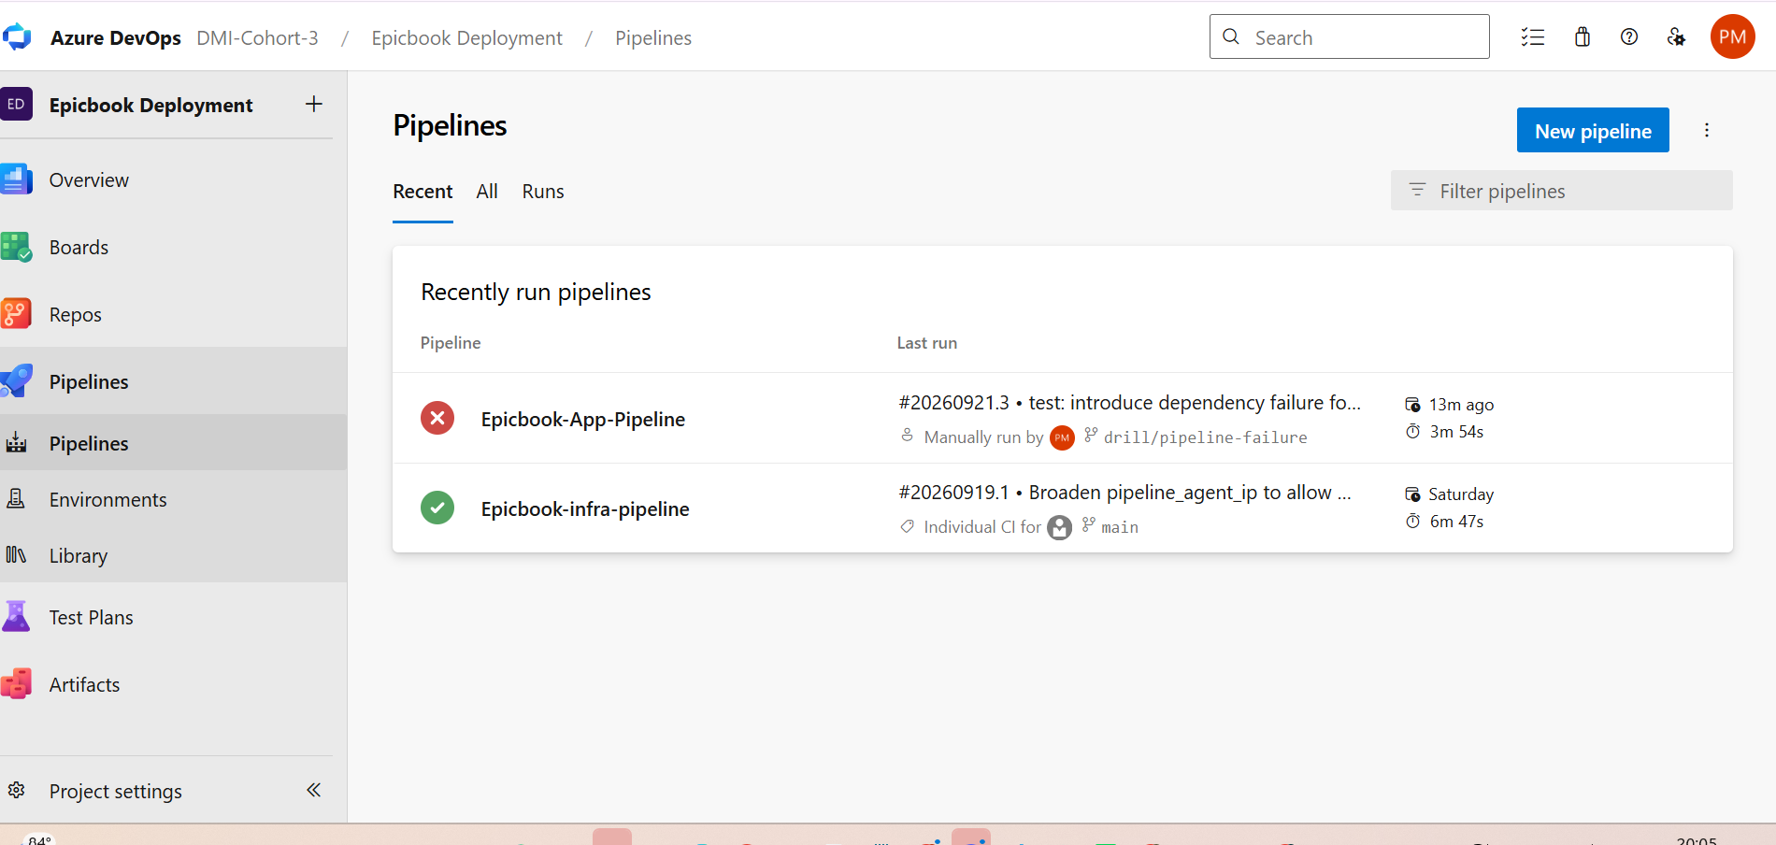
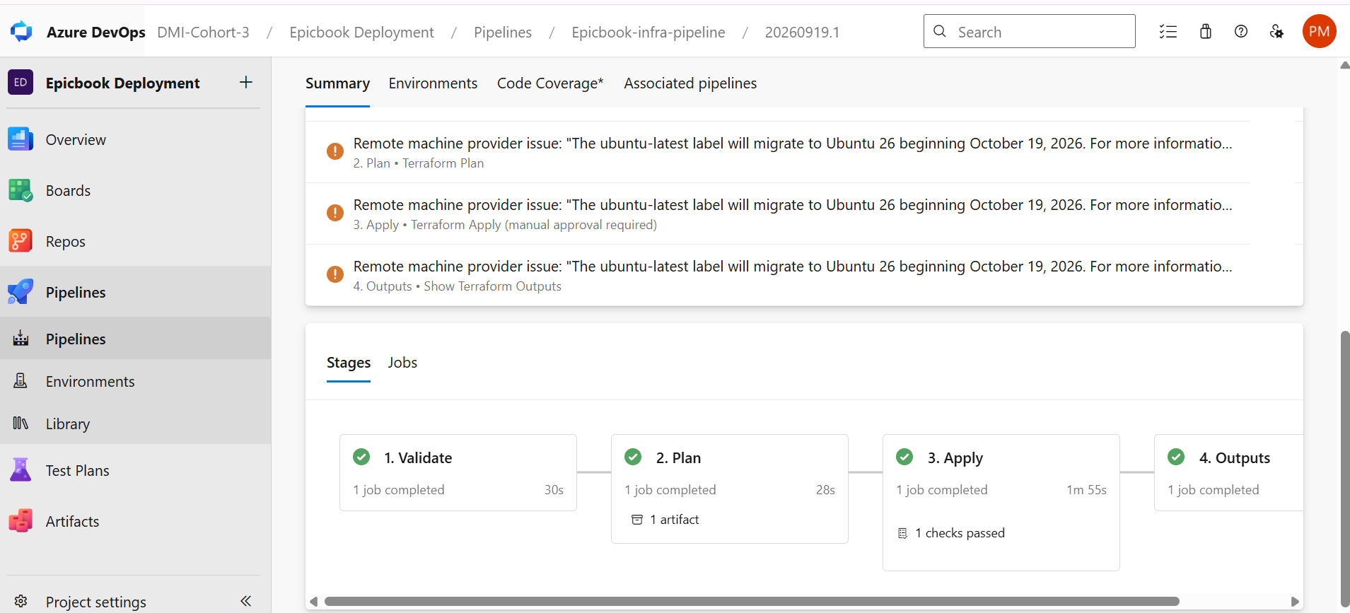
Should still show the same successful run from Task 1/Task 4 — untouched.

Expected Output
- The Application Pipeline fails on drill/pipeline-failure.
- The Infrastructure Pipeline's latest run is unchanged from baseline.
- The failure is safe, reversible, and occurs before any deployment step runs.
- The failed step's log contains clear, recognizable evidence (a test failure message, or a dependency-resolution error, depending on which option you chose).

Task 7 — Diagnose and Save the Incident Evidence

1. Manually queue the Application Pipeline against the drill branch
Since the pipeline's trigger only watches main, pushing to drill/pipeline-failure alone won't fire it — queue it manually instead:
cd ~/ansible-onboarding/theepicbook
az pipelines run \
--organization https://dev.azure.com/DMI-Cohort-3 \
--project "Epicbook Deployment" \
--id 10 \
--branch drill/pipeline-failure

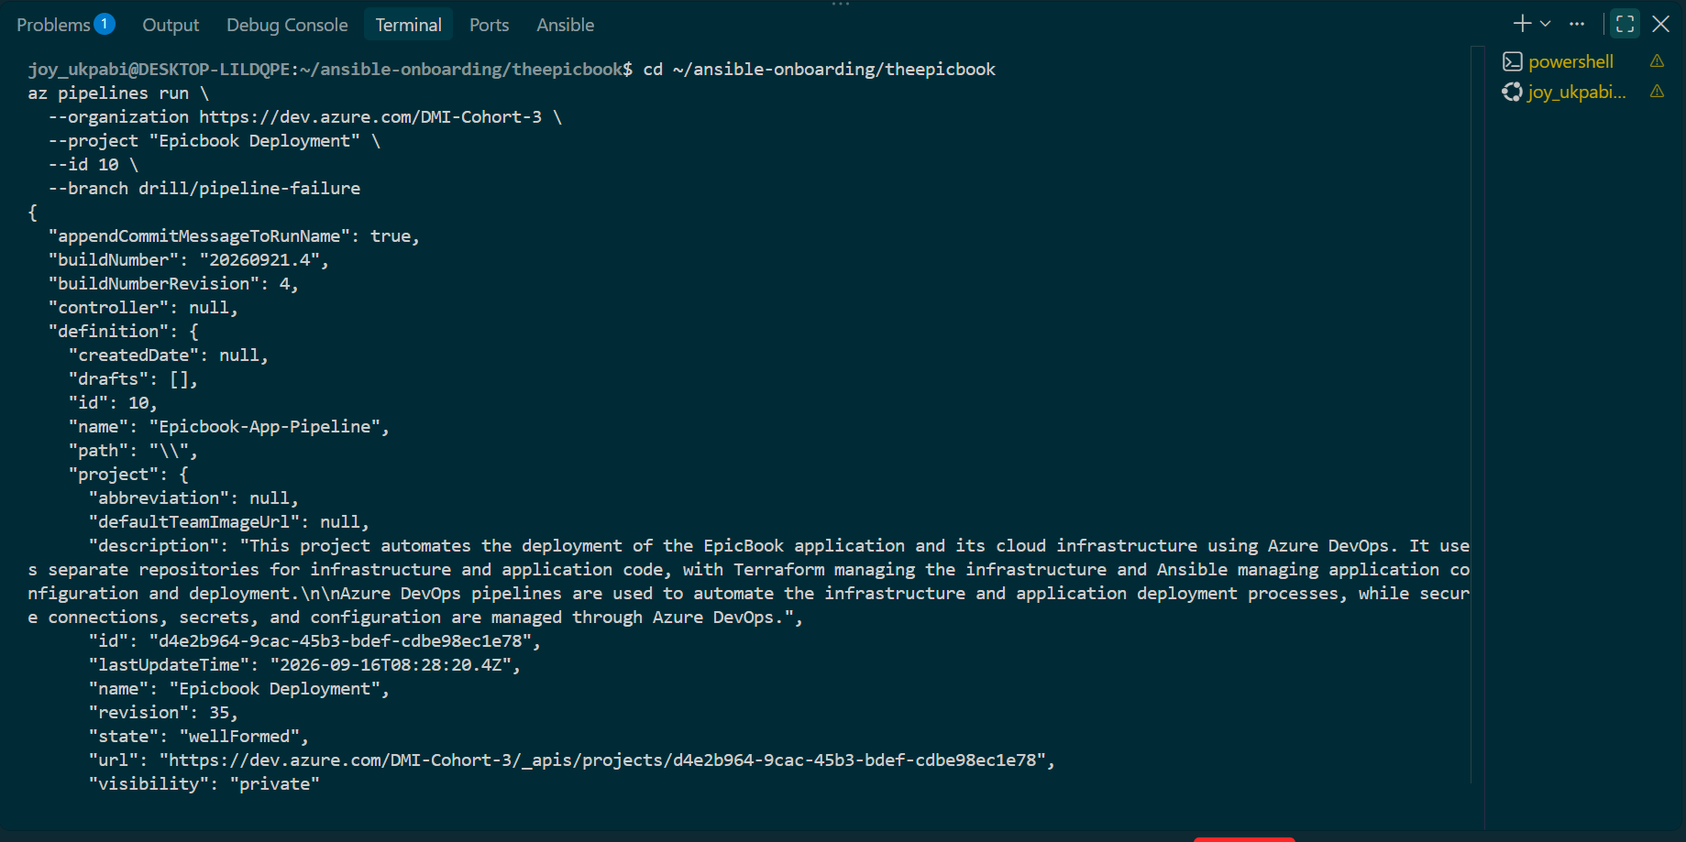

2. Wait for it to fail, then confirm
az pipelines runs list \
--pipeline-ids 10 \
--branch drill/pipeline-failure \
--top 1 \
--output table

Confirm Result: failed before continuing.
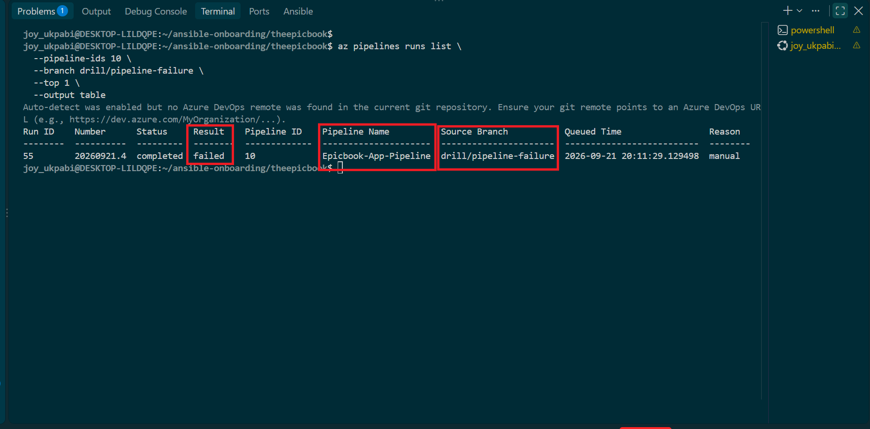

3. Start Claude Code from the assignment root
cd ~/ansible-onboarding/theepicbook/week-10/assignment-05-pipeline-triage

claude

4. Invoke the skill
/pipeline-triage

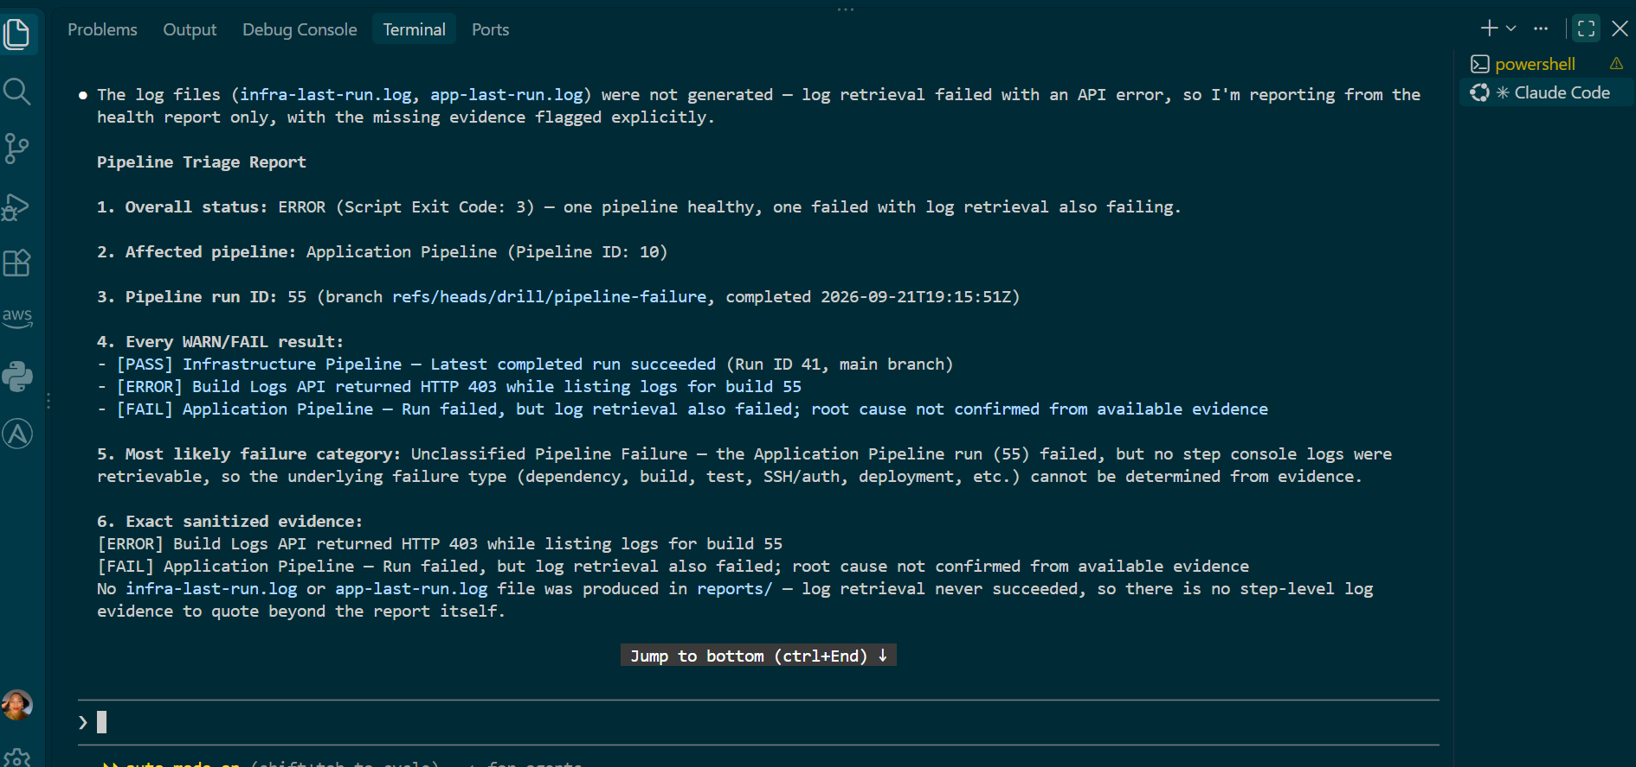

5. Review Claude's output against the checklist
Confirm it correctly identifies:
- The Application Pipeline as failed (this run should now be the latest, since it was queued after the accidental main revert's run resolved)
- The correct failure category (dependency installation failure, matching your intentional package.json break)
- Sanitized quoted evidence from the actual log
- One cause, one recommendation, one verification step
- No file edits, no pushes, no reruns, no fix applied

6. Save the incident report before fixing anything
cp reports/pipeline-health-report.txt reports/incident-failure-report.txt

7. Display and verify it
cat reports/incident-failure-report.txt

Confirm it contains your Full Name, pipeline name, run ID, failure category, sanitized evidence, and the recommended action.
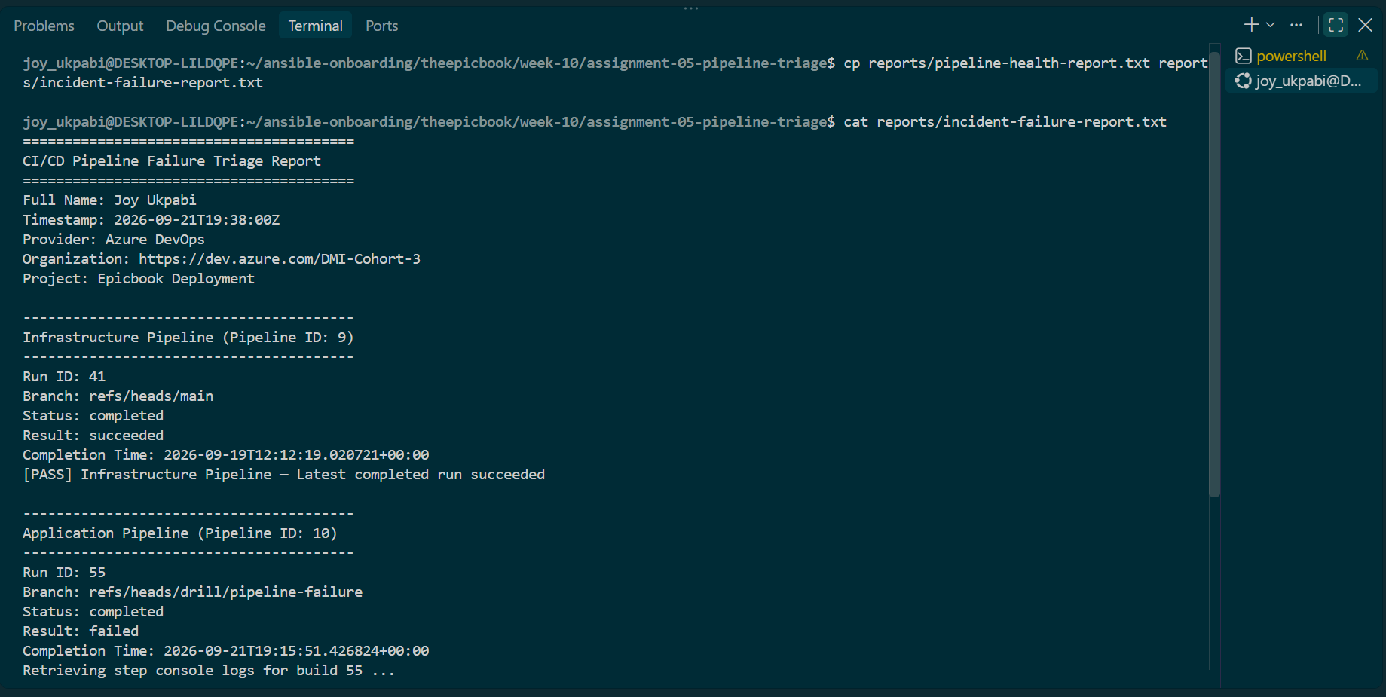

Task 8 — Apply the Human-Reviewed Fix and Verify Recovery

1. Review Claude's recommendation against the actual log evidence
Confirm it matches (e.g., recommends fixing the invalid dependency name in package.json).

2. Fix it directly on the drill branch
cd ~/ansible-onboarding/theepicbook
git checkout drill/pipeline-failure
git revert --no-edit HEAD

This undoes the intentional break with a clear, auditable commit — same pattern as your earlier recovery.

3. Push the corrected branch
git push origin drill/pipeline-failure

4. Re-queue the pipeline against the corrected branch
az pipelines run \
--organization https://dev.azure.com/DMI-Cohort-3 \
--project "Epicbook Deployment" \
--id 10 \
--branch drill/pipeline-failure

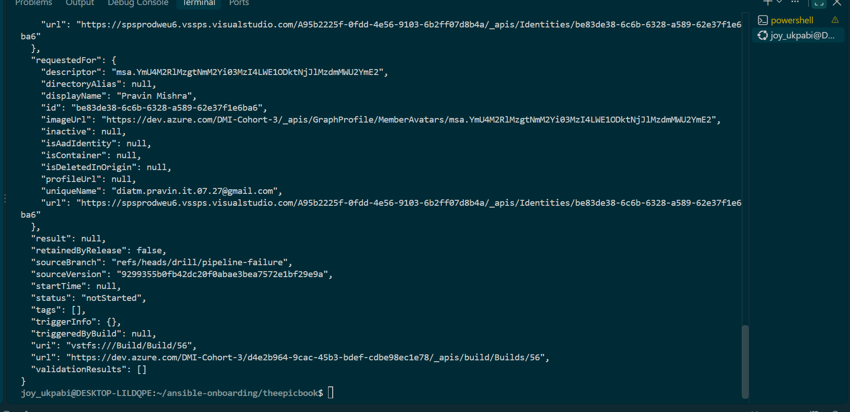

5. Confirm the new run succeeds
az pipelines runs list \
--pipeline-ids 10 \
--branch drill/pipeline-failure \
--top 1 \
--output table

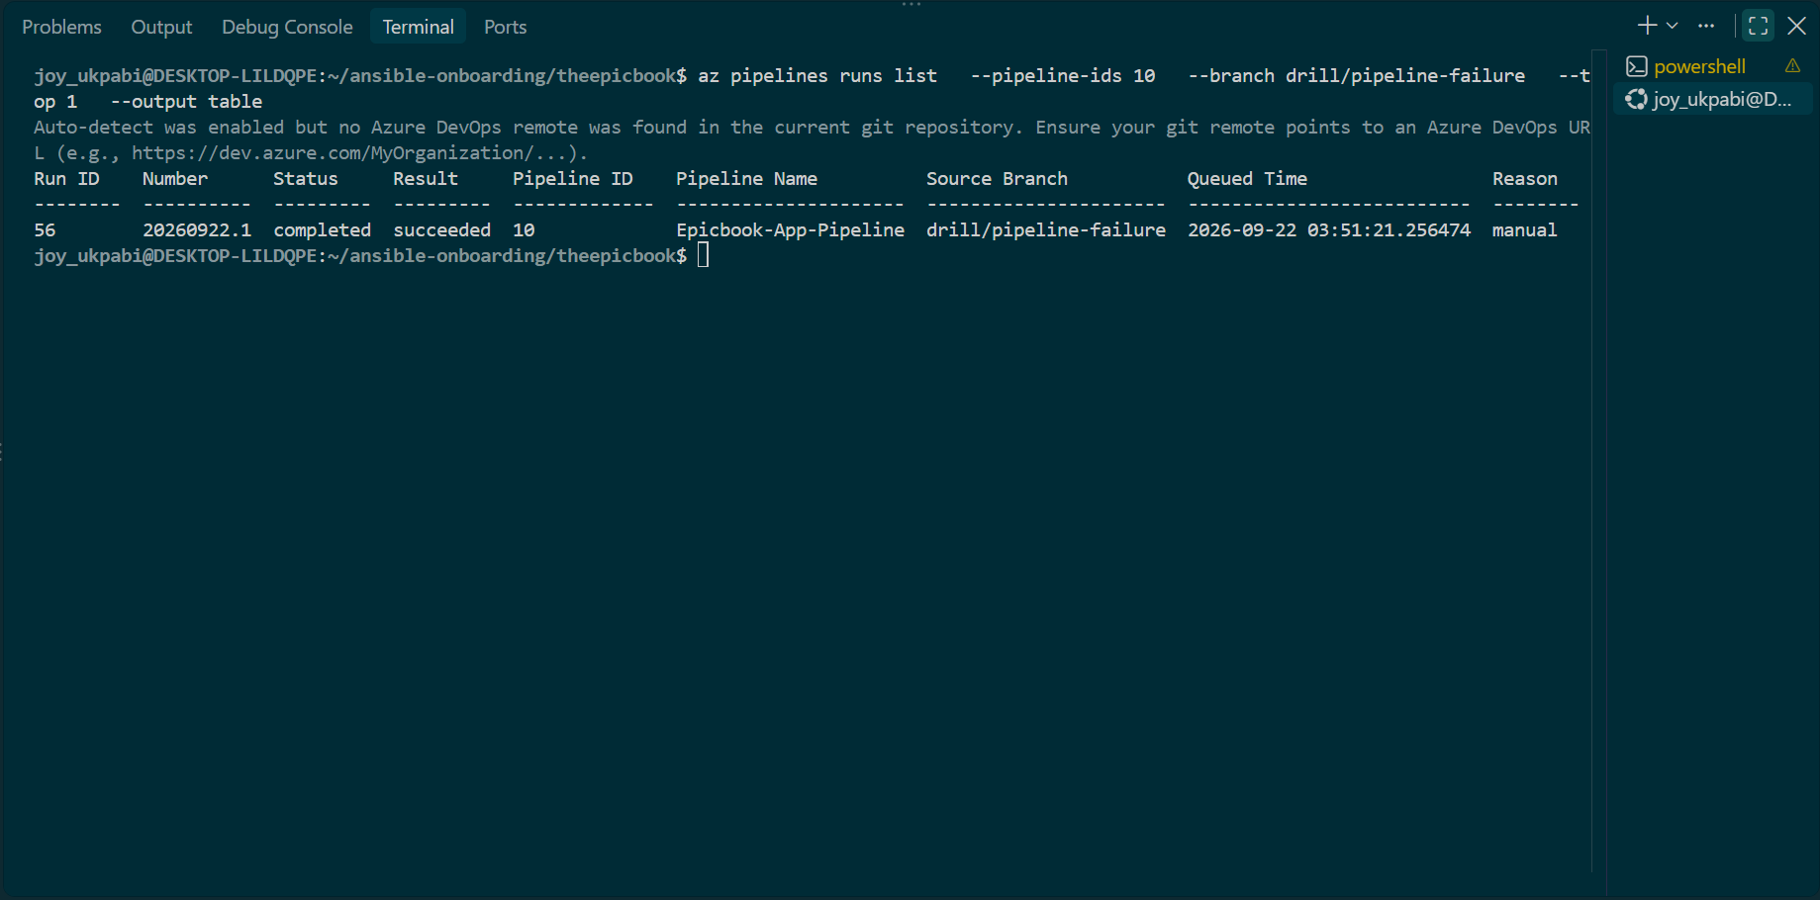

6. Invoke the triage skill again
cd week-10/assignment-05-pipeline-triage

cd ~/ansible-onboarding/theepicbook/week-10/assignment-05-pipeline-triage
claude

/pipeline-triage

Confirm Overall Status: HEALTHY and exit code 0.
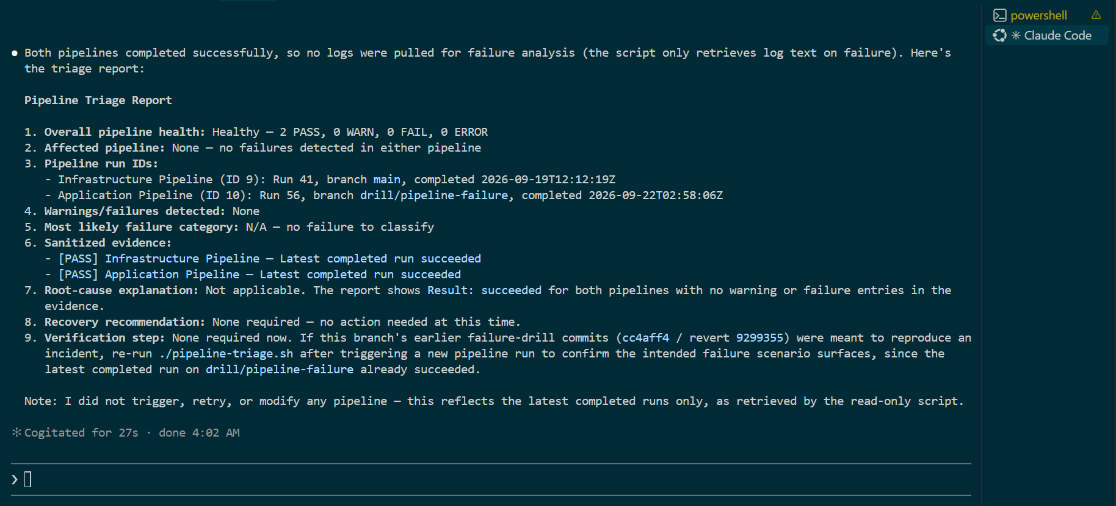

7. Save the recovery report
cp reports/pipeline-health-report.txt reports/recovery-report.txt

8. Confirm both reports exist
ls -la reports/incident-failure-report.txt reports/recovery-report.txt

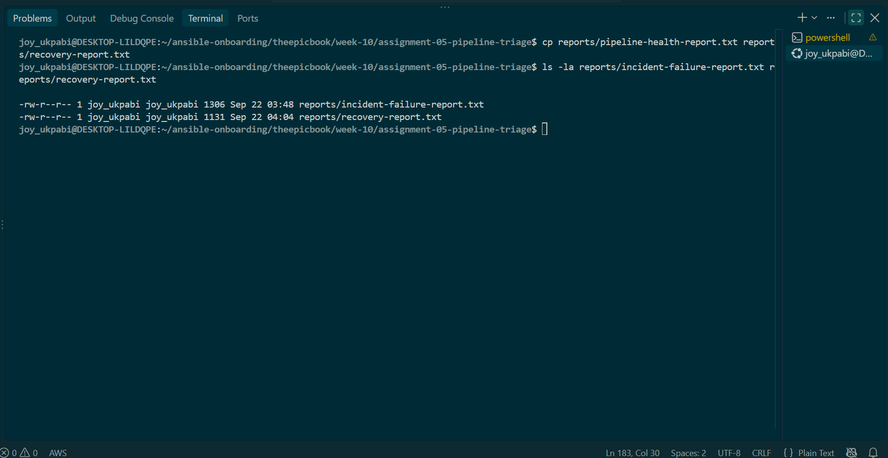

9. Clean up the drill branch — do NOT merge it into main
Since main is already clean (from your earlier revert), the correct move now is to simply delete the drill branch rather than merge it:
git checkout main
git branch -D drill/pipeline-failure
git push origin --delete drill/pipeline-failure

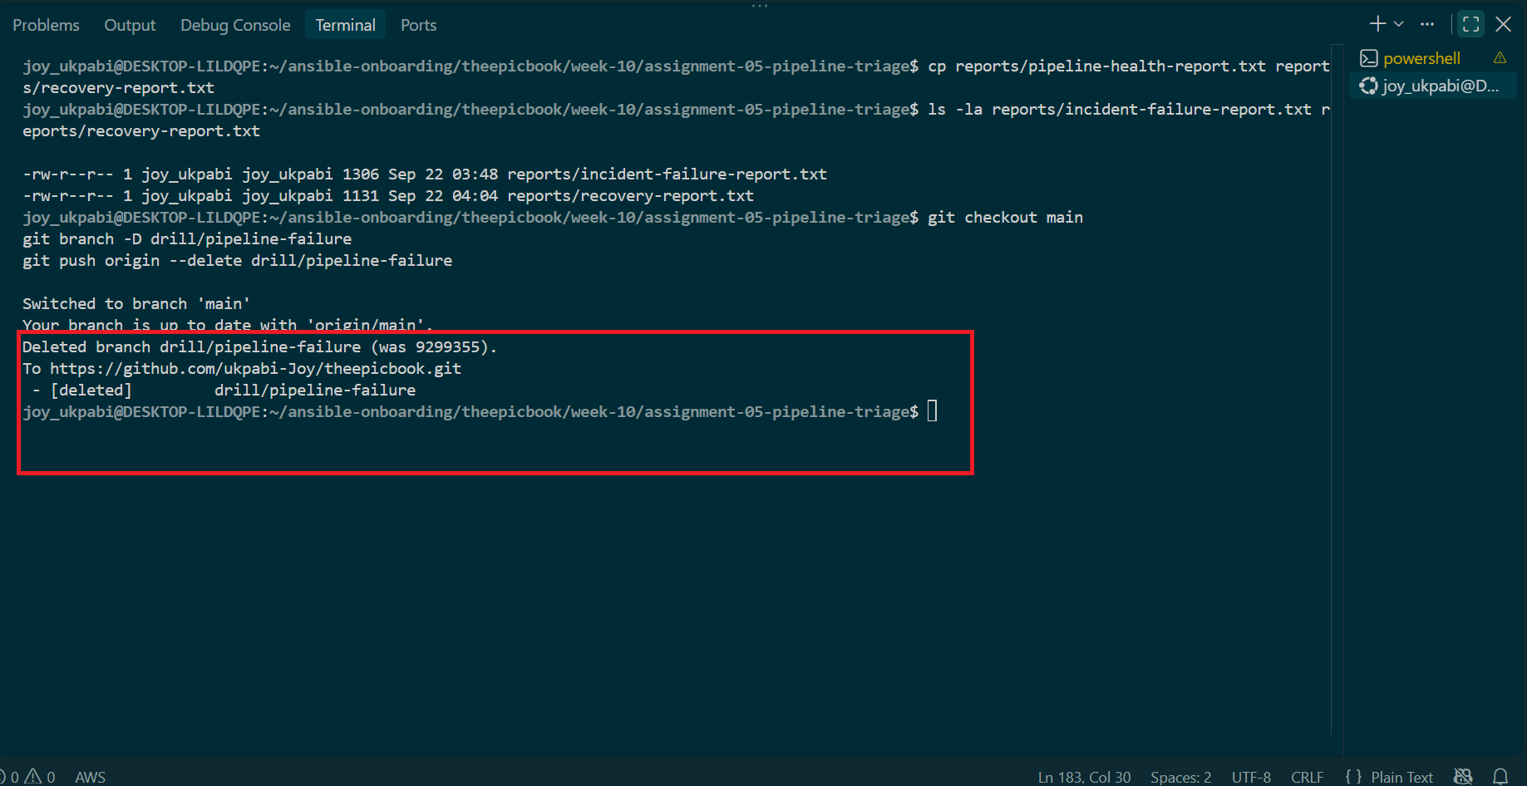

10. Scan everything for exposed secrets before committing
grep -riE "password|secret|BEGIN.*PRIVATE KEY|Bearer |pat=" \
week-10/assignment-05-pipeline-triage/reports/*.txt \
week-10/assignment-05-pipeline-triage/reports/*.log \
week-10/assignment-05-pipeline-triage/CLAUDE.md \
week-10/assignment-05-pipeline-triage/pipeline-triage.sh \
week-10/assignment-05-pipeline-triage/.claude/skills/pipeline-triage/SKILL.md

Expect no matches. If anything shows up, stop and fix the sanitization before committing.

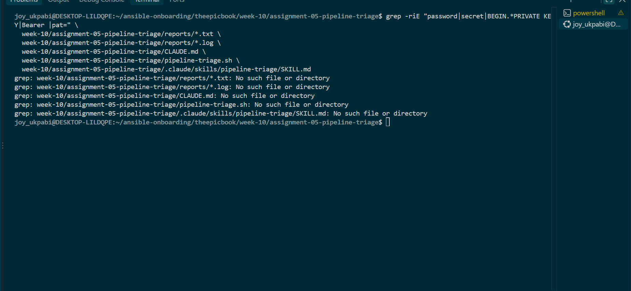

11. Commit the assignment workspace to main
git add week-10/assignment-05-pipeline-triage
git status
git commit -m "Add pipeline triage workspace: CLAUDE.md, extended script, skill, incident and recovery reports"
git push origin main

