Lab 2

**Table of Contents:**

[**1. Make captions for our dataset using the Show and Tell model.**](https://github.com/kaphc/CS5542_Big_Data_and_Analytics_ICP/wiki/LAB-2#q1)  
[**2. Make four captions for each of the Image.**](https://github.com/kaphc/CS5542_Big_Data_and_Analytics_ICP/wiki/LAB-2#q2)  
[**3. NLP Metrics**](https://github.com/kaphc/CS5542_Big_Data_and_Analytics_ICP/wiki/LAB-2#q3)

**1. Making captions for our dataset using the Show and Tell model.**

**Code Flow**

**a. Load the pre-trained model**

This model is trained on MSCOCO dataset where CNN and LSTM are used. This model takes an image as input and gives us a description of the image. CNN is used for image embedding that is to create a dense feature vector. LSTM (recurrent neural network) is used to make captions(descriptions) for the images.

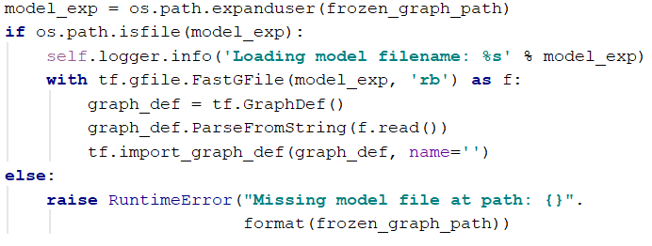

**b. Create Vocabulary**

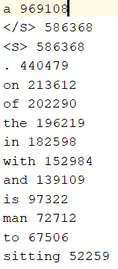

We take a file named word_count.txt which contains all type words used while training and with these words we will be able to make cations out of it.

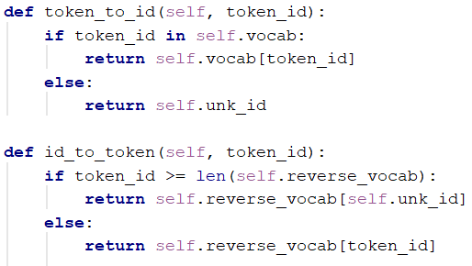  
All the words in the word_count.txt have an id to run LSTM on them. We have used these two functions to convert words to id and vice-versa.

**c. Running the model on our dataset**

We ran the model on our dataset to create captions.  
This caption generation can be viewed as a graph problem where the nodes are the words and edges are the probability of moving one node to another. Here, we are interested to find an optimal solution which can result as in the highest probability that is creating a caption with the highest probability.  
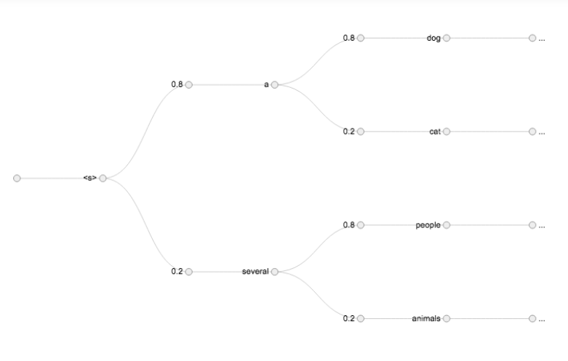  
Code to run an image.  
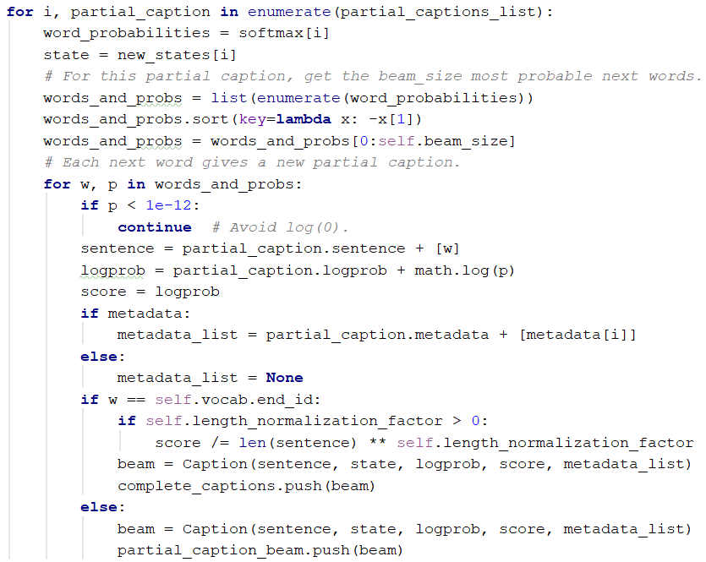

Code to call the caption to class to generate

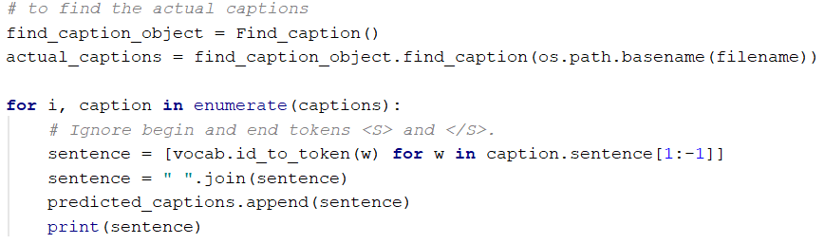

We made this part as a loop to create a caption for all of our dataset  
https://github.com/kaphc/CS5542_Big_Data_and_Analytics_ICP/raw/master/Lab-2/Documentation/6.PNG

**2. Make four captions for each of the Image.**

**To create four captions for each of the images we need to change the Beam Size value to 4**

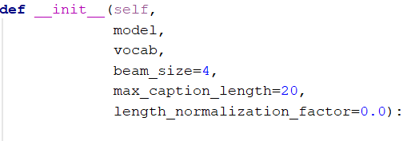

**This is the output of the above code that is creating four captions for each of the images.**

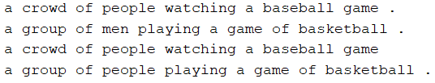

**3. NLP Metrics**

**1. BLEU Score:**

BLEU Score is calculated to find the number of common words between two sentences and we have used this BLEU Score to find the average of common words between actual captions and predicted captions.

Code to calculate the BLUE Score  
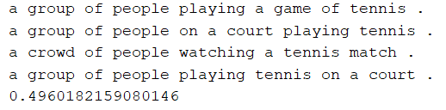

The output of the above code  
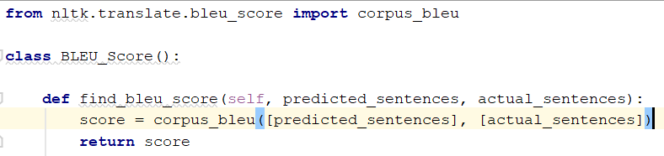

**2. ROGUE Score:**

Rogue Score stands for Recall-Oriented Understudy for Gisting Evaluation. It is calculated by comparing the sentences automatically produced summary and translation.

Code to calculate the BLUE Score  
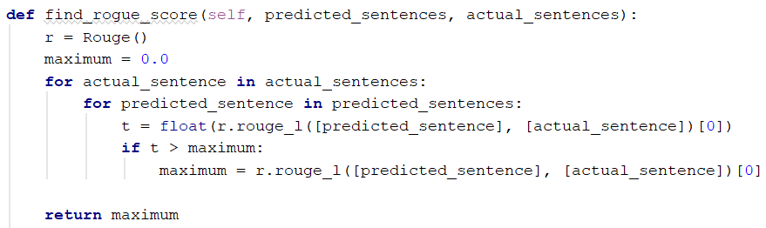

The output of the above code  
