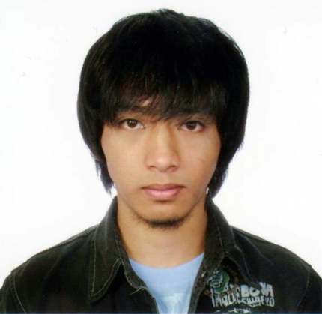**ARNIE JOTHAN EARL P. DAYAOEN**

Tuyangan, Paoay, Atok, Benguet

**Mobile:** 09303124403

**E-mail:** [ArnieDayaoen@gmail.com](mailto:ArnieDayaoen@gmail.com)

**OBJECTIVES**

An entry level programmer position that enables me to learn and nurture my programming skills on job.

**PERSONAL INFORMATION**

Age : 21 years old

Sex : Male

Date of Birth : July 09, 1993

Civil Status : Single

Nationality : Filipino

Religion : Christian (Assembly of God (A/G))

**QUALIFICATIONS**

* Willing to Learn
* Dedicated and hard working

**SKILLS**

* Microsoft Office applications
* Computer Hardware-Install/Repair
* Computer Programming
* Language: java, C#, PHP
* Frameworks: Codeigniter, Bootstrap
* Database: MySQL
* Knowledgeable in Photoshop CS6

**EDUCATIONAL BACKGROUND**

Present : King’s College of the Philippines

Bachelor of Science in Computer Science

4rth Year

Pico, La Trinidad, Benguet

Secondary : Saint Paul’s Academy of Sayangan Inc.

Sayangan, Paoay, Atok, Benguet

Elementary : Bosleng Elementary School

Bosleng, Paoay, Atok, Benguet

**REFERENCES**

Ms. Odicar Joice F. Chavez, MIT College of information and Computing Sciences,

Dean

King’s College of the Philippines

Pico, La Trinidad, Benguet

09215587108

Mr. Satur S. Cadsi, MIT College of information and Computing Sciences

King’s College of the Philippines

Pico, La Trinidad, Benguet

09999916052

Mr. Jumar Bulos National Irrigational Administration

IT manager

NIA

09468478287