# Chapter 2: Analysis

## 2.1 Description of Analysis

Analysis is the detailed examination of the elements or structure of something. It is process of determining the strength and weaknesses of particular matter. In this project analysis is done to gather information for the system. As we know analysis tells us what our system should do. It is a process of understanding a project domain and defining the project scope. So basically project domain features the logic, data, assumptions and understanding that go with a particular problem and project scope means how much of a problem your system is going to address.

Analysis plays important role while developing the project. Analysis provide description of all aspects of the system and description of any problems that exist. While conducting analysis it helps to identify problems and helps to organizing the facts and details of a system. Analysis helps developers to figure out the software requirement, design etc. By conducting analysis it helps to know what works with what, what causes something fail, and what can work independently.

## 2.2 Analysis Methodology

Methodology means steps that need to be monitored when working on a task/project and in what order they should be taken. In other words it is also defined as the steps taken when gathering data, investigating data and documenting requirements. Methodology offers an arrangement to monitor when working on project and makes the analysis and design more controllable. It helps to determine whether the project need to be done on technical consideration, user consideration and organizational considerations.

There are several methodology available for the analysis and development of system. Among them I choose hard system methodology.

Hard approach system analysis refers to taking highly structured approach to analysis of information system. Hard approach follows a logical sequence of steps and follows to rules, guidelines and standards. Mainly hard approach is appropriate to use when working on large and complex information system as well as it is useful for small information system projects.

The main reason for choosing hard approach over other approach are-

* A hard approach takes a highly structured approach to information system analysis.
* It follows a logical sequence of steps.
* It facilitate progress to be measured by referring to objectives that are defied for each steps.
* It ensures thorough planning and scheduling.
* It focus on technical requirements.
* It is likely to be undertaken quicker than other methods. Example, like soft analysis approach.
* It is likely to be less expensive than other approach.
* Easier to manage than soft systems methods due to clearly defined project phase.

Among the hard approach I choose structured system analysis and design methodology (SSAMD). This methodology is similar as waterfall model and useful for small project just like mine.

SSAMD can be used to look in detail at three views of a system:

* **The Process View 🡪**

In this process view it defines the functions that have been carried out by an information system. Mainly in this view it checks how data is moved around system and also ensures how system changes as it is managed.

* **The Data View 🡪**

In this data view it defines the data and information that the system practices.

* **The Event View 🡪**

In the event view it defines the events that agreed the methods running and the consequence of outdoor events on the data.

If SSAMD is started thoroughly, then it helps to generate well-documented and correct information system. This methodology is similar as waterfall model which is very simple and easy to understand. Similar to waterfall model in this methodology each phase must be fully completed before the next phase can begin. Here are the following steps of SSAMD:

* **Feasibility study** 🡪

Feasibility study helps to determines and examines whether the project is socially, operationally, technically, legally and financially feasible or not. It also helps to determine the cost effective of the project and also helps to analyze the drawback of existing system.

* **Analysis and Requirements Specification 🡪**

In analysis and requirements specifications all the features of the system are analyzed like hardware and the software of the system and later on the requirements are defined to produce the technical specification.

* **Design 🡪**

The main purpose of design phase is to change the requirements into complete and thorough system design terms.

* **Implementation 🡪**

In this phase where visions and plans become reality. In this phase it ensure the final deliverable meets the acceptance set by client. As well as system is introduced to the organization directly with the existing system.

* **Testing 🡪**

In this phase where all the aspects of the system are tested to ensure the usability, robustness, security and reliability of the system.

* **Maintenance 🡪**

It is the process of making changes to the hardware, software to support and ensures the robustness and reliability of the system. It means making changes to improve the performance, security of the system.

**Data Flow Diagram**

It shows the flow of data in and out of the system and also helps in data processing. Data flow modelling is the technique of SSAMD which mainly focuses on how model and documents moves around the information system. It also check what changes data and where it is stored and how data enter and leaves the system. So, DFD refers to data flow diagram

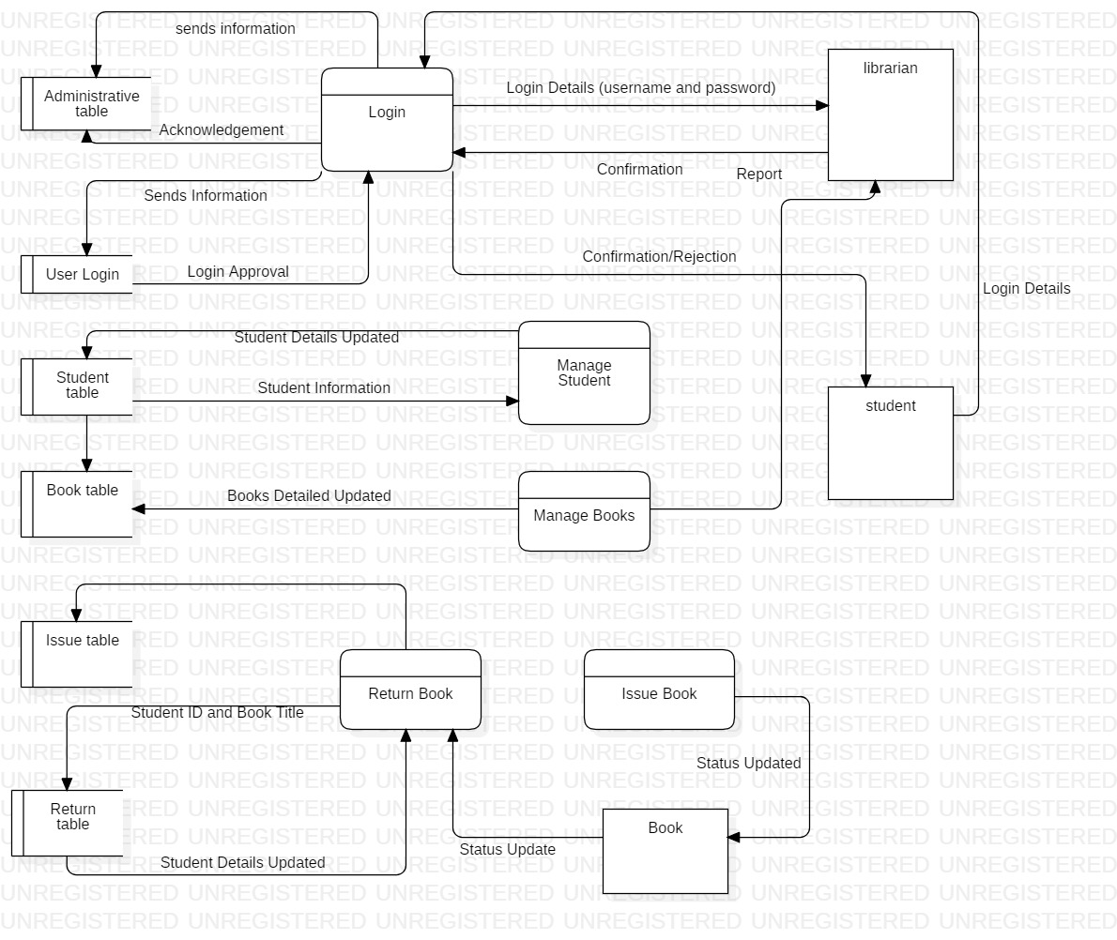

Figure Data Flow Diagram Of Library Management System

## 2.3 Information Gathering Method

Information gathering method is also a part of analysis. We collect information from different source. The information which are meaningful are collected and according to those information planning of the project is done.

The information gather method are-

* Interview
* Questionnaire
* Feedback
* Survey
* Focus group
* Documentation
* Observation

Among these information gather method I choose interview and survey.

**Interview**

Interview is a conservation where question are asked and answer are given. It is one of the simple and easy way to gather the information about any project. Therefore, I have prepare some question that will cover overall information needed while developing library management system.

**Purpose of the interview**

The main purpose of the interview is to gather, identify problems and requirements regarding a software system for the library management system.

**Agenda**

* Changing the manual based library system into computer based system.
* Does library system provide search facility for each books, articles and magazine?

So, for interview I have chosen librarian and student for interview.

* **Interview with librarian**

**Interview taken date: July 25, 2019**

**Time: 11:30 AM**

**Duration: 30 minutes**

**Librarian name: Kapil Pandey**

**Question asked in interview:**

* How would you promote student for reading books?
* Is student find user friendly interface while searching books, article?
* Is student find books, newspaper, and article according to in sequence order?
* How do you record book, article detail and information?
* Does your library open 24 hours for student?
* What system is being used to store library student detail?
* Does system can perform functionality like add, delete, and update?
* **Interview with student**

**Interview taken date: July 25, 2019**

**Time: 1:00 PM**

**Duration: 30 minutes**

**Library user name: Suresh Shrestha**

**Question asked in interview:**

* Do you find difficult to search books and article?
* Do existing system have user friendly interface?
* Do librarians helps you to find information they need?
* Do you get borrowing books facility?
* Do you guys get security and confidentiality of your data and information?
* Do you guys get fined if you not return books in time?

**Survey**

In survey comprehensive information is gathered from a targeted audience and conduct research on the basic of collected data. Therefore, I have prepare some question that will cover overall information needed while developing library management system.

So, for survey I have chosen student and librarian:

**Student**

* How satisfied are you with information and research service provided by library?
* Very satisfied
* Satisfied
* Dissatisfied
* Very dissatisfied
* How satisfied are you with the availability of library provides books, article?
  + Very satisfied
  + Satisfied
  + Dissatisfied
  + Very dissatisfied
* Are you able to get check return date and issue date of books that’s you are looking for?
  + Absolutely yes
  + Yes
  + No
  + I don’t know
* If system provide search facility for book or not?
  + Yes
  + No
* Do you guys can create your own account while accessing library?
  + Yes
  + No
* Do you guys view different group of books like (magazine/newspaper/books) available in the library?
  + Yes
  + No
* If you have any comments or suggestion on how we can improve our service. Please tell us below:

**Librarian**

* If system provides member fine for late returning of books or not?
  + Yes
  + No
* If system provides issue books or not?
  + Yes
  + No
* If system provides database backup and restore facility or not?
  + Yes
  + No
* If system provides modification of record at any time while adding or deleting books or not?
  + Yes
  + No
* If system provides check out/ check in of a books or not?
  + Yes
  + No
* If system provides add/edit/delete/update function for recording the user information or not?
  + Yes
  + No
* If system provides update function for recording the books or not?
  + Yes
  + No
* If you have any comments or suggestion on how we can improve our service. Please tell us below:

## 2.4 feasibility study

Feasibility study examines and determines whether a project is technically, financially and socially feasible or not and also helps to analyze the drawback of existing system. It also helps to determine whether the project is cost effective or not. It also conduct cost-benefit analysis to determine cost and benefit of a project. The project where feasibility study is conducted would able to implement to success as it was carefully planned.

The different type of feasibility study are as follows:

* Technical feasibility 🡪

In technical feasibility study, one has to check whether the projected system can be settled using existing technology or not. It is planned to implement the system using windows 8, apache web server. Since my project is web based application so by use of pc, laptop and mobile device user can find easier to use web application through browser.

* Economic feasibility 🡪

In economic feasibility study it checks the efficiency of a project. It perform cost and benefit analysis which helps to identifying profit and cost from the project called library management system. In this study cost and time are most essential factors.

* legal feasibility 🡪

Legal feasibility is the study to know whether the project confirm the legal and ethical requirements. While developing library management system does this project include licenses, copyrights, contract extension agreement, guarantee agreement etc. The main objective of this study is to ensure that the project is legally done.

* Time feasibility 🡪

A time feasibility study is the period of time, within it a software should produce relevant answer. So in the given project I have given around 120 days to complete the project. So within the time given by client the product should be deliverable if it takes too long to be completed before it is useful, then the project is meaningless. It is necessary to determine the deadlines.

* Social feasibility 🡪

In this feasibility study where the approval of people is measured concerning the product to be launched. In the social feasibility study if the project hampers the social environment then developing the project doesn’t give any meaning. So by conducting social feasibility study we can know the negative impact that may arise in social environment while developing project.

## 2.5 SRS (Software Requirements Specification)

A software requirements specifications is a documents that defines what the software will do and how it will be expected to perform. The main purpose of conducting SRS is to define the functionality of the product requirements and to fulfill all stakeholders’ requirements. The two requirements are:

**Functional requirements 🡪**

Functional requirements are those requirements that are related to the technical functionality of the system. In simple language functional requirements are those requirements which are needed compulsory to run the system example like login, registration etc. it is also defines as the functionality of the software, which the software engineers have to improve so that the customers could simply accomplish their job up to the business requirements.

Here are the functional requirements for library management system

|  |  |  |  |  |
| --- | --- | --- | --- | --- |
| ID | Title | Description | Rational | Dependency |
| K1 | Registration | By the help of registration student can login and able to operate the features of the system | To get login into the system and to use the features of the system. If student can’t create their account, then they can’t login and use feature of system. | N/A |
| K2 | Login | It is process of logging into the system and used to gain access of the system in secure way. | By the help of login student can search and read the books, article and magazine of the library. If user verification is authorized then student can have access to the system | K1 |
| K3 | Add new books | To know the about different kinds of books available in library | By adding books in library student can get variety of information in different field | K2 |
| K4 | Search books | To checks the availability of books in library | Student can search and view about books available in library. | K2, K3 |
| K5 | Edit books | To change the books details | If any changes required in issue books then edit books helps to edit the details. | K2, K3, K4 |
| K6 | Delete books | Delete helps to remove the all the information of books that has been return in context of library | The books details will be removed. | K2, K4, K5 |
| K7 | Remove student user | By remove user it prevents user for accessing the system | Admin can remove the user which doesn’t want to get access of the system. | K1 |
| K8 | Issue books details | It helps to record the books that has been issued by the user. | By having issued books details one can check the availability of the same books. | K2, K4 |
| K9 | Return books details | It helps to checks whether user return respective book that are issued or not. | By having return books details one can check the book details | K2, K4, K8 |
| K10 | Update books details | It helps to add additional feature and function in the system. | By having update functionality user can update the information of books, magazine | K4, K5 |
| K11 | Late fine report | Those student who doesn’t return books after their expiry date | If student doesn’t return books on time then they will be penalized. | K9 |
| K12 | Update student account | It helps to update student personal details in system | By this functionality student can update their account | K2 |
| K13 | View records of book issued | It helps to view the record of books that will be issued to the student. | By viewing records of issued books it helps to checks the availability of books. | K4, K8 |
| K14 | View records of book return | It helps to view the record of return books details | By viewing records of return books it helps to checks the availability of books. | K4, K8, K13 |
| K15 | Books are categorized according to its department | It helps to arrange books and magazine according to its catalog | By arranging books according to its order it makes easier to search books. | K4 |

**Non-Functional Requirements 🡪**

Non-functional requirements are those requirements that defines how the system work. It mainly focuses on the quality of the system. Attribute such as security, reliability, performance, maintainability, scalability and usability are lies in non-functional requirements. Actually in simple terms non-functional requirements are those requirements that helps to verify the performance of the software. It concentrates on the users expectations and captured quality attribute.

Here are the functional requirements for library management system

|  |  |  |
| --- | --- | --- |
| ID | Title | Description |
| KP1 | Usability | The system should use proper navigation bar to guide the student to use the system. To use the system easily student should provide online user guide for reference and help. |
| KP2 | Availability | The system should be available to student for 24 hours. As well as library should available library resources likes books, magazine etc. for 24 hours? |
| KP3 | Reliability | The system has to be 100% reliable. The system quality should be trustworthy. Data integrity and confidentiality must be maintained and data should be reliable. |
| KP4 | Accuracy | The system should accurately provide real time information taking into consideration various concurrency issues. |
| KP5 | Efficiency | Even if the system fails, the system should maintained backup. By help of efficiency, it looks at what current system is produced and compares with what could be achieved with the existing resource. |
| KP6 | Security | When student want to use library website they must be authenticate by the system to avoid fraud and hacker. Only valid users must allow to access the system. |
| KP7 | Maintainability and Portability | The system must be flexible and also allow modification of the system if needed. The system should provide the notification message to student if any books is overdue.  System must cope with changes that occur in system. |
| KP8 | Performance | It is an act of performing a task or function. The developed system should be free from lags and system must respond with the student at the real time speed |

**MoSCoW Prioritization 🡪**

Prioritization means doing first thing first, it means evaluating a group of items and ranking them in their order of importance. MoSCoW prioritization is used to prioritize the requirements of the software. MoSCoW stands for must have, should have, could have, and won’t have.

In Must have 🡪 the project cannot completed without completing this prioritize requirement.

Should have 🡪 requirements which have high priority is done or included.

Could have 🡪 without having this requirement system will run.

Won’t have 🡪 requirement could be useful for future use.

MoSCoW prioritization for functional requirements

|  |  |  |  |  |
| --- | --- | --- | --- | --- |
| ID | Requirement | MoSCoW | Rational | Remarks |
| K1 | Registration and sign up system | Must have | To make system confidentiality, integrity by allowing verified student to access to the system |  |
| K2 | Login | Must have | It is required to authenticate the valid student to access system. |  |
| K3 | Adding new books | Should have | It provides the newly arrived books in library. |  |
| K4 | Search books | Should have | It helps student easier to search books that they want. |  |
| K5 | Edit books | Must have | It is the fundamental function within the system. |  |
| K6 | Delete books | Must have | It is the fundamental function within the system. |  |
| K7 | Remove student user | Must have | This functionality helps to maintain the confidentiality data of the system |  |
| K8 | Issue books details | Must have | It is functional requirement of the system which helps to check availability of books. |  |
| K9 | Return books details | Must have | It is functional requirement of the system which helps to check availability of books. |  |
| K10 | Update books details | Must have | For convenient data handling |  |
| K11 | Late fine report | Could have | It is one of the important requirement given by client so it must include in system. |  |
| K12 | Update student account | Should have | It helps to edit the student details. |  |
| K13 | View records of book issued | Could have | Admin can view the issued books details which helps to record the details of books. It increase availability of books. |  |
| K14 | View records of book return | Could have | Admin can view the return books details which helps to record the details of books. It increase availability of books. |  |
| K15 | Books are categorized according to its department | Must have | This functionality helps student to search books easier and save student while searching books time. |  |

MoSCoW prioritization for functional requirements

|  |  |  |  |  |
| --- | --- | --- | --- | --- |
| ID | Requirement | MoSCoW | Rational | Remarks |
| KP1 | Usability | Must have | Every system should be useable to fulfill the needs of user or client. |  |
| KP2 | Availability | Must have | System should provide books and information anytime while accessing the system. |  |
| KP3 | Reliability | Could have | System could not be 100% perfect. So to avoid these kind of bugs and errors should try to make quality of service to student. |  |
| KP4 | Accuracy | Must have | System should be correct to provide service to the student. |  |
| KP5 | Efficiency | Must have | System must provide the efficient performance to the student while accessing the system. |  |
| KP6 | Security | Must have | Data security is one of the important aspect of system. So to maintain student data system should provide security in it. |  |
| KP7 | Maintainability and Portability | Should have | System itself should be helpful with the system and help to cooperate with problems. |  |
| KP8 | Performance | Must have | With the increase of new technology system should free from lags and should give high performance while accessing the system. |  |

**Hardware and Software Specification**

**Hardware Specification**

* Processor 🡪 32-bit, dual-core, 1.5 GHz minimum per core
* Ram 🡪 4 Gb
* Hard disk 🡪 80 GB for installation of all project software.

**Software Specification**

* Windows operating system 7 or higher.
* Database server (SQL)
* Apache server
* Brackets/ notepad
* Star UML

## 2.5 Use Case Diagram

A use case diagram is a graphic representation of the connections among the components of the system. It is a methodology used in system to classify, explain and unify system requirements.

Use case diagram specific purpose is to gather the system requirements and actors. It specify the events of a system and their flows. The main objective of use case diagram is it make easy to know about the functional requirements of the system and also make it easy to recognize the various connections between the users and the system.

**Actor 1: librarian and admin** 🡪

These actor helps to manage the library, these actor plays vital role in the system, their main role is to add book, add student, issue book, return book, manage student, issue and book report, penalty report, history etc. similarly in library these actor used crud operation to record the details of books and student.

**Actor 2: student** 🡪

Firstly these actor are not registered in the system after the registration these actor can accessed the function of the system. This actor can read the books or take books with them after becoming valid student of the library. These actor can search the books what they want, can see the issue and return report, check history, can see penalty report and can update their profile.

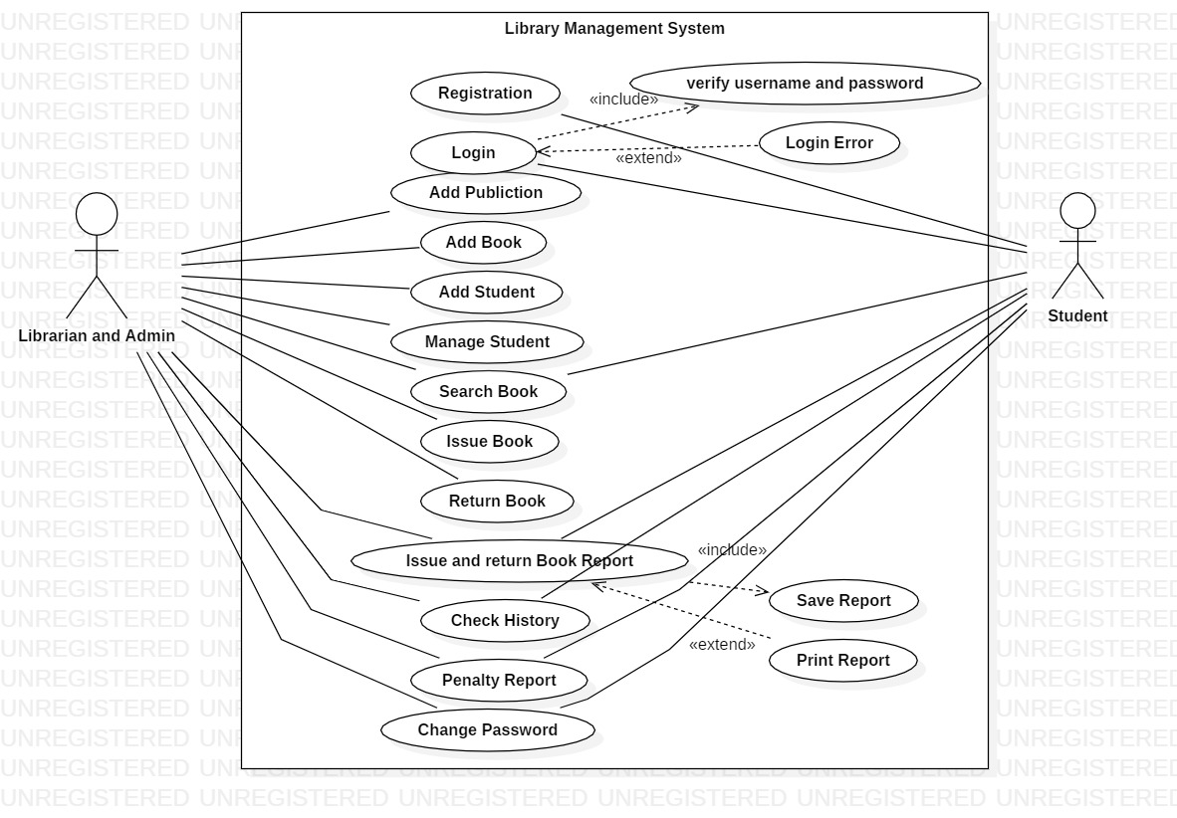

Figure Use Case Diagram of Library Management System

## 2.6 System architecture

In this scenario project collect information from the user and sends that information into database and again that database will be retrieve. In this way it perform client server system by using 3- tier architecture.

The main reason for using 3 tier architecture in my project:

* It improve the data integrity of system and user.
* It improved the security where user is not directly access to the database.
* It is easy to modify and maintain, and won’t affect other module.
* It gives good application performance.
* It can give better re-use facility.
* It gives high degree of flexibility in deployment platform and configuration of the system.

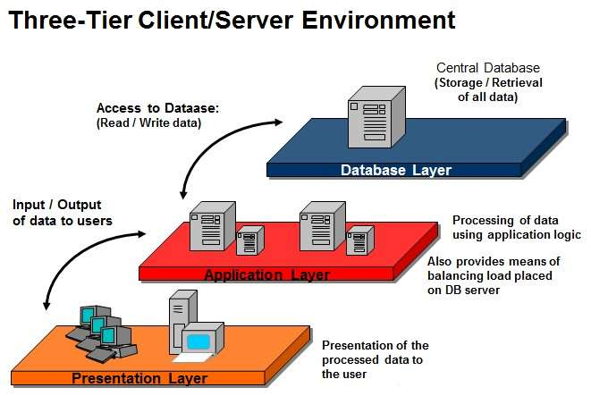 Figure 3-tier architecture model

The three tiers in a three-tier architecture are:

**Presentation Tier**🡪

It conquer upper level data and shows facts related to services offered on a web. The main function of this tier is it attaches with other tiers by delivering results to the browser and other tiers in the network.

**Application Tier**🡪

Application tier is generally also called middle tier or logic tier where information is generally pulled from the presentational tier. It regulate application functionality by implementing complete processing.

**Database Tier**🡪

In data tier generally information or data is retrieved and store in a database server. Data in this tier is preserved independent of application servers or business logic.

**Natural language analysis (NLA)**

Natural language analysis (NLA) is process of identifying nouns, verbs and adjective in a portion of vivid text where noun narrate to potential candidate class, adjective narrate to possible attributes and verb characterize possible actual method.

**Scenario for NLA**

A library management system is a software used to manage the catalog of a library. This helps to keep the records of whole transactions of the books available in the library. A company named ABC wants library management system which is very easy to use and fulfills all the requirement of a librarian and student. The company wants features which helps librarian to keep record of available books as well as issued books. As well as they want to upgrade their manual system into computerized system so they want to have privacy over their student details. Company wants easy and user friendly login interface performance, arranging books according to its publisher, proper monitoring by the administrator/librarians which includes updating account status, showing message if user attempt to issue more than one books and assigning fine if student skip the date of return.

The company wants their software that permits all of this functionality.

* Librarians keep records of different categories like books, journals, newspaper etc.
* Classify the books subject wise.
* A Liberians should have easy way to enter new books.
* Librarians keep record of complete information of books.
* Automatic fine calculation for late returns of books for student.
* Different criteria for searching books for student.
* A librarian can issued a book to the student.
* Librarian can have control panel which allow them to add, remove, edit the books.
* A librarian should record the book returned from students.
* Student can search different books available in the library.
* Student can create their own account.
* Student can view books issued to them.

**Step 1: Listing out class Noun for Candidate classes**

|  |
| --- |
| **Noun selection** |
| Library, system, management, catalog, whole, transaction, books, library, company, library, management, system, easy, fulfills, librarian, student, features, librarians, student, available, manual, system, computerized, performance, system, privacy, student, details, user friendly, proper, administrative, librarian, account, status, fine, librarians, books, journals, newspaper, books, subject, fine, student, librarians, control. |

**Step 2: Reducing synonyms and overlapping classes**

* User, client, student 🡪 student
* software, system, performance 🡪 system
* report, transaction 🡪 report
* library, librarians, administrative 🡪 librarians
* publish, publisher, control, features 🡪 publisher
* books, journals, newspaper 🡪 books

**Step 3: Getting rid of classes that doesn’t cover scope of our project.**

* Catalog, whole, company, easy, fulfills, available, manual, computerized
* Privacy, details, user friendly, proper, fine, subject.

|  |  |  |  |
| --- | --- | --- | --- |
| **S.N** | **Noun identification for class** | **Selected as candidate class** | **Reason for selecting candidate class** |
| 1 | librarian | Yes | It is the fundamental class and suitable for given project. |
| 2 | System | No | Gives similar meaning. |
| 3 | Management | No | Doesn’t give any specific meaning to become candidate class. |
| 4 | transaction | No | Gives similar meaning. |
| 5 | books | Yes | Books are used for reading purpose in library, without having books library is nothing. |
| 6 | Easy | No | It is type of difficulty level. |
| 7 | publisher | Yes | It is used to know the writer of the books. |
| 8 | Student | Yes | Student can read books in the library without student library is nothing? |
| 9 | fine | No | It is out of scope. |
| 10 | Details | No | Gives similar meaning. |
| 11 | User friendly | No | Doesn’t provide any specific meaning. |
| 12 | Subject | No | It is out of scope. |
| 13 | Control | No | Gives similar meaning. |
| 14 | Manual | No | Doesn’t provide any specific meaning. |
| 15 | computerized | No | Gives similar meaning. |

**Step 4: Getting rid of classes finally we get candidate class**

|  |
| --- |
| **Candidate Class** |
| Books |
| Librarians |
| Publisher |
| Student |

**Step 5: Identification of Verb for potential method from scenario**

|  |
| --- |
| **Verb selection** |
| Used, manage, keep, records, wants, use, wants, helps, keep, record, issued, upgrade, wants, arranging, monitoring, updating, showing, assigning, records, classify, add, view, update, record, search, issued, add, remove, delete, edit, return books, issued books, create, view, modify. |

**Step 6: Reducing synonyms and overlapping Verbs**

* Wants, add, keep, use 🡪 add
* Delete, remove 🡪 delete
* Issue, issued books, return books, issued 🡪issue
* Update, edit, modify 🡪 update
* Search, wants, want, monitoring 🡪 search

**Step 7: Getting rid of verb that doesn’t cover scope of our project.**

* Used, records, use, helps, showing, assigning,

|  |  |  |  |
| --- | --- | --- | --- |
| **S.N** | **Verbs** | **Selected as Verb** | **Justification for selecting or rejecting** |
| 1 | Assigning | No | It is out of scope |
| 2 | Add | Yes | It is used to add the book details and student details |
| 3 | Delete | Yes | It is used to delete the book details and student details |
| 4 | Issue | Yes | It is used to record the book details that have been issued to student. |
| 5 | Update | Yes | It is used to update the book details and student details |
| 6 | Search | Yes | It is used to search the book details |
| 7 | Showing | No | Gives similar meaning |
| 8 | helps | No | Doesn’t provide any specific meaning. |

**Step 8: Getting rid of verb finally we get actual verb**

|  |
| --- |
| **Actual verb** |
| Add |
| Delete |
| Issue |
| Update, Search |

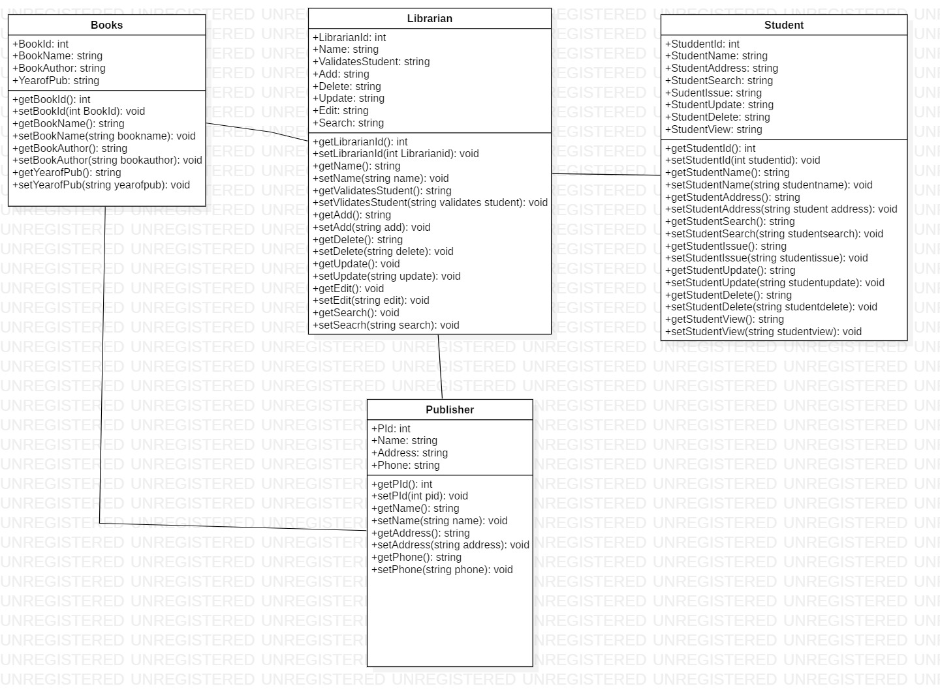

Figure Class Diagram of Library Management System.