# Chapter 3 – Design

# Introduction

Design is a plan or requirement for the building of system for the execution of an activity or process. Design phase describes how the system should be created. System design lies second phase of software development life cycle, after requirement gathering and analysis. The main purpose of design phase is to convert the requirements into whole and comprehensive system. To make design successful in project we must understand the end goal, identify clear roles, collaborate, break it down and look at the past.

The various stages of design phases are structural, behavioral, database and UI modelling.

## 3.1 Structural Modelling

Structural model represent the framework for the system and same framework is placed together where all other component exist. Therefore, class diagram, flowchart, DFD diagram and component diagram are part of structural modelling. It also helps to shows the relationship between classes, object, operation and attribute of the system.

## 3.1.1 Class Diagram

### Definition

Class diagram is a static diagram where it represent the static view of an application. Class diagram is done for constructing executable code for software application. It describes the structure of system by showing the system classes, attributes and relationships among objects.

### Justification

The main purpose of using class diagram is

* It is only diagrams which can be directly diagramed with object-oriented language.
* Class diagram can help to model the static view of an application.
* It also defines the attributes and operation (function) of a class
* It shows a collection of classes, interfaces, association and constraints.

### Notation Used

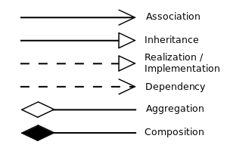

|  |  |
| --- | --- |
| Description | Remarks |
| Association 🡪 it represents a relationship between two classes. It indicates that objects of one class have relationship with objects of another class. |  |
| Inheritance 🡪 it defines the ability of one class (child class) to inherit the identical functionality of another class (parent class). |  |
| Aggregation 🡪 it defines a way of composing different abstractions together in defining class. |  |

### Diagram

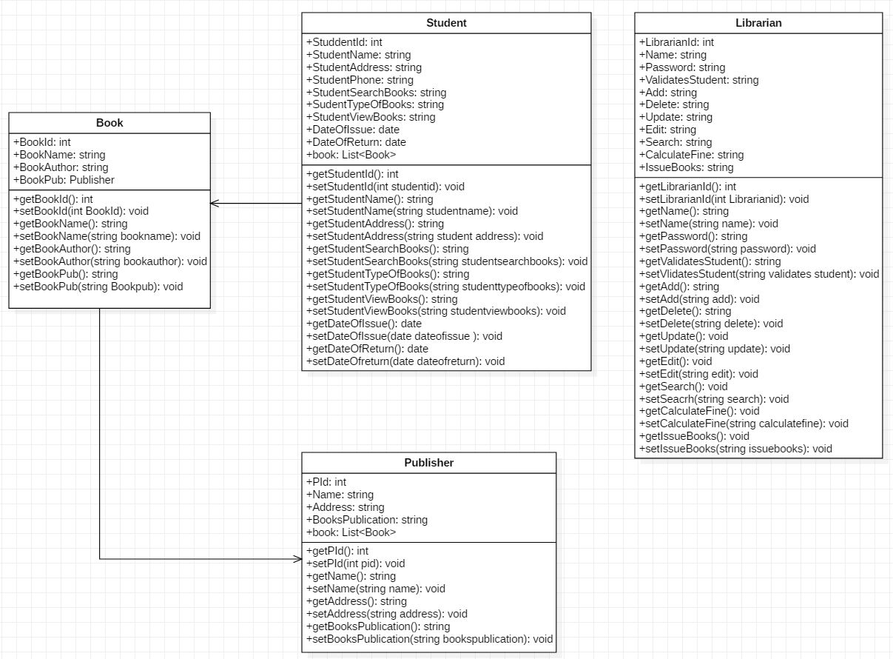

Figure 1 Initial class Diagram

### Diagram Explanation

As shown in the above class diagram each class contains various attributes and functions which appeal other class attributes to share data.

Likewise, in book class it contain attributes such as book name, id, book author, book publication.

In librarian class it contain attributes such as name, password and functions such as add, update, delete, and edit, search and issue books. Also it contain functions like calculate fine etc.

In student class it contain attributes such as student id, name, address, phone number, type of books, date of issue, date of return books, search and view books.

In publisher class it contain attribute such as publisher name, address and year of books publication.

## 3.1.1 DFD Diagram

### Definition

It shows the flow of data in and out of the system and also helps in data processing. Data flow modelling is the technique of SSAMD which mainly focuses on how model and documents moves around the information system. It also check what changes data and where it is stored and how data enter and leaves the system.

### Justification

The main purpose of using DFD diagram is

* It defines the methods that are involved in a system to handover data from the input to the file storage.
* It acts as the starting point for designing the system.
* It defines flow of data through a system to perform certain functionality of a business.

### Notation Used

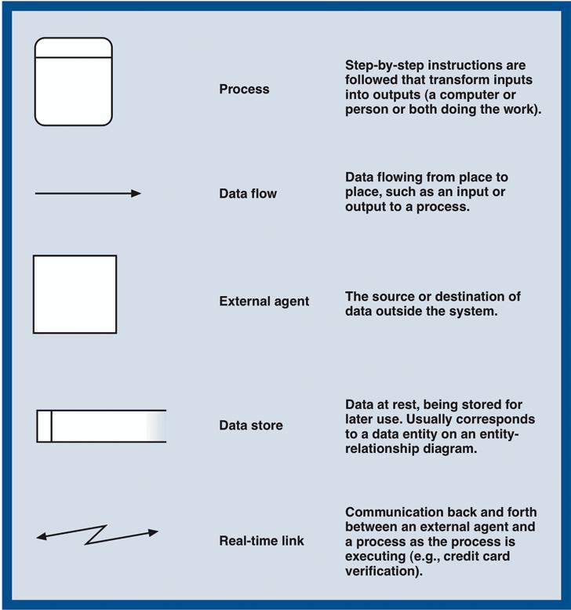

### Diagram

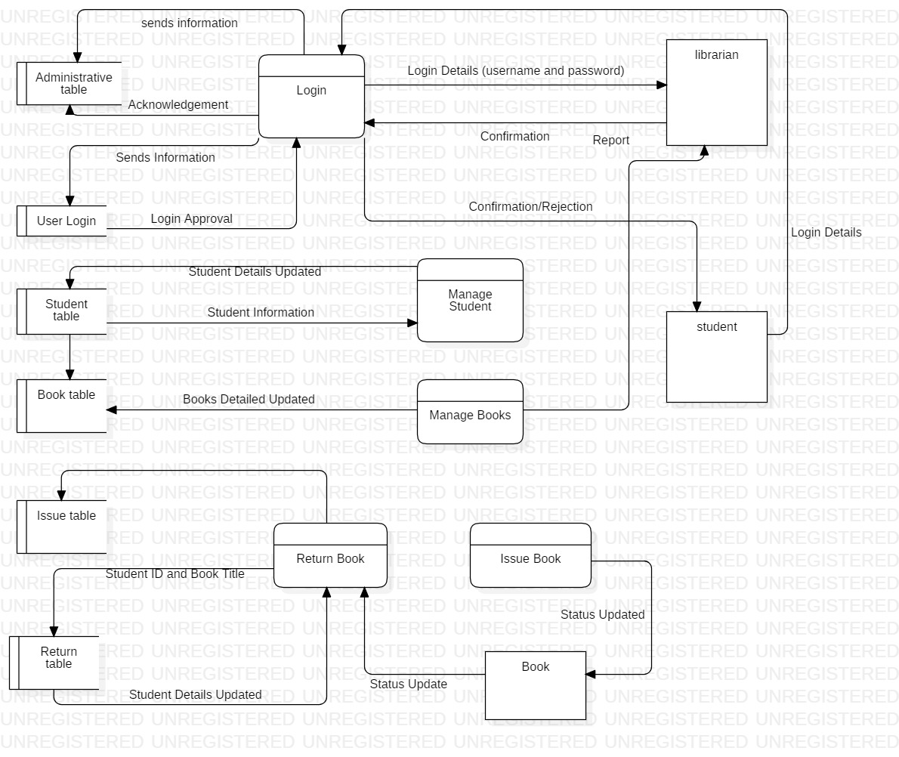

Figure 2 Data Flow Diagram

### Diagram Explanation

As shown in above diagram librarian manage the whole system of library. Firstly librarian insert the username and password to get access of the system. After authenticate login then system provide confirmation message to librarian to access the system. Similarly, student are not authorized to access of the system. But they can view their profile and issued book details. After, successfully login librarian can manage books and student, where separate table is allocated to manage student and books. Similarly, table like issue table and return table is allocated. If student want to issue a books then he/she should give student id and book tile and name. As well as in return table if student return the book then librarian should check book details and his/her expiry date and later should update student detail.

# 3.2 Behavior Modelling

Behavior modelling is also called dynamic modelling. This modelling represent the elements of a system that are reliant on time and deliver the dynamic perceptions of the system and how they relate to each other. This modelling defines how the elements that cooperate to establish a system and interact to provide the functionality of the system and used for system. Activity diagram and sequence diagram are used to show behavior modelling of library management system.

## 3.2.1 Activity Diagram

### Definition

Activity diagram defines the dynamic aspects of the system. Basically, it represent the flow from one activity to another activity and also refers to steps involved in the execution of a use case. In other terms activity diagram can be described as an operation of the system and the control flow is haggard from one operation to another operation.

### Justification

The main purpose of using activity diagram is

* It is used to show message flow from one activity to another activity.
* It describes the parallel, branched and concurrent flow of the system.
* It helps to understand high level functionalities of the systems.
* It is used to build the executable system by using forward and reverse engineering technique.

### Notation Used

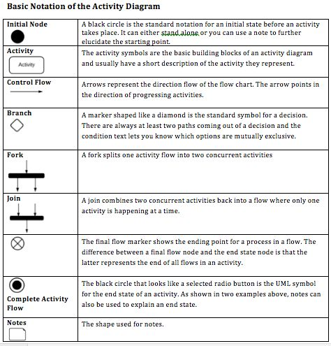

### Diagram

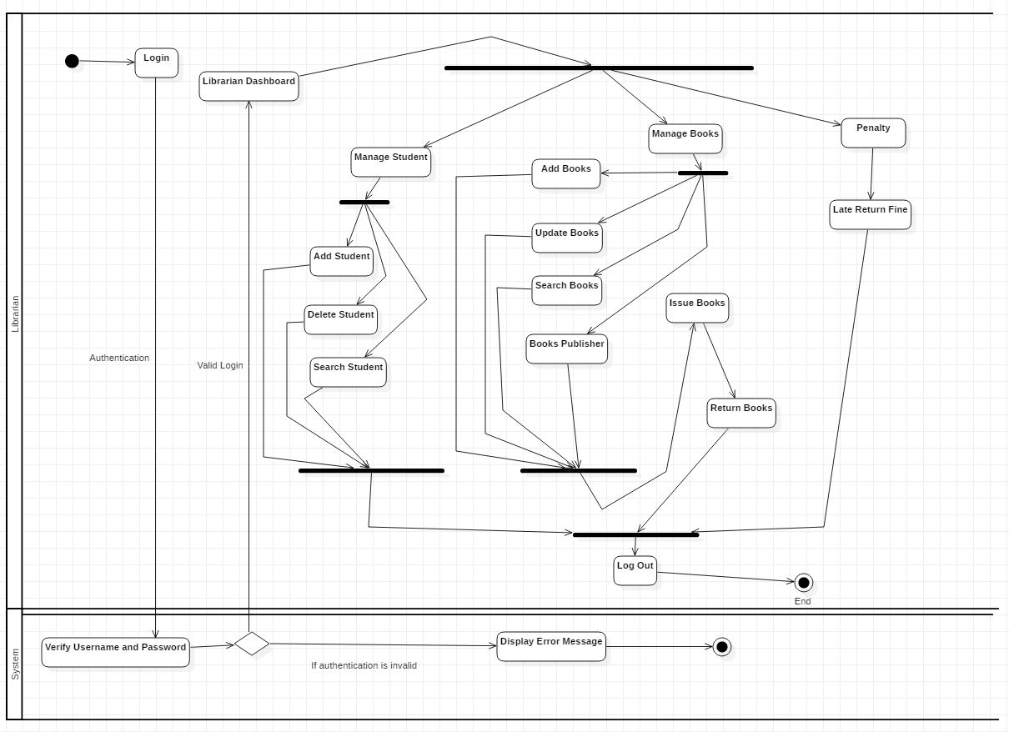

Figure 3 Librarian Activity Diagram

### Diagram Explanation

From the above diagram it shows the librarian activity in the system. Firstly librarian login to the system, then system validates the input data if enter data is valid it display confirmation message otherwise it display error message. After successfully login librarian can manage student, manage books and penalty to student who return book after expiry date. Librarian can add student, delete student, search student in the system.

Similarly, librarian can add books, update books, search books and allocate books according to books publisher. Librarian can able to record the issued book details and return book details

Librarian can also fine to those student who doesn’t return books in time.

### Diagram

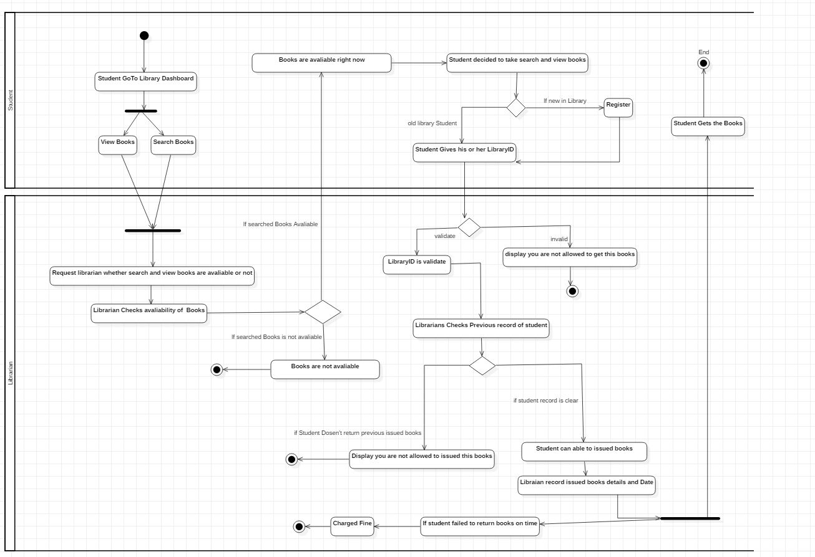

Figure 4 Student Activity Diagram

### Diagram Explanation

As shown in diagram student can view and search in library dashboard. After they find books that they want to read then, he/she request librarian to check the availability of books. If the books is available librarian issued them that books but if that book is not available then librarian gives books not available message to student. If student wants to take available books that they want to read then they should give library card or should become a member in library.

At last librarian checks the student details whether that student failed to return books in past or not. If his/her record is clear then librarian issued books to student and record the issued date details and books details. Likewise, if student failed to return books in time then librarian charged them fine for late return.

## 3.2.2 Sequence Diagram

### Definition

A sequence diagram basically represents interaction between objects in sequential order which means the order in which these interactions take place. Mainly it focuses how and in what order the objects in a system function. Sequence diagram is designed to understand requirements for a new system or to document a current practices. It helps to model the flow of logic within the system.

### Justification

The main purpose of using sequence diagram is

* Sequence diagram is used to document a system’s requirements and to level out a system design.
* It illustration the communication logic between the objects in the system in the time order that the communications take place.
* It helps to understand requirements for a new system or to document an existing process.

### Notation Used

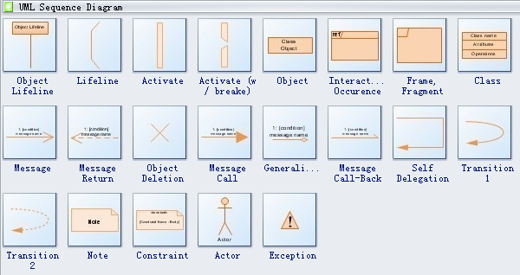

### Diagram

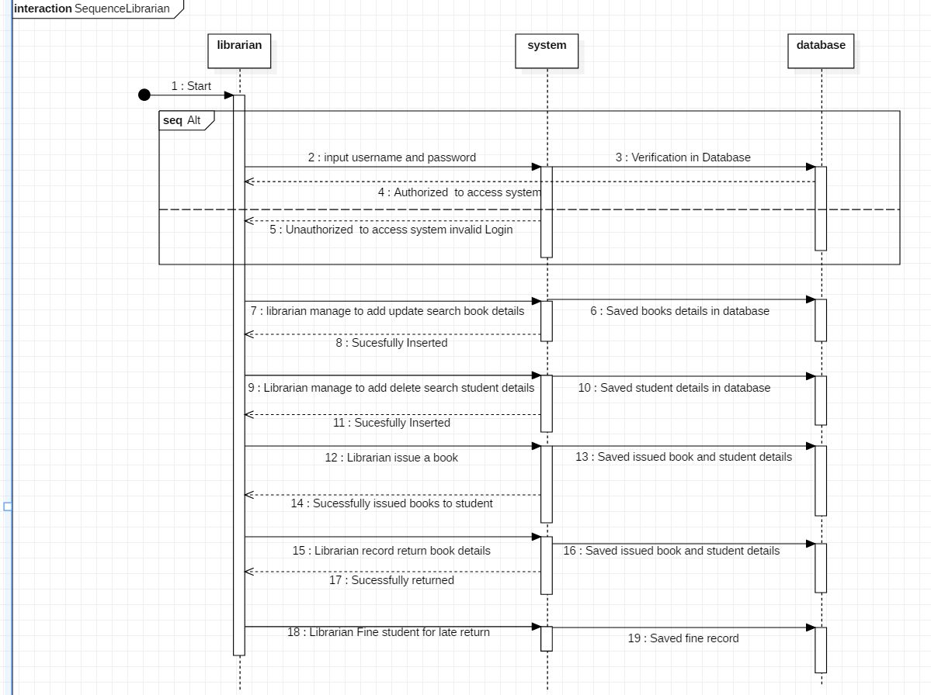

Figure 5 Sequence Diagram of Librarian.

### Diagram Explanation

From the above diagram there are three lifeline which are librarian, system and database. So to access the system firstly librarian login to system if username and password is validate librarian access the system. Otherwise, librarian is not authorized to access the system. Librarian can manage to add, update and search book details and later record books details in database.

Librarian can manage to add, delete and search student details and record student details in database.

Librarian can issued book and record issued books details along with student details.

Librarian can fine student for late return and save fine details of student in the database.

### Diagram

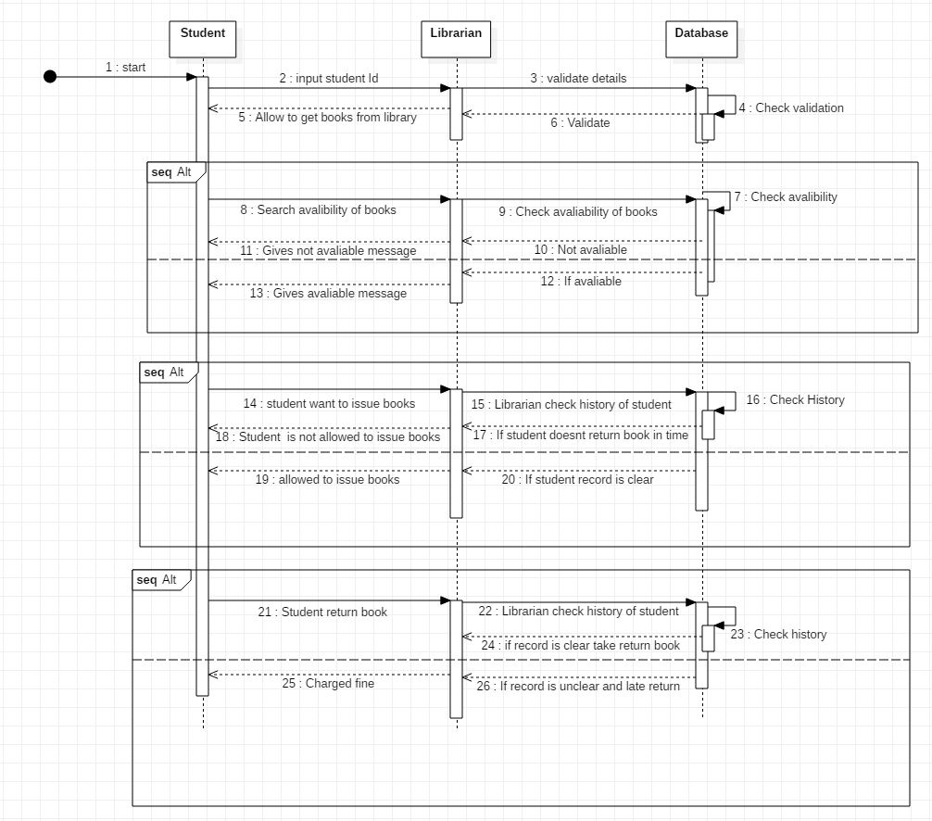

Figure 6 sequence diagram of Student.

### Diagram Explanation

From the above diagram there are three life line student, librarian and database. At first student gives student id to get available books from library. Then, librarian validate card if card is valid then he/she issue books otherwise student can’t get book. Student can able to search availability of books. If student want to take books then librarian check history of student, if student history is bad and student other issue book is still pending then librarian reject it otherwise librarian issue books to student. To return books librarian checks issued and return date if return date is on time, he/she will not be penalized but if return date is already expire then he/she will be charged fine by librarian.

# 3.3 Database Modelling

Database modelling helps to determine the logical structure of a database and basically defines in which way data can be stored and manipulated. Database model is relational model which uses table based format. It shows graphical representation of how data are controlled and shows the relationships among database. Model like data dictionary, ER-diagram and metadata are some of the approach of database modelling.

## 3.3.1 ER Diagram

### Definition

ER diagram also known as entity relationship diagram which is use for database design. The main purpose of using ER diagram is

* It helps to show graphical representation of entities and their relationships to each other.
* It is drawn to understand the requirements of software for which a database is being designed.
* It shows complete logical structure of a database.

### Diagram

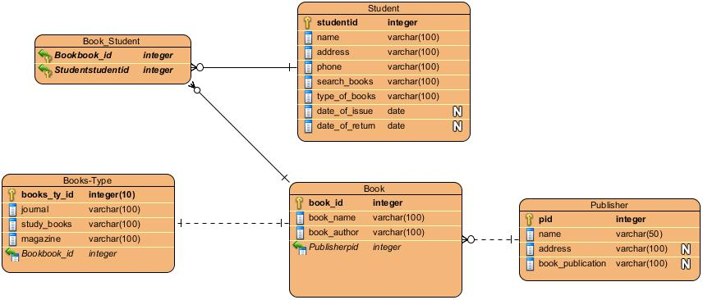

Figure 7 ER Diagram of Library Management System.

## 3.3.2 Data Dictionary

Data dictionary is a file or a set of files that contains a database metadata. It records objects in database, object such as data ownership and data relationships to other object. Data dictionary is important component in rational database. Data dictionary also contain metadata which is data about database.

Below is the metadata of library management system after drawing ER diagram.

**Book**

|  |  |  |  |  |  |
| --- | --- | --- | --- | --- | --- |
| Column Name | Type | Length | Nullable | Key | Constraint |
| book_id | integer | 10 | Not Null | Primary Key | PK_Book |
| book_name | Varchar | 100 | Not Null |  |  |
| book_author | Varchar | 100 | Not Null |  |  |
| Publisherid | integer | 10 | Not Null | Foreign Key | FK_Publisher |

**Student**

|  |  |  |  |  |  |
| --- | --- | --- | --- | --- | --- |
| Column Name | Type | Length | Nullable | Key | Constraint |
| student_id | integer | 10 | Not Null | Primary Key | PK_Student |
| address | Varchar | 100 | Not Null |  |  |
| phone | Varchar | 100 | Not Null |  |  |
| search_books | Varchar | 100 | Not Null |  |  |
| type_of_books | Varchar | 100 | Not Null |  |  |
| date_of_issue | date |  | Null |  |  |
| date_of_return | date |  | Null |  |  |

**Book_Student**

|  |  |  |  |  |  |
| --- | --- | --- | --- | --- | --- |
| Column Name | Type | Length | Nullable | Key | Constraint |
| Bookbook_id | integer | **-** | Not Null | Foreign Key | PK_Book |
| Studentstudentid | integer | **-** | Not Null | Foreign Key | FK_Publisher |

**Publisher**

|  |  |  |  |  |  |
| --- | --- | --- | --- | --- | --- |
| Column Name | Type | Length | Nullable | Key | Constraint |
| pid | integer | - | Not Null | Primary Key | PK_Publisher |
| name | Varchar | 50 | Not Null |  |  |
| address | Varchar | 100 | Null |  |  |
| book_publication | Varchar | 100 | Null |  |  |

**Book-Type**

|  |  |  |  |  |  |
| --- | --- | --- | --- | --- | --- |
| Column Name | Type | Length | Nullable | Key | Constraint |
| books_ty_id | integer | 10 | Not Null | Primary Key | PK_Book-type |
| journal | Varchar | 50 | Not Null |  |  |
| study_books | Varchar | 100 | Not Null |  |  |
| magazine | Varchar | 100 | Not Null |  |  |
| Bookbook_id | integer | - | Not Null |  | FK_Book |

# 3.4 UI (User Interface) Modelling

User interface modelling is a development technique used by computer application programmers. It plays important role in usability of an application. UI helps to design an engaging product and resulting a better understanding of design for everyone involved. It helps to determine the direction of system.

## 3.4.1 Prototyping

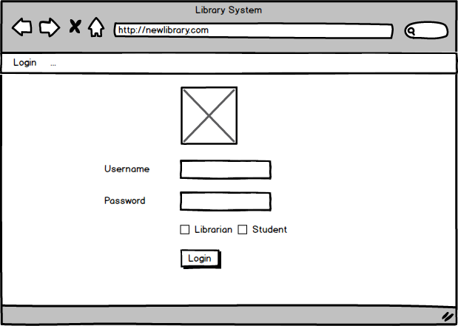

Figure 8 Login form

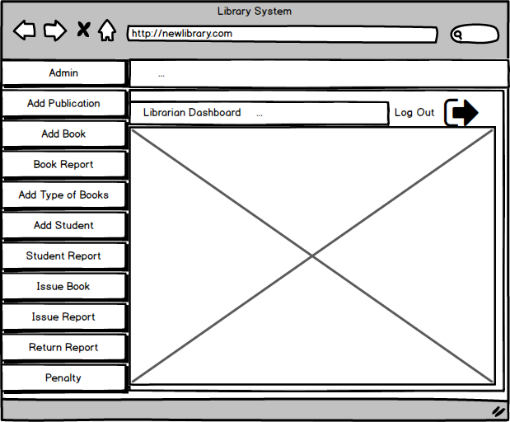

Figure 9 Librarian Dashboard

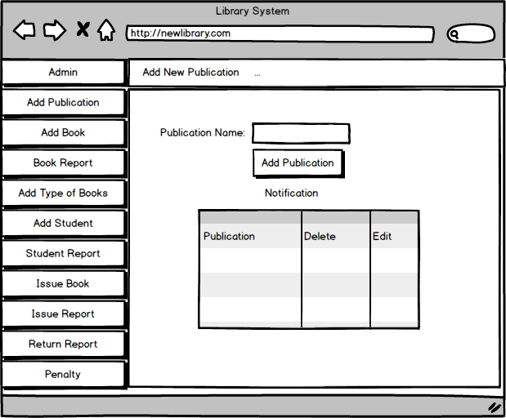

Figure 10 Publication Books Interface.

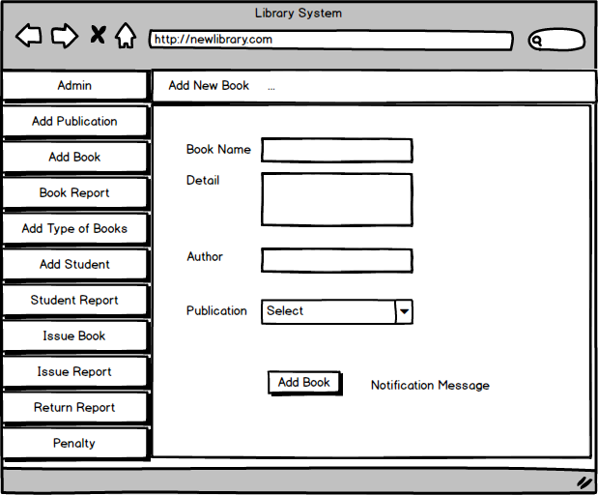

Figure 11 Add Books Interface

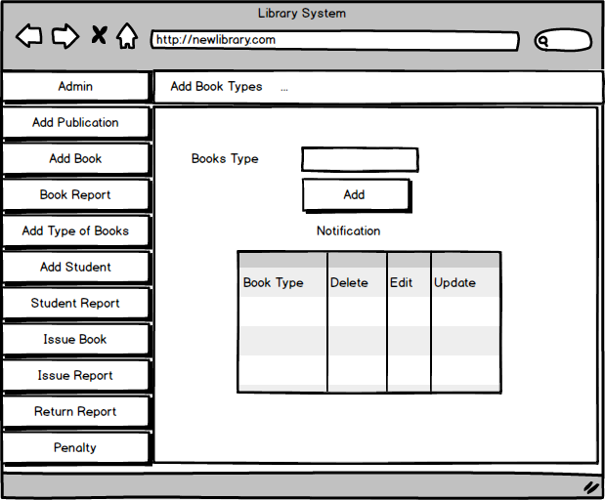

Figure 12 Books Type Interface.

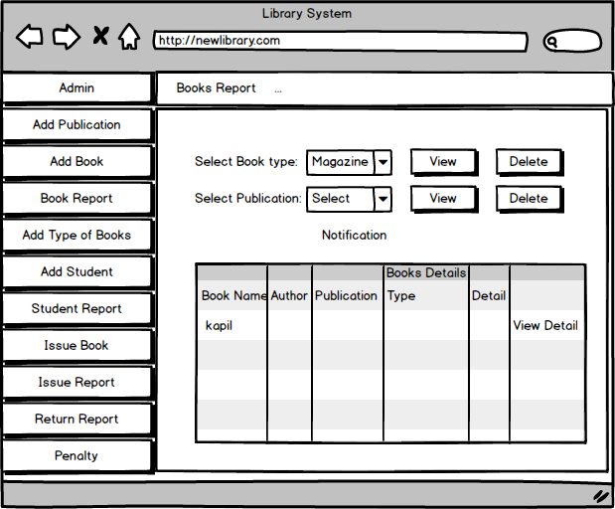

Figure 13 Books report Interface

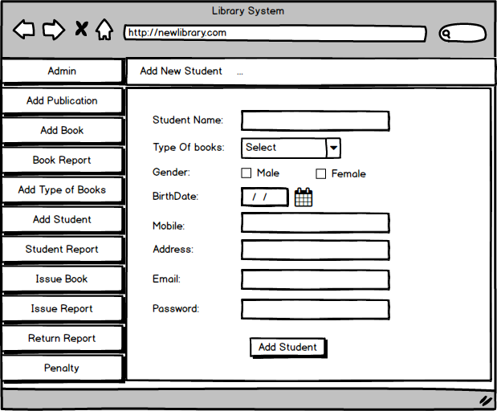

Figure 14 Add Student Interface

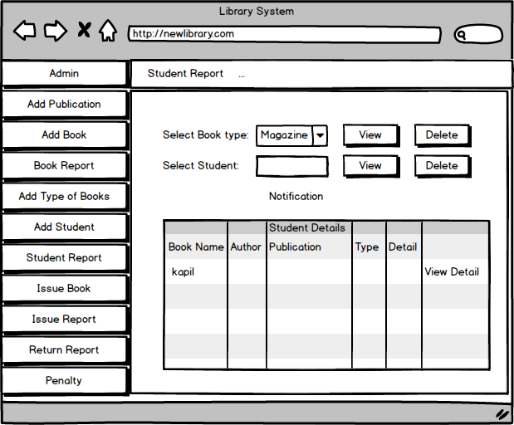

Figure 15 Student Report Interface

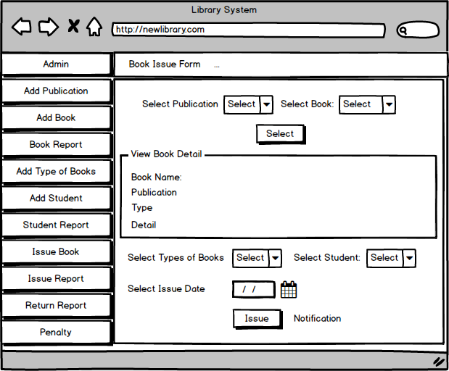

Figure 16 Books Issued Form Interface.

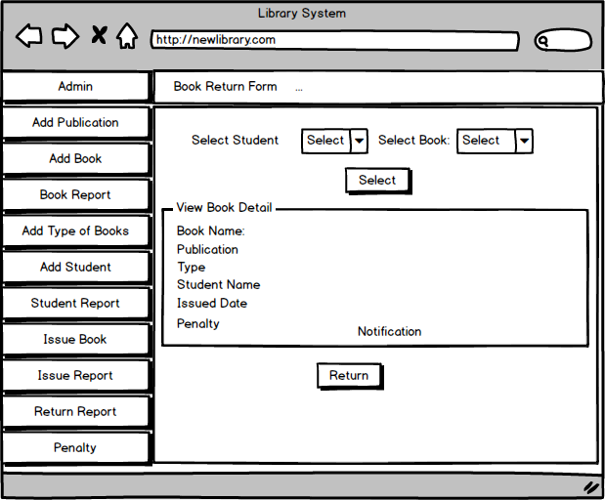

Figure 17 Books Return Form Interface.

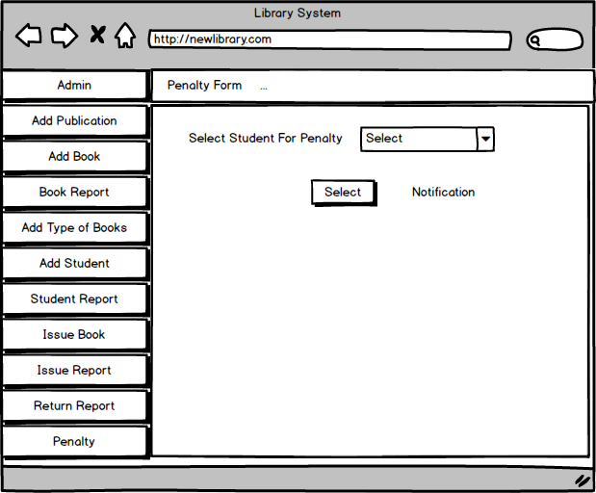

Figure 18 Penalty Form Interface.

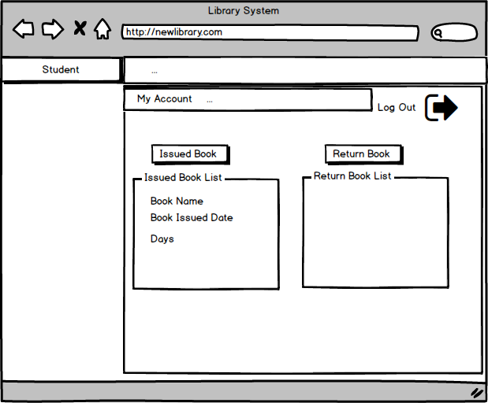

Figure 19 Student Dashboard Interface.