* Step 1:
  + Open Command Prompt (cmd)
  + Change directory to Desktop

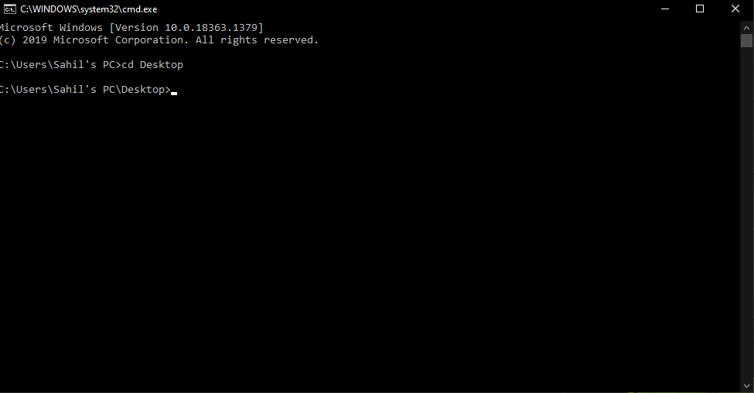

* + Check python version
    - Python --version



* + If python version is not python 3.8.7 change it to python 3.8.7
* Step 2:
  + Create Virtual Environment
    - Python -m venv News_Project



* + - cd News_Project
  + Download the provided project and transfer it to the folder News_Project folder Created on Desktop

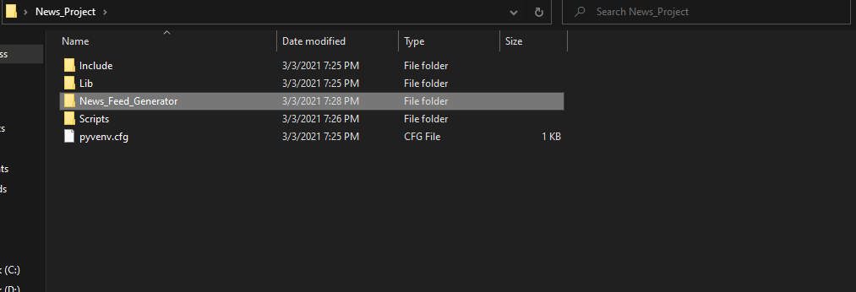

* + Activate Environment
    - Scripts\activate



(note: in Scripts, S is capital)

* Step 3:
  + cd News_Feed_Generator
  + Installing requirements

pip install -r requirements.txt



* + Installing nltk files
  + Type below commands:
    - Python
    - Import nltk
    - nltk.download()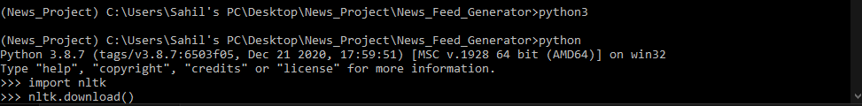
    - Window will appear click on download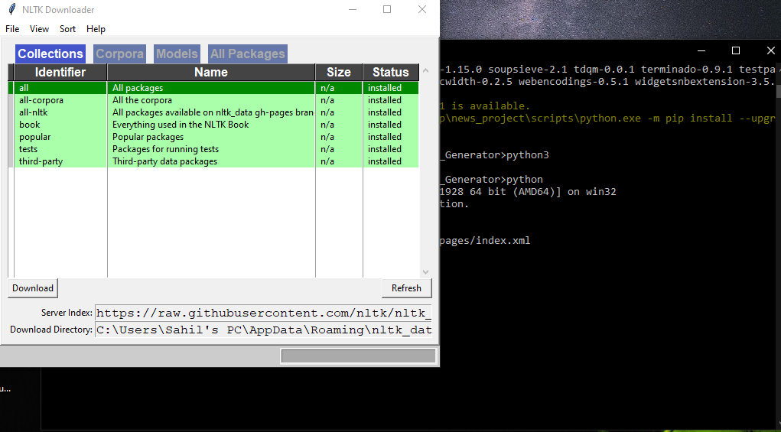
    - After all the status is shown green and installed close the window
    - Type exit()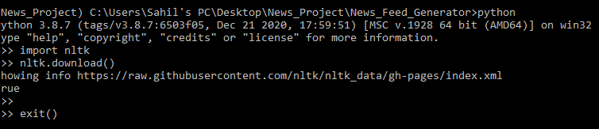
* Step 4:
  + cd Source_code
  + Type below commands:
    - flask db init
    - flask db migrate -m "Initial migration."
    - flask db upgrade
  + Python app.py