**Case**: Impact of staff and services to check the feedback on revenues generated

**Dataset:**

KFC food dataset is used to showcase the approach.

Raw data

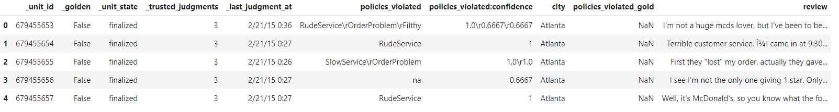

After cleaning and processing

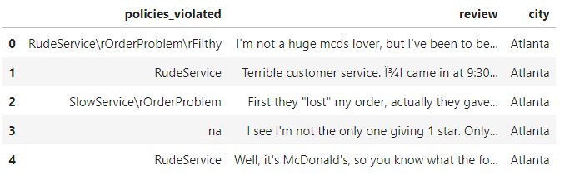

**Abstract:**

To manage well the revenue of restaurant, manager has to do the tedious job of resource allocation correctly. For that he needs to know here he is lagging. Best way to know that is from feedback from the customers. Gathering and manually handling large number of feedbacks is a tough job and gaining insights form that is cumbersome task.

To make it automatic and better know the cause we need to analyse the feedback using machine learning model. From that manager can easily know which services needs to be handled urgently and quickly. And that directly increase the brand value in the market.

Also with comparison on different locations we get to know which location have better services and better labour quality.

**Insights and Visualizations from feedback:**

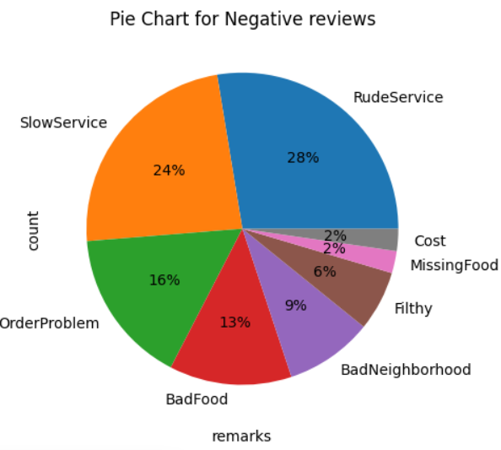

From alone this pie chat it is easily understood that among all the factors affecting services and in turn revenues are

1. Rude service
2. Slow service
3. Order problem

This makes easy to say that apart from food quality staff related factors affect more heavily and scars the revenue.

**Variation of feedbacks with locations**

Skilled labour defines a lot about services that can be delivered and it can depend upon location also. We can understand from the graph below the feedback variation depending on locations.

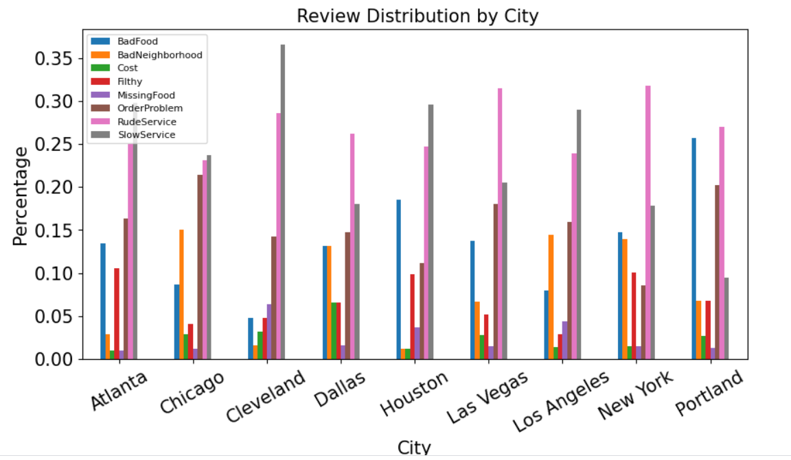

**Data cleaning and featurization:**

Raw data needed to be cleaned before any task to be performed upon it.

After cleaning data from raw data needed to be in structured form

For that we need to do

1. Tokenization
2. Lemmatization
3. Stemming

For proper featurisation of data

1. TF-IDF
2. Word2Vec using glove vectors done.

**Classification Methodologies**

**Random forest classifier:**

Random forest classifier did not provide classification with higher accuracies. So xgboost model was used.

**XG Boost:**

For proper hyper tuning was done and following parameters were good for that XG Boost model.

The Accuracy and F1 score matrix have good results for values for learning_rate =0.1, max_depth= 1 and n_estimators = 125

**Conclusion:**

This study of data shows a model can be generated and employed into business model for feedback oriented policies shift in management level decisions regarding the overall staff as well as employees needed on a particular service like waiters, chef, packaging etc.