**Increasing Restaurant Revenue**

*Abstract* : Restaurants in and around the world, be it in a remote place in London to a booming city like Los Angeles, sometimes struggle to keep up with the increasing cost which may be pertaining to different sets of reasons. The restaurant industry, known for its dynamic and labor-intensive nature, faces a myriad of challenges in today's competitive landscape. One of the most critical factors impacting the success and profitability of restaurants is effective staff management. To address these challenges and ensure smooth operations, there is a pressing need for staff management software tailored specifically for the restaurant sector. In today's highly competitive restaurant industry, efficient staff management is paramount for success. A customized solution is necessary due to labor costs, scheduling difficulties, and customer service requirements. Staff management software designed for restaurants addresses these challenges effectively. It enables precise labor cost control, efficient scheduling, overtime management, and attendance tracking. Furthermore, it promotes effective communication, monitors performance indicators, and aids in worker retention. Ultimately, this software empowers data-driven decision-making and compliance with labor regulations, contributing to an improved guest experience and enhanced profitability for restaurants.

# Step 1: Prototype Selection

## Problem Statement

In this report we covering the various AI/ML techniques we can use to increase restaurant revenue, we are going to analyse the pattern of Labor/Staff Cost in a restaurant by keeping the track of there attendance using face recognition and by analysing customer reviews to analyse restaurant’s performance.

## Introduction

The main issue in starting a new or continuing an already stable restaurant in today’s world isn’t a joke. Even before Covid-19, many were still struggling economically and had to shut down. The expenses that a restaurant must go through in its running time has a huge impact on its total profit or revenue.

*Figure 1: Restaurant revenue breakdown*

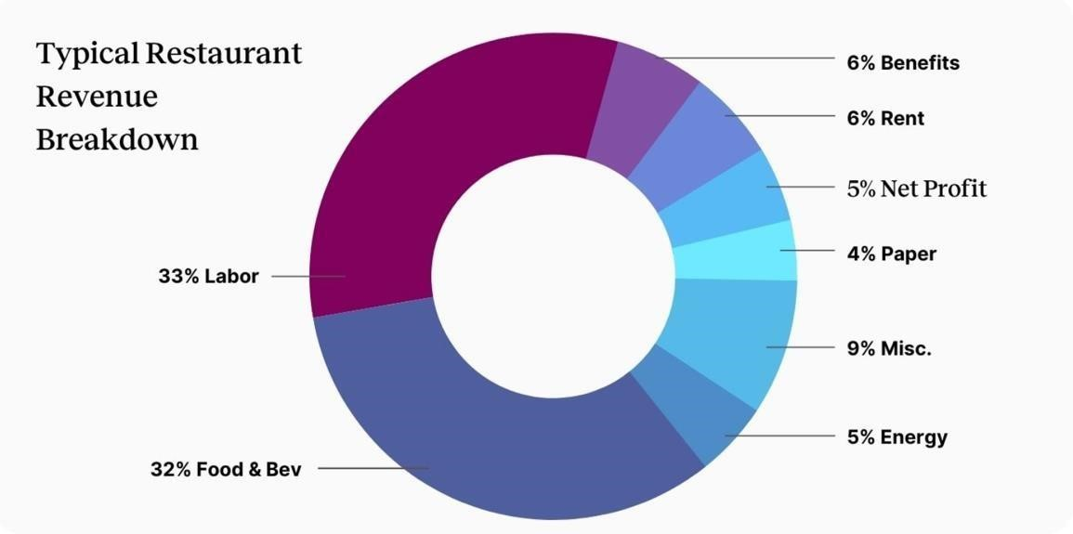

*Source: Family Hospitality, Notch*  Figure 1 shows us how Labor Cost, with the highest percentage of 33%, proves how controlling the labor cost can make a restaurant lower its total staff operational costs. However, the 32% for food and beverages is a bit tough to work on, because with increasing quality (which is essential for a restaurant for a long-time continuity), the cost of food will also increase, which will ultimately result in an increased sale.

Dividing staff into different groups indicates where cost is higher and more varied. Staff in restaurant have different roles in different settings:

1. Front of the House
   * Servers
   * Bartenders
   * Security
2. Back of the House - Head chef
   * Cooks
   * Dishwashers
3. Management
   * Heads
   * Managers
   * Founders

The costs that have to be incurred by any restaurant type is mainly divided into the following classes:

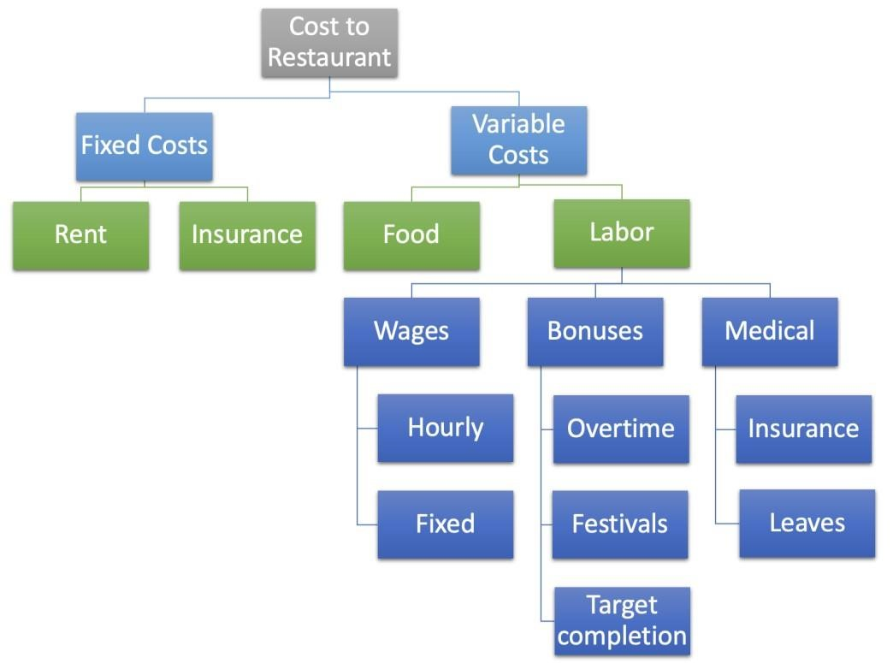

The prime cost, i.e. the variable cost can be calculated in the following steps:

1. Calculate COGS (Cost Of Selling Goods):

COGS = Inventory + Purchases

1. Calculate prime cost/ variable cost:

PC = Labor Cost + COGS

1. Calulate prime cost percentage:

PC (%) = (Prime / Total Sales) * 100 %

This prime cost should ideally be in the range 10% - 30% for small restaurants, <40% for mid-sized restaurants and <50% for larger and more famous dine outs.

## Market/Customer/Business need assessment

What we have seen earlier about the maximum revenue going into labor costs, many restaurants are opting for replacing excess staff with technology, which can provide managers with an increased efficiency with the staff operations, as well as give them data-driven insights into what causes an increased or decreased sales and how are the staff are related to it .We can do this maintain attendance of part time worker and keeping track of working hours of employee. It helps maintain a good balance in profit and quality service. Keeping account of each staff money information and making strategical decisions in ensuring the perfect balance between the cost of operating and efficiency of the restaurant, which will in turn increase the restaurants’ efficiency and infuse a sense of trust and confidence in the staff. Staff retention is also important in controlling the labor costs. Also AI can help owners understand data for the benefit of customers. AI distinguishes patterns in customer behaviors, giving owners insight into repeating successful offers and eliminating past incentives that did not yield results. It can deploy limited-time offers for loyal customers, ensuring a better customer experience for them. **Step 2: Prototype Development**

**CUSTOMER REVIEW ANALYSIS (by Kapil Dev Yadav)**

**Case**: Impact of staff and services to check the feedback on revenues generated **Dataset:**

KFC food dataset is used to showcase the approach. Raw data

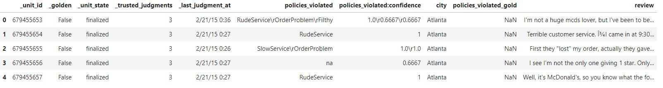

After cleaning and processing

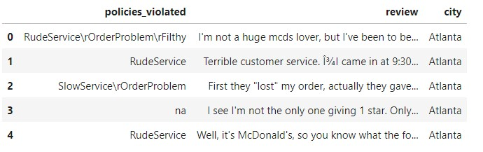

**Abstract:**

To manage well the revenue of restaurant, manager has to do the tedious job of resource allocation correctly. For that he needs to know here he is lagging. Best way to know that is from feedback from the customers. Gathering and manually handling large number of feedbacks is a tough job and gaining insights form that is cumbersome task.

To make it automatic and better know the cause we need to analyse the feedback using machine learning model. From that manager can easily know which services needs to be handled urgently and quickly. And that directly increase the brand value in the market. Also with comparison on different locations we get to know which location have better services and better labour quality.

**Insights and Visualizations from feedback:**

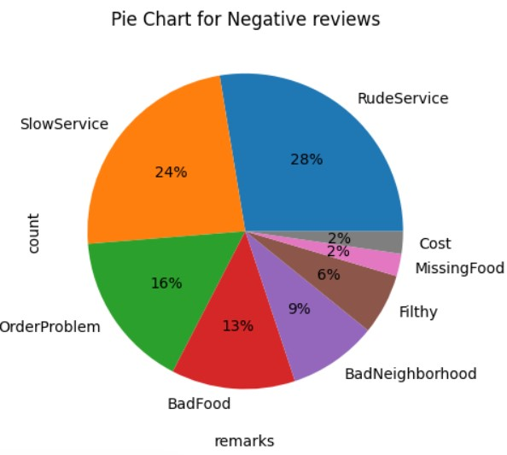

From alone this pie chat it is easily understood that among all the factors affecting services and in turn revenues are

1. Rude service
2. Slow service
3. Order problem

This makes easy to say that apart from food quality staff related factors affect more heavily and scars the revenue.

**Variation of feedbacks with locations**

Skilled labour defines a lot about services that can be delivered and it can depend upon location also. We can understand from the graph below the feedback variation depending on locations.

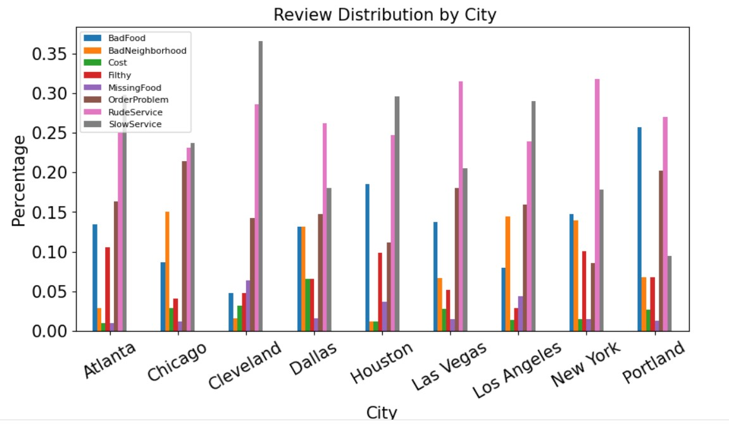

**Data cleaning and featurization:**

Raw data needed to be cleaned before any task to be performed upon it.

After cleaning data from raw data needed to be in structured form

For that we need to do

1. Tokenization
2. Lemmatization
3. Stemming

For proper featurisation of data

* 1. TF-IDF
  2. Word2Vec using glove vectors done.

**Classification Methodologies**

**Random forest classifier:**

Random forest classifier did not provide classification with higher accuracies. So xgboost model was used.

**XG Boost:**

For proper hyper tuning was done and following parameters were good for that XG Boost model.

The Accuracy and F1 score matrix have good results for values for learning_rate =0.1, max_depth= 1 and n_estimators = 125 **Conclusion:**

This study of data shows a model can be generated and employed into business model for feedback oriented policies shift in management level decisions regarding the overall staff as well as employees needed on a particular service like waiters, chef, packaging etc.

**GitHub Link:**

<https://github.com/Dadipya14/Restaurant_revenue/blob/main/restaurant%20(1).ipynb>[https://github.com/Dadipya14/Restaurant_revenue/blob/main/McDonalds-Yelp-SentimentDFE.csv](https://github.com/Dadipya14/Restaurant_revenue/blob/main/McDonalds-Yelp-Sentiment-DFE.csv) (**by Kapil Dev Yadav)**)

**Attendance using Face recognition(by Daidipya sisodiya)**

Attendance Management keeps track of your employee or students present/absent details. It is the system to document the time your employees/students work and the time they take off. In this digital era, face recognition system plays a vital role in almost every sector. Face recognition is one of the mostly used biometrics. It can used for security, authentication, identification.

This is an artificial intelligence based attendance management system with face recognition technology. The main objective of this AI based software solution is to update attendance with employees' face using computer vision.

It has elegant graphical interface along with a live database(Firebase) to create a real-world system.In this we have done following things :

1. Introduction 2. Overview 3. Setup 4. Webcam 5. Graphics 6. Encoding Generator 7. Face

Recognition 8. Database Setup 9. Add Data to the Database 10. Upload Images to the Database 11. Download User Data 12. Update Attendance 13. Check if already Marked 14.

Loading

#Checking if someone is standing in front of camera

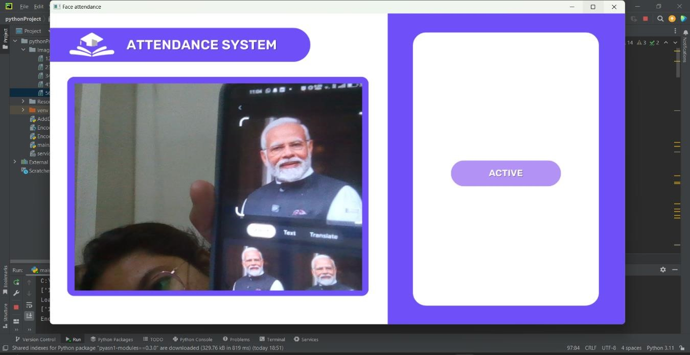

#If the person is already marked

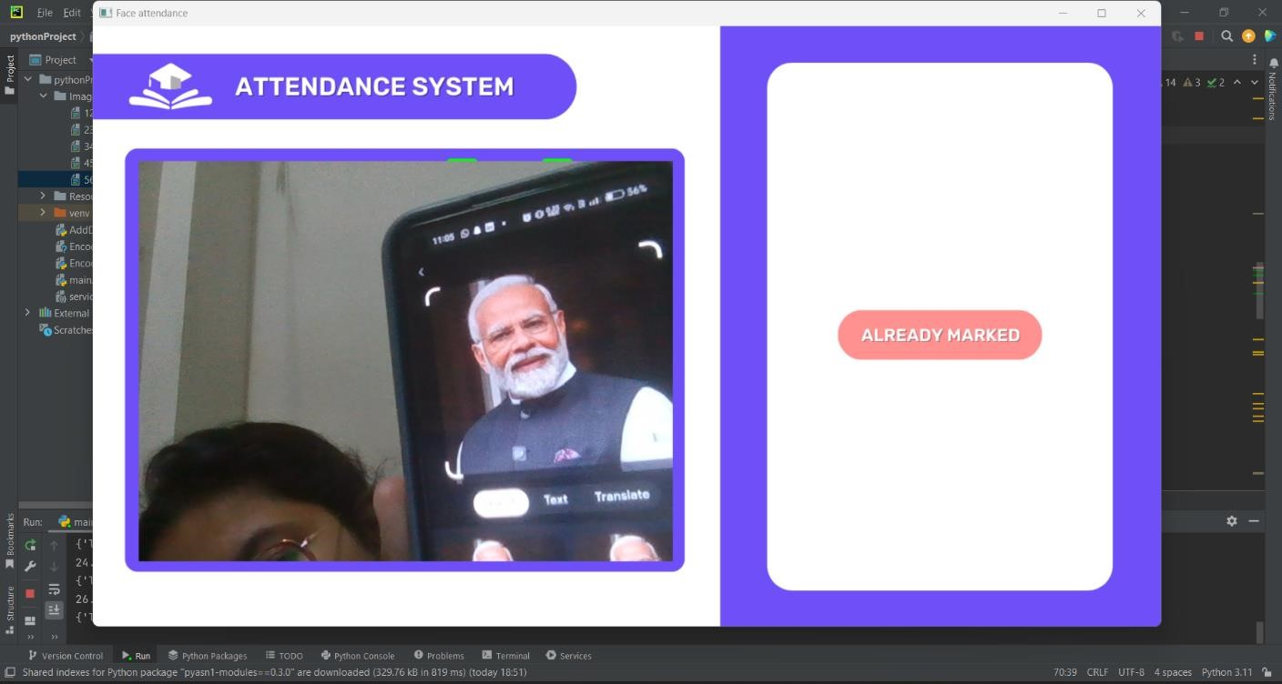

**#**Showing person’s information,total attendence,etc

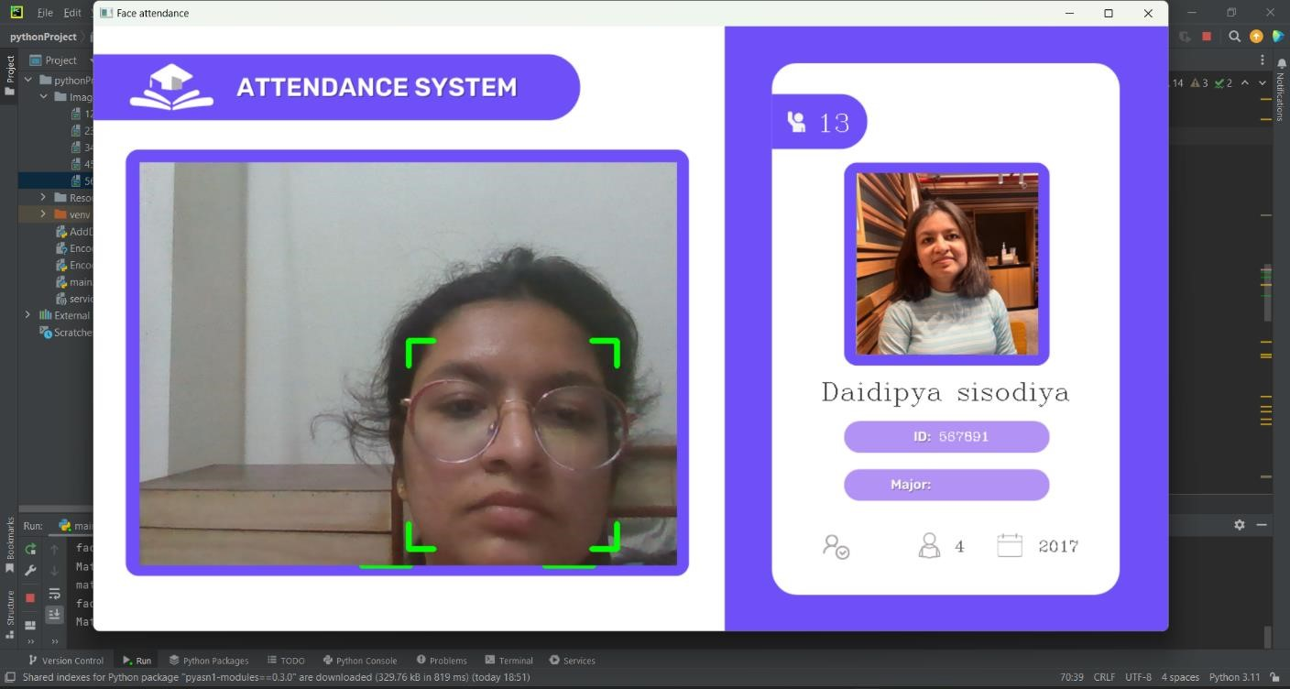

I also have created a real-time database using firebase which can store employees information

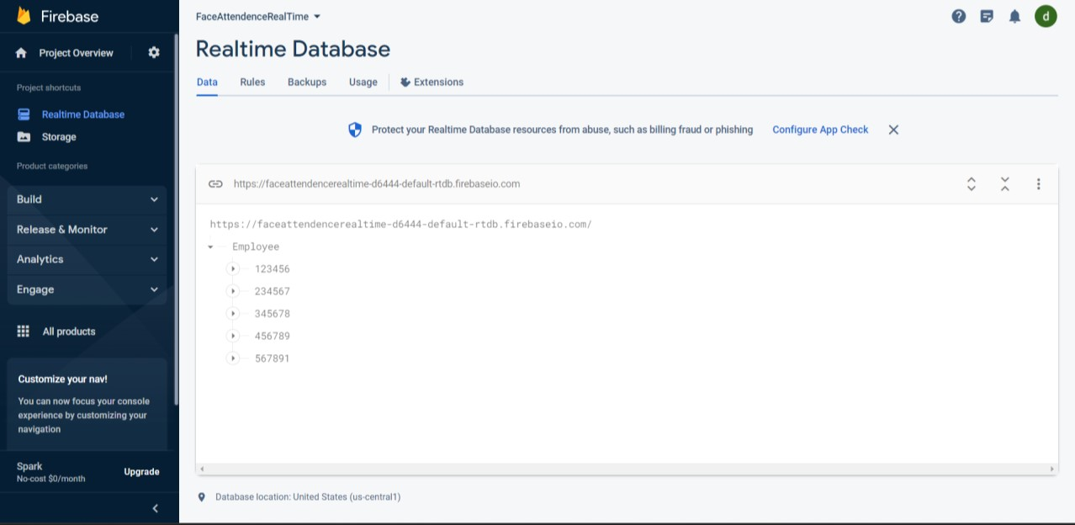

**GitHub link-** <https://github.com/Dadipya14/FaceRecognitionAttendance>

(by Daidipya sisodiya )

**Step 3: Business Modelling Business Model (by Moushreeta Debroy)**

1. **Value Proposition:**

AI-Powered Staff Management: Potere.ai offers an innovative and AI-driven solution to address the complex challenges faced by restaurants in effectively managing their staff. The software leverages advanced artificial intelligence and machine learning algorithms to optimize labor costs, enhance staff efficiency, and drive revenue growth.

Customization for the Restaurant Sector: Our system is specifically tailored for the unique needs of the restaurant industry. It understands the dynamic nature of this sector, where demand fluctuates significantly, and efficient staff management is crucial for success.

1. **Target Market:**

Small and Mid-Sized Restaurants: The initial focus is on small and mid-sized restaurants, particularly in Assam and the North-Eastern region of India. These businesses often lack the resources and sophisticated tools that larger chains may have. Our project aims to level the playing field by providing accessible AI-driven staff management solutions.

1. **Revenue Streams:**

Subscription Model: Restaurants can choose from various subscription plans based on their specific needs. Subscription fees are charged on a monthly basis and vary according to the range of services required. This model provides flexibility for restaurants to select the features that suit their operations.

Pay-Per-Use Model: For added flexibility, Potere.ai offers a pay-per-use model, where restaurants are charged based on the hours of service used. This option is ideal for businesses with varying demands throughout the year.

1. **Key Features:** 
   * Face Recognition for Attendance: Our project employs advanced face recognition technology to accurately track employee attendance. This not only ensures the security of the workplace but also simplifies the attendance recording process, eliminating the need for manual time tracking.
   * Customer Review analysis: Through the analysis of consumers' dining experience and the evaluation of the restaurant's food and service, the restaurant can continuously adjust its business strategy, which is of high economic value to the restaurant. As for consumers, they can avoid unpleasant dining experience and have a better experience of local specialty food by looking at people's reviews. The analysis model based on machine learning algorithms and big data can efficiently and accurately extract the critical letters in customer reviews, predict customer behavior, and proofread the accuracy of reviews to achieve a win-win situation for restaurants and consumers, to strive for the maximum economic benefits.
   * Productivity Tracking: The software monitors staff productivity and correlates it with sales data. By analyzing customer feedback and other factors, Potere.ai provides insights into workforce efficiency and helps identify areas for improvement.
2. **Importance of AI/ML:** 
   * Cost Optimization: AI and ML play a crucial role in optimizing labor costs. Machine learning models analyze historical data to forecast staffing requirements accurately. This results in reduced overstaffing and minimized labor expenses.

Efficiency: AI-driven staff management ensures that the right number of employees is scheduled at the right times. This not only minimizes idle time but also ensures that the restaurant operates smoothly during peak hours.

* + Data-Driven Decision Making: Machine learning algorithms provide data-driven insights into the relationship between staffing levels, sales, and customer satisfaction. By making informed decisions based on this data, restaurants can continuously enhance their operations.
  + Employee Retention: Cross-training and career development opportunities, driven by AI/ML, are essential for retaining employees in an industry with high turnover rates. As staff members see opportunities for growth and development, they are more likely to stay with the company.
  + Competitive Advantage: Our project gives restaurants a competitive edge by efficiently balancing cost, quality service, and operational excellence. With AI/ML at the core of its functionality, it provides the tools needed to stay competitive in a challenging market.
  + Predictive Insights: The use of regression analysis and data analytics allows Potere.ai to provide predictive insights. Restaurants can anticipate fluctuations in demand and adjust staffing levels accordingly, improving cost control and customer service.

1. **Marketing and Expansion:**

Marketing Strategy: The marketing strategy for our project will involve digital marketing, partnerships with restaurant associations, and word-of-mouth referrals. The focus will be on highlighting the software's cost-effective and efficient features that empower restaurants to compete more effectively.

Expansion: After establishing a strong presence in Assam and the North-Eastern region of

India, the plan is to expand nationally and eventually globally. As the demand for advanced

staff management solutions continues to grow, then aims to become a global leader in the restaurant technology industry.

1. **Data and Privacy Compliance:**

To address data and privacy concerns, Potere.ai will implement robust security measures to protect employee data. Compliance with data privacy regulations, especially concerning the collection and handling of personal information, will be a top priority.

**8.Continuous Improvement**:

This project will focus on continuous improvement by regularly updating its AI/ML models and software. This ensures that the software remains adaptable to changing industry dynamics and continues to enhance staff management and cost control.

# Step 4: Financial Modelling with Machine Learning & Data Analysis(by shraddha deori)

**FINANCIAL MODELING:**

The staff in any restaurant needs the following count of each staff type, at least to complete the minimal norms.

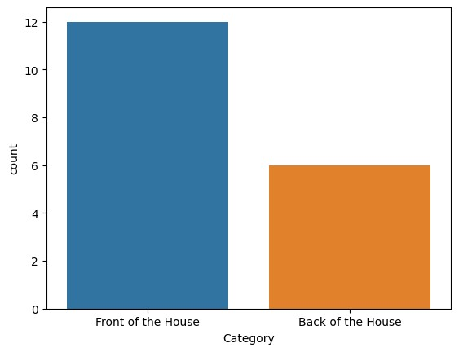

According to our findings:

|  |  |  |  |
| --- | --- | --- | --- |
| **Staff type** | **Salary (per day)** | **Salary (per hour)** | **Tips (per hour)** |
| Front of the House | ₹ 746.39 | ₹ 337.82 | ₹ 152.18 |
| Back of the House | ₹ 876.79 | ₹ 49.94 | ₹ 2.94 |

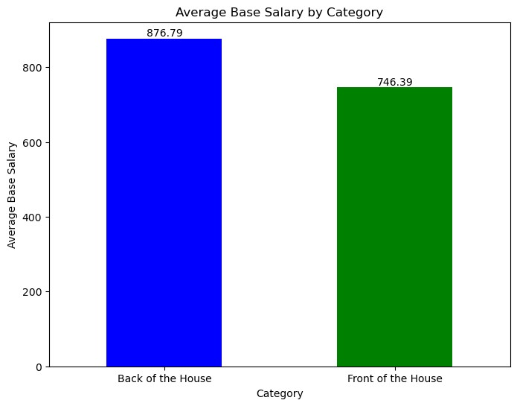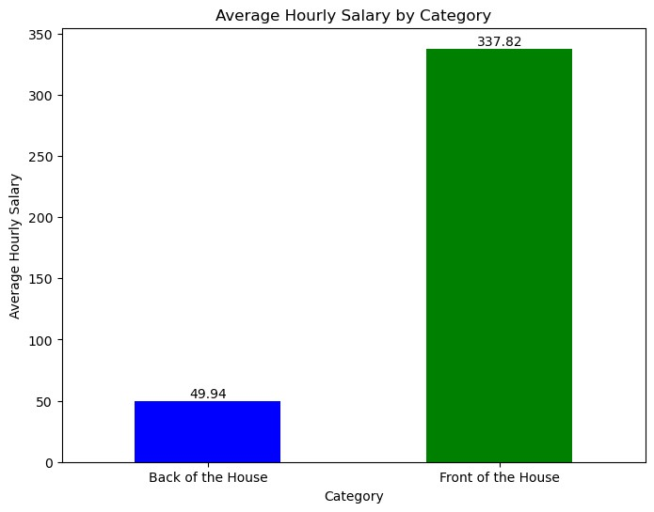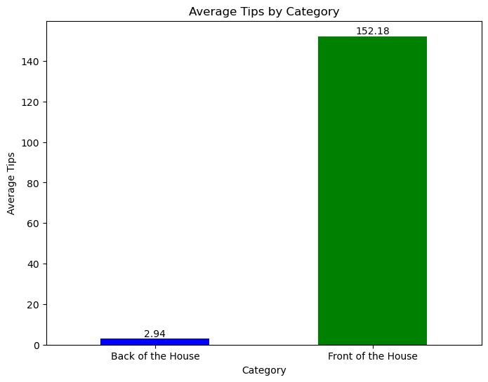

From the above data, we see that:

1. The total count of each staff type constitutes of 12 (66.66%) for Front of the house (FH) and 6 (33.33%) for the Back of the house (BH).
2. However, even after FH being more in number than BH:
   * the average daily pay for the former is 14% less than the latter.
   * the hourly pay for the former is 85% more than the latter.
   * tip per hour pay for the former is 98% more than the latter.

Thus, for the optimal staff scheduling and enhancing the restaurant profit without reducing the staff pay can be done by the following help:

1. ***Reducing per day cost to employee:***

More FH employees can be employed on hourly pay basis rather than a fixed pay, as they are already getting paid by tips directly from customers.

If we can even reduce the total daily pay for the FH staff by even 10%, the cost decreases to ₹ 671.751.

Also, some of the BH staff can also be employed on hourly basis rather than on a fixed pay like Dishwasher, Line Cook (for fast food), Prep Cook (for prepping foods).

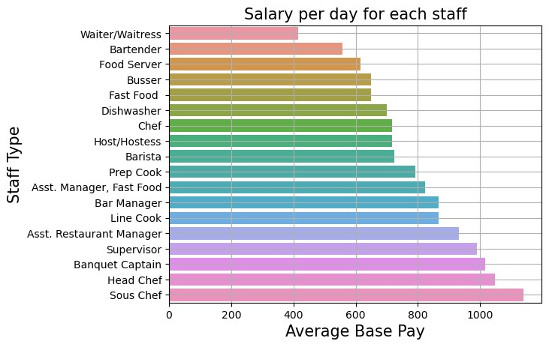

This would in turn decrease the per day total pay by ₹ 4550 (original pay) - ₹ 1400 (daily pay of ₹ 200) = ₹ 3150.

1. ***Reducing hourly cost to employee:***

Salaries of BH employees by type Managers, Main Cook, Host/Hostess etc. who are given fixed pay are not to be included in the hourly pay, unless it is informed in advance. This would decrease the total hourly cost per day by ₹ 955.

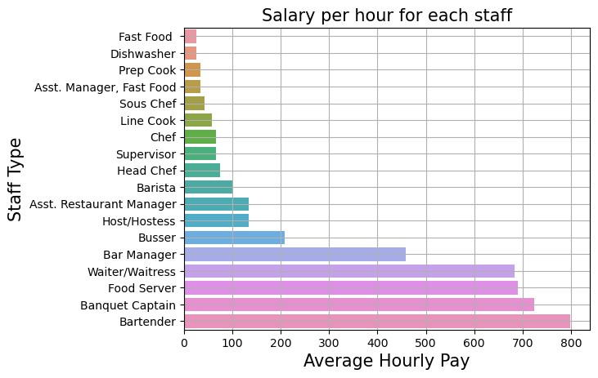

**Modeling the Financial Equation:**

Average revenue for a small/ mid- sized restaurant/ day = ₹ 1,50,000

Average revenue for a small/ mid- sized restaurant/ year = ₹ 1,50,000 * 365 = ₹ 5,47,50,000

## Only fixed pay

Original per day cost to employee = ₹ 14,217.392 Original per year cost to employee = ₹ 51,89,348.08

Reduction per day cost to employee = ₹ 671.751 + ₹ 3150 = ₹ 3,821.751

Reduction per year cost to employee = ₹ 13,94,939.12

**(NF)**

New per year fixed cost to employee = ₹ 51,89,348.08 - ₹ 13,94,939.12 = **₹ 37,94,408.96**

## Only hourly pay

Original per day cost to employee = ₹ 4353.452 Original per year cost to employee = ₹ 15,89,009.98

Reduction per day cost to employee = ₹ 960 Reduction per year cost to employee = ₹ 3,50,400

**(NH)**

New per year hourly cost to employee = ₹ 15,89,009.98- ₹ 3,50,400 = **₹ 12,38,609.98**

Labor Cost= NF + NH = **₹ 37,94,408.96 + ₹ 12,38,609.98** = **₹ 50,33,018.94**

Therefore, Prime Cost (without COGS added) = (**₹ 50,33,018.94/** ₹ 5,47,50,000) * 100%

= 9.19%

~ 10%

**COGS = Cost of Selling Goods

Our model shows an approximate 10% prime cost for the restaurant, which is a really healthy score, even if the COGS % goes up to 30%, the overall Prime Cost percentage of <40% for a mid-sized restaurant is balanced.

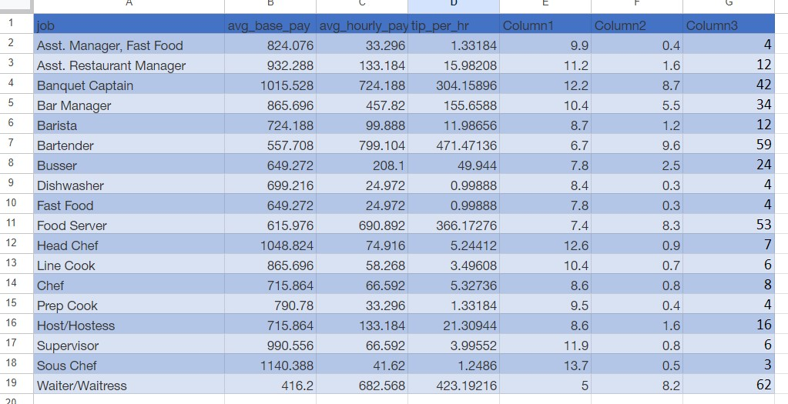

**GitHub Link:**

https://github.com/Dadipya14/Restaurant_revenue/blob/main/restaurant%20revenue%20EDA .ipynb (by shraddha deori)

**Google drive link** https://drive.google.com/drive/folders/1ugeJk83DRU_JqNpCqGwtkudPx_X3y1R?usp=share

_link

## 10.0. Conclusion

Significant challenges are posed by the restaurants, especially in regard to cost control, operational efficiency and staff management. The high percentage of labor costs in restaurant expenses makes it crucial for restaurants to find innovative solutions to manage staff efficiently and cut unnecessary expenses.

Our proposed solution, aims to address these challenges by applying various AI and ML techniques to analyze staff cost patterns & understand customer behaviour. Our product aligns with the evolving trend in the restaurant industry, where technology is increasingly replacing excess staff, leading to enhanced operational efficiency.

Market assessment suggests a growing need for such a product, particularly in small and midsized restaurants, where cost optimization is critical.

While there are other options on the market, according to external search and benchmarking,our project will distinguishes itself out by focusing on employees' well-being, productivity, and real-time data-driven decision-making. The integration of face recognition for attendance further sets our product apart.