

Minutes of Meeting
With
IT Head
Date: 12-August-2020
Time: 12:15 PM TO 01:30 PM and 04:30 to 05:15 PM
Venue: Meeting Room, CEPT. Meeting Called By: Mahroof Sir
Meeting Members:
Name | Department
Mahroof | Head-IT
Nitin Magjikondi | Sr. Project Executive IT
Agenda of Meeting: Connect Portal
CEPT Student Clearance Form
- Student Account:

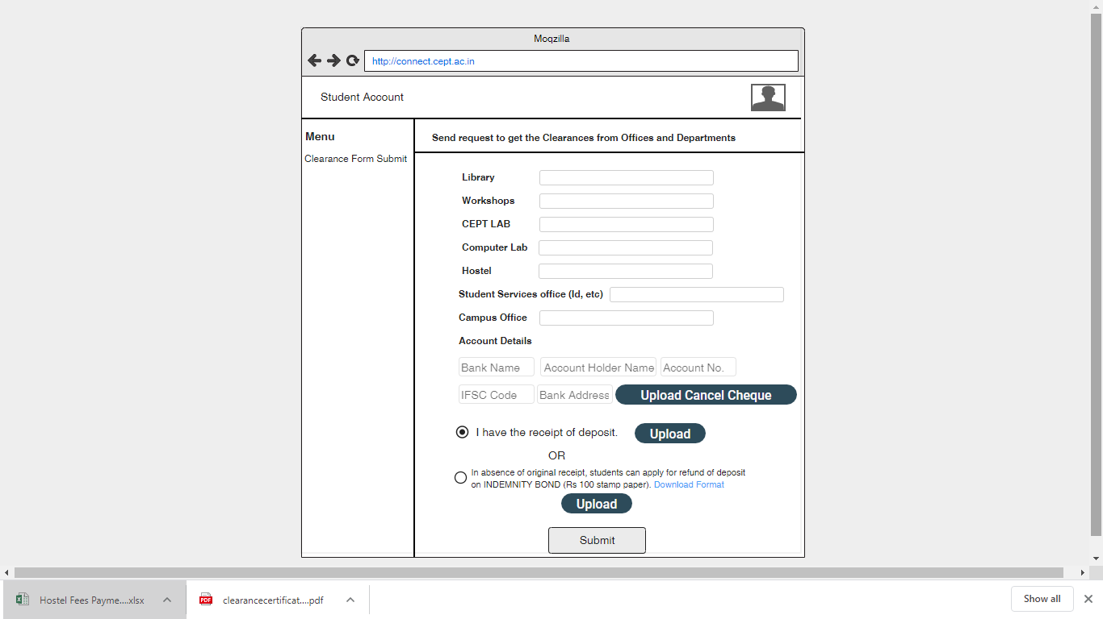

Points:
- After submit by student, all request will be sent to all above department into connect portal as well as it send email notification to particular department Gmail account. Subject line should be Student code_Clearance Request.
- After approval by all department successfully approved, it will send Registrar for approval. Once Registrar will approve, it will show message to student status page that refund will be processed within 30 days. Account department will start process for the refund amount.
- Account Department should have the TWO tab, One for approval for approve and second tab will be shown details of that students whose clearance request is approved by all department and account department can do the refund processed completed for that purpose.
- There should be status like Approved/On Hold/ Pending.
- Each time when any department approved/ On Hold for particular student, Portal should notify student email id as well as show the status at connect portal too.

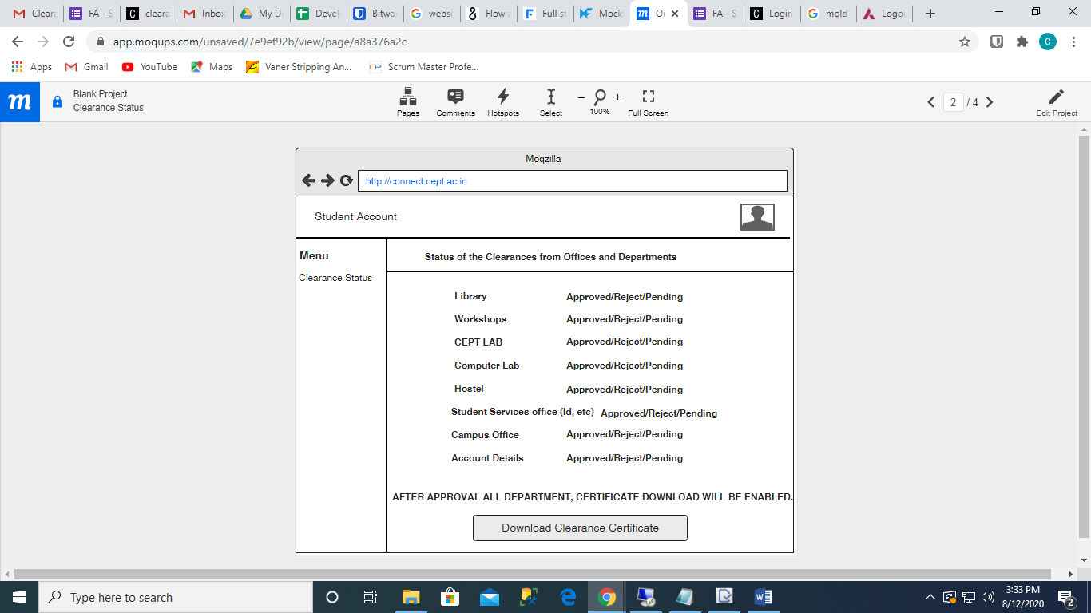

Workshops Account

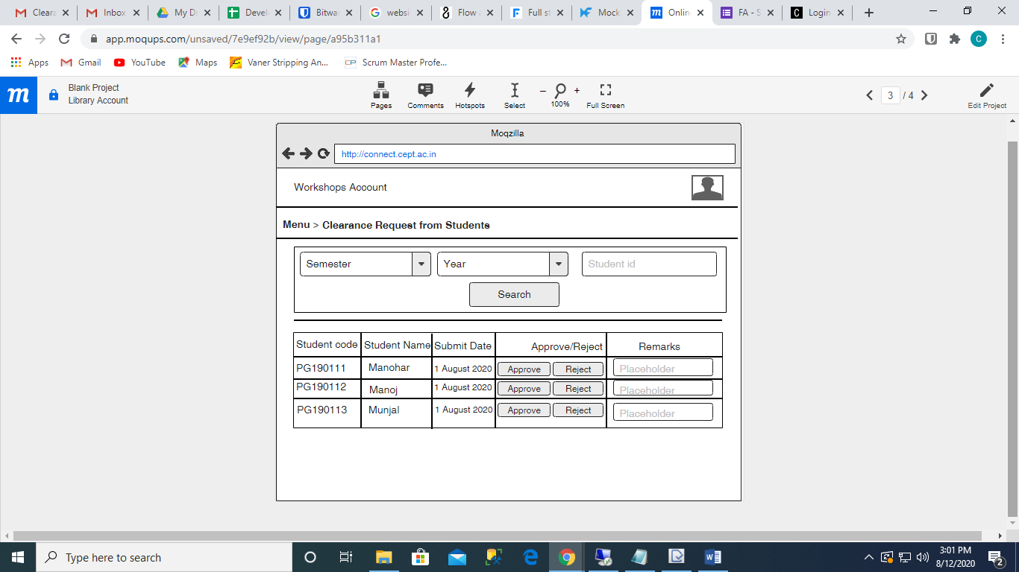

Workshops/Registrar/Accounts/Computer Lab/ CEPT Lab/Admin office

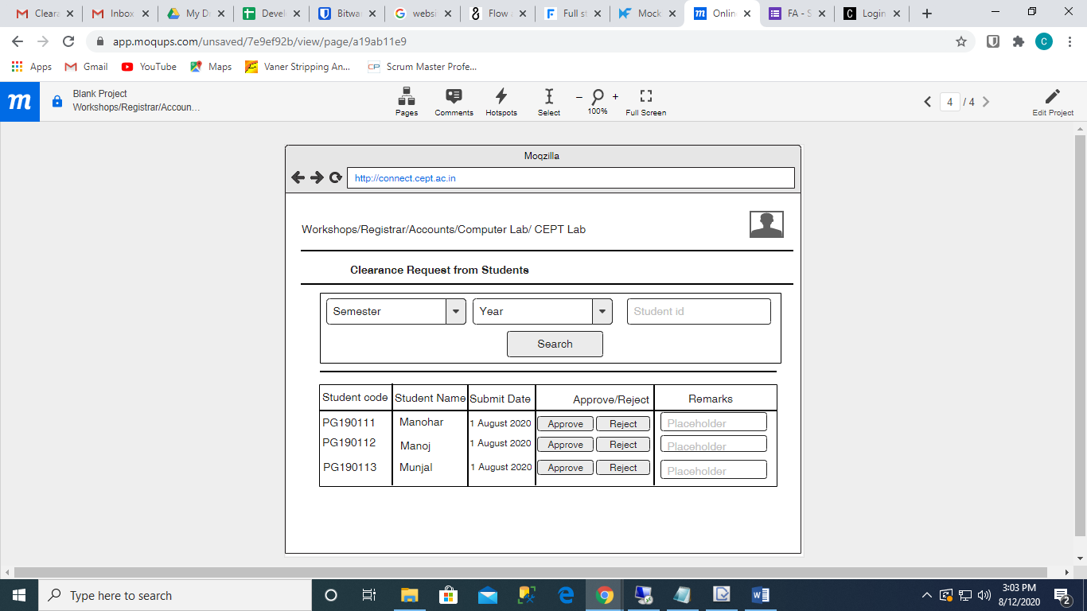

For Database Entry

- Create table in which you have to create the department name, id etc.
Library | 1 | M | 2020 | N
- Now, Student submit their request below details should be processed in database.
PG190111 | Library | Pending | 01-08-2020 06:00:00 | Remarks
PG190111 | Library | On Hold | 02-08-2020 06:30:00 | Submit books
PG190111 | Library | Approved | 03-08-2020 01:00:00

