Task: - Set & Remove Password for the GRUB file
# cd /boot/grub-2/
# grub2-setpassword create the user.cfg file
# Enter password
# Confirm password
# grub2-mkconfig -o / boot/grub-2/grub.cfg update grub.cfg file
# rm -rf /boot/grub-2/user.cfg remove Password for the GRUB file.

Task: - Boot loader grub.cfg file recovery
# cd /boot/grub-2/
Press F2 for enter setup, F12 for network boot, Esc for boot menu

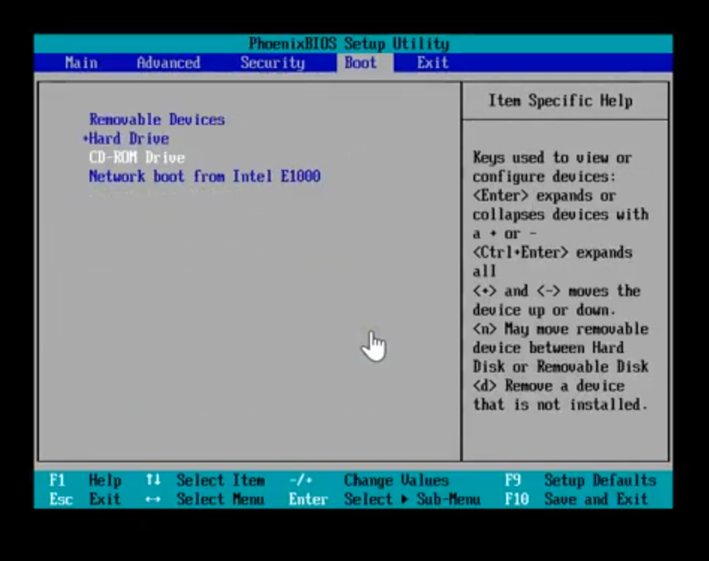

Go to the boot
Select CD-ROM Drive (shift & + move up, shift & - move down)
Go to Exit
Select Exit Saving Changes

Select the troubleshooting option and press enter

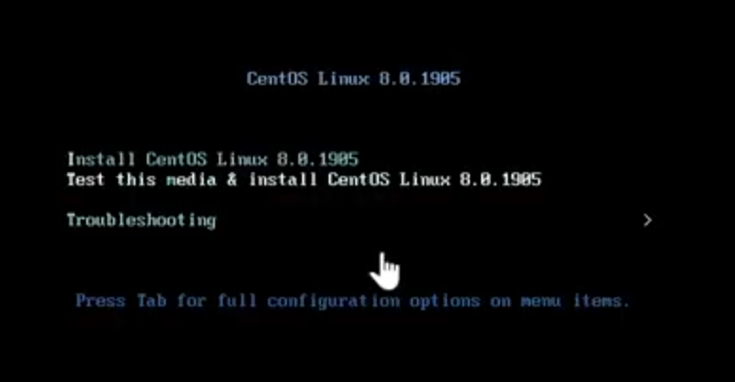

Select 2nd “rescue a centos linux system”

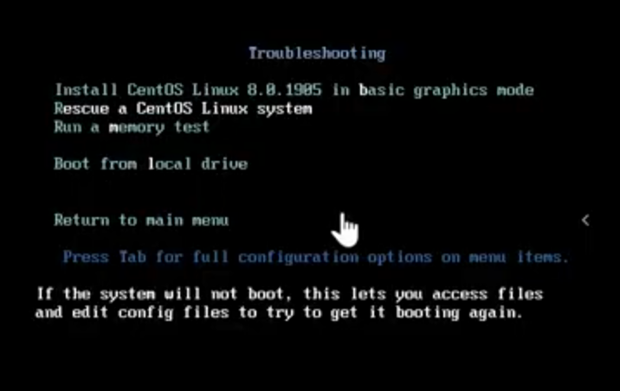

Enter 1 to continue

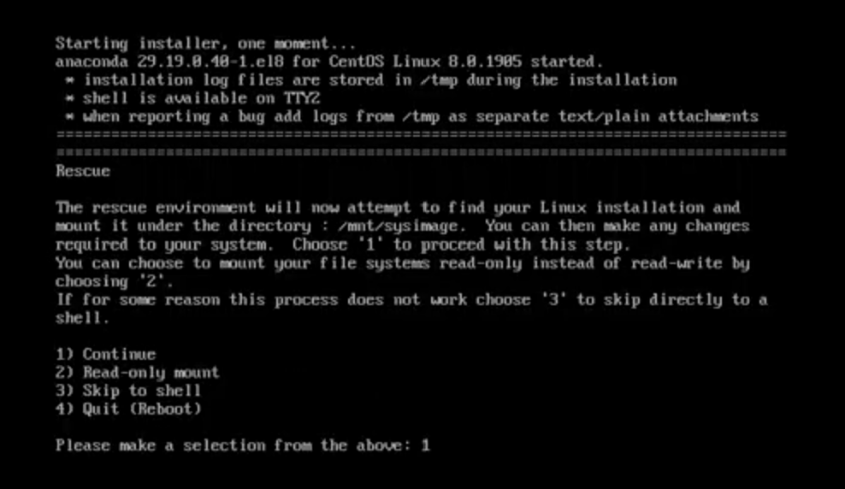

Press enters to get a shell
# Chroot /mnt/sysimage
# grub2-mkconfig -o / boot/grub-2/grub.cfg Get the recovery
# Exit
# Exit

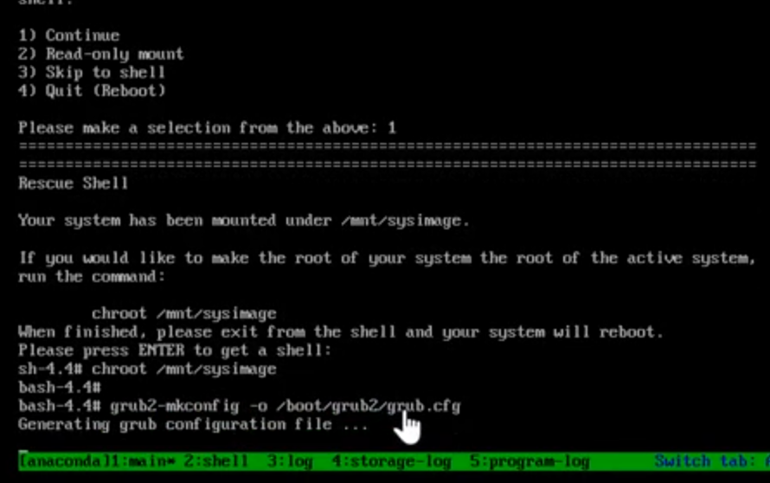

Press F2 for enter setup, F12 for network boot, Esc for boot menu
Go to the boot
Select Hard Drive (shift & + move up, shift & - move down)
Go to Exit
Select Exit Saving Changes

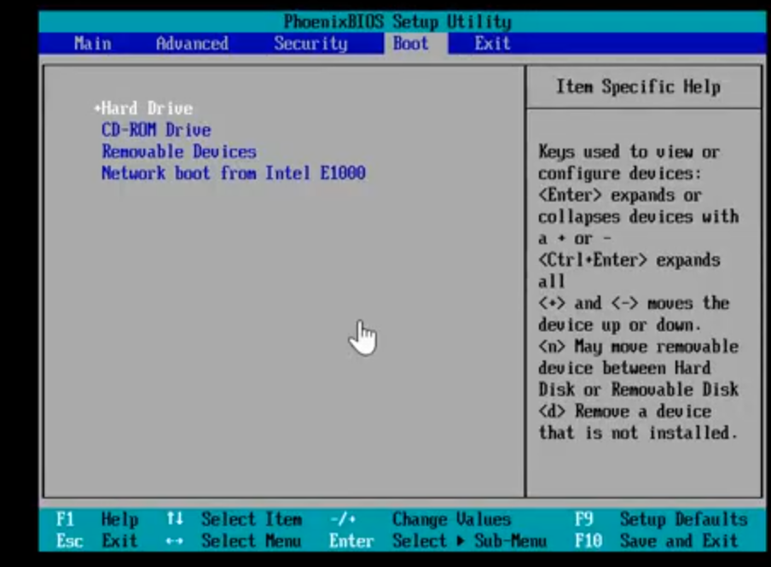
Task: - initramfs file recovery (Kernel pannic error )

Why will this error come? kernel can’t pick up the driver and module from the initramfs file. May be the file is corrupt or file does not exist.

kernel: - Main & rescue.
Driver & module: - Initramfs main, Initramfs rescue & Initramfs kdump
Boot from Kdump mode: - Initramfs kdump (save the reason why the kernel is corrupt)

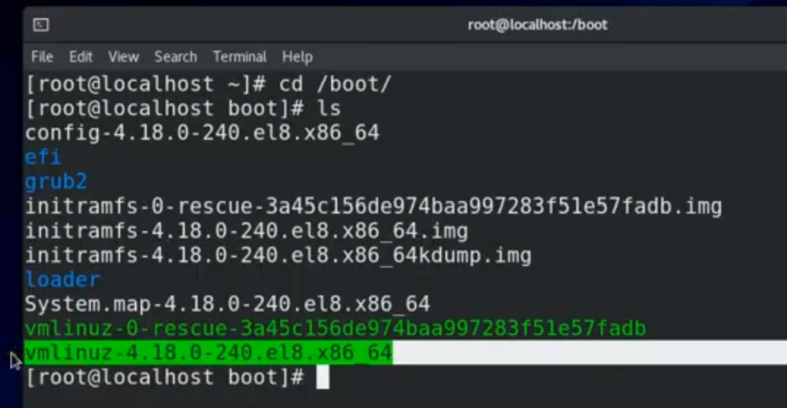

# mkinitrd --force initramfs-4.18.0-240.e18.x86_64.img 4.18.0-240.e18.x86_64 regenerate file
# dracut -v --force initramfs-4.18.0-240.e18.x86_64.img 4.18.0-240.e18.x86_64 regenerate file

In Case of both file corrupt then attached DVD and boot from this.
Press F2 for enter setup, F12 for network boot, Esc for boot menu

Go to the boot
Select CD-ROM Drive (shift & + move up, shift & - move down)
Go to Exit
Select Exit Saving Changes

Select the troubleshooting option and press enter

Select 2nd “rescue a centos linux system”

Enter 1 to continue

Press enters to get a shell
# Chroot /mnt/sysimage
# cd /boot/
# ls
# dracut –regenerate-all --force Get the recovery
# Exit
# Exit
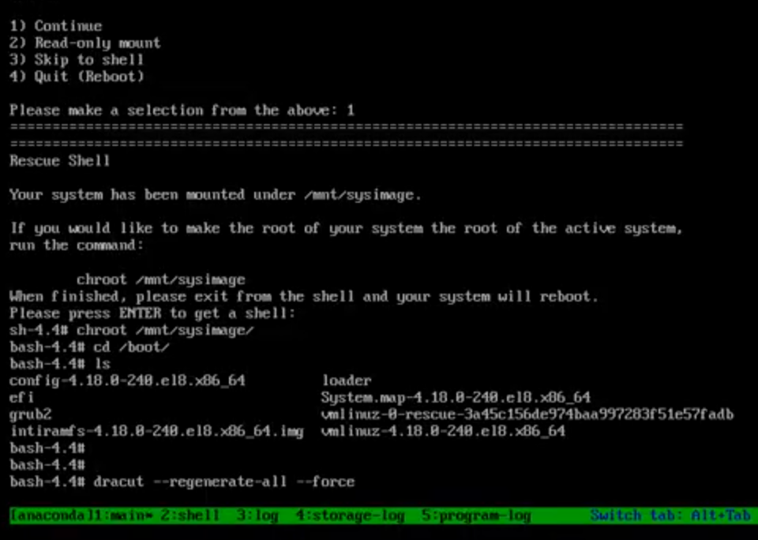

Press F2 for enter setup, F12 for network boot, Esc for boot menu
Go to the boot
Select Hard Drive (shift & + move up, shift & - move down)
Go to Exit
Select Exit Saving Changes

# mkinitrd --force initramfs-0-rescue-3tvsfh35fvszcvffg.fdb.img 4.18.0-240.e18.x86_64 regenerate file
OR
# dracut -v --force initramfs-0-rescue-3tvsfh35fvszcvffg.fdb.img 4.18.0-240.e18.x86_64 regenerate file

Task: - kernel file recovery

Main kernel recovery log in to the server through rescue and install kernel.

Both kernel recovery boot from the CD-ROM
Press F2 for enter setup, F12 for network boot, Esc for boot menu

Go to the boot
Select CD-ROM Drive (shift & + move up, shift & - move down)
Go to Exit
Select Exit Saving Changes

Select the troubleshooting option and press enter

Select 2nd “rescue a centos linux system”

Enter 1 to continue

Press enters to get a shell
# cd /mnt/install
# cd /repo/BaseOS/packages
# ls
# rpm -ivh –root=/mnt/sysimage/ --replacepkgs kernel-core-4.1800.erv33.86_64 --force Get the recovery
# touch /mnt/sysimage/.autorelable
# Exit

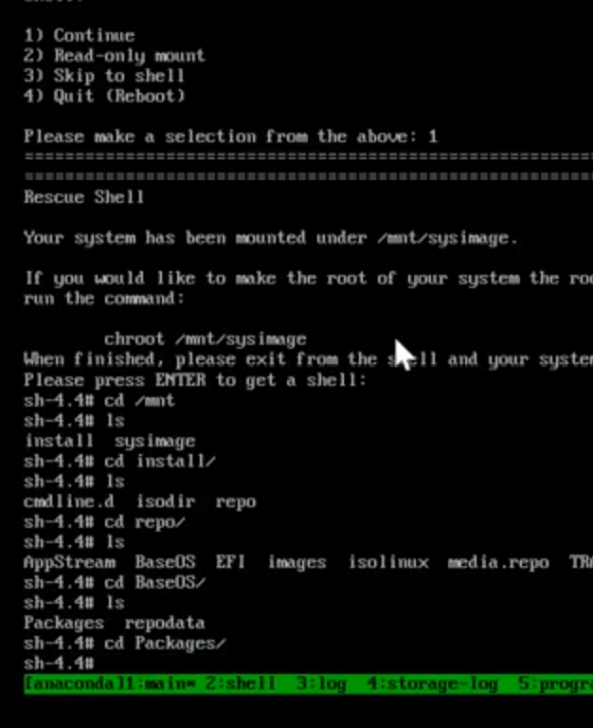

Press F2 for enter setup, F12 for network boot, Esc for boot menu
Go to the boot
Select Hard Drive (shift & + move up, shift & - move down)
Go to Exit
Select Exit Saving Changes

Task: - Change grub time out value

# vi /boot/grub2/grub.cfg but not recommended to change here
# vi /etc/default/grub recommended to change here
# grub2-mkconfig -o /boot/grub2/grub.cfg update grub.cfg file.

Task: - Change by default kernel boot

0,1,2,3, 4...etc.
0 indicate latest kernel version
# grub2-set-default 1 set 1 as default kernel.

