Argo CD – Introduction
-------------------------------------------------------------------------------------------------------------------------------------
Contents
What is Argo CD: 1
Why Argo CD: 1
Argo CD Architecture: 2
Installation: 2
Argo CD Project and Application overview: 2
Demo: 3

-------------------------------------------------------------------------------------------------------------------------------------

What is Argo CD:
- Argo CD is a declarative, GitOps continuous delivery tool for Kubernetes.

Why Argo CD:
- Argo CD improves security in Deployment cycle.
  - As Argo CD components are deployed inside the Kubernetes cluster itself, cluster credentials are stored inside the cluster itself
- State Management [Monitoring after deployment]
  - As Argo CD uses pull mechanism, it compares the desired state (from Repo) with live state of Kubernetes objects at regular intervals. Any deviation between desired and live state is considered OutOfSync.
  - Argo CD will report the status and by manual or auto sync the live state is changed according to desired state
  - In other CD tools like Jenkins, after CD pipeline deploys application to cluster, there is not way of monitoring the application
Argo CD supports Kubernetes manifests as specified below:
- Kustomize applications
- Helm charts
- Jsonnet files
- Plain directory of YAML/json manifests
- Any custom config management tool configured as a config management plugin

Argo CD Architecture:
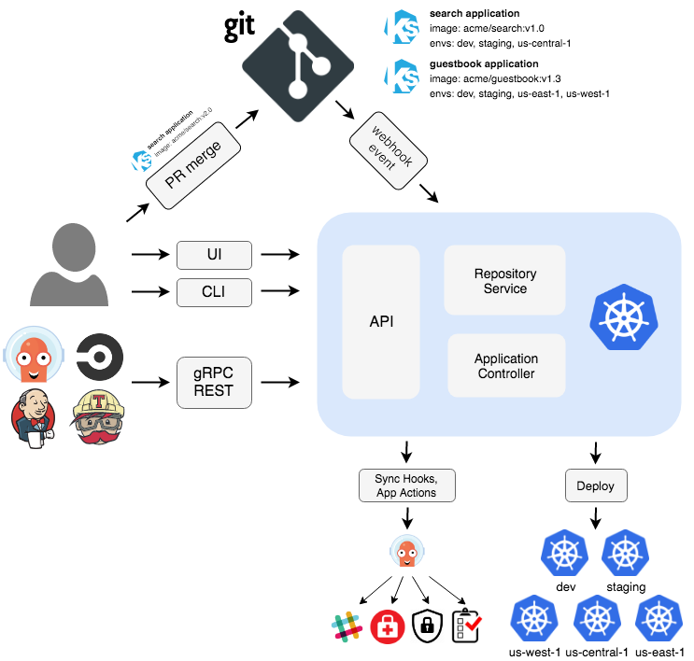

API Server:
API Server expose the API consumed by Web UI, CLI, CI/CD system. It is responsible for all management activities
Repository Server:
Repository Server maintains local cache of Repository holding application manifests
Application Controller:
Application Controller is a Kubernetes Controller which monitory running applications

Installation:
- Pre-Requisites: A Kubernetes cluster should be up and running
- Argo CD can be installed in two ways
  - Multi-Tenant [install.yaml, namespace-install.yaml]
    - Non High Availability
    - High Availability [Recommended for production user]
- Core [This will install only core components that is required for cluster administrators]

Argo CD Project and Application overview:
- Argo CD application and project can be set declaratively. Please find the sample application.yaml and project.yaml

- Argo CD Application: Refers the deployed application in Kubernetes cluster. Application.yaml contains information about application and contains the following fields
  - project – Project in which this application is nested
  - source – Git repository where Kubernetes manifest are maintained
  - destination – This contains information about cluster
- Argo CD Project: Project are used to logically group applications. Project.yaml files contains information related to project and has the following fields
  - sourceRepos – Reference to repo, where application can pull their manifests
  - roles – list of entities with definitions of their access to resources within the project.
  - destination – This contains information about cluster
-------------------------------------------------------------------------------------------------------------------------------------

Demo:
For demo purpose, we deploy nginx and apache to local Kubernetes cluster (minikube). Click here for demo project
Installation:
- As all Argo CD components are deployed in argocd namespace, we need to create argocd namespace
  - kubectl create namespace argocd
- For Argo CD deployment, we use install.yaml file.
  - kubectl apply -n argocd -f https://raw.githubusercontent.com/argoproj/argo-cd/stable/manifests/install.yaml
- Change argocd-server service type to LoadBalancer to serve externally
  - If you are using minikube, after changing the service type to LoadBalancer, use any of the following command to access WebUi
    - minikube tunnel (start new terminal and use this command. Do not close this terminal. WebUI will be served externally until this terminal runs)
    - kubectl port-forward svc/argocd-server -n argocd 8080:443
Adding Argo CD project and application:
- Prepare application and project manifest with required fields
- Using “kubectl apply”, one can create a project and application declaratively in Kubernetes cluster
Adding Repositories:
Repository details are stored in secrets. To configure a repo, create a secret with repository details. Repository secret should contain the following field
- url – Repository url
- type – git or helm [If helm charts are stored in git repository, specify type as git]
- username, password – https authentication
- sshPrivateKey – SSH authentication
- githubAppPrivateKey – GitHub App
Click here to check sample secret file for configuring git repo using various authentication methods
Note: For demo purpose, we are using github public repo. If the repo is public

User Management:
Argo CD comes with default admin user. Admin password will be saved in secrect “argocd-initial-admin-secret” in namespace argocd
There are two ways of adding user to Argo CD application
- Local User
- SSO
Adding Local user:
- To add local user, one need to add user entry in data field of configmap “argocd-cm” in argocd namespace
- Syntax for adding local user “accounts.<local user name>: apiKey, login”. Click here for sample argocd-cm file
- To create password for newly added local user, one need to use argocd binary with the following syntax “argocd account update-password --account <new-username> --new-password <new-password>”
- To update password for local user, use the following command argocd account update-password --account <name> --current-password <current-user-password> --new-password <new-user-password>
SSO:
SSO can be configured using OIDC provider. There are two ways of configuring SSO with Argo CD
- Bundled Dex OIDC provider [Use this option if current provider does not support OIDC]
- Existing OIDC provider
RBAC:
Argo CD has two pre-defined roles
- role:readonly - read-only access to all resources
- role:admin - unrestricted access to all resources
RBAC Permission Structure:
- All resources except applications permissions (see next bullet):
p, <role/user/group>, <resource>, <action>, <object>
- Applications (which belong to an AppProject):
p, <role/user/group>, <resource>, <action>, <appproject>/<object>
RBAC Resource and Actions:
Resources: clusters, projects, applications, repositories, certificates, accounts, gpgkeys
Actions: get, create, update, delete, sync, override, action
Click here for sample rbac file

