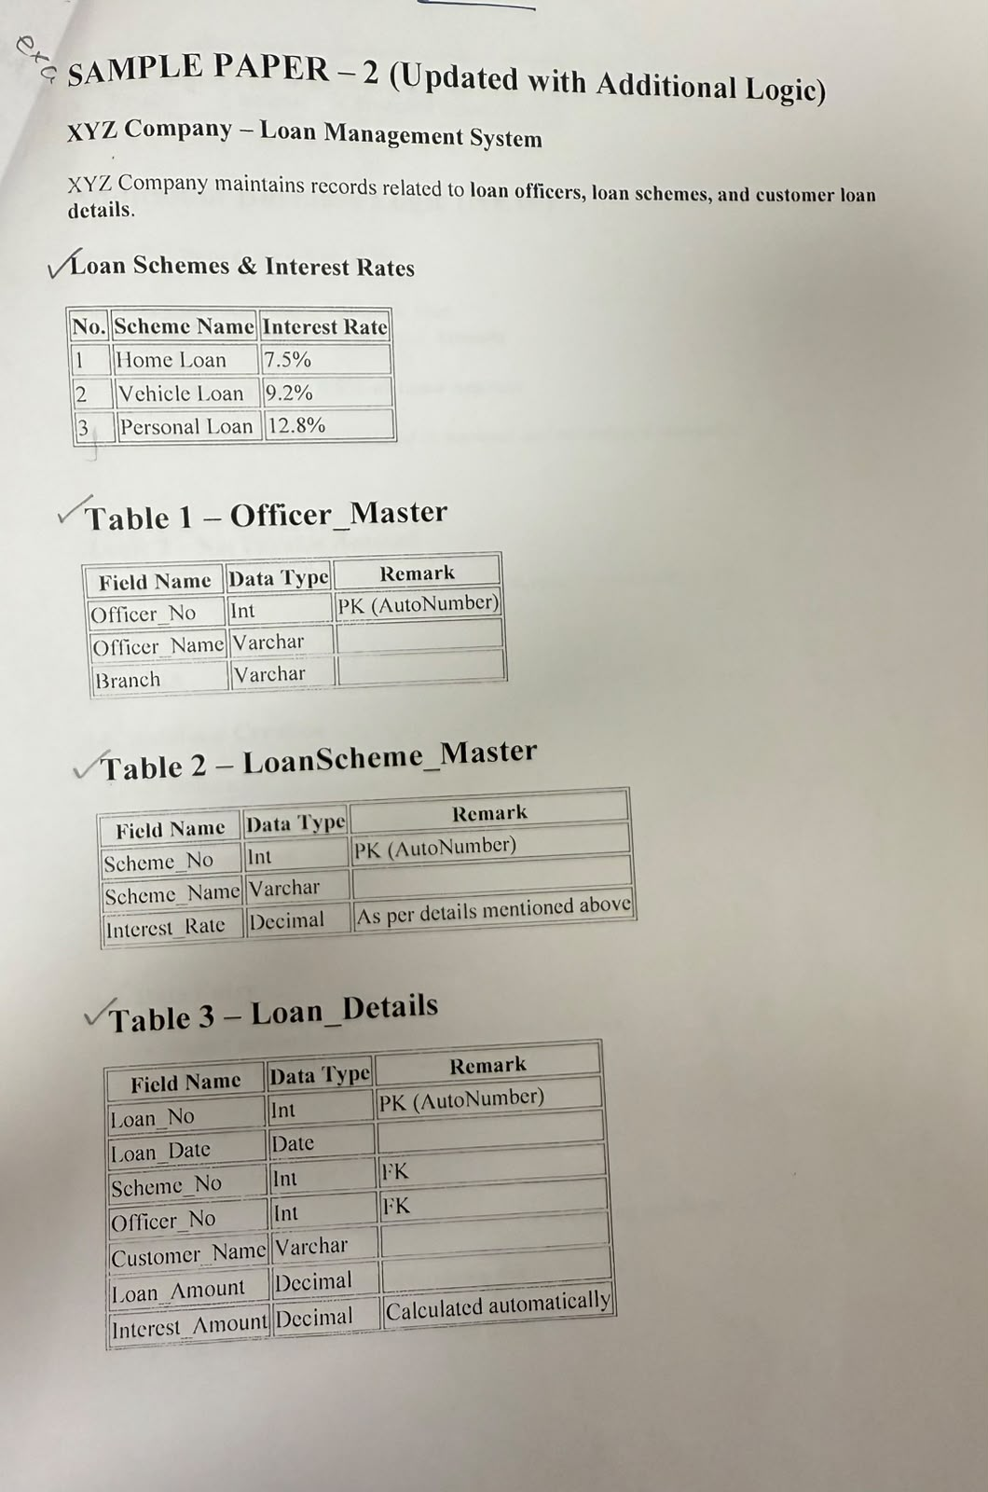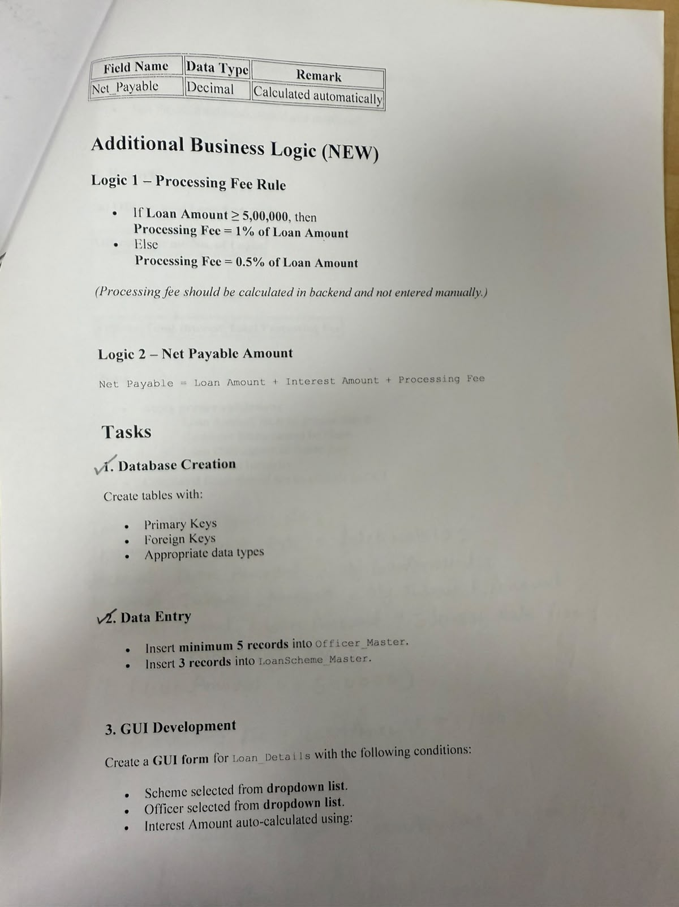
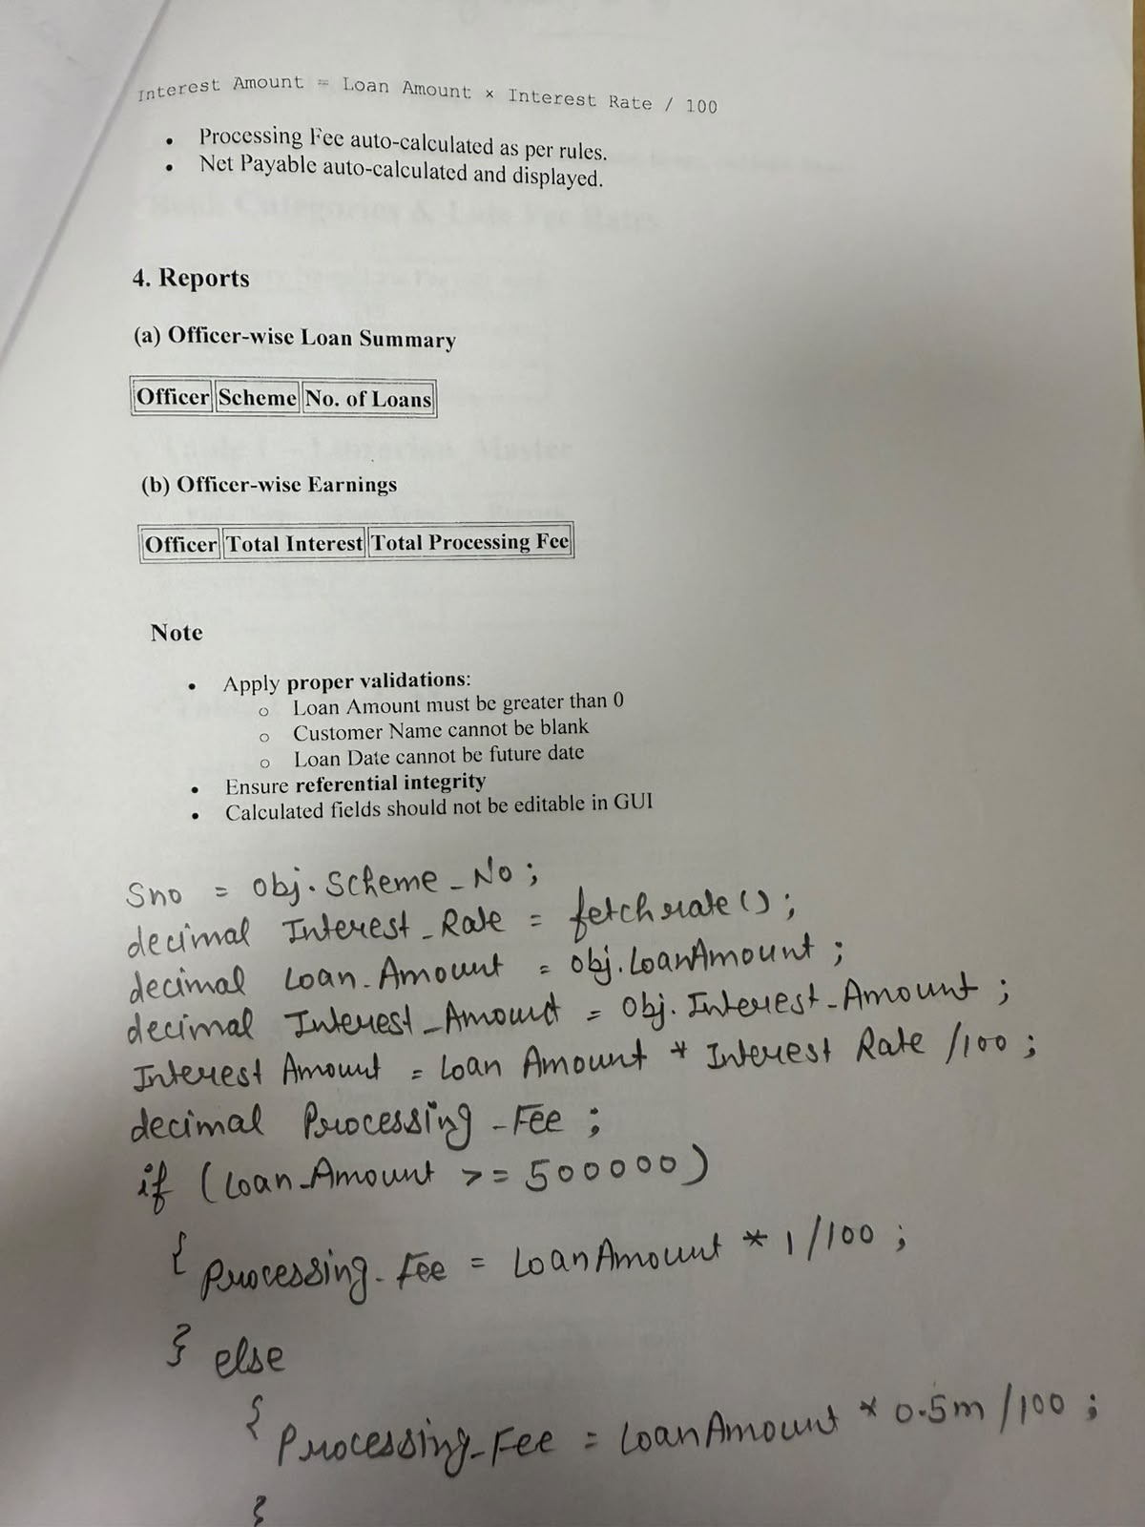
Controller
using Loan.Models;
using Microsoft.Ajax.Utilities;
using System;
using System.Collections.Generic;
using System.Configuration;
using System.Data;
using System.Data.SqlClient;
using System.Linq;
using System.Web;
using System.Web.Mvc;
using System.Web.Services.Description;
using System.Web.UI.WebControls.Expressions;

namespace Loan.Controllers
{
public class HomeController : Controller
{
int sno;
public ActionResult Index()
{
var scheme = getscheme();
var officer = getofficer();
ViewBag.Scheme_No = new SelectList(scheme.AsDataView(), "Scheme_No", "Scheme_Name");
ViewBag.Officer_No = new SelectList(officer.AsDataView(), "Officer_No", "Officer_Name");
return View();
}

[HttpPost]
public ActionResult Index(LoanModel obj)
{
string cnn = ConfigurationManager.ConnectionStrings["cn"].ConnectionString;
SqlConnection con = new SqlConnection(cnn);
sno = obj.Scheme_No;
decimal Loan_Amount = obj.Loan_Amount;
decimal IRate = getinterest();
decimal Interest_Amount = Loan_Amount * IRate / 100;
decimal Processing_Fee;

if(Loan_Amount >=500000)
{
Processing_Fee = Loan_Amount * 1.0m / 100;
}

else
{
Processing_Fee = Loan_Amount * 0.5m / 100;

}

decimal Net_Payable = Loan_Amount + Interest_Amount + Processing_Fee;

string query = "insert into Loan_Details values (@Loan_Date, @Scheme_No, @Officer_No, @Customer_Name, @Loan_Amount, @Interest_Amount, @Net_Payable) ";
SqlCommand cmd = new SqlCommand(query, con);
cmd.Parameters.Add("@Loan_Date", SqlDbType.DateTime).Value = obj.Loan_Date;
cmd.Parameters.Add("@Scheme_No", SqlDbType.Int).Value = obj.Scheme_No;
cmd.Parameters.Add("@Officer_No", SqlDbType.Int).Value = obj.Officer_No;
cmd.Parameters.Add("@Customer_Name", SqlDbType.VarChar).Value = obj.Customer_Name;
cmd.Parameters.Add("@Loan_Amount", SqlDbType.Decimal).Value = obj.Loan_Amount;
cmd.Parameters.Add("@Interest_Amount", SqlDbType.Decimal).Value = Interest_Amount;
cmd.Parameters.Add("@Net_Payable", SqlDbType.Decimal).Value = Net_Payable;
con.Open();
cmd.ExecuteNonQuery();
con.Close();
ViewBag.Message = "Record Saved";
ViewBag.Interest = Interest_Amount;
ViewBag.Processing = Processing_Fee;
ViewBag.NetAmount = Net_Payable;

var scheme = getscheme();
var officer = getofficer();
ViewBag.Scheme_No = new SelectList(scheme.AsDataView(), "Scheme_No", "Scheme_Name");
ViewBag.Officer_No = new SelectList(officer.AsDataView(), "Officer_No", "Officer_Name");
return View();
}

public DataTable getscheme()
{
string cnn = ConfigurationManager.ConnectionStrings["cn"].ConnectionString;
SqlConnection con = new SqlConnection(cnn);
SqlDataAdapter adb = new SqlDataAdapter("Select * from LoanScheme_Master", con);
DataTable dt = new DataTable();
adb.Fill(dt);
return dt;

}

public DataTable getofficer()
{
string cnn = ConfigurationManager.ConnectionStrings["cn"].ConnectionString;
SqlConnection con = new SqlConnection(cnn);
SqlDataAdapter adb = new SqlDataAdapter("Select * from Officer_Master", con);
DataTable dt = new DataTable();
adb.Fill(dt);
return dt;

}

public decimal getinterest()
{
string cnn = ConfigurationManager.ConnectionStrings["cn"].ConnectionString;
SqlConnection con = new SqlConnection(cnn);
string query = "select Interest_Rate from LoanScheme_Master where Scheme_No = '"+sno+"' ";
SqlCommand cmd = new SqlCommand(query, con);
con.Open();
decimal inter = Convert.ToDecimal( cmd.ExecuteScalar());
return inter;

}

public ActionResult report1()
{
string cnn = ConfigurationManager.ConnectionStrings["cn"].ConnectionString;
string query = @"select row_number() over (order by c.Officer_Name) as [Sr. No.], c.Officer_Name as [Officer Name], b.Scheme_Name as [Scheme Name], count( a.Loan_No) as [No. of Loans] from Loan_Details a inner join LoanScheme_Master b on b.Scheme_No = a.Scheme_No inner join Officer_Master c on c.Officer_No = a.Officer_No group by c.Officer_Name, b.Scheme_Name";
SqlDataAdapter adb = new SqlDataAdapter(query, cnn);
DataTable dt = new DataTable();
adb.Fill(dt);

ViewBag.ResultTable = dt;

return View();

}

public ActionResult Report2()
{
string cnn = ConfigurationManager.ConnectionStrings["cn"].ConnectionString;
string query = @"select row_number() over (order by c.Officer_Name) as [Sr. No.], c.Officer_Name as [Officer Name], sum(a.Net_Payable) as[ Net Payable], sum(a.Interest_Amount) as [Interest Amount], sum(a.Net_Payable) - sum(a.Loan_Amount + a.Interest_Amount) as [Processing Fees] from Loan_Details a inner join LoanScheme_Master b on b.Scheme_No = a.Scheme_No inner join Officer_Master c on c.Officer_No=a.Officer_No group by c.Officer_Name, a.Net_Payable, a.Loan_Amount, a.Interest_Amount ";
SqlDataAdapter adb = new SqlDataAdapter(query, cnn);
DataTable dt = new DataTable();

adb.Fill(dt);
ViewBag.ResultTable = dt;

return View();

}

public ActionResult About()
{
ViewBag.Message = "Your application description page.";

return View();
}

public ActionResult Contact()
{
ViewBag.Message = "Your contact page.";

return View();
}
}
}

Index
@model Loan.Models.LoanModel

@using (Html.BeginForm(null, null, FormMethod.Post, new { @class = "col-md-6 col-md-offset-3 well" }))

{
@Html.AntiForgeryToken()
@ViewBag.Message

<div class="form-group">
<h4>LoanModel</h4>
<hr />
@Html.ValidationSummary(true, "", new { @class = "text-danger" })
<div class="form-group">
@Html.LabelFor(model => model.Loan_Date, htmlAttributes: new { @class = "control-label col-md-2" })
<div class="col-md-10">
@Html.EditorFor(model => model.Loan_Date, new { htmlAttributes = new { @class = "form-control", type = "Date" } })
@Html.ValidationMessageFor(model => model.Loan_Date, "", new { @class = "text-danger" })
</div>
</div>

<div class="form-group">
@Html.LabelFor(model => model.Scheme_No, htmlAttributes: new { @class = "control-label col-md-2" })
<div class="col-md-10">
@Html.DropDownListFor(model => model.Scheme_No, (SelectList)ViewBag.Scheme_No, "---Select Scheme Name---", new { @class = "form-control" })
@Html.ValidationMessageFor(model => model.Scheme_No, "", new { @class = "text-danger" })
</div>
</div>

<div class="form-group">
@Html.LabelFor(model => model.Officer_No, htmlAttributes: new { @class = "control-label col-md-2" })
<div class="col-md-10">
@Html.DropDownListFor(model => model.Officer_No, (SelectList)ViewBag.Officer_No, "---Select Officer Name---", new { @class = "form-control" })
@Html.ValidationMessageFor(model => model.Officer_No, "", new { @class = "text-danger" })
</div>
</div>

<div class="form-group">
@Html.LabelFor(model => model.Customer_Name, htmlAttributes: new { @class = "control-label col-md-2" })
<div class="col-md-10">
@Html.EditorFor(model => model.Customer_Name, new { htmlAttributes = new { @class = "form-control" } })
@Html.ValidationMessageFor(model => model.Customer_Name, "", new { @class = "text-danger" })
</div>
</div>

<div class="form-group">
@Html.LabelFor(model => model.Loan_Amount, htmlAttributes: new { @class = "control-label col-md-2" })
<div class="col-md-10">
@Html.EditorFor(model => model.Loan_Amount, new { htmlAttributes = new { @class = "form-control" } })
@Html.ValidationMessageFor(model => model.Loan_Amount, "", new { @class = "text-danger" })
</div>
</div>

<div class="form-group">
<div class="col-md-offset-2 col-md-10">
<input type="submit" value="Save" class="btn btn-success" />
</div>
</div>
</div>
}

<p>The Interest is : Rs.@ViewBag.Interest</p>
<p>The Processing Fees is : Rs.@ViewBag.Processing</p>
<p>The Net Amount is: Rs.@ViewBag.NetAmount</p>

<div>
@Html.ActionLink("Back to List", "Index")
</div>

@section Scripts {
@Scripts.Render("~/bundles/jqueryval")
}

Report 1
@{
var dt = ViewBag.ResultTable as System.Data.DataTable;
}

<table class="table table-bordered table-striped table-hover text-center">
<tr>
<th>Sr. No.</th>
<th>Officer Name</th>
<th>Scheme Name</th>
<th>No. of Loans</th>

</tr>

@if(dt!=null)
{
foreach (System.Data.DataRow row in dt.Rows)
{
<tr>
<td>@row["Sr. No."]</td>
<td>@row["Officer Name"]</td>
<td>@row["Scheme Name"]</td>
<td>@row["No. of Loans"]</td>

</tr>

}
}

</table>

Report 2
@{

var dt = ViewBag.ResultTable as System.Data.DataTable;
}

<table class="table table-bordered table-striped table-hover text-center">

<tr>
<th>Sr. No.</th>
<th>Officer Name</th>
<th>Net Payable</th>
<th>Interest Amount</th>
<th>Processing Fees</th>

</tr>

@{
if (dt != null)
{

foreach (System.Data.DataRow row in dt.Rows)
{
<tr>
<td>@row["Sr. No."]</td>
<td>@row["Officer Name"]</td>
<td>@row[" Net Payable"]</td>
<td>@row["Interest Amount"]</td>
<td>@row["Processing Fees"]</td>

</tr>

}

}
}

</table>

using System;
using System.Collections.Generic;
using System.Linq;
using System.Web;

namespace Loan.Models
{
public class LoanModel
{
public DateTime Loan_Date { get; set; }
public int Scheme_No { get; set; }
public int Officer_No { get; set; }
public string Customer_Name { get; set; }
public decimal Loan_Amount { get; set; }
public decimal Interest_Amount { get; set; }
public decimal Net_Payable { get; set; }
}
}

Model
using System;
using System.Collections.Generic;
using System.Linq;
using System.Web;

namespace Loan.Models
{
public class LoanModel
{
public DateTime Loan_Date { get; set; }
public int Scheme_No { get; set; }
public int Officer_No { get; set; }
public string Customer_Name { get; set; }
public decimal Loan_Amount { get; set; }
public decimal Interest_Amount { get; set; }
public decimal Net_Payable { get; set; }
}
}

