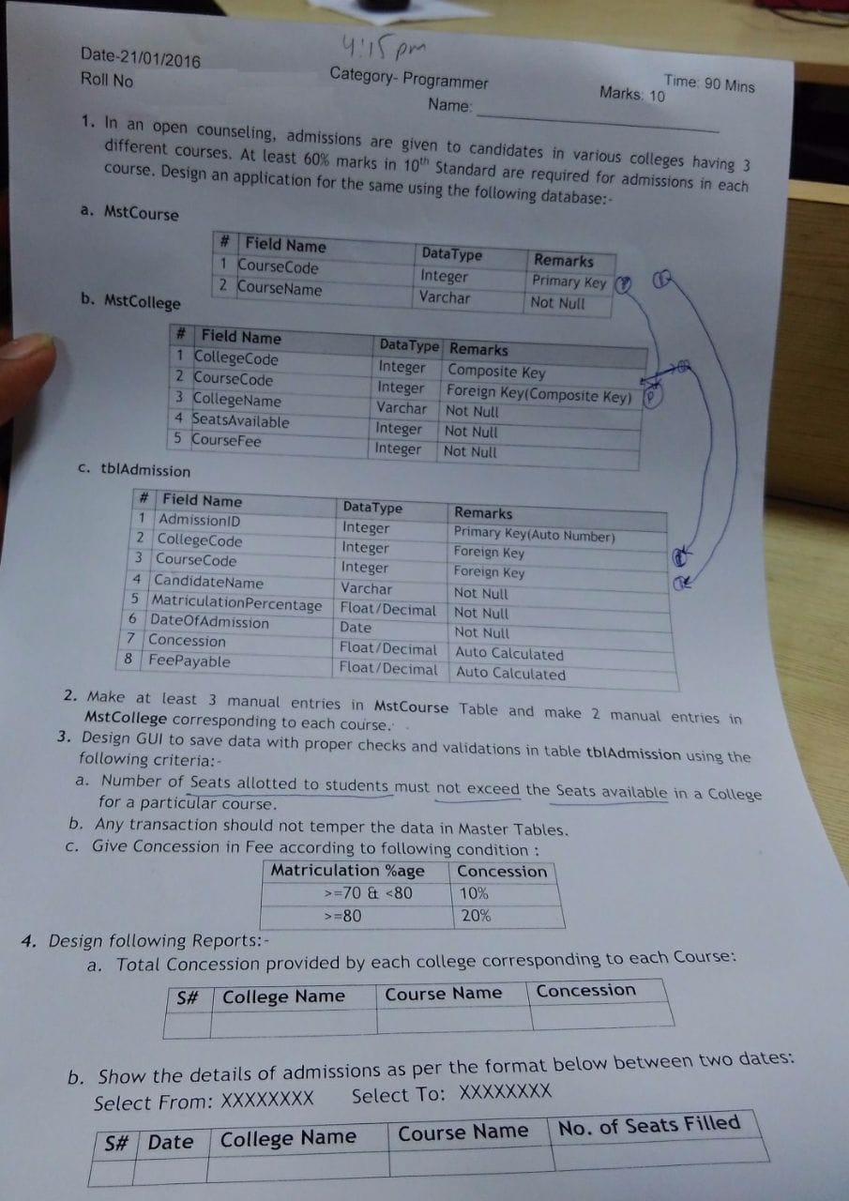
Model
using System;
using System.Collections.Generic;
using System.ComponentModel.DataAnnotations;
using System.Linq;
using System.Web;

namespace College.Models
{
public class CollegeModel
{
[Display(Name = "College Name")]
public int CollegeCode { get; set; }

[Display(Name = "Course Name")]
public int CourseCode { get; set; }

[Display(Name = "Candidate Name")]
public string CandidateName { get; set; }

[Display(Name = "Matriculation Percentage")]
public decimal MatriculationPercentage { get; set; }

[Display(Name = "Date of Admission")]
public DateTime DateOfAdmission { get; set; }

[Display(Name = "Concession")]
public decimal Concession { get; set; }

[Display(Name = "Fee Payable")]
public decimal FeePayable { get; set; }

}
}

Home Controller
using College.Models;
using System;
using System.Collections.Generic;
using System.Configuration;
using System.Data;
using System.Data.SqlClient;
using System.Linq;
using System.Web;
using System.Web.Mvc;

namespace College.Controllers
{
public class HomeController : Controller
{
decimal Conc;
int sno;
public ActionResult Index()
{
var course = getcourse();
ViewBag.course = new SelectList(course.AsDataView(), "CourseCode", "CourseName");

ViewBag.college = new SelectList(new DataTable().AsDataView(), "CollegeCode", "CollegeName");

return View();
}

[HttpPost]
public ActionResult Index(CollegeModel obj)
{
string cnn = ConfigurationManager.ConnectionStrings["cn"].ConnectionString;
SqlConnection con = new SqlConnection(cnn);
sno = obj.CollegeCode;
int Course_Fee = gettotalfees(obj.CourseCode);
int SeatsAvailable = Convert.ToInt32(getseatsavailable(obj.CourseCode));
int Total_Seats_Booked = seatsbooked(obj.CourseCode);

decimal Percentage = obj.MatriculationPercentage;
decimal FeePayable;

if(Percentage >-0 && Percentage <70)
{
Conc = 0;
}

else if (Percentage >= 70 && Percentage < 80)
{
Conc = 10;
}

else if (Percentage >= 80)
{
Conc = 20;
}

decimal Concession = (Course_Fee * Conc) / 100;

FeePayable = Course_Fee - Concession;

if (SeatsAvailable > Total_Seats_Booked)
{
string query = "insert into tblAdmission values (@CollegeCode, @CourseCode, @CandidateName, @MatriculationPercentage, @DateOfAdmission, @Concession, @FeePayable)";
SqlCommand cmd = new SqlCommand(query, con);
cmd.Parameters.Add("@CollegeCode", SqlDbType.Int).Value = obj.CollegeCode;
cmd.Parameters.Add("@CourseCode", SqlDbType.Int).Value = obj.CourseCode;
cmd.Parameters.Add("@CandidateName", SqlDbType.VarChar).Value = obj.CandidateName;
cmd.Parameters.Add("@MatriculationPercentage", SqlDbType.Decimal).Value = obj.MatriculationPercentage;
cmd.Parameters.Add("@DateOfAdmission", SqlDbType.DateTime).Value = obj.DateOfAdmission;
cmd.Parameters.Add("@Concession", SqlDbType.Decimal).Value = Concession;
cmd.Parameters.Add("@FeePayable", SqlDbType.Decimal).Value = FeePayable;
con.Open();
cmd.ExecuteNonQuery();
con.Close();
ViewBag.Message = "Record Saved Successfully";
ViewBag.concession = Concession;
ViewBag.fee = FeePayable;
}
else
{
ViewBag.Message = "All Seats have been Fullfilled";
}

var course = getcourse();
var college = getcollege(obj.CourseCode);
ViewBag.course = new SelectList(course.AsDataView(), "CourseCode", "CourseName");

ViewBag.college = new SelectList(college.AsDataView(), "CollegeCode", "CollegeName");

return View();
}

public DataTable getcourse()
{
string cnn = ConfigurationManager.ConnectionStrings["cn"].ConnectionString;
using (SqlConnection con = new SqlConnection(cnn))
{
SqlDataAdapter adb = new SqlDataAdapter("Select * from MstCourse", con);
DataTable dt = new DataTable();
adb.Fill(dt);
return dt;
}
}

public JsonResult Get_College(int collegeId)
{
DataTable dt = getcollege(collegeId);

var college = dt.AsEnumerable()
.Select(r => new
{
CollegeCode = r["CollegeCode"],
CollegeName = r["CollegeName"].ToString()
});

return Json(college, JsonRequestBehavior.AllowGet);
}

public DataTable getcollege(int courseId)
{
string cnn = ConfigurationManager.ConnectionStrings["cn"].ConnectionString;
using (SqlConnection con = new SqlConnection(cnn))
using (SqlCommand cmd = new SqlCommand("Select CollegeCode, CollegeName from MstCollege where CourseCode = @cid", con))
{
cmd.Parameters.Add("@cid", SqlDbType.Int).Value = courseId;
SqlDataAdapter adb = new SqlDataAdapter(cmd);
DataTable dt = new DataTable();
adb.Fill(dt);
return dt;
}
}

public int gettotalfees(int feeid)
{
string cnn = ConfigurationManager.ConnectionStrings["cn"].ConnectionString;
SqlConnection con = new SqlConnection(cnn);
string query = "select CourseFee from MstCollege where CourseCode = @CourseCode";
SqlCommand cmd = new SqlCommand(query, con);
cmd.Parameters.Add("@CourseCode", SqlDbType.Int).Value = feeid;

con.Open();
int get_fee = Convert.ToInt32(cmd.ExecuteScalar());
con.Close();
return get_fee;
}

public decimal getseatsavailable(int seatid)
{
string cnn = ConfigurationManager.ConnectionStrings["cn"].ConnectionString;
SqlConnection con = new SqlConnection(cnn);
string query = "select SeatsAvailable from MstCollege where CourseCode = @CourseCode and CollegeCode = @CollegeCode";
SqlCommand cmd = new SqlCommand(query, con);
cmd.Parameters.Add("@CourseCode", SqlDbType.Int).Value = seatid;
cmd.Parameters.Add("@CollegeCode", SqlDbType.Int).Value = sno;

con.Open();
decimal get_s = Convert.ToDecimal(cmd.ExecuteScalar());
con.Close();
return get_s;
}

public int seatsbooked(int sId)
{
int seat_booked = 0;
string cnn = ConfigurationManager.ConnectionStrings["cn"].ConnectionString;
SqlConnection con = new SqlConnection(cnn);
string query = "select count(AdmissionID) from tblAdmission where CourseCode = @CourseCode and CollegeCode = @CollegeCode";
SqlCommand cmd = new SqlCommand(query, con);
cmd.Parameters.Add("@CourseCode", SqlDbType.Int).Value = sId;
cmd.Parameters.Add("@CollegeCode", SqlDbType.Int).Value = sno;
con.Open();
object test = cmd.ExecuteScalar();
con.Close();
if (test != null && test != DBNull.Value)
{
seat_booked = Convert.ToInt32(test);
}
return seat_booked;
}

public ActionResult report1()
{
string cnn = ConfigurationManager.ConnectionStrings["cn"].ConnectionString;
string query = @"select row_number() over (order by col.CollegeName) as [Sr. No.], col.CollegeName as [College Name], cor.CourseName as [Course Name], sum(ad.Concession) as [Concession] from tblAdmission ad inner join MstCourse cor on cor.CourseCode = ad.CourseCode inner join MstCollege col on col.CollegeCode = ad.CollegeCode group by col.CollegeName, cor.CourseName";
SqlDataAdapter adb = new SqlDataAdapter(query, cnn);
DataTable dt = new DataTable();
adb.Fill(dt);

ViewBag.ResultTable = dt;

return View();
}

public ActionResult Report2()
{

return View();

}

[HttpPost]
public ActionResult Report2(Report2 obj)
{
DateTime date1 = obj.date1;
DateTime date2 = obj.date2;

string cnn = ConfigurationManager.ConnectionStrings["cn"].ConnectionString;
string query = @"select row_number() over (order by ad.DateOfAdmission) as [Sr. No.], ad.DateOfAdmission as [Date of Admission], col.CollegeName as [College Name], cor.CourseName as [Course Name], count(ad.AdmissionID) as [Number of Admissions] from tblAdmission ad inner join MstCourse cor on cor.CourseCode = ad.CourseCode inner join MstCollege col on col.CollegeCode = ad.CollegeCode where ad.DateOfAdmission between @date1 and @date2 group by ad.DateOfAdmission, col.CollegeName, cor.CourseName";
SqlDataAdapter adb = new SqlDataAdapter(query, cnn);
adb.SelectCommand.Parameters.Add("@date1", SqlDbType.DateTime).Value = date1;
adb.SelectCommand.Parameters.Add("@date2", SqlDbType.DateTime).Value = date2;
DataTable dt = new DataTable();
adb.Fill(dt);
ViewBag.ResultTable = dt;

return View();

}

public ActionResult About()
{
ViewBag.Message = "Your application description page.";

return View();
}

public ActionResult Contact()
{
ViewBag.Message = "Your contact page.";

return View();
}
}
}

Index
@model College.Models.CollegeModel

@{
ViewBag.Title = "Index";
}

<h2>Index</h2>

@using (Html.BeginForm())
{
@Html.AntiForgeryToken()

<div class="form-horizontal">
<h4>CollegeModel</h4>
<hr />
@Html.ValidationSummary(true, "", new { @class = "text-danger" })

<div class="form-group">
@Html.LabelFor(model => model.CourseCode, htmlAttributes: new { @class = "control-label col-md-2" })
<div class="col-md-10">
@Html.DropDownListFor(model => model.CourseCode, (SelectList)ViewBag.course, "---Select Course---", new { @class = "form-control" })
@Html.ValidationMessageFor(model => model.CourseCode, "", new { @class = "text-danger" })
</div>
</div>
<div class="form-group">
@Html.LabelFor(model => model.CollegeCode, htmlAttributes: new { @class = "control-label col-md-2" })
<div class="col-md-10">
@Html.DropDownListFor(model => model.CollegeCode, (SelectList)ViewBag.college, "---Select College---", new { @class = "form-control", Id = "CollegeCode" })
@Html.ValidationMessageFor(model => model.CollegeCode, "", new { @class = "text-danger" })
</div>
</div>
<div class="form-group">
@Html.LabelFor(model => model.CandidateName, htmlAttributes: new { @class = "control-label col-md-2" })
<div class="col-md-10">
@Html.EditorFor(model => model.CandidateName, new { htmlAttributes = new { @class = "form-control" } })
@Html.ValidationMessageFor(model => model.CandidateName, "", new { @class = "text-danger" })
</div>
</div>

<div class="form-group">
@Html.LabelFor(model => model.MatriculationPercentage, htmlAttributes: new { @class = "control-label col-md-2" })
<div class="col-md-10">
@Html.EditorFor(model => model.MatriculationPercentage, new { htmlAttributes = new { @class = "form-control" } })
@Html.ValidationMessageFor(model => model.MatriculationPercentage, "", new { @class = "text-danger" })
</div>
</div>

<div class="form-group">
@Html.LabelFor(model => model.DateOfAdmission, htmlAttributes: new { @class = "control-label col-md-2" })
<div class="col-md-10">
@Html.EditorFor(model => model.DateOfAdmission, new { htmlAttributes = new { @class = "form-control", type = "Date" } })
@Html.ValidationMessageFor(model => model.DateOfAdmission, "", new { @class = "text-danger" })
</div>
</div>

<br />

<div class="form-group">
<div class="col-md-offset-2 col-md-10">
<input type="submit" value="Save Record" class="btn btn-success" />
</div>
</div>
</div>
}
<br />

@ViewBag.Message
<br />
The Consession is : @ViewBag.concession
<br />
Total Payable Amount is : @ViewBag.fee
<div>
@Html.ActionLink("Back to List", "Index")
</div>

@section Scripts {
@Scripts.Render("~/bundles/jqueryval")

<script>
$(function () {
$('#CourseCode').change(function () {
var cour_id = $(this).val();
var coldd = $('#CollegeCode')

coldd.empty().append($('<option>', { value: '', text: '---Select College---' }));
if (cour_id) {
$.getJSON('@Url.Action("Get_College", "Home")', { collegeId: cour_id }, function (data) {
$.each(data, function (i, item) {
coldd.append($('<option>', { value: item.CollegeCode, text: item.CollegeName }));
});
});
}
});
});
</script>

}

Report 1
@{
var dt = ViewBag.ResultTable as System.Data.DataTable;
}

<table class="table table-bordered table-striped table-hover text-center">
<tr>
<th>Sr. No.</th>
<th>College Name</th>
<th>Course Name</th>
<th>Concession</th>

</tr>

@if (dt != null)
{
foreach (System.Data.DataRow row in dt.Rows)
{
<tr>
<td>@row["Sr. No."]</td>
<td>@row["College Name"]</td>
<td>@row["Course Name"]</td>
<td>@row["Concession"]</td>

</tr>

}
}

</table>

Report 2 Model
using System;
using System.Collections.Generic;
using System.ComponentModel.DataAnnotations;
using System.Linq;
using System.Web;

namespace College.Models
{
public class Report2
{
[Display(Name = "From Date")]
public DateTime date1 { get; set; }

[Display(Name = "To Date")]
public DateTime date2 { get; set; }

}
}

Report 2 View
@model College.Models.Report2

@using (Html.BeginForm())
{
@Html.AntiForgeryToken()

<div class="form-horizontal">
<h4>Report2</h4>
<hr />
@Html.ValidationSummary(true, "", new { @class = "text-danger" })
<div class="form-group">
@Html.LabelFor(model => model.date1, htmlAttributes: new { @class = "control-label col-md-2" })
<div class="col-md-10">
@Html.EditorFor(model => model.date1, new { htmlAttributes = new { @class = "form-control", type = "Date" } })
@Html.ValidationMessageFor(model => model.date1, "", new { @class = "text-danger" })
</div>
</div>

<div class="form-group">
@Html.LabelFor(model => model.date2, htmlAttributes: new { @class = "control-label col-md-2" })
<div class="col-md-10">
@Html.EditorFor(model => model.date2, new { htmlAttributes = new { @class = "form-control", Type = "Date" } })
@Html.ValidationMessageFor(model => model.date2, "", new { @class = "text-danger" })
</div>
</div>

<div class="form-group">
<div class="col-md-offset-2 col-md-10">
<input type="submit" value="Generate Report" class="btn btn-success" />
</div>
</div>
</div>
}

@{
var dt = ViewBag.ResultTable as System.Data.DataTable;

}

<table class="table table-bordered table-striped table-hover text-center">
<tr>
<th>Sr. No.</th>
<th>Date of Admission</th>
<th>College Name</th>
<th>Course Name</th>
<th>Number of Admissions</th>

</tr>

@if (dt != null)
{
foreach (System.Data.DataRow row in dt.Rows)

{
<tr>
<td>@row["Sr. No."]</td>

<td>@row["Date of Admission"]</td>

<td>@row["College Name"]</td>

<td>@row["Course Name"]</td>

<td>@row["Number of Admissions"]</td>

</tr>
}

}

</table>>

<div>
@Html.ActionLink("Back to List", "Index")
</div>

<div>
@Html.ActionLink("Back to List", "Index")
</div>

