**Practical 1**

**Name : Kapil Gattani**

**Batch : A3**

**Roll No : 44**

**1 Code :**

%{

#include <stdio.h>

int keywordCount = 0;

int identifierCount = 0;

int operatorCount = 0;

int symbolCount = 0;

int numberCount = 0;

int stringCount = 0;

%}

%%

int|float|char|double|void|if|else|while|for|return|break|continue|switch|case|default|sizeof|typedef|struct|union|enum|const { keywordCount++; }

[a-zA-Z_][a-zA-Z0-9_]* { identifierCount++; }

[+\-*/=<>!%&|^~] { operatorCount++; }

[;:.,(){}[\]#$] { symbolCount++; }

[0-9]+(\.[0-9]+)? { numberCount++; }

\"(\\.|[^\"])*\" { stringCount++; }

[ \t\n] ; // Skip whitespace and newline

. { printf("Unknown Token: %s\n", yytext); }

%%

int main() {

FILE *file = fopen("practical_1.txt", "r");

if (!file) {

fprintf(stderr, "Error opening file\n");

return 1;

}

yyin = file;

yylex();

fclose(file);

printf("\nTotal Counts:\n");

printf("Keywords: %d\n", keywordCount);

printf("Identifiers: %d\n", identifierCount);

printf("Operators: %d\n", operatorCount);

printf("Symbols: %d\n", symbolCount);

printf("Numbers: %d\n", numberCount);

printf("Strings: %d\n", stringCount);

return 0;

}

int yywrap() {

return 1;

}

**Output :** 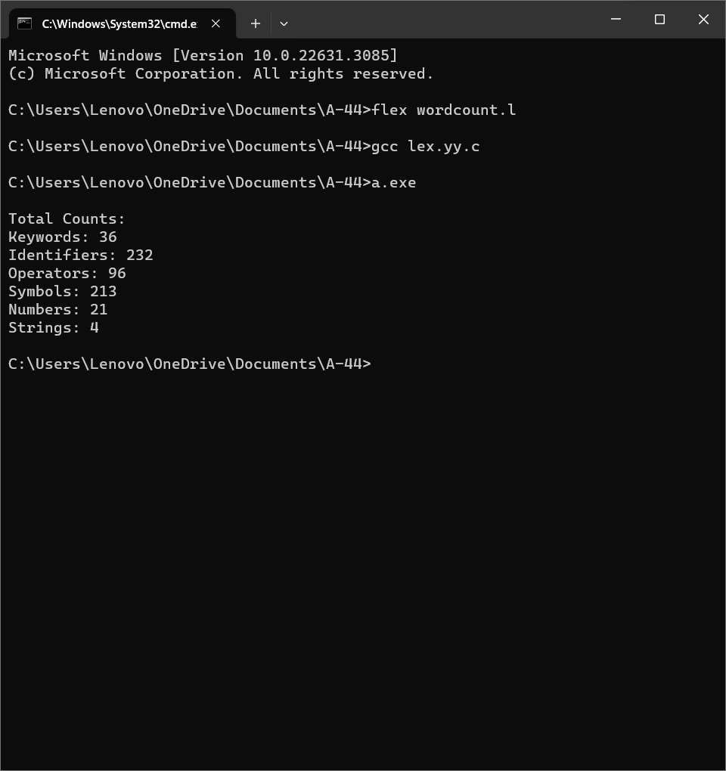

**2 Code :**

%{

#include <stdio.h>

int wordCount = 0,

lineCount = 0,

smallLetterCount = 0,

capitalLetterCount = 0,

digitCount = 0,

specialCharCount = 0;

%}

%%

[0-9]+"/"[0-9]+"/"[0-9]+ { printf("Date of Examination: %s\n", yytext); }

"Sem:"[I|II|III|IV|V|VI|VII|VIII]+ { printf("Semester: %s\n", yytext); }

Question[0-9]+ { wordCount += yyleng; lineCount++; }

[a-z] { smallLetterCount++; }

[A-Z] { capitalLetterCount++; }

[0-9] { digitCount++; }

[^a-zA-Z0-9\n] { specialCharCount++; }

%%

int main(){

FILE *file = fopen("exam_paper.txt", "r");

yyin = file;

yylex();

fclose(file);

printf("Number of Questions: %d\n", lineCount);

printf("Number of Words: %d\n", wordCount);

printf("Number of Lines: %d\n", lineCount);

printf("Number of Small Letters: %d\n", smallLetterCount);

printf("Number of Capital Letters: %d\n", capitalLetterCount);

printf("Number of Digits: %d\n", digitCount);

printf("Number of Special Characters: %d\n", specialCharCount);

return 0;

}

int yywrap(){

return(1);

}

**Output :** 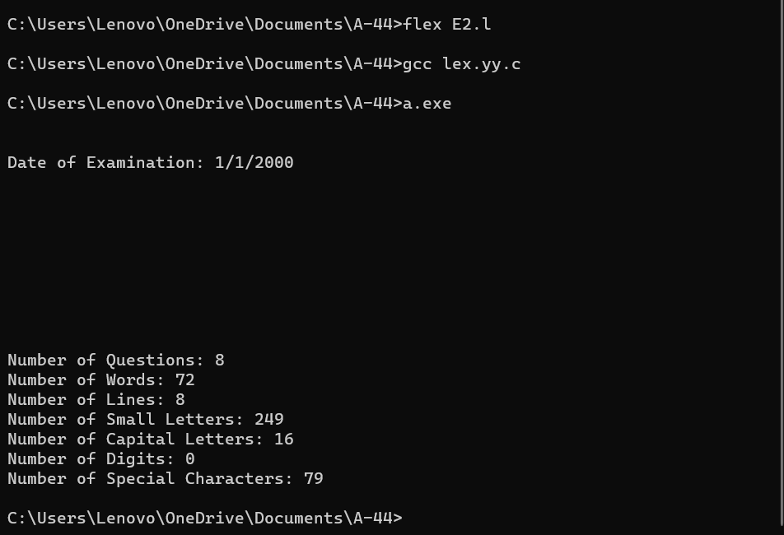

**3 Code :**

%{

#include <stdio.h>

%}

%{

int studentCount = 0;

int tcsCount = 0, infosysCount = 0, wiproCount = 0, accentureCount = 0, informaticaCount = 0;

int femaleCount = 0, maleCount = 0;

int cseCount = 0, itCount = 0, ecCount = 0;

%}

%%

[^\n]*\n {

char name[50], company[20], gender[10], department[5], email[50];

float cgpa, package;

long long int mobile;

sscanf(yytext, "%[^,], %[^,], %[^,], %f, %[^,], %f, %[^,], %lld", name, company, gender, &cgpa, department, &package, email, &mobile);

printf("Name: %s\n", name);

printf("companyname: %s\n", company);

printf("gender: %s\n", gender);

if (cgpa < 10)

printf("CGPA: %.2f\n", cgpa);

else

printf("Invalid CGPA: %.2f\n", cgpa);

printf("Package: %.2f\n", package);

printf("Mail ID: %s\n", email);

printf("Mobile Number: %lld\n", mobile);

if (strcmp(company, "TCS") == 0)

tcsCount++;

else if (strcmp(company, "Infosys") == 0)

infosysCount++;

else if (strcmp(company, "Wipro") == 0)

wiproCount++;

else if (strcmp(company, "Accenture") == 0)

accentureCount++;

else if (strcmp(company, "Informatica") == 0)

informaticaCount++;

// Count female and male students

if (strcmp(gender, "Female") == 0)

femaleCount++;

else if (strcmp(gender, "Male") == 0)

maleCount++;

// Count students in each department

if (strcmp(department, "CSE") == 0)

cseCount++;

else if (strcmp(department, "IT") == 0)

itCount++;

else if (strcmp(department, "EC") == 0)

ecCount++;

studentCount++;

}

%%

int main() {

yyin = fopen("E3.txt", "r");

if (!yyin) {

perror("Error opening file");

return 1;

}

yylex();

printf("\nStatistics:\n");

printf("Total Students: %d\n", studentCount);

printf("Students placed in TCS: %d\n", tcsCount);

printf("Students placed in Infosys: %d\n", infosysCount);

printf("Students placed in Wipro: %d\n", wiproCount);

printf("Students placed in Accenture: %d\n", accentureCount);

printf("Students placed in Informatica: %d\n", informaticaCount);

printf("Female Students: %d\n", femaleCount);

printf("Male Students: %d\n", maleCount);

printf("CSE Students placed: %d\n", cseCount);

printf("IT Students placed: %d\n", itCount);

printf("EC Students placed: %d\n", ecCount);

fclose(yyin);

return 0;

}

int yywrap() {

return 1;

}

**Output :** 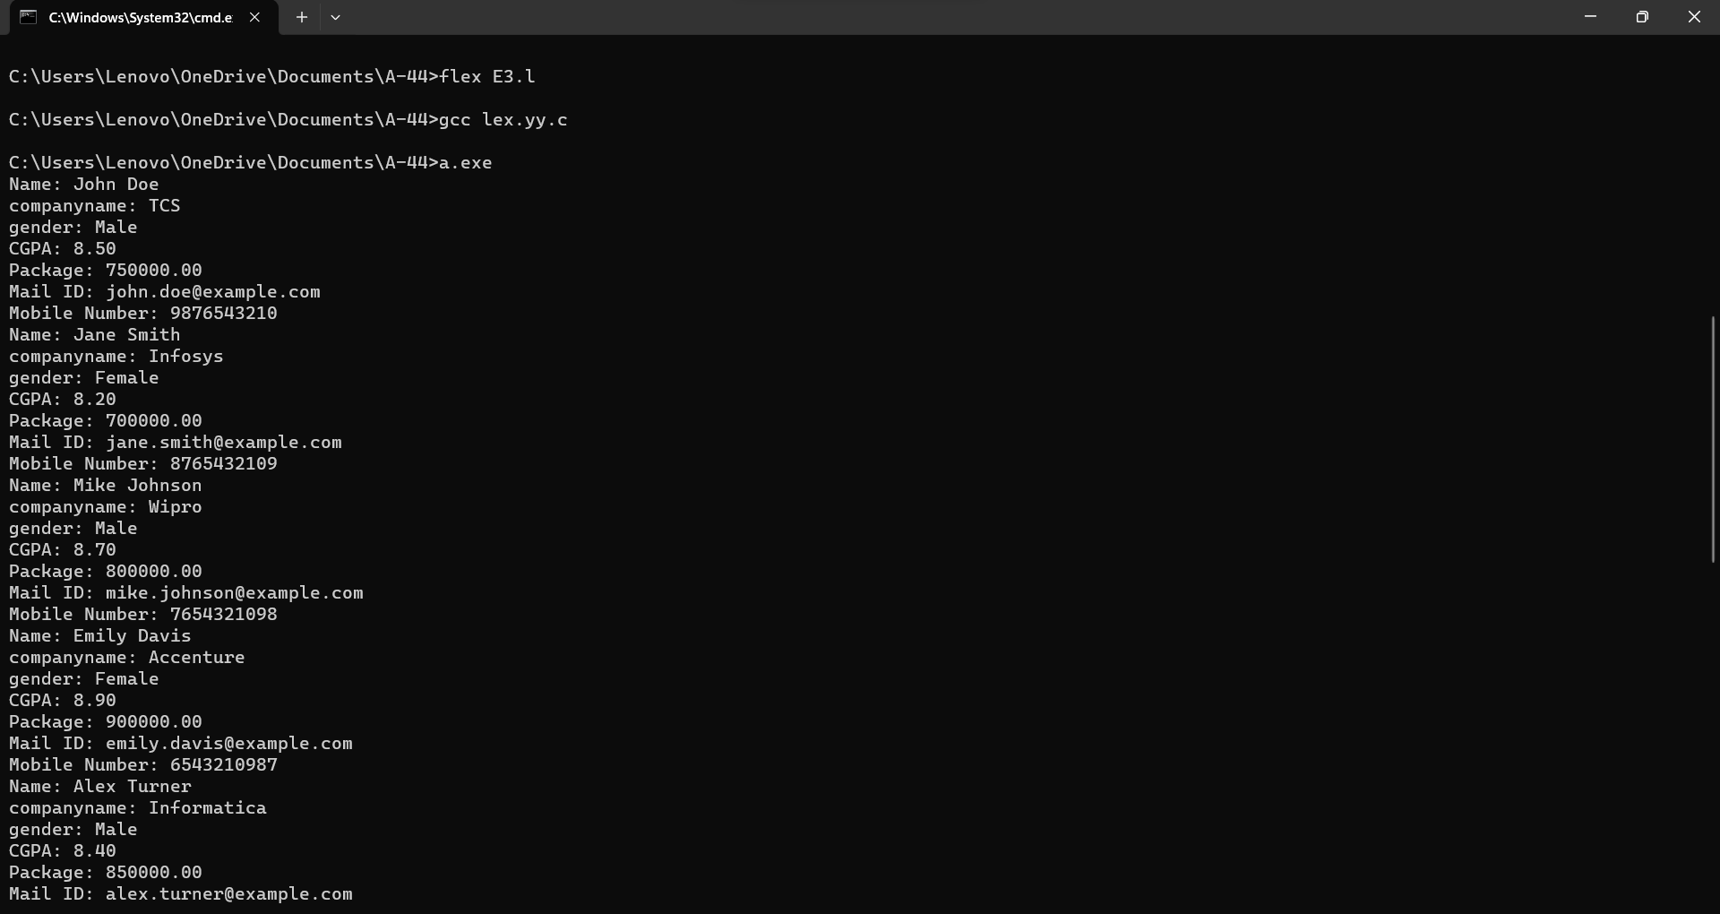

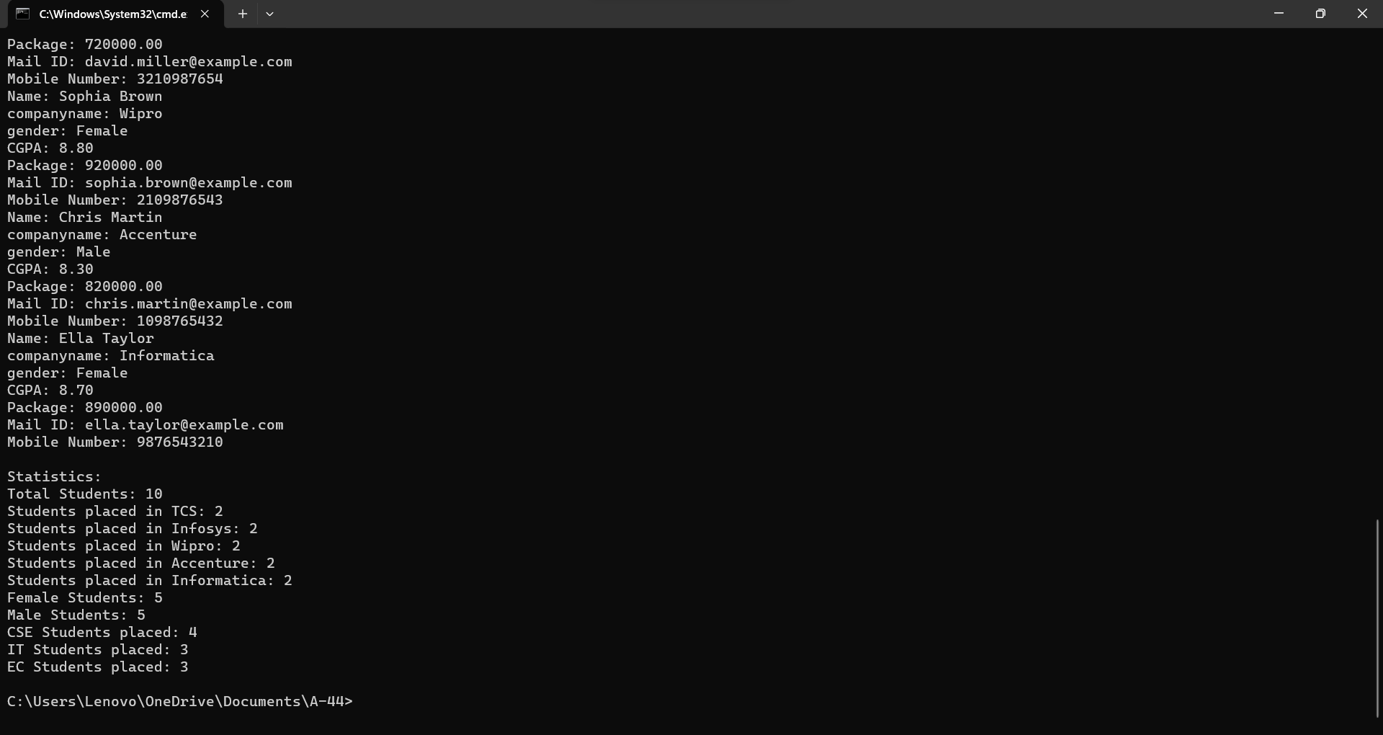

**4 Code :**

%{

#include <stdio.h>

%}

%option noyywrap

%%

"/*" {

int comment_depth = 1;

while(comment_depth > 0) {

int c = getc(yyin);

if (c == EOF) {

fprintf(stderr, "Error: Unterminated comment\n");

return 1;

}

if (c == '/' && comment_depth > 1) {

// Nested comment

c = getc(yyin);

if (c == '*') {

comment_depth++;

}

}

if (c == '*' && comment_depth > 1) {

// Potential end of the comment

c = getc(yyin);

if (c == '/') {

comment_depth--;

}

}

}

}

"//" {

while (1) {

int c = getc(yyin);

if (c == EOF || c == '\n') {

unput(c);

break;

}

}

}

[^/\n] { fputc(yytext[0], yyout); }

"/"([^\n]|[][^/])*

. { fputc(yytext[0], yyout); }

%%

int main(int argc, char** argv) {

if (argc != 3) {

fprintf(stderr, "Usage: %s <input_file> <output_file>\n", argv[0]);

return 1;

}

FILE* inputFile = fopen(argv[1], "r");

if (inputFile == NULL) {

perror("Error opening input file");

return 1;

}

FILE* outputFile = fopen(argv[2], "w");

if (outputFile == NULL) {

perror("Error opening output file");

fclose(inputFile);

return 1;

}

yyin = inputFile;

yyout = outputFile;

int result;

while ((result = yylex()) != 0) {

if (result == 1) {

fclose(inputFile);

fclose(outputFile);

return 1; // Lexical error

}

}

fclose(inputFile);

fclose(outputFile);

return 0;

}

**Output :**

