For Jenkins auto deployment

Step-> download Jenkins deploy plugins->download tomcat server

Step2-> got to manage Jenkins-> manage plugins-> install deploy plugins->advance and deploy war file.

Download sample project war file-> past in j

Step3: post build action:->deploy war to container->give war file new( ****/.war)

Path (user/tool/jenkis/Jenkins_home/workscpace/sample project/copy war file here

Step select tomcat container in above step with credentials. As set in ( tomcat/conf/tomcat user file.

Go to cmd ( cd /tomcat/bin/) Then start tomcat server by command ( ./start.sh)

Step3-> new project->free style->

**PIPELINE**

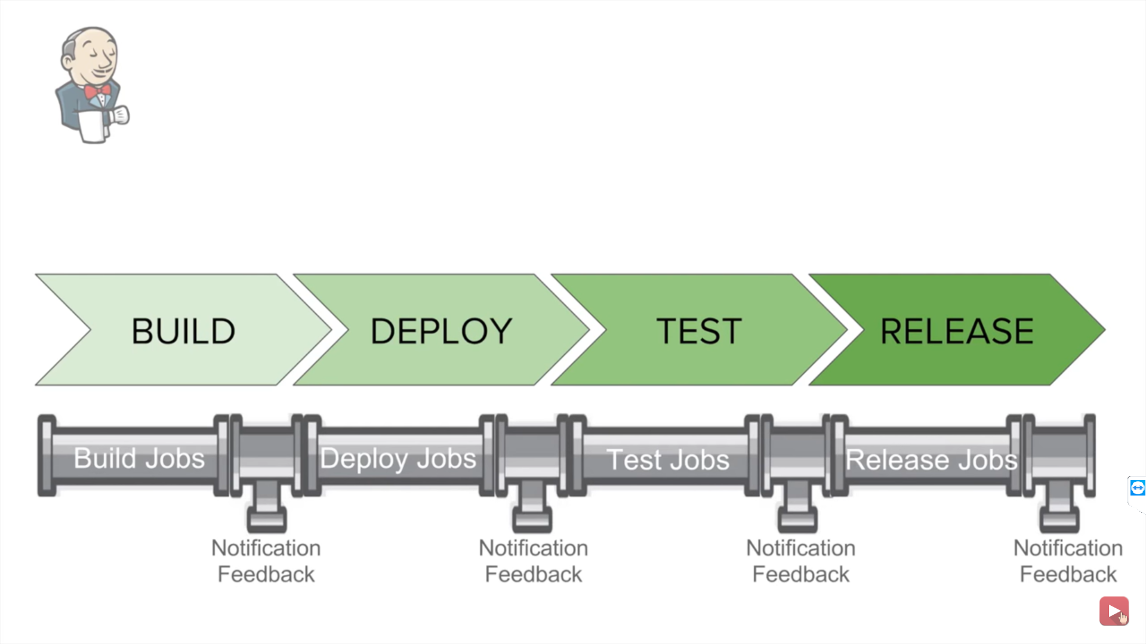

Pipelines: is sequence of task

Set to know upstream & downstream jobs

Install pipelines plugins. Build pipeline & delivery pipeline, build monitor plugins.

Create three project BUILD, DEPLOY & TEST

RUN ( BUILD) ALL THREE project separately to confirm that all are ok

Now create a chain of these projects: => got to second deploy project -> configure->build trigger->build after projects are build-> project to watch-> BUILD sample project

got to 3rd TEST project -> configure->build trigger->build after projects are build-> project to watch-> deploy project

now run first DEPLOY project.

Click + delivery pipeline view

Pipeline component -> select first job-> apply and save

**Sudo systemctl start docker**

#docker run –name Jenkins -d -v Jenkins_home:/var/Jenkins_home -p 8080:8080 -p 50000:50000 Jenkins/Jenkins:lts

Then open browser open 192.168.1.81:8080 then install Jenkins=>manage Jenkins and install Kubernetes plugins

Jenkins->configure->cloud->add new-> Kubernetes< Kubernetes url https://10.92.250.67:6643(find by command{cubectl config view or vi .kibe/config})

1.Add credential: domain :global, kind secret file, scop global(Jenkins, node etc), file<home/.kibe/config> then test connection

2. Jenkins url: <https://192.168.1.81:8080> , Jenkins tunnel https://192.168.1.81:50000

3. Pod #label:add new->

# key:jenkins value: slave

#Default provider template name->Images ->name kube.name space,

#labels<kubepods>,

#uses<only build jobs>,

#container template< name:jnlp

#docker image: Jenkins/jnlp-slave:latest >

#working directory</home/Jenkins>

5.

6.

7.