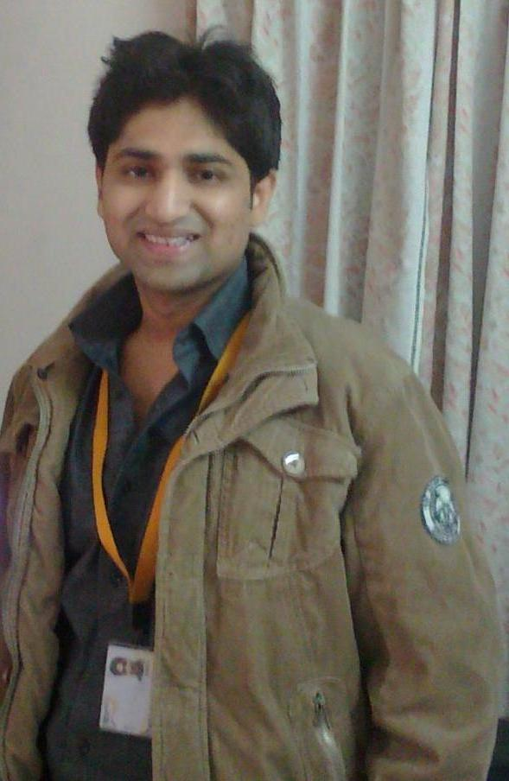  kapil kumar gupta  Nss support Engineer  Cell Phone Number:  9560102391  E-Mail:  kapilgupta.pt@gmail.com  Correspondence Address:  Kapil kumar gupta  338, Niti-Khand-1, Indripuram,  GZB  Permanent Address  s/o jagdish khandelwal  adaesh colony, ward no 12,  govindgarh, Dist- Alwar (raj.)  pincode- 321604  Personal Details  Date of Birth  2.5.1986  Gender  male  Nationality  Indian  Marital Status  married  Languages Known  English  Hindi  Hobbies  - Dancing  - Travelling  - Interacting | RESUME  Career Objective:  Seeking a challenging career in Telecommunication & IT Industry by putting all my technical knowledge, Experience and Hardworking attitude towards progressive output  Academic Qualifications:  Vocational Training:  SYNOPSIS  - A competent professional with 5+ YEARS experience in O&M, trouble shooting, Commissioning & Integration and Technical Support as CS Core and IP Multimedia System Engineer in the Telecom Sector.  - Presently associated with Ericsson Global India Limited as 2LA Engineer  For IMS.  PLATFORM  DX200, IPA2800 , ATCA, AXE 810 and Cisco Routers.  Working on Upcoming Latest technology on ATCA platform :  ATCA is a new series of industry standard specifications for the next generation of carrier grade communications equipment.  The Nokia Siemens Networks Open Mobile Softswitch (Open MSS) is a digital switching product built on top of the Advanced TCA (ATCA) hardware  platform. The Open MSS offers increased capacity with a smaller footprint, improved performance, open architecture and Commercial Off-The-Shelf (COTS) hardware building blocks
  Qualification | Year of Passing | Percentage | Board/University
  B.Tech(ECE) | 2009 | 69.3% | Rajasthan university,jaipur
  Sr.secondary | 2004 | 60.46% | Rajasthan board,ajmer
  Secondary | 2002 | 65.3% | Rajasthan board ,Ajmer
  Company | Module | Duration
  Prolific system and technologies pvt.ltd | Robotics, Embedded C,  Micro controller | 4 weeks  (14 Jul 08 – 22 Aug 08
  Knowledge point jaipur | Core java | 4 weeks
PLATFORM

The PLATFORM which I’m working with in Ericsson

• MSS/MGW Ericsson APZ 2 12 60/R 13.2/R14.1/R6.3.2.0D
• HLR/RHLR Ericsson AXE810 Switch APZ 2 12 60/ R 13.2
• STP/NPDB/FNR Ericsson AXE810 Switch AZZ 2 12 60/R 13.2
• HSS Ericsson 2011A
• CSCF Ericsson 2011A
• SBG Ericsson 4.0

The PLATFORM which I have worked with Nokia.

• MSS on DX200 and ATCA
• HLR on DX200
• MGW on IPA and ATCA

COMMISSIONING AND INTEGRATION

- Commissioning & Integration of ATCA MSS and MGW.

OPERATIONS AND MAINTENANCE

1 Emergency Handling and troubleshooting of call and SMS for complex scenario
2 Network performance review and KPI improvement like CSR, PSR, and LUSR etc.
3 Regular System health checks, backup of all nodes.
4 IP Traffic optimization in MSS and MGW’s.
5. Hardware related issue.

EMPLOYMENT SCAN

July ’13 to till Date – Ericsson Global India Ltd, Noida
Working as 2nd Level assurance Engineer for EGIL. Job responsibilities involve Troubleshooting and O&M support activities for IMS(CSCF,HSS, SBG), CUDB, MSS, MGW, HLR.
Customer Details:---
Customer | Country | Node
UPC LGI | Netherlands | IMS(CSCF,HSS,SBG,MSS,MGW)
ZIGGO | Netherlands | IMS(CSCF,HSS,SBG,MSS,MGW)
MOBILICITY | Canada | MSS,HLR,MGW
Telstra | Australia | HLR_FE,CUDB

Responsibilities
- Automation of system backup(Backup archive server) from all IMS core nodes.
- Acceptance testing of all IMS core nodes.
- Analysis of SIP traces in Wireshark.
- B Number analysis and changes in CSCF.
- Enable Media anchoring on SBG.
- SBG header rule set analysis and changes.
- B number table configurations, Routing case, GT(E.164),IMSI(E.212), MGT(E.214) definition and implementation and In roamer and Out roamer definitions.
- Complete automation of several system dumps like SUDA (HGPFI:MSISDNS=ALL,ext),FNR DUMP (FGNTI),B-number(ANBSP:B=ALL) for frequent customer requirement.
- NTP server implementation in MSS & MGW throughout the network.
- Troubleshooting of call and SMS for complex scenario of LGI and Ziggo.
- Analysis of Wireshark trace for SIP, ISUP, CAMEL, MAP,DNS.
- Implement changes in configuration as per analysis made from Traces.
- Coordinate with AMDOCs, Orange and Customer on Bridge to troubleshoot the incident.
- Emergency handling for core nodes.
- Hardware and configuration changes of CSCF,HSS,SBG,MSC,MGW and CUDB as per requirement.
- Troubleshooting for KPI degrade of Nodes.
- Do the configuration changes in emergency and for plan CR.
- Troubleshooting for hardware alarms of Node.
- User policy implementation on HSS,CSCF,SBG,MSS.
- Analysis of complex scenario like HORLCF, IMS Inter-working, Preferred Roaming,
Home routing etc.
20 Coordinate with CSR handler.

August 2011 – June 2014 - Nokia Siemens Networks, Luck now for Vodafone UP-East
Working as NSS Engineer for Nokia Siemens Networks. Job responsibilities involve configuration and O&M support activities for MSS, MGW, HLR, ATCA MSS & MGW and Cisco Router nodes.
Responsibilities
1. Migration of MSS from DX200 platform to ATCA MSS.
- Integration of BSC on POOL in MSS.
- BSC re-homing.
- Creation of SIGTRAN, RNC, BSC, MGW’s etc. on DX200 and ATCA.
- New feature implementation like HD voice for 3G network.
- Configuration of ODC base MSRN routing as SD provided by Planning.
- Configuration of UPD analysis and creation of VMGW as SD provided by Planning.
- VLR load balancing on pool.
- Trouble shooting for Clear code and critical alarms.
- Core network implementation as per source data for newly commissioned nodes.
- integration of BSC on POOL in MSS.
- Hardware creation, expansion and rectification.
- All creation & deletion activities on MSS and MGW nodes i.e. Circuit creation, CGR creation, VMGW creation, Ater augmentation, Signalling link creation etc.
- Rollout for ATCA, BSC POOLING & Vodafone PSTN.
- Augmentation of POI’s and interconnects to ensure minimum blocking in exchange.
- CD Implementation/ Software up gradation,.
- Announcement mapping.
- Trace analysis with K1208 Tracer of various cases & different nodes for various protocol
like MAP SCCP MTP etc for failure analysis.
- Routine health checkups of core Nodes.
- Intermsc E1 augmentation for reducing TG utilization.
- License loading.
- Creation of trigger.
- User id creation and modifications.
- Complaint management as per priority level.
- Site creation to switch & external LAC definition during BSC REHOMING.
- Provide support to Customer Technical Support Group to solve all sorts of hotline queries.
- Patch Implementation, PRI, RNC, BSC & POI DB Creation, BICC & H.248, SS7, Sigtran,

june ’09 – august ‘11 – Ericsson India pvt ltd. (on payroll of TICS and Essjay Ericsson), Meerut for Airtel.
Responsibilities
- Troubleshooting on APG, CP and RP fault for Rectification.
- Creation of Signaling to the other new nodes coming in the network (MSC, BSC and POIs).
- Analysis of all type of MSC related data like B-Number Analysis Table, Route .
- Processor Load Monitoring of MSCs.
- Configuration of B No. routing plans, charging plans, Short Codes openings, Roaming definitions, GT openings etc.
- Customer Complaint resolution in coordination with TSG.
- Configuration/Coordination for BSNL/OTHER Operator POI AT testing.
- To take CP/APG/RTR backups at specified frequency and maintenance of Backup media.
- BSC Rehoming for load balancing of MSC.
- Site creation to switch & external LAC definition during BSC REHOMING.
- Configuration management as per the requirement from customer (Airtel).
- Parameter changes for better compatibility with Ericsson switches & BSC.
- Announcement loading
- Fault Listing and their rectification of cards in MSC, BSC, Media Gateway and their replacement.
- Familiar with all types of Call Testing Scenarios: Pre-Paid, Post-Paid, VAS.
- Responsible for maintaining KPI of several BSS/NSS nodes.
- Responsible for resolution of POI/Other operator outages.
- Responsible for resolution of GB link/OSS link outages.
- Responsible for Hardware related alarms in Network Nodes.
- Responsible for successful migration of BSS Nodes as per plan provided by DNP.
- Preventive and Corrective Maintenance of MSC/BSC/STP/HLR and other Core .

Technical Skills

Telecom Tools : Ericsson OMT, Ericsson ROMT, Citrix, WinFiol, Alex, RNC Element
Manager, Reflection, Tektronix, Wireshark, Putty, WinSCP

Operating Systems : MS DOS, Windows98/XP, Linux.

Languages : C, C++, Core Java

Assembly Language : Embedded C, µρ8085

RDBMS : SQL

Others : MS-Excel, MS-Word, MS-PowerPoint

Key skills

- Excellent Communication Skills with the ability to deal with issues with precision and accuracy.
- Fundamentals of IP.
- Knowledge in Linux.
- Routing concepts, Number Analysis.
- Knowledge on protocol level of SS7,SIGTRAN, ISUP, SCCP, TCAP, SIP, RTP, GCP,DNS, Diameter Codec G711,G729,AMR etc.
- Excellent command on computer software like MS Office, MS PowerPoint etc., essentially used in any organization.
- Can work effectively in team, as well as individually.
- Have good inter-personal skills as well as leadership qualities.
- Career oriented with an analytical bent of mind and positive attitude.

Expertise:

- Integration of BSC on POOL in MSS on Nokia.
- BSC re-homing..
- Taking traces and analysis for MAP,ISUP,SCCP,TCAP,SIP,RTP,GCP,DNS.
- Creation of Sigtran.
- Hardware creation, expansion and rectification on Nokia.
- UPD analysis, ODC base MSRN routing, IN analysis, announcement Analysis on Nokia.
- SCCP, DPC routing.
- License loading, VMGW creation on Nokia.
- Multi country with Multi operator handling on Ericsson.

Achievements:

- ETCP certification on IMS.
- Migration of MSS from DX200 platform to ATCA MSS.
- More than 50 BSC Migration done successfully on the configuration of pool
- Successfully swap Siemens to Nokia as a important member of the team.

TRAINING Attended

1. 3GSCNOM which includes:

MSS fault management, VMGW creation, UPD analysis, RNC integration to any MSS.
RNC definition to MGW, Nokia Release 4 hardware, MSS-MGW Architecture, VMGW
Definition in MSS/MGW, ATM Switching Limitation of Release 4 Network and Routing on IP.

2. Certification by NOKIA:
1) Trouble Management Process.
2) Change Management Process.
3) Preventive Maintenance Process.
4) User Access Management Process.
5) Back-up & Restoration Process.

3. ATCA (Advanced telecommunication computing architecture)
Architecture of ATCA h/w, Capacity & Compatibility.

4.BSC on pooling.

PERSONAL CREDENTIALS:

- Ability to adapt dynamically.
- Good communication skill
- Team player and leadership qualities.
- Enthusiasm in learning new things.

Declaration:

I hereby declare that all the information furnished above is true to the best of my
Knowledge and belief.

Place: Noida (kapil gupta)
Date:

