“Smart Property Tax Management System”
A
Project Report
submitted
in partial fulfillment
for the award of the Degree of
Bachelor of Technology
in Department of Computer Science and Engineering (AI)



Project Id:
SKIT/2022-26/AI/017

Project Mentor:
Dr. Mehul Maharishi
Submitted By:

Khushal Jangid (22ESKCA057) Gaurav Pratap Singh (22ESKCA035) Kapil Jarwal (22ESKCA054) Himanshu Meena (22ESKCA047)

Department of Computer Science and Engineering (AI) Swami Keshvanand Institute of Technology, M & G, Jaipur Rajasthan Technical University, Kota
Session 2025-2026

Swami Keshvanand Institute of Technology, Management & Gramothan, Jaipur
Department of Computer Science and Engineering (AI)

CERTIFICATE

This is to certify that Mr. Khushal Jangid, a student of B.Tech. (Computer Science & Engineering (AI)) 8th semester has submitted his Project Report entitled ”Smart Property Tax Management System (SMPTMS)” under my guidance.

Mentor Coordinator
Dr. Mehul Maharishi Mr. Manish Bharadwaj Assistant Professor2
Signature............ Signature............

Department of Computer Science and Engineering (AI), SKIT, Jaipur ii

Swami Keshvanand Institute of Technology,
Management & Gramothan, Jaipur
Department of Computer Science and Engineering (AI)

CERTIFICATE

This is to certify that Mr. Gaurav Pratap Singh, a student of B.Tech. (Com-puter Science & Engineering (AI)) has submitted his Project Report entitled ”Smart Property Tax Management System (SMPTMS)” under my guidance.

Mentor Coordinator
Dr. Mehul Maharishi Mr. Manish Bharadwaj Assistant Professor2
Signature............ Signature............

Department of Computer Science and Engineering (AI), SKIT, Jaipur iii

Swami Keshvanand Institute of Technology,
Management & Gramothan, Jaipur
Department of Computer Science and Engineering (AI)

CERTIFICATE

This is to certify that Mr. Kapil Jarwal, a student of B.Tech. (Computer Science & Engineering (AI)) has submitted his Project Report entitled ”Smart Property Tax Management System (SMPTMS)” under my guidance.

Mentor Coordinator
Dr. Mehul Maharishi Mr. Manish Bharadwaj Assistant Professor2
Signature............ Signature............

Department of Computer Science and Engineering (AI), SKIT, Jaipur iv

Swami Keshvanand Institute of Technology,
Management & Gramothan, Jaipur
Department of Computer Science and Engineering (AI)

CERTIFICATE

This is to certify that Mr. Himanshu Meena, a student of B.Tech. (Computer Sci-ence & Engineering (AI)) has submitted his Project Report entitled ”Smart Prop-erty Tax Management System (SMPTMS)” under my guidance.

Mentor Coordinator
Dr. Mehul Maharishi Mr. Manish Bharadwaj Assistant Professor2
Signature............ Signature............

Department of Computer Science and Engineering (AI), SKIT, Jaipur v

DECLARATION

We hereby declare that the report of the project entitled ”Smart Property Tax Man-agement System (SMPTMS)” is a record of an original work done by us at Swami Keshvanand Institute of Technology, Management and Gramothan, Jaipur under the mentorship of ”Dr. Mehul Maharishi” (Dept. of Computer Science and Engi-neering (AI)) and coordination of ”Mr. Manish Bharadwaj” (Dept. of Computer Science and Engineering (AI)). This project report has been submitted as the proof of original work for the partial fulfillment of the requirement for the award of the degree of Bachelor of Technology (B.Tech) in the Department of Computer Science and Engineering (AI). It has not been submitted anywhere else, under any other program to the best of our knowledge and belief.

Team Members Signature
Khushal Jangid (22ESKCA057) Gaurav Pratap Singh (22ESKCA035) Kapil Jarwal (22ESKCA054) Himanshu Meena (22ESKCA047)

Department of Computer Science and Engineering (AI), SKIT, Jaipur vi

ACKNOWLEDGEMENT

A project of such a vast coverage cannot be realized without help from numerous sources and people in the organization. We take this opportunity to express our gratitude to all those who have been helping us in making this project successful.

We are highly indebted to our faculty mentor Dr. Mehul Maharishi, Associate Professor, Department of Computer Science and Engineering (AI), Swami Kesh-vanand Institute of Technology, Management and Gramothan, Jaipur. He has been a guide, motivator, and source of inspiration for us to carry out the necessary pro-ceedings for the project to be completed successfully. We also thank our project coordinator Mr. Manish Bharadwaj for his cooperation, encouragement, valuable suggestions and critical remarks that galvanized our efforts in the right direction.

We would also like to convey our sincere thanks to Dr. Anjana Sangwan, Lab Coordinator and Associate Professor, Department of Computer Science and Engi-neering (AI), for facilitating, motivating and supporting us during each phase of de-velopment of the project. Also, we pay our sincere gratitude to all the Faculty Mem-bers of Swami Keshvanand Institute of Technology, Management and Gramothan, Jaipur and all our Colleagues for their co-operation and support.

Last but not least we would like to thank all those who have directly or indirectly helped and cooperated in accomplishing this project.

Team Members:
Khushal Jangid (22ESKCA057) Gaurav Pratap Singh (22ESKCA035) Kapil Jarwal (22ESKCA054) Himanshu Meena (22ESKCA047)
Department of Computer Science and Engineering (AI), SKIT, Jaipur vii

ABSTRACT

Smart Property Tax Management System (SMPTMS) is a web-based platform de-signed for Jaipur Nagar Nigam to digitize and streamline property tax operations. It automates property registration, tax calculation, payment processing, and receipt generation. The system ensures transparency using the formula: Tax = (Plot Area
× DLC Rate) / 2000. It integrates Razorpay for secure payments and GIS mapping (Leaflet.js with Google Maps tiles) for visualization of property data and payment status. Built with Next.js, TypeScript, Supabase, and Tailwind CSS, the system pro-vides a scalable, secure, and efficient solution for municipal tax administration.

Department of Computer Science and Engineering (AI), SKIT, Jaipur viii

Table of Contents

1 Introduction | 2
1.1 Problem Statement and Objective . . . . . . . . . . . . . . . . . . . | 2
1.2 Literature Survey / Market Survey / Investigation and Analysis . . . | 3
1.3 Introduction to Project . . . . . . . . . . . . . . . . . . . . . . . . | 4
1.4 Proposed Logic / Algorithm / Business Plan / Solution . . . . . . . | 5
1.5 Scope of the Project . . . . . . . . . . . . . . . . . . . . . . . . . . | 6
2 Software Requirement Specification | 7
2.1 Overall Description . . . . . . . . . . . . . . . . . . . . . . . . . . | 7
2.2 Functional Requirements . . . . . . . . . . . . . . . . . . . . . . . | 8
2.2.1 User Authentication . . . . . . . . . . . . . . . . . . . . . | 8
2.2.2 Property Management . . . . . . . . . . . . . . . . . . . . | 8
2.2.3 Tax Calculation & Payment . . . . . . . . . . . . . . . . . | 9
2.2.4 GIS & Admin Features . . . . . . . . . . . . . . . . . . . . | 9
2.3 User Characteristics . . . . . . . . . . . . . . . . . . . . . . . . . . | 9
2.4 Constraints . . . . . . . . . . . . . . . . . . . . . . . . . . . . . . | 10
2.5 Assumptions and Dependencies . . . . . . . . . . . . . . . . . . . | 10
2.5.1 Assumptions . . . . . . . . . . . . . . . . . . . . . . . . . | 10
Department of Computer Science and Engineering (AI), SKIT, Jaipur | ix

    - Dependencies 10
    - Non-Functional Requirements 11

3 System Design Specification | 12
3.1 System Architecture . . . . . . . . . . . . . . . . . . . . . . . . . . | 12
3.2 Module Decomposition Description . . . . . . . . . . . . . . . . . | 13
3.3 High Level Design Diagrams . . . . . . . . . . . . . . . . . . . . . | 14
3.3.1 Use Case Diagram . . . . . . . . . . . . . . . . . . . . . . | 14
3.3.2 Activity Diagram . . . . . . . . . . . . . . . . . . . . . . . | 15
3.3.3 Data-Flow Diagram . . . . . . . . . . . . . . . . . . . . . | 16
3.3.4 ER Diagram . . . . . . . . . . . . . . . . . . . . . . . . . | 17
3.3.5 Sequence Diagram . . . . . . . . . . . . . . . . . . . . . . | 18
3.4 Database Design . . . . . . . . . . . . . . . . . . . . . . . . . . . | 18
3.5 Security Design . . . . . . . . . . . . . . . . . . . . . . . . . . . . | 19
4 Methodology and Team | 20
4.1 Introduction to Agile Methodology . . . . . . . . . . . . . . . . . . | 20
4.2 Team Members, Roles & Responsibilities . . . . . . . . . . . . . . | 21
5 System Testing | 23
5.1 Introduction . . . . . . . . . . . . . . . . . . . . . . . . . . . . . . | 23
5.2 Types of Testing Performed . . . . . . . . . . . . . . . . . . . . . . | 23
Department of Computer Science and Engineering (AI), SKIT, Jaipur | x

    - Unit Testing 23
    - Integration Testing 24
    - System Testing 24
  - Test Cases 25
  - Test Execution Summary 28
    - Test Results Analysis 28
- Project Screen Shots 29
  - Application Screens Overview 29
  - Key Features Demonstration 36
- Conclusion and Future Scope 38
  - Project Conclusion 38
  - Lessons Learned 38
  - Future Scope and Enhancements 39
- Sustainable Development Goals (SDG) 41
  - SDG Alignment 41
  - Environmental Considerations 42
  - Social Impact 42
References 42
Project Poster 44
Department of Computer Science and Engineering (AI), SKIT, Jaipur xi
Certificate 45
GitHub Link 46

Department of Computer Science and Engineering (AI), SKIT, Jaipur xii

List of Figures
  - System Architecture Overview 13
  - Use Case Diagram 14
  - Activity Diagram – Citizen Tax Payment Flow 15
  - Data-Flow Diagram 16
  - ER Diagram 17
  - Sequence Diagram – Payment Processing Flow 18
  - Agile Model 20
  - SMPTMS Homepage 29
  - Home Page – How It Works 29
  - New Integrated Login Page 30
  - Registration Page – Step 1 31
  - Registration Page – Step 1 Continued 31
  - Citizen Dashboard 31
  - Property Registration – Tax Calculation 32
  - Tax Payment Interface 32
  - Bill Summary 33
  - Razorpay Payment Gateway 33
Department of Computer Science and Engineering (AI), SKIT, Jaipur xiii

  - Payment Success Confirmation 34
  - Official Property Tax Receipt 34
  - Admin Control Center 35
  - Property Records Management 35
  - Analytics Reports Panel 35
  - Tax Settings Configuration 36
  - GIS Map View of Properties 36
  - Project Poster 44

Department of Computer Science and Engineering (AI), SKIT, Jaipur xiv

List of Tables
  - Test Case table for User Management Module 25
  - Test Case table for Tax Calculation Module 26
  - Test Case table for Testing Module 27
  - Test Case table for Surveying Module 28
  - Module-wise Test Results Analysis 28

Department of Computer Science and Engineering (AI), SKIT, Jaipur xv

Chapter 1 Introduction

  - Problem Statement and Objective

Municipal corporations across India, including Jaipur Nagar Nigam, continue to rely heavily on manual processes for property tax administration. These manual systems are plagued by inefficiencies such as inaccurate property valuations, delayed pay-ment collection, lack of real-time tracking, and significant scope for corruption and tax evasion. Citizens face difficulties in accessing tax information, making pay-ments, and obtaining receipts, resulting in low compliance rates and reduced munic-ipal revenue.
SMPTMS aims to improve efficiency, transparency, and revenue collection for urban local bodies by providing a comprehensive digital platform for property registration, tax calculation, online payment, and real-time tracking.
Key Objectives:

    - Develop a secure, web-based platform for property tax management

    - Implement automated tax calculation using the formula: Tax = (Plot Area × DLC Rate) / 2000
    - Integrate Razorpay for secure and convenient online payment processing

    - Provide GIS-based visualization of property data and payment status using Leaflet.js
    - Enable PDF receipt generation for all completed transactions
Department of Computer Science and Engineering (AI), SKIT, Jaipur 1

    - Build an admin analytics dashboard for municipal authorities

    - Ensure data privacy, security, and scalability for municipal-scale deployment

  - Literature Survey / Market Survey / Investigation and Anal-ysis

Property tax management has been a subject of significant research and technologi-cal intervention globally. Traditional systems rely on manual survey and paper-based records, which are highly susceptible to errors, fraud, and inefficiencies. Several e-governance initiatives have been undertaken by Indian municipalities, though adop-tion remains uneven.
Market Analysis:

    - India’s e-governance market is projected to grow at 17.2% CAGR through 2027

    - Less than 40% of properties in Tier-2 cities are registered under digital tax systems
    - Municipal revenue loss due to tax evasion estimated at 30-45% in manual sys-tems
    - GIS-based property mapping has shown 28% improvement in tax collection in pilot cities

Technical Gap Analysis:

    - Existing portals lack real-time GIS visualization for property mapping

    - No integrated payment gateway with automated receipt generation in most por-tals
    - Absence of transparent, formula-driven tax calculation visible to citizens
Department of Computer Science and Engineering (AI), SKIT, Jaipur 2

    - SMPTMS bridges these gaps by combining Next.js, Supabase, Razorpay, and Leaflet.js

  - Introduction to Project

SMPTMS (Smart Property Tax Management System) is a comprehensive web-based application developed for Jaipur Nagar Nigam. The platform provides distinct inter-faces for citizens and municipal administrators, enabling end-to-end digitization of the property tax lifecycle — from registration to payment and receipt generation.
Core Features:

    - Secure user authentication for both Citizens and Administrators

    - Property management system for registration and updates

    - Automated tax calculation using the DLC Rate formula

    - Online payment integration via Razorpay gateway

    - PDF receipt generation for all successful transactions

    - Admin analytics dashboard with revenue and compliance insights

    - GIS-based visualization using Leaflet.js with Google Maps tiles

Technology Stack:

    - Frontend: Next.js 14 + TypeScript

    - Backend: Node.js (API Routes via Next.js)

    - Database: Supabase (PostgreSQL)

    - Styling: Tailwind CSS

    - Maps: Leaflet.js
Department of Computer Science and Engineering (AI), SKIT, Jaipur 3

    - Payments: Razorpay

    - Deployment: Vercel

  - Proposed Logic / Algorithm / Business Plan / Solution

SMPTMS implements a 3-tier architecture with clear separation of concerns across the Presentation, Application, and Data layers:

- Presentation Layer: Next.js 14 frontend with TypeScript and Tailwind CSS for responsive UI
- Application Layer: Node.js API routes handling business logic, authentication, and payment processing
- Data Layer: Supabase (PostgreSQL) for persistent storage of property, user, and transaction data

Tax Calculation Algorithm:

- Citizen inputs: Plot Area (sq. ft.) and property location

- System retrieves DLC Rate for the corresponding zone

- Formula applied: Tax = (Plot Area × DLC Rate) / 2000

- Calculated amount displayed with breakdown before payment

- Razorpay payment gateway invoked on confirmation

- PDF receipt generated and stored on successful transaction

Payment Processing Flow:

- User initiates payment → Order created in Razorpay

- Payment gateway → Secure card/UPI/netbanking transaction
Department of Computer Science and Engineering (AI), SKIT, Jaipur 4

- Webhook confirmation → Database updated

- Receipt PDF generated → Downloadable by citizen

  - Scope of the Project

In Scope:

    - Property registration and management for Jaipur Nagar Nigam

    - Automated tax calculation using DLC Rate formula

    - Online payment through Razorpay integration

    - PDF receipt generation and download

    - GIS mapping with Leaflet.js for property visualization

    - Admin dashboard with analytics and reporting

    - Role-based access control (Citizen / Admin)

Out of Scope:

    - Mobile application (planned as future enhancement)

    - Integration with existing legacy municipal ERP systems

    - Automated property valuation using AI/ML (future scope)

    - Multi-city deployment (Phase 1 limited to Jaipur)

Department of Computer Science and Engineering (AI), SKIT, Jaipur 5

Chapter 2
Software Requirement Specification

  - Overall Description

Product Perspective: SMPTMS is a web-based property tax management platform developed for Jaipur Nagar Nigam. The system provides a seamless experience for citizens to register properties, calculate taxes, and make payments, while of-fering municipal administrators comprehensive tools for monitoring, analytics, and data management. The platform leverages Next.js for frontend development and Supabase for backend services, ensuring scalability and real-time data access.
System Interfaces:

- User Interface: Responsive web interface accessible through modern browsers

- API Interface: RESTful API routes via Next.js for frontend-backend commu-nication
- Supabase Integration: Real-time PostgreSQL database and authentication ser-vices
- Razorpay Interface: Payment gateway API for secure transaction processing

- Leaflet.js Interface: GIS mapping integration with Google Maps tile layers

User Interfaces:

- Landing Page: Project overview with login/registration options

- Citizen Dashboard: Property management, tax calculation, payment history
Department of Computer Science and Engineering (AI), SKIT, Jaipur 6

- Admin Dashboard: Analytics, property records, revenue monitoring

- GIS Map View: Visual property distribution and payment status

- Payment Interface: Razorpay-integrated payment flow with receipt generation

Communication Interfaces:

- HTTP/HTTPS: Web protocol for API communication

- Supabase Realtime: Real-time database subscriptions

- Razorpay Webhooks: Payment status notifications

  - Functional Requirements

    - User Authentication

      - REQ-AUTH-001: Citizens shall be able to register with email and password

      - REQ-AUTH-002: Users shall be able to login with valid credentials

      - REQ-AUTH-003: Users shall be able to reset password via email

      - REQ-AUTH-004: Role-based access control (Citizen / Admin) shall be en-forced
      - REQ-AUTH-005: Secure logout and session termination

    - Property Management

      - REQ-PROP-001: Citizens shall be able to register new properties

      - REQ-PROP-002: Citizens shall be able to view and update property details

      - REQ-PROP-003: Admin shall be able to approve or reject property registra-tions
Department of Computer Science and Engineering (AI), SKIT, Jaipur 7

      - REQ-PROP-004: System shall store plot area, location, DLC zone, and owner details
      - REQ-PROP-005: GIS coordinates shall be captured for each registered prop-erty

    - Tax Calculation & Payment

      - REQ-TAX-001: System shall calculate tax using: Tax = (Plot Area × DLC Rate) / 2000
      - REQ-TAX-002: Tax breakdown shall be visible to citizen before payment

      - REQ-TAX-003: Razorpay gateway shall process payments securely

      - REQ-TAX-004: PDF receipt shall be generated on successful payment

      - REQ-TAX-005: Payment history shall be maintained and accessible

    - GIS & Admin Features

      - REQ-GIS-001: Leaflet.js map shall display all registered properties

      - REQ-GIS-002: Properties shall be color-coded by payment status on the map

      - REQ-ADM-001: Admin dashboard shall show revenue analytics and compli-ance rate
      - REQ-ADM-002: Admin shall be able to export property and payment data

  - User Characteristics

- Primary Users (Citizens): Property owners registering and paying taxes

- Admin Users: Municipal officers managing records and analytics
Department of Computer Science and Engineering (AI), SKIT, Jaipur 8

- Age Range: 18-65 years

- Technical Proficiency: Basic computer and internet literacy

- Language: Hindi and English interface support

  - Constraints

- Technology Stack: Must use Next.js, Supabase, and Razorpay

- Compliance: Must adhere to Jaipur Nagar Nigam DLC Rate schedule

- Timeline: 23-week development cycle

- Team Size: 4-member development team

- Platform: Web-based application for Phase 1

  - Assumptions and Dependencies

    - Assumptions

      - Users have stable internet connection

      - DLC Rate data provided and maintained by municipal authority

      - Supabase and Razorpay services remain available and stable

      - Users have valid government-issued property documents for registration

    - Dependencies

      - External Services: Supabase, Razorpay, Leaflet.js, Google Maps tiles

      - Third-party Libraries: Next.js ecosystem, Tailwind CSS

      - Infrastructure: Vercel hosting for deployment
Department of Computer Science and Engineering (AI), SKIT, Jaipur 9

    - Non-Functional Requirements

      - Performance: Tax calculation and page load within 2 seconds

      - Security: JWT-based authentication, encrypted payments, RLS on Supabase

      - Scalability: Architecture supports 10,000+ concurrent users

      - Availability: 99.5% uptime target

      - Accessibility: WCAG 2.1 compliance

Department of Computer Science and Engineering (AI), SKIT, Jaipur 10

Chapter 3
System Design Specification

  - System Architecture

SMPTMS implements a 3-tier client-server architecture leveraging Supabase as a backend-as-a-service platform and Vercel for deployment. The system follows a lay-ered architecture pattern with clear separation of concerns across the Presentation, Application, and Data layers, ensuring maintainability, scalability, and security.
Architecture Overview:

- Presentation Layer: Next.js 14 + TypeScript + Tailwind CSS (Web Browser)

- Application Layer: Node.js API Routes, Razorpay integration, Tax calculation engine
- Data Layer: Supabase (PostgreSQL) with Row-Level Security (RLS)

Department of Computer Science and Engineering (AI), SKIT, Jaipur 11

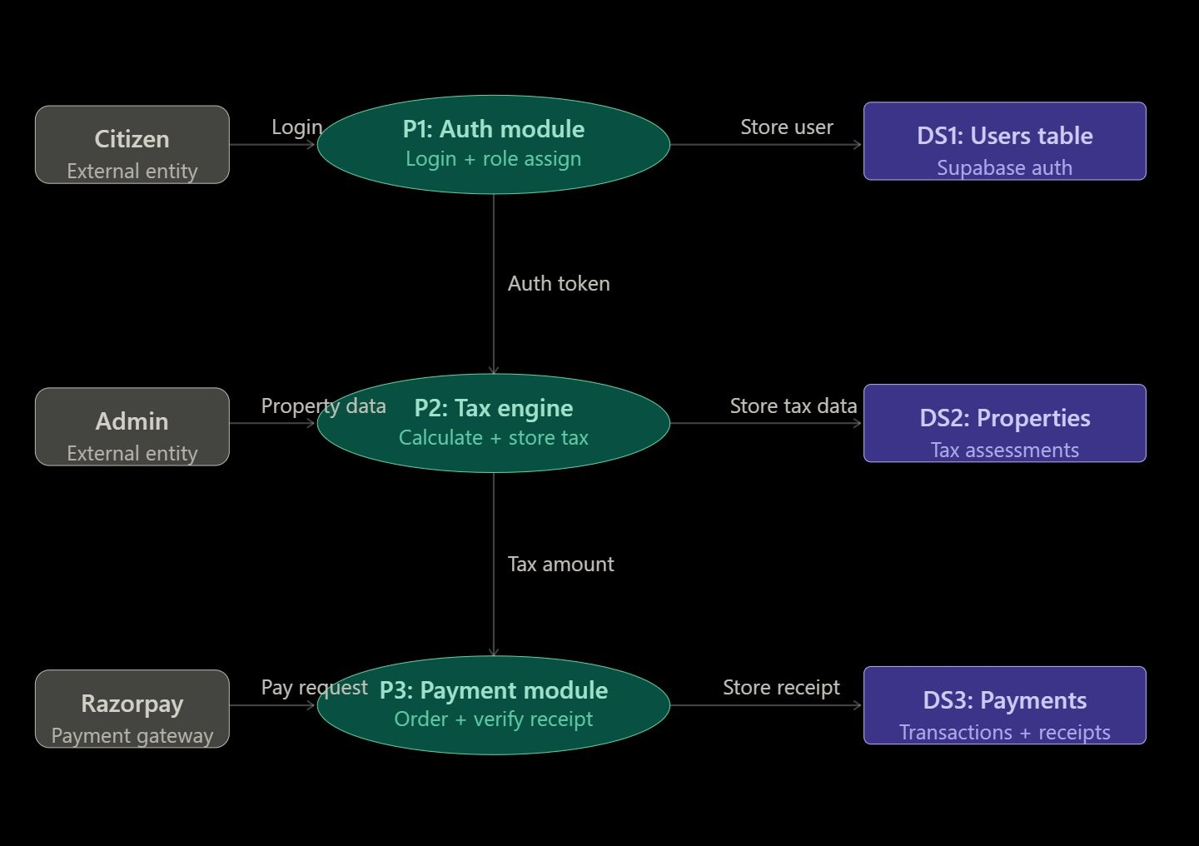
Figure 3.1: System Architecture Overview

  - Module Decomposition Description

User Management Module:

- Purpose: Handle citizen/admin registration, login, and session management

- Components: LoginPage, RegisterPage, AuthService, RoleGuard

- Dependencies: Supabase Auth, JWT tokens

Tax Calculation Module:

- Purpose: Retrieve DLC rates and compute property tax

- Components: TaxCalculator, DLCRateService, PropertyForm

- Dependencies: Supabase DB, DLC Rate table

Payment & Receipt Module:

Department of Computer Science and Engineering (AI), SKIT, Jaipur 12

- Purpose: Process payments and generate PDF receipts

- Components: PaymentPage, RazorpayService, ReceiptGenerator

- Dependencies: Razorpay API, PDF generation library

GIS / Survey Module:

- Purpose: Visualize property locations and payment status on map

- Components: MapView, LeafletMapComponent, GeoDataService

- Dependencies: Leaflet.js, Google Maps tile API, Supabase geo data

  - High Level Design Diagrams

    - Use Case Diagram

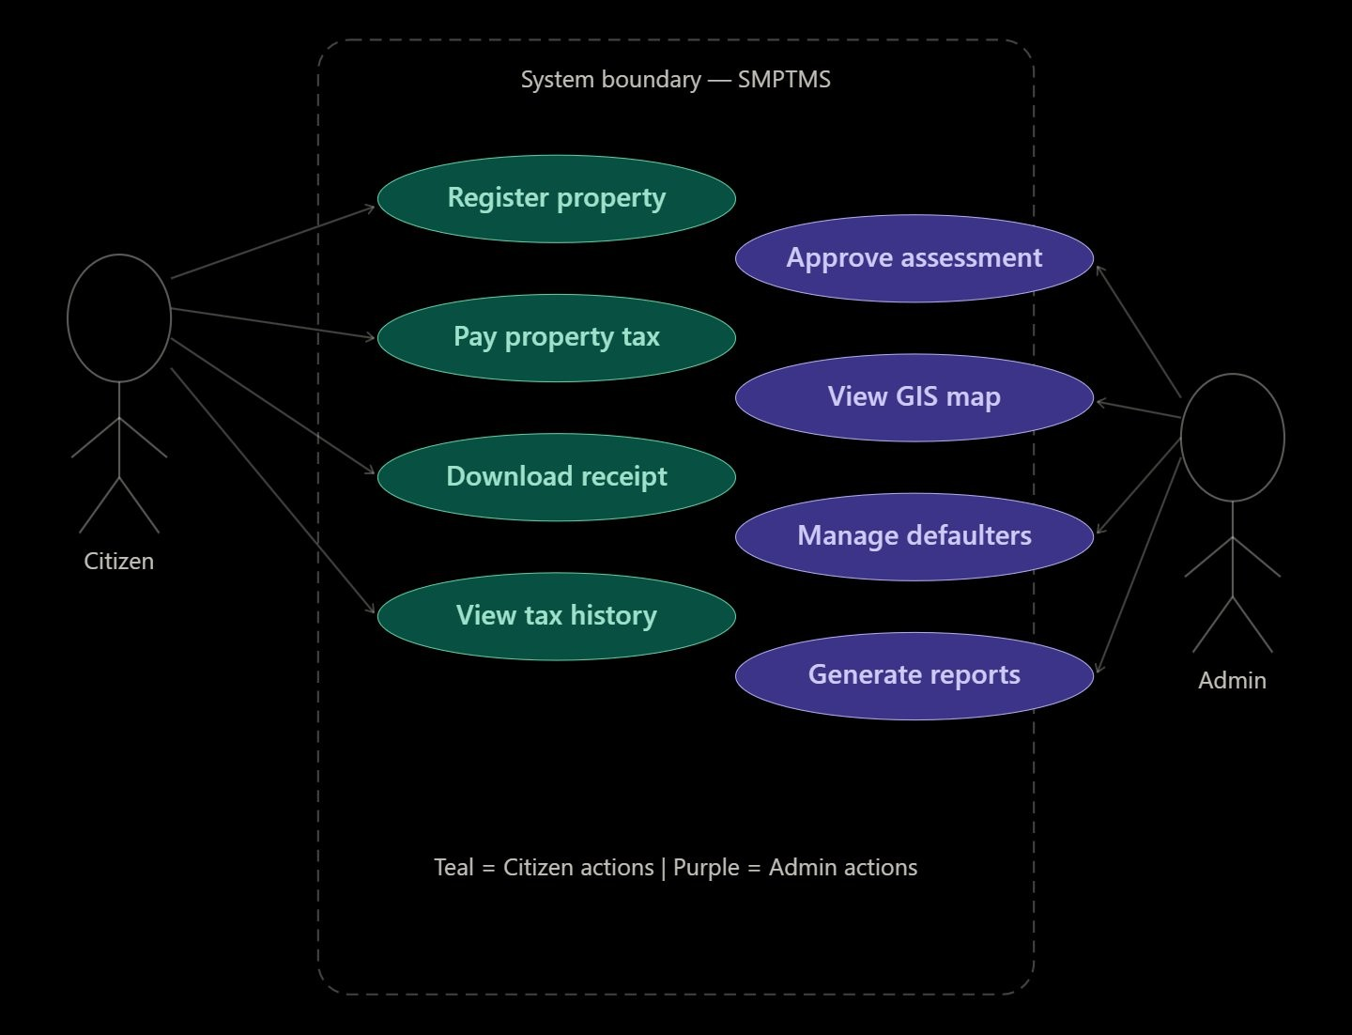
Figure 3.2: Use Case Diagram
Department of Computer Science and Engineering (AI), SKIT, Jaipur 13

    - Activity Diagram

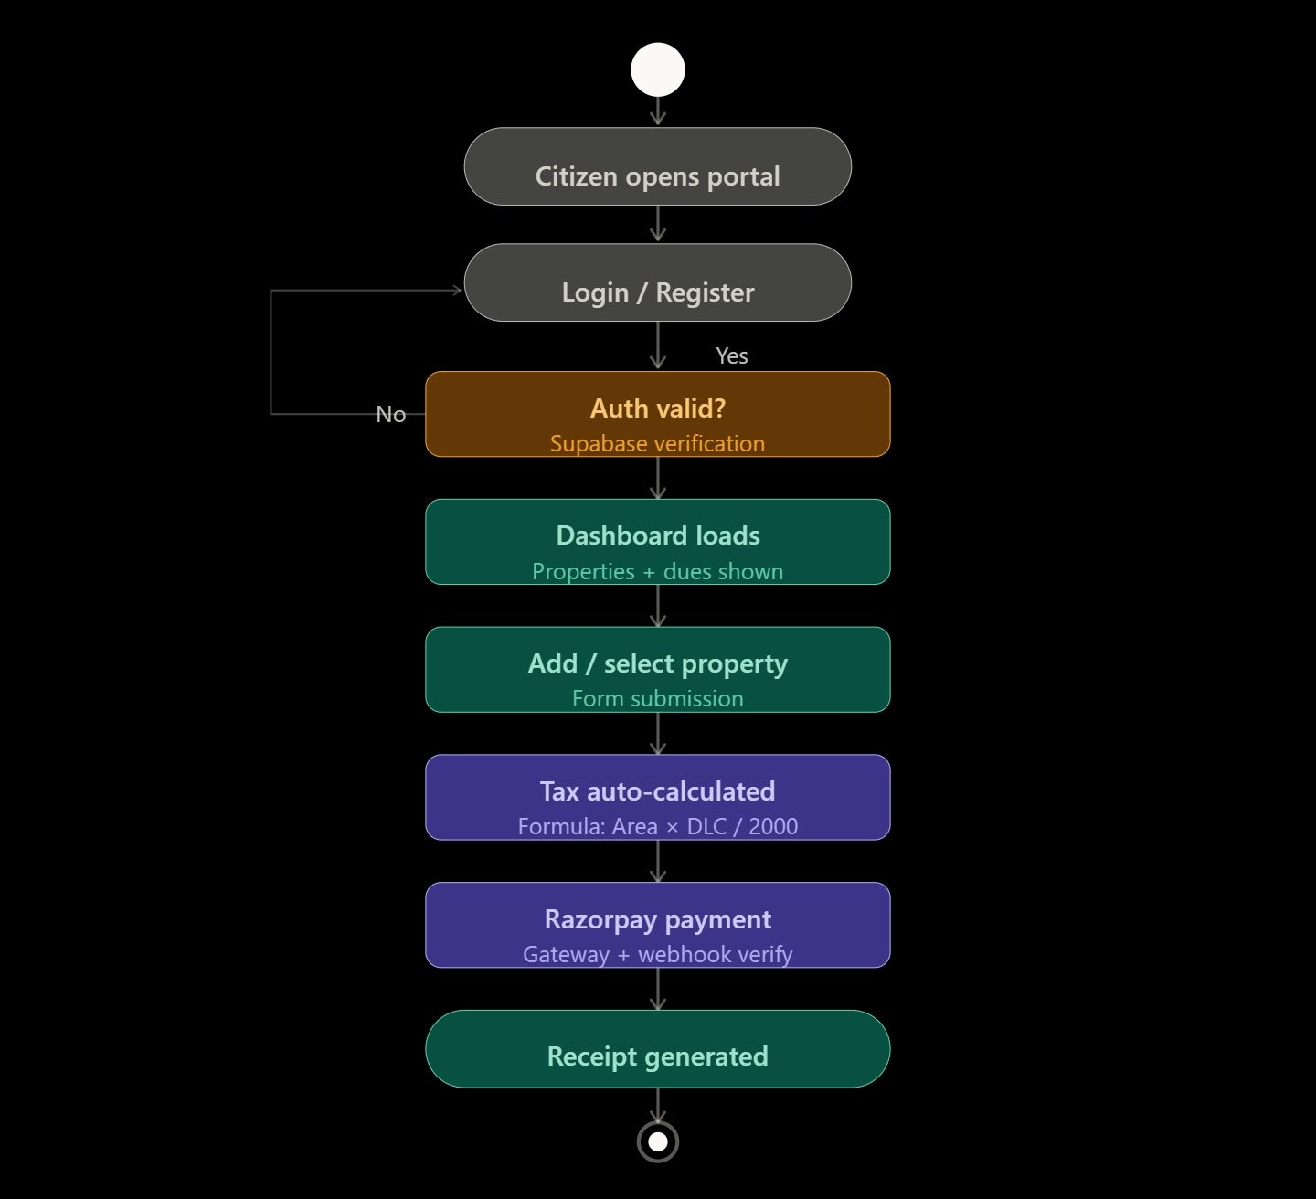
Figure 3.3: Activity Diagram – Citizen Tax Payment Flow

Department of Computer Science and Engineering (AI), SKIT, Jaipur 14

    - Data-Flow Diagram


Figure 3.4: Data-Flow Diagram

Department of Computer Science and Engineering (AI), SKIT, Jaipur 15

    - ER Diagram

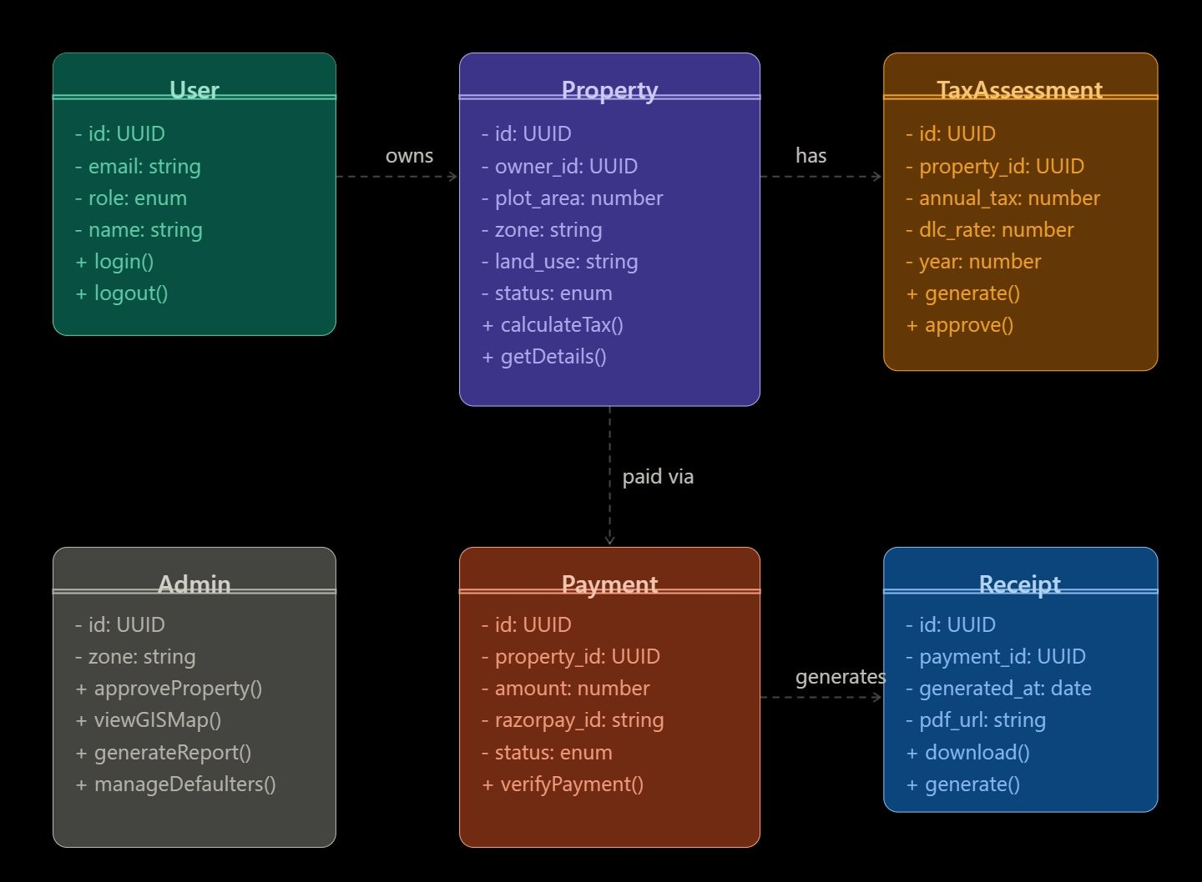
Figure 3.5: ER Diagram

Department of Computer Science and Engineering (AI), SKIT, Jaipur 16

    - Sequence Diagram

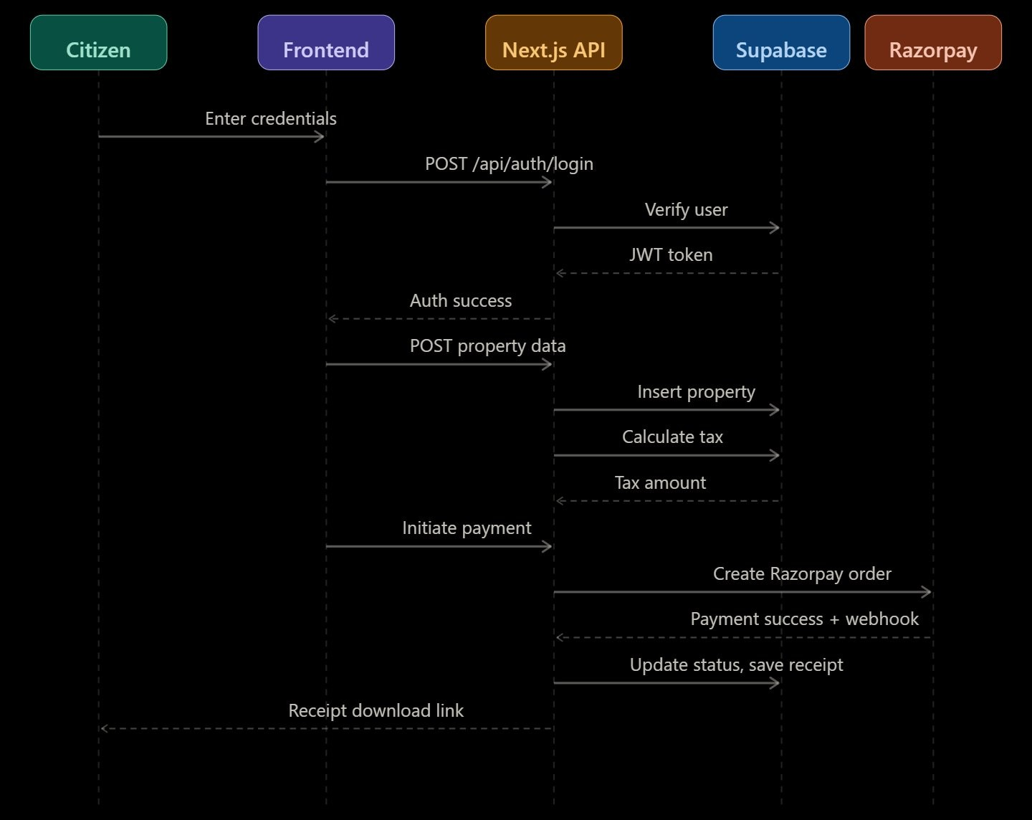
Figure 3.6: Sequence Diagram – Payment Processing Flow

  - Database Design

Supabase (PostgreSQL) Schema:

users table: id (UUID), email (string), name (string), role (citizen/admin), cre-atedat (timestamp)
properties table: id (UUID), ownerid (FK users), plot area (float), dlc zone (string), dlcrate (float), address (string), latitude (float), longitude (float), status (pending/ap-proved/rejected), createdat (timestamp)
payments table: id (UUID), propertyid (FK properties), citizen id (FK users), amount (float), taxamount (float), razorpayorderid (string), razorpaypaymentid (string), status (pending/success/failed), receipturl (string), paidat (timestamp)
Department of Computer Science and Engineering (AI), SKIT, Jaipur 17

dlcrates table: id (UUID), zonename (string), ratepersqft (float), effectivefrom (date), effectiveto (date)

  - Security Design

Authentication Security:

- Supabase Auth with JWT tokens for session management

- Role-Based Access Control (RBAC) enforced at API and database levels

- Row-Level Security (RLS) policies on all Supabase tables

Payment Security:

- All payment data handled exclusively by Razorpay — no card data stored lo-cally
- Webhook signature verification for payment confirmation

- HTTPS enforced for all API communication

Department of Computer Science and Engineering (AI), SKIT, Jaipur 18

Chapter 4 Methodology and Team
  - Introduction to Agile Methodology
Agile Methodology is a project management approach that focuses on iterative de-velopment, where requirements and solutions evolve through the collaborative ef-fort of self-organizing and cross-functional teams. It breaks down the project into small, manageable units called ”sprints,” which allow for continuous feedback and improvement. For the SMPTMS project, we chose the Agile methodology because it allowed us to develop the different modules of the system simultaneously while ensuring that they all worked together seamlessly.
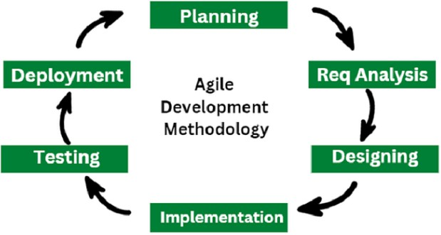

Figure 4.1: Agile Model

The sequential phases in Agile model are-

    - Requirement Gathering: Stakeholder interviews with Jaipur Nagar Nigam of-ficials, user story creation, and technical feasibility assessment for DLC-based
Department of Computer Science and Engineering (AI), SKIT, Jaipur 19

tax calculation.

    - Design: UI/UX wireframing for citizen and admin interfaces, Supabase schema design, GIS integration planning, and Razorpay payment flow architecture.
    - Development (Coding): Implemented Next.js frontend, Supabase backend in-tegration, Razorpay payment flow, Leaflet.js GIS mapping, and PDF receipt generation.
    - Testing: Unit testing, integration testing, and user acceptance testing with 100% test case pass rate across all modules.
    - Deployment: Deployed on Vercel with production environment, environment variable configuration, and monitoring setup.
    - Maintenance/Review: Ongoing bug fixes, performance optimization, and fea-ture enhancements based on user and stakeholder feedback.

  - Team Members, Roles & Responsibilities

Khushal Jangid (22ESKCA057) – Team Lead & Backend

- Overall project planning, task delegation, and team coordination

- Next.js API route development and backend business logic

- Supabase schema design and database optimization

- GitHub repository management and code review

- CI/CD pipeline setup on Vercel

Gaurav Pratap Singh (22ESKCA035) – Frontend & UI/UX

- Next.js 14 + TypeScript UI component development

- Tailwind CSS responsive design implementation
Department of Computer Science and Engineering (AI), SKIT, Jaipur 20

- Citizen dashboard and property registration forms

- End-to-end integration testing of frontend flows

Kapil Jarwal (22ESKCA054) – Payment & GIS Integration

- Razorpay payment gateway integration and webhook handling

- PDF receipt generation using server-side rendering

- Leaflet.js GIS map integration with Google Maps tiles

- Property geolocation capture and map marker implementation

Himanshu Meena (22ESKCA047) – Database & Admin Module

- Supabase (PostgreSQL) setup and Row-Level Security (RLS) configuration

- Admin analytics dashboard development

- DLC rate management and tax calculation engine

- Data export and reporting features for municipal officers

Department of Computer Science and Engineering (AI), SKIT, Jaipur 21

Chapter 5 System Testing

  - Introduction

Software testing is the process of evaluating a system or application to ensure that it works correctly and meets the specified requirements. The main objective of testing is to identify errors, bugs, or missing functionalities before the system is deployed for users. SMPTMS underwent comprehensive testing across all modules including authentication, tax calculation, payment processing, and GIS mapping.

  - Types of Testing Performed

Unit Testing

Unit testing involves testing individual components or modules separately. Each function or module was tested independently to verify its correctness. For SMPTMS, unit testing included:

      - Tax Module: Validation of the calculation formula (Area ×DLC)/2000 with various inputs.
      - Auth Module: Testing independent functions for login, registration, and role assignment.
      - Payment Module: Verifying Razorpay order creation and webhook signature validation.
Department of Computer Science and Engineering (AI), SKIT, Jaipur 22

Integration Testing

Integration testing checks whether different modules work together properly. For SMPTMS, this involved:

      - Verifying the flow between Supabase Authentication and the Next.js frontend protected routes.
      - Ensuring the Tax Calculation engine correctly pulls real-time DLC rates from the database.
      - Validating that successful Razorpay callbacks trigger status updates in the prop-erty database.

System Testing

System testing is performed on the complete integrated system to validate overall behavior and functionality. For SMPTMS, this covered:

      - The end-to-end citizen journey: Registration → Property Entry → Tax Payment
→ Receipt Download.

      - Admin workflows for property approval and viewing GIS analytics.

      - Testing the application’s responsiveness and performance on a live Vercel stag-ing environment.

Department of Computer Science and Engineering (AI), SKIT, Jaipur 23

Test Cases

NAME OF MODULE: User Management |  |  |  | TESTING TOOL : Postman + Manual
Test  ID | Test Description |  | Input Data | Expected Out-  put | Actual Output
TC-  UM-01 | Valid user registration |  | Name:  Kapil, Email: kapil@ gmail.com | Account created, redirect to dash-board | Account created successfully
TC-  UM-02 | Login with credentials | correct | Email:  kapil@ gmail.com, Pass: Test@123 | Dashboard loads with user data | Dashboard loaded correctly
TC-  UM-03 | Login with password | wrong | Email:  kapil@ gmail.com, Pass: wrong123 | Error – Invalid credentials | Error displayed correctly
TC-  UM-05 | Access dashboard without login |  | Direct  URL:  /dashboard | Redirected to /lo-gin | Redirected rectly | cor-
TC-  UM-06 | Admin login with citi-zen credentials |  | Citizen  credentials on admin panel | Access denied, role mismatch | Access correctly blocked
TC-  UM-08 | Duplicate email regis-tration |  | Same email  registered twice | Error – Email al-ready exists | Duplicate  blocked rectly | cor-
Table 5.1: Test Case table for User Management Module

Department of Computer Science and Engineering (AI), SKIT, Jaipur 24

NAME OF MODULE: Tax Calculation |  |  | TESTING TOOL : Postman + Manual
Test  ID | Test Description | Input Data | Expected Out-  put | Actual Output
TC-TC-01 | Basic tax calculation (Zone C) | Area: 280,  Zone C, Res. | Tax = (280 ×  DLC)/2000 | Correct amount calculated
TC-TC-02 | Tax calculation (Zone A) | Area: 520,  Zone A, Comm. | Higher tax due to Zone A DLC | Correct amount calculated
TC-  TC-05 | Zero area input valida-  tion | Area: 0,  Zone C | Error – Invalid  plot area | Validation error  shown
TC-TC-06 | Negative area input | Area: -100 | Error – Area can-not be negative | Validation  blocked in-put
TC-TC-07 | DLC rate change ef-fect | Admin up-  dates DLC rate | New rate applied to properties | Rate updated cor-rectly
TC-TC-08 | Total dues calculation | 2 properties  in dash-board | Correct total dues displayed | Correct total dis-played
Table 5.2: Test Case table for Tax Calculation Module

Department of Computer Science and Engineering (AI), SKIT, Jaipur 25

NAME OF MODULE: Testing |  |  | TESTING TOOL : Razorpay + Postman
Test  ID | Test Description | Input Data | Expected Out-  put | Actual Output
TC-  PM-01 | Successful payment  (Test Mode) | Razorpay  Test Card | Payment success,  status: Paid | Payment pro-  cessed correctly
TC-PM-02 | Payment cancelled by user | Cancel  Razorpay popup | Status remains Pending | Status unchanged correctly
TC-PM-04 | Receipt generation | Completed  Transaction ID | Downloadable PDF generated | Receipt gener-ated correctly
TC-PM-05 | Webhook verification | Razorpay  signed callback | Backend verifies and updates DB | Signature verified correctly
TC-  PM-06 | Double payment at-  tempt | Pay on paid  property | Warning – Tax al-  ready paid | Blocked correctly
TC-  PM-08 | Admin real-time up-  date | Payment by  citizen | Admin panel re-  flects paid status | Real-time update  confirmed
Table 5.3: Test Case table for Testing Module

Department of Computer Science and Engineering (AI), SKIT, Jaipur 26

NAME OF MODULE: Surveying |  |  | TESTING TOOL : Leaflet.js + Manual
Test  ID | Test Description | Input Data | Expected Out-  put | Actual Output
TC-  GIS-01 | Map initial load | Open /map route | Map centered on Jaipur | Map loaded cor-rectly
TC-  GIS-02 | Paid marker color | Paid prop-erty | Green marker on map | Green marker displayed
TC-  GIS-03 | Pending marker color | Pending property | Orange marker on map | Orange marker displayed
TC-  GIS-04 | Search by owner | ”Rajesh Kumar” | Sidebar high-lights, map pans | Search worked correctly
TC-  GIS-05 | Filter pending only | Click Pend-ing filter | Only pending properties shown | Filter applied cor-rectly
TC-  GIS-08 | Satellite view toggle | Click Satel-lite button | Tiles switch to satellite view | Toggle worked correctly
Table 5.4: Test Case table for Surveying Module

Test Execution Summary

Test Results Analysis

Module | Total Tests | Passed | Failed | Pass Rate
User Management | 8 | 8 | 0 | 100%
Tax Calculation | 8 | 8 | 0 | 100%
Testing | 8 | 8 | 0 | 100%
Surveying | 10 | 10 | 0 | 100%
Total | 34 | 34 | 0 | 100%
Table 5.5: Module-wise Test Results Analysis

Department of Computer Science and Engineering (AI), SKIT, Jaipur 27

Chapter 6
Project Screen Shots

Application Screens Overview

Public Landing Page

Figure 6.1: SMPTMS Homepage
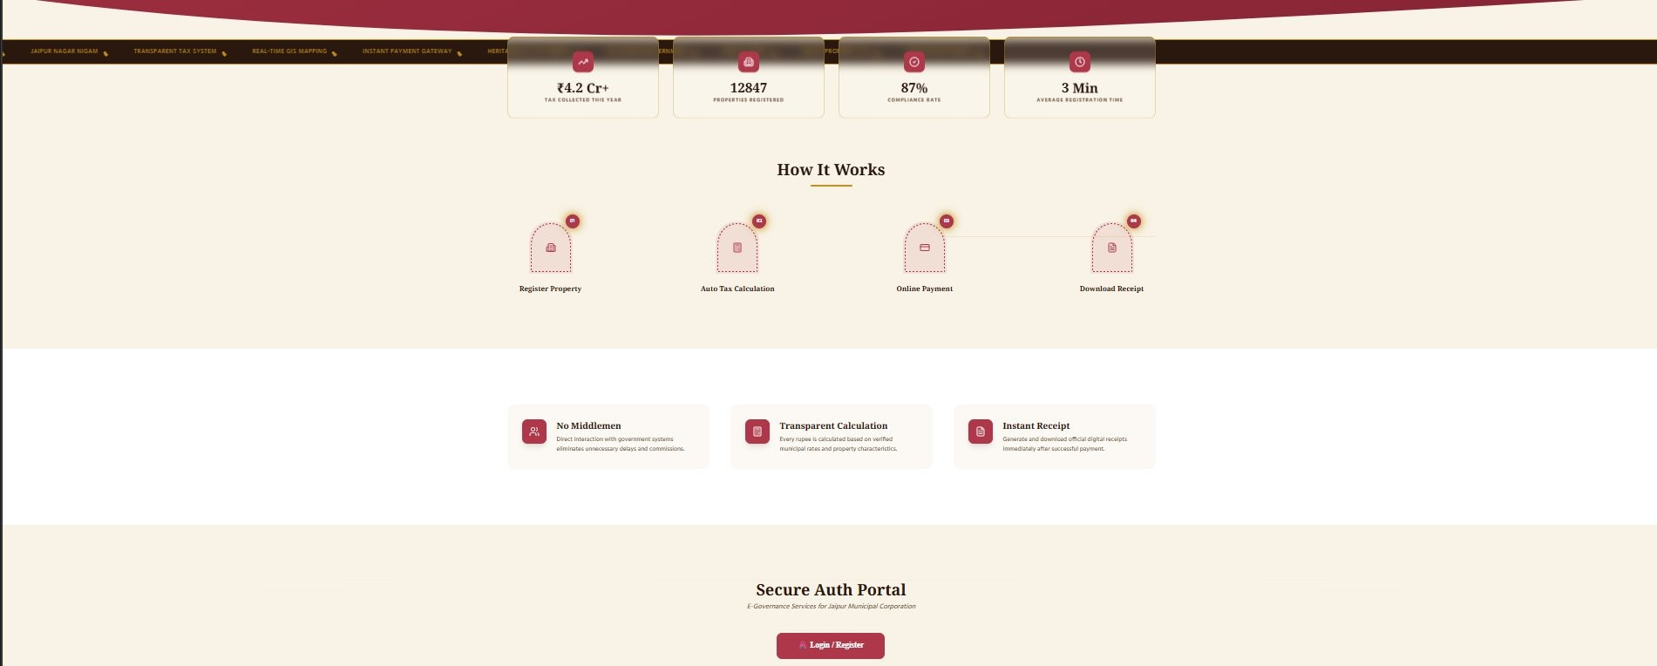
Figure 6.2: Home Page – How It Works

Authentication Screens
Department of Computer Science and Engineering (AI), SKIT, Jaipur 28

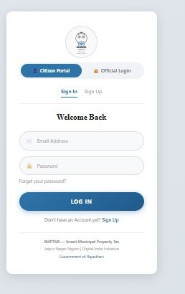
Figure 6.3: New Integrated Login Page

Department of Computer Science and Engineering (AI), SKIT, Jaipur 29

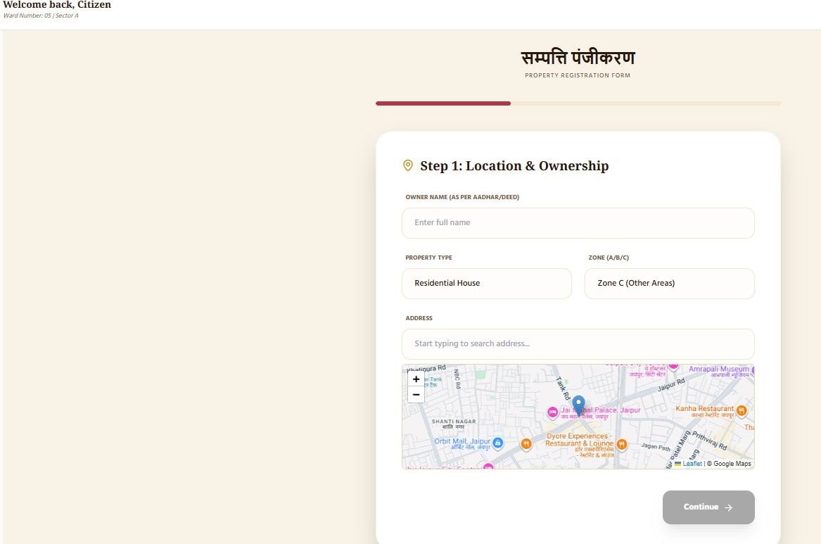

Figure 6.4: Registration Page – Step 1

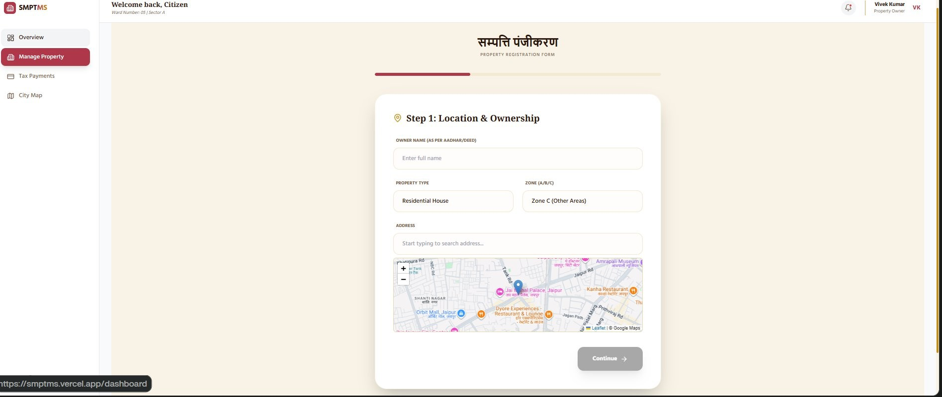

Figure 6.5: Registration Page – Step 1 Continued

Citizen Dashboard & Tax Workflow
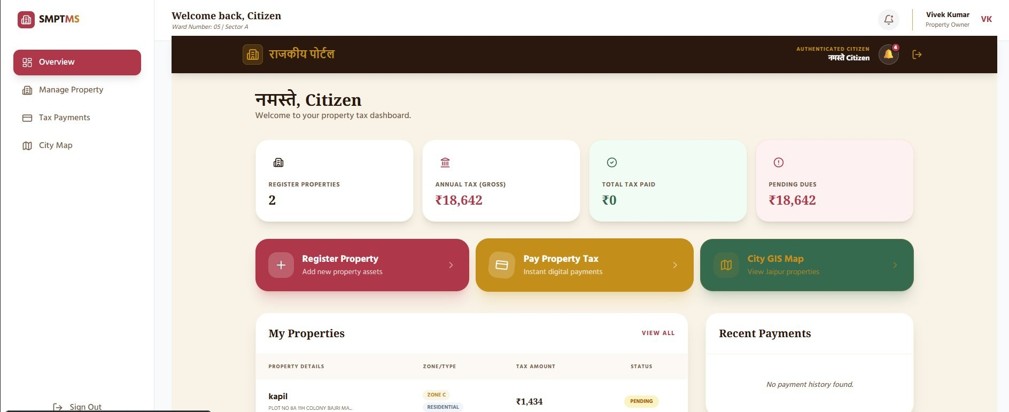
Figure 6.6: Citizen Dashboard
Department of Computer Science and Engineering (AI), SKIT, Jaipur 30

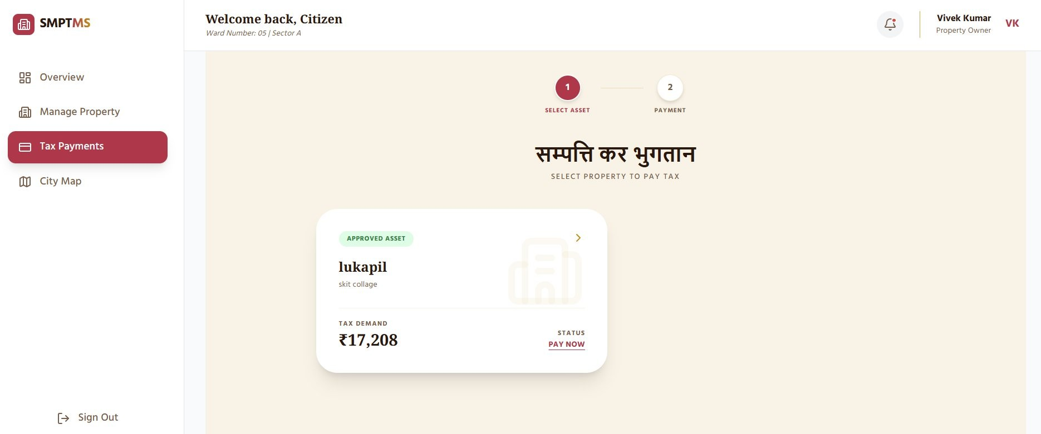
Figure 6.7: Property Registration – Tax Calculation

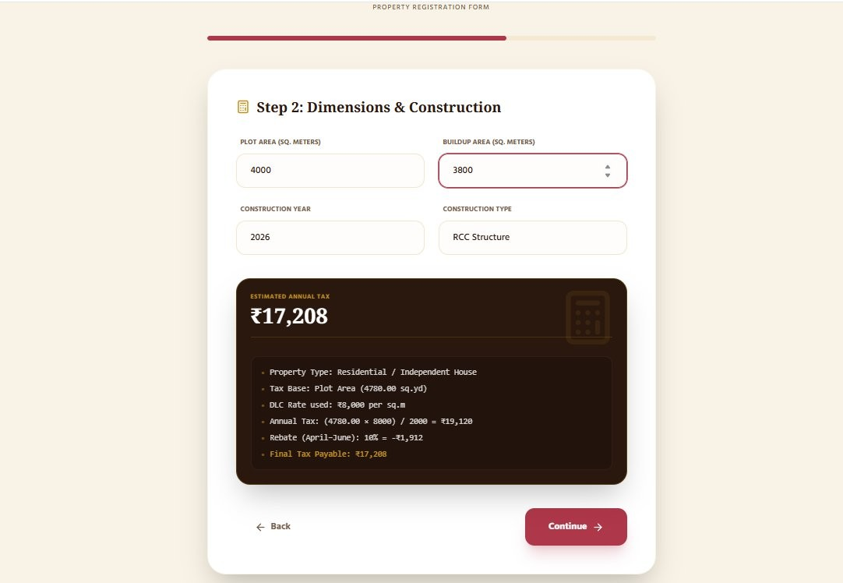
Figure 6.8: Tax Payment Interface

Department of Computer Science and Engineering (AI), SKIT, Jaipur 31

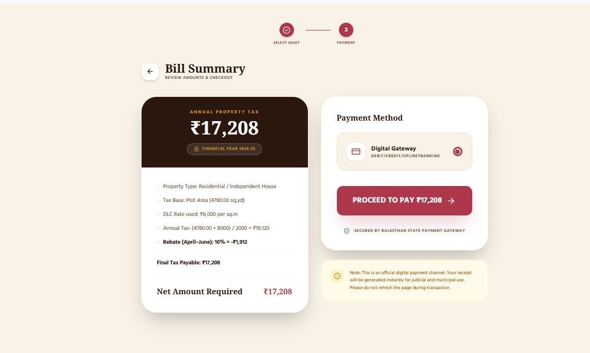
Figure 6.9: Bill Summary

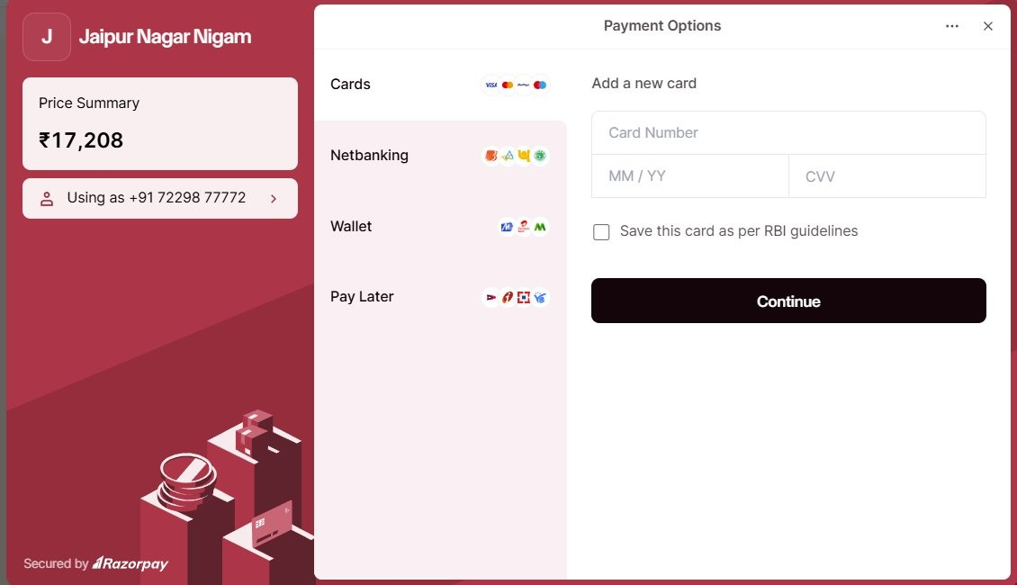
Figure 6.10: Razorpay Payment Gateway

Department of Computer Science and Engineering (AI), SKIT, Jaipur 32

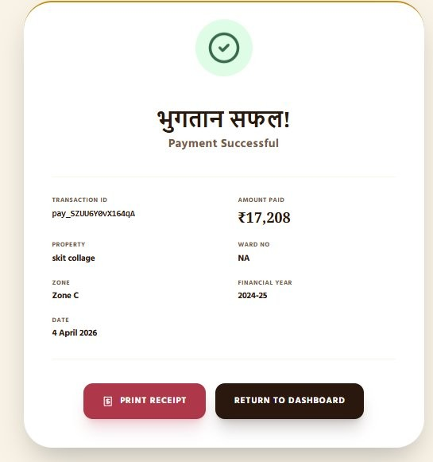
Figure 6.11: Payment Success Confirmation



Figure 6.12: Official Property Tax Receipt
Department of Computer Science and Engineering (AI), SKIT, Jaipur 33

Admin Section
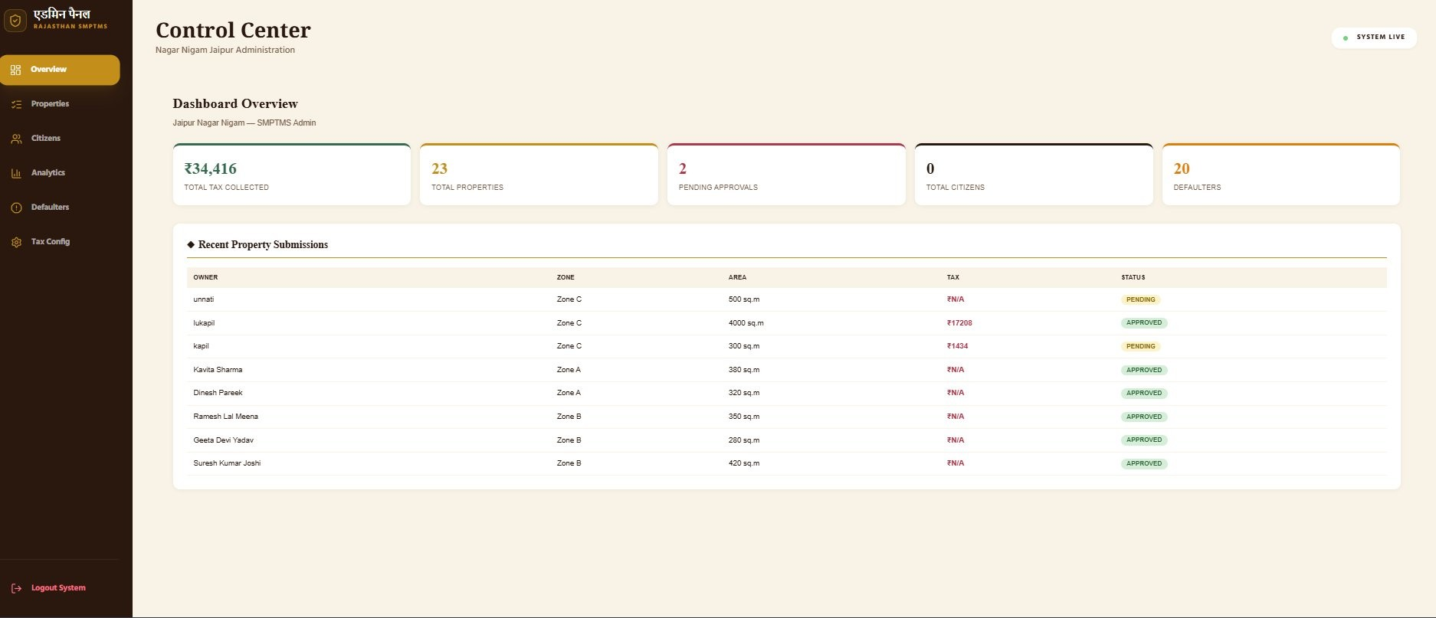
Figure 6.13: Admin Control Center

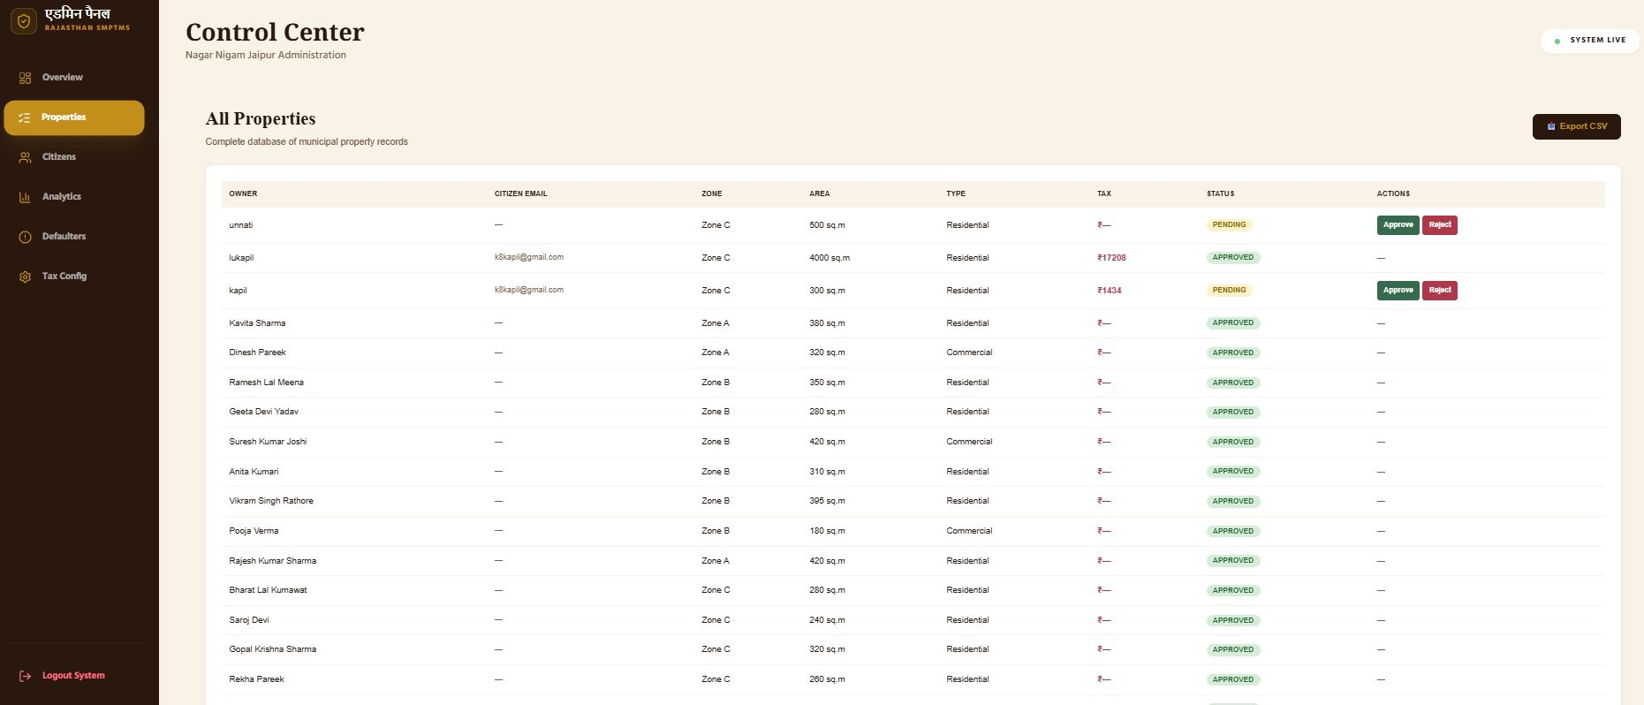
Figure 6.14: Property Records Management

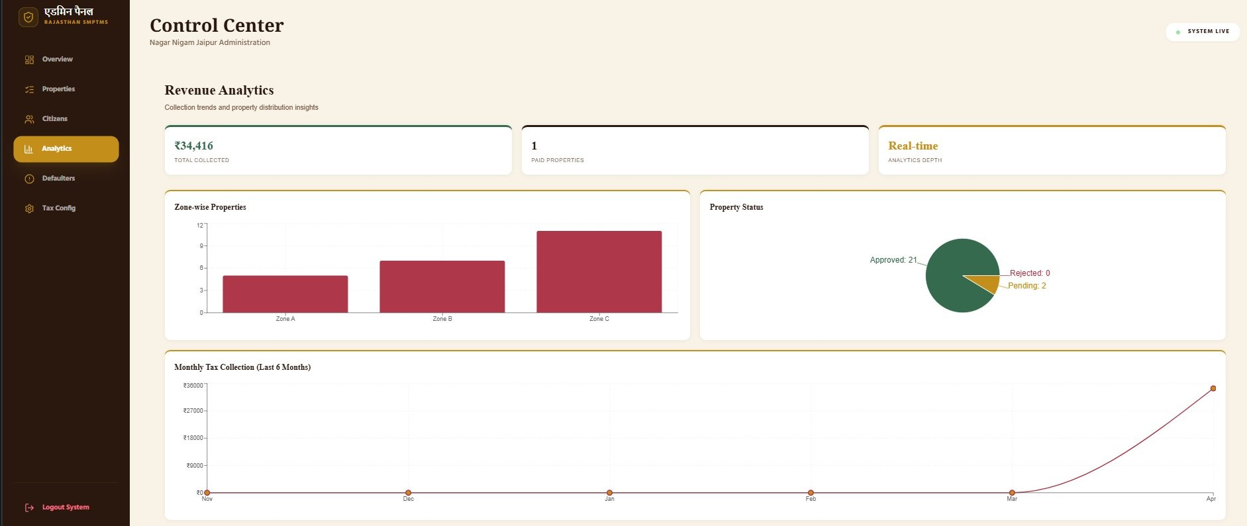
Figure 6.15: Analytics Reports Panel
Department of Computer Science and Engineering (AI), SKIT, Jaipur 34

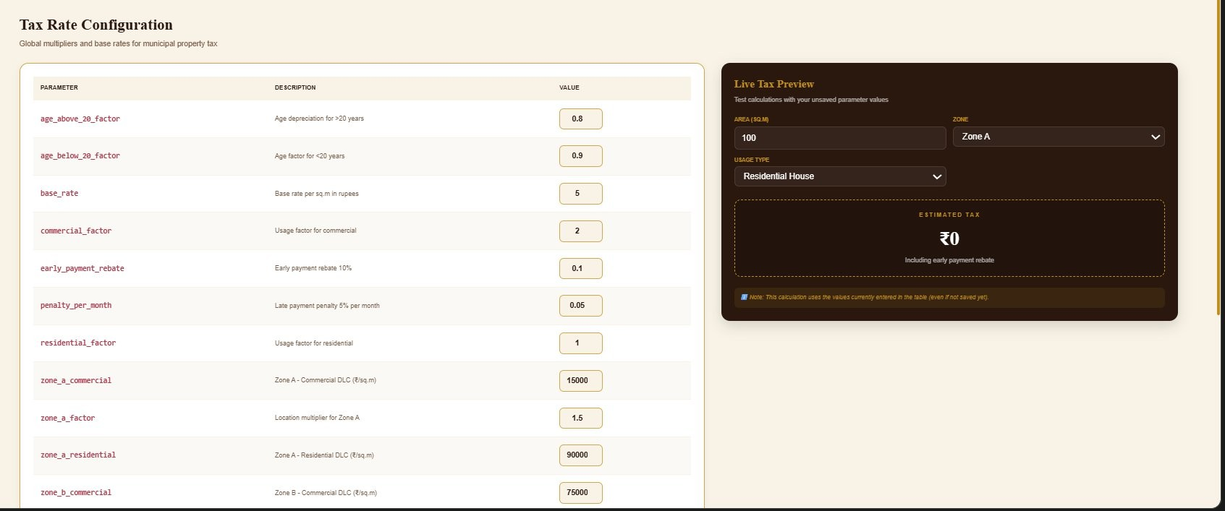
Figure 6.16: Tax Settings Configuration

City GIS Map
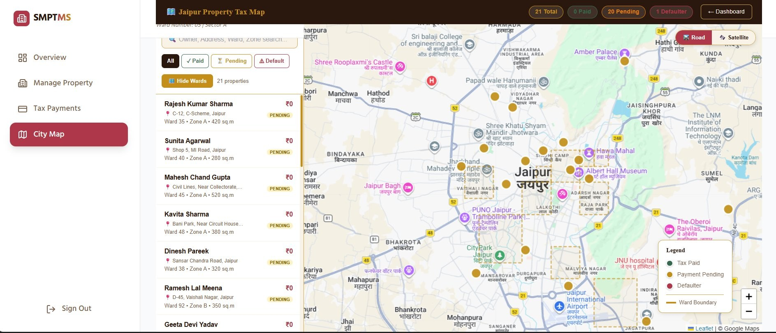
Figure 6.17: GIS Map View of Properties

Key Features Demonstration

Tax Calculation UI:

    - Citizens enter plot area and select DLC zone

    - Real-time tax calculation displayed with itemized breakdown

    - Formula displayed transparently: Tax = (Plot Area × DLC Rate) / 2000
Department of Computer Science and Engineering (AI), SKIT, Jaipur 35

GIS Map Features:

    - Interactive Leaflet.js map with Google Maps tile layer

    - Properties color-coded: Green (paid), Red (pending), Yellow (partial)

    - Clickable markers showing property details and payment status

Payment & Receipt Flow:

    - Razorpay modal for card/UPI/netbanking payments

    - Instant payment confirmation with database update

    - Downloadable PDF receipt with property details, tax amount, and transaction ID

Department of Computer Science and Engineering (AI), SKIT, Jaipur 36

Chapter 7
Conclusion and Future Scope

Project Conclusion

SMPTMS provides a digital, transparent, and efficient solution for property tax management. It reduces manual effort, improves user convenience, and enhances revenue collection for municipal authorities. The system successfully addresses the critical gaps in Jaipur Nagar Nigam’s existing manual tax administration by automat-ing the complete lifecycle from property registration to payment receipt generation.
Key Achievements:

    - Complete digitization of property tax workflow for Jaipur Nagar Nigam
    - Transparent tax calculation using the standardized DLC Rate formula
    - Secure online payments via Razorpay with automated receipt generation
    - GIS-based visualization enabling spatial analysis of tax compliance
    - Admin analytics dashboard providing real-time revenue insights
    - 100% test case pass rate across all modules

Lessons Learned

Technical Insights:

    - Supabase with Row-Level Security proved highly effective for multi-role data isolation
Department of Computer Science and Engineering (AI), SKIT, Jaipur 37

    - Next.js API routes provided seamless full-stack development experience

    - Razorpay webhook handling requires robust idempotency checks to prevent duplicate records
    - Leaflet.js with dynamic data loads requires careful performance optimization

Development Process:

    - Agile sprints enabled rapid iteration and early stakeholder feedback incorpora-tion
    - Early GIS integration testing prevented major architectural issues late in devel-opment
    - Municipal data standards (DLC rates, property classifications) required careful validation

Future Scope and Enhancements

Short-term Enhancements (6 months):

    - Mobile application development for Android and iOS

    - Multi-language support (Hindi/English)

    - SMS and email notifications for payment reminders

    - Bulk property import for initial data migration

Medium-term Features (1 year):

    - AI-based property analysis for automated valuation

    - Integration with existing municipal ERP systems

    - Advanced analytics with trend prediction for revenue forecasting
Department of Computer Science and Engineering (AI), SKIT, Jaipur 38

Long-term Vision (2+ years):

    - Blockchain integration for immutable property ownership records

    - Expansion to other Rajasthan municipalities (Jodhpur, Udaipur, Kota)

    - National-level deployment framework for smart city initiatives

Department of Computer Science and Engineering (AI), SKIT, Jaipur 39

Chapter 8
Sustainable Development Goals (SDG)

SDG Alignment

SDG 11: Sustainable Cities and Communities

    - Target 11.3: Enhance inclusive and sustainable urbanization and planning
    - Contribution: SMPTMS directly supports SDG 11 by improving urban gover-nance and municipal revenue systems through digital property tax management
    - Impact: Increased tax compliance improves funding for urban infrastructure, public services, and sustainable city development

SDG 16: Peace, Justice and Strong Institutions

    - Target 16.6: Develop effective, accountable, and transparent institutions
    - Contribution: Transparent DLC-based tax calculation reduces corruption and promotes fair governance
    - Impact: Citizens have access to clear tax breakdowns and digital receipts, re-ducing disputes

SDG 9: Industry, Innovation, and Infrastructure

    - Target 9.c: Significantly increase access to information and communications technology
    - Contribution: Digitizing a traditionally manual government service using mod-ern web technologies
Department of Computer Science and Engineering (AI), SKIT, Jaipur 40

Environmental Considerations

    - Cloud-based infrastructure eliminating need for local government servers

    - Paperless receipts and digital records reducing paper consumption

    - Remote access capability reducing citizen travel to municipal offices

    - Energy-efficient deployment on Vercel using renewable energy data centers

Social Impact

    - Improved tax compliance increases funding for public infrastructure and ser-vices
    - Accessible digital interface empowers citizens regardless of technical back-ground
    - Transparent tax calculation builds public trust in municipal governance

    - GIS data enables evidence-based urban planning decisions

    - Reduced corruption through automated, rule-based calculation and payment

Department of Computer Science and Engineering (AI), SKIT, Jaipur 41

REFERENCES

- Sharma, A., & Jain, K. (2022). Designing Geographic Information System Based Property Tax Assessment in India. Smart Cities, 5(1), 364–381. https:
//doi.org/10.3390/smartcities5010021

- Alimbuyog, R., & Flores, J. (2022). Rethinking real property assessment and tax management system through an interoperable e-government framework. Electronic Government, an International Journal, 18(4), 424–437. https:
//doi.org/10.1504/EG.2022.125921

- Okunogbe, O., & Tourek, G. (2022). A conceptual framework for digital tax ad-ministration – A systematic review. Government Information Quarterly, 39(3), 101692. https://doi.org/10.1016/j.giq.2022.101692
- Koibichuk, V., et al. (2023). E-Governance in Smart Cities: Global Trends and Key Enablers. Smart Cities, 6(4), 1–22. https://doi.org/10.3390/ smartcities6040078
- Brockmeyer, A., Estefan, A., Ram´ırez, K., & Sua´rez Serrato, J. C. (2022). Taxing Property in Developing Countries: Theory and Evidence from Mexico. NBER Working Paper No. 28637. https://www.nber.org/papers/w28637

Department of Computer Science and Engineering (AI), SKIT, Jaipur 42

Project Poster

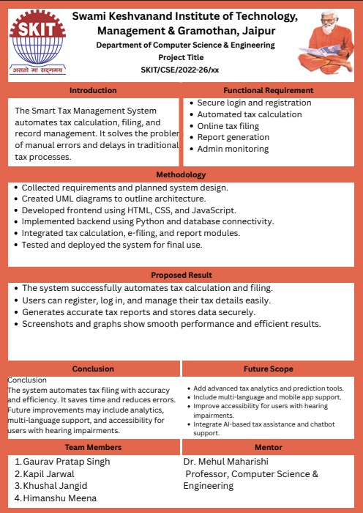
Figure 8.1: Project Poster

Department of Computer Science and Engineering (AI), SKIT, Jaipur 43

Certificate

Swami Keshvanand Institute of Technology, Management & Gramothan, Jaipur
Department of Computer Science and Engineering (AI)

This is to certify that the project report entitled ”Smart Property Tax Management System (SMPTMS)” is a record of an original work done by Khushal Jangid, Gaurav Pratap Singh, Kapil Jarwal, and Himanshu Meena in partial fulfillment of the requirements for the award of the degree of Bachelor of Technology in the Department of Computer Science and Engineering (AI).

Mentor Coordinator
Dr. Mehul Maharishi Mr. Manish Bharadwaj

Assistant Professor
Signature............ Signature............

Department of Computer Science and Engineering (AI), SKIT, Jaipur 44

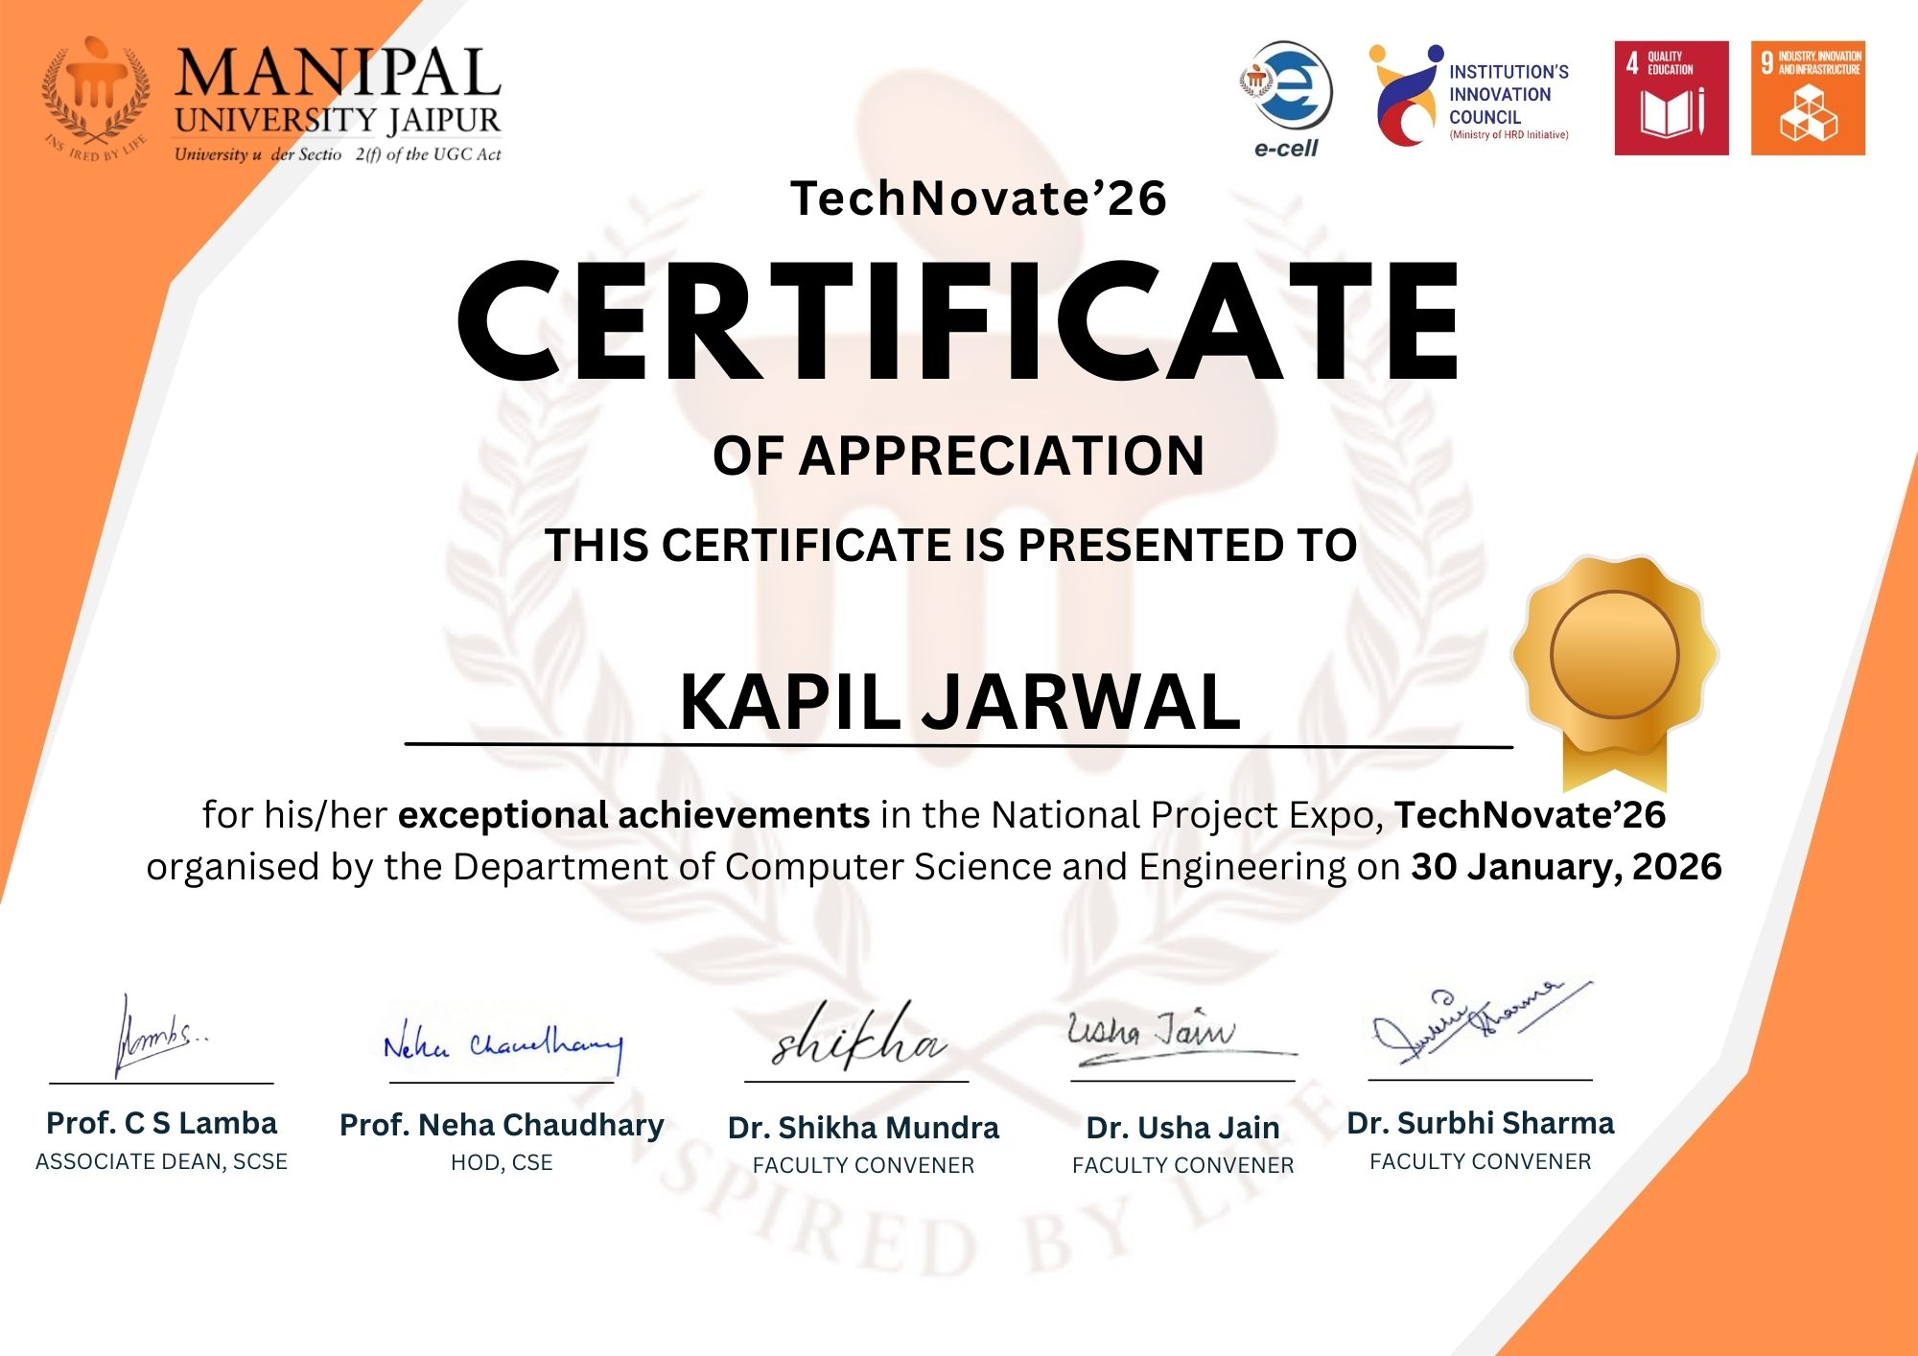
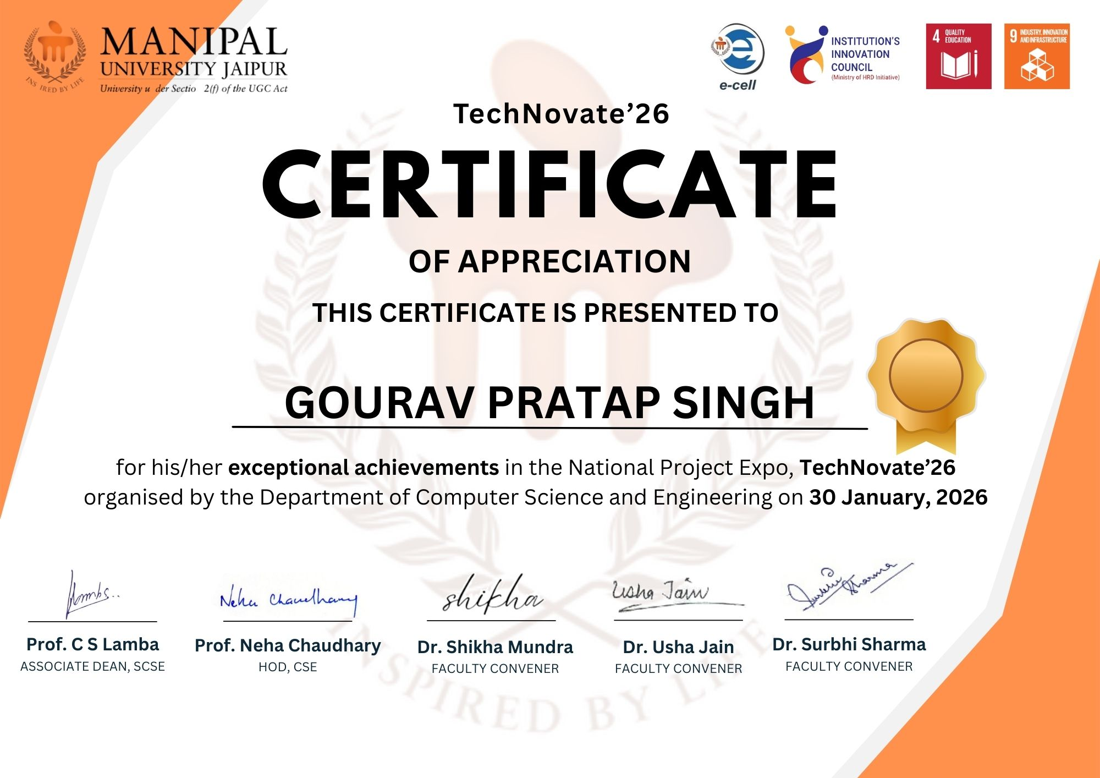

GitHub Link

Project Repository

The complete source code, documentation, and project resources for SMPTMS are available in the GitHub repository.
Repository Details:

- Project Name: Smart Property Tax Management System (SMPTMS)
- Project ID: SKIT/2022-26/AI/Group-03
- GitHub URL: https://github.com/kapilk8/smptms
- Live Project Link: https://smptms.vercel.app
- Technologies Used: Next.js, TypeScript, Supabase, Tailwind CSS, Leaflet.js, Razorpay
- Hosting Platform: Vercel
- Database: PostgreSQL (Supabase)
- Access: Private Repository

Repository Structure:

- src/app — Next.js 14 App Router pages and API routes
- src/components — Reusable UI components (Map, PaymentModal, Receipt)
- src/lib — Supabase client, Razorpay helpers, tax calculation utilities
- public — Static assets and fonts
- supabase — Database migrations and RLS policy definitions
Department of Computer Science and Engineering (AI), SKIT, Jaipur 45

