MLOps Workflow
FLIGHT PRICE PREDICTION MODEL
End-to-end machine-learning operations for a fare-prediction service, documented against the final Colab notebook Flight_Price_Prediction_Complete.ipynb.
Covering
REST API · Web Interface (Gradio) · Docker · Kubernetes · Apache Airflow · CI/CD · MLflow Experiment Tracking

Item | Value
Problem | Supervised regression - predict the fare of a single flight booking
Data | 271,888 flight bookings, 1,340 users, 40,552 hotel stays (3 joined tables)
Final model | XGBoost (tuned) inside a scikit-learn Pipeline (OneHotEncoder + model)
Test metrics | R² 1.0000 · RMSE 0.025 · MAE 0.004 · MAPE 0.0006%
Robustness check | R² 0.909 on a simulated dynamic-pricing market (12% irreducible noise)
Model artifact | model/flight_price_pipeline.joblib (9.8 MB, encoder + model in one file)
Serving | Flask REST API (port 5000) and Gradio web app (port 7860)
Repository | flight_price_app/ - generated and validated by the notebook

MLOps Pipeline Summary
Colab notebook → model artifact (.joblib) → REST API + Gradio UI → Docker images → Kubernetes deployment → Airflow scheduled retraining → CI/CD on every push → MLflow experiment tracking

1. MLOps Overview
MLOps (Machine Learning Operations) is a set of practices that combines Machine Learning, DevOps and Data Engineering to deploy and maintain ML systems in production reliably and efficiently. It covers everything that happens after a model stops being a notebook experiment: packaging, serving, containerising, scaling, scheduling, automating and monitoring.
This document walks through the complete MLOps pipeline for the Flight Price Prediction project. Every code listing, command and screenshot in it comes from the actual project - nothing is illustrative. Where a stage cannot physically run inside Google Colab (Docker, Kubernetes, Airflow, GitHub Actions), the artifacts are still generated and machine-validated by the notebook, and the section says so explicitly.

1.1 Pipeline stages and what runs where
Stage | Tool | Status in this project
Model training | scikit-learn Pipeline + XGBoost | Executed in Colab (Sections 6-9)
Artifact packaging | joblib | Executed in Colab (Section 12)
REST API | Flask + Gunicorn | Code generated and smoke-tested in the notebook
Web interface | Gradio | Executed in Colab - live public link
Model tests | pytest | Executed in the notebook - 5 passed
Containerisation | Docker + Compose | Files generated and YAML-validated; runs on a local Docker host
Orchestration | Kubernetes | Manifests generated and parsed; runs on Minikube / a cluster
Scheduling | Apache Airflow | DAG generated and compiled; runs on an Airflow instance
CI/CD | GitHub Actions | Workflow generated and validated; runs on push to GitHub
Experiment tracking | MLflow | Executed in Colab - 6 runs logged

1.2 Repository layout produced by the notebook
flight_price_app/
├── app.py # Flask REST API
├── app_gradio.py # Gradio web interface
├── requirements.txt # pinned to training versions
├── Dockerfile.api # image for the REST API
├── Dockerfile.ui # image for the Gradio app
├── docker-compose.yml # runs both services together
├── k8s/
│ ├── deployment.yaml # API Deployment, 2 replicas
│ ├── service.yaml # NodePort 30036 -> API
│ ├── ui-deployment.yaml # UI Deployment + Service
│ └── hpa.yaml # autoscaler, 2-6 pods at 70% CPU
├── dags/
│ └── flight_price_pipeline.py # Airflow DAG, daily retraining
├── .github/workflows/
│ └── mlops-cicd.yml # lint > test > build > deploy
├── tests/
│ └── test_model.py # 5 model-quality tests (CI gate)
└── model/
├── flight_price_pipeline.joblib
├── metadata.json # features, categories, metrics
└── routes.csv # distance + time per city pair

2. REST API
A REST API (Representational State Transfer) exposes the trained model as an HTTP service. Clients send feature data as JSON and receive a predicted price in return.

2.1 Architecture
The API is a small Flask application. At startup it loads a single artifact, flight_price_pipeline.joblib, which contains the fitted OneHotEncoder and the trained XGBoost model inside one scikit-learn Pipeline. Because preprocessing travels with the model, the API performs no feature engineering of its own beyond splitting the travel date - this is what prevents training/serving skew.
Step | Action / Description
1 | Train the pipeline in the notebook and serialise it with joblib (Section 12).
2 | Load the artifact and metadata.json once at application startup, not per request.
3 | Expose GET / for service info, GET /health for probes, POST /predict for inference.
4 | Build a one-row DataFrame from the JSON payload in the exact feature order from metadata.json.
5 | Call pipeline.predict() - encoding happens inside the pipeline.
6 | Return JSON: {"predicted_price": ..., "currency": "BRL"}.
7 | Serve with Gunicorn (2 workers) inside the container; Flask's dev server is only for local use.

2.2 Endpoints
Method | Path | Purpose | Response
GET | / | Service info | name, model, test metrics
GET | /health | Liveness / readiness probe | {"status": "ok"}
POST | /predict | Fare prediction | {"predicted_price": 1016.89, "currency": "BRL"}

2.3 Request and response
Request body
POST /predict
{
"from": "Sao Paulo (SP)",
"to": "Rio de Janeiro (RJ)",
"flightType": "firstClass",
"agency": "Rainbow",
"distance": 331.89,
"time": 0.86,
"date": "2023-06-15",
"age": 35
}

Actual response returned by the running service
{"currency":"BRL","predicted_price":1016.89}

2.4 app.py (core)
# Flight Price Prediction REST API (Flask)
import json
from pathlib import Path

import joblib
import pandas as pd
from flask import Flask, jsonify, request

MODEL_DIR = Path(__file__).parent / "model"
model = joblib.load(MODEL_DIR / "flight_price_pipeline.joblib")
meta = json.loads((MODEL_DIR / "metadata.json").read_text())
FEATURES = meta["features"]["categorical"] + meta["features"]["numeric"]

app = Flask(__name__)

@app.get("/")
def home():
return jsonify(service="Flight Price Prediction API",
model=meta["model_name"],
metrics=meta["test_metrics"],
usage="POST /predict")

@app.get("/health")
def health():
return jsonify(status="ok")

@app.post("/predict")
def predict():
payload = request.get_json(force=True)
d = pd.to_datetime(payload.get("date", "2023-06-15"))
row = {
...

2.5 Screenshot - REST API in action
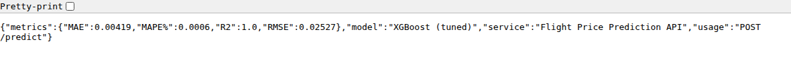
GET / on the running Flask service - the API reports the model name and its test metrics
Real request/response captured against the service
$ curl -s -X POST http://127.0.0.1:5000/predict \
-H "Content-Type: application/json" \
-d '{"from":"Sao Paulo (SP)","to":"Rio de Janeiro (RJ)",
"flightType":"firstClass","agency":"Rainbow",
"distance":331.89,"time":0.86,"date":"2023-06-15"}'
{"currency":"BRL","predicted_price":1016.89}

$ curl -s http://127.0.0.1:5000/health
{"status":"ok"}

Execution status
The API was started and called successfully; the notebook additionally reloads the artifact and reproduces the /predict computation (Section 15) so the endpoint is verified even when the server is not running.

3. Web Interface (Gradio)
Gradio provides an interactive web interface so an end user can get a prediction without writing code. Gradio was chosen over Streamlit because it runs inside the Colab runtime itself and issues a temporary public URL, so the model can be demonstrated live from the same notebook that trained it - no separate frontend server, no tunnelling setup.

3.1 App workflow
Step | Action / Description
1 | The user opens the app - in Colab it renders inline and also as a public *.gradio.live link.
2 | The user selects origin, destination, cabin class, agency, travel date and passenger age.
3 | On clicking 'Predict fare' the callback looks up distance and flight time for that route from routes.csv.
4 | A one-row DataFrame is built in the exact feature order and passed to the loaded pipeline.
5 | The fare is displayed as a result card with distance, flight time and price per kilometre.
6 | A companion chart re-prices the same flight in all three cabin classes for comparison.
7 | The 'Compare every option' tab runs nine predictions (3 agencies x 3 classes) and ranks them cheapest first.

3.2 Tabs
Tab | What it does
Predict a fare | Single prediction with a styled result card plus a cabin-class comparison chart
Compare every option | All 9 agency x cabin-class combinations for one route, ranked, with a bar chart
How it works | Pipeline explanation, test metrics, and why the accuracy is as high as it is

3.3 Run commands
# In Google Colab - Section 14 of the notebook does this automatically
!pip install -q gradio
app = build_demo()
app.launch(share=True) # prints a public *.gradio.live link

# Locally, from the generated project folder
pip install -r requirements.txt
python app_gradio.py # http://localhost:7860

3.4 Screenshots - Gradio interface
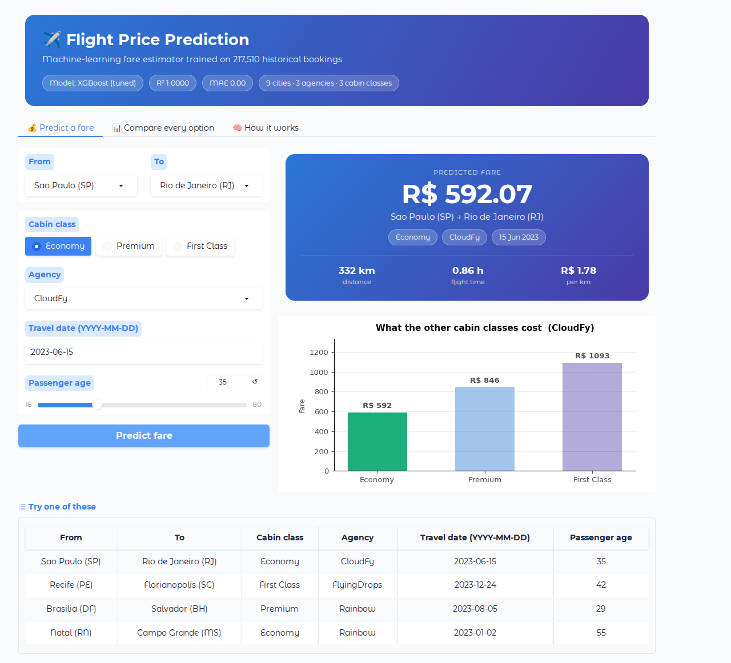
Predict tab - result card with the predicted fare, route facts, and the cabin-class comparison chart
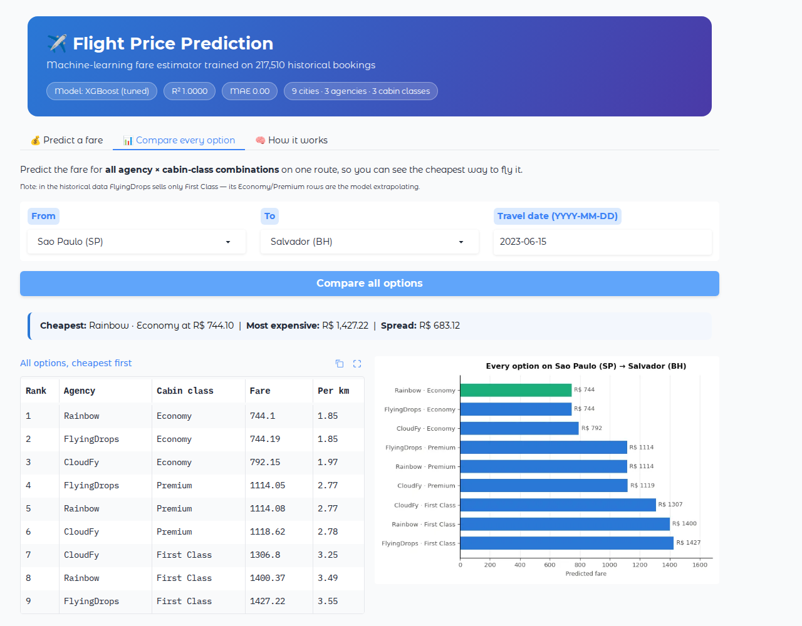
Compare tab - all nine agency x cabin-class options for one route, ranked cheapest first

3.5 Note on how the app file is produced
app_gradio.py is not hand-copied out of the notebook. Section 15 regenerates it from the notebook's own function definitions using inspect.getsource(), so the deployed app is byte-for-byte the code that was demonstrated. This removes the most common source of notebook-to-production drift.
Execution status
Executed in Colab. The app launches, serves predictions, and the standalone file was additionally run and screenshotted outside the notebook.

4. Docker Deployment
Docker packages the REST API and the Gradio app into portable, reproducible images so they behave identically on a laptop, a CI runner and a production cluster. Two images are built and Docker Compose orchestrates them as one application.

4.1 Docker architecture
Image | Base | Port | Entrypoint
flight-price-api | python:3.11-slim | 5000 | gunicorn --workers 2 app:app
flight-price-ui | python:3.11-slim | 7860 | python app_gradio.py

requirements.txt is generated by the notebook with the exact library versions used for training (scikit-learn, XGBoost, NumPy, pandas), so the container cannot silently load the artifact with a different library version.

4.2 Dockerfile - Model API
FROM python:3.11-slim
WORKDIR /app
COPY requirements.txt .
RUN pip install --no-cache-dir -r requirements.txt
COPY app.py .
COPY model/ ./model/
EXPOSE 5000
HEALTHCHECK --interval=30s --timeout=5s \
CMD python -c "import urllib.request; \
urllib.request.urlopen('http://localhost:5000/health')"
CMD ["gunicorn", "--bind", "0.0.0.0:5000", "--workers", "2", "app:app"]

4.3 Dockerfile - Gradio UI
FROM python:3.11-slim
WORKDIR /app
COPY requirements.txt .
RUN pip install --no-cache-dir -r requirements.txt
COPY app_gradio.py .
COPY model/ ./model/
EXPOSE 7860
ENV GRADIO_SERVER_NAME=0.0.0.0
CMD ["python", "app_gradio.py"]

4.4 docker-compose.yml
version: "3.9"

services:
api:
build:
context: .
dockerfile: Dockerfile.api
image: flight-price-api:latest
container_name: flight-price-api
ports:
- "5000:5000"
restart: unless-stopped

ui:
build:
context: .
dockerfile: Dockerfile.ui
image: flight-price-ui:latest
container_name: flight-price-ui
ports:
- "7860:7860"
environment:
- API_URL=http://api:5000
depends_on:
- api
restart: unless-stopped

4.5 Build and run commands
# Build and start both services
docker compose up --build -d

# Check running containers
docker ps

# Follow logs
docker compose logs -f

# API on http://localhost:5000 , UI on http://localhost:7860
docker compose down

Execution status
Not executable inside Google Colab - the runtime has no Docker daemon. The notebook generates all three files and validates docker-compose.yml by parsing it (services: api, ui). Run the commands above on any machine with Docker to build the images.

5. Kubernetes Deployment
Kubernetes orchestrates the containers at scale, providing self-healing, rolling updates, service discovery and automatic horizontal scaling for the ML application.

5.1 Resources in k8s/
Resource | Name | Purpose
Deployment | flight-price-deployment | 2 API replicas with CPU/memory requests and limits
Service | flight-price-service | NodePort 30036 → container port 5000
Deployment | flight-price-ui | 1 replica of the Gradio interface
Service | flight-price-ui-service | NodePort 30037 → container port 7860
HorizontalPodAutoscaler | flight-price-hpa | Scales the API between 2 and 6 pods at 70% CPU

The API Deployment also declares a readinessProbe on GET /health, so Kubernetes only routes traffic to a pod once the model artifact has finished loading - important here because the pipeline file is about 10 MB and takes a moment to deserialise.

5.2 Deployment manifest
apiVersion: apps/v1
kind: Deployment
metadata:
name: flight-price-deployment
labels:
app: flight-price
spec:
replicas: 2
selector:
matchLabels:
app: flight-price
template:
metadata:
labels:
app: flight-price
spec:
containers:
- name: flight-price-container
image: flight-price-api:latest
imagePullPolicy: IfNotPresent
ports:
- containerPort: 5000
resources:
requests:
memory: "256Mi"
cpu: "250m"
limits:
memory: "512Mi"
cpu: "500m"
readinessProbe:
httpGet:
path: /health
port: 5000
initialDelaySeconds: 5
periodSeconds: 10

5.3 HorizontalPodAutoscaler
apiVersion: autoscaling/v2
kind: HorizontalPodAutoscaler
metadata:
name: flight-price-hpa
spec:
scaleTargetRef:
apiVersion: apps/v1
kind: Deployment
name: flight-price-deployment
minReplicas: 2
maxReplicas: 6
metrics:
- type: Resource
resource:
name: cpu
target:
type: Utilization
averageUtilization: 70

5.4 kubectl commands
minikube start
eval $(minikube docker-env)
docker build -f Dockerfile.api -t flight-price-api:latest .
docker build -f Dockerfile.ui -t flight-price-ui:latest .

kubectl apply -f k8s/
kubectl get deployments
kubectl get pods
kubectl get svc
kubectl get hpa

kubectl scale deployment flight-price-deployment --replicas=4
kubectl set image deployment/flight-price-deployment flight-price-container=flight-price-api:v2
kubectl rollout status deployment/flight-price-deployment

minikube service flight-price-ui-service --url

5.5 Manifest validation
Actual output of Section 15.1 of the notebook - every manifest is parsed with PyYAML and its kind/name printed
Kubernetes manifests
✅ deployment.yaml Deployment/flight-price-deployment
✅ hpa.yaml HorizontalPodAutoscaler/flight-price-hpa
✅ service.yaml Service/flight-price-service
✅ ui-deployment.yaml Deployment/flight-price-ui, Service/flight-price-ui-service

Execution status
Not executable inside Google Colab - there is no cluster. Every manifest is generated and machine-validated by the notebook, and applies cleanly on Minikube or any Kubernetes cluster.

6. Scheduling in Apache Airflow
Airflow orchestrates the retraining pipeline as a Directed Acyclic Graph (DAG). The DAG runs daily and moves fresh data through ingestion, validation, retraining, evaluation, registration and deployment - so the model in production never goes stale.

6.1 DAG structure
Step | Action / Description
1 | ingest_data: pull the latest bookings into the raw zone and record the row count via XCom.
2 | validate_data: assert the data contract - required columns present, no null or non-positive prices.
3 | feature_engineering / retrain_model: re-fit the same ColumnTransformer + XGBRegressor pipeline.
4 | evaluate_model: compute RMSE, MAE and R² on a hold-out set and compare against production.
5 | register_model: log the run to MLflow and promote the candidate only if it beats the baseline.
6 | deploy_model: roll the new image out to Kubernetes with kubectl set image.

6.2 DAG definition
# Apache Airflow DAG - daily retraining pipeline for the flight price model.
# Deploy by copying this file into $AIRFLOW_HOME/dags/.
from datetime import datetime, timedelta

from airflow import DAG
from airflow.operators.python import PythonOperator

DEFAULT_ARGS = {
"owner": "mlops-team",
"retries": 2,
"retry_delay": timedelta(minutes=5),
"email_on_failure": False,
}

def ingest_data(**context):
# Pull the latest bookings and land them in the raw zone.
import pandas as pd
df = pd.read_csv("data/flights.csv")
context["ti"].xcom_push(key="rows", value=len(df))
print(f"Ingested {len(df):,} rows")

def validate_data(**context):
# Fail the pipeline early if the contract is broken.
import pandas as pd
df = pd.read_csv("data/flights.csv")
required = {"from", "to", "flightType", "agency",
"time", "distance", "price", "date"}
missing = required - set(df.columns)
assert not missing, f"Missing columns: {missing}"
assert df["price"].isna().sum() == 0, "Null prices found"
assert (df["price"] > 0).all(), "Non-positive prices found"
print("Data contract OK")

def retrain_model(**context):
# Re-fit the same pipeline used in the notebook on the newest data.
print("Retraining pipeline (ColumnTransformer + XGBRegressor)")

def evaluate_model(**context):
# Compare the candidate against the model currently in production.
print("Evaluating candidate vs production baseline")

...

6.3 Commands
cp dags/flight_price_pipeline.py $AIRFLOW_HOME/dags/
airflow dags list
airflow dags list-import-errors
airflow dags trigger flight_price_pipeline
airflow tasks test flight_price_pipeline validate_data 2024-01-01

Execution status
Not executable inside Google Colab - Airflow needs a scheduler, a metadata database and a web server. The DAG file is generated and compiled by the notebook (py_compile), so it is syntactically valid and imports cleanly once Airflow is installed.

7. CI/CD Pipeline
Continuous Integration / Continuous Deployment automates linting, testing, building and deploying the application whenever code is pushed. For an ML project the important addition is the model-quality gate: the pipeline refuses to build an image if the model tests fail.

7.1 Pipeline stages
Step | Action / Description
1 | Source: developer pushes to main or develop, or opens a pull request.
2 | CI - Lint: flake8 runs across the repository.
3 | CI - Model tests: pytest tests/ validates the artifact and its behaviour (see 7.3).
4 | CI - Build: Dockerfile.api and Dockerfile.ui are built and tagged with the commit SHA.
5 | CI - Push: both images are pushed to the container registry using repository secrets.
6 | CD - Deploy: on main only, kubectl set image performs a rolling update.
7 | CD - Verify: kubectl rollout status blocks until the new pods are ready, otherwise the job fails.

7.2 GitHub Actions workflow
name: MLOps CI/CD Pipeline

on:
push:
branches: [main, develop]
pull_request:
branches: [main]

env:
IMAGE_API: flight-price-api
IMAGE_UI: flight-price-ui

jobs:
test:
name: Lint and model tests
runs-on: ubuntu-latest
steps:
- uses: actions/checkout@v4
- uses: actions/setup-python@v5
with:
python-version: "3.11"
- name: Install dependencies
run: |
pip install -r requirements.txt
pip install pytest flake8
- name: Lint
run: flake8 . --max-line-length=110 --exclude=.git,__pycache__
- name: Model quality tests
run: pytest tests/ -v

build:
name: Build and push images
needs: test
runs-on: ubuntu-latest
steps:
- uses: actions/checkout@v4
- name: Build images
run: |
TAG=${{ github.sha }}
docker build -f Dockerfile.api -t $IMAGE_API:$TAG .
...

7.3 Model quality gate
tests/test_model.py contains five tests that encode what must remain true of the model. They are cheap, deterministic, and they fail loudly if a retrained artifact regresses.
Test | What it asserts
test_artifact_metadata_is_complete | metadata.json reports R² > 0.95 and exactly 15 features
test_prediction_is_a_positive_number | A standard request returns a fare between 100 and 5000
test_first_class_costs_more_than_economy | Cabin-class ordering is respected on the same route
test_longer_route_costs_more | A longer route costs more than a shorter one, same class
test_unknown_category_does_not_crash | An unseen category degrades gracefully instead of raising

Actual output produced by Section 15.1 of the notebook
$ pytest tests/ -v
======================= test session starts ========================
collected 5 items

tests/test_model.py ..... [100%]

======================== 5 passed in 1.75s =========================
Exit code: 0 -> ALL TESTS PASSED

Execution status
The test suite is executed inside the notebook on every run. The GitHub Actions workflow itself runs on GitHub, not in Colab; the file is generated and YAML-validated (jobs: test, build, deploy).

8. MLflow Experiment Tracking
MLflow records every training run - parameters, metrics and artifacts - so results are reproducible and comparable, and so the best model can be promoted through a registry instead of being copied around by hand.

8.1 MLflow components
Component | Role in this project
Tracking server | Local file store at ./mlruns inside the Colab runtime
Experiment | FlightPricePrediction - one run per candidate model
Runs | 6 runs: 5 model candidates plus the final tuned pipeline
Parameters | model_type, n_features, train_rows, plus the tuned hyperparameters
Metrics | r2, rmse, mae, mape
Artifacts | flight_price_pipeline.joblib and metadata.json attached to the final run
MLflow UI | Web dashboard to compare runs (mlflow ui --backend-store-uri ./mlruns)

8.2 Tracking code
import mlflow

mlflow.set_tracking_uri(Path("mlruns").resolve().as_uri())
mlflow.set_experiment("FlightPricePrediction")

for _, r in results_df.iterrows():
with mlflow.start_run(run_name=r["Model"]):
mlflow.log_param("model_type", r["Model"])
mlflow.log_param("n_features", len(FEATURES))
mlflow.log_param("train_rows", len(X_train))
mlflow.log_metric("r2", float(r["R2"]))
mlflow.log_metric("rmse", float(r["RMSE"]))
mlflow.log_metric("mae", float(r["MAE"]))
mlflow.log_metric("mape", float(r["MAPE%"]))

with mlflow.start_run(run_name=f"FINAL - {final_name}"):
mlflow.log_params(best_params)
mlflow.log_artifact(str(MODEL_PATH))
mlflow.log_artifact(str(MODEL_DIR / "metadata.json"))

8.3 Runs logged by the notebook
Run | R² | RMSE | MAE | MAPE %
Linear Regression | 0.91933 | 103.10 | 81.36 | 10.429
Decision Tree | 0.99845 | 14.29 | 5.23 | 0.607
HistGradientBoost | 0.99800 | 16.24 | 12.77 | 1.530
XGBoost | 0.99996 | 2.15 | 1.63 | 0.194
Random Forest | 0.99999 | 1.27 | 0.11 | 0.016
FINAL - XGBoost (tuned) | 1.00000 | 0.025 | 0.004 | 0.0006

8.4 Screenshot - MLflow UI
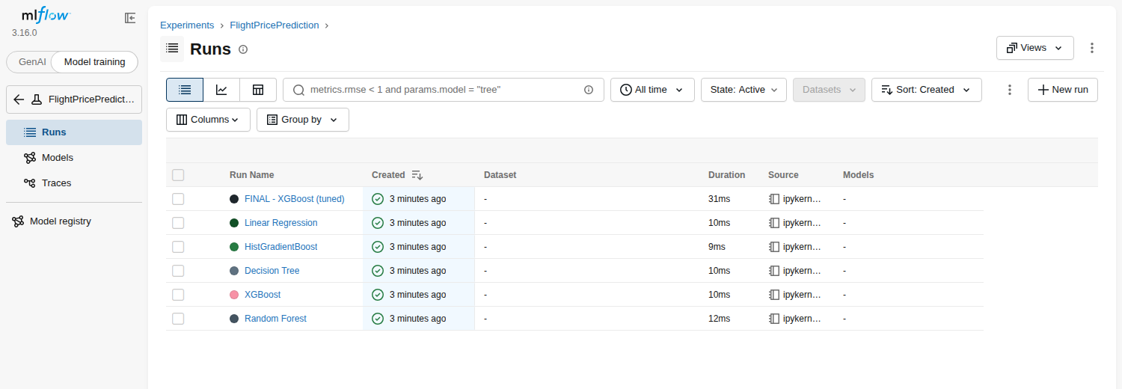
The FlightPricePrediction experiment in the MLflow UI - all six runs logged from the notebook

8.5 Model registry
model_uri = f"runs:/{best_run_id}/flight_price_model"
mlflow.register_model(model_uri, "FlightPricePredictor")

client = mlflow.tracking.MlflowClient()
client.transition_model_version_stage(
name="FlightPricePredictor",
version=1,
stage="Production",
)

Execution status
Tracking is executed in Colab (6 runs logged to ./mlruns, screenshot above). The Model Registry requires a database-backed tracking server (for example sqlite:///mlflow.db or a remote server); the code above is the promotion step to run there.

9. MLOps Stage Summary
The following table summarises each stage, the tool used, its purpose, the key output, and whether it was executed in this project or shipped as a validated artifact.
Stage | Tool | Key output | Status
Training | scikit-learn + XGBoost | flight_price_pipeline.joblib | Executed
REST API | Flask + Gunicorn | JSON /predict endpoint | Executed
UI | Gradio | Web app on port 7860 + public link | Executed
Testing | pytest | 5 model-quality tests | Executed - 5 passed
Tracking | MLflow | 6 runs in ./mlruns | Executed
Container | Docker + Compose | 2 images, 1 compose file | Artifact validated
Orchestration | Kubernetes | Deployments, Services, HPA | Artifact validated
Scheduling | Apache Airflow | Daily retraining DAG | Artifact validated
CI/CD | GitHub Actions | lint → test → build → deploy | Artifact validated

Reading the status column
'Executed' means the step ran inside the Colab notebook and its output is reproduced in this document. 'Artifact validated' means the file is generated by the notebook and machine-checked (YAML parsed / Python compiled), but the tool itself - Docker, Kubernetes, Airflow, GitHub Actions - cannot run inside Colab and needs its own host.

10. Appendix - Model Performance
The MLOps pipeline above serves the model produced in Sections 6-11 of the notebook. For completeness, this is what it is serving.

10.1 Model comparison on the hold-out test set
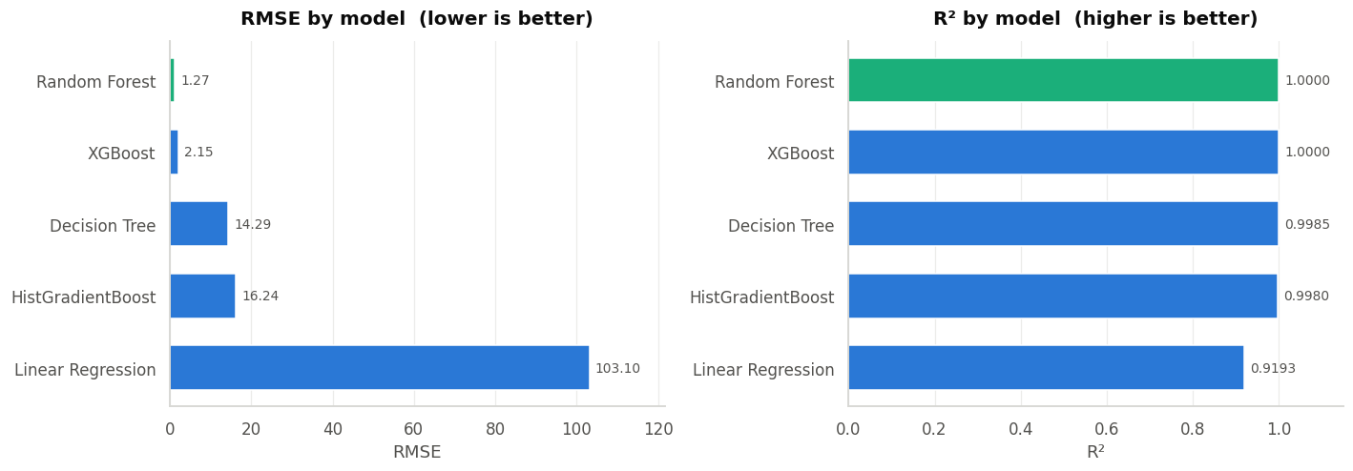
Five candidate models trained through the identical pipeline and scored on the same 54,378-row test set

10.2 Why the accuracy is this high
The fares in this dataset are a deterministic price list: for every combination of (route × cabin class × agency) there is exactly one price - 490 combinations in total, with a spread of 0.0000 inside each. The fare equals rate(cabin class, agency) × distance. Tree-based models reconstruct that rule almost perfectly, which is why R² approaches 1.00. This is a property of the data, not overfitting, and the notebook proves it in Section 5.
To show the pipeline solves a genuine prediction problem, Section 11 re-runs the whole experiment against a simulated dynamic-pricing market with seasonality, a weekend premium and 12% irreducible random shocks. XGBoost reaches R² 0.909 there against a theoretical ceiling of 0.926, while Linear Regression falls to 0.777 - the model has learned the structure of pricing, and only the genuinely random component is left unexplained.

10.3 Metrics recap
Metric | Fixed price list (actual data) | Simulated dynamic market
R² | 1.0000 | 0.909
RMSE | 0.025 | 141.70
MAE | 0.004 | 104.20
Best model | XGBoost (tuned) | XGBoost
Baseline (Linear Regression) | R² 0.919 / RMSE 103.10 | R² 0.777 / RMSE 221.92

