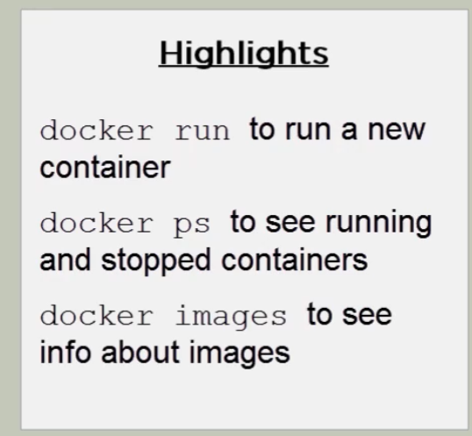

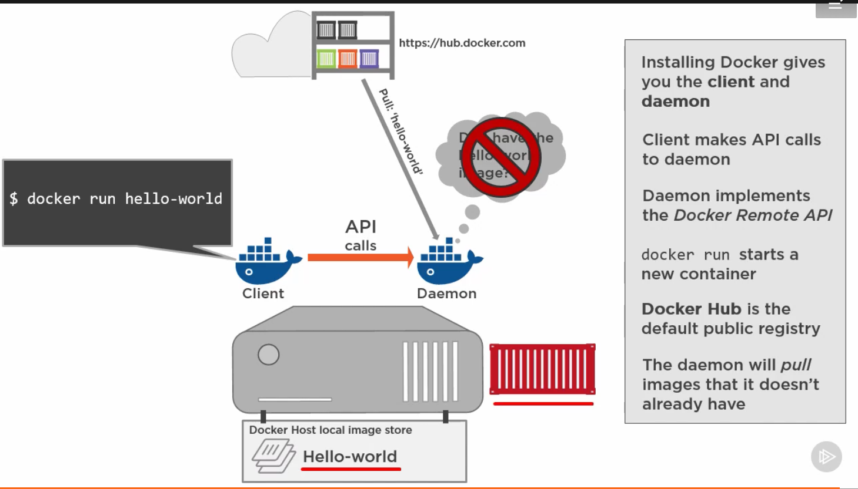

To remove all docker containers

FOR /f "tokens=\*" %i IN ('docker ps -aq') DO docker rm %i

To stop all docker containers

FOR /f "tokens=\*" %i IN ('docker ps -aq') DO docker stop %i

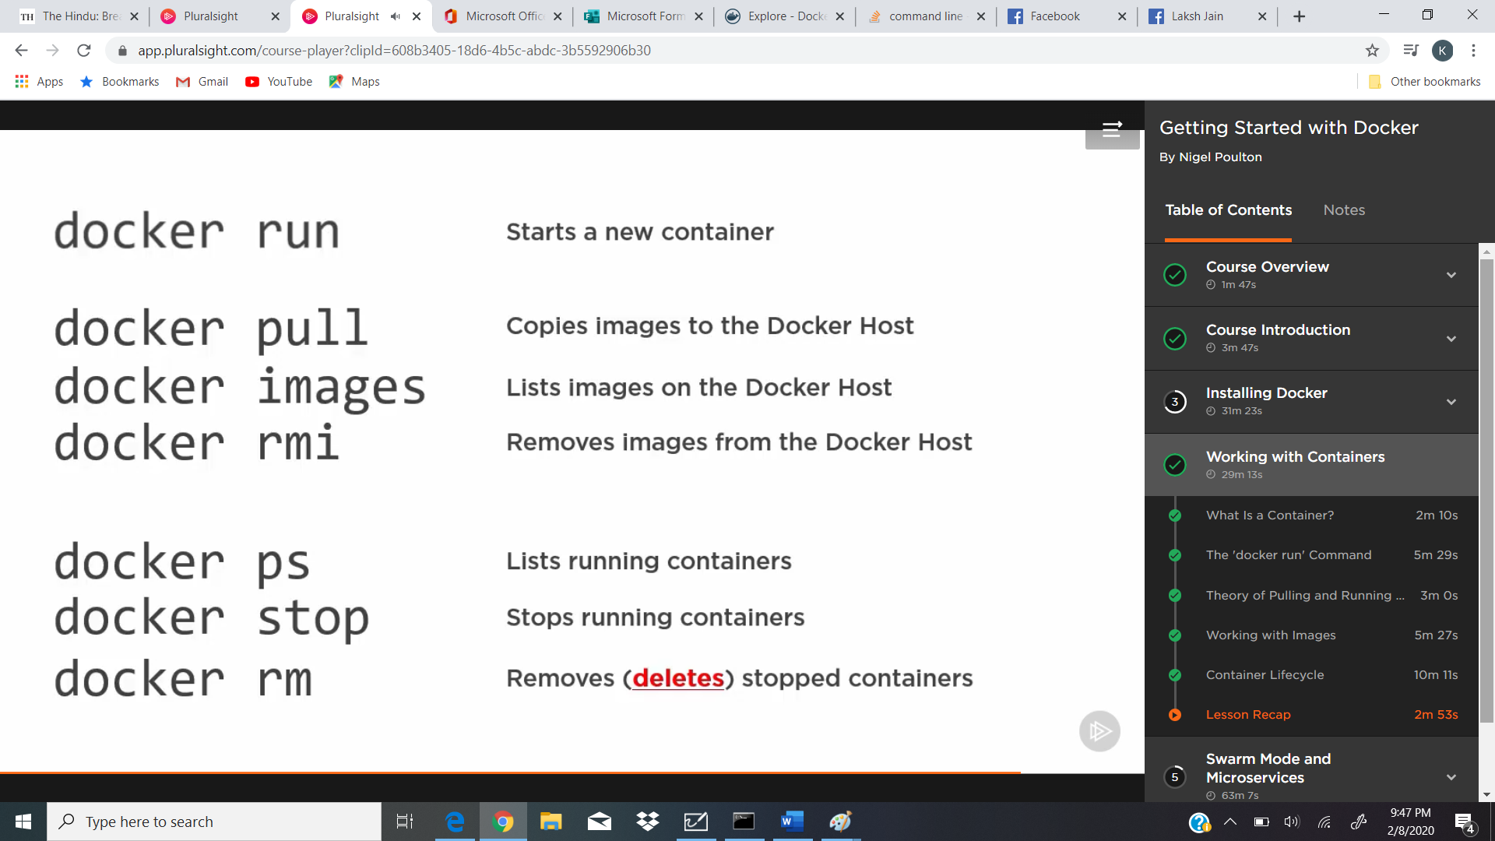

To initialize a swarm

docker swarm init --advertise-addr 172.17.113.145:2377 --listen-addr 172.17.113.145:2377

--advertise-addr = no matter how many NICs and IP address this machine got, this is the one to use for swarm-related stuff, like exposing the API

–listen-addr = this is what the node listens on for swar manager traffic

Copy code from local file system to container

docker run --rm -it -v %cd%:c:\api mcr.microsoft.com/dotnet/core/aspnet

publish port command

docker run --rm -it -v %cd%:c:\api -p 8080:80 mcr.microsoft.com/dotnet/core/aspnet

publish port (on linux)

docker run --rm -it -v %cd%:c:\api -p 8080:80 mcr.microsoft.com/dotnet/core/aspnet