**Name: Kapil Poudel Registration No: 11900475**

**Roll No: 3 Course: INT301**

**Q. Using desired Open-Source Software display an overview of all the hardware and operating system detail; also do live monitoring to show the temperature and current usage of various hardware components.**

**Open-Source Software: ASTRA32**

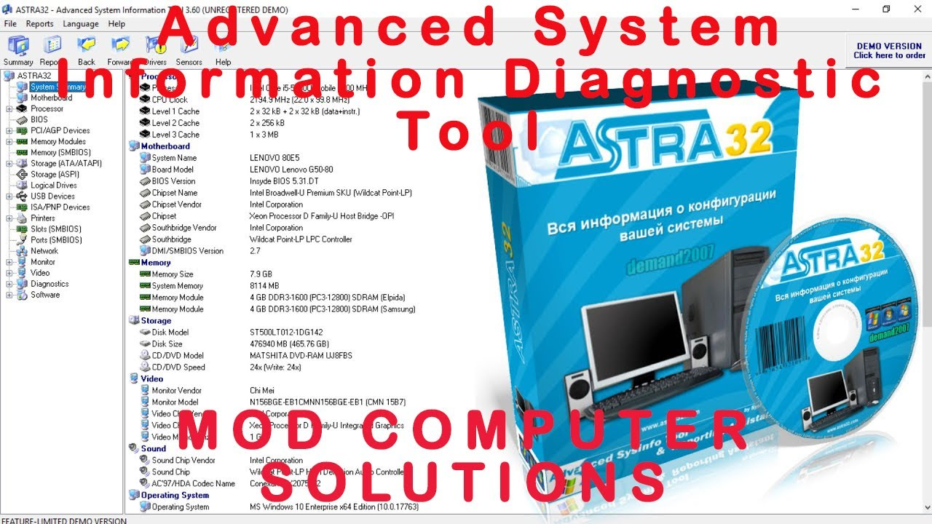

**1. Introduction**

**1.1 Objective of The Software**

The main objective of ASTRA32 is to provide detailed information about the hardware and software components of a computer system. Specifically, the objectives of ASTRA32 are:

* To identify the type and model of various hardware components installed on the system, including the processor, motherboard, memory, storage devices, graphics card, and network adapters.
* To display information about the operating system and installed software, including drivers and applications.
* To provide real-time monitoring data for temperature and current usage of various hardware components.
* To generate detailed reports that can be used for analysis or documentation purposes.
* To export system information data in various formats such as HTML, CSV, XML, or plain text.
* To assist system administrators and technicians in diagnosing hardware and software problems.
* To aid in the process of upgrading or replacing hardware components by providing detailed information about the existing hardware configuration.
* To assist in the process of software licensing and compliance by providing detailed information about installed software applications.

Overall, the objectives of ASTRA32 are to provide users with a comprehensive understanding of the hardware and software components of their computer system, and to assist them in managing and maintaining their system more effectively.

**1.2 Description of the Project**

. ASTRA32 is a system information tool designed for Windows operating systems. It can identify and displaying detailed information about various hardware components and software installed on a computer system. The software is designed to provide users with a comprehensive understanding of their system's hardware and software configuration, and to assist them in managing and maintaining their system more effectively.

ASTRA32 can display information about various hardware components such as the processor, motherboard, memory, storage devices, graphics card, and network adapters. It can also display information about the operating system and installed software, including drivers and applications. The software can provide real-time monitoring data for temperature and current usage of various hardware components, allowing users to monitor their system's performance and ensure that it is running at optimal levels.

ASTRA32 can generate detailed reports that can be used for analysis or documentation purposes. These reports can be exported in various formats such as HTML, CSV, XML, or plain text. The software can also assist system administrators and technicians in diagnosing hardware and software problems, as well as aid in the process of upgrading or replacing hardware components by providing detailed information about the existing hardware configuration.

Overall, ASTRA32 is a powerful and comprehensive system information tool that provides users with a detailed understanding of their computer's hardware and software configuration and assists them in managing and maintaining their system more effectively

* **Scope of the Project**

The scope of the project is to use ASTRA32 to display an overview of all the hardware and operating system details of a computer system. Additionally, the project involves live monitoring to show the temperature and current usage of various hardware components.

The scope of the project may include, but is not limited to, the following:

1. Running ASTRA32 software on the target system.

2. Using ASTRA32 to identify and display information about various hardware components such as the processor, motherboard, memory, storage devices, graphics card, and network adapters.

3. Displaying information about the operating system and installed software, including drivers and applications.

4. Configuring ASTRA32 to perform live monitoring of hardware components such as CPU, GPU, and RAM to show the temperature and current usage.

5. Generating detailed reports of the system information for analysis or documentation purposes.

6. Exporting the system information data in various formats such as HTML, CSV, XML, or plain text.

7. Using the system information and live monitoring data to diagnose hardware and software problems or to aid in the process of upgrading or replacing hardware components.

The scope of the project may vary depending on the specific requirements and objectives of the user. However, the main goal is to use ASTRA32 to provide a comprehensive understanding of the hardware and software configuration of the system and to assist in managing and maintaining the system more effectively.

**2. System Description**

The target system of ASTRA32 is a computer or laptop running a Windows operating system. ASTRA32 is compatible with various versions of Windows, including Windows 10, Windows 8, Windows 7, Windows Vista, and Windows XP.

ASTRA32 can be used on both 32-bit and 64-bit versions of Windows and is designed to work with a wide range of hardware components and software configurations. The software can identify and display information about various hardware components such as the processor, motherboard, memory, storage devices, graphics card, and network adapters, and can display information about the operating system and installed software, including drivers and applications.

Overall, ASTRA32 is a versatile system information tool that is designed to work with a wide range of hardware and software configurations, making it a useful tool for system administrators, technicians, and home users alike.

**2.1 Target System Description**

Target system is the laptop (MSI) having window 10 operating system.

Windows 10 is a widely used operating system developed by Microsoft. It was first released in 2015 and is the successor to Windows 8.1. Windows 10 is designed to work on a wide range of devices including desktops, laptops, tablets, and smartphones.

Some of the key features of Windows 10 include:

Start Menu: The Start Menu in Windows 10 is a combination of the traditional Start Menu and the Start Screen from Windows 8. It provides quick access to frequently used applications and settings.

Cortana: Windows 10 includes a voice-activated personal assistant called Cortana, which can help users with a wide range of tasks, from setting reminders to searching the web.

Virtual Desktops: Windows 10 allows users to create multiple virtual desktops, which can help to improve productivity by keeping workspaces organized.

Microsoft Edge: Windows 10 includes a new web browser called Microsoft Edge, which is designed to be faster and more secure than its predecessor, Internet Explorer.

Action Center: The Action Center in Windows 10 provides quick access to frequently used settings and notifications.

Universal Apps: Windows 10 includes a range of universal apps that are designed to work across all Windows devices, providing a consistent experience across desktops, laptops, tablets, and smartphones.

Continuum: Windows 10 includes a feature called Continuum, which allows the operating system to automatically adapt to the device it is being used on, providing a seamless user experience across different devices.

Overall, Windows 10 is a powerful and flexible operating system that is designed to work on a wide range of devices, providing a range of features and functionality to improve productivity and enhance the user experience.

**2.2 Assumption and dependencies of Window 10**

Assumptions and dependencies of Windows 10 system include:

1. Hardware compatibility: Windows 10 is designed to work with a wide range of hardware configurations, but some hardware may not be compatible with the operating system. Users should check the compatibility of their hardware components before upgrading to Windows 10.

2. Driver compatibility: Windows 10 requires drivers that are compatible with the operating system. Users should ensure that all their hardware components have updated drivers that are compatible with Windows 10.

3. Internet connectivity: Windows 10 requires an active internet connection to download updates and access certain features, such as Cortana and Microsoft Edge.

4. System requirements: Windows 10 has minimum system requirements that must be met for the operating system to run smoothly. These requirements include a 1 GHz or faster processor, 1 GB of RAM for 32-bit systems or 2 GB of RAM for 64-bit systems, and at least 16 GB of free disk space.

5. Software compatibility: Some software applications may not be compatible with Windows 10, and users may need to update or replace these applications to work with the new operating system.

6. Security updates: Windows 10 requires regular security updates to protect against new threats and vulnerabilities. Users should ensure that their system is set to automatically download and install these updates to maintain the security of their system.

Overall, users should ensure that their hardware and software components are compatible with Windows 10 and keep their system up to date with the latest security updates to ensure a smooth and secure computing experience.

**2.3 Functional/Non-Functional Dependencies:**

Windows 10 is a widely used operating system developed by Microsoft. It was first released in 2015 and is the successor to Windows 8.1. Windows 10 is designed to work on a wide range of devices including desktops, laptops, tablets, and smartphones.

Some of the key features of Windows 10 include:

1. Start Menu: The Start Menu in Windows 10 is a combination of the traditional Start Menu and the Start Screen from Windows 8. It provides quick access to frequently used applications and settings.

2. Cortana: Windows 10 includes a voice-activated personal assistant called Cortana, which can help users with a wide range of tasks, from setting reminders to searching the web.

3. Virtual Desktops: Windows 10 allows users to create multiple virtual desktops, which can help to improve productivity by keeping workspaces organized.

4. Microsoft Edge: Windows 10 includes a new web browser called Microsoft Edge, which is designed to be faster and more secure than its predecessor, Internet Explorer.

5. Action Center: The Action Center in Windows 10 provides quick access to frequently used settings and notifications.

6. Universal Apps: Windows 10 includes a range of universal apps that are designed to work across all Windows devices, providing a consistent experience across desktops, laptops, tablets, and smartphones.

7. Continuum: Windows 10 includes a feature called Continuum, which allows the operating system to automatically adapt to the device it is being used on, providing a seamless user experience across different devices.

Overall, Windows 10 is a powerful and flexible operating system that is designed to work on a wide range of devices, providing a range of features and functionality to improve productivity and enhance the user experience.

**2.4 Dataset used in support of your project:**

ASTRA32 does not require any specific dataset to display an overview of hardware and operating system details or to perform live monitoring of temperature and current usage of hardware components on Windows 10. Instead, it uses the system's own hardware and software data to generate its reports and monitoring data.

ASTRA32 scans the system's hardware and software components, retrieves their data, and displays it in a comprehensive and user-friendly format. This information includes details about the CPU, motherboard, RAM, hard drives, optical drives, network adapters, sound cards, graphics cards, and more. It also displays information about the operating system, including version, build number, and system architecture.

In summary, ASTRA32 does not require any external dataset to operate on Windows 10. It uses the system's own data to generate its reports and monitoring data.

3**. Analysis Report**

System snapshots and full analysis report

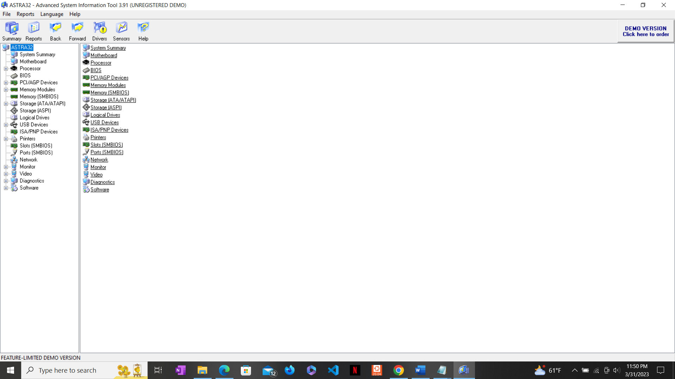

This is the Home page of the ASTRA32 where we can see many features which can display all the overview of hardware and operating systems. Features like system summary, motherboard, processor, BIOS, memory modules, storage, logical drivers, USB devices, ports, network, monitor, video, software and many more. It also has live monitoring features like sensor which can measure the temperature of parts of my system.

**Details features of ASTRA32 with analysis report**.

1. **System Summary**

**Motherboard**

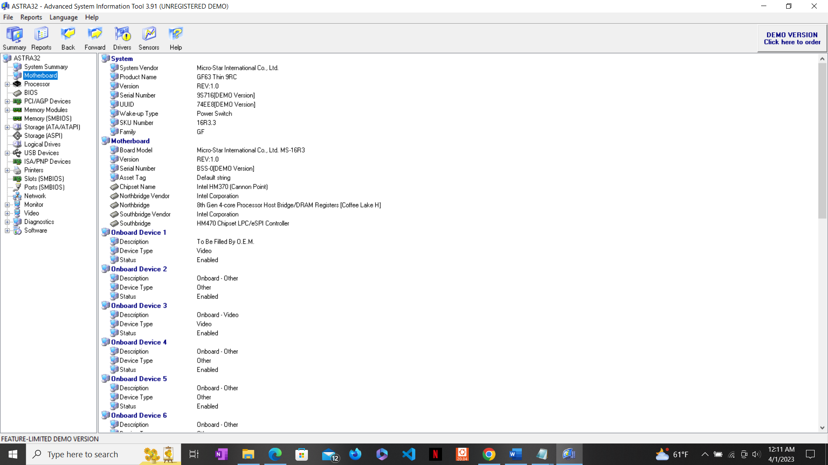

**Processor**

**PCI/APG Devices**

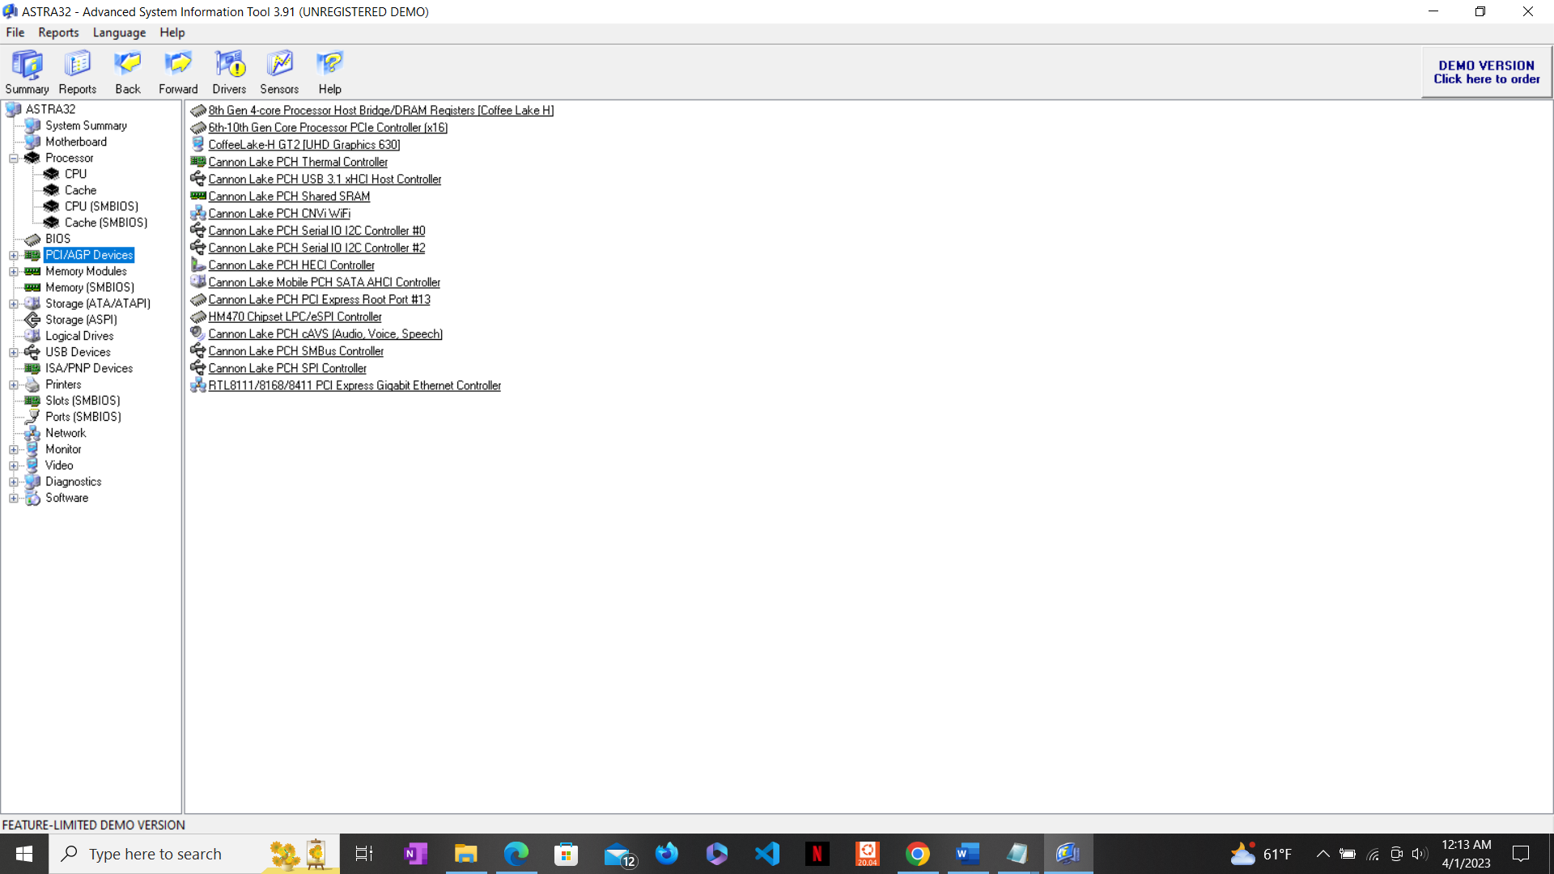

**Memory Modules**

**Storage**

**USB devices**

**Printers**

**Monitor**

**Network**

**Diagnostics**

**Live Monitoring the Temperature and current usage of various Hardware Components:**

Live Snapshot of temperature of components at 12:26 AM

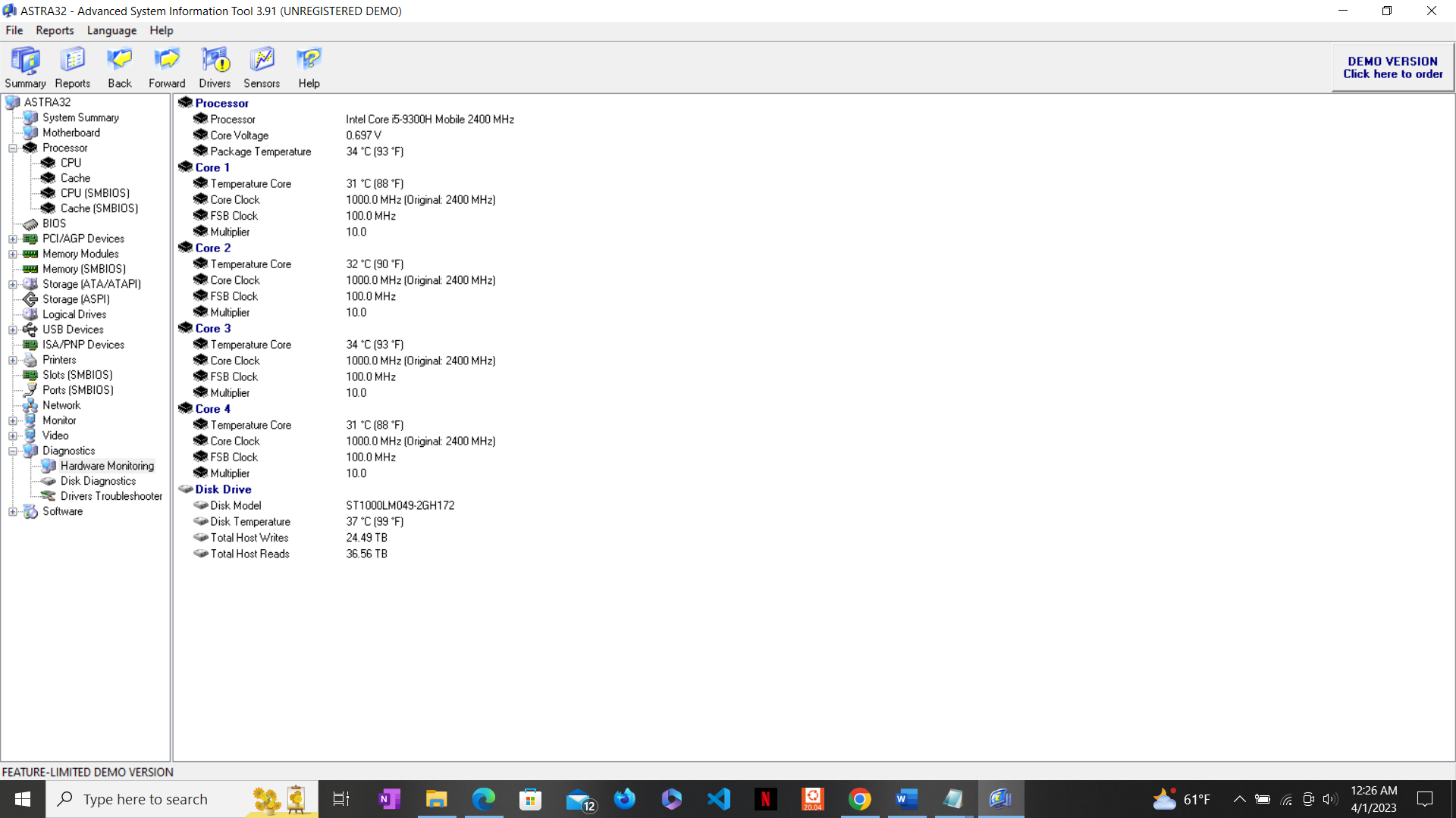

Live Snapshot of temperature of Components

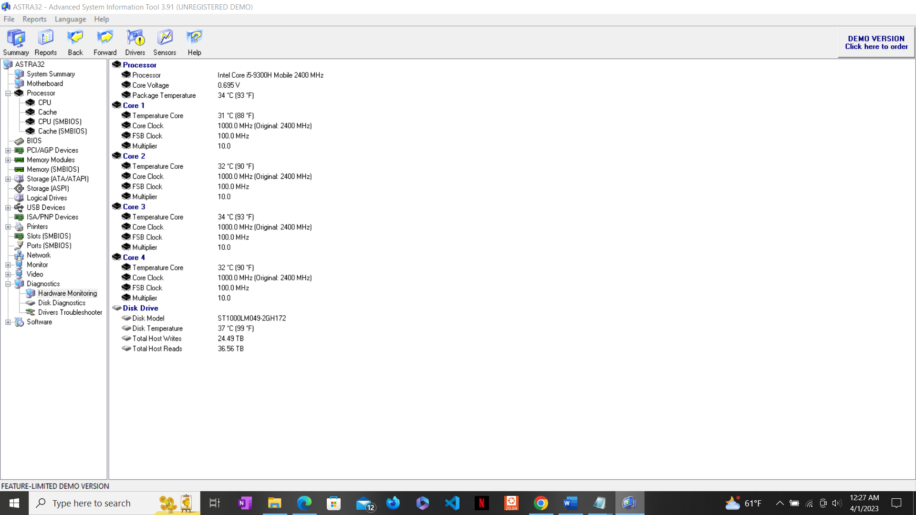

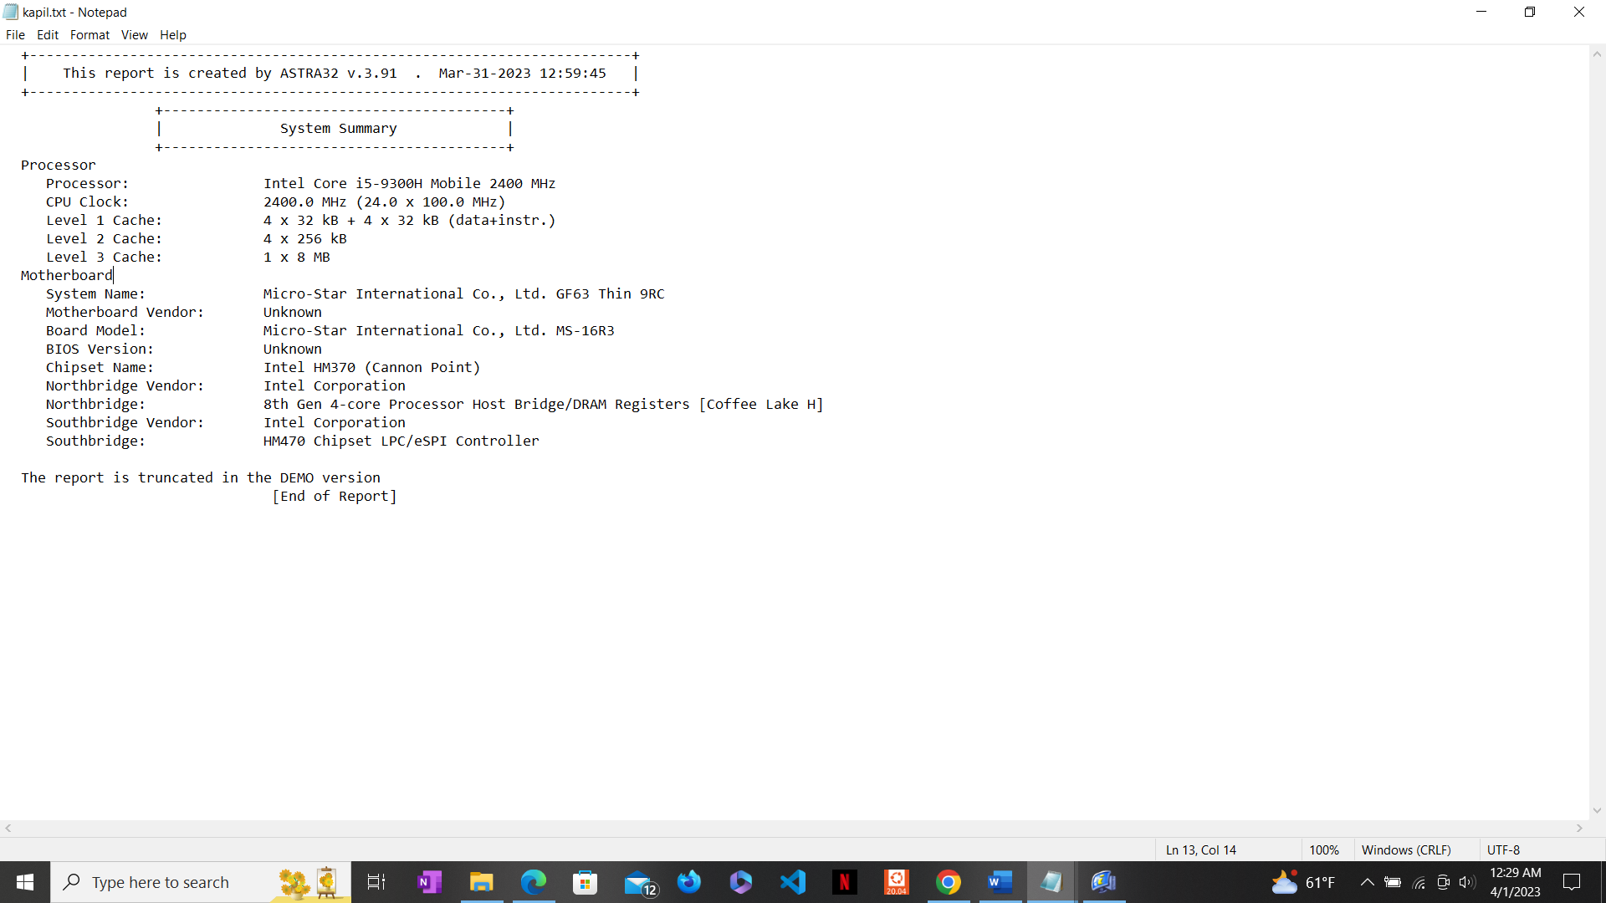

Summary of hardware components of my System.

**Conclusion:**

ASTRA32 - Advanced System Information Tool is an ideal solution for providing comprehensive information about the configuration of your system. Not only does ASTRA32 provide a detailed analysis of your system it also offers diagnostics and comes with some unique features such as a Drivers Troubleshooter and a quick HDD Health Status checker. You will appreciate the accuracy with which ASTRA32 acquires the information about the detected devices as it mostly refers directly to the hardware not to the registry. ASTRA32 uncovers even undocumented data.

**4. Reference/Bibliography**

[**http://www.astra32.com/**](http://www.astra32.com/)

**GitHub link: https://github.com/kapilpoudel/OpenSource_CA3.git**