**# RecoverTwitter**

**If Twitter Suspended you. Don't Worry Here it is how to restore your Account.**

**Step 1 :-** Visit this link and fill out the form https://support.twitter.com/forms/general?subtopic=suspended

To appeal a Twitter suspension, you’ll fill out a form that looks like this :

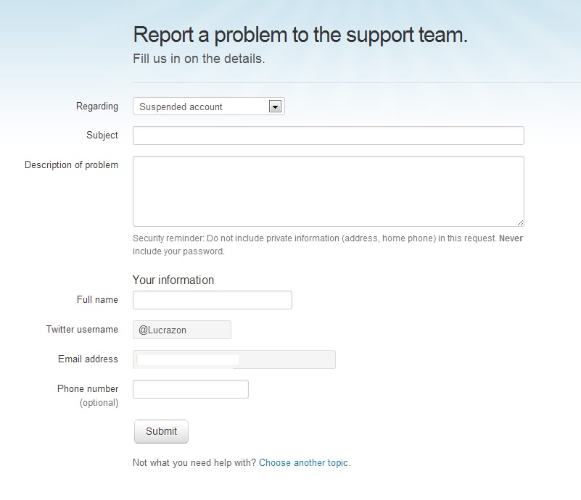

Please Logged in with your suspended account and fill carefully. Make sure all information are correct.

**Step 2 :-** Submit the form and wait for the reply.

**They will send the reply to the email your Twitter account is registered to, so be sure you check that inbox or double-check your mail forwarding settings!**

They will send the reply to the email your Twitter Account register with. After submitting your email (**Form**) you will receive an email from twitter like this :

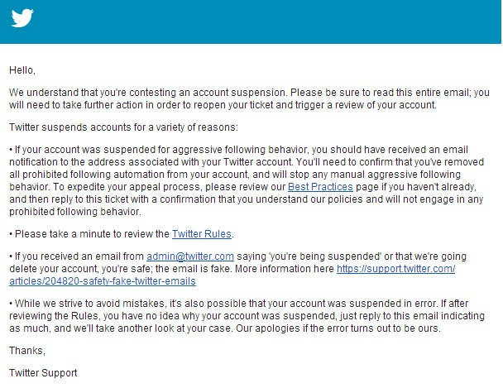In the reply, It is mentions that if we were suspended for aggressive following behaviour, we’d get a separate email.

**Step 3:-** If you didn’t receive reply, check status of the ticket. This isn’t too clear on the website, and I only stumbled upon this by accident while searching, but you can keep track of your ticket status via their Zendesk home**. If you’re already logged in, you’ll see your ticket in “Check your Existing Requests” tab**. (Update 3/17/15: Twitter has disconnected Zendesk's direct link to check status of your ticket. Please log into your own account and see if there is a status section).

*You’ll either see a “Waiting for your reply” or “Ticket being processed” message.*

If you found **“Waiting for your reply”** then check your email immediately as they don’t copy what their response is on this page. If it says **“Ticket being processed”**, it either means they haven’t read it yet, or are still investigating.

**Hope It will help you, and you get your Account** [**@SirJadeja**](https://twitter.com/SirJadeja)**.**

**Thank You.!!!!**