# Session 1: Assignment 1

## Code and screenshot below

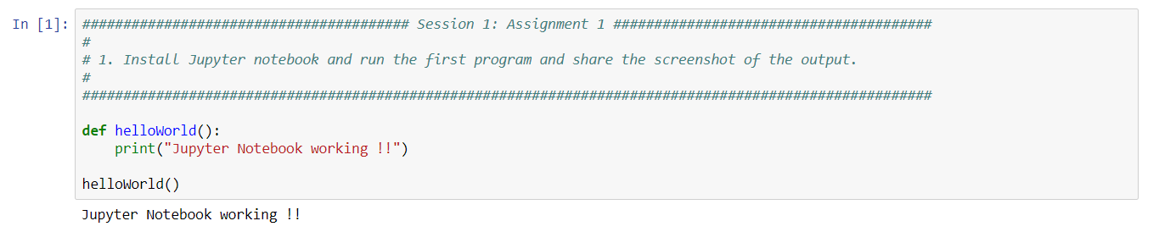

## For all remaining questions (2,3,4) complete code and screenshots below:

