# Assignment 9

See all code with relevant output of code for all questions 1, 2,3,4,5:

1. The column “Unnamed: 0” was deleted

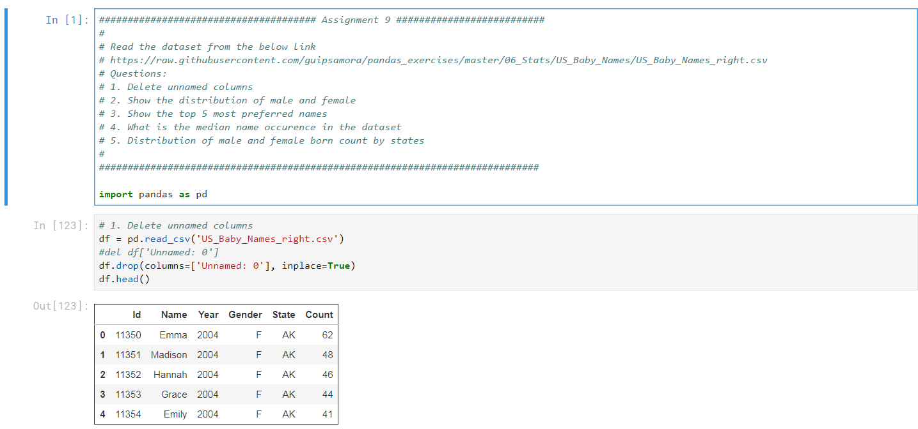

1. Below is the distribution of male and female
2. The top 5 most preferred names are: Riley, Avery, Jordan, Peyton, Hayden

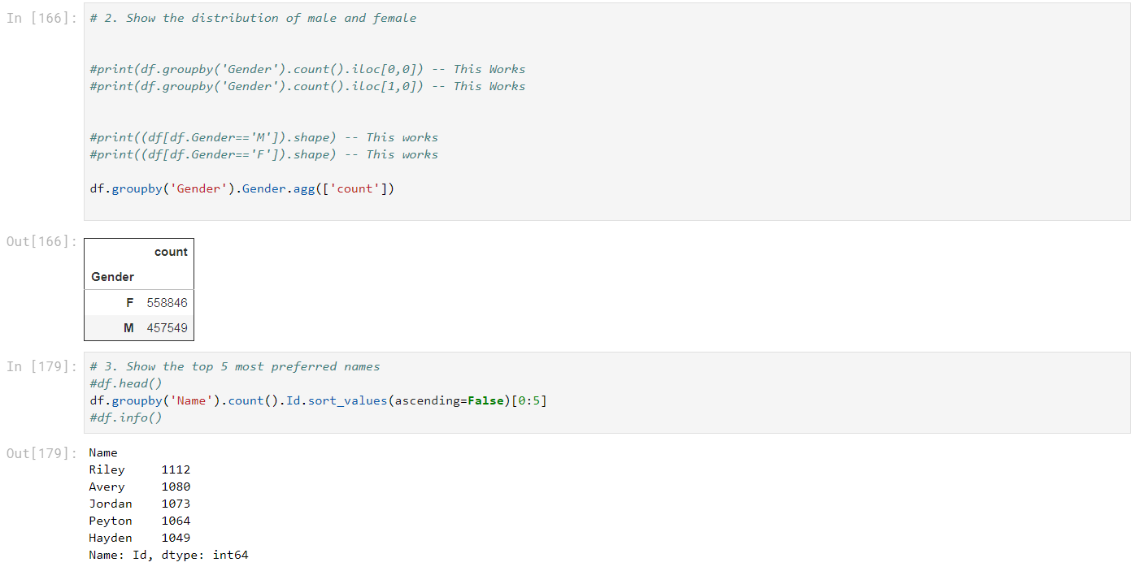

For question 4:

-The mean is coming to 57.644906987295826

- All baby names whose count is 57(which is closer to mean and not going over mean) is shown in screenshot below

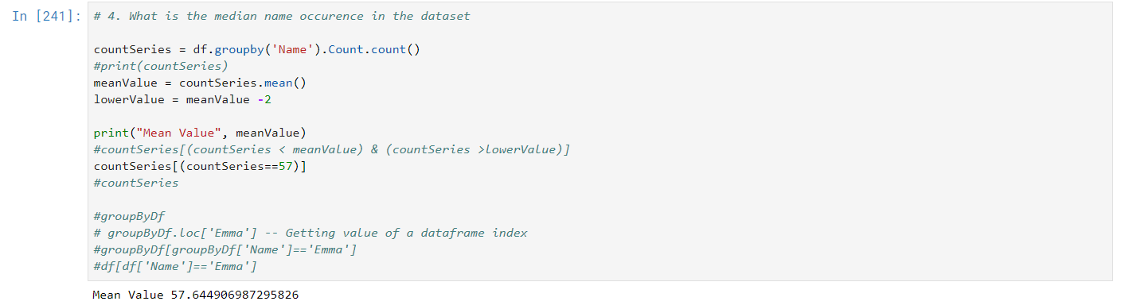

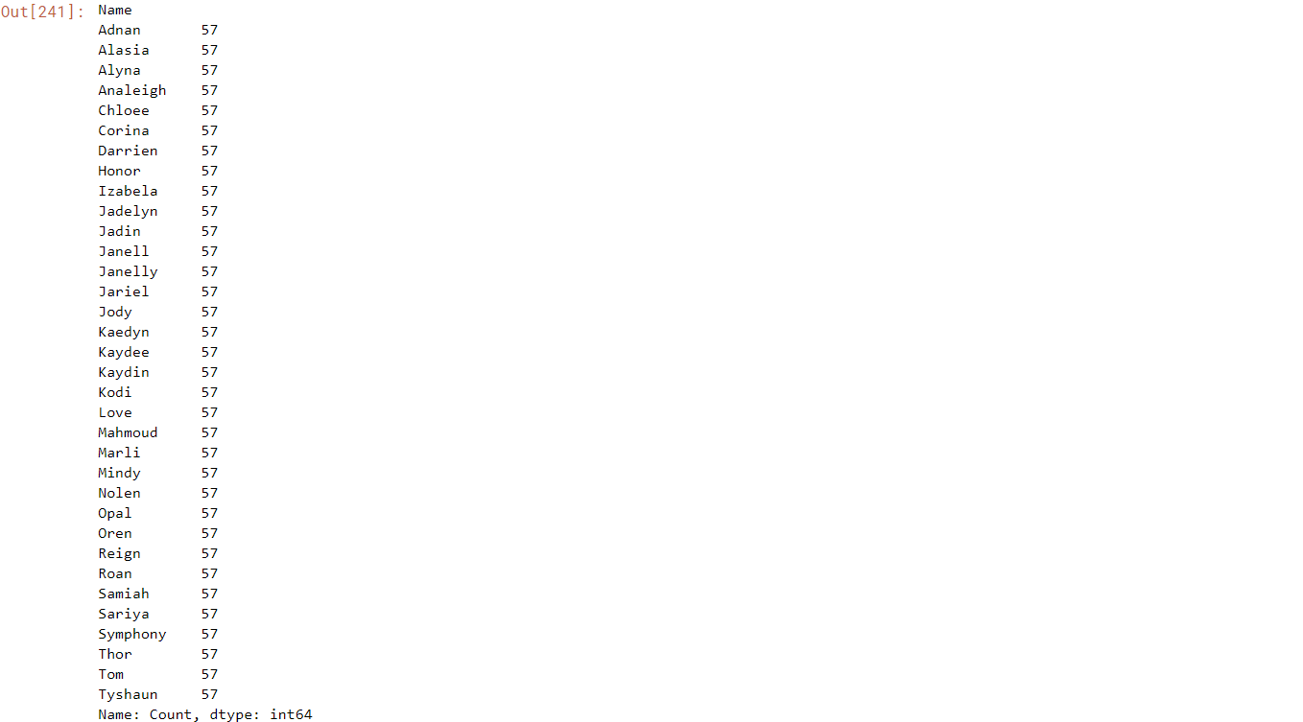

1. Below is the distribution of male and female born by states

