# Session 5: Assignment 1

## Complete Code and results in one screenshot below

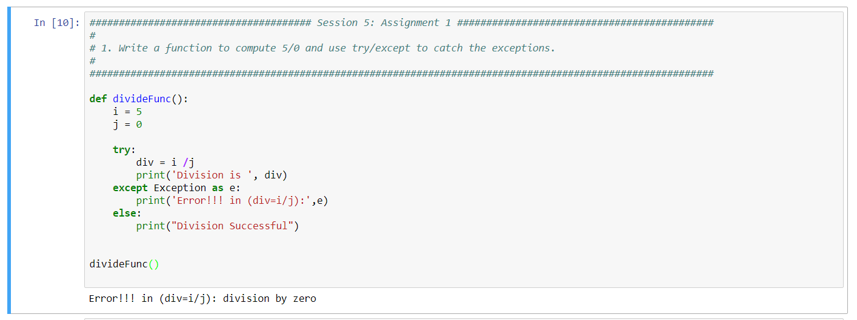

## Complete code on first screenshot, results in 2nd screenshot below:

