Report for CS731 Term Project

Yue Pan

Learning Probabilities(CPTs) in Presence of Missing Data Using Gibbs Sampling

1. Introduction

Belief networks (BN) (also known as Bayesian networks and directed probabilistic networks) are a graphical representation for probability distributions. These networks provide a compact and natural representation of uncertainty in artificial intelligence. They have been successfully applied in expert systems, diagnostic engines, and optimal decision-making systems.

The most difficult and time consuming part of the task in building a Bayesian network model is coming up with the probabilities to quantify it. Probabilities can be derived from various sources. They can be obtained by interviewing domain experts to elicit their subjective probabilities. They can be gathered from published statistical studies or can be derived analytically from the combinatorics of some problems. Finally, they can be learned directly from raw data. The learning of Bayesian networks has been one of the most active areas of research within the Uncertainty in AI community in recent years.
We can classify learning of Bayesian network models along two dimensions: data can be complete or incomplete and the structure of the network can be known or unknown.
When the network structure is known, the most straightforward case is that in which the complete data is available for all variables in the network. A prior is assumed for each network parameter (probability table) and is updated using the available data. In the real world application, the data from which we wish to learn a network may be incomplete. First, some values may simply be missing. For example, in learning a medical diagnostic model, we may not have all symptoms for each patient. A second cause of incomplete data may be the lack of observability of some variables in the network.
Assuming that the data is missing at random, several techniques are available, of which the two most popular are Gibbs sampling and expectation-maximization. Both can handle continuous domain variables and dependent parameters. Gibbs sampling is a stochastic method that can be used to approximate any function of an initial joint distribution provided that certain conditions are met. The expectation-maximization (EM) algorithm can be used to search for the maximum a posteriori (MAP) estimate of the model parameters. The EM algorithm iterates through two steps: the expectation step and the maximization step.
In this report, we focused on the Gibbs sampling method for learning network parameters (CPTs values) from incomplete data with known structure. Roughly speaking, we implemented this algorithm in Java language, built a simple user interface for data input and output and tested the accuracy of the learning results. As we experimentally show, Gibbs sampling method is capable of learning network parameters from non-trivial datasets.

2. Fundamental of Bayesian Networks

Bayesian networks are graphical models that encode probabilistic relationships among variables for problems of uncertain reasoning. They are composed of a structure and parameters. The structure is a directed acyclic graph that encodes a set of conditional independence relationships among variables. The nodes of the graph correspond directly to the variables and the directed arcs represent dependence of variables to their parents. The lack of directed arcs among variables represent a conditional independence relationship. Take, for example, the network in Figure 0. The lack of arcs between symptoms S1, S2, and S3 indicates that they are conditionally independent given C. In other words, knowledge of S1 is irrelevant to that of S2 given we already know the value of C. If C is not known, then knowledge of S1 is relevant to inferences about the value of S2.
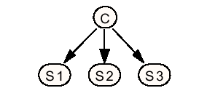
Figure 0. Bayesian Network for generic disease and Symptoms (from J. Myers, 1999)
The parameters of the network are the local probability distributions attached to each variable. The structure and parameters taken together encode the joint probability of the variables. Let U = {X1,...,Xn} represent a finite set of discrete random variables. The set of parents of Xi are given by pa(Xi). The joint distribution represented by a Bayesian network over the set of variables U is
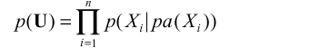

where n is the number of variables in U and p (Xi|pa (Xi))=p (Xi) when Xi has no parents. The joint distribution for the set of variables U = {C, S1, S2, S3} from Figure 0 is specified as

In addition to specifying the joint distribution of U, efficient inference algorithms allow any set of nodes to be queried given evidence on any other set of nodes.
The problem of learning a Bayesian network from data can be broken into two components as mentioned in introduction: learning the structure, and learning the parameters. If the structure is known, then the problem reduces to learning the parameters. If the structure is unknown, the learner must first find the structure before learning the parameters. Until recently most research has concentrated on learning networks from complete datasets.

3. Experiment

3.1 Algorithm

We first initialize the states of all the unobserved variables in data set randomly. As a result, we have a complete sample data set. Second, we tally all the data points’ values in the data set to their corresponding original B-prior distributions and update all the CPT values based on these new B-distributions. We save the updated CPT. Third, based on the updated CPT parameters, we use Gibbs sampling to sample all the missing data points in the data set and get a complete data set again. We iterate second and third steps until the averages of all the saved CPTs are stable.

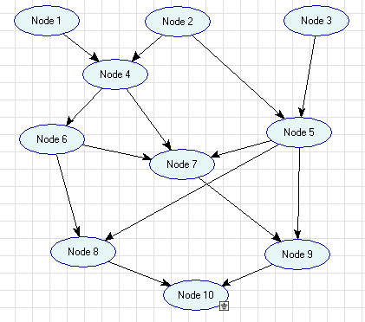
3.2 Result And Analysis

In this section we report initial experimental results on a 10-node network. (See the graph on the right). We assume all the nodes have only two states (Binomial distribution). This network has totally 33 CPT parameters (CPT entries). The minimum of the CPT parameter for a node is one, which is the case that the node doesn’t have parents at all. The maximum of the CPT parameters for a node is 8, which is the case that the node has three parents. Generally, we evaluate the performance of the learned networks by measuring how well they model the target distribution, i.e. how many CPT entries in the whole network are within certain error ranges compared to original (correct) CPT. The 5 error ranges we take are: [0.00, 0.05), [0.05, 0.10), [0.10, 0.15), [0.15, 0.20) and > 0.20.

We generated all the original (correct) data points for the data set based on the original (correct) CPT. When we start test and set the deviation for CPT, we mean all the CPT entries are set off by the deviation (may plus or minus that deviation).

We performed the following experiments. In all cases, the blue bar represents the number of CPT entries in the network whose learning results are off from the correct ones between 0.00 and 0.05. The red bar represents the number of entries with error between 0.05 and 0.10. The yellow bar represents those off between 0.10 and 0.15. The cyan bar shows those with the error ranging from 0.15 to 0.20. The last bar in each group shows the number of entries whose errors are larger than 0.20.

Case 1:

We set all the CPT off by 0.20, set node 6 100% missing, other nodes were observed. We input the data sets with varying size. From the raw data in table1 (See the file called size_on_node_6.doc in the hand in directory, same as below), we generated figure 1.

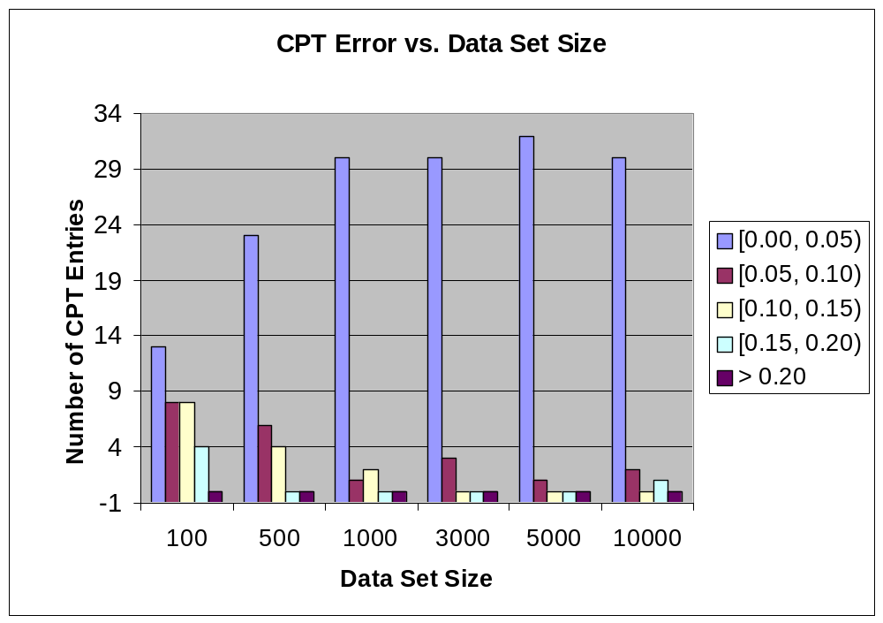

Figure 1. The data set size affects learning

The result shows when data set size is 100, out of 33 CPT entries, 13 entries are off from the correct ones by [0.00, 0.05), 8 entries are off by [0.05, 0.10), 8 entries are off by [0.10, 0.15),

and 4 entries are off by [0.15, 0.20). None of them are off by more than 0.20. Since the deviation we set is 0.20, data set size 100 is not good enough for “wrong CPT” to target the correct distribution.

When the size of the data set was 500, we observed the number of CPT entries whose errors are within [0.00, 0.05) increased and those entries whose errors are within [0.05, 0.10) or [0.10, 0.15) decreased.

This trend keeps until the size of the data set reaches 1000. When the data set size is 3000, none of the CPT entries has error more than 0.10. After that, there is no significant change of the error distribution. So we conclude that the size of data set will affects how well wrong CPTs target correct CPTs, but it’s not linear relationship.

As for the missing node itself, i.e. node 6, the error trend of its CPT values is the same as the trend for other nodes. When the data set size is 100 or 500, its error is more than 0.10. When the data set size is more than 1000, its error is below 0.05.

Since the data set size 3000 is fairly good for all wrong CPT values to “come back” to the correct ones, all our experiments below will use 3000 as the fixed data set size.

Case 2:

We set node 6 100% missing, other nodes were observed. All the CPTs were set off by the deviations shown below. From raw data in the table 2, we derived the following figure.

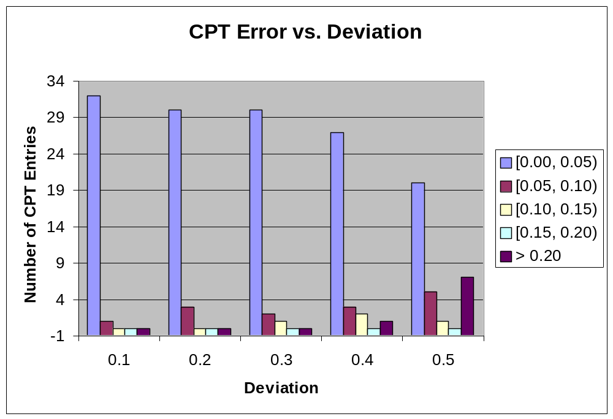

Figure 2. Deviation affects learning

When all the CPT entries were set 0.1 or 0.2 off their correct ones, most entries came back to the correct values. None of learning results is off by more than 0.10. When they were set off by 0.3, only one CPT entry was off by 0.10 after learning. But when all the CPT entries were set off by 0.4, we observed one entry were off by more than 0.20 after learning. The worst is there were 8 entries off by more than 0.20 after learning when they were set off by 0.5 originally.

As for the missing node itself, i.e. node 6, it has the same trend as the overall nodes’ trend.

So we conclude, if we guess the CPT values off by [0.1, 0.3], it is more likely the learning results are fairly right. If our guess is too wrong initially, say, off by more than 0.5, the overall learning result is not good as shown. So all the experiments below will use 0.2 as the deviation from correct values.

Case 3:

We set all CPT entries off by 0.2 originally. Missing percentage of the specified nodes is 100%. Figure 3 is derived from the raw data in table 3.

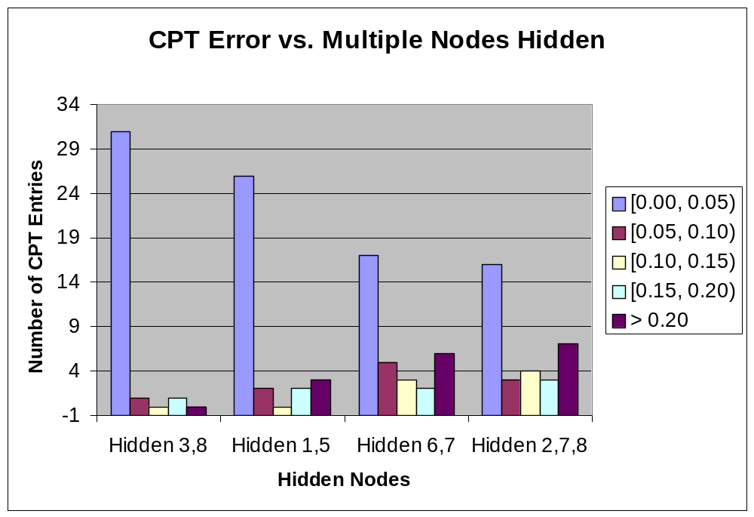

Figure 3. Number of missing variable affects learning

It is clear from the figure 3, the results vary depending on which nodes are missing in the network. When node 3 and node 8 are missing, 31 CPT entries can recover to correct values with error less than 0.05. One entry has the error within [0.05, 0.10) and only one entry has the error between [0.15, 0.20). But if node 1 and node 5 are hidden (100% missing), 3 CPT entries have errors more than 0.2. When 3 nodes (node2, 7,8) are missing, learning results get worse.

We also observed those nodes with big learning errors are not necessarily the missing nodes, i.e. missing nodes may have good learning results. But the offset is that some other nodes’ learning results have relatively significant errors.

Case 4:

Data points are missing globally. We randomly set certain percentage data points missing. All CPTs are off by 0.2 originally. Figure 4 was derived from raw data in table 4.

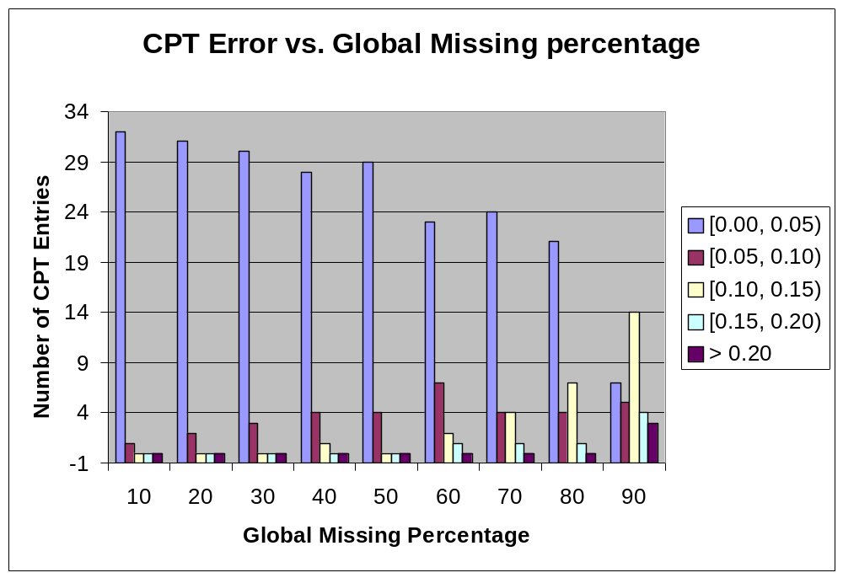

Figure 4. Global missing percentage affects learning

From figure 4, it is obvious, when missing data points are less than 50% of all the data points, almost all the CPT entries can come back to correct values with error less than 0.05. When overall missing percentage reaches 80% or above, more than 5 entries have significant errors.

Case 5:

Finally, we tested the learning performance when only one node was partially missing. We set node 4 missing with varying missing percentage. All CPTs were set off by 0.2. Figure 5 was derived from the raw data in table 5.

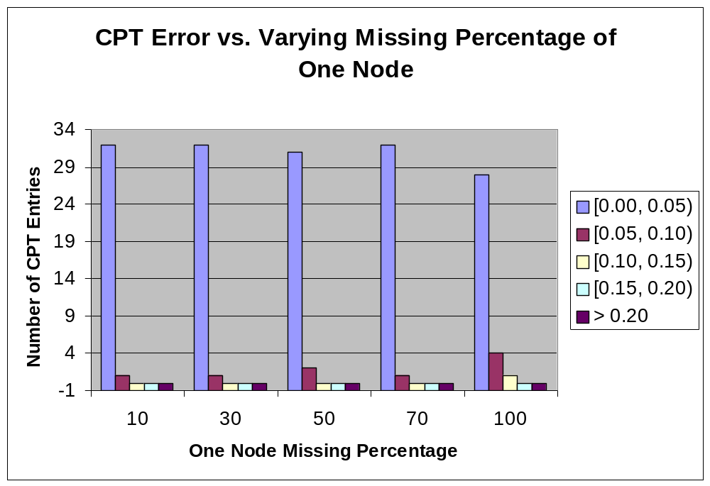

Figure 5. One node’s missing percentage has no significant effect on learning

The result shows there is no significant difference when only one node is partially missing. All the CPT entries have correct values after learning.

4. Conclusion and Discussion
Based on the experimental results above, we can conclude that learning Bayesian network parameters (CPTs) in presence of missing data using Gibbs Sampling is feasible. With reasonable setting, learned CPTs are almost the same as the correct CPTs. In respect to a specific Bayesian network, CPTs can be learned from a practical size sample data set. Although we may still get good results, the guessed CPTs should not be more than 0.4 away from correct CPTs. The missing percentage is not an important factor, 100% missing for a node and up to 60% data missing for the whole network do not change the final results significantly. Depending on which node(s) missing, we can still get acceptable results when multiple nodes are not observed. The size of the network may determine how many missing variables it can tolerate so the learning performance is still good.
The algorithm may be not perfect. The learned CPTs for some nodes, especially the missing node(s) and nodes directly connecting to the missing node(s) may have some relatively bigger errors. For example, in Table 3, when node 4 is 100% missing, deviation is 0.2 and sample data set size is 3000, the 5th CPT entry for node 7, p (7=true|4=true, 5=false, 6=false) is 0.139 away from correct CPT. The phenomenon is consistent in our tests. We believe, in these cases, a local maximum achieved.
In order to analyze why this happens, let’s see a simple case -- a Bayesian network with just 3 nodes: A, B and C. A is B’s parent and B is C’s parent. If C’s values are missing, and guessed P(C|B) has error, then every time, when we use Gibbs sampling to fill the missing values, the distribution for C will be the same as the wrong CPT. The calculated CPT from newly generated data will also be wrong and keep the same values. In other words, the CPT won’t change much in every iteration. Same scenario happens to node A when its values are missing. This is shown in Table 3. Node 1 has no parent, when its values missing and probability was set to 0.6, after learning, it keeps almost the same value, 0.622. For the intermediate node B, its CPT is constrained by both node A and C, it is more likely that it will have a good result. But, after carefully examination, it turns out that it may be not always true. We know:
P (b)=ΣΣP(b|A)P(C|b)= P(b|a)P(c|b) + P(b|~a)P(c|b) + P(b|a)P(~c|b) + P(b|~a)P(~c|b)
Suppose all data for node B is missing. From the sample data set, we can know only P(A), P(C) and P(A|C), P(C|A). In the equation above, we have 4 variables: P(b), P(c|b), P(b|a) and P(b|~a), because P(~c|b)= 1 – P(c|b), etc. This is an under-constrain equation, i.e., we can get different results that will make the equation hold, depending on what the guessed CPT is and what the random number sequence is. It is possible to get the local maximum which is closest to the initial CPT setting. This is why p(7=true | 4=true, 5=false, 6=false) could have relative significant error.
In brief, when missing node has no parent(s) or child(ren), it is less likely to find the correct CPT using this learning method; if the missing node is an intermediate one, its learned CPT is more likely but not always exactly right. The error depends on its neighbor node(s). It is beyond our ability to further analyze how they interfere with each other.
Worthy mention as well, when 5000 points data set is used, the result is quite right for the node 6. But if 10,000 entries data set is used, the missing node 6’s CPT is inversed – the correct value is (0.3, 0.7), the learned is (0.707, 0.306). We guess bad “search direction” or over-fitting happened although it is not frequent in our experiments.
Theoretically, there is no convention on how long the Markov chain should run when performing learning CPTs using Gibbs sampling. Common belief is that the longer chain will help to get more accurate results. But in our experiments, we found that all the learning results came to a stationary status after about 3000 iterations.
There are some other factors that were not studied in this project, such as how network size affects the learning results. More theoretical analysis and practical tests could be performed later.

References
Friedman, N. , Learning belief networks in the presence of missing values and hidden variables, in D. Fisher, ed., `Proceedings of the Fourteenth International Conference on Machine Learning', Morgan Kaufmann, San Francisco, CA, 1997, pp. 125-- 133.
Friedman, N. and Goldszmidt, M., Slides from the AAAI-98 Tutorial on Learning Bayesian Networks from Data. http://www.cs.berkeley.edu/~nir /Tutorial/, 1998.
Haddaway, P. An overview of some recent developments in Bayesian problem solving techniques. AI Magazine, Spring 1999.
Heckerman, D., A Tutorial on Learning with Bayesian Networks. Technical Report MSR-TR-95-06, Microsoft Research, Redmond, Washington. March 1995 (revised Nov1996). Available at ftp://ftp.research.microsoft.com/pub/tr/TR-95-06.PS
Friedman, N., L. Getoor, D. Koller, A. Pfeffer. Learning Probabilistic Relational Models. IJCAI-99, Stockholm, Sweden (July 1999).
Myers, J. and DeJong K. Learning Bayesian Networks from Incomplete Data using Evolutionary.. - James Myers George Paper and presentation for GECCO 99

