Simple Asynchronous FIFO
Plain Verilog, basic tests, timing causes, and Vivado waveform verification
Language: Verilog only
FIFO size: 8 entries x 8 bits
Simulation clocks: wr_clk = 10 ns; rd_clk = 14 ns with a 2 ns starting offset
Tool: AMD Vivado 2024.1 / XSim
Final result: PASS - all 5 basic tests completed at 1590 ns

1. The whole idea
An asynchronous FIFO moves data between two unrelated clock domains. The write side uses wr_clk. The read side uses rd_clk. Because the clocks have different periods and no fixed phase relationship, the design must never send a changing multi-bit binary pointer directly into the other clock domain.
The final project keeps four ideas separate: memory stores bytes, binary pointers address memory, Gray pointers cross clock domains, and local full/empty flags block unsafe operations.
Write-clock side | Shared storage | Read-clock side
wr_en, data_in, wr_bin, wr_gray, full | 8 memory locations, each 8 bits | rd_en, data_out, rd_bin, rd_gray, empty

2. Signals you need to know
Signal | Direction | Simple meaning
wr_clk | Input | Clock for writes and the full flag.
wr_reset | Input | Active-high reset for the write side.
wr_en | Input | Requests one write.
data_in[7:0] | Input | Byte to store.
full | Output | 1 means no more writes are allowed.
rd_clk | Input | Clock for reads and the empty flag.
rd_reset | Input | Active-high reset for the read side.
rd_en | Input | Requests one read.
data_out[7:0] | Output | Last byte read from the FIFO.
empty | Output | 1 means no read is allowed.

3. What happens on each clock edge

Write operation
A write is accepted only when wr_en is 1 and full is 0 at a rising edge of wr_clk. The byte is stored at the current write address. Then the binary write pointer advances by one and its Gray version is updated.
write_allowed = wr_en && !full;
if (write_allowed) memory[write_address] <= data_in;

Read operation
A read is accepted only when rd_en is 1 and empty is 0 at a rising edge of rd_clk. data_out receives the byte at the current read address. Then the binary read pointer advances by one and its Gray version is updated.
read_allowed = rd_en && !empty;
if (read_allowed) data_out <= memory[read_address];

Why blocked operations do nothing
Condition | Local action | Reason
wr_en=1 and full=1 | No memory write; write pointer stays still. | Unread data must not be overwritten.
rd_en=1 and empty=1 | No output update; read pointer stays still. | There is no valid word to remove.

4. Why binary and Gray pointers are both used
Binary pointers are easy for memory addressing, but several binary bits can change together. For example, binary 0111 becomes 1000. If that multi-bit change is sampled by another clock at the wrong instant, the receiver can see a mixed value.
Gray code changes only one bit between adjacent counts. The conversion is simple:
gray = binary ^ (binary >> 1);
Only the Gray pointer crosses the clock boundary. It passes through two flip-flops in the destination clock domain. The first flip-flop may see metastability; the second gives it a full destination-clock period to settle before the pointer is used.
Pointer | Used for | Clock domain
wr_bin | Write address and normal counting | wr_clk
wr_gray | Safe write-pointer value sent to read side | wr_clk -> rd_clk synchronizer
rd_bin | Read address and normal counting | rd_clk
rd_gray | Safe read-pointer value sent to write side | rd_clk -> wr_clk synchronizer

5. full and empty timing
The important rule is: asserting a local boundary flag can be immediate, but clearing a flag because of activity in the other clock domain is delayed. The delay is intentional and safe.
Event | When it occurs | Cause | Why
empty becomes 1 | On the final accepted read | Next read pointer equals synchronized write pointer | The read side knows it consumed the final visible word.
empty becomes 0 | A few rd_clk edges after a write | New write Gray pointer crosses two synchronizer registers | The read side must wait for a safe pointer value.
full becomes 1 | On the eighth accepted write | Next write pointer is one FIFO depth ahead | All 8 locations are now occupied.
full becomes 0 | A few wr_clk edges after a read | New read Gray pointer crosses two synchronizer registers | The write side waits until freed space is safely visible.

How many clock edges is a few?
The source pointer first has to change. Then the destination clock samples it through sync1 and sync2. The registered full or empty flag updates from the synchronized value. Because the two clocks can meet at any phase, the visible delay is commonly two to three destination-clock edges. This is not lost performance caused by bad code; it is the safety cost of clock-domain crossing.

Reset timing
Reset assertion is asynchronous, so local pointers, flags, and synchronizer registers clear immediately when reset goes high. In a real system, assert wr_reset and rd_reset together for a clean FIFO restart. Releasing the two resets near their own clock edges is preferred.

6. The five basic tests
ID | Test | Action | What must be true | Result
T01 | Reset + empty read | Reset, then pulse rd_en while empty | Reset values are correct; read pointer does not move | PASS
T02 | One transfer | Write A5, then read once | A5 appears; empty returns to 1 | PASS
T03 | FIFO order | Write 10-13, then read four times | Values leave in the same order | PASS
T04 | Full + extra write | Write 8 bytes, then try EE | full=1; EE is blocked; 80-87 remain correct | PASS
T05 | Wraparound | Fill and drain twice | All values are correct; both extended pointers return to 0 | PASS

Every test runs with wr_clk at 10 ns and rd_clk at 14 ns with a 2 ns starting offset. This means even the basic tests use genuinely unrelated clock edges.

7. How Vivado verified the result
Step | Tool use | Acceptance evidence | Result
1 | Vivado Tcl Console created one project | Part xc7a35tcpg236-1; Verilog language; one RTL and one testbench | PASS
2 | xvlog compiled both .v files | No ERROR or WARNING in compile.log | PASS
3 | xelab built async_fifo_tb_behav | No ERROR or WARNING in elaborate.log | PASS
4 | XSim ran the testbench to $finish | Console showed ASYNC_FIFO_TESTS: PASS and All 5 basic tests passed | PASS
5 | Waveform view was cleaned and saved | Only useful clocks, enables, data, flags, pointers, and synchronized pointers remain | PASS

Waveform reading order
Look at | Question to answer
wr_clk and rd_clk | Are the clocks different and continuously running?
wr_reset and rd_reset | Where does each test start?
wr_en, data_in, full | Which writes are accepted, and is the extra EE write blocked?
rd_en, data_out, empty | Which reads are accepted, and does the final read assert empty?
wr_bin / wr_gray | Does the write pointer advance only for accepted writes?
rd_bin / rd_gray | Does the read pointer advance only for accepted reads?
sync2 pointers | Can you see the deliberate delay before the other side reacts?

8. What was removed and why
The old working folder contained many separate testbenches, synthesis reports, netlists, screenshots, logs, checkpoints, and generated simulation directories. Those files made the learning task look much harder than the FIFO itself. They were removed from the source-of-truth layout.
The original logic also calculated full and empty directly from next pointers while the next pointers depended on full and empty. That creates a combinational feedback loop. Registering full in wr_clk and empty in rd_clk breaks the loop and makes the timing clear.

9. Final folder and rerun steps
File | Purpose
async_fifo.v | Simple FIFO design in plain Verilog.
async_fifo_tb.v | Five basic self-checking tests.
Asynchronous_FIFO_Test_Cases.xlsx | Test cases, expected results, observed results, and short timing sheet.
Asynchronous_FIFO_Guide.docx | This timing, cause, and verification guide.
vivado/async_fifo_vivado.xpr | Vivado 2024.1 project.
vivado/async_fifo_waveform.wcfg | Saved clean waveform view.

Step | What to do
1 | Open vivado/async_fifo_vivado.xpr.
2 | Run Behavioral Simulation.
3 | Run the simulation to completion.
4 | Accept only ASYNC_FIFO_TESTS: PASS with no FAIL line.
5 | Open async_fifo_waveform.wcfg and click Zoom Fit.

10. Final takeaway
The FIFO is simple when each job stays local: binary pointers address memory, Gray pointers cross clock domains, synchronizers delay remote information safely, and registered full/empty flags block unsafe operations. The five basic tests prove the boundaries without adding a complicated verification framework.

11. High-Definition Vivado Waveform Evidence
The following plots come from the actual Vivado XSim VCD output of this project. The simulator recorded signals at 1 ps resolution and completed all five basic tests at 1590 ns. Each image is embedded at high resolution so it stays clear when zoomed or printed.
How to read the colors: blue shows clocks, reset, and write-side binary pointers; green shows enables; purple shows data and Gray-code buses; red shows full; orange shows empty and read-side pointers.

11.1 Complete Simulation Overview
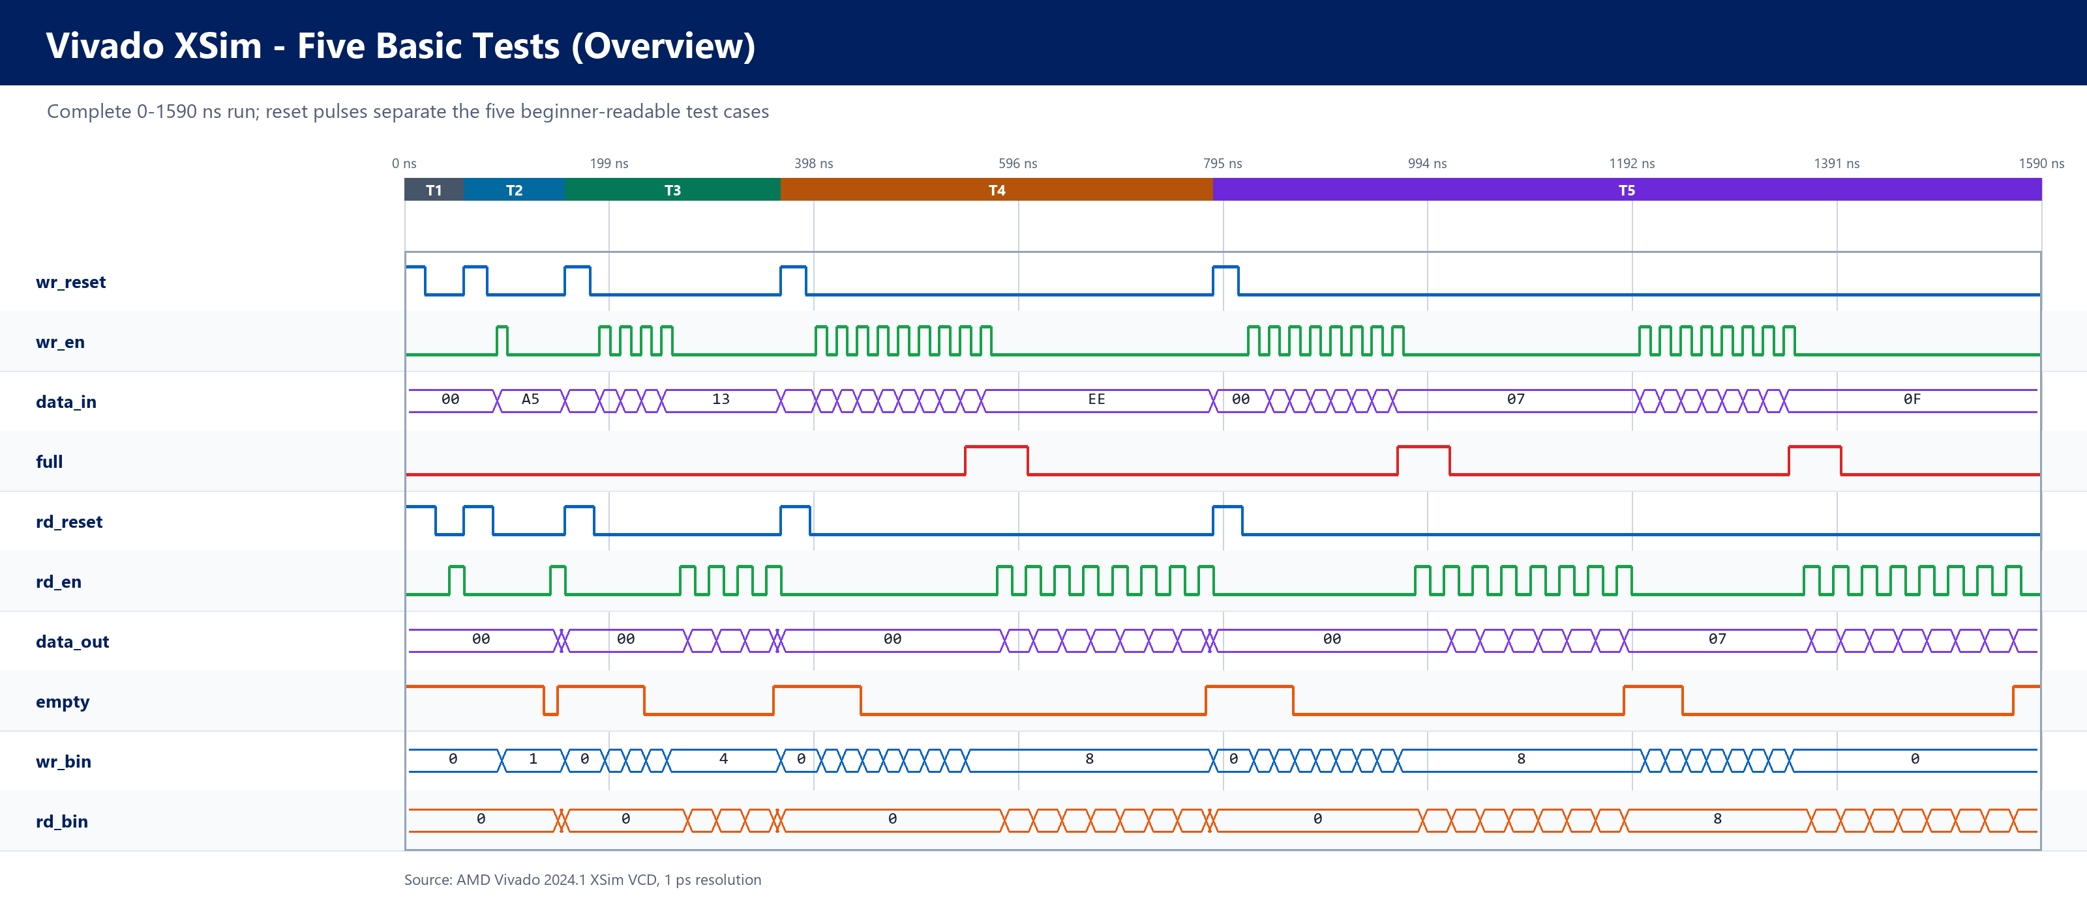
Figure 11.1 — Complete XSim run. The shaded bands identify the five basic tests.
What: The full run shows every test from reset through the final wraparound check.
When: T1 is 0–58 ns, T2 is 58–156 ns, T3 is 156–366 ns, T4 is 366–786 ns, and T5 is 786–1590 ns.
Cause: The testbench resets the FIFO before each case. Only accepted writes and reads move the pointers or data.
Why: This proves that the complete five-test sequence reached the end and that full and empty respond only to valid FIFO activity.

11.2 One Write and One Read
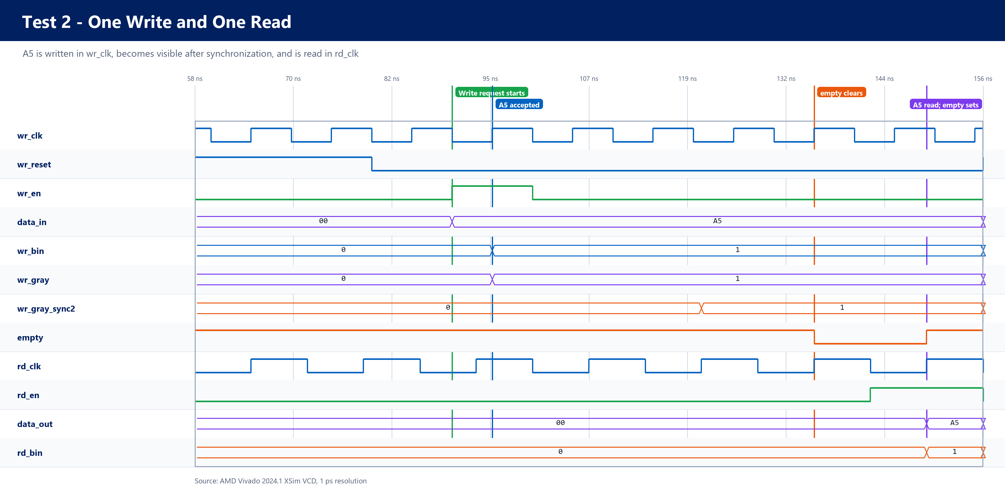
Figure 11.2 — Test 2 detail: one byte crosses safely from the write clock domain to the read clock domain.
What: Data A5 is written once, crosses the clock-domain boundary, and is read once.
When: The write request starts at 90 ns, A5 is accepted at 95 ns, empty clears at 135 ns, and A5 is read at 149 ns.
Cause: The write pointer changes locally, converts to Gray code, and passes through two read-clock synchronizer stages before the read side sees it.
Why: The delay before empty clears is intentional CDC safety. Empty asserts immediately after the final local read because no unread item remains.

11.3 Full Flag and Blocked Extra Write
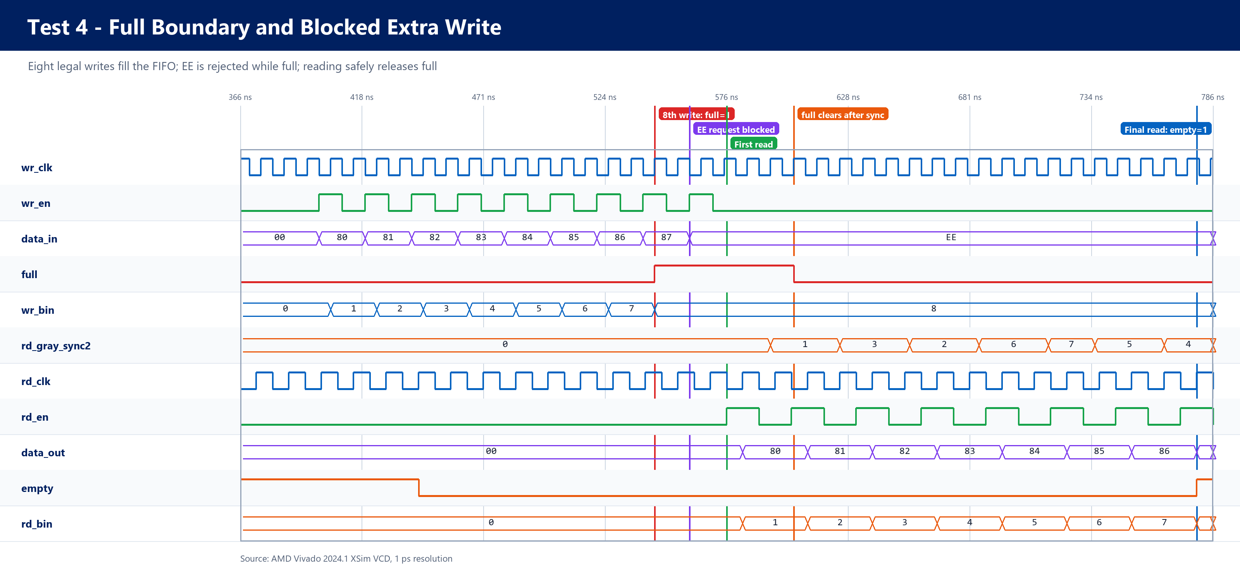
Figure 11.3 — Test 4 detail: the FIFO becomes full, rejects EE, and drains without overwriting data.
What: Eight bytes, 80 through 87, fill the FIFO. An extra EE request is blocked, and the original eight bytes are then read in order.
When: Full asserts at 545 ns, EE is requested at 560 ns, the first read occurs at 576 ns, full clears at 605 ns, and empty asserts at 779 ns.
Cause: The next write pointer reaches the full comparison value, so the write-side logic refuses EE and does not advance wr_bin. After a read, its Gray pointer must cross the synchronizer before full can clear.
Why: This shows that full prevents overwrite. The short delay before full clears is a safe consequence of using two independent clocks.

11.4 Pointer Wraparound
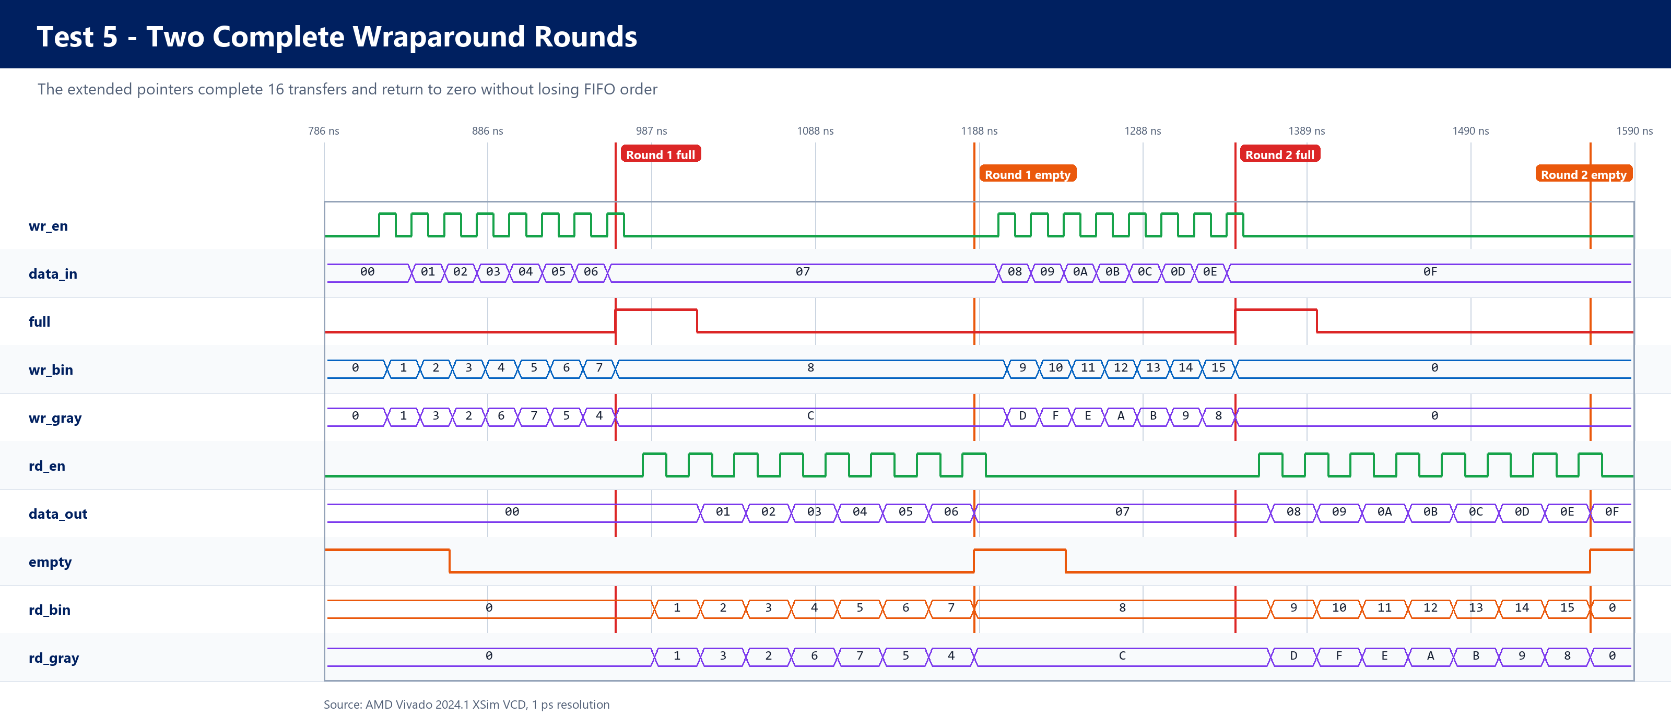
Figure 11.4 — Test 5 detail: two complete rounds verify pointer wraparound and all 16 transfers.
What: The FIFO is filled and drained twice, forcing the address pointers to wrap around.
When: Round 1 reaches full at 965 ns and empty at 1185 ns. Round 2 reaches full at 1345 ns and empty at 1563 ns.
Cause: The extra pointer bit distinguishes the same memory address before and after a complete wrap. Binary pointers select memory, while Gray pointers cross the clock boundary.
Why: This confirms 16 ordered transfers and shows that the pointers return correctly after wrapping instead of confusing full with empty.
Verification result: Vivado XSim reported PASS for all five tests at 1590 ns. Compilation and elaboration completed without errors or warnings. The waveform images explain the timing; the self-checking testbench supplies the pass/fail decision.

