Multithreading and concurrency:
- Print Even Odd with 2 threads
- Print 1-100 with 3 threads
- Fibonacci Using 2 Threads with Semaphore
- Bounded Blocking Queue (Producer Consumer)
- Producer–Consumer using BlockingQueue.
- Thread-safe Singleton (double-checked locking).
- Implement a custom thread pool (basic).

- Print ABC Using 3 Threads in Sequence
- Dining Philosophers

- FizzBuzz Multithreaded

ARYAN:
Print Zero Even Odd
Fizz Buzz Multithreaded
Design Bounded Blocking Queue
The Dining Philosophers
Multithreaded Web Crawler

acquire
if(done)
release(next)
break
work
release(next)

Custom Input from user:

Scanner sc = new Scanner(System.in);
Integer bufferSize = sc.nextInt();
Integer n = sc.nextInt();

nextLine()
nextDouble()
nextFloat()
nextLong()
nextBoolean()

Print 1-100 with 3 threads
Print 1-100 with 3 threads
class NumberPrinter {
private int number = 1;
private int limit;

public NumberPrinter(int limit) {
this.limit = limit;
}

public synchronized void print(int threadId) throws InterruptedException {

while (number <= limit) {
while ((number - 1) % 3 != threadId) {
wait();
}

if (number <= limit) {
System.out.println(Thread.currentThread().getName() + " : " + number);
number++;
}

notifyAll();
}
}
}

public class Main {
public static void main(String[] args) {
NumberPrinter printer = new NumberPrinter(100);

Thread t1 = new Thread(() -> {
try {
printer.print(0);
} catch (InterruptedException e) {}
}, "Thread-1");

Thread t2 = new Thread(() -> {
try {
printer.print(1);
} catch (InterruptedException e) {}
}, "Thread-2");

Thread t3 = new Thread(() -> {
try {
printer.print(2);
} catch (InterruptedException e) {}
}, "Thread-3");

t1.start();
t2.start();
t3.start();
}
}

Print 1-100 with 3 threads using semaphore

import java.util.concurrent.Semaphore;

class NumberPrinter {
private int number = 1;
private int limit;
private Semaphore s1 = new Semaphore(1);
private Semaphore s2 = new Semaphore(0);
private Semaphore s3 = new Semaphore(0);

public NumberPrinter(int limit) {
this.limit = limit;
}

public void print1() throws InterruptedException {
while (true) {
s1.acquire();

if (number > limit) {
s2.release();
break;
}

System.out.println(Thread.currentThread().getName() + " : " + number++);
s2.release();
}
}

public void print2() throws InterruptedException {
while (true) {
s2.acquire();

if (number > limit) {
s3.release();
break;
}

System.out.println(Thread.currentThread().getName() + " : " + number++);
s3.release();
}
}

public void print3() throws InterruptedException {
while (true) {
s3.acquire();

if (number > limit) {
s1.release();
break;
}

System.out.println(Thread.currentThread().getName() + " : " + number++);
s1.release();
}
}
}

public class Main {

public static void main(String[] args) {

NumberPrinter printer = new NumberPrinter(100);

Thread t1 = new Thread(() -> {
try { printer.print1(); } catch (Exception e) {}
}, "Thread-1");

Thread t2 = new Thread(() -> {
try { printer.print2(); } catch (Exception e) {}
}, "Thread-2");

Thread t3 = new Thread(() -> {
try { printer.print3(); } catch (Exception e) {}
}, "Thread-3");

t1.start();
t2.start();
t3.start();
}
}

Print Odd and even Numbers
Print numbers from 1 to N where one thread prints odd numbers and another prints even numbers.

- Using synchronized

class OddEvenPrinter {
private int number = 1;
private final int limit;

public OddEvenPrinter(int limit) {
this.limit = limit;
}

public synchronized void printOdd() throws InterruptedException {
while (number <= limit) {
while (number % 2 == 0) {
wait();
}
if (number <= limit) {
System.out.println("Odd: " + number++);
notify();
}
}
}

public synchronized void printEven() throws InterruptedException {
while (number <= limit) {
while (number % 2 == 1) {
wait();
}
if (number <= limit) {
System.out.println("Even: " + number++);
notify();
}
}
}
}

public class Main {
public static void main(String[] args) {
OddEvenPrinter printer = new OddEvenPrinter(10);

Thread oddThread = new Thread(() -> {
try {
printer.printOdd();
} catch (InterruptedException e) {
Thread.currentThread().interrupt();
}
});

Thread evenThread = new Thread(() -> {
try {
printer.printEven();
} catch (InterruptedException e) {
Thread.currentThread().interrupt();
}
});

oddThread.start();
evenThread.start();
}
}

- Using Semaphore :

import java.util.concurrent.Semaphore;

class NumberPrinter {
private int curr = 1;
private int n;
private Semaphore s1 = new Semaphore(1);
private Semaphore s2 = new Semaphore(0);

NumberPrinter(int n) {
this.n = n;
}

public void print1() throws InterruptedException {
while (true) {
s1.acquire();
if (curr > n) {
s2.release();
break;
}
System.out.println("Thread1 : " + curr++);
s2.release();
}
}

public void print2() throws InterruptedException {
while (true) {
s2.acquire();
if (curr > n) {
s1.release();
break;
}
System.out.println("Thread2 : " + curr++);
s1.release();
}
}
}

public class Main {
public static void main(String[] args) {
NumberPrinter printer = new NumberPrinter(100);

Thread t1 = new Thread(() -> {
try {
printer.print1();
} catch (InterruptedException e) {
e.printStackTrace();
}
});

Thread t2 = new Thread(() -> {
try {
printer.print2();
} catch (InterruptedException e) {
e.printStackTrace();
}
});

t1.start();
t2.start();
}
}

Fibonacci Using 2 Threads
Fibonacci Using 2 Threads (Alternate Printing):

Idea
- Shared Fibonacci state: a, b
- Two threads print numbers alternately
- Use a boolean flag to control turn.

class FibonacciPrinter {
private int n;
private int a = 0;
private int b = 1;
private boolean firstThreadTurn = true;

public FibonacciPrinter(int n) {
this.n = n;
}

public synchronized void printByFirstThread() throws InterruptedException {
for (int i = 0; i < n; i += 2) {

while (!firstThreadTurn)
wait();

System.out.println(Thread.currentThread().getName() + " : " + a);

int next = a + b;
a = b;
b = next;

firstThreadTurn = false;
notify();
}
}

public synchronized void printBySecondThread() throws InterruptedException {
for (int i = 1; i < n; i += 2) {

while (firstThreadTurn)
wait();

System.out.println(Thread.currentThread().getName() + " : " + a);

int next = a + b;
a = b;
b = next;

firstThreadTurn = true;
notify();
}
}
}

public class FibonacciTwoThreads {

public static void main(String[] args) {

FibonacciPrinter printer = new FibonacciPrinter(10);

Thread t1 = new Thread(() -> {
try {
printer.printByFirstThread();
} catch (InterruptedException e) {}
}, "Thread-1");

Thread t2 = new Thread(() -> {
try {
printer.printBySecondThread();
} catch (InterruptedException e) {}
}, "Thread-2");

t1.start();
t2.start();
}
}

Possible Follow-up Questions
1. Can we do it with Lock + Condition?
Yes.
2. Can we do it with Semaphore?
Yes (two semaphores).
3. Why while instead of if with wait()?
To handle spurious wakeups.

Fibonacci using 2 threads with Semaphore

import java.util.concurrent.Semaphore;

class FibonacciPrinter {

private int a = 0;
private int b = 1;
private int limit;

private Semaphore computeSem = new Semaphore(0);
private Semaphore printSem = new Semaphore(1);

FibonacciPrinter(int limit) {
this.limit = limit;
}

public void compute() throws InterruptedException {

for (int i = 0; i < limit; i++) {
computeSem.acquire();
int next = a + b;
a = b;
b = next;
printSem.release();
}
}

public void print() throws InterruptedException {

for (int i = 0; i < limit; i++) {
printSem.acquire();
System.out.println(a);
computeSem.release();
}
}
}

public class Main {

public static void main(String[] args) {

FibonacciPrinter printer = new FibonacciPrinter(10);

Thread t1 = new Thread(() -> {
try {
printer.compute();
} catch (Exception e) {}
});

Thread t2 = new Thread(() -> {
try {
printer.print();
} catch (Exception e) {}
});

t1.start();
t2.start();
}
}

Print ABC Using 3 Threads in Sequence
Print ABC Using 3 Threads in Sequence

Three threads should print A, B, C in order repeatedly.

class ABCPrinter {
private int state = 0;

public synchronized void printA() throws InterruptedException {
while (state % 3 != 0) wait();
System.out.print("A");
state++;
notifyAll();
}

public synchronized void printB() throws InterruptedException {
while (state % 3 != 1) wait();
System.out.print("B");
state++;
notifyAll();
}

public synchronized void printC() throws InterruptedException {
while (state % 3 != 2) wait();
System.out.print("C ");
state++;
notifyAll();
}
}

public class Main {
public static void main(String[] args) {
ABCPrinter p = new ABCPrinter();

new Thread(() -> {
try { for (int i = 0; i < 5; i++) p.printA(); } catch (Exception e) {}
}).start();

new Thread(() -> {
try { for (int i = 0; i < 5; i++) p.printB(); } catch (Exception e) {}
}).start();

new Thread(() -> {
try { for (int i = 0; i < 5; i++) p.printC(); } catch (Exception e) {}
}).start();
}
}

Print ABC Using 3 Threads in Sequence using semaphore

import java.util.concurrent.Semaphore;

class ABCPrinter {
private Semaphore semA = new Semaphore(1);
private Semaphore semB = new Semaphore(0);
private Semaphore semC = new Semaphore(0);

public void printA() throws InterruptedException {
semA.acquire();
System.out.print("A");
semB.release();
}

public void printB() throws InterruptedException {
semB.acquire();
System.out.print("B");
semC.release();
}

public void printC() throws InterruptedException {
semC.acquire();
System.out.print("C ");
semA.release();
}
}

public class Main {
public static void main(String[] args) {
ABCPrinter printer = new ABCPrinter();
int n = 5;

Thread t1 = new Thread(() -> {
try {
for (int i = 0; i < n; i++) {
printer.printA();
}
} catch (Exception e) {}
});

Thread t2 = new Thread(() -> {
try {
for (int i = 0; i < n; i++) {
printer.printB();
}
} catch (Exception e) {}
});

Thread t3 = new Thread(() -> {
try {
for (int i = 0; i < n; i++) {
printer.printC();
}
} catch (Exception e) {}
});

t1.start();
t2.start();
t3.start();
}
}

FizzBuzz:
FizzBuzz:

import java.util.concurrent.Semaphore;
import java.util.function.IntConsumer;

class FizzBuzz {

private int n;

private final Semaphore numberSemaphore;
private final Semaphore fizzSemaphore;
private final Semaphore buzzSemaphore;
private final Semaphore fizzBuzzSemaphore;

public FizzBuzz(int n) {
this.n = n;

numberSemaphore = new Semaphore(1);
fizzSemaphore = new Semaphore(0);
buzzSemaphore = new Semaphore(0);
fizzBuzzSemaphore = new Semaphore(0);
}

public void fizz(Runnable printFizz) throws InterruptedException {
for (int i = 1; i <= n; i++) {
if (i % 3 == 0 && i % 5 != 0) {
fizzSemaphore.acquire();
printFizz.run();
numberSemaphore.release();
}
}
}

public void buzz(Runnable printBuzz) throws InterruptedException {
for (int i = 1; i <= n; i++) {
if (i % 5 == 0 && i % 3 != 0) {
buzzSemaphore.acquire();
printBuzz.run();
numberSemaphore.release();
}
}
}

public void fizzbuzz(Runnable printFizzBuzz) throws InterruptedException {
for (int i = 1; i <= n; i++) {
if (i % 3 == 0 && i % 5 == 0) {
fizzBuzzSemaphore.acquire();
printFizzBuzz.run();
numberSemaphore.release();
}
}
}

public void number(IntConsumer printNumber) throws InterruptedException {

for (int i = 1; i <= n; i++) {
numberSemaphore.acquire();
if (i % 3 == 0 && i % 5 == 0) {
fizzBuzzSemaphore.release();
}
else if (i % 3 == 0) {
fizzSemaphore.release();
}
else if (i % 5 == 0) {
buzzSemaphore.release();
}
else {
printNumber.accept(i);
numberSemaphore.release();
}
}
}
}

public class Main {

public static void main(String[] args) {
int n = 20;
FizzBuzz fb = new FizzBuzz(n);
Thread fizzThread = new Thread(() -> {
try {
fb.fizz(() -> System.out.print("Fizz "));
} catch (Exception e) {}
});

Thread buzzThread = new Thread(() -> {
try {
fb.buzz(() -> System.out.print("Buzz "));
} catch (Exception e) {}
});

Thread fizzBuzzThread = new Thread(() -> {
try {
fb.fizzbuzz(() -> System.out.print("FizzBuzz "));
} catch (Exception e) {}
});

Thread numberThread = new Thread(() -> {
try {
fb.number((x) -> System.out.print(x + " "));
} catch (Exception e) {}
});

fizzThread.start();
buzzThread.start();
fizzBuzzThread.start();
numberThread.start();
}
}

Implement a Custom Thread Pool
Implement a Custom Thread Pool

Implement a basic thread pool without using ExecutorService.

import java.util.concurrent.BlockingQueue;
import java.util.concurrent.LinkedBlockingQueue;

class CustomThreadPool {
private final BlockingQueue<Runnable> queue;

public CustomThreadPool(int size) {
queue = new LinkedBlockingQueue<>();

for (int i = 0; i < size; i++) {
new Worker().start();
}
}

public void submit(Runnable task) {
queue.offer(task);
}

private class Worker extends Thread {
@Override
public void run() {
while (true) {
try {
Runnable task = queue.take();
task.run();
} catch (InterruptedException e) {
Thread.currentThread().interrupt();
break;
}
}
}
}
}

public class Main {
public static void main(String[] args) {
CustomThreadPool pool = new CustomThreadPool(2);
pool.submit(() -> System.out.println("Task 1"));
pool.submit(() -> System.out.println("Task 2"));
}
}

Bounded Blocking Queue:
Blocking Queue: Blocking queue is an interface.
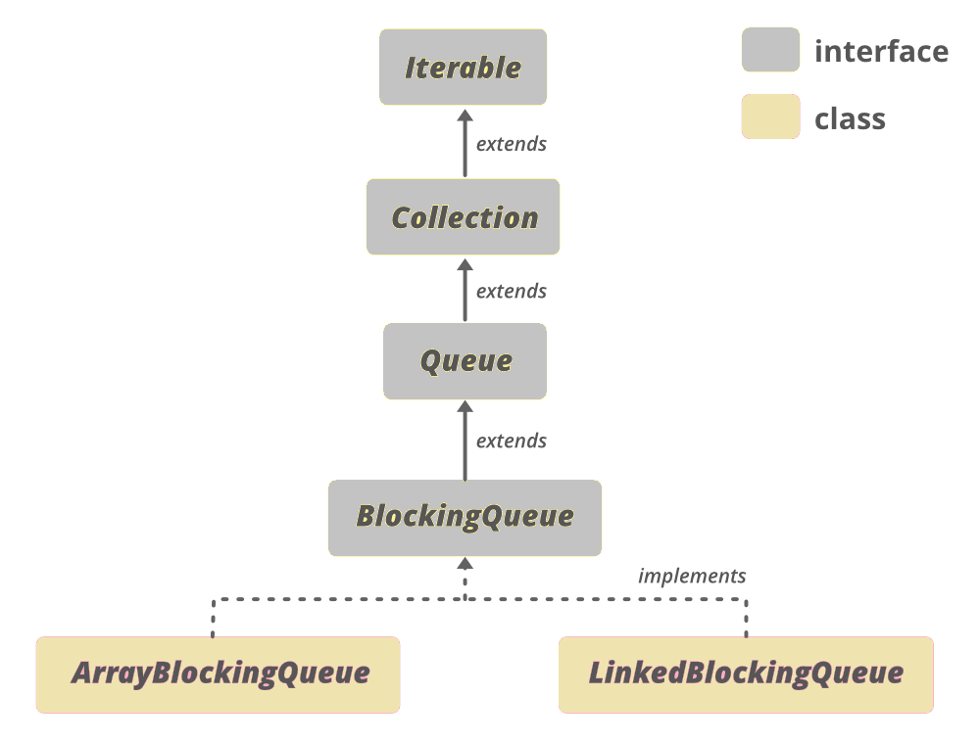
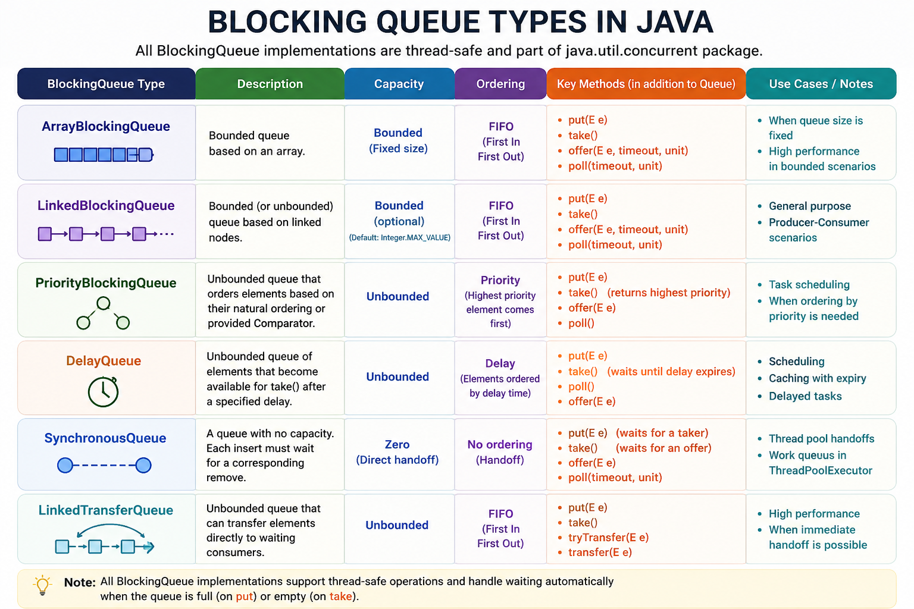
BlockingQueue (Interface) adds:
- put(), take() → blocking operations
- offer(), poll() with timeout

2. Class Hierarchy
AbstractQueue<E>
↑
ArrayBlockingQueue<E>
↑
implements BlockingQueue<E>, Serializable

ArrayBlockingQueue<E>
--------------------------------
- final Object[] items
- int takeIndex
- int putIndex
- int count
- ReentrantLock lock
- Condition notEmpty
- Condition notFull
--------------------------------
+ put(E e)
+ take()
+ offer(E e)
+ poll()

4. Internal Working
- Uses fixed-size array (circular buffer)
- Two pointers:
  - putIndex → where to insert
  - takeIndex → where to remove
- Synchronization:
  - Single ReentrantLock
  - notFull.await() → when queue is full
  - notEmpty.await() → when queue is empty

Bounded Blocking Queue:
A Bounded Blocking Queue is a thread-safe queue with a fixed capacity where:
- Producers block if the queue is full.
- Consumers block if the queue is empty.

Methods:

Method | Behavior
put(E e) | blocks if full
take() | blocks if empty
offer(E e) | returns false if full
poll() | returns null if empty
peek() | read without removing
size() | current size

But we need to implement enqueue, dequeue, and size;

Key Idea
We maintain three things:
- availableSlots → number of empty spaces in queue
- availableItems → number of items ready to consume
- mutex → ensures only one thread modifies the queue at a time

Code :

import java.util.LinkedList;
import java.util.Queue;
import java.util.concurrent.Semaphore;

class BoundedBlockingQueue {

private Queue<Integer> queue;
private int capacity;

private Semaphore availableSlots;
private Semaphore availableItems;
private Semaphore mutex;

public BoundedBlockingQueue(int capacity) {
this.capacity = capacity;
this.queue = new LinkedList<>();

availableSlots = new Semaphore(capacity);
availableItems = new Semaphore(0);
mutex = new Semaphore(1);
}

public void enqueue(int element) throws InterruptedException {
availableSlots.acquire(); // wait if queue is full
mutex.acquire();
try {
queue.add(element);
availableItems.release(); // signal item available
} finally {
mutex.release();
}
}

public int dequeue() throws InterruptedException {
availableItems.acquire(); // wait if queue empty
mutex.acquire();
try {
int value = queue.poll();
availableSlots.release(); // signal empty slot
} finally {
mutex.release();
}
return value;
}

public int size() throws InterruptedException {
int size;
mutex.acquire();
try {
size = queue.size();
} finally {
mutex.release();
}
return size;
}
}

public class Main {

public static void main(String[] args) {
BoundedBlockingQueue queue = new BoundedBlockingQueue(3);

Thread producer = new Thread(() -> {
try {
for(int i=1;i<=5;i++){
queue.enqueue(i);
System.out.println("Produced: " + i + " size=" + queue.size());
}
} catch (Exception e) {}
});

Thread consumer = new Thread(() -> {
try {
for(int i=1;i<=5;i++){
int val = queue.dequeue();
System.out.println("Consumed: " + val + " size=" + queue.size());
}
} catch (Exception e) {}
});

producer.start();
consumer.start();
}
}

Q. ) Why size() needs a lock?
size() needs the lock (mutex) because the queue is not thread-safe and may be modified concurrently by enqueue() and dequeue().
Without the lock, size() could read the queue while another thread is modifying it, which leads to race conditions and inconsistent results.

Creating separate Producer, Consumer Class:

class Producer implements Runnable {
private BoundedBlockingQueue queue;

Producer(BoundedBlockingQueue queue) {
this.queue = queue;
}

public void run() {
try {
for (int i = 1; i <= 5; i++) {
queue.enqueue(i);
System.out.println( "Produced: " + i + " size=" + queue.size() );
Thread.sleep(500);
}
} catch (Exception e) {
Thread.currentThread().interrupt();
}
}
}

Consumer Class:

class Consumer implements Runnable {
private BoundedBlockingQueue queue;

Consumer(BoundedBlockingQueue queue) {
this.queue = queue;
}

public void run() {
try {
for (int i = 1; i <= 5; i++) {
int val = queue.dequeue();
System.out.println("Consumed: " + val + " size=" + queue.size());
Thread.sleep(800);
}
} catch (Exception e) {
Thread.currentThread().interrupt();
}
}
}

Main Class:

public class Main {
public static void main(String[] args) {
BoundedBlockingQueue queue = new BoundedBlockingQueue(3);

Thread producer = new Thread(new Producer(queue));
Thread consumer = new Thread(new Consumer(queue));

producer.start();
consumer.start();
}
}

Producer–Consumer Using BlockingQueue
Producer Consumer using Blocking Queue:

import java.util.concurrent.BlockingQueue;
import java.util.concurrent.LinkedBlockingQueue;

class Producer implements Runnable {
private BlockingQueue<Integer> queue;

Producer(BlockingQueue<Integer> queue) {
this.queue = queue;
}

public void run() {
try {
for (int i = 1; i <= 5; i++) {
queue.put(i);
System.out.println("Produced: " + i);
}
} catch (InterruptedException e) {
Thread.currentThread().interrupt();
}
}
}

class Consumer implements Runnable {
private BlockingQueue<Integer> queue;

Consumer(BlockingQueue<Integer> queue) {
this.queue = queue;
}

public void run() {
try {
for (int i = 1; i <= 5; i++) {
int val = queue.take();
System.out.println("Consumed: " + val);
}
} catch (InterruptedException e) {
Thread.currentThread().interrupt();
}
}
}

public class Main {
public static void main(String[] args) {
BlockingQueue<Integer> queue = new LinkedBlockingQueue<>(2);

Thread producer = new Thread(new Producer(queue));
Thread consumer = new Thread(new Consumer(queue));

producer.start();
consumer.start();
}
}

Producer consumer using wait and notify:

import java.util.*;

class SharedBuffer {

private Queue<Integer> queue = new LinkedList<>();
private int capacity;

SharedBuffer(int capacity) {
this.capacity = capacity;
}

public synchronized void produce(int value) throws InterruptedException {

while (queue.size() == capacity) {
wait(); // buffer full
}

queue.add(value);
System.out.println("Produced: " + value);

notify(); // wake consumer
}

public synchronized void consume() throws InterruptedException {

while (queue.isEmpty()) {
wait(); // buffer empty
}

int value = queue.poll();
System.out.println("Consumed: " + value);

notify(); // wake producer
}
}

public class Main {
public static void main(String[] args) {
SharedBuffer buffer = new SharedBuffer(5);

Thread producer = new Thread(() -> {
int value = 1;
try {
while (true) {
buffer.produce(value++);
Thread.sleep(500);
}
} catch (InterruptedException e) {}
});

Thread consumer = new Thread(() -> {
try {
while (true) {
buffer.consume();
Thread.sleep(800);
}
} catch (InterruptedException e) {}
});

producer.start();
consumer.start();
}
}

Read–Write Lock Problem:
Read–Write Lock Problem:

Problem
- Multiple threads can read simultaneously
- Only one thread can write at a time
- No read during write
- No write during read

Key Concept
Use ReentrantReadWriteLock
- readLock() → shared lock
- writeLock() → exclusive lock

import java.util.concurrent.locks.*;

class SharedResource {

private int data = 0;

private final ReentrantReadWriteLock lock = new ReentrantReadWriteLock();

// READ operation
public void read() {
lock.readLock().lock();
try {
System.out.println(Thread.currentThread().getName() +
" reading value: " + data);

Thread.sleep(100); // simulate read delay
} catch (InterruptedException e) {
e.printStackTrace();
} finally {
lock.readLock().unlock();
}
}

// WRITE operation
public void write(int value) {
lock.writeLock().lock();
try {
System.out.println(Thread.currentThread().getName() +
" writing value: " + value);

Thread.sleep(100); // simulate write delay
data = value;

} catch (InterruptedException e) {
e.printStackTrace();
} finally {
lock.writeLock().unlock();
}
}
}

public class Main {

public static void main(String[] args) {

SharedResource resource = new SharedResource();

// Reader threads
Runnable reader = () -> {
for (int i = 0; i < 3; i++) {
resource.read();
}
};

// Writer thread
Runnable writer = () -> {
for (int i = 1; i <= 3; i++) {
resource.write(i * 10);
}
};

Thread r1 = new Thread(reader, "Reader-1");
Thread r2 = new Thread(reader, "Reader-2");
Thread w1 = new Thread(writer, "Writer-1");

r1.start();
r2.start();
w1.start();
}
}

Dining Philosopher Problem
Dining Philosopher Problem:

import java.util.concurrent.Semaphore;

class DiningPhilosophers {

private final Semaphore table = new Semaphore(4);
private final Semaphore[] forks = new Semaphore[5];

public DiningPhilosophers() {
for (int i = 0; i < 5; i++) {
forks[i] = new Semaphore(1);
}
}

public void wantsToEat(int id) throws InterruptedException {

int left = id;
int right = (id + 1) % 5;

table.acquire();

forks[left].acquire();
forks[right].acquire();

eat(id);

forks[left].release();
forks[right].release();

table.release();
}

private void eat(int id) {
System.out.println("Philosopher " + id + " is eating");
}
}

public class Main {

public static void main(String[] args) {

DiningPhilosophers dp = new DiningPhilosophers();

for (int i = 0; i < 5; i++) {
int id = i;
new Thread(() -> {
try {
dp.wantsToEat(id);
} catch (InterruptedException e) {
Thread.currentThread().interrupt();
}
}).start();
}
}
}

Another approach:

import java.util.concurrent.Semaphore;

class DiningPhilosophers {

private Semaphore semaphore;
private Semaphore[] forks;

public DiningPhilosophers() {
// Allow only 4 philosophers to try eating simultaneously
semaphore = new Semaphore(4);

forks = new Semaphore[5];
for (int i = 0; i < 5; i++) {
forks[i] = new Semaphore(1);
}
}

public void wantsToEat(int philosopher,
Runnable pickLeftFork,
Runnable pickRightFork,
Runnable eat,
Runnable putLeftFork,
Runnable putRightFork) throws InterruptedException {

semaphore.acquire();

int left = philosopher;
int right = (philosopher + 1) % 5;

Semaphore leftFork = forks[left];
Semaphore rightFork = forks[right];

leftFork.acquire();
rightFork.acquire();

pickLeftFork.run();
pickRightFork.run();

eat.run();

putRightFork.run();
rightFork.release();

putLeftFork.run();
leftFork.release();

semaphore.release();
}
}

public class Main {

public static void main(String[] args) {

DiningPhilosophers dp = new DiningPhilosophers();

for (int i = 0; i < 5; i++) {

int philosopher = i;

new Thread(() -> {
try {
dp.wantsToEat(
philosopher,

() -> System.out.println("Philosopher " + philosopher + " picked LEFT fork"),

() -> System.out.println("Philosopher " + philosopher + " picked RIGHT fork"),

() -> System.out.println("Philosopher " + philosopher + " is EATING"),

() -> System.out.println("Philosopher " + philosopher + " put LEFT fork"),

() -> System.out.println("Philosopher " + philosopher + " put RIGHT fork")

);
} catch (InterruptedException e) {
Thread.currentThread().interrupt();
}
}).start();
}
}
}

Why this works
- Maximum 4 philosophers allowed → circular wait breaks
- Deadlock avoided

Other Solutions Interviewers Like
- Odd-Even Fork Pickup
- ReentrantLock with tryLock
- Waiter solution (monitor)

Sum of Array Using Multithreading

Sum of Array Using Multithreading

Approach
- Split array into chunks
- Each thread computes partial sum
- Combine results using Future

- Using newFixedThreadPool and future

import java.util.*;
import java.util.concurrent.*;

// Callable Task
class SumTask implements Callable<Long> {
private int[] arr;
private int start;
private int end;

public SumTask(int[] arr, int start, int end) {
this.arr = arr;
this.start = start;
this.end = end;
}

@Override
public Long call() {
long sum = 0;
for (int i = start; i < end; i++) {
sum += arr[i];
}
return sum;
}
}

public class Main {

public static void main(String[] args) throws Exception {

int[] arr = {1,2,3,4,5,6,7,8,9,10};

int numThreads = 4;
ExecutorService executor = Executors.newFixedThreadPool(numThreads);

List<Future<Long>> futures = new ArrayList<>();

int chunkSize = (arr.length + numThreads - 1) / numThreads;

// Submit tasks
for (int i = 0; i < arr.length; i += chunkSize) {
int start = i;
int end = Math.min(i + chunkSize, arr.length);
futures.add(executor.submit(new SumTask(arr, start, end)));
}

long totalSum = 0;

// Collect results
for (Future<Long> future : futures) {
totalSum += future.get();
}

executor.shutdown();

System.out.println("Total Sum: " + totalSum);
}
}

- Using ThreadPoolExecutor and future:

import java.util.*;
import java.util.concurrent.*;

public class Main {

public static void main(String[] args) throws Exception {

int[] arr = new int[100];
Arrays.fill(arr, 1);

int numThreads = 4;

ExecutorService executor = new ThreadPoolExecutor(
numThreads,
numThreads,
0L, TimeUnit.MILLISECONDS,
new ArrayBlockingQueue<>(5),
new ThreadPoolExecutor.AbortPolicy()
);

List<Future<Long>> futures = new ArrayList<>();

int chunkSize = arr.length / numThreads + (arr.length % numThreads == 0 ? 0 : 1);

for (int i = 0; i < arr.length; i+=chunkSize) {

int start = i ;
int end = Math.min(chunkSize, arr.length);

if (start >= arr.length) break;

futures.add(executor.submit(() -> {
long localSum = 0;
for (int j = start; j < end; j++) {
localSum += arr[j];
}
return localSum;
}));
}

long total = 0;

for (Future<Long> f : futures) {
try {
total += f.get();
} catch (ExecutionException e) {
System.out.println("Task failed: " + e.getCause());
}
}

executor.shutdown();

System.out.println("Total Sum: " + total);
}
}

Using CompletableFuture:

import java.util.*;
import java.util.concurrent.*;
import java.util.stream.*;

public class Main {

public static void main(String[] args) {

int[] arr = {1,2,3,4,5,6,7,8,9,10};

int numThreads = 4;
ExecutorService executor = Executors.newFixedThreadPool(numThreads);

int chunkSize = (arr.length + numThreads - 1) / numThreads;

List<CompletableFuture<Long>> futures = new ArrayList<>();

for (int i = 0; i < arr.length; i += chunkSize) {
int start = i;
int end = Math.min(i + chunkSize, arr.length);

CompletableFuture<Long> future = CompletableFuture.supplyAsync(() -> {
long sum = 0;
for (int j = start; j < end; j++) {
sum += arr[j];
}
return sum;
}, executor);

futures.add(future);
}

// Combine results
long totalSum = futures.stream()
.map(CompletableFuture::join) // non-checked exception
.mapToLong(Long::longValue)
.sum();

executor.shutdown();

System.out.println("Total Sum: " + totalSum);
}
}

import java.util.*;
import java.util.concurrent.*;

// Callable Task (same as yours)
class SumTask implements Callable<Long> {
private int[] arr;
private int start;
private int end;

public SumTask(int[] arr, int start, int end) {
this.arr = arr;
this.start = start;
this.end = end;
}

@Override
public Long call() {
long sum = 0;
for (int i = start; i < end; i++) {
sum += arr[i];
}
return sum;
}
}

public class Main {

public static void main(String[] args) {

int[] arr = {1,2,3,4,5,6,7,8,9,10};

int numThreads = 4;
ExecutorService executor = Executors.newFixedThreadPool(numThreads);

List<CompletableFuture<Long>> futures = new ArrayList<>();

int chunkSize = (arr.length + numThreads - 1) / numThreads;

// Submit tasks using SumTask explicitly
for (int i = 0; i < arr.length; i += chunkSize) {
int start = i;
int end = Math.min(i + chunkSize, arr.length);

SumTask task = new SumTask(arr, start, end);

CompletableFuture<Long> future = CompletableFuture.supplyAsync(() -> {
try {
return task.call(); // reuse Callable
} catch (Exception e) {
throw new RuntimeException(e);
}
}, executor);

futures.add(future);
}

// Combine results
CompletableFuture<Long> finalResult =
CompletableFuture.allOf(futures.toArray(new CompletableFuture[0]))
.thenApply(v ->
futures.stream()
.mapToLong(CompletableFuture::join)
.sum()
);

long totalSum = finalResult.join();

executor.shutdown();

System.out.println("Total Sum: " + totalSum);
}
}

Even with CompletableFuture: future.join();
You are still waiting at the end
So:
- It becomes async internally
- But final aggregation is still blocking

1. CompletableFuture.allOf()

✅ Problem
You have multiple async tasks → want to wait for all of them

Without allOf()
for (CompletableFuture<Long> f : futures) {
total += f.join(); // waiting one by one
}

With allOf()

import java.util.*;
import java.util.concurrent.*;

public class Main {

public static void main(String[] args) {

int[] arr = {1,2,3,4,5,6,7,8,9,10};
int numThreads = 4;

ExecutorService executor = Executors.newFixedThreadPool(numThreads);

List<CompletableFuture<Long>> futures = new ArrayList<>();

int chunkSize = (arr.length + numThreads - 1) / numThreads;

for (int i = 0; i < arr.length; i += chunkSize) {
int start = i;
int end = Math.min(i + chunkSize, arr.length);

futures.add(CompletableFuture.supplyAsync(() -> {
long sum = 0;
for (int j = start; j < end; j++) {
sum += arr[j];
}
return sum;
}, executor));
}

// ✅ Wait for all
CompletableFuture<Void> all = CompletableFuture.allOf(
futures.toArray(new CompletableFuture[0])
);

// ✅ Combine after all complete
long total = all.thenApply(v ->
futures.stream()
.mapToLong(CompletableFuture::join)
.sum()
).join();

executor.shutdown();

System.out.println("Total Sum: " + total);
}
}

Key Idea
CompletableFuture.allOf(f1, f2, f3)
Returns:
- CompletableFuture<Void>
- Completes when ALL tasks finish

2. CompletableFuture vs parallelStream()

parallelStream()

long sum = Arrays.stream(arr).parallel().asLongStream().sum();

CompletableFuture
- Manual control over:
  - threads
  - task splitting
  - Execution

Feature | parallelStream | CompletableFuture
Ease | ✅ Very easy | ❌ More code
Control | ❌ Low | ✅ High
Thread Pool | Common ForkJoinPool | Custom pool
Debugging | ❌ Hard | ✅ Easier
Composition | ❌ Limited | ✅ Powerful
Best for | CPU-bound simple ops | Complex async workflows

When to Use What

Use parallelStream() when:
- Simple operations
- Stateless computation
- CPU-bound tasks

Use CompletableFuture when:
- Need custom thread pool
- Need chaining (thenApply)
- Need error handling
- Need multiple async dependencies

Q: Process 3 APIs in parallel and combine result
Use : CompletableFuture.allOf(...)

- parallelStream() = quick & simple
- CompletableFuture = powerful & scalable
- allOf() = sync multiple async tasks

Parallel Processing:

10. Parallel File Processing / Log Processing
Problem:
Process large files concurrently
Concepts:
- Thread pool
- Chunking
- I/O + CPU balance

Java Code

import java.io.*;
import java.util.*;
import java.util.concurrent.*;

class FileChunkTask implements Callable<Integer> {

private List<String> lines;

public FileChunkTask(List<String> lines) {
this.lines = lines;
}

@Override
public Integer call() {
int count = 0;

for (String line : lines) {
// Example: count lines containing "ERROR"
if (line.contains("ERROR")) {
count++;
}
}

return count;
}
}

public class Main {

public static void main(String[] args) throws Exception {

String filePath = "large_log.txt";

int numThreads = Runtime.getRuntime().availableProcessors();
ExecutorService executor = Executors.newFixedThreadPool(numThreads);

List<Future<Integer>> futures = new ArrayList<>();

int chunkSize = 1000; // lines per chunk

BufferedReader reader = new BufferedReader(new FileReader(filePath));

List<String> chunk = new ArrayList<>();
String line;

while ((line = reader.readLine()) != null) {
chunk.add(line);

if (chunk.size() == chunkSize) {
futures.add(executor.submit(new FileChunkTask(new ArrayList<>(chunk))));
chunk.clear();
}
}

// Remaining lines
if (!chunk.isEmpty()) {
futures.add(executor.submit(new FileChunkTask(chunk)));
}

reader.close();

int totalCount = 0;

for (Future<Integer> future : futures) {
totalCount += future.get();
}

executor.shutdown();

System.out.println("Total ERROR lines: " + totalCount);
}
}

Sum of Squares
Q. ) Find the sum of square of even numbers using multithreading

import java.util.*;
import java.util.concurrent.*;

class SumTask implements Callable<Long> {

private List<Integer> list;
private int start;
private int end;

public SumTask(List<Integer> list, int start, int end) {
this.list = list;
this.start = start;
this.end = end;
}

@Override
public Long call() {
long localSum = 0;

for (int i = start; i < end; i++) {
int num = list.get(i);
if (num % 2 == 0) {
localSum += num * num;
}
}
return localSum;
}
}

public class Main {
public static void main(String[] args) throws Exception {
List<Integer> list = Arrays.asList(1,2,3,4,5,6,7,8,9,10);

int numThreads = 4;
ExecutorService executor = Executors.newFixedThreadPool(numThreads);

List<Future<Long>> futures = new ArrayList<>();
int chunkSize = (list.size() + numThreads - 1) / numThreads;

// Submit tasks
for (int i = 0; i < list.size(); i += chunkSize) {
int start = i;
int end = Math.min(i + chunkSize, list.size());
futures.add(executor.submit(new SumTask(list, start, end)));
}

long finalSum = 0;

// Collect results
for (Future<Long> future : futures) {
finalSum += future.get();
}

executor.shutdown();

System.out.println("Sum of squares of even numbers: " + finalSum);
}
}

Main Exceptions from Future:

1. ExecutionException
- Thrown when task itself throws an exception
- Wraps the actual exception

Future<Integer> future = executor.submit(() -> {
int x = 10 / 0; // ArithmeticException
return x;
});

try {
future.get();
} catch (ExecutionException e) {
System.out.println(e.getCause()); // ArithmeticException
}
Always use: e.getCause()

2. InterruptedException
- Thrown when thread waiting on get() is interrupted

try {
future.get();
} catch (InterruptedException e) {
Thread.currentThread().interrupt(); // best practice
}

3. CancellationException
- Thrown when:
  - Task was cancelled
  - and you call get()

future.cancel(true);
future.get(); // ❌ throws CancellationException

Summary Table
Exception | When
ExecutionException | Task threw exception
InterruptedException | Waiting thread interrupted
CancellationException | Task cancelled

Future itself does NOT throw exceptions during executor.submit(...)
All exceptions appear during: uture.get()

Q: Why don’t we see exception immediately?
✔️ Answer:
Because submit() captures exceptions and stores them inside Future, to be retrieved later via get()

Difference with execute()
Method | Exception Behavior
submit() | Wrapped in Future
execute() | Thrown immediately (uncaught handler)

ExecutorService executor = Executors
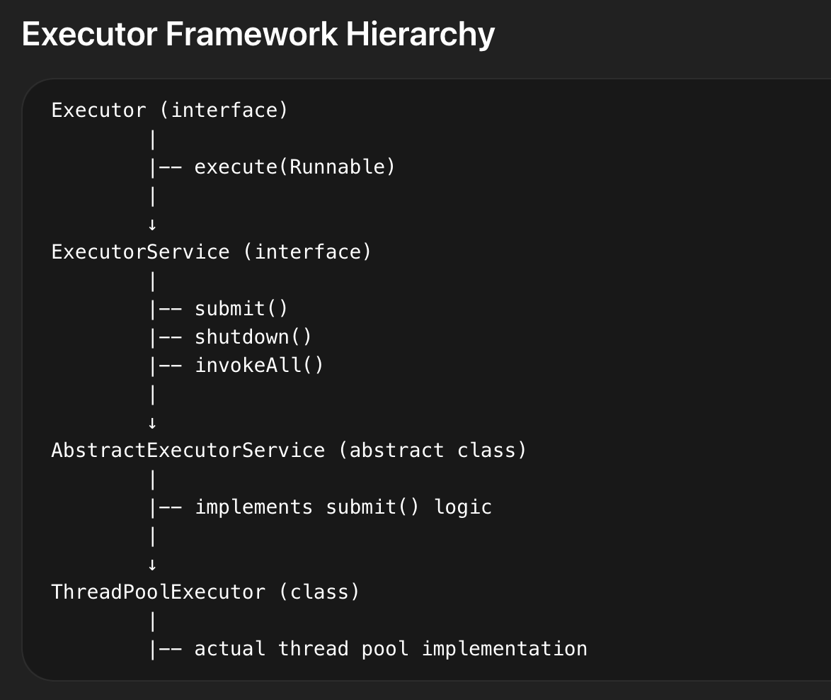
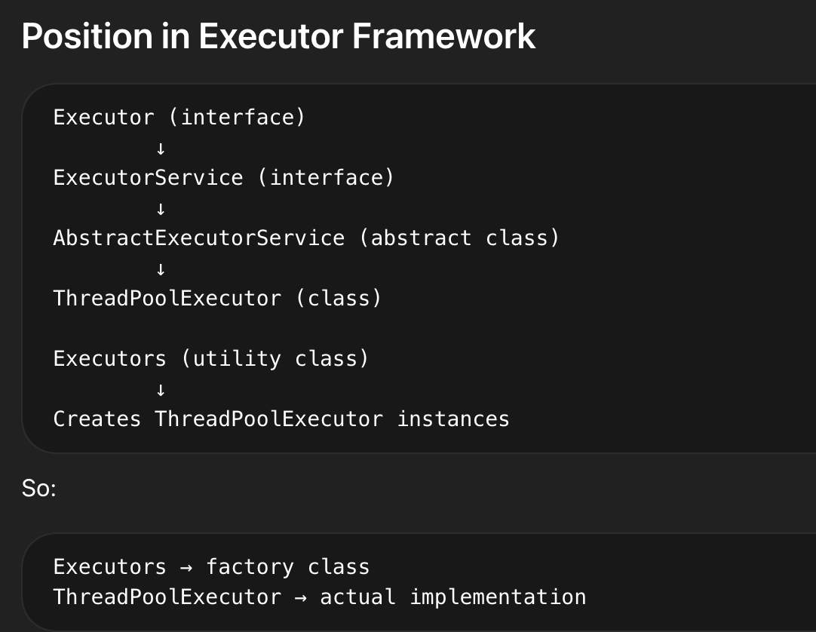

- newFixedThreadPool
ExecutorService executor = Executors.newFixedThreadPool(3);

executor.submit(() -> {
System.out.println("Task executed by: " + Thread.currentThread().getName());
});

2. newCachedThreadPool
ExecutorService executor = Executors.newCachedThreadPool();

executor.submit(() -> System.out.println("Working..."));
executor.shutdown(); // Initiates an orderly shutdown

// Custom Thread Pool

ThreadPoolExecutor customPool = new ThreadPoolExecutor(
int corePoolSize,
int maximumPoolSize,
long keepAliveTime,
TimeUnit unit,
BlockingQueue<Runnable> workQueue
);

4. newScheduledThreadPool

ScheduledExecutorService scheduler = Executors.newScheduledThreadPool(1);

scheduler.schedule(() -> {
System.out.println("Executed after 3 seconds!");
}, 3, TimeUnit.SECONDS);

//delay execution by 3 seconds

scheduledExecutorService.scheduleAtFixedRate(()->{
System.out.println("hello " + System.currentTimeMillis()/1000);
},1,1000, TimeUnit.MILLISECONDS);

scheduledExecutorService.scheduleWithFixedDelay(()->{
System.out.println("hello " + System.currentTimeMillis()/1000);
},1,1000, TimeUnit.MILLISECONDS);

Mimicking the scheduleWithFixedDelay:

public class Main {
public static void main(String[] args) throws ExecutionException, InterruptedException {
int n =5;
ScheduledExecutorService scheduler = Executors.newScheduledThreadPool(1);

scheduler.scheduleWithFixedDelay(() -> {
System.out.println("Start: " + System.currentTimeMillis()/1000);

try {
Thread.sleep(2000); // simulate work
} catch (InterruptedException e) {
Thread.currentThread().interrupt();
}

System.out.println("End: " + System.currentTimeMillis()/1000);
}, 0, 3, TimeUnit.SECONDS);

}

}
- Task takes: 2 sec
- Delay: 3 sec
- Next execution starts after: 2 + 3 = 5 sec

Mimicking the scheduleAtFixedRate:

Case A: Single thread pool
newScheduledThreadPool(1)
- No piling up
- Tasks run back-to-back
- Scheduler tries to "catch up"
Behavior:
No overlap, but no gap either

Case B: Multiple threads
newScheduledThreadPool(5)
- YES — tasks can pile up
- Multiple executions run in parallel
Behavior:
Thread1 → task1
Thread2 → task2 (scheduled at t=3)
Thread3 → task3 (scheduled at t=6)
This can cause:
- CPU spike
- Memory pressure
- System instability

public class Main {
public static void main(String[] args) throws ExecutionException, InterruptedException {
int n =5;
ScheduledExecutorService scheduler = Executors.newScheduledThreadPool(2);

scheduler.scheduleAtFixedRate(() -> {
System.out.println("Start: " + System.currentTimeMillis()/1000);

try {
Thread.sleep(5000); // simulate work
} catch (InterruptedException e) {
Thread.currentThread().interrupt();
}

System.out.println("End: " + System.currentTimeMillis()/1000);
}, 0, 3, TimeUnit.SECONDS);

}

}

Case 1: Single Thread

Behavior
- Tasks run one by one
- No overlap
- Predictable execution
- No race conditions (if shared state)
Example:
- Log cleanup
- Cache refresh
- Health checks

Case 2: Multiple Threads
ScheduledExecutorService scheduler = Executors.newScheduledThreadPool(5);

Behavior
- Multiple tasks can run in parallel
- Overlap possible (especially with scheduleAtFixedRate)
- Better throughput

Use this when:
- Tasks are independent
- Tasks are long-running
- You want parallel execution
Example:
- Processing multiple independent jobs
- Parallel API calls
- Batch processing

Monitoring and management facilities

System.out.println("Active Threads: " + executor.getActiveCount());

System.out.println("Queued Tasks: " + executor.getQueue().size());

Lifecycle control and graceful shutdown capabilities

executor.shutdown();

Feature | execute() | submit()
Interface | Executor | ExecutorService
Return type | void | Future
Accepts | Runnable | Runnable / Callable
Result retrieval | No | Yes
Exception handling | Direct | Stored in Future

ScheduledThreadPoolExecutor
ScheduledThreadPoolExecutor:

ScheduledThreadPoolExecutor is a concrete implementation of ScheduledExecutorService used to schedule tasks to run after a delay or periodically.
It extends:
- ThreadPoolExecutor and implements:
- ScheduledExecutorService

Why do we need it?
It solves problems like:
- Run a task after some delay
- Run a task repeatedly (cron-like behavior)
- Replace old Timer (which has limitations)

Key Features
- Supports delayed execution
- Supports periodic execution
- Uses a thread pool (not single thread like Timer)
- Handles exceptions better
- Uses internal DelayQueue

public ScheduledThreadPoolExecutor(int corePoolSize) {
super(corePoolSize, Integer.MAX_VALUE,
DEFAULT_KEEPALIVE_MILLIS, MILLISECONDS,
new DelayedWorkQueue());
}

public ScheduledThreadPoolExecutor(int corePoolSize,
ThreadFactory threadFactory) {
super(corePoolSize, Integer.MAX_VALUE,
DEFAULT_KEEPALIVE_MILLIS, MILLISECONDS,
new DelayedWorkQueue(), threadFactory);
}

public ScheduledThreadPoolExecutor(int corePoolSize,
RejectedExecutionHandler handler) {
super(corePoolSize, Integer.MAX_VALUE,
DEFAULT_KEEPALIVE_MILLIS, MILLISECONDS,
new DelayedWorkQueue(), handler);
}

public ScheduledThreadPoolExecutor(int corePoolSize,
ThreadFactory threadFactory,
RejectedExecutionHandler handler) {
super(corePoolSize, Integer.MAX_VALUE,
DEFAULT_KEEPALIVE_MILLIS, MILLISECONDS,
new DelayedWorkQueue(), threadFactory, handler);
}

Important Methods

1. schedule() → Run once after delay

ScheduledExecutorService scheduler = Executors.newScheduledThreadPool(2);
scheduler.schedule(() -> {
System.out.println("Task executed after 3 seconds");
}, 3, TimeUnit.SECONDS);

2. scheduleAtFixedRate() → Fixed interval

scheduler.scheduleAtFixedRate(() -> {
System.out.println("Running every 2 seconds");
}, 0, 2, TimeUnit.SECONDS);
Behavior:
- Starts every 2 sec from start time
- If task takes longer → next execution may overlap

3. scheduleWithFixedDelay() → Delay after completion

scheduler.scheduleWithFixedDelay(() -> {
System.out.println("Running with delay");
}, 0, 2, TimeUnit.SECONDS);

Behavior:
- Waits 2 sec AFTER task finishes
- No overlap → safer for long tasks

FixedRate vs FixedDelay :

Feature | scheduleAtFixedRate | scheduleWithFixedDelay
Timing | Based on start time | Based on end time
Overlap | Possible | Not possible
Use case | Monitoring, metrics | Background jobs

Internal Working
- Uses DelayQueue
- Each task = ScheduledFutureTask
- Tasks sorted by execution time
- Worker threads pick tasks when delay expires
Flow:
Task → DelayQueue → Worker Thread → Execute

import java.util.concurrent.*;
public class SchedulerExample {
public static void main(String[] args) {
ScheduledThreadPoolExecutor scheduler =
new ScheduledThreadPoolExecutor(2);
scheduler.scheduleAtFixedRate(() -> {
System.out.println(Thread.currentThread().getName()
+ " Running task " + System.currentTimeMillis());
}, 0, 2, TimeUnit.SECONDS);
try {
Thread.sleep(10000);
} catch (InterruptedException e) {}
scheduler.shutdown();
}
}

1. Why not use Timer?
- Single thread → blocking issue
- If one task fails → all stop

2. Difference between ScheduledThreadPoolExecutor and ThreadPoolExecutor?

Feature | ThreadPoolExecutor | ScheduledThreadPoolExecutor
Scheduling | ❌ | ✅
Delay support | ❌ | ✅
Queue | BlockingQueue | DelayQueue

3. What happens if task throws exception?
For periodic tasks:
- Task stops executing further

4. Can tasks overlap?
- scheduleAtFixedRate → YES
- scheduleWithFixedDelay → NO

5. What is core pool size here?
- Number of threads handling scheduled tasks
- Fixed (no max pool like ThreadPoolExecutor)

When to Use in Real Systems
- Health check scheduler
- Polling APIs every few seconds
- Cache refresh
- Retry mechanisms
- Heartbeat signals

Example :

import java.util.concurrent.*;
public class Main {
public static void main(String[] args) throws InterruptedException {
ScheduledThreadPoolExecutor scheduler =
new ScheduledThreadPoolExecutor(2); // 2 threads
scheduler.setRemoveOnCancelPolicy(true); // good practice
scheduler.scheduleAtFixedRate(() -> {
System.out.println("Running at: " + System.currentTimeMillis() +
" | Thread: " + Thread.currentThread().getName());
try {
Thread.sleep(2000); // simulate work
} catch (InterruptedException e) {
Thread.currentThread().interrupt();
}
}, 0, 3, TimeUnit.SECONDS);
Thread.sleep(15000);
System.out.println("Shutting down...");
scheduler.shutdown();
}
}

Thread Executors :
Executor Framework Hierarchy:

Executor (interface)
│
├── void execute(Runnable command)
│
└── ExecutorService (interface) extends Executor
│
├── void shutdown()
├── List<Runnable> shutdownNow()
├── boolean isShutdown()
├── boolean isTerminated()
├── boolean awaitTermination(long timeout, TimeUnit unit)
│
├── <T> Future<T> submit(Callable<T> task)
├── Future<?> submit(Runnable task)
├── <T> Future<T> submit(Runnable task, T result)
│
├── <T> List<Future<T>> invokeAll(Collection<? extends Callable<T>> tasks)
├── <T> List<Future<T>> invokeAll(Collection<? extends Callable<T>> tasks,
│ long timeout, TimeUnit unit)
│
├── <T> T invokeAny(Collection<? extends Callable<T>> tasks)
├── <T> T invokeAny(Collection<? extends Callable<T>> tasks,
│ long timeout, TimeUnit unit)
│
└── ScheduledExecutorService (interface) extends ExecutorService
│
├── ScheduledFuture<?> schedule(Runnable command,
│ long delay, TimeUnit unit)
│
├── <V> ScheduledFuture<V> schedule(Callable<V> callable,
│ long delay, TimeUnit unit)
│
├── ScheduledFuture<?> scheduleAtFixedRate(Runnable command,
│ long initialDelay, long period, TimeUnit unit)
│
└── ScheduledFuture<?> scheduleWithFixedDelay(Runnable command,
long initialDelay,
long delay, TimeUnit unit)

Core Implementations:

ThreadPoolExecutor (class) extends AbstractExecutorService
( AbstractExecutorService implements ExecutorService)
│
├── execute()
├── submit()
├── shutdown()
├── shutdownNow()
├── beforeExecute()
├── afterExecute()
├── terminated()
│
└── ScheduledThreadPoolExecutor (class) extends ThreadPoolExecutor implements
ScheduledExecutorService

Factory Methods (Executors class):

Executors (utility class)
│
├── newFixedThreadPool(int nThreads)
├── newCachedThreadPool()
├── newSingleThreadExecutor()
├── newScheduledThreadPool(int corePoolSize)
├── newSingleThreadScheduledExecutor()
├── newWorkStealingPool()

Supporting Interfaces / Classes:
Future<T>
│
├── T get()
├── T get(long timeout, TimeUnit unit)
├── boolean cancel(boolean mayInterruptIfRunning)
├── boolean isDone()
├── boolean isCancelled()

Callable<V>
│
└── V call()

Runnable
│
└── void run()

Interview Notes
- Executor → only fire-and-forget
- ExecutorService → lifecycle + result handling
- submit() vs execute():
  - execute() → no result
  - submit() → returns Future
- invokeAll() → wait for ALL tasks
- invokeAny() → return FIRST completed
- ScheduledExecutorService → replaces Timer
- shutdown → graceful shutdown
- shutdownNow → interrupts
- beforeExecute / afterExecute : Hooks for logging / monitoring
Executors:
Executors is a utility class in java.util.concurrent that provides factory methods to create different types of thread pools.
it creates objects that implement ExecutorService, usually ThreadPoolExecutor.

public static ExecutorService newFixedThreadPool(int nThreads) {

public static ExecutorService newFixedThreadPool(int nThreads, ThreadFactory threadFactory) {

public static ExecutorService newCachedThreadPool() {

public static ExecutorService newCachedThreadPool(ThreadFactory threadFactory) {

Executors creating thread pool using ScheduledThreadPoolExecutor:

public static ScheduledExecutorService newScheduledThreadPool(int corePoolSize) {

public static ScheduledExecutorService newScheduledThreadPool(int corePoolSize, ThreadFactory threadFactory) {

What is ThreadPoolExecutor?
ThreadPoolExecutor is the core implementation of ExecutorService that manages:
- Thread creation & reuse
- Task queueing
- Worker lifecycle
- Rejection handling
It is the actual engine behind Executors.newFixedThreadPool(), newCachedThreadPool() etc.

ThreadPoolExecutor customPool = new ThreadPoolExecutor(
int corePoolSize,
int maximumPoolSize,
long keepAliveTime,
TimeUnit unit,
BlockingQueue<Runnable> workQueue
);

Example :
ThreadPoolExecutor executor = new ThreadPoolExecutor(2, 4, 1, TimeUnit.SECONDS, new LinkedBlockingQueue<>(2));

public ThreadPoolExecutor(int corePoolSize, int maximumPoolSize, long keepAliveTime, TimeUnit unit, BlockingQueue<Runnable> workQueue)

public ThreadPoolExecutor(int corePoolSize, int maximumPoolSize, long keepAliveTime, TimeUnit unit, BlockingQueue<Runnable> workQueue, ThreadFactory threadFactory)

public ThreadPoolExecutor(int corePoolSize, int maximumPoolSize, long keepAliveTime, TimeUnit unit, BlockingQueue<Runnable> workQueue, RejectedExecutionHandler handler)

public ThreadPoolExecutor(int corePoolSize, int maximumPoolSize, long keepAliveTime, TimeUnit unit, BlockingQueue<Runnable> workQueue, ThreadFactory threadFactory, RejectedExecutionHandler handler)

1. Core Parameters
ThreadPoolExecutor(
int corePoolSize,
int maximumPoolSize,
long keepAliveTime,
TimeUnit unit,
BlockingQueue<Runnable> workQueue,
ThreadFactory threadFactory,
RejectedExecutionHandler handler
)

Meaning
- corePoolSize → min threads always alive
- maximumPoolSize → max threads allowed
- keepAliveTime → idle thread timeout
- workQueue → where tasks wait
- handler → rejection policy

The queue is shared by all worker threads in a ThreadPoolExecutor.
┌───────────────┐
│ TASK QUEUE │ ← shared
└───────────────┘
↑ ↑ ↑ ↑
T1 T2 T3 T4 ← worker threads

Execution Flow (Step-by-step)
When execute(task) is called:
- If currentThreads < corePoolSize
→ create new thread
- Else → put task in queue
- If queue full & threads < maxPoolSize
→ create new thread
- Else → reject task (via handler)

Worker Thread Concept
- Each thread is a Worker
- Worker:
  - runs tasks
  - fetches next task from queue
- Uses runWorker() loop internally

Rejection Policies
Built-in:
- AbortPolicy → throws exception
- CallerRunsPolicy → runs in caller thread
- DiscardPolicy → silently drops
- DiscardOldestPolicy → removes oldest

Queue Types Impact Behavior

Queue | Behavior
LinkedBlockingQueue | queue first, then scale
SynchronousQueue | no queue → direct thread
ArrayBlockingQueue | bounded queue

Internal Working

if (workers < corePoolSize)
addWorker(task)
else if (queue.offer(task))
// queued
else if (workers < maxPoolSize)
addWorker(task)
else
reject(task)

Why is newFixedThreadPool dangerous?
- Uses unbounded queue
- Can cause OOM (Out of memory risks)

Difference: core vs max threads?
- Core → always alive
- Max → burst handling
When threads die?
- Only when:
  - idle > keepAliveTime
  - above above corePoolSize
  - or core timeout enabled

Why BlockingQueue?
- Decouples producer & consumer
- Controls load

DelayQueue:
DelayQueue:

DelayQueue is a blocking queue in Java that holds elements only after a delay has expired.

It is part of java.util.concurrent

Core Idea
- Elements must implement: Delayed
- Queue behavior:
  - You can insert anytime
  - You can only take when delay = 0
  - Elements are ordered by remaining delay (min first)

Key Properties

Feature | Description
Type | Unbounded Blocking Queue
Ordering | Based on delay time
Thread-safe | Yes
Blocking nature | take() waits until element expires
Internal DS | Priority Queue (Min Heap)

Important Methods

void put(E e)
E take() // Blocks until delay expires
E poll() // Returns null if not expired
E peek() // Check head without removing
int size()

How It Works Internally
- Uses PriorityQueue (min heap)
- Element with smallest delay is at top
- take():
  - If delay > 0 → thread waits
  - If delay = 0 → returns element

Real Use Cases

1. Task Scheduling (Without Scheduler)
- Retry after delay
- Backoff strategies

2. Cache Expiry (TTL)
- Remove elements after expiry

3. Message Delay System
- Delayed processing (like Kafka retry)

AbstractExecutorService:

AbstractExecutorService:
AbstractExecutorService is a core abstract class in Java’s concurrency framework that provides default implementations for many methods of the ExecutorService interface.
It acts as a base class so that you don’t have to implement everything from scratch when creating custom executors.

You only need to implement:

protected <T> RunnableFuture<T> newTaskFor(Callable<T> callable)

protected <T> RunnableFuture<T> newTaskFor(Runnable runnable, T value)

void execute(Runnable command)

Important Methods

1. submit()

Future<?> submit(Runnable task)

Future<T> submit(Callable<T> task)

Future<T> submit(Runnable task, T result)
- Converts task → RunnableFuture
- Calls execute() internally

2. invokeAll()

List<Future<T>> invokeAll(Collection<? extends Callable<T>> tasks)
- Executes all tasks
- Waits for ALL to complete
- Returns list of Futures

3. invokeAny()

T invokeAny(Collection<? extends Callable<T>> tasks)

- Executes multiple tasks
- Returns result of first successfully completed task
- Cancels others

4. newTaskFor() (VERY IMPORTANT)

protected <T> RunnableFuture<T> newTaskFor(Callable<T> callable)
- Wraps task into FutureTask
- Used internally by submit()

Internal Flow of submit()

submit(task)
↓
newTaskFor(task) → creates FutureTask
↓
execute(futureTask)
↓
ThreadPool runs it
↓
FutureTask stores result

Scheduler
Implement the scheduler which will update my object ,
let' say device object every 10 minutes

import java.util.concurrent.*;

class Device {
private final String id;
private volatile String status;
private volatile long lastUpdated;

public Device(String id) {
this.id = id;
this.status = "INIT";
this.lastUpdated = System.currentTimeMillis();
}

public synchronized void updateStatus() {
this.status = "UPDATED@" + System.currentTimeMillis();
this.lastUpdated = System.currentTimeMillis();

System.out.println(Thread.currentThread().getName() +
" -> Device " + id + " updated at " + lastUpdated);
}
}

public class Main {

public static void main(String[] args) throws InterruptedException {
ScheduledExecutorService scheduler = Executors.newScheduledThreadPool(4);

int numberOfDevices = 5;

// Schedule devices
for (int i = 1; i <= numberOfDevices; i++) {
Device device = new Device("D" + i);

scheduler.scheduleWithFixedDelay( () -> {
try {
device.updateStatus();
} catch (Exception e) {
System.out.println("Error: " + e.getMessage());
}
}, 0, 10, TimeUnit.MINUTES);
}

Thread.sleep(30000); // run for 30 seconds

System.out.println("Shutting down...");
scheduler.shutdown();
}
}

For multiple devices, above approach is not good:

Use Single Scheduler + Worker Pool
Idea:
- Scheduler triggers periodically
- Worker pool processes devices in parallel

Design

Scheduler → triggers every X time
↓
Submit 100 tasks to worker thread pool
↓
Parallel execution

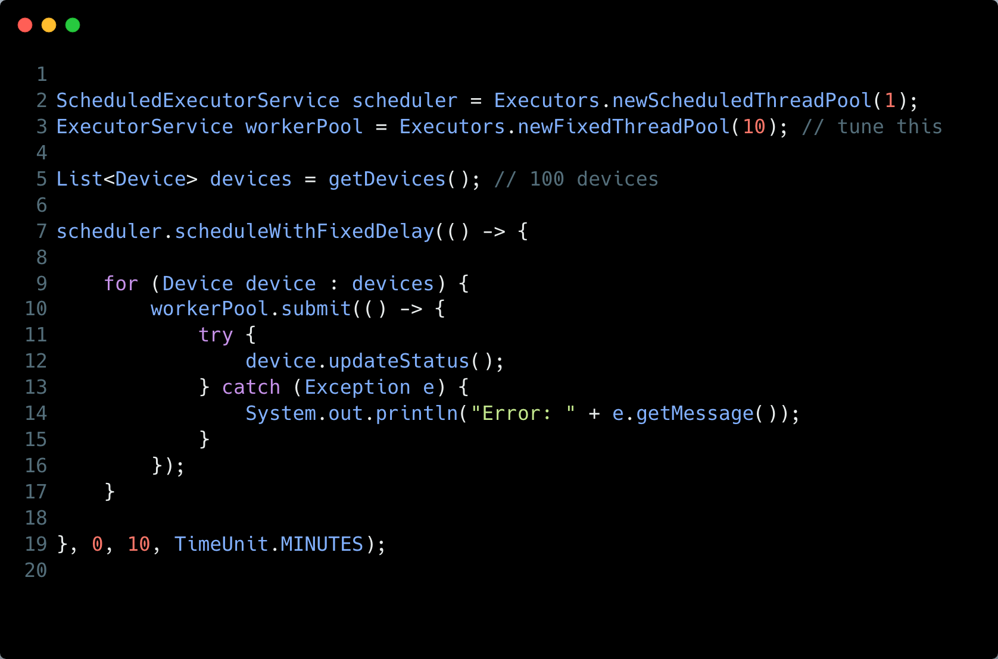

Important Enhancement

🔹 Use batching (for large scale)
Instead of 1 device per task:

List<List<Device>> batches = partition(devices, 10);

for (List<Device> batch : batches) {
workerPool.submit(() -> {
for (Device d : batch) {
d.updateStatus();
}
});
}

Singleton
1. Double Checked Locking

Don't forget to add class in singletonholder
Thread-Safe Singleton (Double Checked Locking):

Implement a thread-safe Singleton with lazy initialization.

class Singleton {
private static volatile Singleton instance;

private Singleton() {}

public static Singleton getInstance() {
if (instance == null) {
synchronized (Singleton.class) {
if (instance == null) {
instance = new Singleton();
}
}
}
return instance;
}
}

1. Enum Singleton (Best and Recommended)

public enum Singleton {
INSTANCE;

public void doSomething() {
System.out.println("Singleton using enum");
}
}

2. Bill Pugh Singleton (Best Lazy Initialization)
This is the best classic singleton pattern for lazy initialization.

public class Singleton {
private Singleton() {}

private static class SingletonHelper {
private static final Singleton INSTANCE = new Singleton();
}

public static Singleton getInstance() {
return SingletonHelper.INSTANCE;
}
}

Factory:

class NotificationFactory {

public static Notification createNotification(String type) {

if (type.equalsIgnoreCase("EMAIL")) {
return new EmailNotification();
} else if (type.equalsIgnoreCase("SMS")) {
return new SMSNotification();
} else if (type.equalsIgnoreCase("PUSH")) {
return new PushNotification();
}

throw new IllegalArgumentException("Invalid type");
}
}

Notification n = Notification.createNotificaiton(“email”);

Deadlock :
Deadlock :

class Resource {
private final String name;

public Resource(String name) {
this.name = name;
}

public String getName() {
return name;
}
}

public class DeadlockDemo {

public static void main(String[] args) {

Resource r1 = new Resource("R1");
Resource r2 = new Resource("R2");

Thread t1 = new Thread(() -> {
synchronized (r1) {
System.out.println("Thread1 locked " + r1.getName());

try { Thread.sleep(100); } catch (InterruptedException e) {}

synchronized (r2) {
System.out.println("Thread1 locked " + r2.getName());
}
}
});

Thread t2 = new Thread(() -> {
synchronized (r2) {
System.out.println("Thread2 locked " + r2.getName());

try { Thread.sleep(100); } catch (InterruptedException e) {}

synchronized (r1) {
System.out.println("Thread2 locked " + r1.getName());
}
}
});

t1.start();
t2.start();
}
}

Avoid Deadlock :

Always acquire locks in same order

class Resource {
private final String name;

public Resource(String name) {
this.name = name;
}

public String getName() {
return name;
}
}

public class DeadlockFixed {

public static void main(String[] args) {

Resource r1 = new Resource("R1");
Resource r2 = new Resource("R2");

Thread t1 = new Thread(() -> lockInOrder(r1, r2));
Thread t2 = new Thread(() -> lockInOrder(r1, r2)); // same order

t1.start();
t2.start();
}

public static void lockInOrder(Resource r1, Resource r2) {
synchronized (r1) {
System.out.println(Thread.currentThread().getName() + " locked " + r1.getName());

try { Thread.sleep(100); } catch (InterruptedException e) {}

synchronized (r2) {
System.out.println(Thread.currentThread().getName() + " locked " + r2.getName());
}
}
}
}

Exceptions
Exceptions
Checked vs Unchecked Exceptions in Java :

Checked Exceptions :
Checked exceptions are exceptions that must be either declared in the method signature using throws or handled using try-catch.
They are checked at compile-time.
Examples:
IOException (e.g., file not found)
SQLException (e.g., database connection failure)
InterruptedException (e.g., thread interruption)
‍

Unchecked Exceptions :
Unchecked exceptions are runtime errors that do not require explicit handling.
They are checked at runtime, meaning they occur due to logical errors in the program.
Examples:
NullPointerException (e.g., calling a method on null)
ArrayIndexOutOfBoundsException (e.g., accessing an invalid array index)
ArithmeticException (e.g., division by zero)

Exceptions in Future:

1. One task failure does NOT stop others
- All tasks run independently
long total = 0;

for (Future<Long> f : futures) {
try {
total += f.get();
} catch (ExecutionException e) {
System.out.println("Task failed: " + e.getCause());
} catch (InterruptedException e) {
Thread.currentThread().interrupt();
}
}

What happens if one task throws an exception?

Suppose:
for (int i = 0; i < 5; i++) {
futures.add(executor.submit(() -> {
if (ThreadLocalRandom.current().nextInt(5) == 0) {
throw new RuntimeException("Failure");
}
return 10L;
}));
}

Case 1: While submitting tasks
futures.add(executor.submit(...));
- All tasks are submitted normally
- Even if one task fails → others are NOT affected
- Program continues

Case 2: While collecting results (IMPORTANT)
for (Future<Long> f : futures) {
total += f.get();
}

What happens?
- If ANY task failed →
f.get() throws ExecutionException
👉 But only for THAT specific future

Important Behavior
- Loop stops immediately if exception not handled
- Remaining futures are never processed ❌

Using CompletableFuture:
long total = futures.stream()
.map(f -> {
try {
return f.get();
} catch (Exception e) {
return 0L; // fallback
}
})
.mapToLong(Long::longValue)
.sum();

Reentrant Locks:
Reentrant Locks:

1. lock()

2. unlock()
Releases the lock.

3. tryLock()
Attempts to acquire lock without blocking.

if (lock.tryLock()) {
try {
// critical section
} finally {
lock.unlock();
}
}

4. tryLock(long time, TimeUnit unit)
Waits for a specified time.

When the same thread acquires the lock again:
- The hold count increases
Example:

lock.lock() → hold count = 1
lock.lock() → hold count = 2
lock.unlock() → hold count = 1
lock.unlock() → hold count = 0 (lock released)
Only when hold count becomes 0 is the lock released and available for other threads.

3. Fair Lock
new ReentrantLock(true)
Provides fairness:
FIFO style

Lock Internals
ReentrantLock uses:
CAS + AQS(AbstractQueuedSynchronizer)

Which One Should You Use?

Use synchronized
When:
- simple locking needed
- basic thread safety
- cleaner code

Use Lock
When you need:
- tryLock()
- timeout
- interruptibility
- fairness
- advanced concurrency control

The real differentiator is:

Lock gives CONTROL

synchronized gives SIMPLICITY
That is the core difference.

Lock
You manually control locking behavior.

lock.lock();
try {
} finally {
lock.unlock();
}
Now you can:
- try acquiring lock
- timeout
- interrupt
- implement fairness
- use multiple conditions
It is: powerful but verbose

Completable Future:
Completable Future:

import java.util.concurrent.*;
public class CompletableFutureExample {
public static void main(String[] args) throws Exception {
ExecutorService executor = Executors.newFixedThreadPool(2);
// Task 1: Fetch User
CompletableFuture<String> userFuture = CompletableFuture.supplyAsync(() -> {
sleep(1000);
return "User: Kapil";
}, executor);
// Task 2: Fetch Orders
CompletableFuture<String> orderFuture = CompletableFuture.supplyAsync(() -> {
sleep(1500);
return "Orders: [Book, Laptop]";
}, executor);
// Combine both results
CompletableFuture<String> combinedFuture =
userFuture.thenCombine(orderFuture, (user, orders) -> user + " | " + orders);
// Final result
String result = combinedFuture.get();
System.out.println(result);
executor.shutdown();
}
private static void sleep(int millis) {
try {
Thread.sleep(millis);
} catch (InterruptedException e) {
Thread.currentThread().interrupt();
}
}
}

- supplyAsync() → async task with return
- runAsync() → async task no return
- thenApply() → transform
- thenCompose() → chain async
- thenCombine() → merge 2 futures
- allOf() → wait all

CopyOnWriteArrayList:

CopyOnWriteArrayList:

2. CopyOnWriteArrayList:
CopyOnWriteArrayList is a thread-safe variant of ArrayList that creates a fresh copy of the underlying array for every modification operation. This unique approach ensures thread safety while providing non-blocking read operations, making it particularly well-suited for specific concurrency scenarios. 🔒
‍
Both ArrayList and CopyOnWriteArrayList in Java implement the List interface, providing ordered collections of elements. 📚 However, they differ significantly in their handling of concurrent access, particularly in their approach to thread safety, making them suitable for different scenarios. ⚖️
‍
Here's a breakdown of their differences, functionalities, and thread-safety mechanisms: 🧩🔍

How ArrayList works (Internals): 📋
• ArrayList internally uses a dynamic array to store elements. ➕ When the array reaches its capacity, a new larger array is created, and all elements are copied to the new array. 📦
‍
• When you add or remove elements, the array is modified directly, and in multi-threaded environments, this can lead to data corruption if multiple threads modify the array concurrently. ⚠️🧵
‍
• Operations like get(), add(), and remove() directly access or modify the underlying array without any built-in synchronization. 🚫🔐\
‍
• If one thread is iterating through an A
rrayList while another thread modifies it, a ConcurrentModificationException is likely to be thrown, as the iterator detects that the collection has been modified during iteration. 🚨🔁
‍

How CopyOnWriteArrayList Works (Internals): 📝
• CopyOnWriteArrayList maintains an immutable array that is only changed by creating and reassigning a new array instance. 🔁📄
‍
• When a modification operation (add, remove, set) is performed, the entire array is copied to a new array with the modification applied, and the reference to the array is atomically updated to point to the new array. ⚙️🔄
‍
• Read operations (like get(), size(), contains()) operate on the current array reference without any locking, providing non-blocking reads. 🚀👓
‍
• Iterators created from the list work on a snapshot of the array at the time the iterator was created, making them immune to concurrent modifications and eliminating the need to throw ConcurrentModificationException. 🛡️🧭

‍

CopyOnWriteArrayList vs. ArrayList: How Thread Safety Differs (Basic): 🔄🧷
The core difference in thread safety lies in how they manage access when multiple threads interact with the list. 👥🧠
‍

ArrayList 🧾:
Not thread-safe by default. 🚫 When multiple threads access and modify an ArrayList concurrently, it can lead to data corruption or inconsistent states. 💥 Imagine multiple people trying to modify a document simultaneously without any coordination – the result would be chaos. 📝😵
‍
Solutions for thread safety with ArrayList typically involve external synchronization, such as using Collections.synchronizedList() which essentially locks the entire list during any operation, severely limiting concurrency. 🔒🧍‍♂️🧍‍♀️
‍
Example: If one thread is adding elements to an ArrayList while another thread is iterating over it, a ConcurrentModificationException will likely be thrown, or worse, the iteration might miss elements or see partially updated states. ⚠️📉

Hierarchy

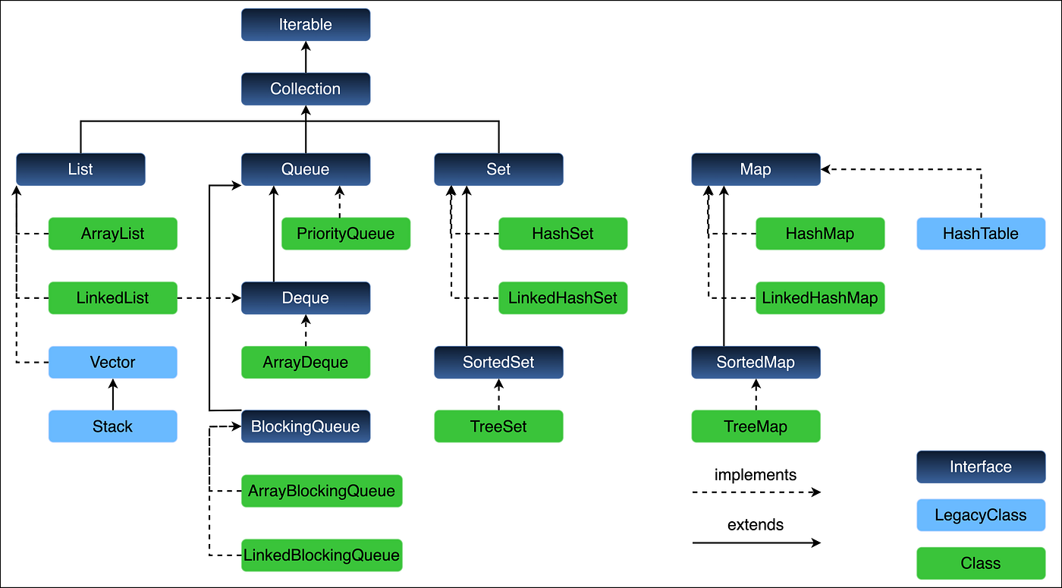

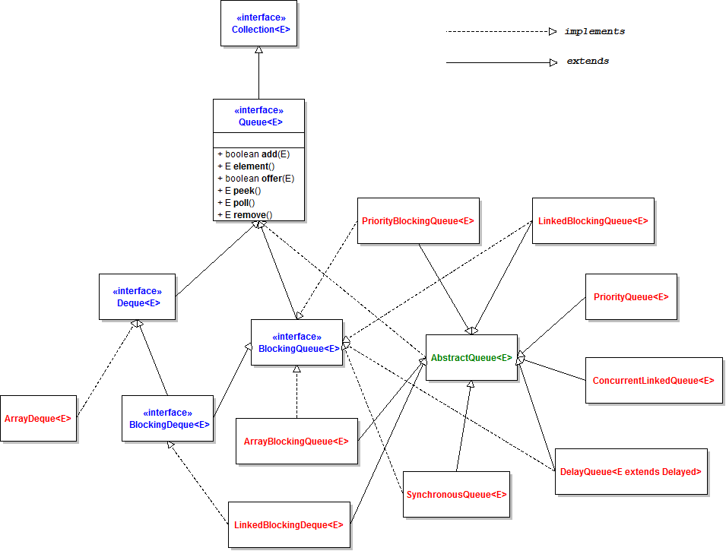

RADIUS:
RADIUS:

The RADIUS Protocol (Remote Authentication Dial-In User Service) is a widely used networking protocol for authentication, authorization, and accounting (AAA). It is commonly used by ISPs, enterprise networks, and telecom systems to control access to network resources.

1. What is RADIUS?
RADIUS is a client-server protocol where:
- Client : Network device (NAS: router, switch, access point)
- Server : RADIUS server (validates users)
It works over UDP
- Authentication → Port 1812
- Accounting → Port 1813

2. Core Functions (AAA)

1. Authentication
Verifies who the user is
- Username/password
- Certificates
- Tokens

2. Authorization
Determines what the user can access
- VLAN assignment
- IP allocation
- Bandwidth limits

3. Accounting
Tracks user activity
- Session start/stop
- Data usage
- Time duration

3. RADIUS Architecture
User : NAS (Router/Switch/AP) : RADIUS Server : Database

Flow:
- User tries to connect (WiFi/VPN)
- NAS sends request to RADIUS server
- RADIUS validates credentials
- Access Accept / Reject sent back
- Accounting logs maintained

4. Packet Types

Authentication Packets
- Access-Request : Sent by client
- Access-Accept : Success
- Access-Reject : Failure
- Access-Challenge : Additional verification (OTP)

Accounting Packets
- Accounting-Request
- Accounting-Response

5. Key Features
- Centralized authentication
- Scalable for large networks
- Supports multiple authentication methods (PAP, CHAP, EAP)
- Encrypts only password (not full packet)

6. Example (WiFi Login)
- User connects to enterprise WiFi
- Access Point acts as NAS
- Credentials sent to RADIUS server
- Server validates (e.g., Active Directory)
- User gets access if valid

7. Limitations
- Uses UDP : unreliable transport
- Only password is encrypted (rest is plaintext)
- Less secure compared to modern protocols

CORBA stands for:
Common Object Request Broker Architecture

CORBA is a standard defined by the Object Management Group that enables communication between distributed objects written in different programming languages and running on different machines.

Key Concept
- Uses an ORB (Object Request Broker)
- ORB acts like middleware that:
  - Finds the remote object
  - Sends request
  - Returns response

Tejas uses : JACORB

Hashmap:
Hashmap:

HashMap internally uses an array of nodes of initial capacity 16.
When we insert a key-value pair, first hashCode() of key is calculated. Then HashMap applies hash spreading to generate optimized hash. Using this hash and capacity, bucket index is calculated.
If bucket is empty, entry is inserted directly. Otherwise collision occurs, and HashMap traverses the linked list/tree in that bucket. It first compares hash, then equals() on keys. If key already exists, value is updated; otherwise new node is appended.
HashMap uses load factor (default 0.75). When entries exceed capacity × load factor, resize happens and capacity doubles. During resize, all entries are rehashed because bucket indexes may change.
In Java 8, if collisions in one bucket exceed threshold 8 and capacity is at least 64, linked list converts into red-black tree, improving worst-case complexity from O(n) to O(log n).

Flow:

hashCode()
↓
optimized hash
↓
bucket index
↓
go to bucket
↓
compare node.hash
↓
compare equals()

Deep copy vs shallow copy:
Deep copy vs shallow copy:

class Address {
String city;

Address(String city) {
this.city = city;
}
}

class Person implements Cloneable {
String name;
Address address;

Person(String name, Address address) {
this.name = name;
this.address = address;
}

// Shallow Copy
protected Object clone() throws CloneNotSupportedException {
return super.clone();
}

// Deep Copy
Person deepCopy() {
Address newAddress = new Address(this.address.city);
return new Person(this.name, newAddress);
}
}

public class Main {
public static void main(String[] args) throws Exception {

Address address = new Address("Delhi");

Person p1 = new Person("Kapil", address);

// Shallow Copy
Person p2 = (Person) p1.clone();

// Deep Copy
Person p3 = p1.deepCopy();

// Change original object's address
p1.address.city = "Gurgaon";

System.out.println("Original: " + p1.address.city);
System.out.println("Shallow Copy: " + p2.address.city);
System.out.println("Deep Copy: " + p3.address.city);
}
}

Records
Records
: for immutable classes .

Java Memory Model:
Of course! The Java Memory Model defines how threads interact through memory. It ensures visibility of shared variables and establishes rules like "happens-before," ensuring that changes made by one thread are visible to others. This is crucial for writing correct, thread-safe code!

Method Reference :

Of course! A daemon thread is a background thread that doesn't prevent the JVM from exiting. Once all user threads finish, daemon threads are terminated automatically. They’re typically used for things like background tasks or cleanup, whereas user threads keep the application alive.

What is the difference between the String.intern() method and a regular string in Java?

The intern() method stores a string in the string pool, ensuring that identical literals share the same reference. It’s useful, but not a core interview focus.

Volatile ;
Exactly! The volatile keyword ensures that reads and writes go directly to main memory, making changes visible to all threads immediately. It’s perfect for simple flags or state that’s shared among threads.

var:
The "var" keyword allows you to declare local variables without specifying the type explicitly. The compiler infers the type from the context, making code more concise. It doesn't change Java’s static typing—you just let the compiler figure it out!

