Wydział EAIiE  Kierunek AiR  Rok III | Ćwiczenie 1  Wprowadzenie do Matlaba
Modelowanie Systemów  Dynamicznych | 8.10.2012 08:00

FUNKCJE REZULTATY

Zad. A

function [C] = zadA( )
%
A=[2,1,3,;-2,0,-1];
B=[1,-1,2;2,3,-1;-3,2,1];
C=A*B
end

>>C=zadA

C =

-5 7 6
1 0 -5

Zad. B
>> D=ZadB(C)

D =

-5 1 10
7 0 2
6 -5 10
function [ D ] = zadB( C )
%

C1=[C;10,2,10];
D=C1'

end

Zad.C

function [ Dret ] = zadC( D )
%
Dret=[D(:,1:3),[14,10,13]'];
Dret=[Dret;[14,11,10,13]];

end
>> D=ZadC(D)

D =

-5 1 10 14
7 0 2 10
6 -5 10 13
14 11 10 13

Zad.D

function [ W,V ] = zadD( D )
%
[W,V]=EIGS(D);

end
>> [W,V]=ZadD(D)

W =

0.4014 0.8958 0.3393 -0.0634
0.3386 -0.1768 -0.6413 0.4629
0.4530 -0.0449 -0.5714 -0.7560
0.7205 -0.4054 0.3836 0.4585

V =

32.2564 0 0 0
0 -12.0337 0 0
0 0 -7.9028 0
0 0 0 5.6801

Zad.E

function [ ] = zadE( )
%
wlm=[1,4,-18,-12,9];
R=roots(wlm);
ezplot('x^4+4*x^3-18*x^2-12*x+9',[-6.5,3.5]);

hold on;
YR=zeros(length(R),1);
scatter(R,YR);
hold off;

end
>> zadE

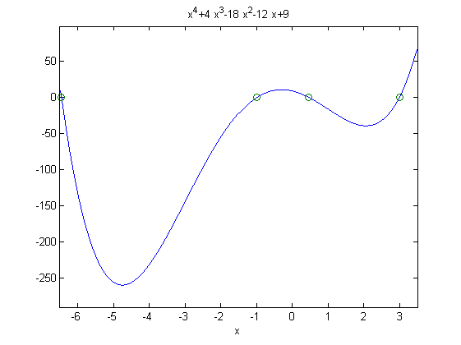

Zad.F
function [ ] = zadF( delta )
%
N=floor(4*pi/delta);
Xs=linspace(0,N*delta,N+1);
if Xs(N) ~= 4*pi
Xs(N+1)=4*pi
end;

for i=1:length(Xs)
Ys(i)=((sin(Xs(i)))^2+2*sin(Xs(i)))*(cos(Xs(i)))^2;

end;

plot(Xs,Ys);
end
>> zadF(1)

Xs =

Columns 1 through 5

0 1.0000 2.0000 3.0000 4.0000

Columns 6 through 10

5.0000 6.0000 7.0000 8.0000 9.0000

Columns 11 through 13

10.0000 11.0000 12.5664

>> zadF(12)

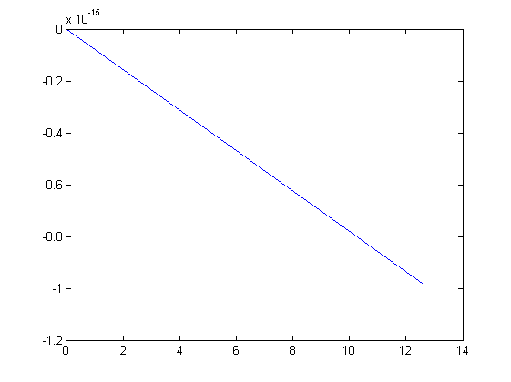

>> zadF(6)

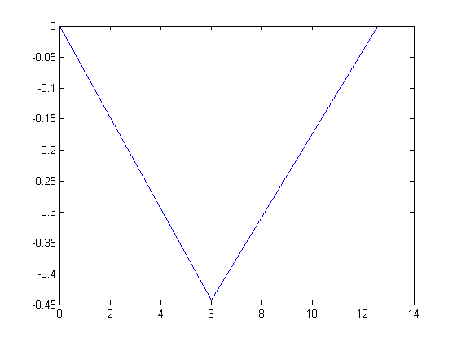

>> zadF(2)

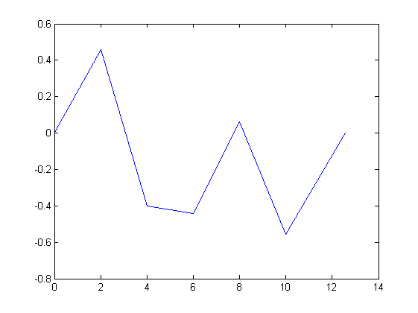
>> zadF(1)

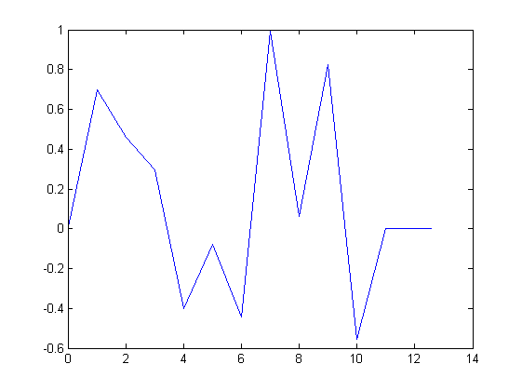

>> zadF(0.5)

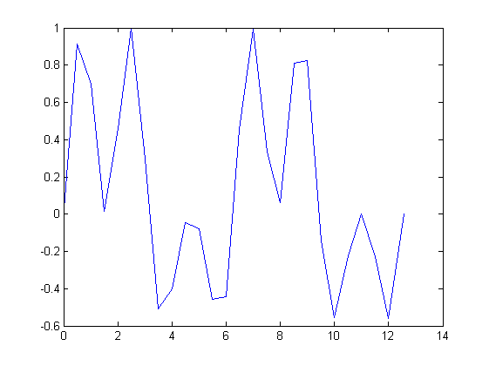

>> zadF(0.2)

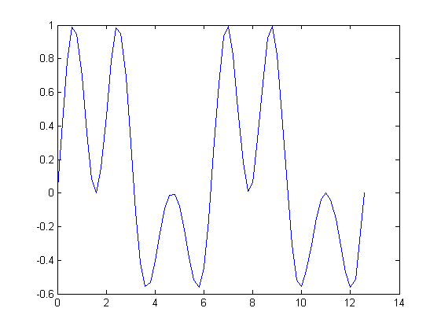
>> zadF(0.1)

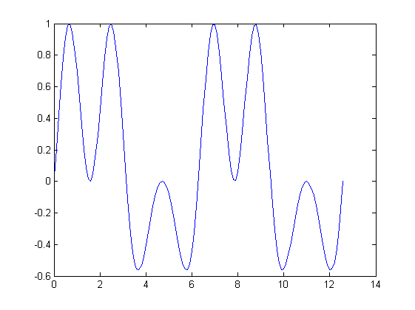

>> zadF(0.01)

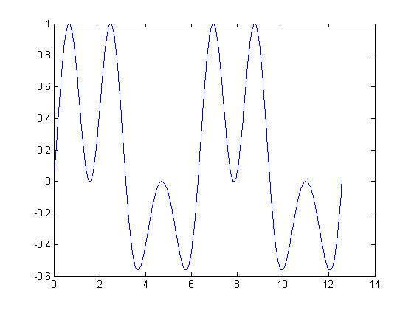
>> zadF(0.001)

