Kapkyi Lwai

Foundation Of Programing: Python

Assignment 5: To Do List

November 15, 2022

**To Do List File**

**Introduction:**

In this assignment, a new project is created in PyCharm for a program to create a ‘To Do List’ file. The program will allow user to input data, view their data, save their data, and also make changes to their data. The program scripted to allow reading and writing to a text file, ‘ToDoList.txt’. This project will also be uploaded to GitHub repository as public for other users to read and also make changes or recommendations.

**Getting Started:**

I created a new project on PyCharm and I named it ‘Assignment05’ and open a python file called ‘Assignment05_starter.py’. The codes from this file were added from Module 5 file to be modified and add necessary codes for the program to process. This program contains two columns of data, ‘Task’ and ‘Priority’. These columns will be loaded into a Python dictionary object as each object represents as one row of data. The row data were then added as lists and create a table of data.

**Headers and Variables:**

After the starter script have been added to the new Python project, I modified the headers by adding my information and declared my variables (Figure 1). This project contains many pseudo codes from top to bottom with ‘#’ at beginning followed by comments. (Figure 1)

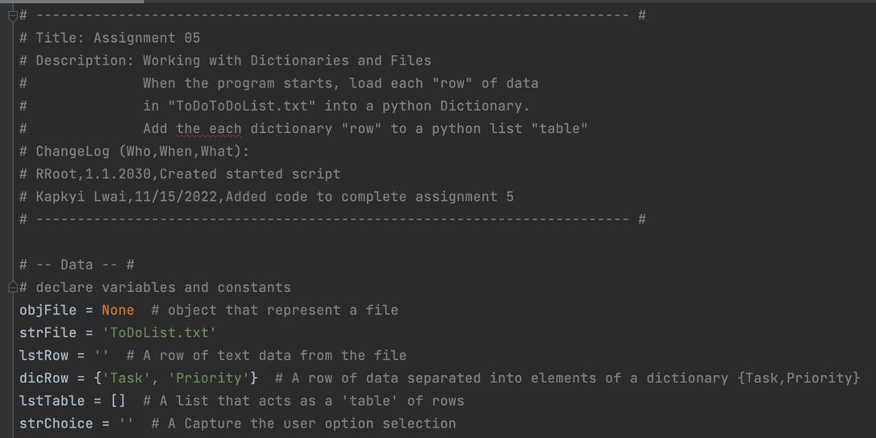

*Figure 1: headers and variables with comments #*

**Writing The Script:** step 1 (Load data in text file ToDoList.txt)

The first step for writing the script was to open text file ‘ToDoList.txt’ for data to be added. I created a code that allows to load data in the file into list of dictionaries rows. The code I created for this step as you can see in (Figure 2) did not work as an error occurred and a text file was not created. In order resolve this issue, I added another code line for to open the file ‘ToDoList.txt’ with ‘w’. Another way was to open a new file manually and name the file as ‘ToDoList.txt’ (Figure 3).

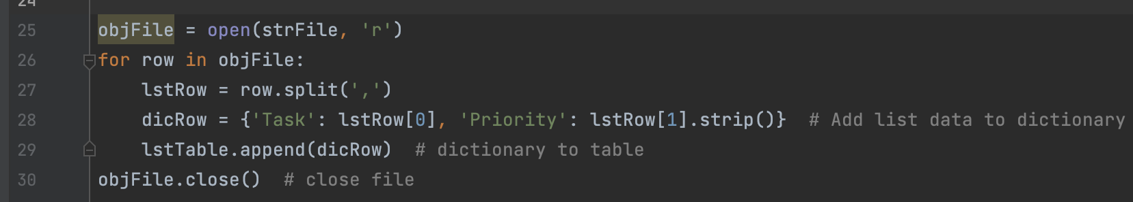

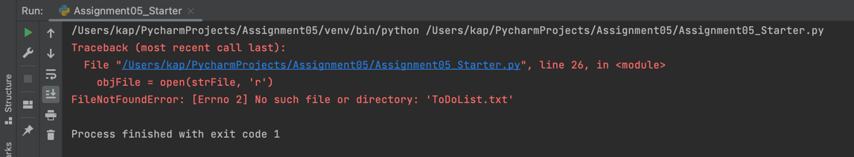

*Figure 2: error to create text file*

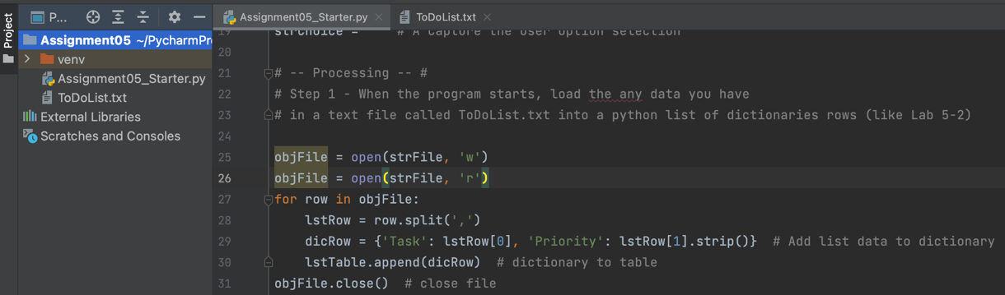

*Figure 3: creating text file manually and adding extra code with ‘w’*

**Writing The Script:** step 2 (Display menu of choices)

The next step is to write codes to display menu for user to input their choice. In this menu, there are a total of five options to choose. As you can see in Figure 4 below, the ‘while’ loop was used to create menu of options and followed by ‘input’ function and ‘print’ function to display choices for user.

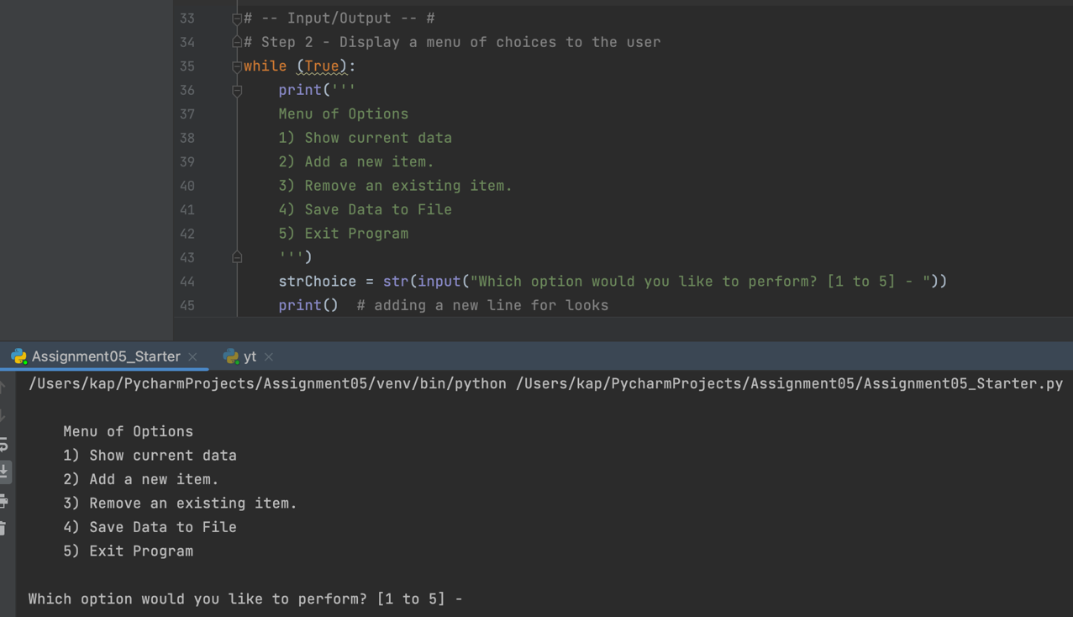

*Figure 4: display menu & input/output for user*

**Writing The Script:** step 3 (Display current data in table)

Step 3 of my program script was to display the current items in the table created (‘ToDoList.txt’) by separating the Task and Priority with comma and tab (Figure 5). The ‘if’ function was used for choosing any option and if option 1 is chosen, the program will print out current data. The ‘for’ function was used to print the data in table as rows separated by comma. The ‘continue’ function allow the program to display menu of choices to user except when choosing option 5 which will end the program.

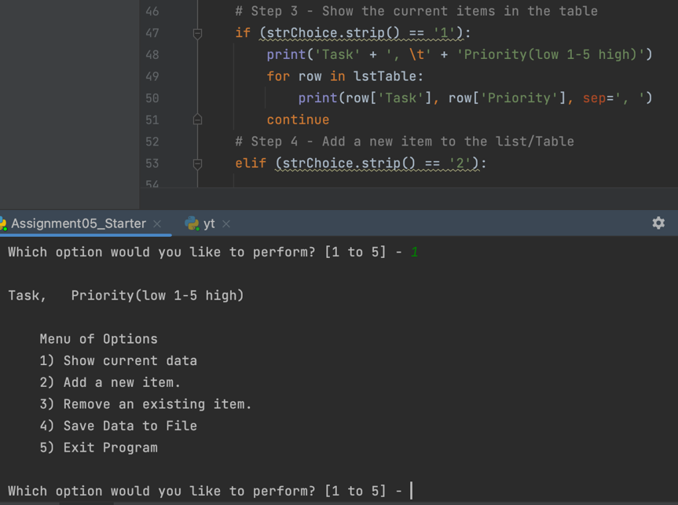

*Figure 5: display current data by choosing option 1 from menu*

**Writing The Script:** step 4 (enter new data to table)

The next step was to get user input data when option 2 is chosen. The ‘elif’ function was used for this step as to imply if the first option was not chosen, any other options are available. Variables ‘strTask’ and ‘strPriority’ were scripted with ‘input’ function for user to enter in any task and its priority anywhere between 1 being low to 5 being high. The data entered were then listed to the ‘dicRow’ in a table. The ‘append()’ method was used to add dictionary to ‘lstTable’. (Figure 6)

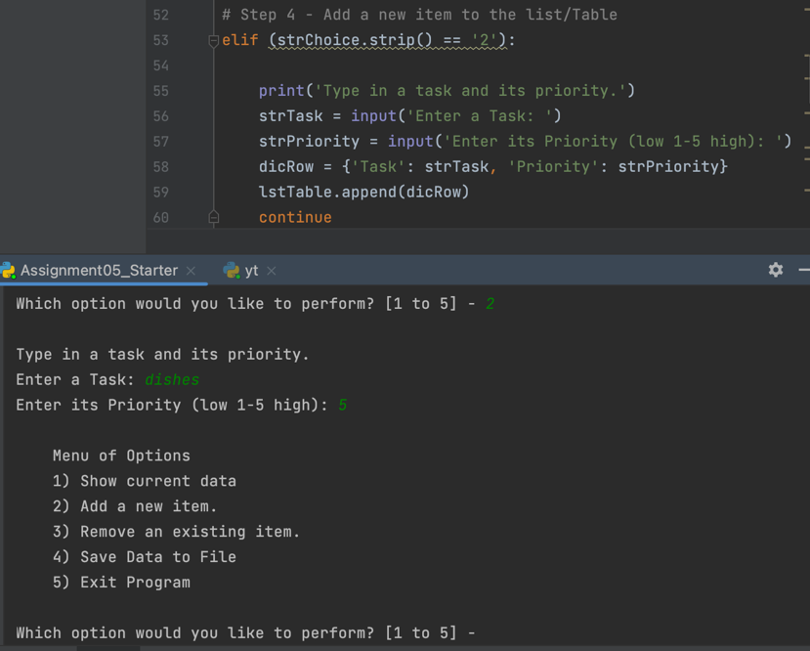

*Figure 6: display of user data input to table*

**Writing The Script:** step 5 (removing a task & priority)

This program is also coded so that user have option to remove the data they entered previously. For this step, the ‘elif’ function was used for user choice to be option 3 and ‘lstTable’ was printed so that user can see their data and choose which to remove (Figure 8). The ‘strRemove’ was used to delete the specific data entered in the ‘lstTable’. When user enter the matching item/data from their list, the program will remove and display a message that their ‘task’ is removed. If the user entered item/data not in their list, the program will display invalid message (Figure 7). This part of the program is coded by using ‘else’ function (Figure 8).

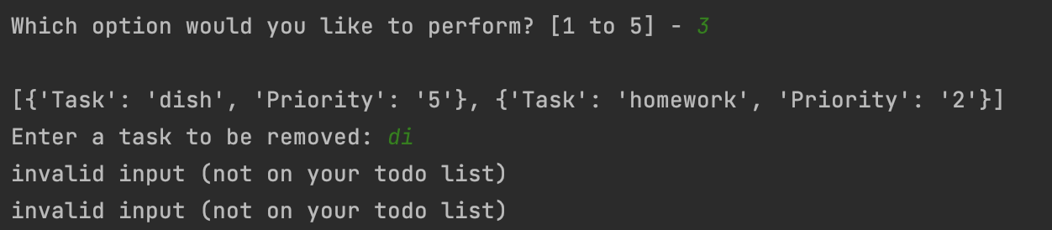

*Figure 7: invalid input to remove data*

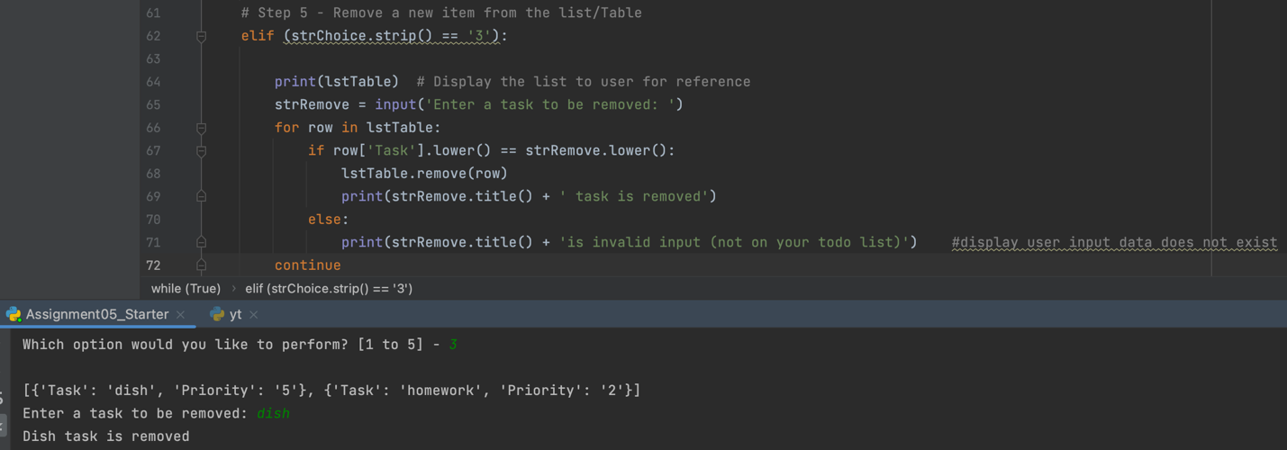

*Figure 8: removing data entered from table*

**Writing The Script:** step 6 (save data to file)

Option 4 from the menu would allow user to save their data to text file (‘ToDoList.txt’). To make the program to save data, the text file is ‘open’ with ‘w’ mode and the ‘for’ is used to write data in lstTable to the file ‘ToDoList.txt’. The file is then closed with code ‘objFile.close()’ and the program print out a display of ‘Data Saved to File!’. (Figure 9)

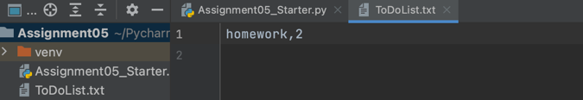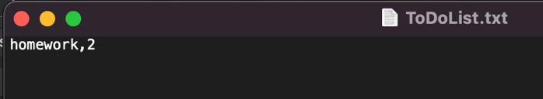

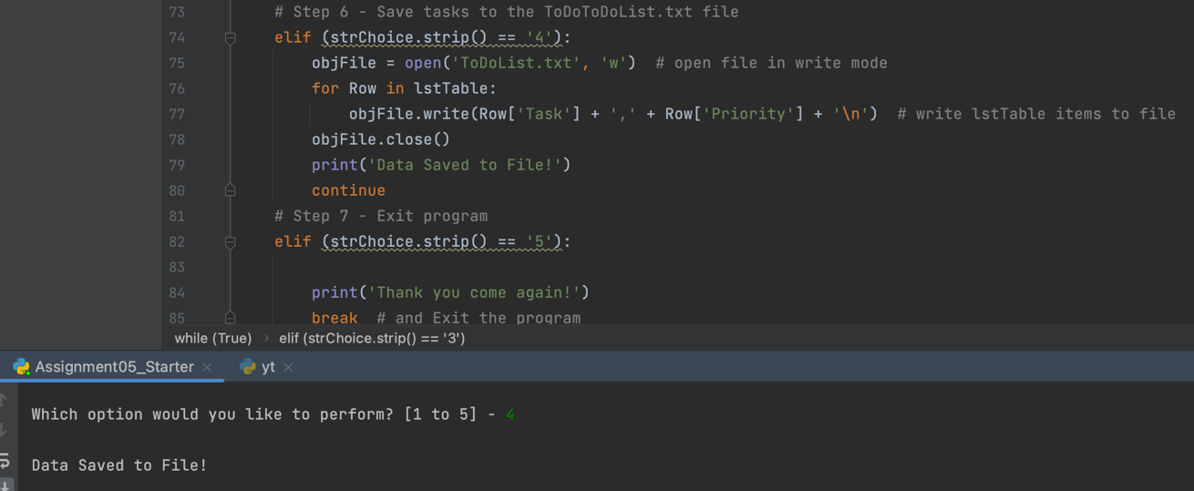

*Figure 9: saving data to file ‘ToDoList.txt’*

**Writing The Script:** step 7 (exit/end program)

The final step for coding the program was to end the program when user chooses option 5. In this step, a final message was printed ‘Thank you come again!’ when user entered ‘5’ from the menu. The function ‘break’ was used to allow the program to end the loop and exit the whole program. (Figure 10)

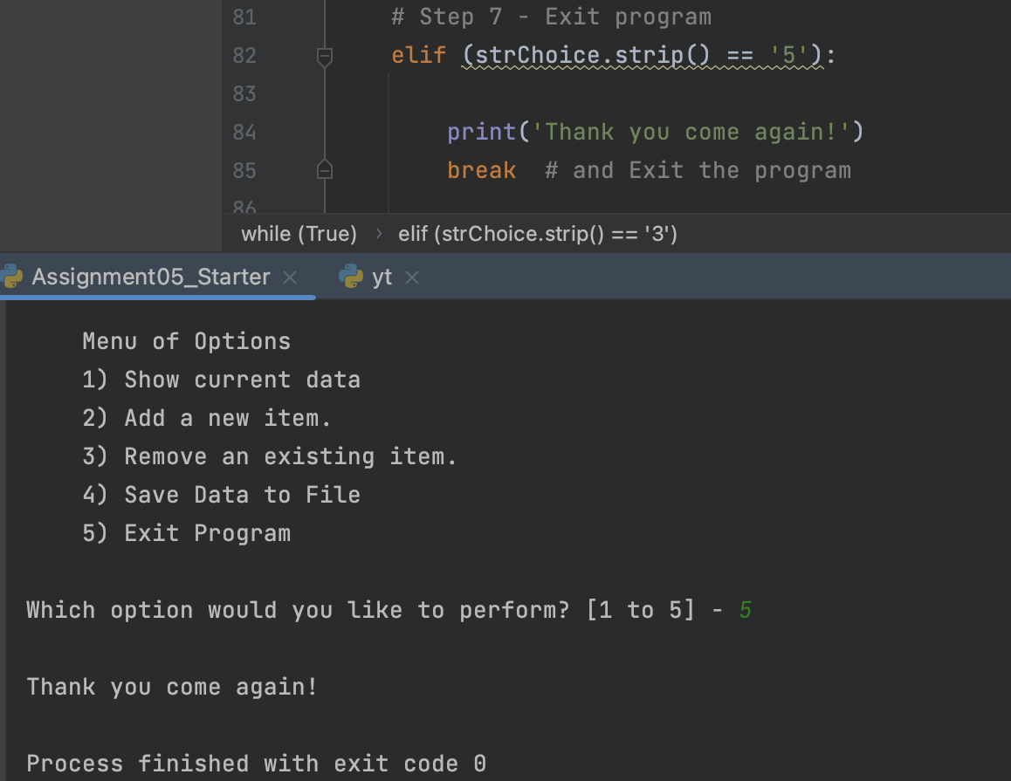

*Figure 10: display of program exit*

**Running The Script:**

Lastly, I ran the program in PyCharm as well as on Shell window to double check it is working. The program ran smoothly in PyCharm as shown in screenshots (Figure 1 to Figure 10) above as well as on Shell window (Figure 11).

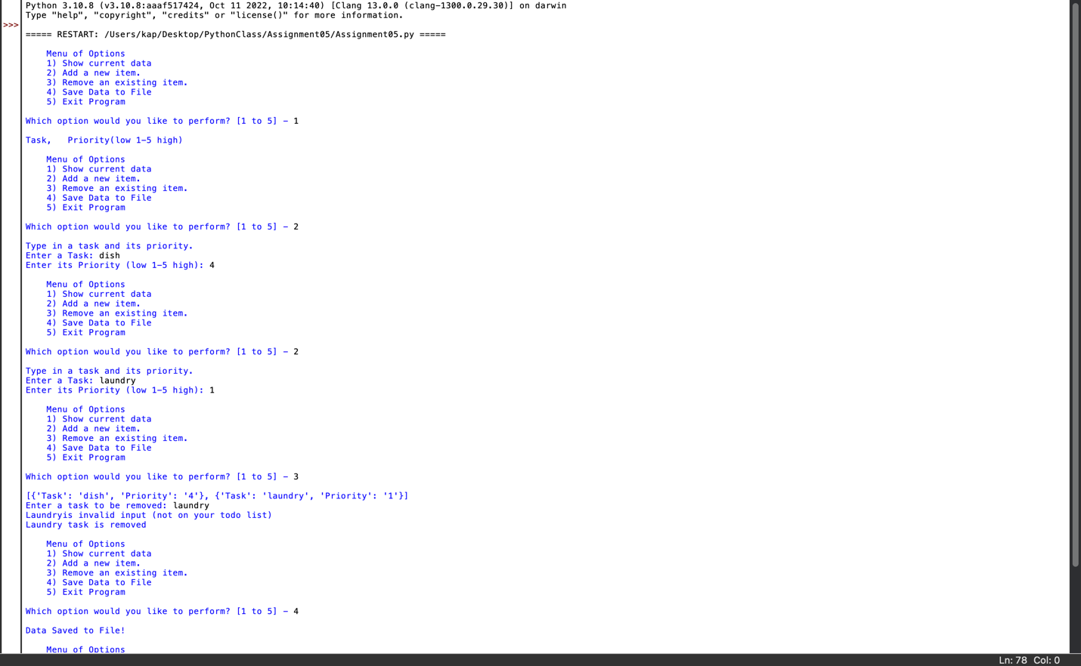

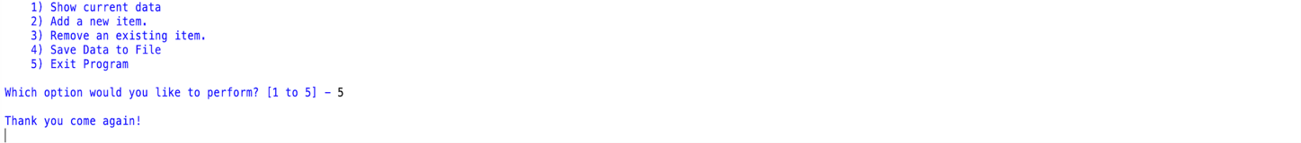

Figure 11: program running in Shell

**Upload to GitHub: link:** [**https://github.com/kapkyi/IntroToProg-Python**](https://github.com/kapkyi/IntroToProg-Python)

This project was uploaded to my GitHub account as public. The project was uploaded for others to view and provide comments or edits. (Figure 12)

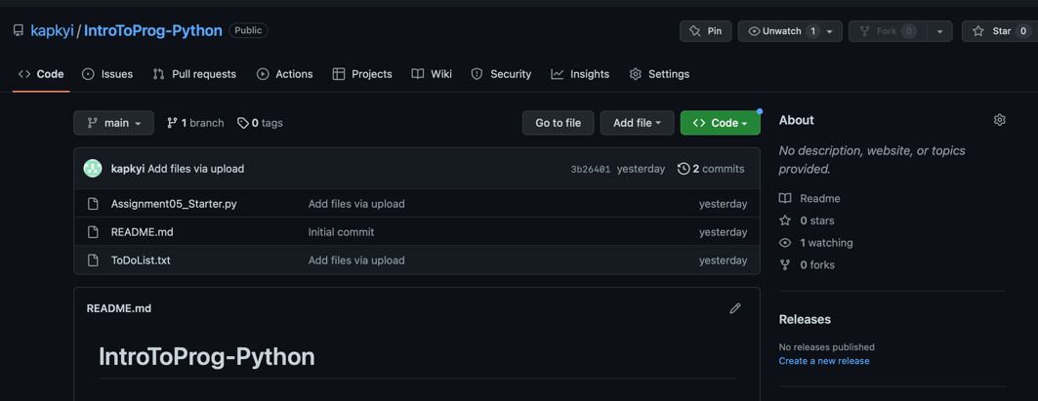

*Figure 11: project uploaded to GitHub as public*

**Summary:**

In conclusion, this project was created from already made outline and it was modified with added codes to complete the program. From this assignment, I learned how to edit and modify Python script and upload my project to GitHub. The assignment allows me to demonstrate my knowledge of how to open, write, and save data to a file, continue the use of *print* and *input* function for user interaction, and loop functions such as *while, if, elif, else*, for, *continue,* and *break.* The new skill to use and create dictionaries and removing data from table/file were also applied in this assignment. From reading Chapter 5 of the textbook (Python Programing, 3rd edition, Michael Dawson, 2010), looking at the Module 5 documentation, lecture video, and the starter Python script outline provided for the assignment, I was able to successfully create the program.