- Lumina IVF


- Prime TG Diagnostic Ltd


- Graduate General Hospital

- The Lab Aid Diagnostic center (Habiganj)


- Aiyaat Medical Service

- Active Diagnostic & Blood Bank
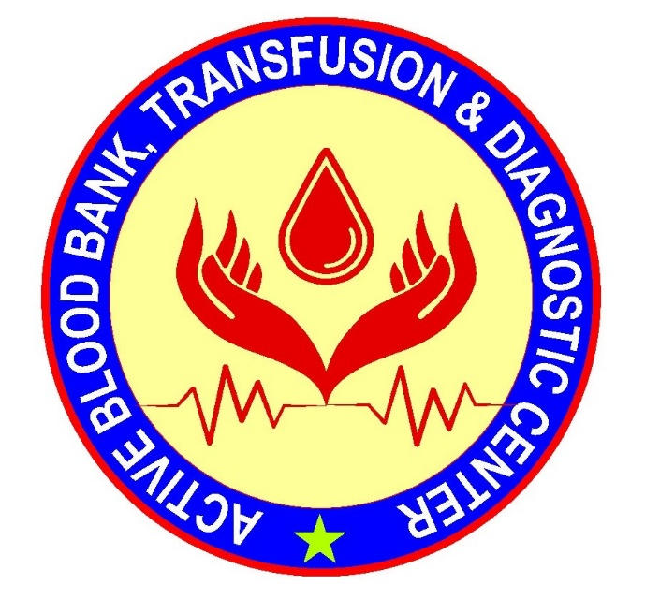
- Medicure Diagnostic Center
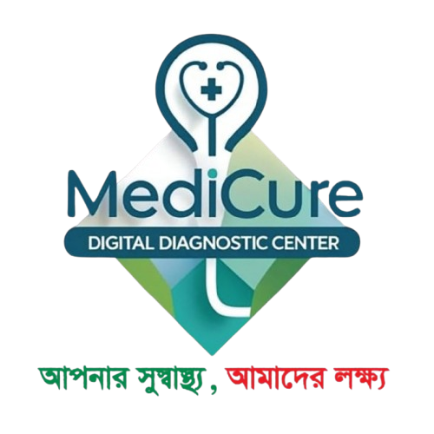
- Prime Diagnostic Center
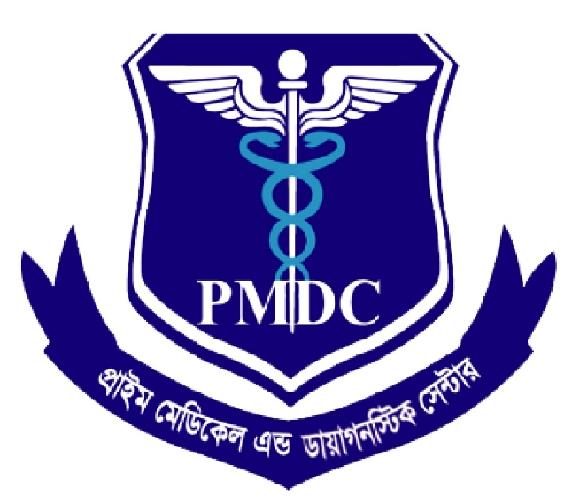

- Al-Aksa health care & Diagnostic

- Apollo Plus Medical Service


- Lab Aid Hospital (Bhairab)

