TECHNICAL PROPOSAL
PROVISION OF DIGITAL ARCHIVING SOLUTIONS
Technical Documentation, Infrastructure & Deployment Architecture
Prepared for Soko & Co. Lawyers | Malawi
Prepared by: [Malawian-Based Bidder / Company Name]
Date: August 2026

1. Executive Summary
This proposal provides a practical digital archiving platform together with the physical and logical infrastructure required to operate it. The recommended baseline is an on-premises or office-controlled deployment: scanning and OCR are performed at the firm's premises, the application and document repository run on a dedicated server or virtualised server environment, and backups are maintained on separate storage. An off-site/cloud backup layer can be added where the firm's policy, connectivity and data-handling requirements permit.
This architecture is preferred for a legal practice because it keeps the primary archive under direct organisational control, avoids making the core system dependent on continuous Internet connectivity, and allows local users to access records over the firm's LAN.

2. Recommended Deployment Model
The recommended model is <b>on-premises primary storage with optional hybrid disaster recovery</b>. The primary archive is hosted at the firm's premises. Users access it through a secure internal web application. Only approved remote access should traverse a VPN or equivalent secure tunnel; the document repository should not be exposed directly to the public Internet.
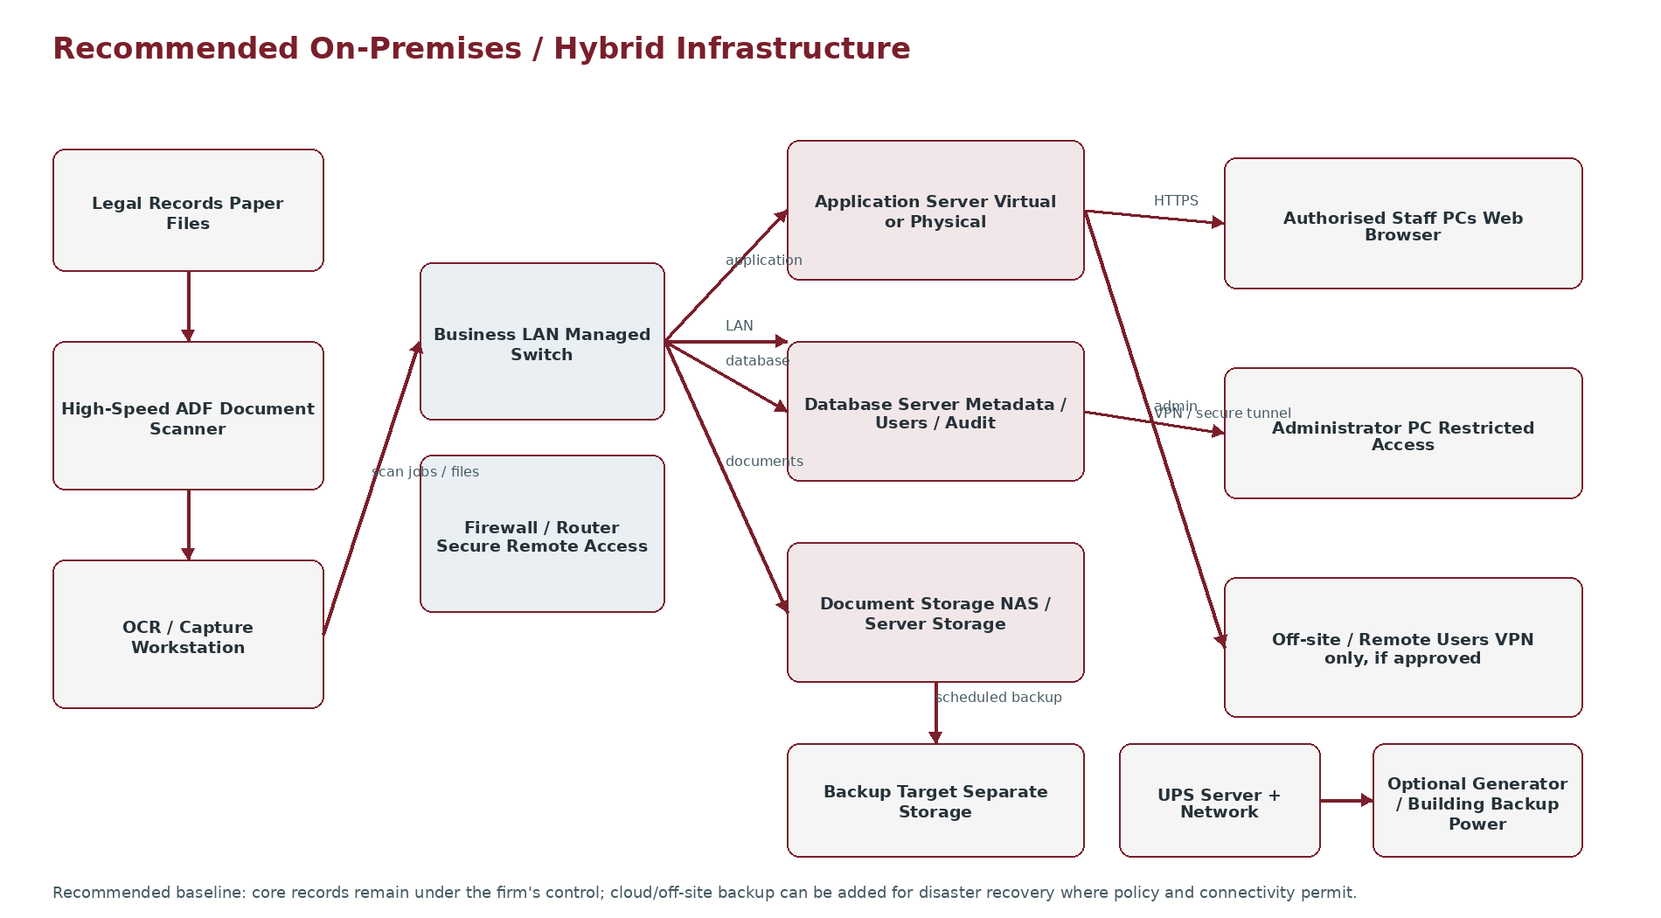

3. Physical Infrastructure Required
Component | Recommended baseline | Purpose | Location | Notes
Application Server | 1 dedicated server or VM; 8 CPU cores, 32 GB RAM | Runs archiving application/services | Secure server area | Can initially be combined with DB for modest workloads
Database | PostgreSQL/MySQL-class relational DB; 4–8 cores, 16–32 GB RAM | Metadata, users, audit and configuration | Server environment | Separate DB VM/server preferred as volume grows
Document Storage | NAS/server storage, starting around 8–16 TB usable | Stores scanned PDFs/images and digital files | Secure server area | Capacity must be sized from actual record volume
Backup Storage | Separate NAS/storage, ideally >= primary protected data set | Backup and recovery | Separate physical location if possible | Do not rely on same disk/server as the live archive
Document Scanner | High-speed duplex ADF scanner, preferably 40–60+ ppm | Bulk paper capture and OCR input | Records/scanning area | ADF + duplex is important for legal files
OCR/Capture Workstation | Core i5/Ryzen 5-class or better, 16 GB RAM, SSD | Scanner control, OCR, QA and batch processing | Scanning area | GPU is not required for conventional OCR
User PCs | Existing office PCs with modern browser | Search/retrieval and administration | User desks | No special client software required
Network Switch | Managed Gigabit switch | Connects servers, scanners and users | Network/server area | 10GbE may be considered for larger storage workloads
Firewall/Router | Business-grade firewall/router | Network security and controlled remote access | Network edge | VPN capability recommended
UPS | Online/line-interactive UPS sized for server + network load | Protects against outages and voltage events | Server/network area | Runtime to be sized against equipment load
Optional Generator/Backup Power | Existing building generator or equivalent | Extended power continuity | Facility | Useful but not mandatory if reliable backup power exists

4. Server & Storage Architecture
For a small-to-medium initial archive, a single physical server running separate virtual machines is a practical starting point. One VM can host the application and another can host the database, while document files reside on dedicated storage. For higher volumes or stricter availability requirements, the application, database and storage can be separated onto dedicated systems.
- <b>Server OS:</b> Linux or Windows Server according to the selected application stack and support requirements.
- <b>Application service:</b> hosts the web interface, authentication, document workflows and indexing services.
- <b>Database:</b> stores structured metadata, users, permissions, audit events and configuration; it should not be used as the primary store for large document binaries unless the final design specifically calls for it.
- <b>Document repository:</b> stores PDF/TIFF/JPEG or other agreed archival formats, with controlled file permissions.
- <b>Storage redundancy:</b> RAID is recommended for operational resilience, but RAID is not a backup.
- <b>Backup:</b> backups should be stored separately from the live system and periodically tested by restoring sample records.

5. OCR & Document Capture Equipment
OCR is primarily a software processing function; the important hardware requirement is a reliable document scanner and a workstation capable of processing batches. A dedicated GPU is not required for conventional OCR. The system should capture clean, sufficiently high-resolution source images before OCR is attempted.
- <b>Scanner type:</b> production document scanner with automatic document feeder (ADF) and duplex scanning.
- <b>Recommended throughput:</b> approximately 40–60+ pages per minute for a moderate archive workload; higher throughput can be selected after a volume study.
- <b>Optical resolution:</b> 300 dpi should be the normal baseline for text documents; higher resolution can be used for difficult source material where justified.
- <b>Paper handling:</b> multi-feed detection, mixed-size handling where available, ultrasonic/multi-feed detection and reliable duplex capture are desirable.
- <b>Workstation:</b> 16 GB RAM, SSD, modern multi-core CPU and sufficient local scratch space for batch processing.
- <b>OCR software:</b> production OCR engine capable of PDF creation, searchable text layers, batch processing and language configuration appropriate to the firm's documents.
- <b>Quality control:</b> operator verifies page completeness, orientation, legibility, correct document separation and metadata before final archival.

6. Network Architecture
- Scanning workstation, application server, database and storage should communicate over the firm's internal LAN.
- Use wired Gigabit Ethernet for servers, storage and scanning workstations where practical.
- Users access the system through a browser using HTTPS.
- The application/server network should be separated from ordinary guest Wi-Fi and other untrusted networks.
- Remote access, if required, should use VPN or another approved secure access mechanism rather than exposing the database or file shares directly to the Internet.
- Firewall rules should permit only the services required for application operation, administration, backup and approved remote access.

7. Backup, Disaster Recovery & Physical Protection
The live repository and its backup must not depend on the same physical failure domain. A practical baseline is a primary server/storage system plus a separate backup NAS. Where feasible, a second backup copy should be maintained at a different physical location or through an approved cloud/off-site service.
- Daily incremental or scheduled backups of application/database data and newly archived documents.
- Regular full backup or snapshot strategy based on storage capacity and recovery requirements.
- Separate backup storage with restricted administrator access.
- Periodic restore tests using selected records and database backups.
- UPS protection for servers, storage, switches and firewall equipment.
- Controlled server-room access and adequate ventilation/temperature conditions.
- Documented recovery procedure identifying who restores the system and how users are informed.

8. Proposed Minimum Bill of Infrastructure
Item | Qty | Minimum / Target Specification | Purpose
Application/Database Server | 1 | 8 cores; 32 GB RAM; SSD; redundant disks/RAID; dual NIC preferred | Core application and DB; may use VMs
Primary Document Storage | 1 | 8–16 TB usable starting capacity; RAID/redundancy | Digital archive
Backup NAS/Storage | 1 | Capacity sized to protected data; separate from primary | Recovery
Production Document Scanner | 1–2 | ADF duplex; 40–60+ ppm; 300 dpi baseline | Bulk digitisation
OCR Workstation | 1 per scanning station | 16 GB RAM; modern multi-core CPU; SSD | OCR/capture/QA
Managed Gigabit Switch | 1 | 24-port class or sized to office | LAN connectivity
Firewall/Router | 1 | Business-grade; VPN support | Security and remote access
UPS | 1–2 | Sized for server, storage and network load | Power protection
Backup/off-site location | 1 | Separate physical location or approved cloud target | Disaster recovery
User PCs | Existing / as needed | Modern browser; 8 GB+ RAM recommended | Search and retrieval

9. Infrastructure Sizing Caveat
The quantities above are a defensible starting architecture, not a claim that every environment requires exactly these specifications. Before procurement, the implementation team should sample the archive and calculate: number of pages, average file size, number of records, expected annual growth, users, scanning rate, retention period and recovery objectives. Storage should then be sized with growth headroom rather than purchasing a fixed capacity blindly.
For example, if a 10-page record averages 2 MB after scanning, 100,000 records would represent roughly 2 TB before additional copies, indexing overhead and growth. This is why actual record sampling should precede final storage procurement.

10. Recommended Physical Arrangement
- <b>Records/scanning area:</b> scanner(s), capture workstation and temporary controlled staging area for documents awaiting QA.
- <b>Server/network area:</b> server, primary storage, backup NAS, managed switch, firewall and UPS in a restricted-access location.
- <b>User area:</b> existing staff computers accessing the archive via browser.
- <b>Backup location:</b> preferably a different room/building/site; if this is not practical initially, a separate protected backup device is the minimum starting control.
- Paper originals should be retained, returned or destroyed only according to the firm's approved records policy and any applicable legal/contractual requirements.

11. Implementation Stages

Stage 1 — Infrastructure Assessment
Inspect the firm's network, power, server area, Internet connectivity, existing PCs and available scanning equipment.

Stage 2 — Records Sampling
Measure page volumes, document types, condition, average scan sizes and OCR suitability.

Stage 3 — Procurement / Preparation
Acquire or allocate server, storage, scanner, UPS and networking equipment as approved.

Stage 4 — Pilot
Digitise a representative sample and validate OCR, metadata, search, access and storage requirements.

Stage 5 — Production Deployment
Configure the application, repository, database, backup and user roles.

Stage 6 — Bulk Digitisation
Process agreed batches with quality assurance and exception handling.

Stage 7 — Handover
Train users, document infrastructure and recovery procedures, and conduct acceptance testing.

12. Scope Boundaries
- Perfect OCR is not guaranteed for poor-quality, handwritten, damaged or unusual documents.
- A GPU server is not assumed because conventional OCR does not require one; specialised AI extraction would be a separate requirement.
- High availability clustering, redundant Internet links, off-site disaster recovery and cloud hosting are optional enhancements unless required by the final specification.
- The proposal does not assume unlimited scanning throughput; bulk timelines depend on page volume, scanner speed, operator capacity and QA.
- Hardware quantities and final specifications must be confirmed after the infrastructure and records assessment.

13. Conclusion
The recommended solution is a practical, supportable on-premises/hybrid architecture suitable for a Malawi-based legal practice: production scanning and OCR at the office, controlled application and database services, dedicated document storage, separate backup storage, protected network infrastructure and UPS-backed power. This provides a clear physical foundation for the digital archiving system rather than treating the project as software-only.

