NEXS
ENGINEERED FOR PERFECT SURFACES
Figma / UI Design Handoff
Step 4 — v4.0
Think New. Think NEXS.
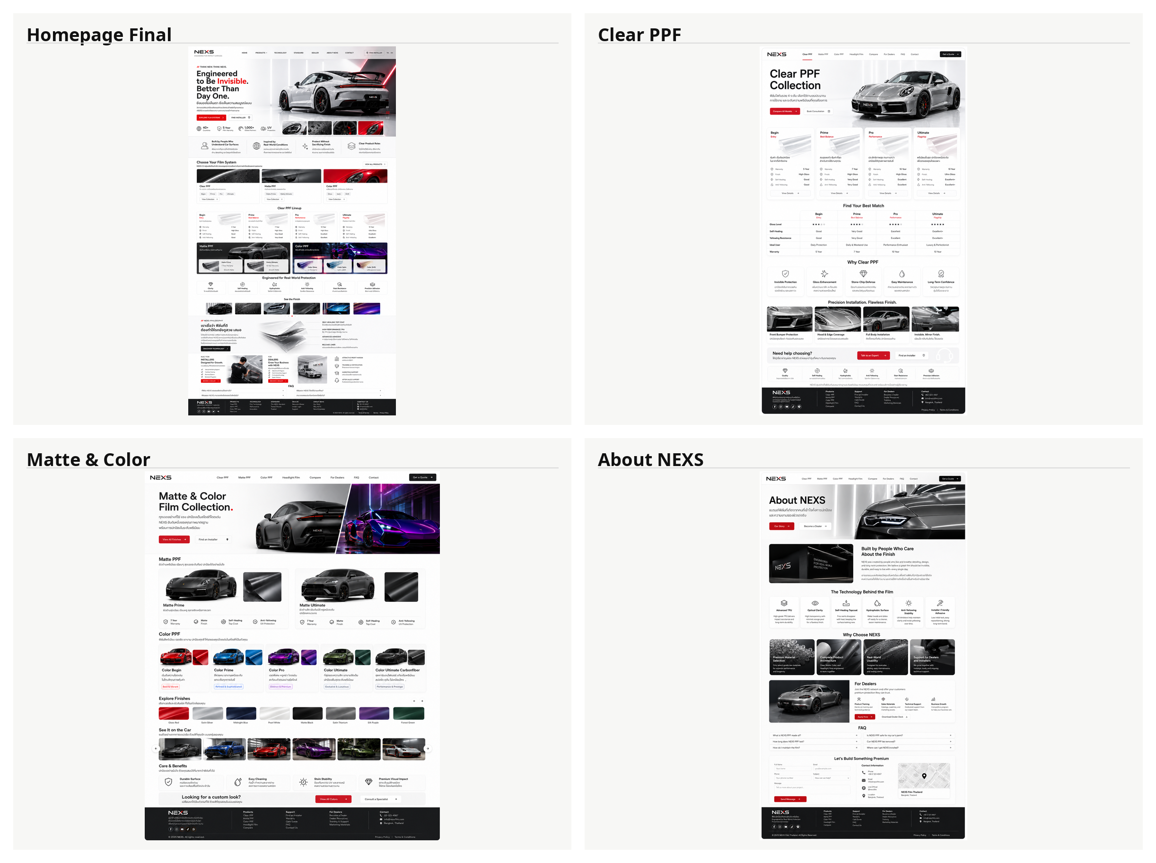
Purpose: convert approved visuals, copy, spec, and asset brief into a Figma-ready UI system for designer/developer execution.

STEP 4 SCOPE
What this handoff locks
Area | Locked direction
Theme | White / soft grey / silver / black / restrained red accent. Apple-inspired premium minimalism. Avoid full black homepage.
Brand descriptor | ENGINEERED FOR PERFECT SURFACES
Campaign | Think New. Think NEXS.
Hero | Engineered to Be Invisible. Better Than Day One.
Thai hero | ยิ่งมองไม่เห็นฟิล์ม ยิ่งเห็นความสมบูรณ์แบบ
Quote block | A Higher Standard for Invisible Surfaces.
Product architecture | 12 Film Options: Clear 4, Matte 3, Color 5.
Pricing rule | No public pricing, no starting price, no ranges, no dealer cost, no supplier cost.

This document does not replace the final Figma file. It defines the structure, components, frame list, responsive rules, and handoff checklist that the Figma designer must follow.
Core production rule
• Do not generate a new visual concept. Use the approved final screenshots as the visual reference.
• Do not switch the site into a dark theme. Black is allowed only for contrast sections such as quote blocks, carbon detail, or CTA panels.
• Use real product data from the no-pricing product matrix only.
• All copy must come from the locked copy document; AI image text is not a source of truth.

FIGMA FILE STRUCTURE
Required Figma pages and naming
Figma Page | Purpose | Required frames
00_Cover | Project cover and links to docs. | Cover, status, document links
01_Foundations | Design tokens and brand rules. | Colors, typography, spacing, grid, imagery rules
02_Components | Reusable UI kit. | Header, buttons, cards, forms, tables, accordions, quote blocks
03_Desktop_1440 | Approved desktop layouts. | All public pages at 1440px
04_Tablet_768 | Tablet responsive layouts. | Key pages and navigation behavior
05_Mobile_390 | Mobile responsive layouts. | All public pages and mobile menu
06_Prototype_Flow | Clickable prototype path. | Home > products > quote/contact/dealer
07_Dev_Handoff | Annotated design specs for build. | Specs, redlines, spacing, behavior notes
99_Archive | Old versions only. | V1/V2 explorations; do not use for build

Component names should use predictable paths, for example: NEXS/Header/Desktop, NEXS/Button/Primary, NEXS/Card/ProductTier, NEXS/Form/Contact.

FOUNDATIONS
Design tokens
Color system
Token | Hex | Usage
Canvas | #FFFFFF | Default page background
Canvas Soft | #F7F7F5 | Section background and card staging
Surface Warm | #ECEBE8 | MacBook-box style product panels
Surface Cool | #F2F3F4 | Technology panels and tables
Ink | #111111 | Primary headline and navigation text
Ink Muted | #5F6368 | Body/supporting text
Border | #DADADA | Hairline cards, tables, dividers
Metal | #BFC3C7 | Subtle metallic accents
Accent Red | #D71920 | CTA, active states, micro highlights only
Dark Panel | #0E0E0F | Quote block / carbon contrast section

Typography
Style | Desktop | Mobile | Usage
Hero H1 | 72 / 76 / 600 | 40 / 44 / 600 | Homepage and product hero
Section H2 | 48 / 54 / 600 | 32 / 38 / 600 | Major section title
Card Title | 24 / 30 / 600 | 20 / 26 / 600 | Product and feature cards
Body | 16 / 28 / 400 | 15 / 24 / 400 | Paragraph copy
Caption / Eyebrow | 12 / 18 / 600 | 11 / 16 / 600 | Uppercase labels, campaign line

Use Inter or system sans for English. Use Noto Sans Thai or IBM Plex Sans Thai for Thai. SF Pro can be used as a visual reference, but do not depend on proprietary fonts for web implementation.

LAYOUT
Grid, spacing, and section rhythm
Viewport | Frame | Grid | Margin | Gutter | Content max
Desktop | 1440px | 12 columns | 72px | 24px | 1200px
Tablet | 768px | 6 columns | 32px | 20px | 704px
Mobile | 390px | 4 columns | 20px | 16px | 350px

Token | Value | Use
Space 1 | 4px | Icon/text micro gap
Space 2 | 8px | Compact controls
Space 3 | 12px | Small card spacing
Space 4 | 16px | Card internal padding minimum
Space 5 | 24px | Default card padding and gaps
Space 6 | 32px | Grid gap / medium section spacing
Space 7 | 48px | Section internal rhythm
Space 8 | 64px | Desktop section padding minimum
Space 9 | 96px | Hero/product large spacing
Space 10 | 128px | Premium whitespace / major break

Default section padding: 96px top/bottom desktop, 64px tablet, 48px mobile. Hero can use 128px top/bottom desktop if the car render needs breathing room.

COMPONENTS
UI component system
Component | Variants | Notes
Header / Navigation | Desktop, tablet, mobile menu, sticky compact | Logo descriptor, nav links, quote CTA. White translucent background with hairline border.
Button | Primary red, secondary dark, ghost, text link | Primary CTA uses restrained red; button radius pill; include hover/focus/disabled.
Hero Block | Homepage, product, about | Large headline + Thai subcopy + car/render stage. Use wide whitespace and centered premium staging.
Product Group Card | Clear, Matte, Color | Shows product family, tier count, short copy, CTA.
Product Tier Card | Begin, Prime, Pro, Ultimate, Carbon | No price. Show role, key benefits, warranty language, CTA.
Comparison Table | Desktop table, mobile stacked cards | No pricing columns. Use sticky header on desktop if page is long.
Technology Card | Layer, TPU, Self-healing, Adhesive, Finish | Use line icons or minimal 3D renders.
Quote Block | Light, dark | Primary dark quote: A Higher Standard for Invisible Surfaces.
FAQ Accordion | Closed, open, hover | One open item allowed. Icons must be minimal.
Form | Contact, dealer application | Include validation, success state, error state, privacy note.
Footer | Desktop, mobile | Product links, dealer links, contact, social, legal.

SCREENS
Desktop screen blueprint
Page | Route | Key sections in order
Homepage | / | Header, hero, product systems, NEXS standard, technology preview, quote block, dealer CTA, FAQ preview, footer
Clear PPF | /clear-ppf | Hero, 4-tier lineup, invisible technology, comparison, use cases, FAQ, quote CTA
Matte PPF | /matte-ppf | Hero, Matte Prime/Pro/Ultimate, finish guide, comparison, care notes, quote CTA
Color PPF | /color-ppf | Hero, 5-tier lineup, swatch gallery, carbon fiber detail, comparison, quote CTA
Technology | /technology | Hero, layer stack, material system, self-healing, hydrophobic, adhesive, testing language
Compare | /compare | Hero, public product comparison matrix, selection guide, quote CTA
For Dealers | /for-dealers | Hero, dealer value, training/support, application form, FAQ
About NEXS | /about | Hero, brand story, standard pillars, visual philosophy, quote block, contact CTA
FAQ | /faq | Grouped FAQ by product, warranty, care, dealer, contact CTA
Contact | /contact | Hero, contact form, dealer enquiry, map/contact details, LINE CTA

Screen creation requirement
• Create desktop frames first, then derive tablet and mobile from approved desktop frames.
• Every page must have both Thai and English-ready layout capacity even if final launch is Thai-first.
• No frame should include pricing. CTAs replace pricing: Get a Quote, Book Consultation, Find Installer, Talk to an Expert.
• Product cards must accommodate 12 options: Clear 4, Matte 3, Color 5.

RESPONSIVE DESIGN
Responsive behavior
Element | Desktop | Tablet | Mobile
Header | Full nav + CTA | Compressed nav + CTA or menu | Logo + menu + CTA icon/text
Hero | Two-column or centered stage | Stacked with reduced car scale | Stacked; H1 max 2-4 lines; CTA full width optional
Product cards | 3-column groups / 4-tier rows | 2-column cards | 1-column stacked cards
Comparison table | Full table | Horizontal scroll allowed | Stacked cards; avoid tiny table text
Quote block | Large centered typography | Centered, reduced padding | Short line breaks, no overflow
Forms | 2-column where useful | 1-2 column hybrid | 1-column; large inputs; sticky submit optional
Footer | Multi-column | 2-column groups | Accordion or stacked groups

Mobile layout must be designed, not left to developer interpretation. Required frames: mobile homepage, mobile product page pattern, mobile menu, mobile form state, mobile FAQ accordion.

PROTOTYPE
Interactions, states, and prototype flow
Interaction | Required states / flow
Navigation | Default, hover, active page, sticky compact, mobile menu open/close.
Buttons | Default, hover, pressed, focus-visible, disabled.
Product cards | Default, hover lift, active/selected if comparison tool is added later.
FAQ accordion | Closed/open, one item open, keyboard accessible behavior note.
Forms | Empty, focus, validation error, success, loading/submitting.
Gallery / swatches | Default, hover, selected color, mobile carousel behavior.
Dealer CTA | CTA to dealer application form; success state must show no price or commercial terms.

Prototype path
• Home > Clear PPF > Get a Quote > Contact form success
• Home > Color PPF > Ultimate Carbon Fiber detail > Book Consultation
• Home > For Dealers > Dealer Application > success state
• Home > FAQ > Contact / LINE CTA

HANDOFF QA
Figma delivery checklist
Check | Acceptance requirement
Visual direction | Matches final white Apple-style screenshots. No full dark homepage redesign.
Text accuracy | Uses locked copy; no AI-generated placeholder text remains.
Product architecture | Clear 4, Matte 3, Color 5 shown consistently.
Pricing | No public price or price-like field appears anywhere.
Components | Header, buttons, cards, tables, forms, FAQ, footer are components with variants.
Responsive | Desktop 1440, tablet 768, mobile 390 frames completed for all main pages.
Assets | Image placeholders match Step 3 asset tracker IDs.
Developer notes | Spacing, colors, typography, states, and behavior are annotated.
Prototype | Main flow links work. No dead primary CTAs.
Export readiness | Icons, logos, and key images are exportable with correct names.

Step 4 is complete when the Figma file can be handed to a developer without asking which page, component, breakpoint, image, or CTA behavior to build.

NEXT STEP
After Step 4
After this handoff, the next step is Step 5: Development Build Plan. That step converts the Figma screens and components into a technical build plan, including frontend framework, CMS strategy, page templates, form handling, analytics events, deployment, and QA procedure.
Files connected to Step 4
• NEXS_Figma_UI_Design_Handoff_v4_0.docx — this document.
• NEXS_Figma_Screen_Component_Matrix_v4_0.xlsx — screen, component, and QA matrix.
• nexs_design_tokens_v4_0.json — machine-readable design tokens.
• nexs_design_tokens_v4_0.css — CSS variables for developer reference.

