NEXS
ENGINEERED FOR PERFECT SURFACES
Production Asset Brief
Step 3 / v3.0
Image direction, shot list, AI render guidance, and asset production rules for the NEXS website build.

1. Locked Brand Direction
Position | Locked copy / rule
Brand Descriptor | ENGINEERED FOR PERFECT SURFACES
Main Campaign | Think New. Think NEXS.
Homepage Hero | Engineered to Be Invisible. Better Than Day One.
Thai Hero | ยิ่งมองไม่เห็นฟิล์ม ยิ่งเห็นความสมบูรณ์แบบ
Quote Block | A Higher Standard for Invisible Surfaces. / ใช้กับทั้งเว็บ
Visual Mood | Apple-style white premium: bright studio, silver/white cars, soft shadows, minimal red accents.
Pricing Rule | Public website must show no price, no price range, no dealer cost, no supplier/factory cost.
Asset production must support the approved white/silver premium direction. Do not move the site back into a mostly black theme. Black can appear in footer, cards, shadows, carbon texture, or contrast areas only.

2. Approved Visual References
Use these mockups as design references, not as final production assets. Text inside AI mockups may be inaccurate; final copy is controlled by the copy lock document.
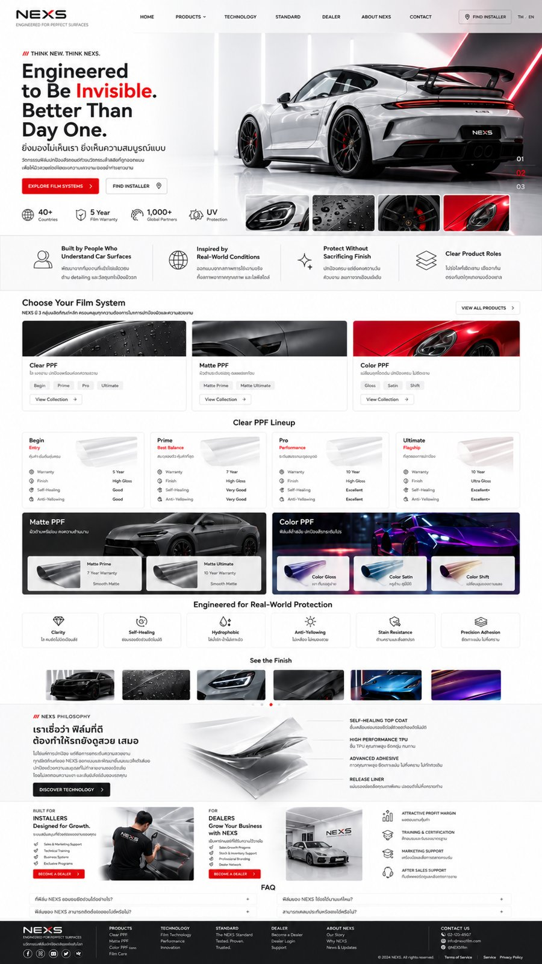  Homepage Final | 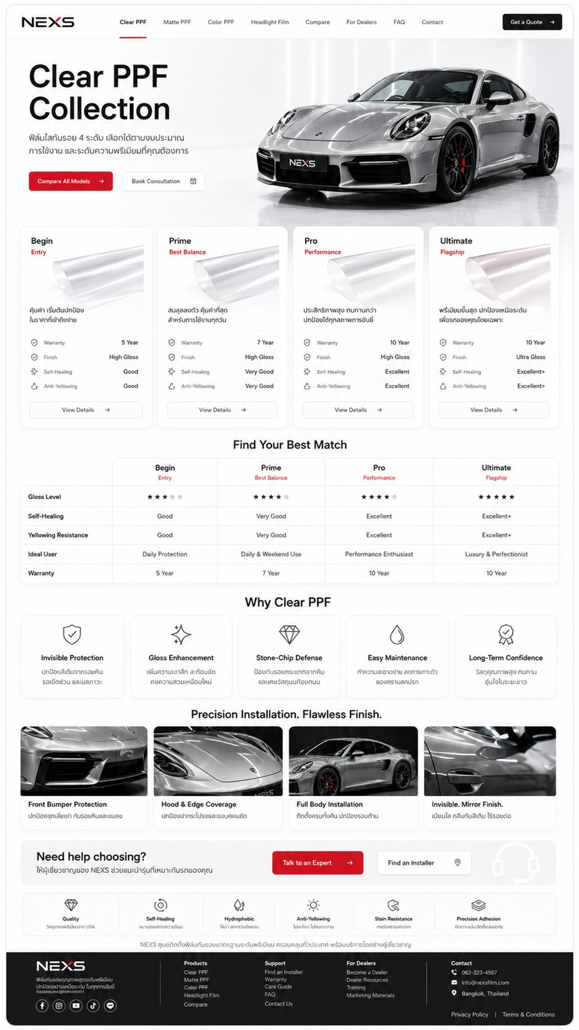  Clear PPF
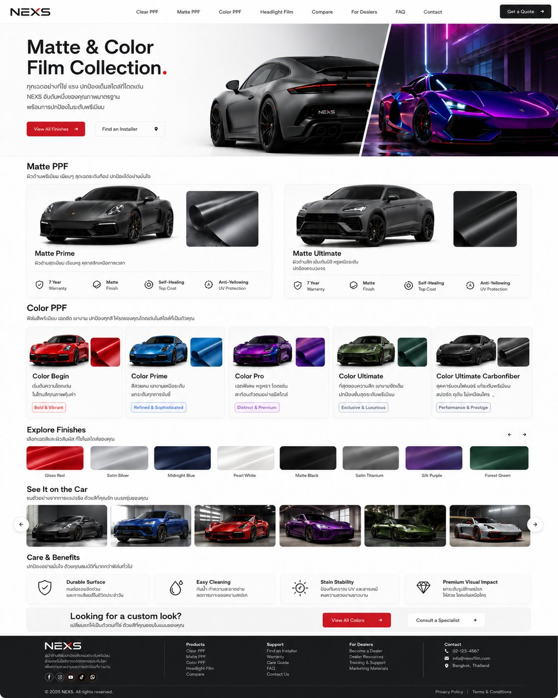  Matte & Color | 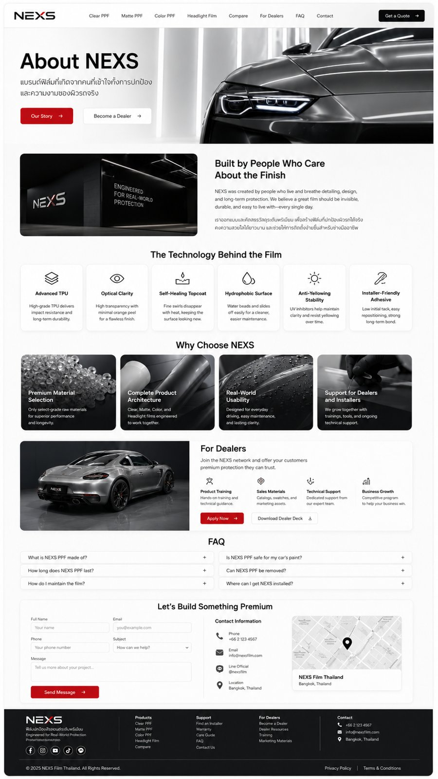  About NEXS

3. Global Image System
- Primary palette: white, warm light gray, silver, charcoal, black text, and NEXS red as a small accent only.
- Lighting: high-key studio lighting, clean reflections, soft vertical light bars, glossy white or light gray floor.
- Cars: use white, silver, gray, black, red, blue, green, purple, and carbon surfaces depending on product category. Avoid visible OEM logos or license plates unless legally cleared.
- Composition: generous negative space for typography. Hero images should leave clean space on the left for copy and place vehicle mass on the right.
- Detail language: macro shots of film layers, water beads, edges, mirror covers, hood lines, wheel/caliper accent, carbon texture.
- Avoid: cluttered garage backgrounds, heavy neon except Color PPF inspiration, over-dark homepage, cartoon/CG toy look, fake badges, unreadable text rendered into images.

4. Export Sizes and Ratios
Asset Type | Ratio | Recommended Size | Format | Usage
Hero desktop | 16:9 / wide crop | 2880 x 1500 or larger | WebP/JPG | Primary page hero images
Hero mobile | 4:5 or 3:4 | 1200 x 1600 | WebP/JPG | Create separate crop; do not rely only on desktop crop
Product card | 4:3 or 16:9 | 1200 x 800 | WebP/JPG | Clear / Matte / Color cards
Small gallery thumb | 16:9 | 800 x 450 | WebP/JPG | Finish gallery and carousel thumbnails
Technology render | 3:2 or transparent PNG | 1600 x 1000 | WebP/PNG | Layer stack and film cross-section
Icon set | 1:1 vector | SVG first, PNG fallback | SVG/PNG | Line icons; 1.5-2 px stroke; same family
Swatch | 1:1 or 4:3 | 800 x 600 | WebP/JPG | Color and carbon swatches

5. Production Source Strategy
Source | Use For | Rule
AI / 3D Render | Hero cars, product category cards, layer-stack technology, film rolls, controlled macro shots. | Fast, consistent, clean. Must be reviewed for realism and no fake text/logos.
Real Photography | Installer work, dealer showroom, finished customer cars, sample books, training. | Use wherever trust matters. Best for dealer and installer credibility.
Stock Placeholder | Temporary map, abstract backgrounds, generic studio textures. | Only if license is clear. Replace important brand images with custom assets later.
Vector / SVG | Icons, process diagrams, line illustrations, UI badges. | Keep consistent stroke weight and rounded geometry.

6. Product Category Direction
Category | Visual Idea | Asset Notes
Clear PPF | Invisible clarity, white/silver car, water beads, high gloss, close edge coverage. | White/silver car, transparent film roll, bright studio reflections.
Matte PPF | Satin matte finish, smooth low-gloss surfaces, premium gray/black bodywork. | Gray/silver performance car, diffused light, matte roll texture.
Color PPF | Premium color depth and style; more expressive but still clean. | Red, blue, green, purple and carbon variants; use vivid color only inside product cards or gallery.
Ultimate Carbon Fiber | Performance/prestige texture, carbon close-up, dark surface with controlled highlights. | Black carbon texture, diagonal weave, no messy pattern, no fake brand marks.
Technology | Layered film architecture, precision engineering, invisible work. | Floating translucent layers, subtle arrows, no clutter.
Dealer/Installer | Trust, professional workflow, premium shop environment. | Clean studio/workshop, technician hands, NEXS uniform optional, no messy tools in foreground.

7. P0 Asset Shortlist
These assets are required before the first Figma/dev build. Full list is in the Image Asset Tracker workbook.
Asset ID | Asset | Direction
HOME-001 | Homepage hero car | White/silver premium sports car in Apple-style studio, red accent details.
HOME-006/007/008 | Film system category cards | Clear, Matte, Color category images matched to homepage cards.
HOME-012 | Advanced film technology layer stack | Transparent film layers, premium engineering visual.
CLR-001 to CLR-005 | Clear PPF hero and four product roll renders | Begin / Prime / Pro / Ultimate.
MAT-001 to MAT-003 | Matte product cards | Matte Prime / Matte Pro / Matte Ultimate mockup aligned with Clear tier logic.
COL-001 to COL-005 | Color product cards | Color Begin / Prime / Pro / Ultimate / Ultimate Carbon Fiber.
ABT-001/002 | About hero and NEXS studio/signage | Brand trust and standard story.
DLR-001/006 | Dealer showroom + installer working photo | Build trust with professional shops.

8. AI Render Prompt Library
Use prompt templates as a starting point. Generated images must be retouched and checked. Do not keep fake text, malformed logos, distorted wheels, incorrect reflections, or visible OEM marks.
Template | Prompt
Master homepage hero | Premium automotive website hero image, high-key white studio, silver performance sports car, clean glossy floor, soft vertical light bars, elegant reflections, minimal red accent details, car positioned to the right, empty space on left for typography, Apple-style minimalism, ultra realistic, no text, no visible brand logo, no license plate.
Clear PPF macro | Transparent paint protection film on glossy silver hood, invisible edge coverage, water beads, clean bright studio lighting, premium product photography, shallow depth of field, no text, no logos.
Matte PPF product | Matte satin gray performance car in white studio, soft diffused reflections, smooth premium low-gloss surface, close-up film roll texture, minimal background, no text, no brand logo.
Color PPF product | Premium color paint protection film on sports car, rich deep color, red/blue/green/purple variant, glossy controlled reflections, white studio or clean modern garage, no text, no brand logo.
Carbon Fiber | Close-up of premium carbon fiber film on automotive panel, realistic weave, dark black graphite surface, soft highlights, high-end performance mood, no text, no logo.
Technology layer stack | Floating multilayer transparent automotive film structure, TPU layer, adhesive layer, release liner, clean white background, premium technical render, subtle shadows, no text labels.
Installer/dealer photo | Professional installer applying paint protection film in clean premium white workshop, organized tools, silver car, realistic hands, no visible face required, no clutter, no brand logos except approved NEXS signage.

9. Asset QA Checklist
- No public prices or price hints appear in any image, graphic, table, or callout.
- No supplier/factory names, cost data, internal spec notes, or RMB/dealer pricing appear in public assets.
- All assets follow the white/silver premium design; black is used only as accent/contrast/footer/carbon detail.
- Images have enough negative space for responsive cropping and text overlay.
- No visible OEM marks, plate numbers, fake text, unreadable badges, distorted car geometry, or malformed wheels.
- Every asset has desktop and mobile crop plan before dev handoff.
- Every image has alt text in the tracker before upload.
- Final exports should use WebP for website; keep original PSD/AI/PNG/JPG masters separately.

10. Next Step After This Brief
Use the companion workbook “NEXS Image Asset Tracker v3.0” as the production control sheet. Assign owner, due date, and status for each asset. Once P0 assets are approved, move to Figma production and responsive design.

