**Report**

**Stock Sentiment Analysis**

**Parshiv Kapoor**

**Enrollment No.-23124022**

**Introduction**

* **Project Overview**-The project aims to develop a sentiment analysis model to predict the movement of stock prices based on textual data from news articles. By analyzing the sentiment expressed in these texts, the model will seek to uncover insights into investor sentiment and market sentiment, which can be valuable indicators for making informed trading decisions.

**Flow Of Project:**

1. **Data Collection**

* Collection of textual news headlines of different companies through Web Scraping.
* Collection of historical data.
* Resources Used-Market Insider,Beautiful Soup for web scraping,yfinance for historical data.
* Companies used-Tesla,Apple.

2. **Data Labeling**

* Labeling the collected data with respect to the stock movement that day(1 if it goes up 0 if it goes down)

3. **Text Cleaning And Preprocessing**

* Using different text cleaning processes like removing stopwords,lemmatization,stemming etc.
* VaderSentiment to tag the sentence with their corresponding sentiment scores.

4. **Model Development**

* For my model i used one of the most efficient machine learning algorithm LinearDiscriminantAnalysis(LDA)
* About the algorithm-Linear Discriminant Analysis (LDA) is a technique used in statistics, pattern recognition, and machine learning to find a linear combination of features that best separates two or more classes of objects or events.

5. **Training and Testing**

* For training I used the data from around 2014 to 2020 of both the companies i.e TESLA and APPLE.
* For testing I used the data from 2020 to 2024 of both the companies.
* For training i used both the companies together and for testing i tested on them separately to get individual performance of the model

6. **Evaluation Of Model**

* Metrics like accuracy score,precision,recall,F1 score and roc curve analysis to assess the performance of both the companies individually.

**Metrics For Apple**

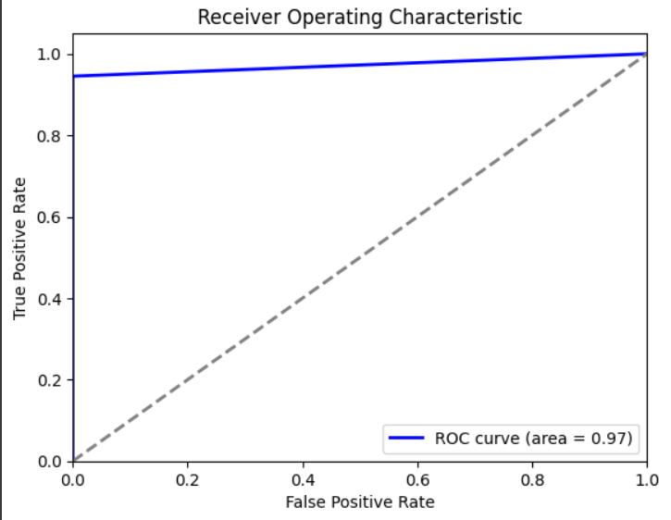

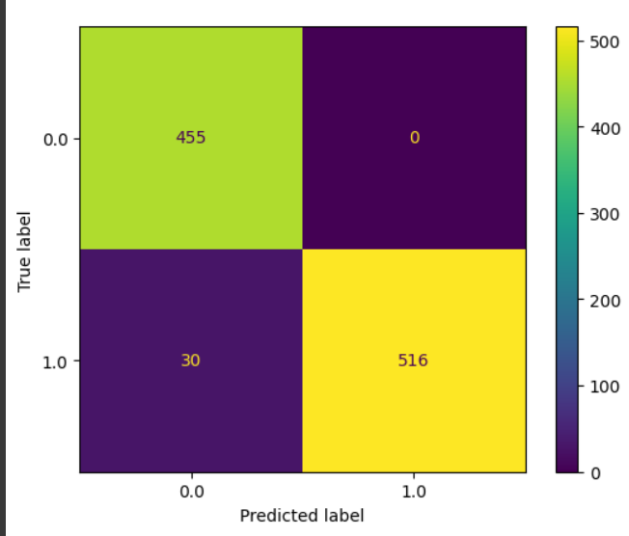

**Metrics For Tesla**

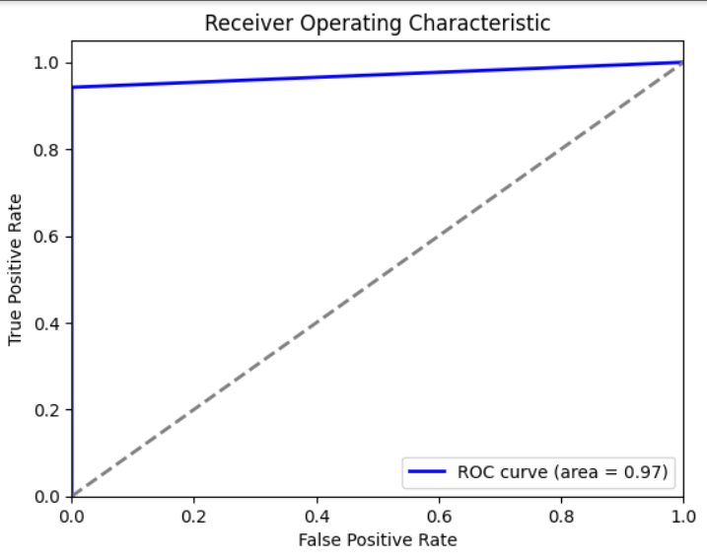

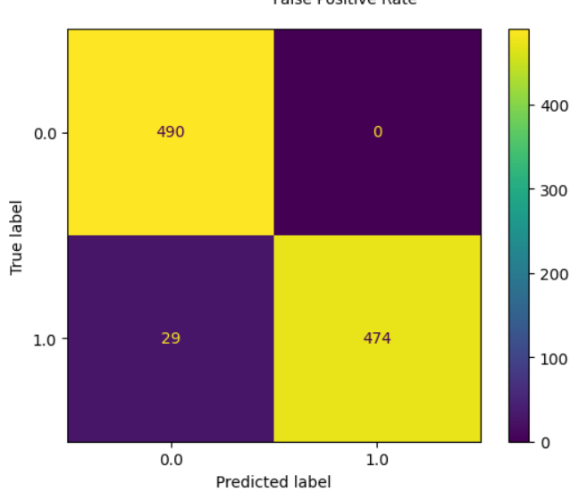

**Trading Strategy Explanation**

1. **Overview**

* The trading strategy implemented in the code is a simple buy-and-hold strategy with specific conditions for buying and selling stocks based on predictions and certain risk management rules. The goal is to buy stocks when a prediction signal indicates a potential price increase and sell them when a prediction signal indicates a potential price decrease or when predefined stop-loss or take-profit conditions are met. The performance of this strategy is evaluated using several key metrics, including the Sharpe ratio, maximum drawdowns, number of trades executed, and win ratio.

1. **Initial Steps**

* **Initial Capital**: The strategy starts with an initial capital of $10,000.
* **Stop-Loss and Take-Profit**: The stop-loss is set at 5% below the purchase price, and the take-profit is set at 10% above the purchase price.
* **Position Size**: Each trade involves buying 100 shares of the stock.

1. **Trading Logic**

* **Buy Condition**: The strategy buys stocks when the prediction signal is 1 (indicating a buy signal) and there is enough cash to purchase the stocks.
* **Sell Condition**: The strategy sells stocks when the prediction signal is 0 (indicating a sell signal) and there is an open position.
* **Stop-Loss and Take-Profit**: If the stock price falls below the stop-loss threshold or rises above the take-profit threshold, the strategy sells the stocks.

1. **Performance Metrics**

* **Number of Trades Executed**: The total number of buy/sell transactions.
* **Win Ratio**: The proportion of profitable trades out of the total trades executed.
* **Sharpe Ratio**: A measure of risk-adjusted return.
* **Maximum Drawdown**: The largest peak-to-trough decline in the value of the portfolio.

**For Apple**

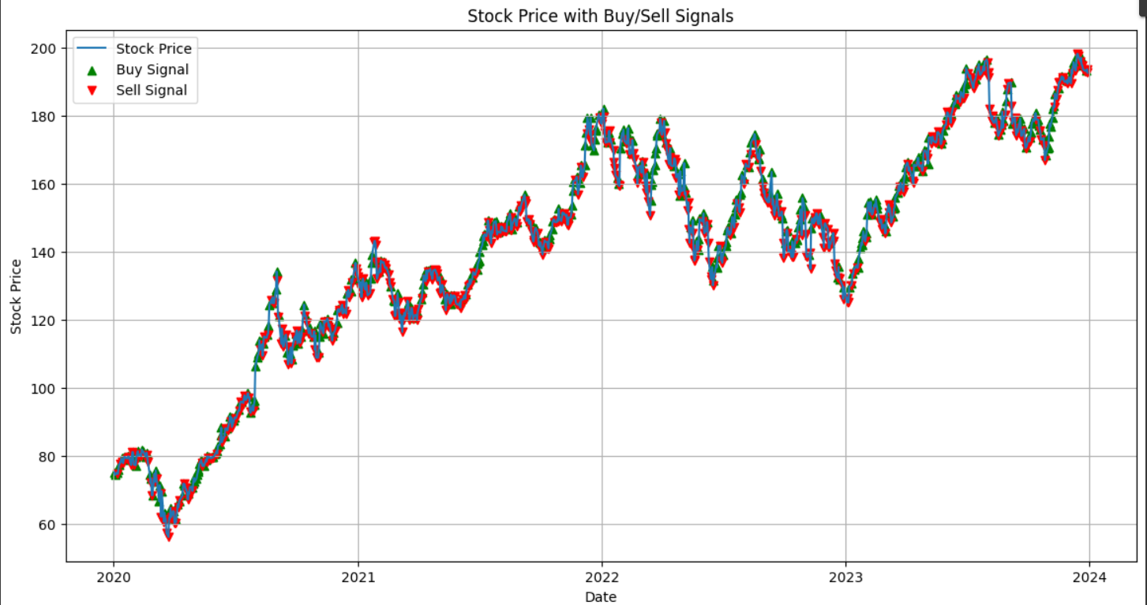

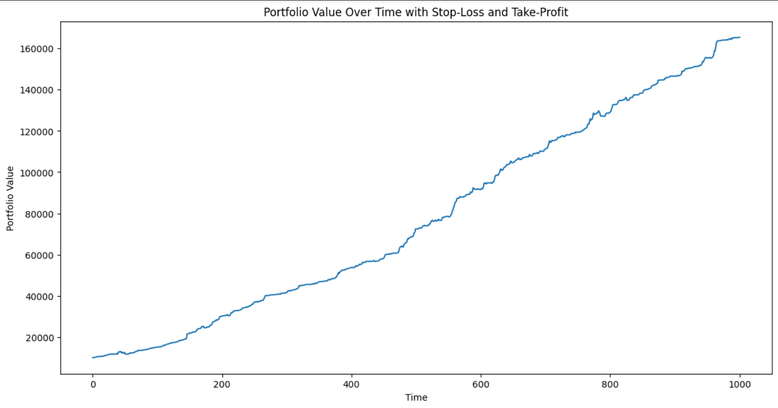

**Initial Capital:** 10,000

**Final Capital:** 165,400

**Total Return:** 1,537.18%

**Sharpe Ratio:** 5.92

**Maximum Drawdown:** -9.59%

**Total Trades:**1034

**Win Ratio:**0.81

**For Tesla**

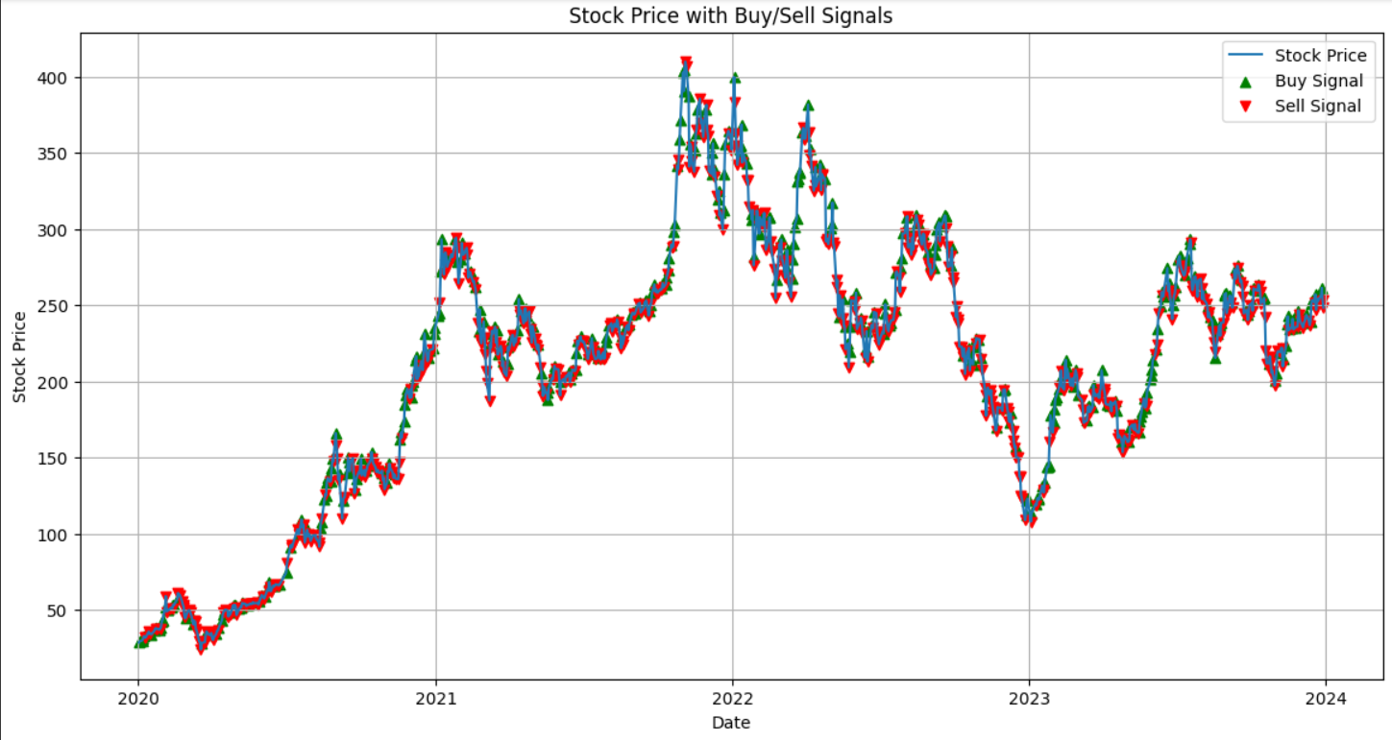

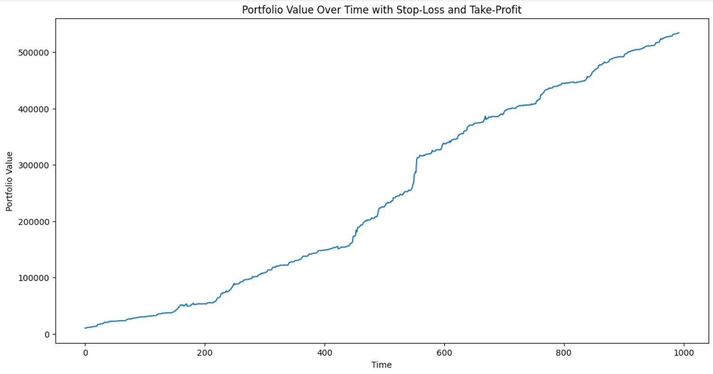

**Initial Capital:** 10,000

**Final Capital:** 534,122

**Total Return:** 52,20.79%

**Sharpe Ratio:** 5.54

**Maximum Drawdown:** -7.25%

**Total Trades:**994

**Win:**0.86