CSCI 5408

DATA MANAGEMENT AND WAREHOUSING

DDB Builder Sprint-1 Report

**Group Members:**

| Chinmaya Garg | ch745692@dal.ca |
| --- | --- |
| Abhishek Kapoor | ab210637@dal.ca |
| Shivangkumar Kalpeshkumar Patel | sh587705@dal.ca |
| Nikulkumar Popatbhai Kukadiya | nk865270@dal.ca |
| Axata Darji | ax583820@dal.ca |

**GitLab Link:** [**https://git.cs.dal.ca/abhishekk/csci5408_w24_ddb-builder-group-8**](https://git.cs.dal.ca/abhishekk/csci5408_w24_ddb-builder-group-8)

## Table of Contents

Background Research...................................................................................................................3

Table: Information Collected……………………………………………………………………………..5

Initial Conceptual Model..............................................................................................................10

Database Design Issues Report..................................................................................................12

Final Model (ERD).......................................................................................................................16

Meeting Logs - Sprint 1…………………………………………………………………………………17

References….……………………………………………………………………………………………18

## 

## Background Research

**Topic**: The “Canadian Health Care System”

**Primary Reference:**

* Canada Health Care Website - <https://www.canada.ca/en/health-canada/services/canada-health-care-system.html>

**Summarization of the database design logic**

* To begin designing the hospital database. We referred to many different flows and functionalities of different healthcare service providers. To begin with, we first analyzed the patient appointment flow. We referred to **Clayton Park Medical Clinic** [1] which offers a walk-in service**.**
* From there we got the functional flow such as the **patient** requested an appointment and then the front desk staff made him **check in** to the clinic if the patient did not have any prior appointment booked then the front desk staff also marked them as a walk-in appointment.
* Apart from this type of appointment, there are two more types of appointment patients can request one is for a **flu-shots** (Vaccination) appointment and one for **Tele Visit.**
  + By exploring more regarding Tele visit appointments on **Viva Care** [2] we got to know that for such appointments patient and provider both need to connect over a video call and then both can discuss the health problem.
  + By exploring TeleVisits more we found that the provider takes **notes** and patients are also able to provide **feedback** for consultation.
  + There are separate applications that provide the secured end-to-end encrypted Tele Visit.
* For patient **flu shot** appointments, we explored **Nova Scotia Health** [3][4] and **CMPA** [5] which gives hints regarding the flu shots or vaccinations working as separate appointments then the normal consultations.
  + Patients can book shots and they can get those shots directly from the clinic as per their appointment time.
* To explore patients more we explored **MD Anderson** [6], the **National Library of Medicine** [7]**,** and **Dietitians of Canada** [8] as well as **Science Direct** [9]. Which gives patients **dietary preferences** information as well as **patient allergies** and different **demographic** information such as **race**, **ethnicity,** and so on.
* For all types of appointments, there are few **consent forms** We researched the patient consent forms on the **HIPAA, MD Anderson** and **Langortho** [10], which states that for all kinds of appointment, the patient should provide the concern to the health care provider with few terms and conditions as well as the privacy information of the **diagnosis**.
* During the check-in process, front-desk staff also verifies the patient’s insurance policies and plan details. During the exploration of the **insurance**, we found the **insurance companies** and **insurance plan** details and how they are linked with the patient’s medical and hospital **billing.** All the appointments have some amount of charge which is either payable by the insurance or the patient itself.
* Apart from this Hospital staff also collects information regarding the **patient’s vitals**. **CMPA** provides us with more details regarding the Different services provided to patients via health care providers such as different **lab tests**. All lab tests are linked to the **patient's health records** for further assistance or observation in the future.
* During all the appointments the provider continuously takes notes of the issues and at the end of the diagnosis the provider prescribes the drugs.
* **Drugs** cannot be directly given by the provider, but the provider gives a **prescription** later with all the drug information and the **pharmacy** details from where the patient can collect the drugs. As per **Viva Care** or **Shoppers Drug Mart,** some pharmacies also provide **drug delivery** to patient’s addresses.
* As per the **Government of Nova Scotia** [11], Patients also request a previously prescribed drug from the provider whenever they want. Then the provider approves that **drug request** and the patient can collect drugs from the pharmacy.
* As per the diagnosis provider also schedules a **follow-up appointment** with the patient and that appointment also links with the previous appointment.
* From the given sources we collected most of the entities and the attributes of the database. We are not able to cover all the entities of the hospital management as the health care system contains many roles and flows. So, we only took a small portion of it.

## 

## Table: Information Collected

| **Name of the Source** | **URL** | **Entities covered** | **Information Collected** |
| --- | --- | --- | --- |
| MD Anderson | <https://my.mdanderson.org/RequestAppointment> | Signed Forms, Patient Consent | Information was gathered about patient appointments, including the requirement for signed forms and patient consent. The process involves completing necessary documentation, potentially containing personal and medical information, when requesting appointments at MD Anderson. |
| Md Anderson | <https://www.mdanderson.org/patients-family/becoming-our-patient/planning-for-care/returning-patients.html> | Follow up appointment | Information related to planning for care for returning patients at MD Anderson was found. The emphasis is on the significance of follow-up appointments in the context of ongoing medical care. |
| Lang Ortho | <https://langortho.com/wp-content/uploads/2016/11/HIPAA-consent.pdf> | Consent Form | A HIPAA consent form from Langortho was retrieved, indicating the necessity for patients to provide consent for the use and disclosure of their protected health information. |
| National Library of medicine | <https://www.ncbi.nlm.nih.gov/pmc/articles/PMC7704710/> | Patient Allergies, Allergies | Information was obtained from an article discussing patient allergies. It likely covers various aspects of allergies, providing insights into types and their impact on patients' health. |
| Mayo Clinic | <https://www.mayoclinic.org/diseases-conditions/allergies/symptoms-causes/syc-20351497> | Allergies | Mayo Clinic's page on allergies was explored, obtaining extensive information on symptoms, causes, and treatments. The content offers valuable insights into understanding allergies for patients. |
| Stanford healthcare | <https://stanfordhealthcare.org/for-patients-visitors/health-insurance-plans.html> | Insurance Plan | The data retrieved provides details about health insurance plans offered by Stanford Healthcare, including information on coverage options and eligibility criteria. |
| Special benefits insurance services | <https://sbis.ca/nova-scotia-health-insurance.html> | Insurance Company | The information gathered indicates that Special Benefits Insurance Services provides details on health insurance in Nova Scotia, likely covering information on insurance plans and coverage. |
| Md Anderson | <https://faculty.mdanderson.org/> | HealthCare Provider, Provider-Specialization Specialization | The link appears to lead to information about healthcare providers and their specializations within MD Anderson, suggesting insights into the institution's faculty. |
| Md Anderson | <https://my.mdanderson.org/RequestAppointment> | Insurance Plan | Information retrieved from this link is related to insurance plans, possibly providing details for patients requesting appointments at MD Anderson. |
| CMPA | <https://www.cmpa-acpm.ca/en/education-events/good-practices/physician-patient/documentation-and-record-keeping> | Vitals, Lab tests, Prescription, Schedule of shots | The CMPA link offers insights into good practices for documentation and record-keeping in physician-patient interactions. It covers vital signs, lab tests, prescriptions, and vaccination schedules. |
| CMPA | <https://www.cmpa-acpm.ca/en/education-events/good-practices/physician-patient/documentation-and-record-keeping> | Schedule of shots, Vaccinations, vaccination enrollment | Information was gathered regarding good practices for documentation and record-keeping in physician-patient interactions. The link covers details related to the schedule of shots, vaccinations, and vaccination enrollment. |
| Testing | <https://www.testing.com/tests/> | Lab tests, lab test results | Information is obtained from the link providing details on various lab tests and their results. It serves as a resource for understanding different testing procedures. |
| Medline Plus | <https://medlineplus.gov/druginformation.html> | Allergies | Information from this link pertains to drug information, including prescriptions. It serves as a resource for understanding different medications. |
| Government of Nova Scotia | <https://novascotia.ca/dhw/pharmacare/documents/forms/Standard-Exception-Status-Drug-Request-Form.pdf> | Drug request | The link directs to a Standard Exception Status Drug Request Form from the Government of Nova Scotia, outlining the process for requesting specific drugs. |
| Government of Nova Scotia | <https://novascotia.ca/dhw/pharmacare/documents/Criteria-for-Exception-Status-Coverage.pdf> | Drug request | The document outlines criteria for exception status coverage for drug requests in Nova Scotia, providing insights into the process and eligibility. |
| Medline Plus | <https://medlineplus.gov/druginfo/herb_All.html> | Drug | The link provides information on herbal drugs, serving as a resource for understanding various herbal supplements. |
| John hopkins | <https://www.hopkinsmedicine.org/health/conditions-and-diseases/vital-signs-body-temperature-pulse-rate-respiration-rate-blood-pressure> | Vitals | Information from John Hopkins covers vital signs, providing details on body temperature, pulse rate, respiration rate, and blood pressure. |
| CMS | <https://www.cms.gov/medicare/coding-billing/electronic-billing> | Transaction, Insurance Billing | The link provides information on electronic billing in Medicare, covering transactions and insurance billing procedures. |
| Nova Scotia Health | <https://novascotia.flow.canimmunize.ca/en/covid-flu-booking> | FluShots Appointment | The link leads to a platform for booking flu shots appointments in Nova Scotia, offering a convenient way for individuals to schedule vaccinations. |
| Dietitians of Canada | <https://dcjournal.ca/doi/abs/10.3148/cjdpr-2018-002> | Dietary Preferences | The link provides information on dietary preferences, possibly related to a journal article discussing dietetic practices. |
| Science direct | <https://www.sciencedirect.com/science/article/abs/pii/S0261561402002054> | Dietary Preferences | The ScienceDirect link may contain information on dietary preferences, possibly related to a scientific article providing insights into dietetic practices. |
| Viva care | <https://vivacare.ca/locations/delta-bc/> | Televisit Appointment | The link provides information on locations offering televisit appointments at Viva Care, indicating a convenient way for patients to access healthcare services. |
| Viva care | <https://vivacare.ca/services/> | Pharmacy, drug delivery | The link appears to lead to Viva Care's services, suggesting it may contain information on various healthcare services offered by the organization. |
| Clynton Park Medical Clinic | <https://ns.skipthewaitingroom.com/walk-in-clinic/halifax/clayton-park-medical-clinic/clayton-park-medical-clinic> | Walkin Appointment | The link provides information on accessing walk-in appointments at Clayton Park Medical Clinic, offering a convenient option for immediate healthcare needs. |

## Initial Conceptual Model

**Team’s Approach to building the Initial Conceptual Model**:

1. We started the process with an individual approach to the project.
2. All of the team members collected a list of Entities that they thought were suitable for the ERD, their internal relationship. Everyone came up with their own version of ERD for the project.
3. The team then brainstormed on the group’s ERD Entities where each one of us advised based on our own ERD Entity Set.
4. After the Entity set was finalized, the team listed what relationship can be there in each entity and we created the initial ERD. It is called **Conceptual-Diagram-with-Traps.**
5. The team researched more about the Connection traps (Fan and Chasm traps) to be on the same knowledge level.
6. We then divided the team in two parts to search for Fan and Chasm traps in the ERD. W
   1. We successfully found two instances of Fan Traps and no instance of Chasm trap.
7. After finding the Traps in the ERD, we again brainstormed for the solutions of the trap situations. Hence we created the second attempt of the ERD. It is called **Conceptual-Diagram-Traps-Resolved.**
8. Now, we had an ERD with no traps and it covered the main idea that we wanted to present.
9. The team then brainstormed a set of valid attributes that could be set to the entities and we created the final ERD called “**Conceptual-Diagram-Traps-Resolved-Attributes-Added”**

**Note:** All the ERDs are uploaded in the Brightspace zip folder, and also uploaded on Group’s Gitlab Repository: [**https://git.cs.dal.ca/abhishekk/csci5408_w24_ddb-builder-group-8**](https://git.cs.dal.ca/abhishekk/csci5408_w24_ddb-builder-group-8)

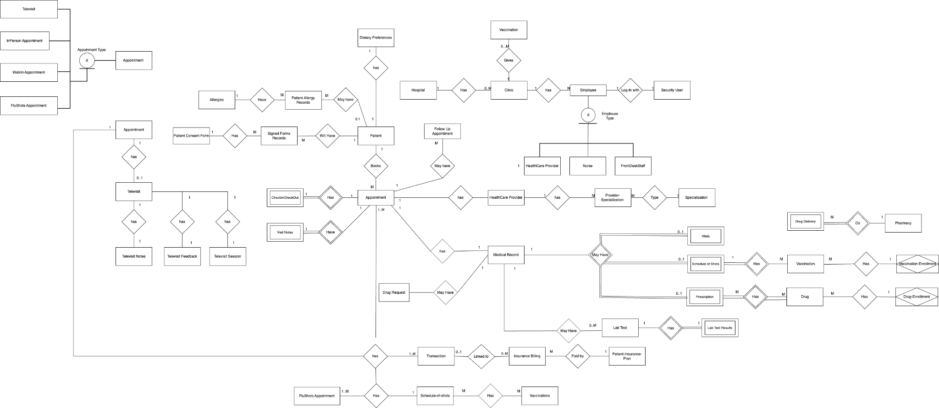

Fig 1: Conceptual Diagram with Traps [15]

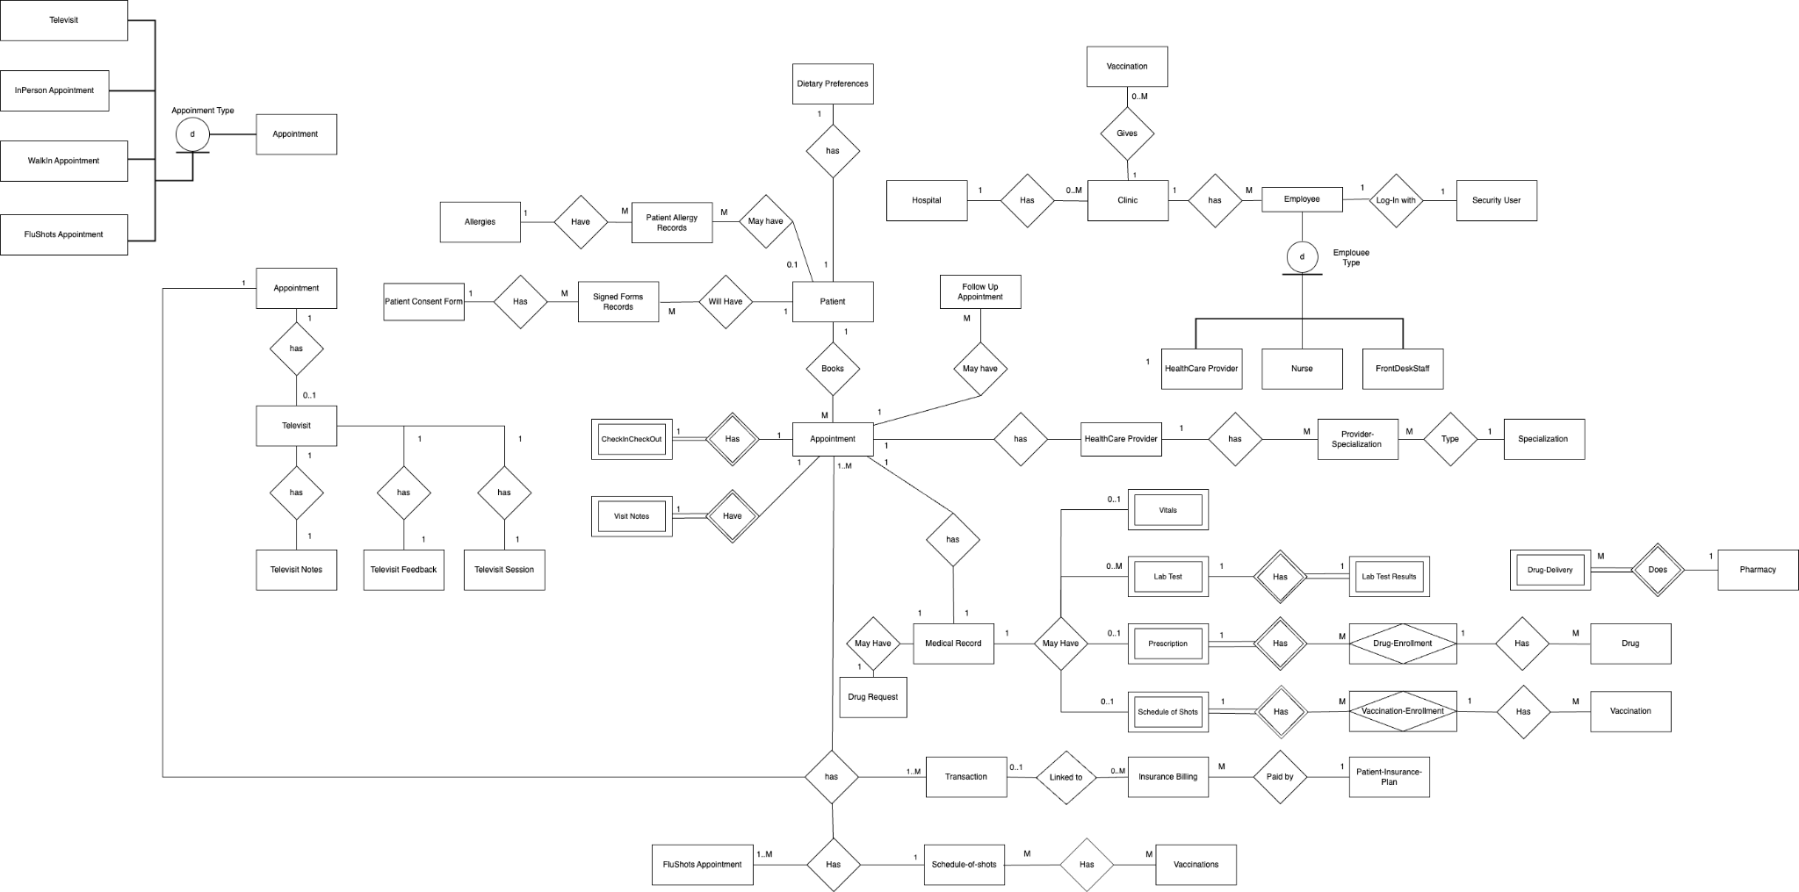

Fig 2: Conceptual Diagram Traps Resolved [16]

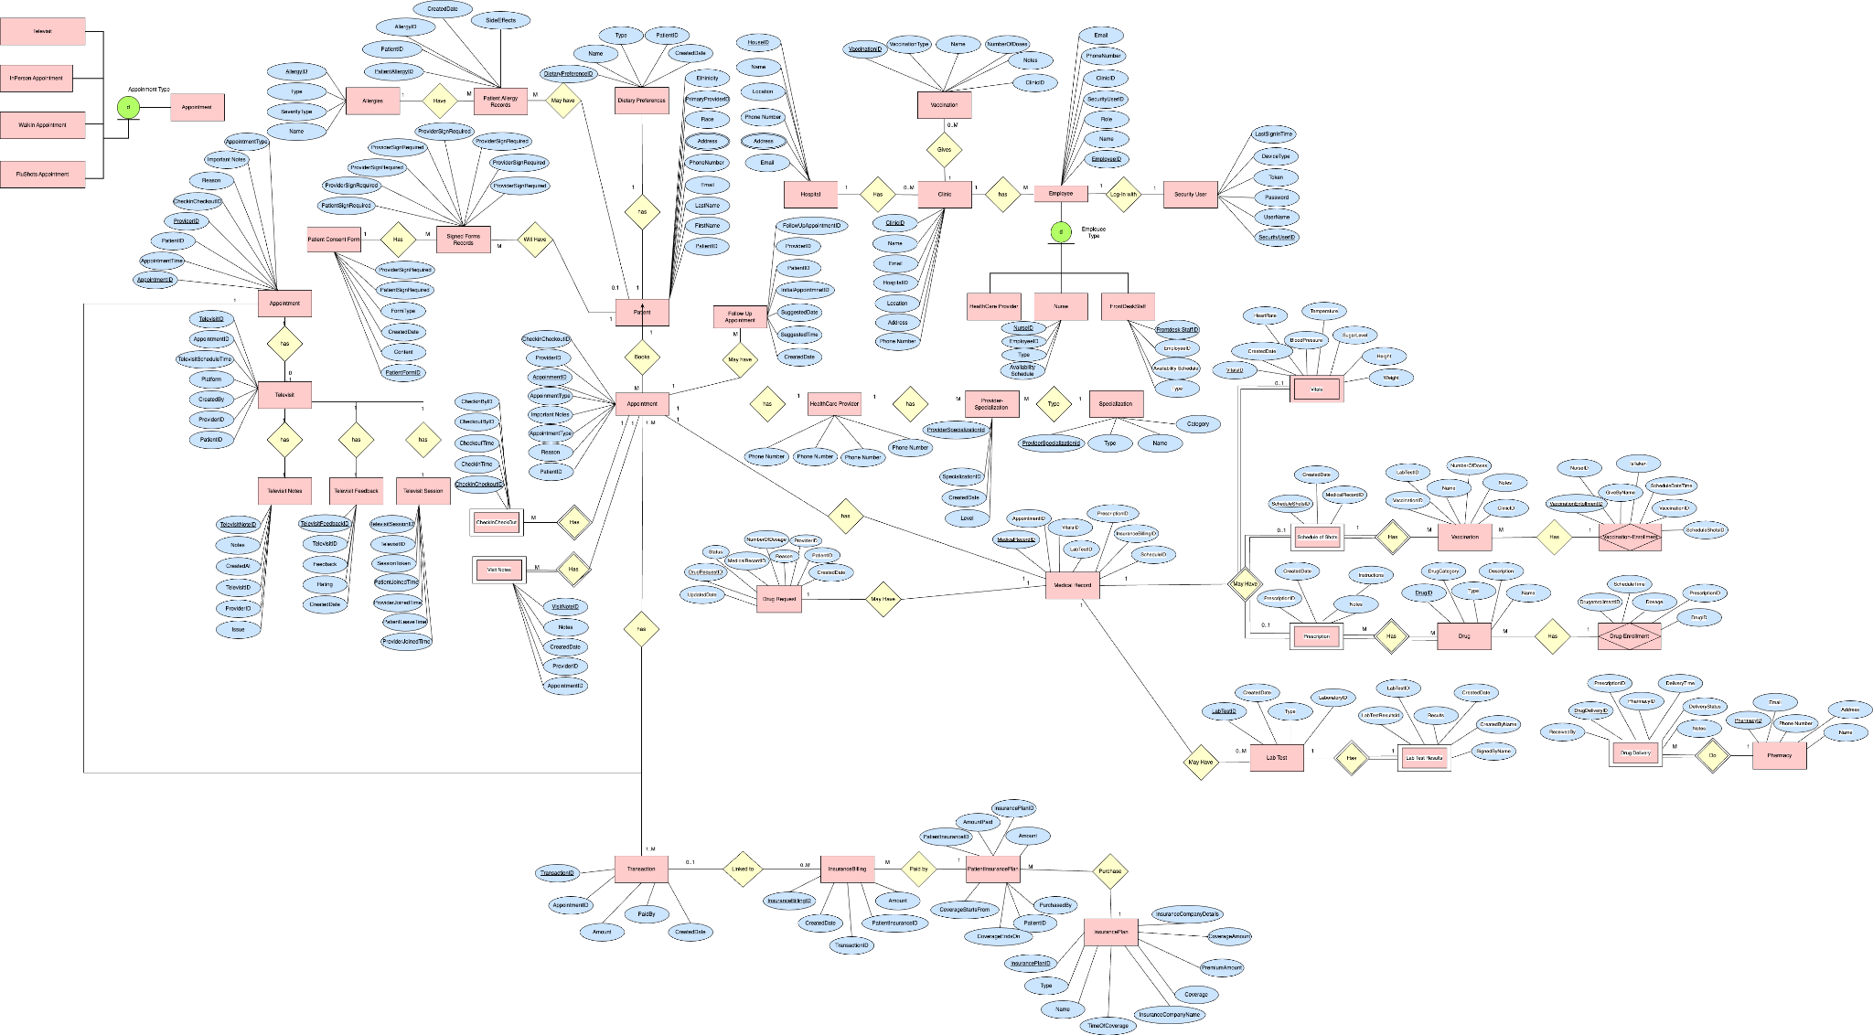

Fig 3: Conceptual DiagramTraps Resolved and Attributes added [17]

## 

## 

## 

## Database Design Issues Report

### Introduction

We can encounter Database schema design challenges that can lead to inconsistencies in query and inaccurate results. Two common issues are Chasm Traps and Fan Traps. This project report discusses the concepts of both traps, how they occur, if we faced these challenges in our project and strategies to handle them in a database schema.

### Fan Trap

#### Definition and Occurrence

* A fan trap occurs when a data model represents a relationship between entity types, but the pathway between certain entity occurrences becomes ambiguous [12].
* This ambiguity arises when multiple paths exist between entities, leading to potential over-counting of records.

#### Example

* In the provided example, a fan trap is demonstrated in the data model involving branches, salespeople, and customers.
* The model fails to specify which salesperson is responsible for which customer within a branch, creating ambiguity. Joining the tables in this scenario increases the number of records, resulting in incorrect aggregations.

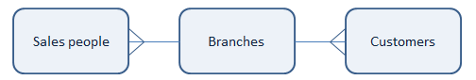

Fig 4: Example situation to understand Fan Trap [2]

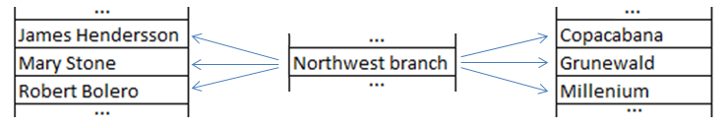

Fig 5: Fan trap situation explained using dummy data [13]

#### Handling Fan Traps

* It can be handled by refining the data model by incorporating additional information about assignments between customers and salespeople to enhance clarity.

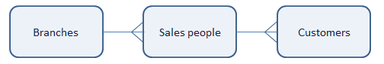

Fig 6: Fan trap situation resolved by rearranging the entities

We can take these additional steps to handle Fan traps in our data model [12]

* Handle ambiguity resulting from multiple paths between entity occurrences.
* Incorporate additional information or restructure relationships within the schema to enhance clarity and understanding.
* Avoid over-counting in aggregations by carefully designing and adjusting the schema to manage fan traps effectively.
* Ensure reliable data analysis by implementing strategies that align with the specific challenges posed by fan traps in the database

#### Fan Trap in Database Builder Project

We encountered the Fan Trap condition at two instances in our project as shown in Fig 4.

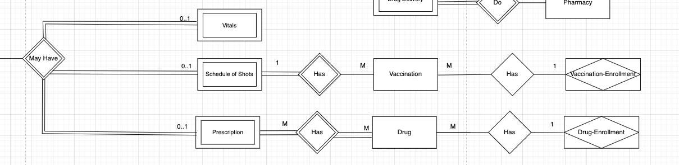

Fig 7: Database Builder Project Fan Trap Snapshot

The issue was created because the center entity has multiple 1:M connections towards it. The pathway between the left entity (Schedule of Shots and Prescription) and right entity (Vaccination Enrollment and Drug Enrollment) has become ambiguous.

Resolving the Issue involves re-arranging the entity diagram such that a single entity having 1:M relations is replaced by two entities with two different 1:M relationships.

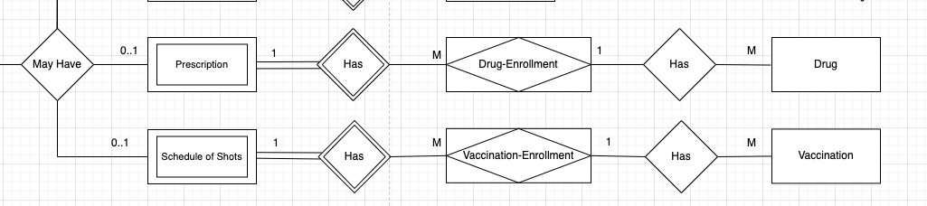Fig 8: Database Builder Project Fan Trap Resolved

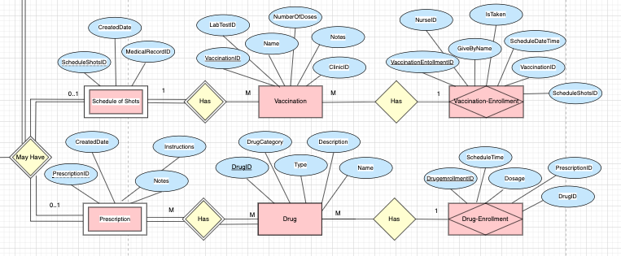

Fig 9: Database Builder Project Fan Trap Resolved

## Chasm Trap

#### Definition and Occurrence

A chasm trap occurs when a data model **suggests** a relationship between entity types, but a **pathway** between certain entity occurrences **does not exist**. This often happens when navigating a complex schema, and missing data in the middle table breaks the link between entities. [14]

#### Example

In the provided example, a chasm trap is illustrated in the data model involving the relationship between branches, salespeople, and customers. The model suggests a connection between branches and customers through salespeople. However, if a customer is unassigned to a salesperson, the link between the customer and the branch is broken, resulting in a chasm trap.

### 

#### Handling Chasm Traps

Chasm traps can be addressed by adding dummy records to the intermediary table (Salespeople in this case). These dummy records, labeled 'No salesperson,' act as placeholders, maintaining the link between entities even when certain occurrences lack direct relationships. This method ensures the functionality of the data model.

#### Chasm Trap in Database Builder Project

We did not encounter any Chasm trap in the Database builder project. We tried to avoid chasm traps by following these steps:

* Map relationships between entities directly where possible, avoiding unnecessary intermediary tables to avoid the chasm trap.
* We organized the data into separate tables based on their attributes, avoiding situations where relationships between tables become ambiguous due to redundant or overlapping information.

## 

### Conclusion: Traps

Chasm traps and fan traps are common challenges in database schema design that can impact the accuracy of queries and analytics. Understanding their definitions, occurrences, and employing appropriate strategies for handling them is crucial for maintaining the integrity of the data model. Addressing these traps at the design level ensures more accurate and efficient data analysis.

## 

## 

## Final Model (ERD)



Fig 10: Conceptual DiagramTraps Resolved and Attributes added [17]

## 

## 

## Meeting Logs - Sprint 1

| **MeetingDate** | **Meeting Time (Start)** | **Meeting Time (End)** | **Meeting Place** | **Sprint** | **Outcomes** | **Duration** | **Attendees** |
| --- | --- | --- | --- | --- | --- | --- | --- |
| 2/11/2024 | 11:00 AM | 1:00 PM | online | Sprint 1 | Individual Research and ERD Assigned | 2 hours | All present |
| 2/14/2024 | 5:00 PM | 7:00 PM | In-person | Sprint 1 | ERD Discussion | 2 hours | All present |
| 2/16/2024 | 1:00 PM | 3:00 PM | online | Sprint 1 | ERD Finalized | 2 hours | All present |
| 2/19/2024 | 9:00 AM | 11:00 PM | online | Sprint 1 | ERD Traps Discovery | 2 hours | All present |
| 2/20/2024 | 10:30 AM | 12:30 PM | In-person | Sprint 1 | ERD Traps resolution | 2 hours | All present |
| 2/21/2024 | 9:00 AM | 10:00 AM | online | Sprint 1 | ERD Attributes Addition | 1 hour | All present |
| 2/21/2024 | 10:30 AM | 12:30 PM | online | Sprint 1 | ERD Attributes Addition | 2 hours | All present |
| 2/27/2024 | 9:30 AM | 10:30 AM | online | Sprint 1 | Submission Report Finalize | 1 hour | All present |

## 

## References

1. Clayton Park Medical Clinic, "Skip the Waiting Room - Clayton Park Medical Clinic," Skip the Waiting Room, Available: <https://ns.skipthewaitingroom.com/walk-in-clinic/halifax/clayton-park-medical-clinic/clayton-park-medical-clinic>, Accessed: February 27, 2024
2. Viva Care, "Telehealth & Online Doctor Services," Viva Care, Available: <https://vivacare.ca/telehealth-online-doctor/>, Accessed: February 27, 2024
3. Nova Scotia, "Flu," Nova Scotia Government, Available: <https://novascotia.ca/flu/>, Accessed: February 27, 2024
4. Nova Scotia, "COVID-19 and Flu Booking," Nova Scotia Immunization, Available: <https://novascotia.flow.canimmunize.ca/en/covid-flu-booking>, Accessed: February 27, 2024.
5. CPMA, "About Us," Canadian Medical Protective Association, Available: <https://www.cmpa-acpm.ca/en/about>, Accessed: February 27, 2024.
6. MD Anderson Cancer Center, "Care Centers & Clinics," MD Anderson Clinic and Family Care, Available: <https://www.mdanderson.org/patients-family/diagnosis-treatment/care-centers-clinics.html>, Accessed: February 27, 2024.
7. National Library of Medicine, "PubMed Central," Available: <https://pubmed.ncbi.nlm.nih.gov/>, Accessed: February 27, 2024
8. Dietitians of Canada, "Resource Library," Available: <https://www.dietitians.ca/Advocacy/Toolkits-and-Resources>, Accessed: February 27, 2024
9. ScienceDirect, "Journal of Advanced Research," Available: <https://www.sciencedirect.com/journal/journal-of-advanced-research>, Accessed: February 27, 2024.
10. Lang Ortho, "What to Expect at Your First Visit," Available: <https://langortho.com/what-to-expect-at-your-first-visit/>, Accessed: February 27, 2024.
11. Government of Nova Scotia, "Programs and Services," Available: <https://beta.novascotia.ca/programs-and-services>, Accessed: February 27, 2024.
12. J. Feng, "An Analysis of 'Fan Traps' in an EER Schema by Using a Set of 'Info Concepts', Department of Computing and Information Systems, University of Paisley, Paisley, UK, PA1 2BE, 2023.
13. Hic, "Fan traps and Chasm traps," Sep. 8, 2015. [Online]. Available: [<https://community.qlik.com/t5/Design/Fan-traps-and-Chasm-traps/ba-p/1463093>]
14. "Fan trap and chasm trap - Database," Stack Overflow, Available: [<https://stackoverflow.com/questions/14328319/fan-trap-and-chasm-trap-database>], Accessed: 26 Feb, 2024
15. “Conceptual-Diagram-with-Traps.draw.io,” [Online]. Available: <https://drive.google.com/file/d/1lH8G7qDXv0mVNyLnMu8qafRUs0UZKvRK/view?usp=sharing>. Accessed: 27-Feb-2024.
16. “Conceptual-Diagram-Traps-Resolved.draw.io,” [Online]. Available: <https://drive.google.com/file/d/1eybWpnIeGP71ETwOyehqbOw-kTjNDkk7/view?usp=sharing>. Accessed: 27-Feb-2024.
17. “Conceptual-Diagram-Traps-Resolved-Attributes-Added.draw.io,” [Online]. Available: <https://drive.google.com/file/d/1fQ1N_gP8FsHXiGUILB-CkJZQmDKzdj6b/view?usp=sharing>. Accessed: 27-Feb-2024.