**VARIATION**

**OF**

**CONDUCTANCE**

**WITH TEMPERATURE**

**IN**

**ELECTROLYTES**

***INDEX***

***1. Certificate ……………………………………………………………………………………………………… 3***

***2. Acknowledgement ………………………………………………………………………………………… 4***

***3. Aim ………………………………………………………………………………………………………………. 5***

***4. Apparatus Required …………………………………………………………………………………….. 6***

***5. Important Terms ………………………………………………………………………………………….. 7***

***6. Conductivity ………………………………………………………………………………………………. 9***

***7. Factors Affecting Electrical Conductivity ………………………………………………. 10***

***8. Procedure …………………………………………………………………………………………………… 11***

***9. Physical Constants …………………………………………………………………………………... 13***

***10. Observation Set-1 …………………………………………………………………………………….. 14***

***11. Graph of Observation Set-1 ……………………………………………………………………. 15***

***12. Observation Set-2 …………………………………………………………………………………….. 16***

***13. Graph of Observation Set-2 ……………………………………………………….…………. 17***

***14. Result …………………………………………………………………………………………………….….. 18***

***15. Conclusion …………………………………………………………………………………….……..….. 19***

***16. Precautions …………………………………………………………………………………………….. 20***

***17. Bibliography …………………………………………………………………………………………. 21***

**CERTIFICATE**

This is to certify that *KHUSHAL KAPOOR*,

student of class XII , DAVPS has completed the

project titled “ *VARIATION OF CONDUCTANCE WITH TEMPERATURE IN* *ELECTROLYTES*” during the academic year

2014-2015 towards partial fulfilment of credit for the

practical evaluation and submitted report , as compiled

in the following pages .

……………………………………..

Teacher’s signature

D.A.V.P.S

**ACKNOWLEDGEMENT**

**I would like to express my sincere gratitude to**

**my physics mentors *Mrs VINEETA Ma’am***

**for their vital support , guidance and**

**encouragement without this project would not**

**have come forth. I would also like to express my**

**gratitude to the staff members of the lab at**

**DAVPS for their support during the making of**

**this project.**

**AIM**   
  
TO FIND THE VARIATION OF CONDUCTANCE WITH TEMPERATURE IN ELECTROLYTES.

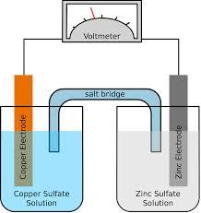

***APPARATUS REQUIRED***

**Glass beaker, CuSO4solution , Cu electrodes , ZnSO4 solution , Zn electrodes , rheostat , battery eliminator , water, burner , thermometer, flask , ammeter , voltmeter.** 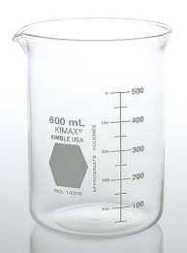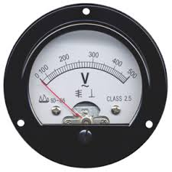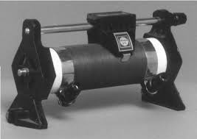

***SOME IMPORTANT TERMS***  
  
**Conductance** : **The property of ease of flow of electric current through a body is called conductance .**

**Resistance** : **The obstacle offered to the flow of electric current is called resistance (Ω) .**

**Electrolysis** :**The operation in which electricity cause a chemical reaction is called electrolysis .**

**Ohm’s Law** : **This law states that the current flowing through a resistance is directly proportional to the potential difference applied across its ends , at constant temperature and pressure .**

(V=I×R)

**Faraday’s Laws**:  
***First Law*** : **The mass of a substance produced or consumed in electrolysis is directly proportional to the quantity of charge passing through it.**  
**mα Q   
  
or, m= Z × I×t  
where, Z is electrochemical equivalent ; I is current;  
t is time in seconds; Q is charge .**  
  
**Second Law : The mass of substance produced in electrolysis directly proportional to its equivalent mass.**

**W1 /E1 =W2 / E2 = W3 /E3……..**

**Third Law : The mass of a substance produced in electrolysis is directly proportional to the number of electrons per mole needed to cause desired change in oxidationstate.**

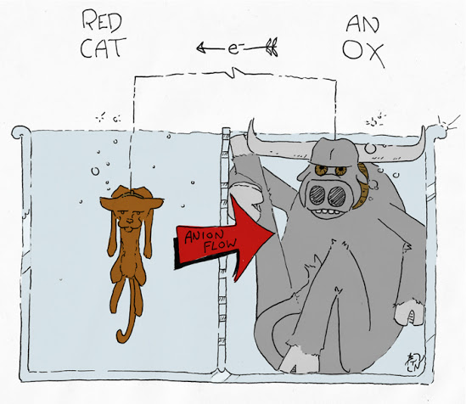

***C o n d u c t i v i t y***

When voltage applied to the electrodes immersed into an electrolyte solution , ions of electrolyte move, and thus, electric current flows through the electrolytic solution . The electrolytic solution and the metallic conductor exhibit obey Ohm’s law .  
  
**The reciprocal of resistance is called electrical conductance.  
The unit of electrical conductance is Siemens (S) or Ω– 1 or mho.**  
If a solution is placed between two parallel electrodes having cross sectional are A and distance L apart then the resistance is given by :

**R =(1/ C)**  
**“P” ( called ‘rho’) is known as resistivity .**

**Its reciprocal gives the conductivity of the solution which is denoted by K (called‘kappa’).   
Its unit is Siemens / meter.   
 K=1/R*L/A**

**L/A is a fixed quantity for a cell and is called the ‘cell constant’.**

**Factors Affecting**

**Electrical Conductivity**

The factors which affect the electrical conductivity of the solutions are :

**Inter -Ionic Attraction :** It depends on solute – solute interactions.

**Solvation of Ions :** It depends on solute –solvent interactions .

**Viscosity of the solvent :** It depends on solvent- solvent interactions .

***PROCEDURE***

**1. The electrolytes chosen are ZnsO4 and the electrodes are of Zn.**

**2. Readings for the measurement of conductance are taken at intervals of 3o C.**

**3. Proper precautions are taken to avoid evaporation and to keep other factors constant .**

**4. The vessel and electrodes are removed and the vessel is cleaned and filled with ZnSO4 solution .**

**5. The electrodes are refitted in their original place so that the distance between them does not change .**

**6. Current is passed and when the voltmeter and ammeter show steady readings , they are noted.**

**7. The current is switched off .**

**8. It is seen that while the ammeter reading returns at once to** 0 **position . The voltmeter needle pauses for a while at a particular reading which is noted down .**

**9. This reading indicates the back EMF in the electrolyte.**

**10. Similarly , more sets of reading are taken , and resistance is calculated .Thus, the value of conductance is calculated.**

**11. The switched on circuit readings in voltmeter and ammeter are taken .**

**12. The current through the electrolyte is changed by adjusting the rheostat and more sets of readings are taken .**

**13. Thus, the mean value of resistance is calculated .**

**14. Above steps are repeated for CuSO4 as electrolyte with electrodes made of Cu.**

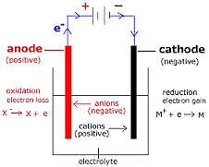

***Physical Constants***

For the purpose of accuracy and convenience , some important aspects of the electrolyte process are kept constant in the experiment as their variation might affect the conductivity of the electrolyte .

They are:

* Voltage
* Size of electrodes
* Nature of electrodes
* Separation between the electrodes
* Concentration of the electrolytes
* Nature of electrolytes
* Resistance in the circuit

OBSERVATION SET-1

**For ZnSO4 Electrolyte :**

|  |  |  |  |  |  |
| --- | --- | --- | --- | --- | --- |
| S.NO. | Temperature  (oC) | Reading  of Ammeter  (mA) | Reading of voltmeter  (V) | Resistance  (Ω)  R=V/I | Conductance  (Ω-1)  C=1/R |
| 1 | 25 | 100 | 2.05 | 20.5 | 0.048 |
| 2 | 28 | 150 | 2 | 13.33 | 0.075 |
| 3 | 31 | 170 | 1.95 | 11.47 | 0.087 |
| 4 | 34 | 187 | 1.9 | 10.13 | 0.098 |

**GRAPH OF OBSERVATION SET-1**

OBSERVATION SET-2

**For CuSO4 Electrolyte :**

|  |  |  |  |  |  |
| --- | --- | --- | --- | --- | --- |
| S.NO. | Temperature  (oC) | Reading  of Ammeter  (mA) | Reading of voltmeter  (V) | Resistance  (Ω)  R=V/I | Conductance  (Ω-1)  C=1/R |
| 1 | 25 | 190 | 1.75 | 9.21 | 0.108 |
| 2 | 28 | 230 | 1.7 | 7.39 | 0.135 |
| 3 | 31 | 240 | 1.65 | 6.87 | 0.175 |
| 4 | 34 | 251 | 1.6 | 6.36 | 0.157 |

**GRAPH OF OBSERVATION SET-2**

***RESULT***

The relevant graph shows that 1/R of an electrolyte increases at a steady rate as the temperature increases .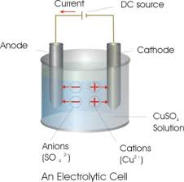

**CONCLUSION**

On heating a solution , it is known that a viscosity gradually decreases , with decrease in viscosity , the speed and movement of the ions increases . In other words , the conductance of the electrolyte increases with increase in temperature . Hence , the result of the experiment agrees with reasoning.

**PRECAUTIONS**

1. Variation of R due to all 0f the factors should be kept constant.
2. The electrode used in each case should always be kept parallel to each other.
3. The solution should be kept undisturbed.
4. For each observation , take 3 readings and then mean value should be considered.

**BIBLIOGRAPHY**

1. **Chemistry (part-1)-Textbook for Class XII,NCERT.**
2. **Concepts of Physics 2 by HC Verma , Bharti Bhawan.**

**(Publishers and Distributors)**