NeoPayroll
Re-Engineered Employee & Payroll Management System
A Modern Decoupled 3-Tier Enterprise Architecture (React 19 + Python FastAPI + SQLite) Re-Engineered from Legacy PHP CodeIgniter System (Smohanta23/Payroll_Mgmt_System)
ACADEMIC SUBMISSION OVERVIEW
Field | Details
Project Title | NeoPayroll: Re-Engineered Employee & Payroll Management System
Project Type | Full-Stack Web Application (Modern 3-Tier Architecture)
Backend Framework | Python 3.10+ / FastAPI / SQLAlchemy ORM / Pydantic
Frontend Framework | React 19 / Vite / React Router DOM / Recharts / jsPDF
Database | SQLite3 Relational Database
Styling & UI | Responsive Corporate SaaS Design System (Light/Dark Themes)
API Architecture | RESTful API
Target Evaluation | Practical Examination
Baseline Legacy System | Smohanta23 / Payroll_Mgmt_System (PHP CodeIgniter 4 + MySQL)

Submitted By: Pranav Kapoor

Table of Contents
01. | Executive Summary & Abstract
02. | Legacy System Analysis & Software Re-Engineering Process with Screenshots
03. | System Architecture
04. | Technology Stack & Justification
05. | Database Design & Data Models
06. | REST API Specifications
07. | Core Modules & System Features
08. | Workflow & Sequence Diagrams
09. | Installation & Execution Guide with Screenshots
10. | Test Cases & Quality Assurance
11. | Future Enhancements & Conclusion

1. Executive Summary & Abstract
Traditional human resource and payroll management systems in small-to-medium enterprises (SMEs) and academic organizations often suffer from high manual friction: attendance is tracked on paper or detached spreadsheets, salary disbursements require repetitive calculations, and generating individual payslips is tedious and error-prone.
NeoPayroll is a high-performance, re-engineered, full-stack enterprise automation system built to modernize workforce administration. By decoupling the interface into a reactive Single Page Application (SPA) powered by React 19 and a high-throughput asynchronous REST API built with FastAPI and SQLAlchemy, NeoPayroll delivers:
• Automated real-time attendance analytics and workforce tracking.
• Role-based separation of concerns between Administrators and Employees.
• End-to-end leave application and approval governance.
• Single-click payroll disbursement and client-side vectorized PDF payslip generation.
• Responsive, accessible corporate SaaS user experience featuring clean light-first design and real-time Light/Dark theme switching.

2. Legacy System Analysis & Software Re-Engineering Process

2.1 The Baseline Legacy System (Smohanta23/Payroll_Mgmt_System)
The baseline project selected for re-engineering is the open-source Employees Payroll Management System authored by Smohanta23 (GitHub Repository (https://github.com/Smohanta23/Payroll_Mgmt_System)).
The legacy application was engineered using:
• Backend Framework: PHP (CodeIgniter 4 MVC Framework)
• Database Engine: MySQL with procedural SQL migrations and relational tables
• Server Environment: Traditional LAMP/XAMPP stack (Apache HTTP Server, PHP Module, MySQL Daemon)
• Frontend Layer: Server-Side Rendered (SSR) HTML views, jQuery, and Bootstrap 4

2.2 Technical Debt & Deficiencies in the Legacy Architecture
Through rigorous software reverse engineering, several critical limitations and architectural bottlenecks were identified:
1. Monolithic Coupling: UI presentation templates (.php views) were tightly intertwined with CodeIgniter controller logic and SQL queries, impeding modular testing and horizontal scalability.
2. Full-Page Server Reloads: Every navigation event, search query, or form submission triggered a complete round-trip HTTP request and full DOM re-rendering, causing high network latency and poor user experience.
3. Heavy Deployment Overhead: Running the legacy system required configuring a full XAMPP/LAMP runtime with local Apache virtual hosts and MySQL daemon services, creating deployment friction on modern cloud or containerized environments.
4. Synchronous Blocking I/O: The PHP execution model was synchronous and single-threaded per request, leading to throughput degradation during concurrent payroll operations.
5. Lack of Automated API Documentation: Legacy API routes and form-action handlers were completely undocumented, making third-party integrations and mobile client extensions difficult.
6. Inflexible Document Generation: Payslip records were rendered as raw HTML tables or required resource-heavy server-side PDF generation libraries that caused CPU spikes on the web server.

2.3 Architectural Re-Engineering: Legacy vs. NeoPayroll Modernization
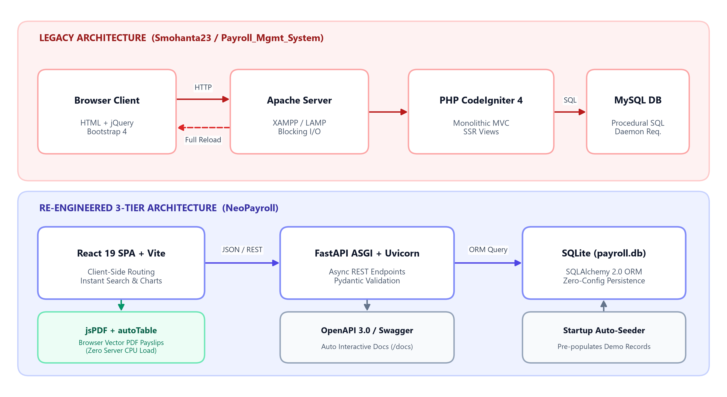
Figure 2.1: Architectural Re-Engineering — Legacy System vs. NeoPayroll Modernization

2.4 Comprehensive Comparative Matrix
Evaluation Dimension | Legacy Baseline (Payroll_Mgmt_System) | Re-Engineered NeoPayroll System | Architectural Advantage
Architectural Model | Monolithic Model-View-Controller (MVC) | Decoupled 3-Tier (Client SPA + Asynchronous REST API + Relational ORM) | Modularity, independent scaling, and separation of concerns.
Backend Stack | PHP 7/8 + CodeIgniter 4 Framework | Python 3.10+ + FastAPI + Uvicorn ASGI Server | Near-C asynchronous execution speeds, native async/await, and Pydantic runtime type validation.
Frontend Stack | Server-side rendered PHP views + jQuery | React 19 + Vite 8 + React Router 7 | Lightning-fast Single Page Application (SPA), zero full-page reloads, and component reusability.
Database & ORM | MySQL (requires active service daemon) | SQLite3 Relational Database via SQLAlchemy 2.0 ORM | Serverless, zero-configuration local deployment with declarative object modeling and transaction safety.
API Architecture | Undocumented custom PHP controller routes | RESTful API with automated OpenAPI 3.0 (Swagger UI at /docs) | Automatic API schema generation, interactive endpoint testing, and standardized HTTP status codes.
Data Filtering & Search | Slow server-side SQL queries with page refreshes | Instant client-side reactive in-memory search across Name, Email, and Department | Sub-millisecond search response without network overhead.
Payslip Compilation | Server-rendered HTML print tables | Client-side vectorized PDF compilation via jsPDF + jspdf-autotable | Zero server CPU load, automated Amount in Words conversion, and dual-column financial breakdown.
Workforce Analytics | Static tabular text without data visualization | Dynamic 5-day attendance trend area chart via Recharts with integer Y-axis | Real-time visual executive observability.
Role Governance | Basic username/password database seeding | Role-Based Access Control (RBAC) with locked employee profiles and salary confidentiality | Prevents employee spoofing and protects coworker remuneration privacy.
Design System | Generic Bootstrap 4 tables | Custom Stripe & Tailwind-inspired two-tone corporate SaaS design system | Crisp enterprise aesthetic with light/dark theme switching and no AI neon giveaways.

2.5 Visual Comparison: Legacy Baseline vs. Re-Engineered Interface
The paired screenshots below visually contrast the legacy PHP CodeIgniter 4 + Bootstrap 5 views (Smohanta23/Payroll_Mgmt_System) against the modernized React 19 + FastAPI NeoPayroll interface:
BEFORE: Legacy Login (PHP CodeIgniter + Bootstrap 5) | AFTER: NeoPayroll Role-Based Portal (React 19)
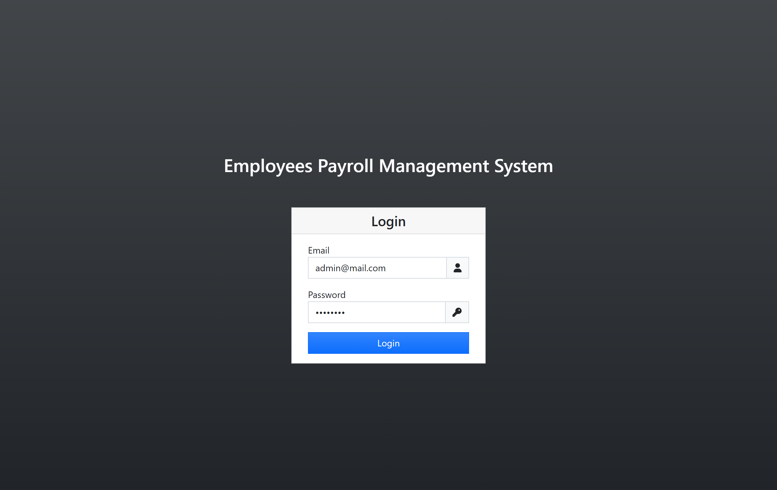 | 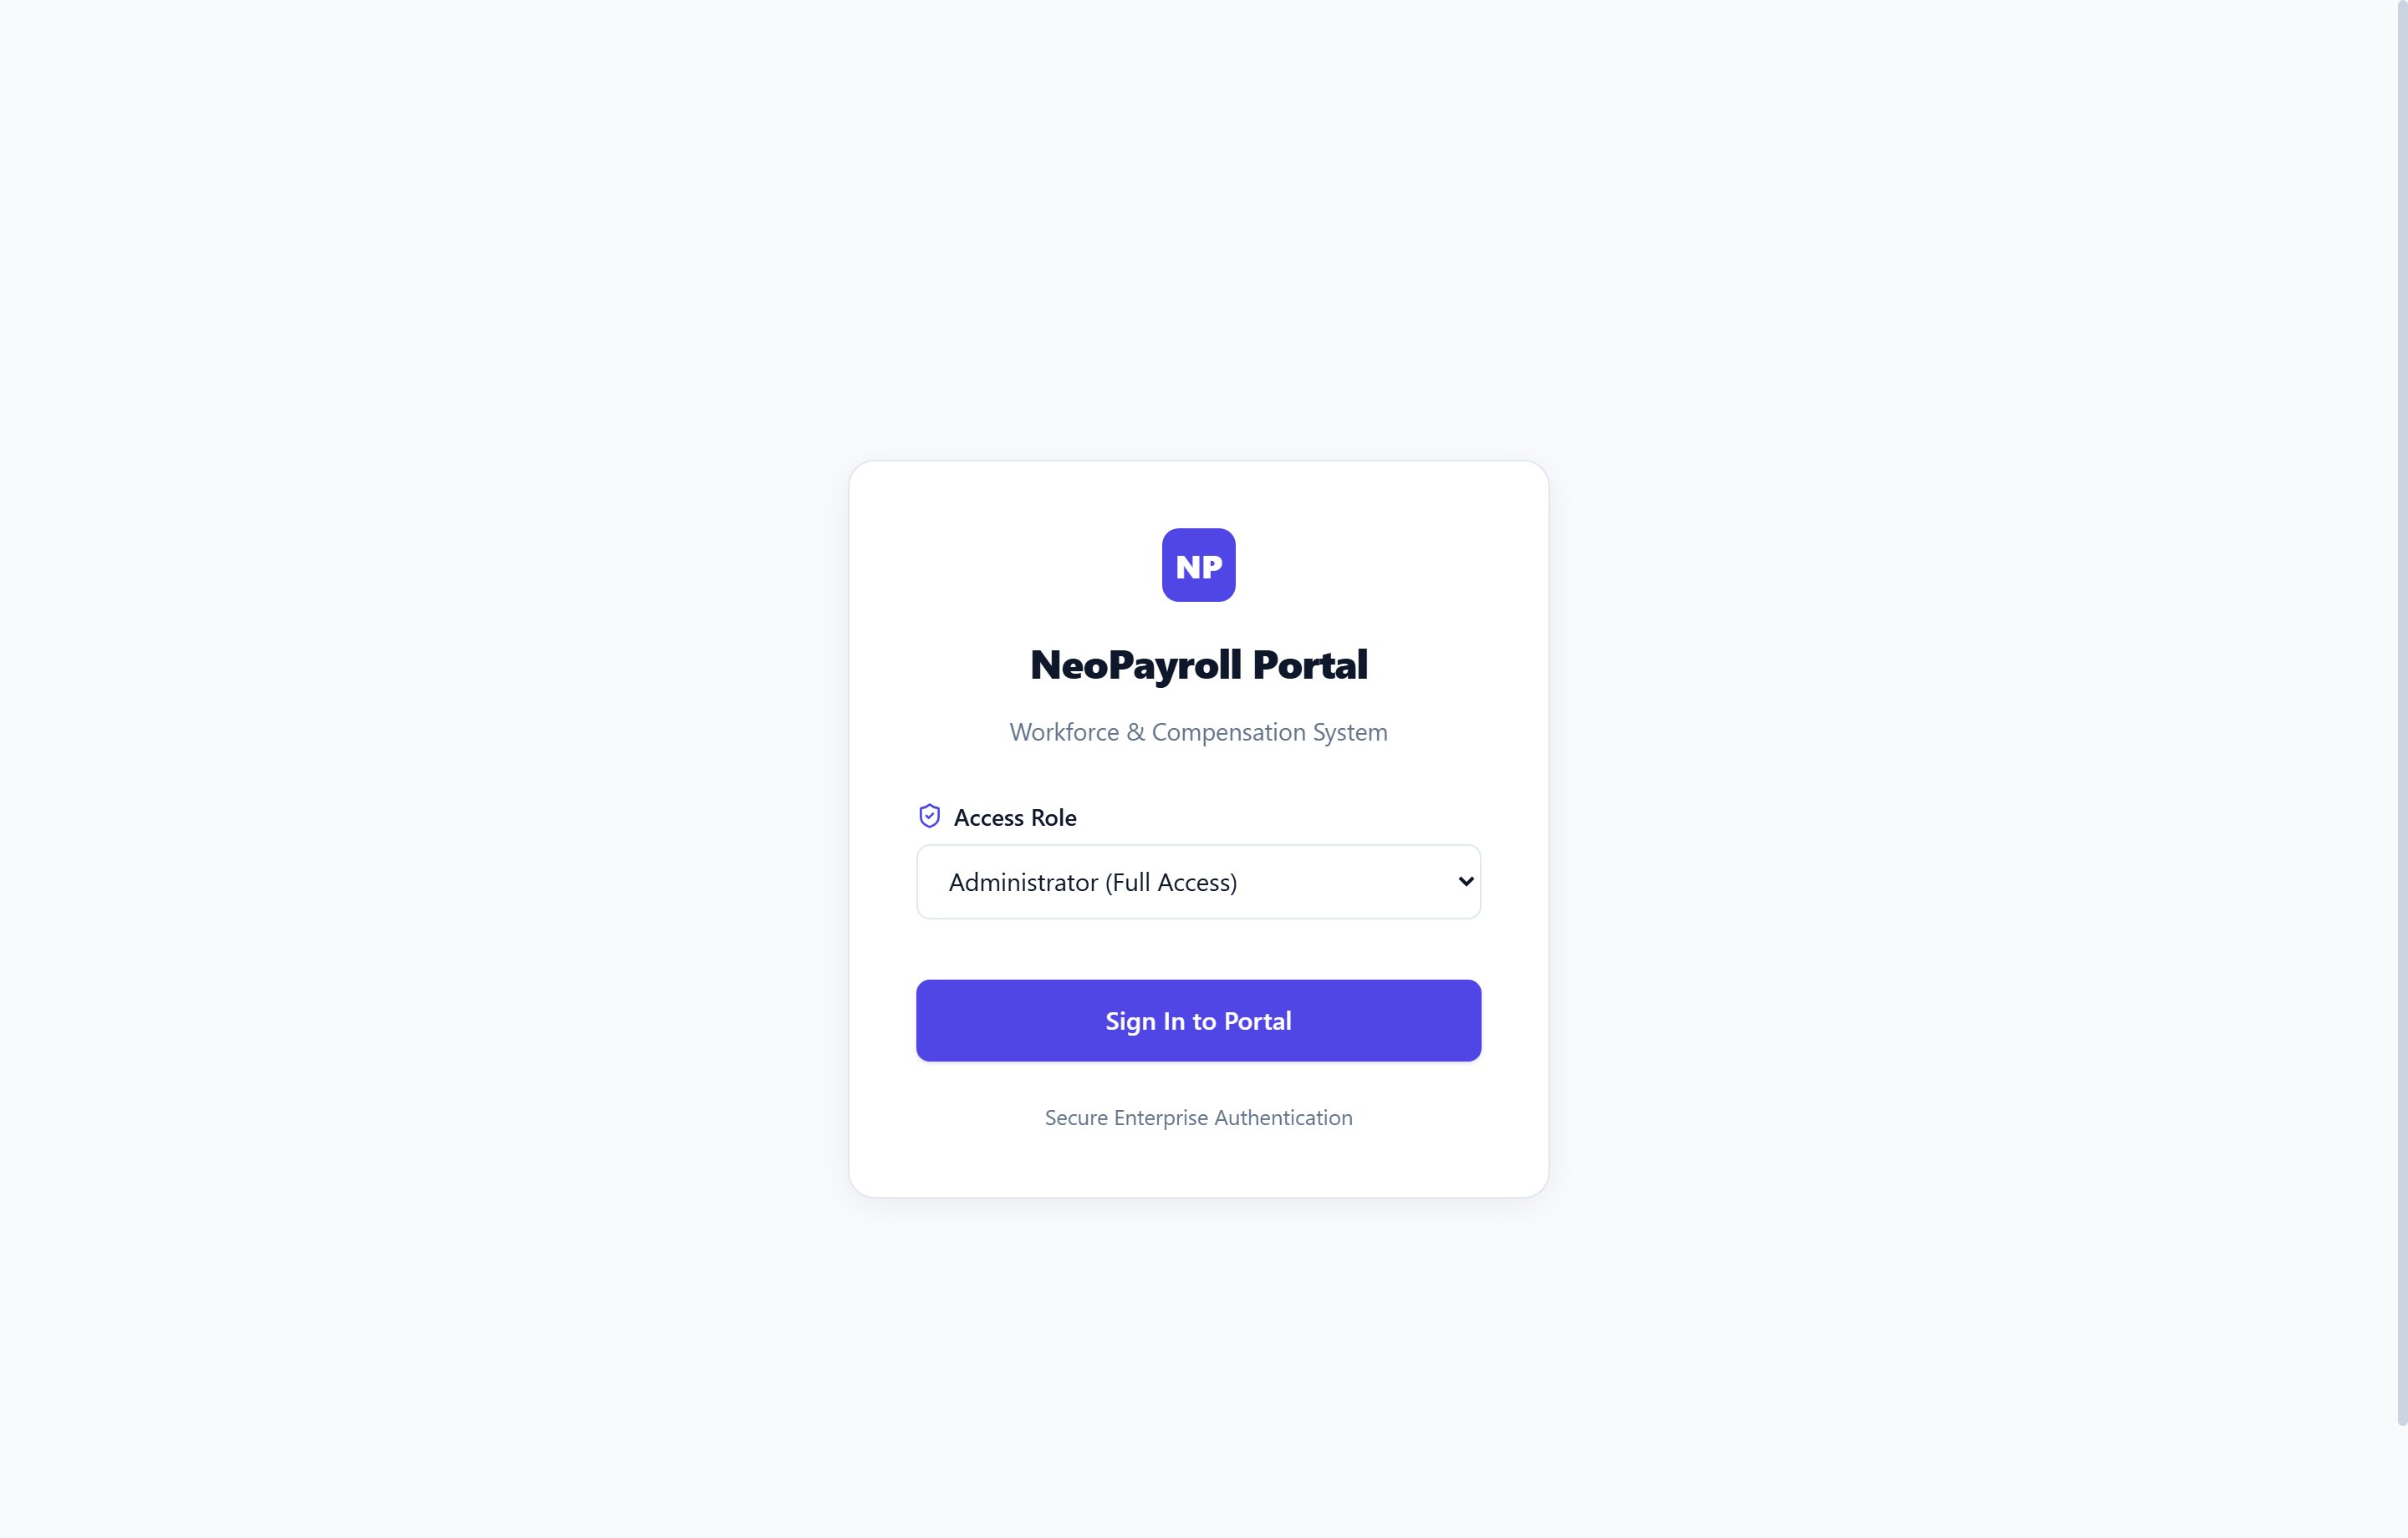
Figure 2.2: Authentication Screen Comparison — Single Admin Gate vs. Dual Role-Based Self-Service Portal
BEFORE: Legacy Dashboard (Static Summary Cards) | AFTER: NeoPayroll Dashboard (Live Charts & Actions)
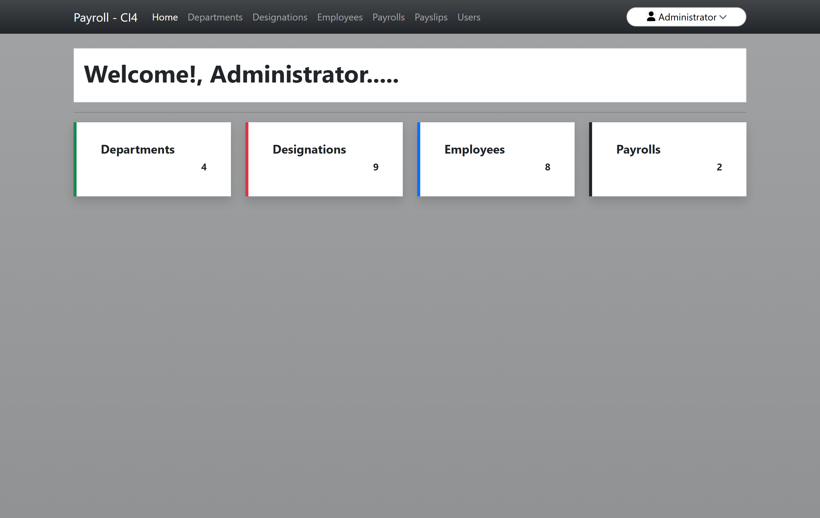 | 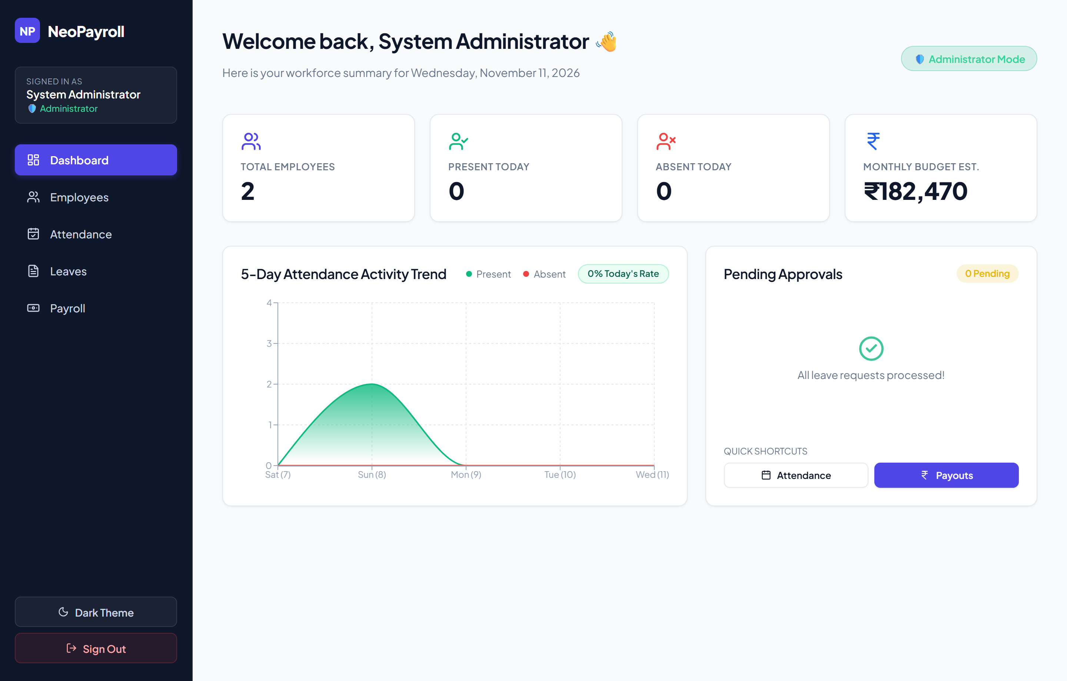
Figure 2.3: Dashboard Comparison — Static Counters vs. Live 5-Day Attendance Trend Analytics & Quick Approvals
BEFORE: Legacy Employees Table (Server-Paginated) | AFTER: NeoPayroll Directory (Instant Search & Modal CRUD)
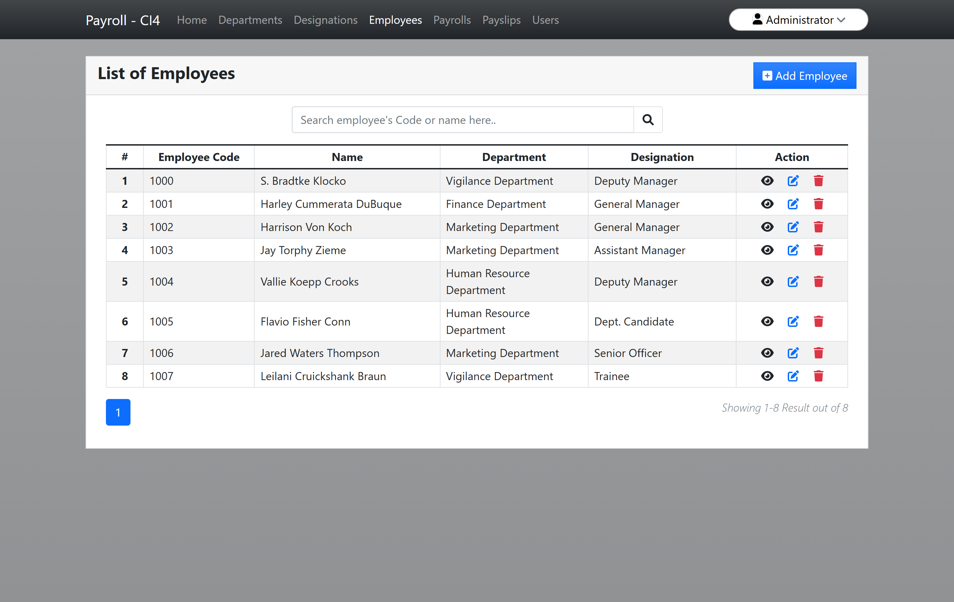 | 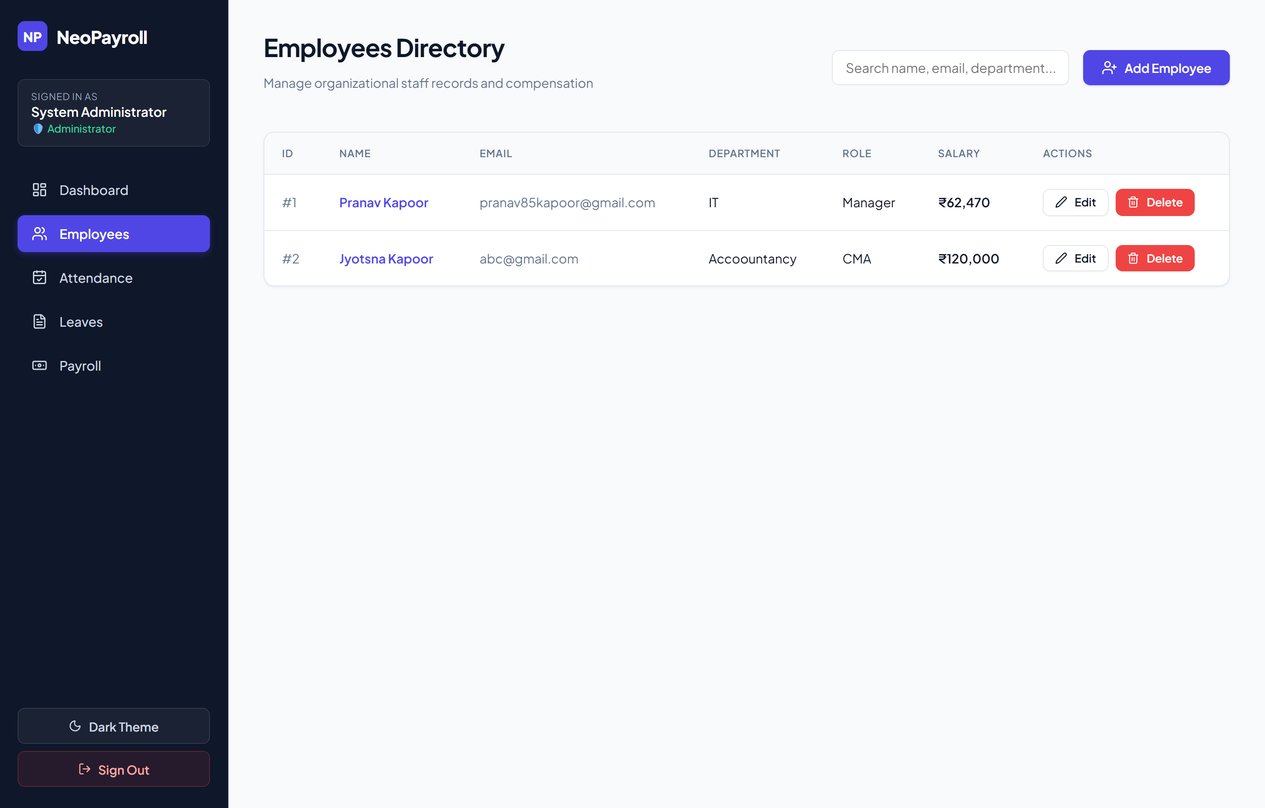
Figure 2.4: Employee Directory Comparison — Server-Reload Table vs. Reactive SPA Directory with Salary Privacy
BEFORE: Legacy Payslip (HTML Print Page) | AFTER: NeoPayroll Corporate PDF Payslip (jsPDF Vector Engine)
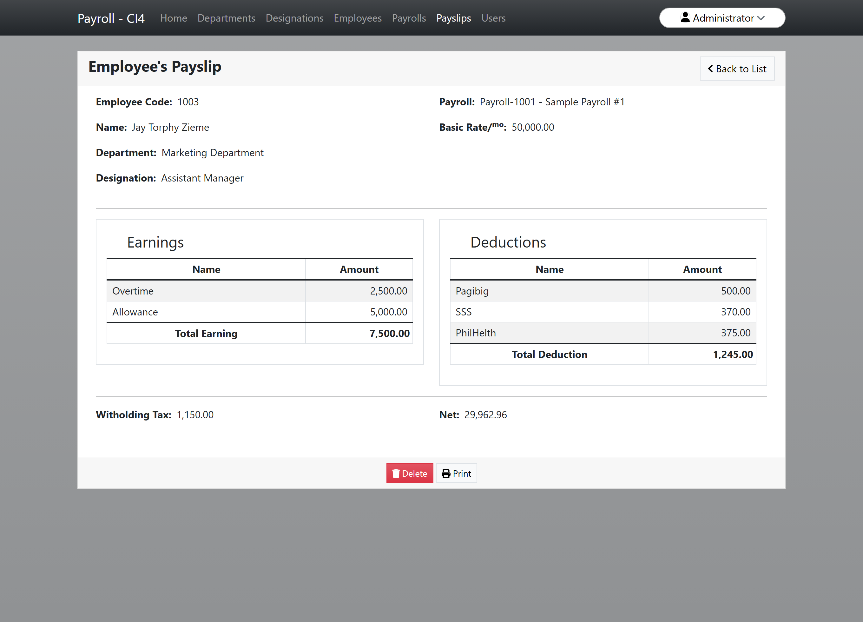 | 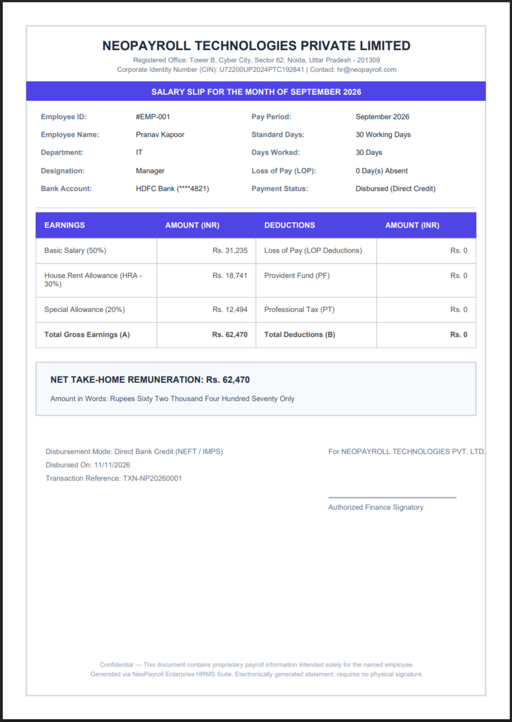
Figure 2.5: Payslip Comparison — Server HTML Print View vs. Client-Side Corporate PDF with Amount in Words

3. System Architecture
NeoPayroll adheres to the Modern 3-Tier Decoupled Client-Server Architecture:
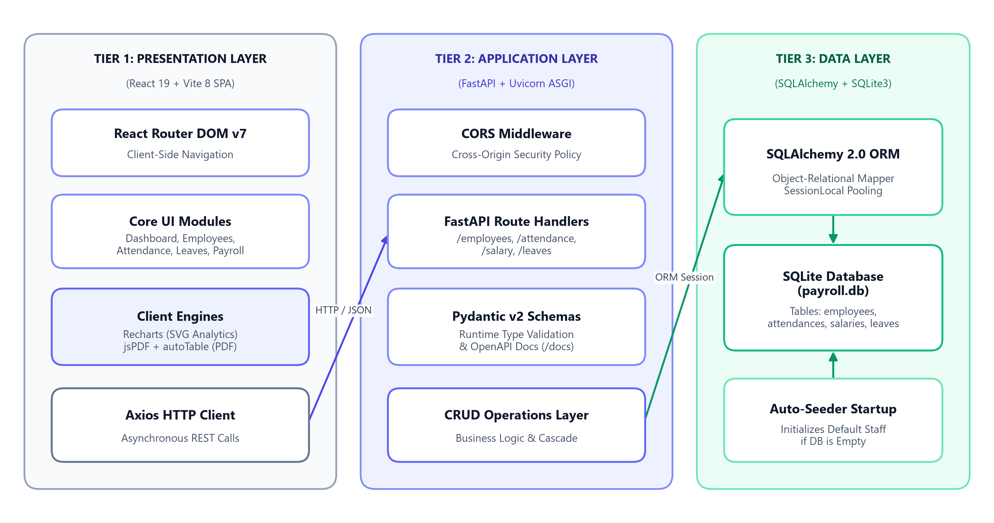
Figure 3.1: Decoupled 3-Tier Enterprise System Architecture

Architectural Highlights:
1. Decoupled Architecture: The frontend and backend run as independent processes communicating strictly via asynchronous JSON over HTTP.
2. Stateless Business Logic: The FastAPI backend does not maintain in-memory session states, making it lightweight and horizontally scalable.
3. Optimized Client Operations: PDF compilation occurs client-side using Web Canvas and JavaScript DOM APIs, eliminating server CPU spikes during bulk report generation.

4. Technology Stack & Justification
Technology | Layer | Purpose | Technical Justification
Python 3.10+ | Backend | Core Runtime | Robust standard library, high readability, wide enterprise adoption.
FastAPI | Backend | REST Framework | Built on Starlette and Pydantic; offers near-C execution speeds (asynchronous ASGI), automatic OpenAPI (Swagger) schema generation, and strict type checking.
Uvicorn | Backend | ASGI Web Server | Lightning-fast asynchronous web server implementation for Python.
SQLAlchemy 2.0 | Backend | ORM | Provides Object-Relational Mapping, automated SQL query composition, and connection pooling with session management.
Pydantic v2 | Backend | Data Validation | High-speed data parsing and validation using Python type annotations.
SQLite3 | Database | Relational Storage | Serverless, zero-configuration SQL engine stored in a single file (payroll.db), ideal for standalone enterprise tools and academic practical demonstrations.
React 19 | Frontend | UI Library | Component-driven declarative UI with concurrent rendering and optimized state management.
Vite 8 | Frontend | Build Tool | Instant Hot Module Replacement (HMR) and optimized ESBuild bundling.
React Router 7 | Frontend | Client Routing | Declarative nested routing enabling single-page navigation without page refreshes.
Recharts | Frontend | Data Visualization | Declarative SVG-based charting library integrated seamlessly with React state.
jsPDF & AutoTable | Frontend | Document Generator | Client-side vectorized document compilation for pixel-perfect printable payslips.
Lucide React | Frontend | UI Icons | Lightweight, consistent SVG iconography.
React Hot Toast | Frontend | Notification System | Non-blocking corporate toast notifications for asynchronous user feedback.

5. Database Design & Data Models

5.1 Entity-Relationship (ER) Diagram
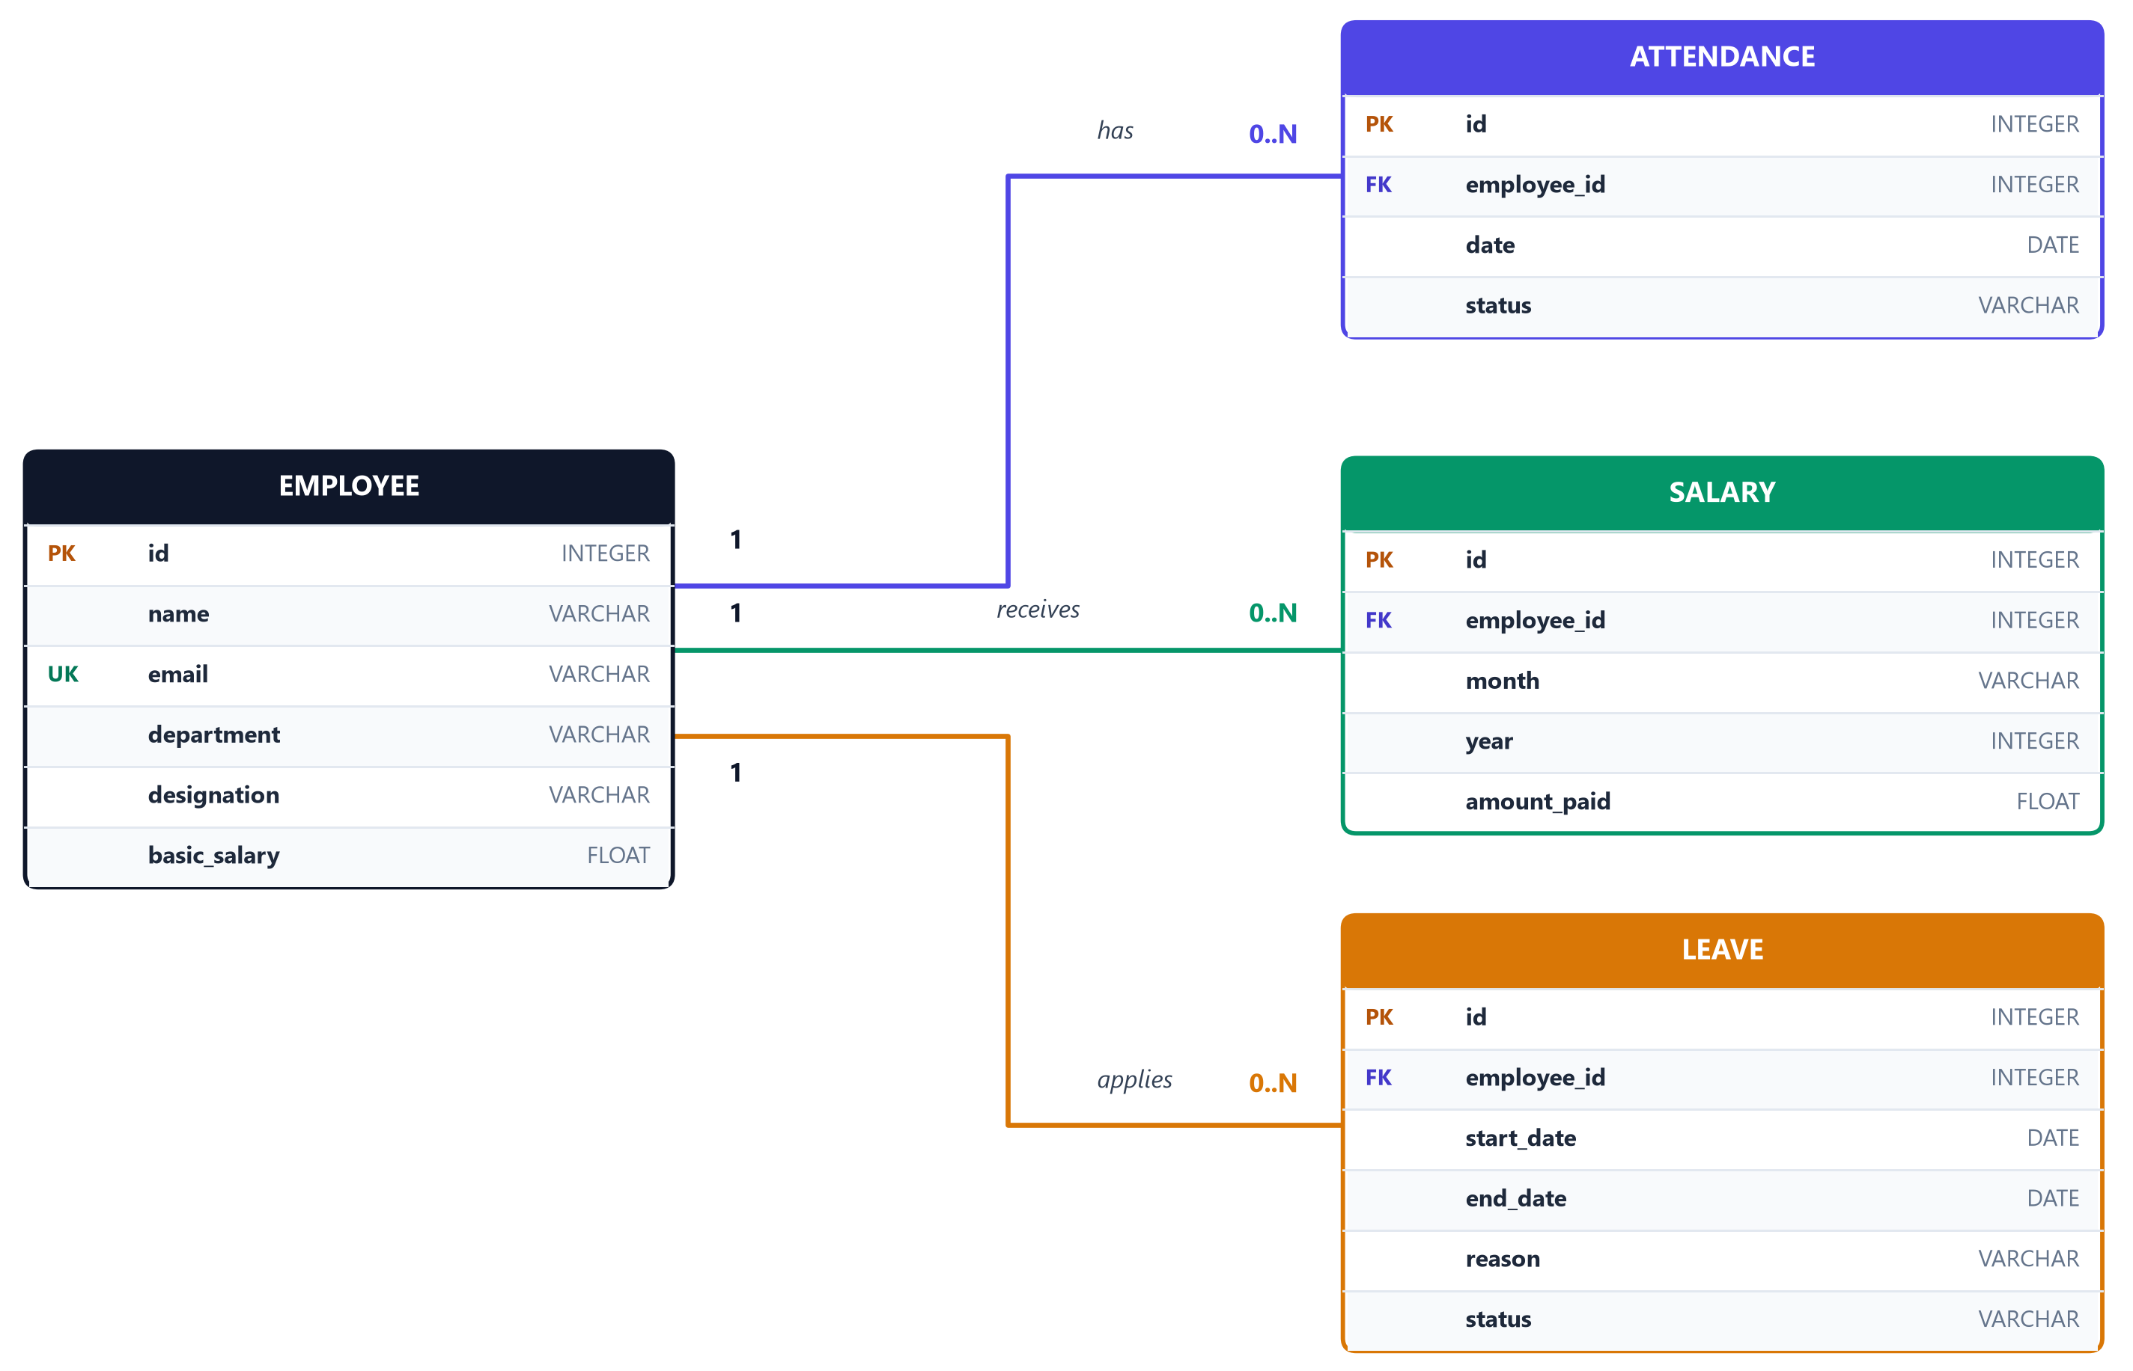
Figure 5.1: Relational Database Entity-Relationship (ER) Diagram

5.2 Database Schema Specifications

Table 1: employees
• id (INTEGER, PRIMARY KEY, AUTOINCREMENT): Unique identifier.
• name (VARCHAR, NOT NULL, INDEXED): Full name of the employee.
• email (VARCHAR, UNIQUE, NOT NULL, INDEXED): Corporate email ID used for uniqueness validation.
• department (VARCHAR, NOT NULL): Functional unit (e.g., Engineering, HR, Finance).
• designation (VARCHAR, NOT NULL): Job title (e.g., Senior Software Engineer).
• basic_salary (FLOAT, NOT NULL): Monthly remuneration figure.

Table 2: attendances
• id (INTEGER, PRIMARY KEY, AUTOINCREMENT): Unique log ID.
• employee_id (INTEGER, FOREIGN KEY -> employees.id): Associated employee.
• date (DATE, NOT NULL): ISO calendar date (YYYY-MM-DD).
• status (VARCHAR, NOT NULL): Attendance state (Present, Absent, Half-Day).

Table 3: salaries
• id (INTEGER, PRIMARY KEY, AUTOINCREMENT): Transaction ID.
• employee_id (INTEGER, FOREIGN KEY -> employees.id): Associated employee.
• month (VARCHAR, NOT NULL): Name of disbursement month.
• year (INTEGER, NOT NULL): Financial year.
• amount_paid (FLOAT, NOT NULL): Total net salary transferred.

Table 4: leaves
• id (INTEGER, PRIMARY KEY, AUTOINCREMENT): Leave application ID.
• employee_id (INTEGER, FOREIGN KEY -> employees.id): Applicant employee.
• start_date (DATE, NOT NULL): Commencement date of leave.
• end_date (DATE, NOT NULL): Conclusion date of leave.
• reason (VARCHAR, NOT NULL): Justification text.
• status (VARCHAR, DEFAULT: "Pending"): Current approval state (Pending, Approved, Rejected).

6. REST API Specifications
The backend exposes RESTful endpoints adhering strictly to HTTP verb standards. The interactive Swagger interface is hosted at http://127.0.0.1:8000/docs.
Endpoint | Method | Request Payload (Schema) | Response Code | Description
/employees/ | POST | EmployeeCreate (name, email, department, designation, basic_salary) | 200 OK / 400 Bad Request | Enrolls a new employee. Validates email uniqueness.
/employees/ | GET | Query Params: skip=0, limit=100 | 200 OK | Retrieves paginated list of all employees.
/employees/{id} | PUT | EmployeeCreate (name, email, department, designation, basic_salary) | 200 OK / 404 Not Found | Updates existing employee records.
/employees/{id} | DELETE | Path Param: employee_id | 200 OK / 404 Not Found | Deletes employee and cascades removal of attendance/salary records.
/attendance/ | POST | AttendanceCreate (employee_id, date, status) | 200 OK | Logs daily attendance. Updates existing record if marked multiple times for same day.
/attendance/ | GET | Query Params: date (optional), skip=0, limit=1000 | 200 OK | Retrieves attendance history logs, filterable by date.
/salary/ | POST | SalaryCreate (employee_id, month, year, amount_paid) | 200 OK | Processes salary generation and creates historical ledger record.
/salary/ | GET | Query Params: skip=0, limit=100 | 200 OK | Fetches historical payroll disbursement records.
/leaves/ | POST | LeaveCreate (employee_id, start_date, end_date, reason) | 200 OK | Submits a new employee leave request with default Pending status.
/leaves/ | GET | Query Params: skip=0, limit=100 | 200 OK | Lists all submitted leave requests across the organization.
/leaves/{id} | PUT | LeaveStatusUpdate (status: "Approved" \ | "Rejected") | 200 OK

7. Core Modules & System Features

1. Role-Based Access Control (RBAC) & Authentication
• Administrator Role: Full executive authority including enrolling new staff, modifying profiles, deleting employees, logging attendance, batch-marking company presence, approving/rejecting leave requests, executing monthly payroll payouts, and accessing corporate budgets.
• Employee Role (Self-Service Portal): Authenticates directly into their employee profile.
◦ Automatically locks leave applications to the authenticated identity (preventing unauthorized filings on behalf of peers).
◦ Keeps colleague salaries confidential (Confidential badge).
◦ Restricts payroll administration controls and administrative creation actions (+ Add Employee hidden).
◦ Grants read-only visibility into organization attendance.

2. Intelligent Executive Dashboard
• Personalized Header Greeting: Welcomes the logged-in user by name with live formatted calendar dates and active portal mode chips ( Administrator Mode / Department Portal).
• Role-Adaptive Stat Cards:
◦ Admin View: Total Staff, Present Today, Absent Today, and Total Monthly Budget Estimation.
◦ Employee View: My Designation & Department, Today's Punch Status (Present / Not Marked), My Base Salary, and Personal Pending Leave count.
• 5-Day Attendance Activity Trend Chart: Rendered dynamically using Recharts area charts from actual historical logs. Features integer-locked Y-axis (preventing fractional employees), live legend indicators ( Present / Absent), and a live attendance rate percentage pill.
• Pending Approvals & Quick Actions Widget:
◦ Admin: Live feed of pending leave requests with one-click direct "Approve" triggers and quick navigation shortcuts.
◦ Employee: Scheduled payroll cycle reminders and direct links to apply for leave.

3. Employee Directory & Full CRUD Engine
• Tabular record listing showing Employee ID badge, Name, Email, Department, Role, and Remuneration.
• Complete CRUD Operations: Full capability to enroll new employees (POST), update existing employee details/salary (PUT), and safely remove records (DELETE) with cascaded cleanup of related attendance, salary, and leave histories.
• Real-time instant search bar filtering employees across Name, Email, and Department substrings.
• Inline modal creation and editing form with live validation.
• Role-based confidentiality: Salaries of colleagues are marked confidential for regular employee logins.

4. Smart Daily Attendance Tracker
• Real-Time Date-Filtered Attendance: Interactive ISO Date Picker querying /attendance/?date=... to inspect any historical day or log today's records.
• Three-State Status Badges: Clear visual indicators for each staff member: Present, Absent, or Not Marked.
• Deduplication Engine: Prevents duplicate rows when toggling attendance on the same calendar day by updating existing records in-place.
• "Mark All Present" Shortcut: One-click administrative bulk action to mark all active staff present for the selected day.
• Daily Attendance Breakdown: Live top-level summary cards tallying Present, Absent, and Unmarked staff counts.

5. Secure Leave Governance Workflow
• Applicant Identity Locking: When an employee applies for leave, the applicant profile field is locked to their authenticated account, preventing spoofing.
• Date Range Validation: Enforces business logic ensuring End Date is not earlier than Start Date.
• Personal vs. Corporate Archive: Employees view their own submitted leave history with real-time status badges (Pending, Approved, Rejected), while administrators inspect the global queue with instant Approve and Reject controls.

6. Automated Attendance-Based Payroll & Executive Payslip Engine
• Attendance-Based Loss of Pay (LOP) Formula: Dynamically computes monthly salary by assessing recorded absences:
Per Day Rate = (Basic Salary) / 30
Deduction = Absent Days x Per Day Rate
Net Payable = max(0, Basic Salary - Deduction)
• Duplicate Payout Protection: Detects if an employee has already been disbursed in the current month/year cycle and disables repetitive payouts with a Paid (Month) badge.
• Executive Corporate Payslip Generation: High-resolution, client-side vectorized PDF compilation powered by jsPDF and jspdf-autotable:
◦ Company Branding: NEOPAYROLL TECHNOLOGIES PRIVATE LIMITED, Corporate Identity Number (CIN: U72200UP2024PTC192841), and registered office address.
◦ Document Banner: SALARY SLIP FOR THE MONTH OF [MONTH] [YEAR].
◦ Employee & Attendance Meta Grid: Employee ID (#EMP-001), Department, Designation, Bank Account (HDFC Bank ****4821), Working Days (30), Days Worked, and Loss of Pay (LOP) Days.
◦ Dual-Column Financial Table: Standard corporate format with Earnings on the left (Basic 50%, HRA 30%, Special Allowance 20%) and Deductions on the right (Loss of Pay deductions, PF, PT).
◦ Net Remuneration Box: Highlights net take-home remuneration.
◦ Dynamic Amount in Words: Automatically converts numbers to official words (e.g., "Rupees Sixty Two Thousand Four Hundred Seventy Only").
◦ Transaction Stamp & Signatures: Generated transaction reference (TXN-NP2026...), disbursement mode (NEFT/IMPS), and official authorized signatory stamp line.

7. Modern Corporate SaaS UI (Stripe & Tailwind Inspired)
• Authentic Two-Tone Layout: Classic enterprise dark navy sidebar (#0f172a) paired with a clean, airy slate-gray main content workspace (#f8fafc).
• Professional Color Palette: Modern Royal Indigo (#4f46e5) and slate blue accents replacing generic AI neon-cyan aesthetics.
• Default Light Theme: Boots into an authentic corporate light theme by default, with a dark mode toggle available in the sidebar.
• Crisp, Accessible Cards & Tables: Solid opaque white cards (#ffffff) with subtle 1px slate borders (#e2e8f0) and soft natural elevation shadows.
• Tailwind-Style Status Badges: Soft mint green (#ecfdf5) for Present, soft rose (#fef2f2) for Absent, and warm amber (#fffbeb) for Pending.
• Responsive Feedback: Non-blocking react-hot-toast notifications providing immediate visual feedback for all network actions.

8. Workflow & Sequence Diagrams

8.1 Daily Attendance Marking Workflow
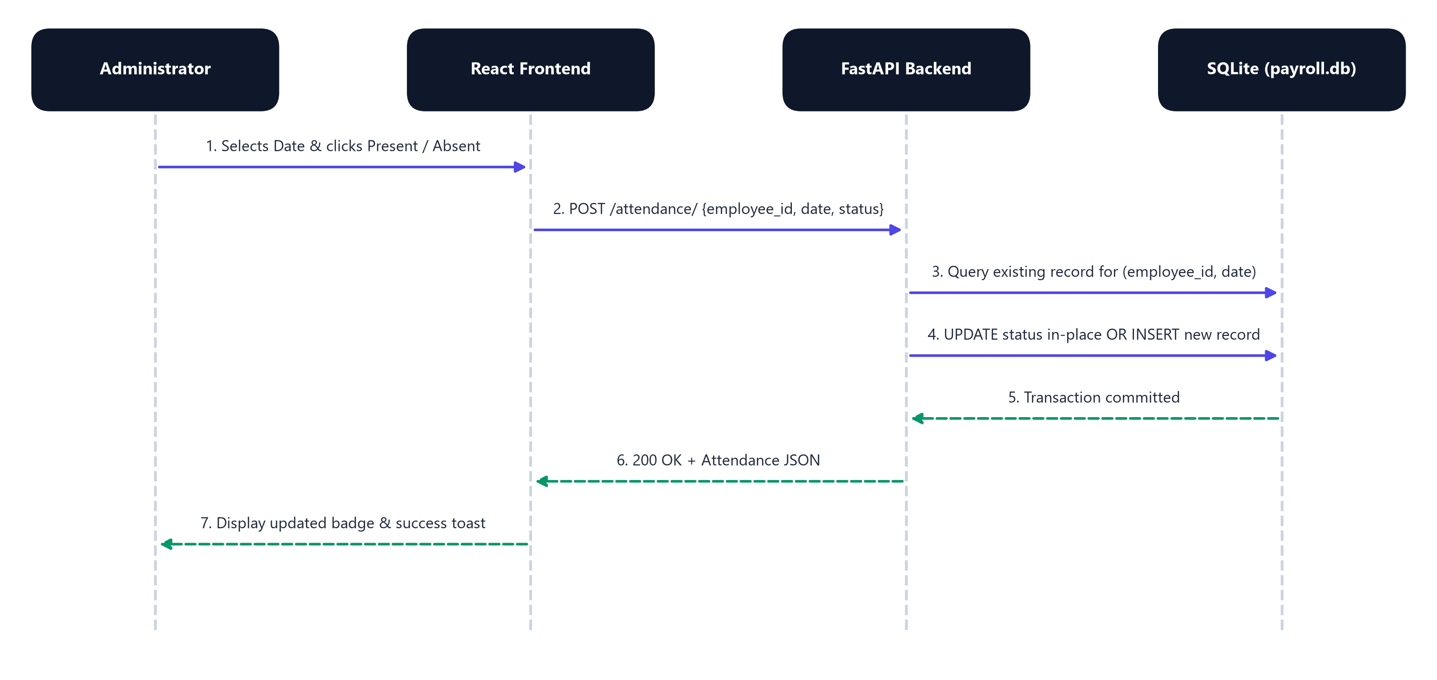
Figure 8.1: Daily Attendance Marking Sequence Workflow

8.2 Leave Application & Approval Lifecycle
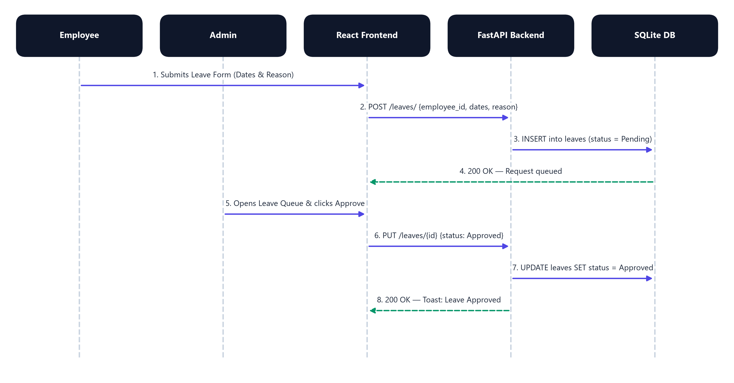
Figure 8.2: Leave Application & Administrative Approval Lifecycle

8.3 Payroll Disbursement & Client-Side PDF Generation
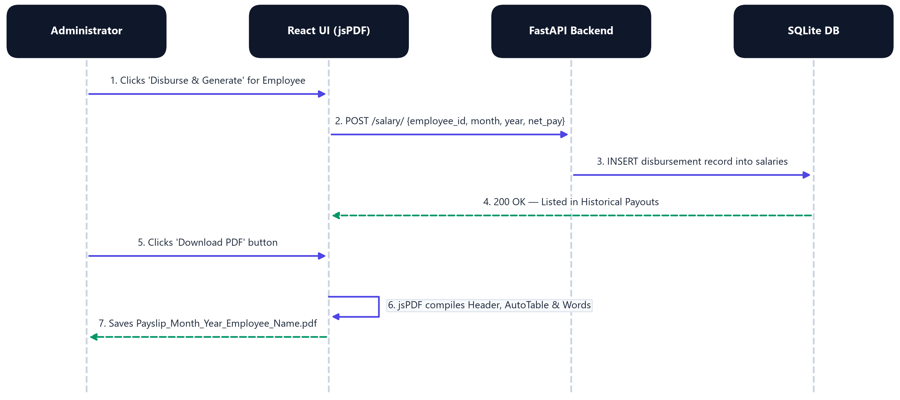
Figure 8.3: Payroll Disbursement & Client-Side PDF Generation Sequence

9. Installation & Execution Guide

9.1 System Prerequisites
• Operating System: Windows 10/11, macOS, or Linux
• Python: Version 3.10 or higher
• Node.js: Version 18.0 or higher (with npm)

9.2 Quick Launch (One-Click Windows Launcher)
The project includes a pre-configured automation script start.bat. Simply double-click the file or execute:
.\start.bat
This concurrently boots:
1. Backend Server: http://127.0.0.1:8000 (FastAPI with live reload).
2. Frontend Server: http://localhost:5173 (Vite development server).

Live Execution Output (start.bat & FastAPI Endpoint):
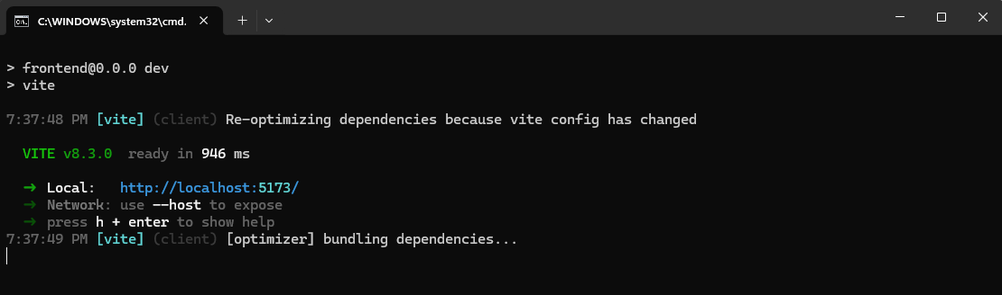
Figure 9.1: Live Terminal Execution — FastAPI Backend (Port 8000) & Vite Frontend (Port 5173) Running Concurrently
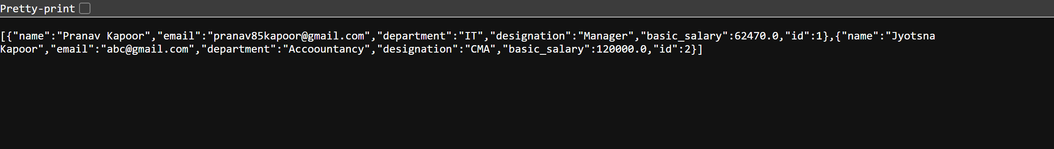
Figure 9.2: Backend REST API Live Response Output — GET http://127.0.0.1:8000/employees/ (HTTP 200 OK JSON)
9.3 Manual Step-by-Step Setup

Step 1: Backend Setup
Open a terminal in the project directory:
# Navigate to backend directory
cd backend
# Create virtual environment (if not already created)
python -m venv venv
# Activate virtual environment (Windows PowerShell)
.\venv\Scripts\Activate.ps1
# (On macOS/Linux: source venv/bin/activate)
# Install required dependencies
pip install -r requirements.txt
# Start the FastAPI ASGI server
uvicorn main:app --reload --port 8000

Step 2: Frontend Setup
Open a second terminal window:
# Navigate to frontend directory
cd frontend
# Install npm packages
npm install
# Start Vite development server
npm run dev
Frontend application will be live at: http://localhost:5173

9.4 Step-by-Step Execution Workflow & Output Screenshots
The following screenshots document the live execution sequence and actual system output generated at each functional step:

Step 1 — Role-Based Portal Authentication (http://localhost:5173)
User opens http://localhost:5173, selects Administrator or Employee mode, and signs into the portal.
Figure 9.3: Step 1 Output — NeoPayroll Role-Based Login Screen

Step 2 — Administrator Executive Dashboard & Trend Analytics
Upon login, the Dashboard queries FastAPI endpoints and renders real-time staff counts, monthly payroll budget, 5-day Recharts attendance area chart, and pending leave notifications.
Figure 9.4: Step 2 Output — Administrator Executive Dashboard Overview

Step 3 — Employee Directory & Instant CRUD Management
Navigating to Employees loads staff records with live client-side filtering alongside Add, Edit, and Delete controls.
Figure 9.5: Step 3 Output — Employee Directory with Salary & Action Controls

Step 4 — Smart Daily Attendance Tracker
Selecting any date queries GET /attendance/?date=... to display Present, Absent, or Not Marked status badges alongside the bulk 'Mark All Present' action.
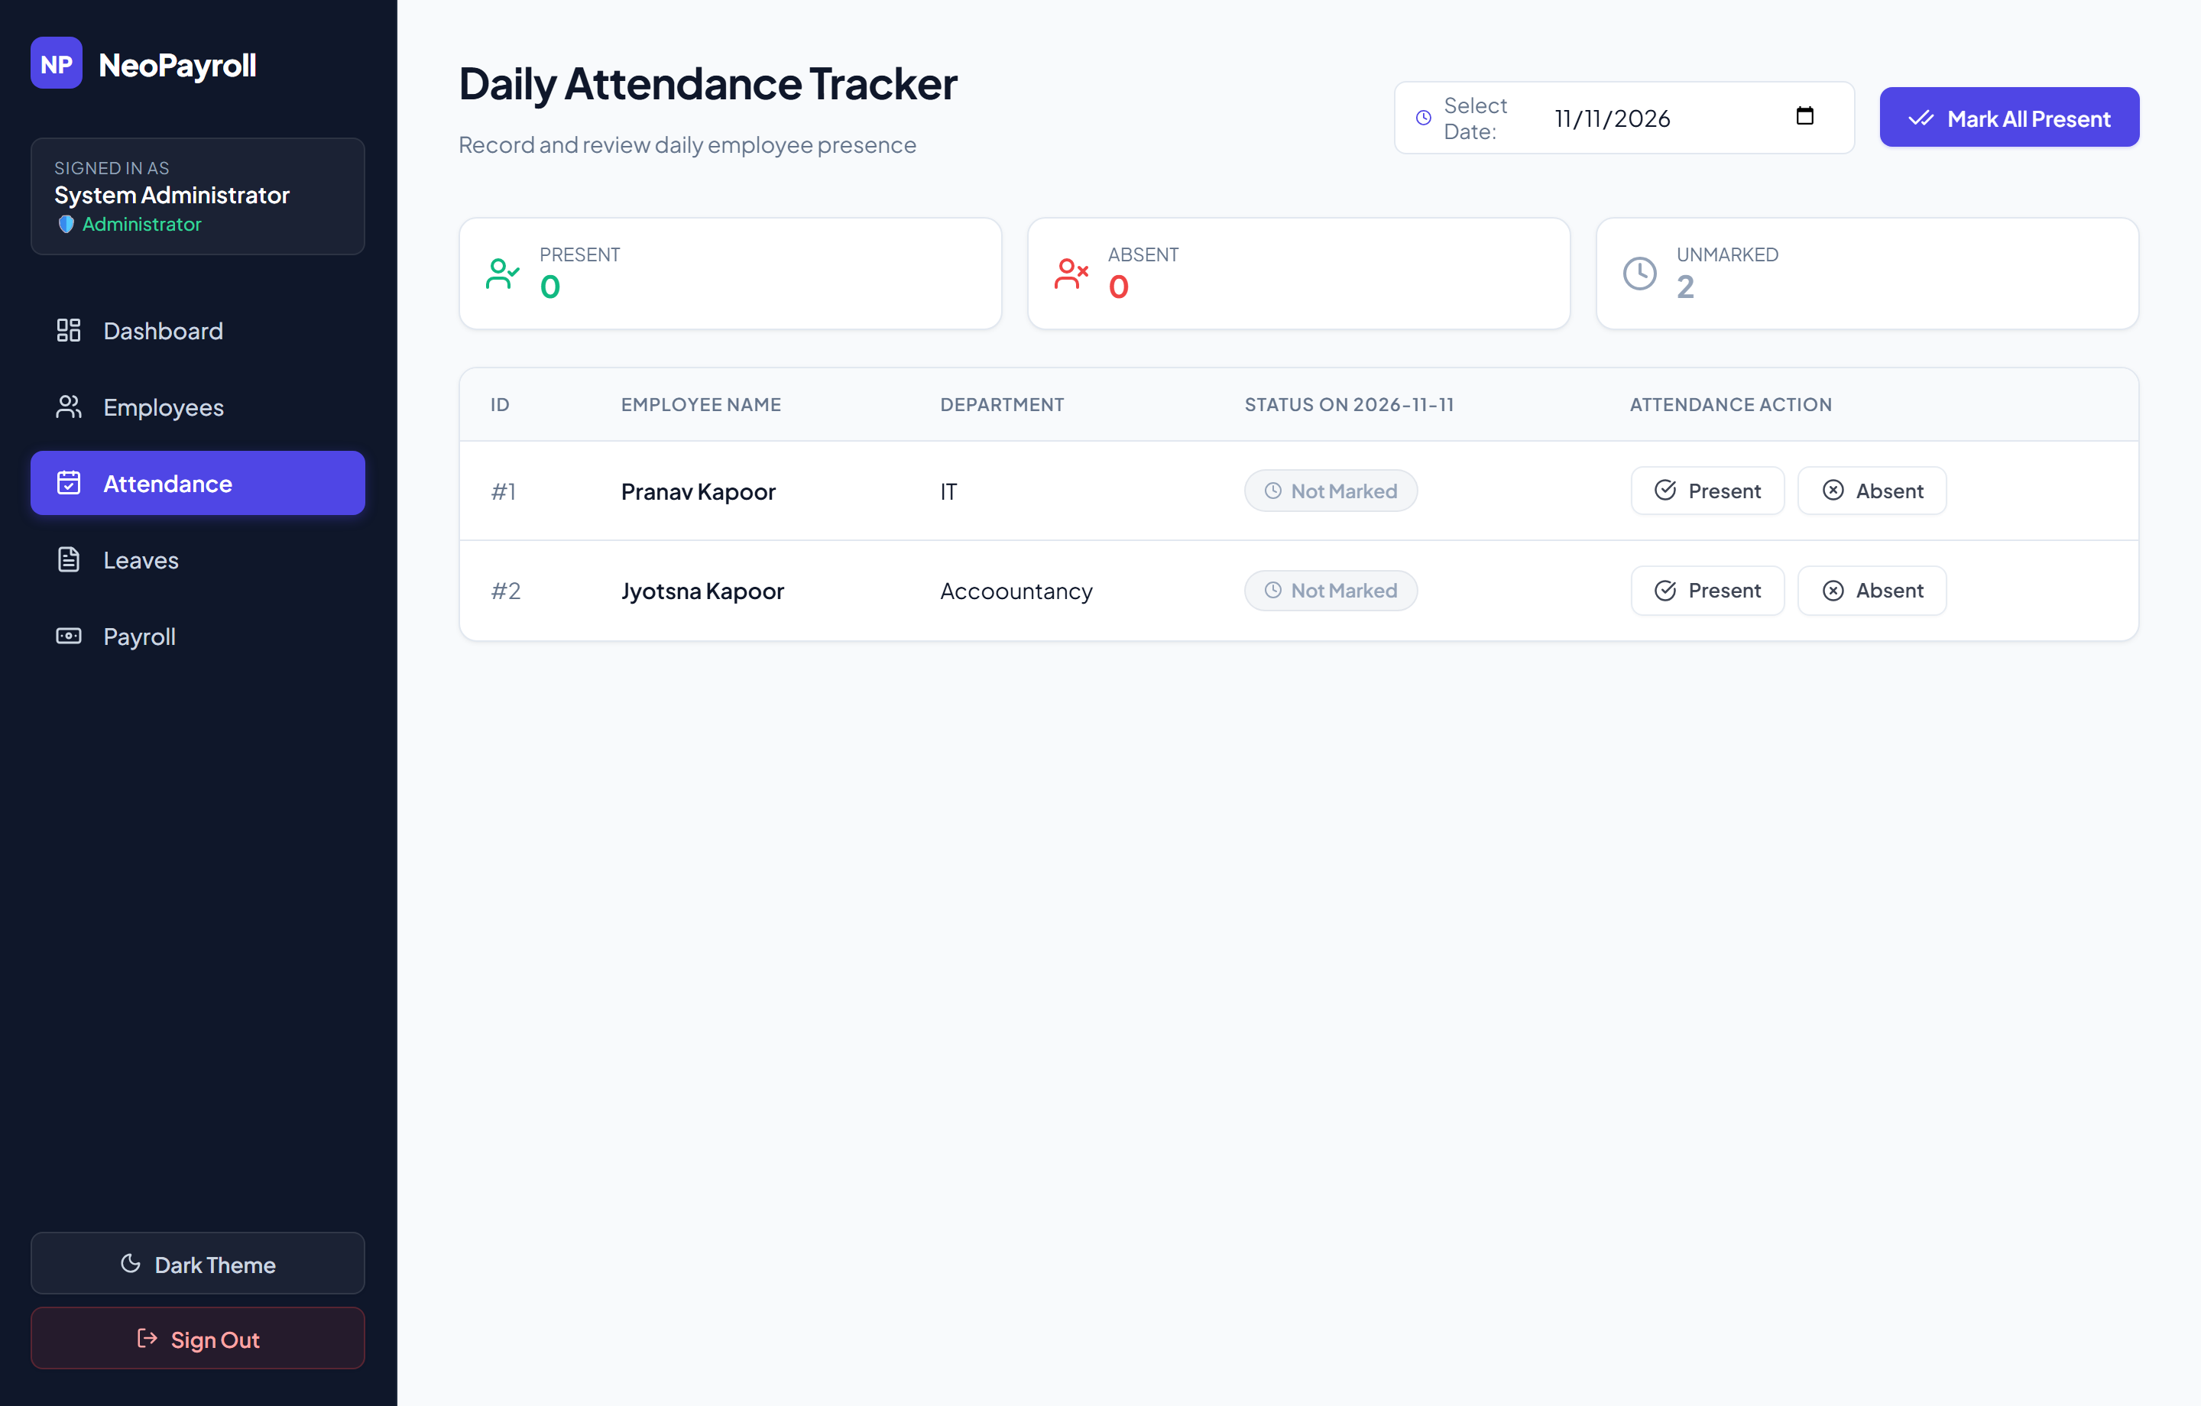
Figure 9.6: Step 4 Output — Daily Attendance Tracker with ISO Date Filtering

Step 5 — Leave Governance & Approval Queue
Administrators inspect employee leave filings with date spans, reasons, and approval statuses in real time.
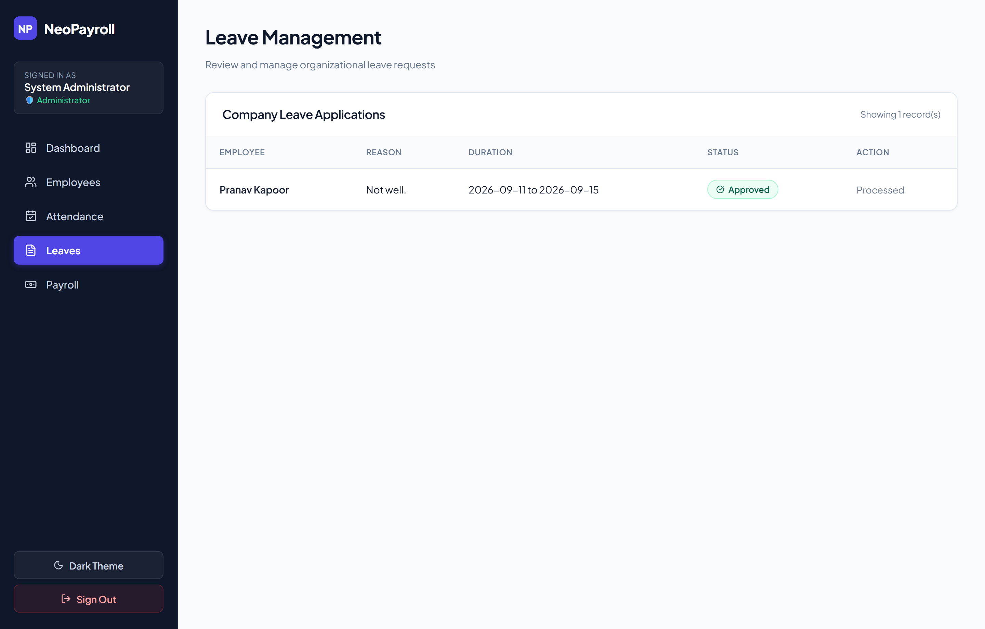
Figure 9.7: Step 5 Output — Organizational Leave Applications & Approval Status

Step 6 — Automated Payroll Calculation & Disbursement Archive
The Payroll module computes net salaries after monthly Loss-of-Pay deductions, prevents duplicate disbursements, and stores historical payout records.
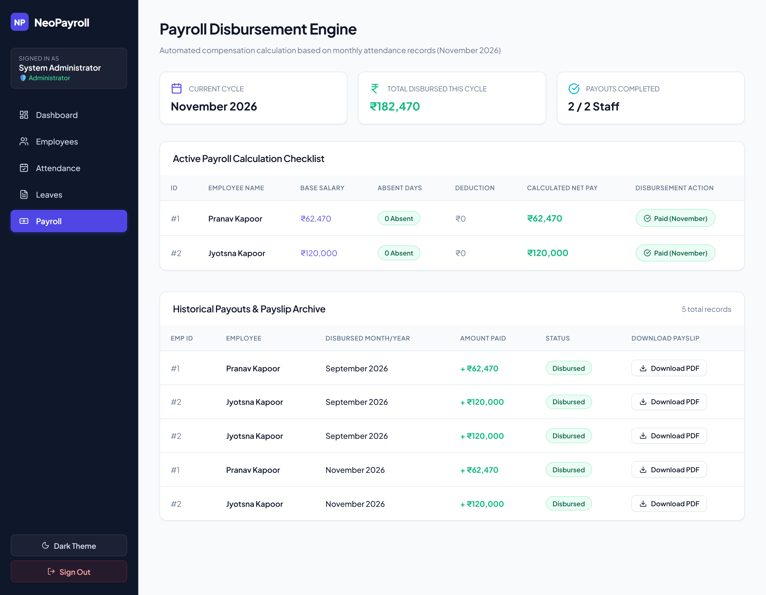
Figure 9.8: Step 6 Output — Active Payroll Checklist & Historical Payouts Archive

Step 7 — Client-Side Corporate PDF Payslip Output
Clicking 'Download PDF' compiles a vectorized corporate payslip in browser memory with Earnings/Deductions breakdown, bank metadata, and dynamic Amount in Words.
Figure 9.9: Step 7 Output — Generated Payslip_September_2026_Pranav_Kapoor.pdf

10. Test Cases & Quality Assurance
Test ID | Module | Scenario / Input | Expected Result | Actual Result | Status
TC-01 | Employee | Register employee with unique email address | Record added to SQLite database; HTTP 200 returned | Employee visible in table with success toast | PASS
TC-02 | Employee | Register employee with an already existing email address | API intercepts duplicate; returns HTTP 400 error | Toast: "Error adding employee. Email might already exist." | PASS
TC-03 | Attendance | Mark employee "Present" on current date | Record inserted into attendances table with date and status | Row confirms status; Dashboard incremented | PASS
TC-04 | Attendance | Change status from "Present" to "Absent" on same date | Existing record updated in-place (no duplicate rows) | Record modified correctly without row duplication | PASS
TC-05 | Leave | Employee submits leave dates with reason | Request created with status Pending | Appears in leave request queue | PASS
TC-06 | Leave | Admin approves pending leave request | PUT request sent; status changes to Approved | Badge turns green; action buttons disabled | PASS
TC-07 | Payroll | Admin clicks "Disburse & Generate" | Salary calculated with absent deductions and recorded in salaries | Added to Historical Payouts list; duplicate payouts locked | PASS
TC-08 | Payroll | Admin clicks "Download PDF" button | Client-side jsPDF script compiles executive corporate payslip | Clean corporate PDF with words and breakdown downloaded | PASS
TC-09 | UI/Theme | Click theme toggle button | document.body class toggled between dark and light themes | Complete palette shifts instantly | PASS
TC-10 | Employee | Admin edits employee designation and salary | PUT /employees/{id} executed; updates database row | Table and active dashboard budget updated live | PASS
TC-11 | Employee | Admin deletes employee with confirmation | DELETE /employees/{id} cascades cleanup across all tables | Removed cleanly without orphan database records | PASS
TC-12 | Attendance | Admin clicks "Mark All Present" | Bulk update marks all active staff present for selected date | All status badges turn green simultaneously | PASS
TC-13 | Leave | Employee selects End Date earlier than Start Date | Frontend validation intercepts invalid date range | Blocked with error: "End date cannot be earlier than start date" | PASS

11. Future Enhancements & Conclusion

11.1 Planned Upgrades
1. Dynamic Formula-Based Payroll: Incorporate tax brackets, Provident Fund (PF), Employee State Insurance (ESI), and leave deductions automatically into net pay calculation.
2. Email Integration: Send payslips directly to employees' email addresses as PDF attachments via SMTP/SendGrid.
3. Biometric Device Integration: Connect IoT biometric fingerprint or RFID card readers directly to the /attendance/ endpoint.
4. Mobile Responsive PWA: Package the frontend into a Progressive Web App for Android and iOS mobile access.

11.2 Conclusion
NeoPayroll demonstrates how modern web engineering principles, decoupled architecture, reactive client-side rendering, asynchronous API backends, and lightweight relational persistence, can transform a traditionally cumbersome corporate process into a lightning-fast, intuitive, and error-free digital workflow.

